Boluwatito Arowosafe

New Wheels Project

Introduction to SQL

Problem Statement
Business Context
A lot of people in the world share a common desire: to own a vehicle. A car or an automobile is seen as an object that gives the freedom of mobility. Many now prefer pre-owned vehicles because they come at an affordable cost, but at the same time, they are also concerned about whether the after-sales service provided by the resale vendors is as good as the care you may get from the actual manufacturers.
New-Wheels, a vehicle resale company, has launched an app with an end-to-end service from listing the vehicle on the platform to shipping it to the customer's location. This app also captures the overall after-sales feedback given by the customer.
Objective
New-Wheels sales have been dipping steadily in the past year, and due to the critical customer feedback and ratings online, there has been a drop in new customers every quarter, which is concerning to the business. The CEO of the company now wants a quarterly report with all the key metrics sent to him so he can assess the health of the business and make the necessary decisions.
As a data analyst, you see that there is an array of questions that are being asked at the leadership level that need to be answered using data. Import the dump file that contains various tables that are present in the database. Use the data to answer the questions posed and create a quarterly business report for the CEO.

Business Questions

Question 1: Find the total number of customers who have placed orders. What is the distribution of the customers across states?
Solution Query:
SELECT state,
COUNT(customer_id) AS customer_count
FROM customer_t
GROUP BY state
ORDER BY customer_count desc;

Output:
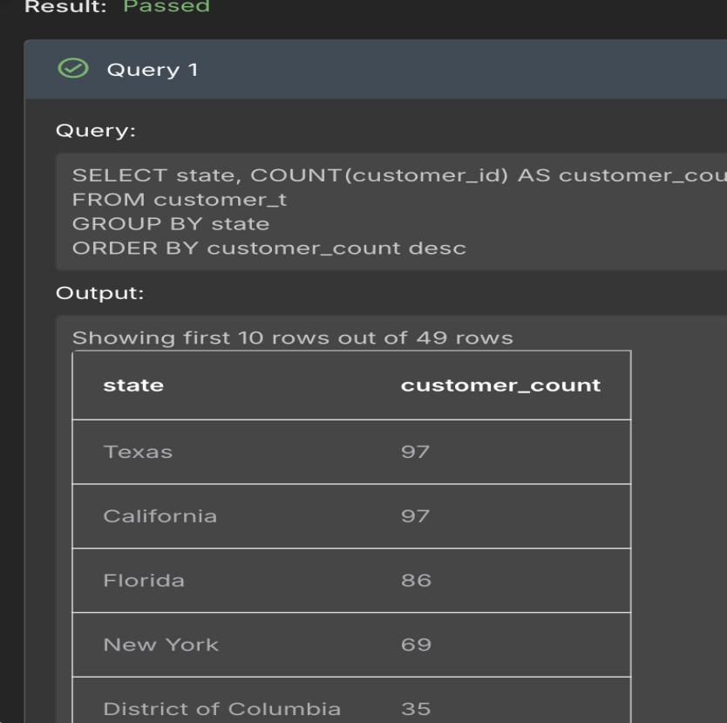

Observations and Insights:
- Texas and California have the most customers.
- This may be due to the size of the states as, these two are among the biggest states in the US. Therefore, occupants will need a convenient mode of transport.
- Moreover, Texas and California have very large populations.

Question 2: Which are the top 5 vehicle makers preferred by the customers?
Solution Query:
SELECT p.vehicle_maker,
COUNT(o.customer_id) AS order_count
from product_t p
left join order_t o
on p.product_id = o.product_id
GROUP BY p.vehicle_maker
ORDER BY order_count DESC;

Output:
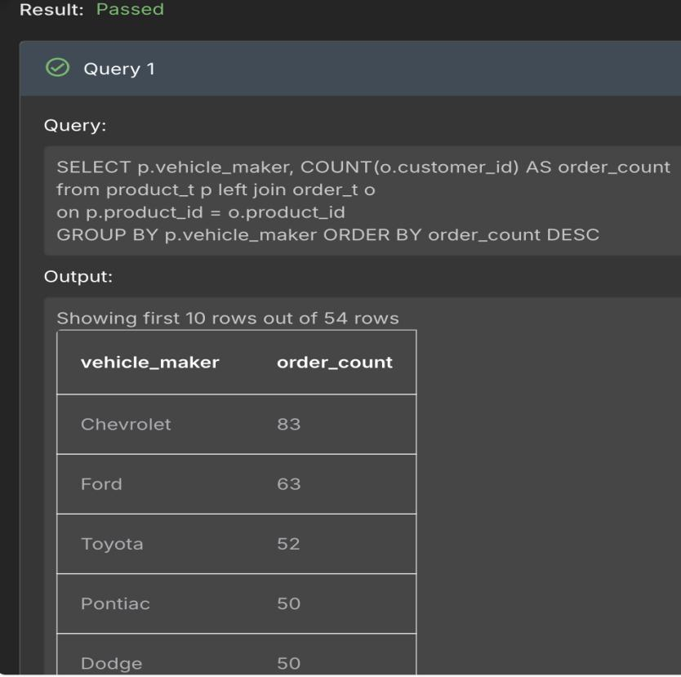
Observations and Insights:
- Chevrolet has the highest demand. Ford has the second highest.
- This is most likely due to its price.
- These top five may have low prices and high reliability.

Question 3: Which is the most preferred vehicle maker in each state?
Solution Query:
select state,
vehicle_maker,
total_customer
from
(select
c.state,
p.vehicle_maker,
count(c.customer_id) as total_customer,
rank()over(partition by c.state order by count(c.customer_id) desc) as rnk
from order_t o
inner join customer_t c
on o.customer_id = c.customer_id
inner join product_t p
on p.product_id = o.product_id
group by c.state, p.vehicle_maker) as x
where rnk = 1;

Output:
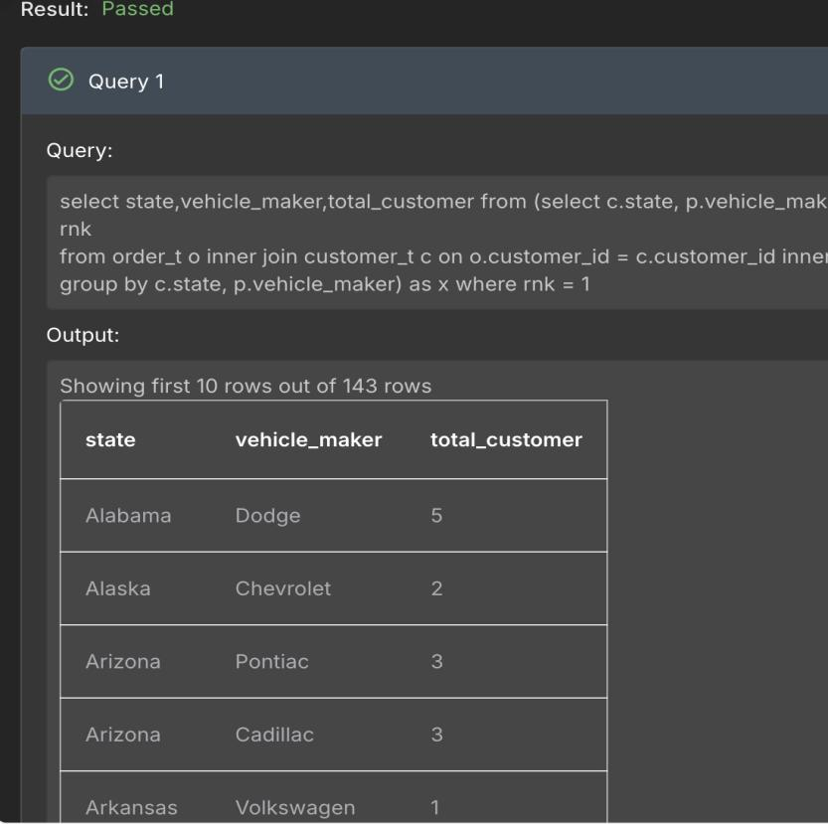
Observations and Insights:
- Most states prefer the more affordable cars.
- Alabama shows a preference for Dodge with 5 customers. Arkansas shows a preference for Volkswagen, with one customer.
- This may be due to price, family size, weather etc.

Question 4: Find the overall average rating given by the customers. What is the average rating in each quarter?

Consider the following mapping for ratings: “Very Bad”: 1, “Bad”: 2, “Okay”: 3, “Good”: 4, “Very Good”: 5
Solution Query:
select
quarter_number,
round(avg(rate_num), 2) as avg_rating
from (
select quarter_number,
case WHEN customer_feedback = 'Very Bad' then 1
WHEN customer_feedback = 'Bad' THEN 2
WHEN customer_feedback = 'Okay' THEN 3
WHEN customer_feedback = 'Good' THEN 4
ELSE 5
END AS rate_num
from order_t) as temp
group by quarter_number
order by quarter_number;

Output:
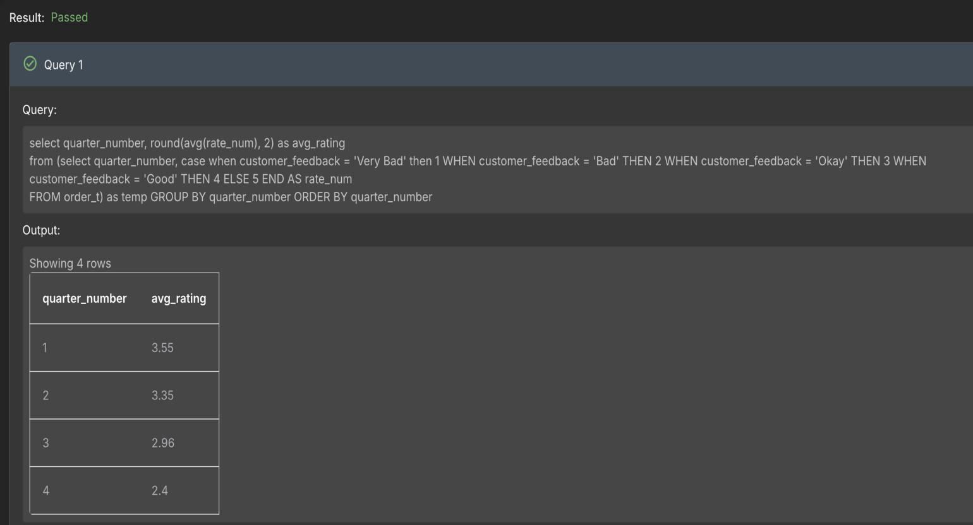
Observations and Insights:
- The average ratings get lower as the quarter increases. The first quarter has the highest average rating of 3.55, which is between okay and good. The fourth quarter has the lowest average rating of 2.4, which is between bad and okay.
- This may be due to wear and tear accumulated as the years go by.
- This may also be due to depreciation in value over the course of the year as a result of outdated tech.

Question 5: Find the percentage distribution of feedback from the customers. Are customers getting more dissatisfied over time?
Solution Query:
select quarter_number,
round(very_good *100.0/total_feedback, 2) as perc_very_good,
round(good *100.0/total_feedback, 2) as perc_good,
round(okay *100.0/total_feedback, 2) as perc_okay,
round(bad *100.0/total_feedback, 2) as perc_bad,
round(very_bad *100.0/total_feedback, 2) as perc_very_bad
from
(select quarter_number,
sum(case when customer_feedback = 'Very Good' then 1 else 0 end) as very_good,
sum(case when customer_feedback = 'Good' then 1 else 0 end) as good,
sum(case when customer_feedback = 'Okay' then 1 else 0 end) as okay,
sum(case when customer_feedback = 'Bad' then 1 else 0 end) as bad,
sum(case when customer_feedback = 'Very Bad' then 1 else 0 end) as very_bad,
count(customer_feedback) as total_feedback
from order_t
group by quarter_number) as x;

Output:
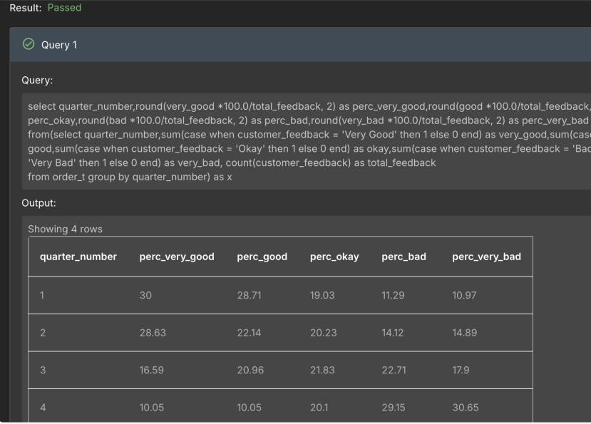
Observations and Insights:
- The very good percentage is the highest in quarter 1 with a percentage of 30% and the very bad percentage is the highest in quarter 4 with a percentage of 30.63%.
- The very good, good and okay percentages reduce as the quarters go by, while the bad and very bad percentages increase as the quarters go by.
- Consumer satisfaction reduces as the quarters go by. This may be due to lowered values, wear and tear, slow shipping time etc.

Question 6: What is the trend of the number of orders by quarter?
Solution Query:
SELECT quarter_number,
COUNT(order_id) AS order_count
FROM order_t
GROUP BY quarter_number
ORDER BY order_count ;

Output:
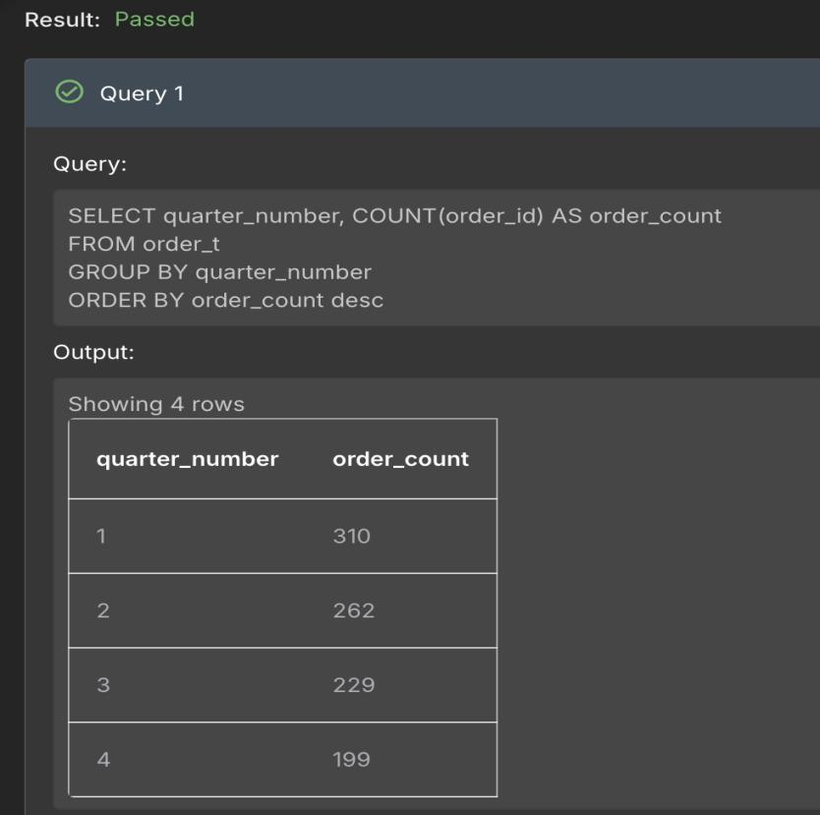
Observations and Insights:
- The number of orders decreases as the quarters increase. Quarter 1 has an order count of 310 and quarter 4 has an order count of 199.
- Similar to the average rating per quarter, this may be due to reduction in value and outdated tech during the later quarters
- Additionally, customers may be budgeting for the new year or may hold back car purchases to get newer models and better deals in the early quarters of a year.

Question 7: Calculate the net revenue generated by the company. What is the quarter-over-quarter % change in net revenue?
Solution Query:
select quarter_number,
net_revenue,
round(100*(net_revenue - lag(net_revenue)over(order by quarter_number))/lag(net_revenue)over(order by quarter_number), 2) as prev_qoq
from
(select quarter_number,
round(sum(quantity*(vehicle_price- ((discount/100)*vehicle_price))),2) as net_revenue
from order_t
group by quarter_number
order by quarter_number) as x

Output:
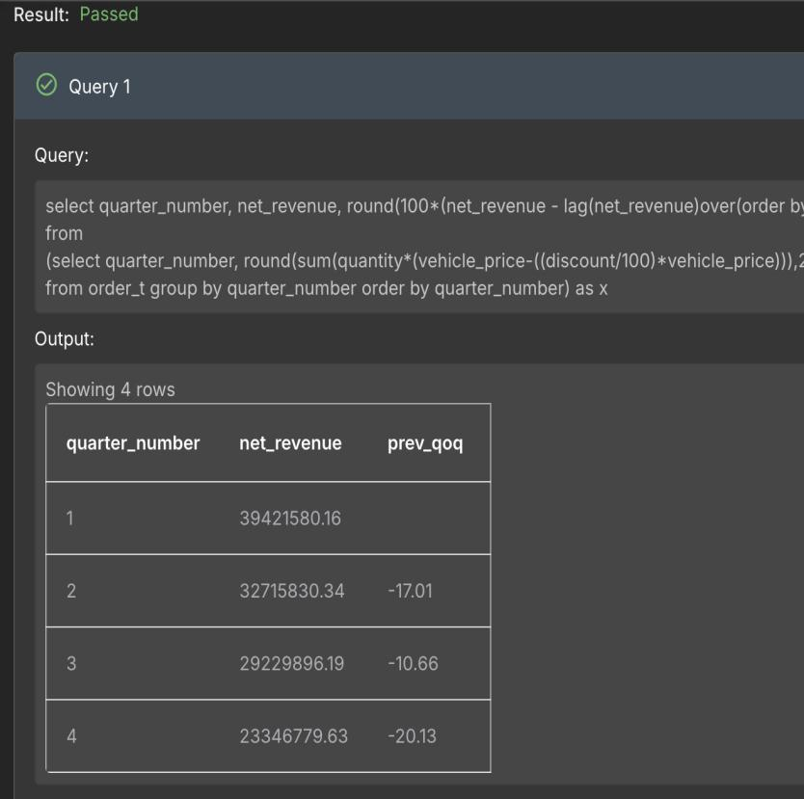
Observations and Insights:
- As the quarters go on, the net revenue reduces. The first quarter has the highest revenue of 39,421,580.16 while the last quarter has the lowest revenue of 23,346,779.63.
- As the quarters go on, the quarter over quarter percent change in revenue reduces, getting more negative.
- This may be due to reduction in value as the quarters go by, better deals in earlier quarters etc.

Question 8: What is the trend of net revenue and orders by quarters?
Solution Query:
select quarter_number,
round(sum(quantity*(vehicle_price-((discount/100)*vehicle_price))),2) as net_revenue,
count(order_id) as order_count
from order_t
group by quarter_number
order by quarter_number;

Output:
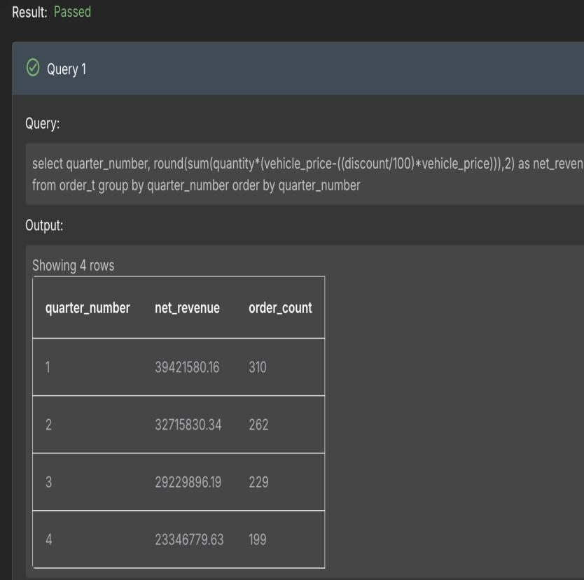
Observations and Insights:
- The number of orders and total net revenue decreases as the quarters go by.
- As discussed in question 6, this is most likely due to lowered value, outdated tech, better deals and newer models during earlier quarters, budgeting, etc.
- These conditions will lower order numbers, thefore lowering the total net income as the quarters go by.

Question 9: What is the average discount offered for different types of credit cards?
Solution Query:
select c.credit_card_type,
round(avg(o.discount), 2) as avg_discount
from customer_t c
left join order_t o on c.customer_id = o.customer_id
group by c.credit_card_type
order by avg_discount desc;

Output:
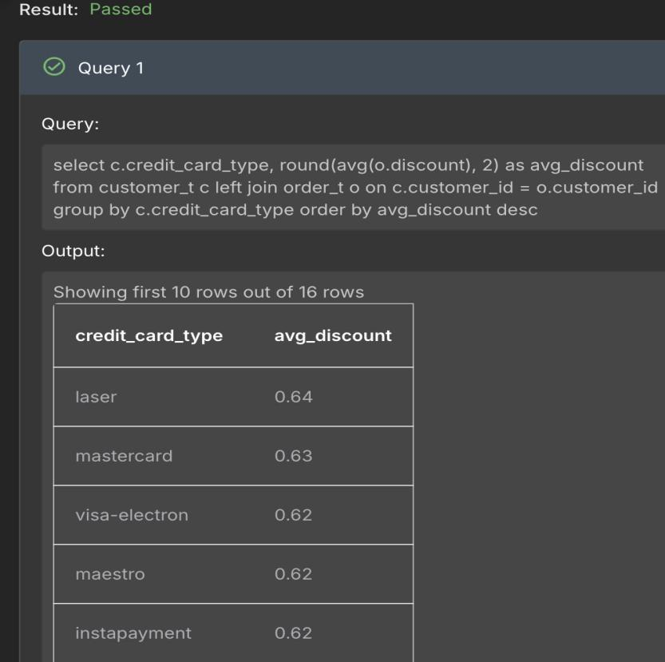
Observations and Insights:
- The laser credit card type has the highest average discount.
- This may be due to partnerships with specific credit card types.
- Also, this could have been done to attract high end spenders.

Question 10: What is the average time taken to ship the placed orders for each quarter?
Solution Query:
select quarter_number,
round(avg(julianday(ship_date) - julianday(order_date)), 1) as avg_shipping_days
from order_t
group by quarter_number;

Output:
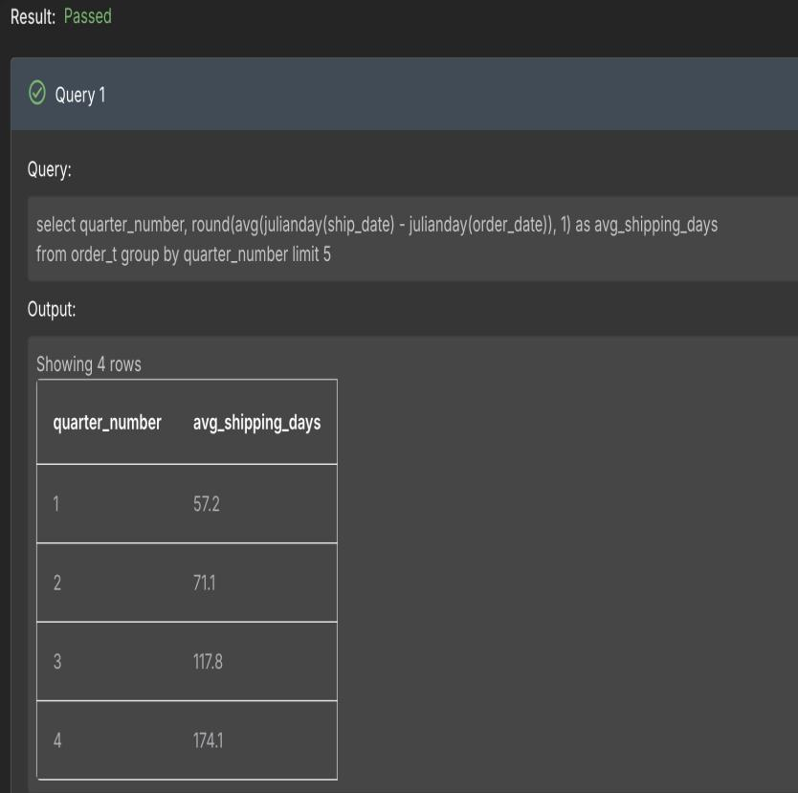

Business Metrics Overview
Total Revenue | Total Orders | Total Customers | Average Rating
124,714,086.32 | 1000 | 994 | 3.14
Last Quarter Revenue | Last quarter Orders | Average Days to Ship | % Good Feedback
23,346,779.63 | 199 | 98 | 83

Business Recommendations
- New Wheels should target states with the highest populations and tendencies to buy used cars like Texas and California.
- New Wheels should endorse in the most demanded car make, which is the Chevrolet in their case.
- New Wheels should introduce good deals and discounts in later quarters e.g quarter 4 to increase the number of orders, therefore incresing the net revenue in later quarters.
- New Wheels should improve the customer experience. For example, test drives and an easier purchasing process.
- New Wheels should ensure constant repair and servicing to avoid wear and tear in later quarters, thereby increasing rating, and keep up with the latest technologies.
- New Wheels should ensure faster shipping to increase customer satisfaction, thereby increasing ratings, customer numbers and revenue eventually.

