**NAME : ____________________________________________**

**KNOWLEDGE TEST FOR AN IT-BA POSITION**

The test is divided into 4 sections :

AGILE

UML

CASE STUDIES

OBJECT MODELLING

**AGILE**

1. Briefly describe the Agile development life cycle
2. In your experience, what is the role of an IT analyst in the Agile development life cycle?
3. What is a User Story? What would you find in a User Story?

**UML**

1. Identify the different sections you would normally find in a Use Case.
2. What would one normally find in a User Interface documentation?
3. What is a Use Case Diagram and what would one find there?
4. What purpose does an Activity Diagram serve?

**CASE STUDY 1**

1. The business requirement specifies the need to capture client information.

Two available options are: Cancel the entry, Save changes.

The information to be captured is the client’s personal information (name, date of birth, gender, employer, occupation), address and communication information (telephone numbers, e-mail).

The solution team has indicated to you that only one screen will be developed to meet these requirements.

This function will be used by internal employees of the company and the company external insurance brokers.

Demonstrate, using a Use Case Diagram, your proposed solution.

Describe the Basic Path and any Alternate paths, if any.

Describe the Business Rules relative to the User Interface documentation.

1. In the context of entering address information, you have been told that it is possible to search the Canada Post records using the postal code. The search may return one or more results.

Demonstrate, using an activity diagram, your proposed solution.

1. Name a few User Stories.

**CASE STUDY 2**

Several contracts are blocked in production following a deployment and it is urgent to resolve the situation. What would your strategy be?

**CASE STUDY 3**

Here are two stories

1- Describe the requirements life cycle in the Agile Methodology, from the creation of the stories  
 that are assigned to you in the backlog, until their delivery to production  
 2- Produce the functional documentation (use case and / or screen rules) of these two stories  
 3- Describe a few test cases

**User story 1**

As a user, I want to be able to make a request to the claims central file to retrieve the customer's claims report.

Description:

1- New field in the Driver screen with 3 possible values (NO, YES, FORCED).  
 English wording: ‘CMF Search:’ / French wording: ‘FCSA search:’  
 The field is displayed only if the driver’s license of the Driver was issued in Quebec.  
 The drop-down list of possible values depends on whether a request has already been  
 executed or not. Initially, all 3 values are available. As soon as a request has been executed,   
 only the YES and FORCED values are available.  
 The field must be reset to 'NO' when the rate guarantee date of the quote has expired (for   
 information: at Intact, when a customer calls for a quote for auto or home insurance, they are   
 provided with the premium and by specifying that this premium amount is valid for a certain   
 period).

2- The search is done only if the value of the field is YES or FORCED

Companies: belairdirect, National Bank, Intact  
 Province: Québec  
 Line of Business: Automobile

**User Story 2**

As a user, I can only make a request to the claims central file if the driver’s license number is valid.

Description:

The driver’s license number is required to request the report  
 The driver's license number must also have a valid format (Quebec format) (note: no need to  
 detail the driver's license validation algorithm)

Companies: belairdirect, National Bank, Intact  
 Province: Québec  
 Line of Business: Automobile

|  |  |
| --- | --- |
| **Mockups** |  |

**MODELLING**

Describe your understanding of the following object model:

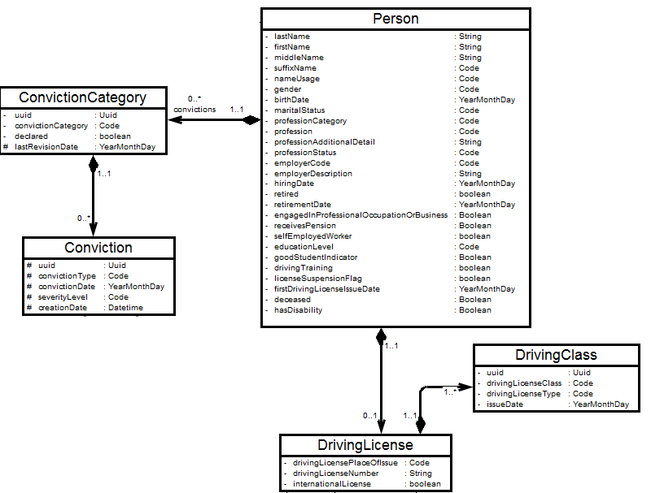

|  |
| --- |
| 1. Agile SDLC methodologies is base on collaborative decision making between requirements and solutions teams, and an iterative progression of producing working software. Within the agile SDLC, work is **divided into sprints**, with the goal of producing a working product at the end of each sprint. |
|  |
| 1. I am the middle man between the business and the development team. I identify business requirements and convert them into viable solution. |
|  |
| 1. A user story is an informal, general explanation of a software feature written from the perspective of the end user or customer.    The three elements are : As a (role), I want (function) so that (business value). |
|  |
|  |
| 1. Use Case ID, Use Case Name, Use Case History, Actor, Description, Preconditions, Postconditions, Priority, Normal event, Alternative event, Exceptions, Special requirements, Assumptions, Notes and Issues. |
|  |
| 1. user interface specification (UI specification) is a document that captures the details of the software user interface into a written document. |
|  |
| 1. Use-case diagrams describe the high-level functions and scope of a system. These diagrams also identify the interactions between the system and its actors. The use cases and actors in use-case diagrams describe what the system does and how the actors use it |
|  |
| 1. Activity diagrams show the workflow from a start point to the finish point detailing the many decision paths that exist in the progression of events contained in the activity. They may be used to detail situations where parallel processing may occur in the execution of some activities |
|  |
|  |
| 1. I will do a GAP analysis of the current state and determine the future state. I will draw a process flow diagram of how the future state can integrate and work well with the current state without interruptions. |
|  |
|  |
| 1. Define the Problem, Determine the Causes, Generate Ideas, Select the Best Solution and Take Action. |
|  |
| 1. The Agile software development life cycle is the structured series of stages that a product goes through as it moves from beginning to end. It contains six phases: concept, inception, iteration, release, maintenance, and retirement. |
|  |
| The test case is defined as a group of conditions under which a tester determines whether a software application is working as per the customer's requirements or not. Test case designing includes preconditions, case name, input conditions, and expected result. |
|  |
|  |
| I understand that as a data integration process |
|  |
|  |
|  |
|  |
|  |
|  |
|  |
|  |
|  |
|  |
|  |
|  |
|  |
|  |
|  |
|  |
|  |
|  |
|  |
|  |
|  |
|  |
|  |
|  |
|  |
|  |
|  |
|  |
|  |
|  |
|  |
|  |
|  |
|  |
|  |
|  |
|  |
|  |
|  |
|  |
|  |
|  |
|  |
|  |
|  |
|  |
|  |
|  |
|  |
|  |
|  |
|  |
|  |
|  |
|  |
|  |
|  |
|  |
|  |
|  |
|  |
|  |
|  |
|  |
|  |
|  |
|  |
|  |
|  |
|  |
|  |
|  |
|  |
|  |
|  |
|  |
|  |
|  |
|  |
|  |
|  |
|  |
|  |
|  |
|  |
|  |
|  |
|  |
|  |
|  |
|  |
|  |
|  |
|  |
|  |
|  |
|  |
|  |
|  |
|  |
|  |
|  |
|  |
|  |
|  |
|  |
|  |
|  |
|  |
|  |
|  |
|  |
|  |
|  |
|  |
|  |
|  |
|  |
|  |
|  |
|  |
|  |
|  |
|  |
|  |
|  |
|  |
|  |
|  |
|  |
|  |
|  |
|  |
|  |
|  |
|  |
|  |
|  |
|  |
|  |
|  |
|  |
|  |
|  |
|  |
|  |
|  |
|  |
|  |
|  |
|  |
|  |