ET0706 Mini Project Report
Project title: Hotel Booking System

Submitted by: Shi Jianfa, 2043610, DCPE/FT/3A/22

Overview
This project aims to create a JavaFX application that enables travelers to compare hotels and easily choose their preferences, as well as provide a seamless booking function. The design of the application focuses on providing a user-friendly GUI and increasing administrative efficiency by reducing manual work, such as extracting booking reports for each user.

Requirements
To set up for this project in Eclipse, it is required to have:
JDK Version: jdk-17-0-4-1
JavaFX Version: javafx-sdk-18.0.2
Scene Builder Version: 19.0.0
Eclipse Version: 2022-06(4.24.0)
External JAR/dependencies:
controlsfx-11.1.2.jar
fontawesomefx-8.1.jar
itextpdf-5.1.0.jar
javax.mail.jar
mysql-connector-java-8.0.30.jar
javax.activation-1.2.0.jar
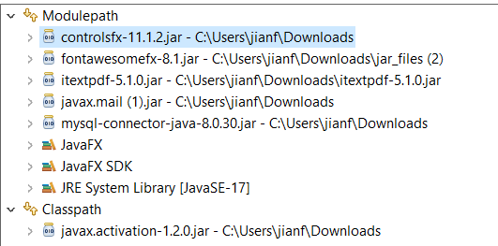

User Interface Design
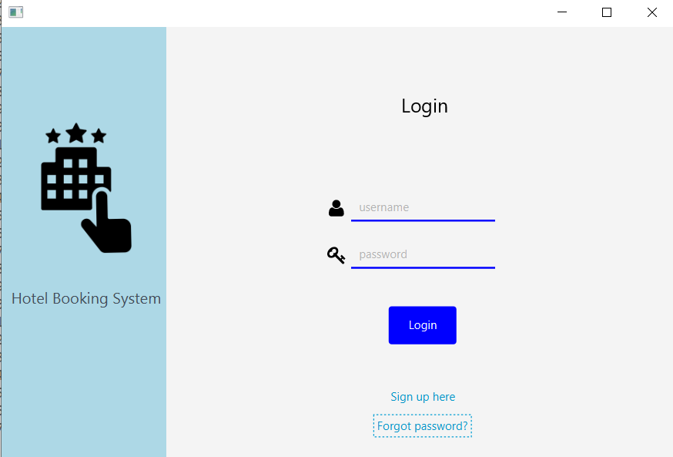
Login page
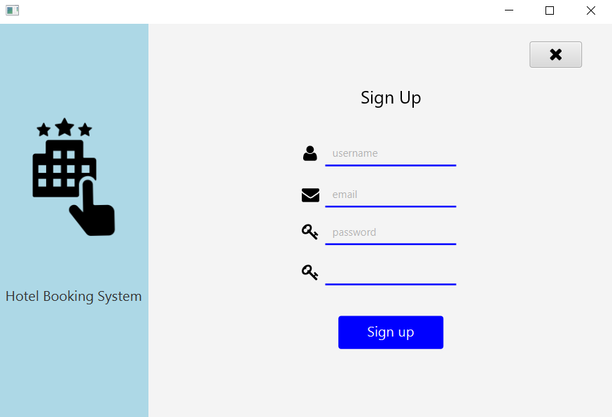
Sign up page
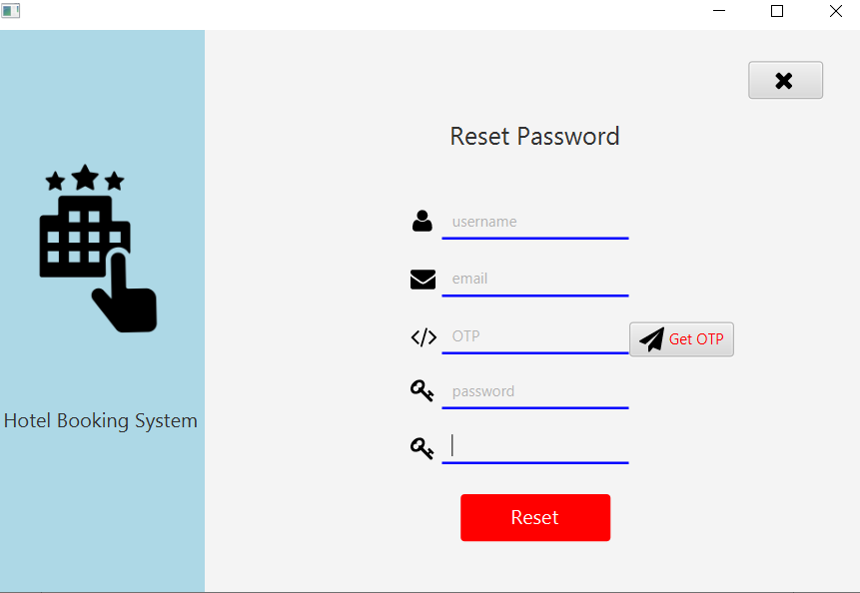
Reset password page
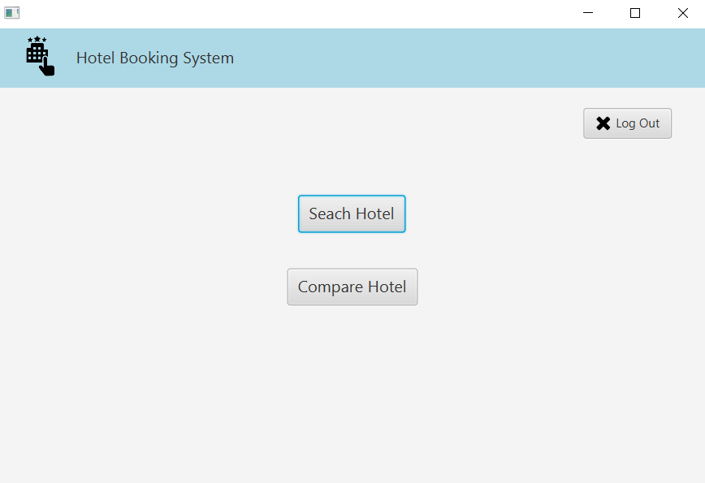
Upon login, main page
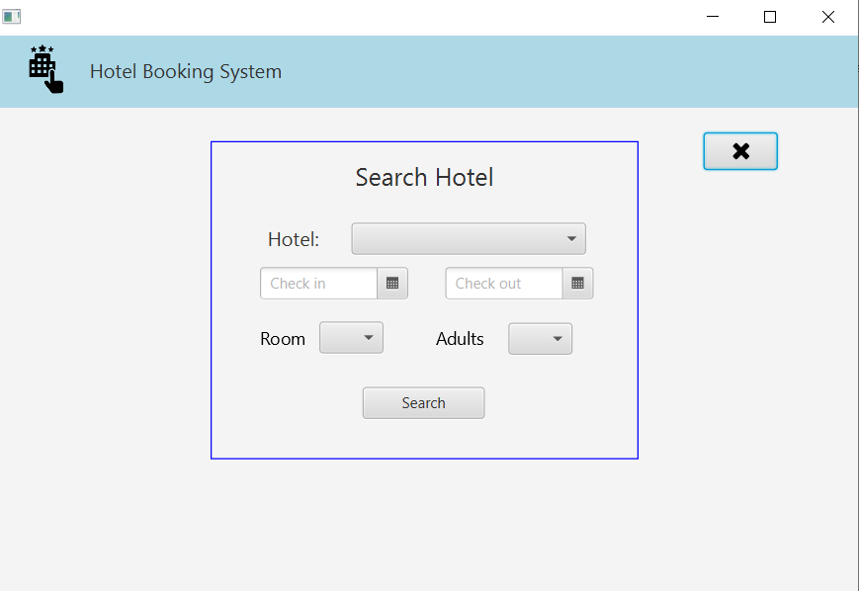
Search hotel page
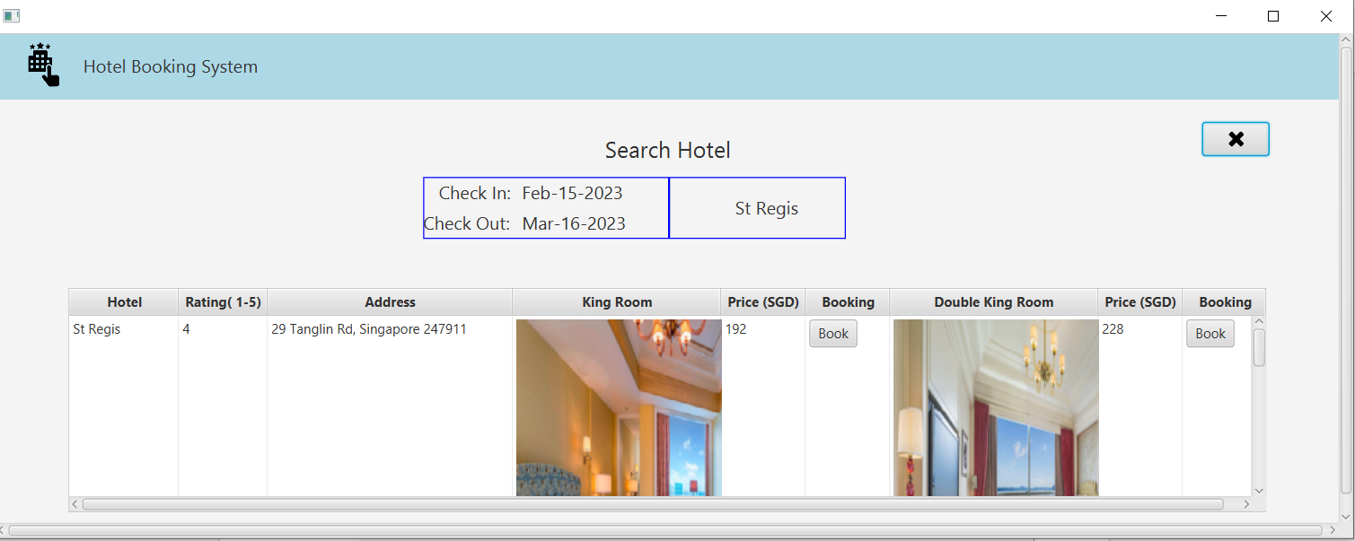
Search hotel result page (Scrollable)
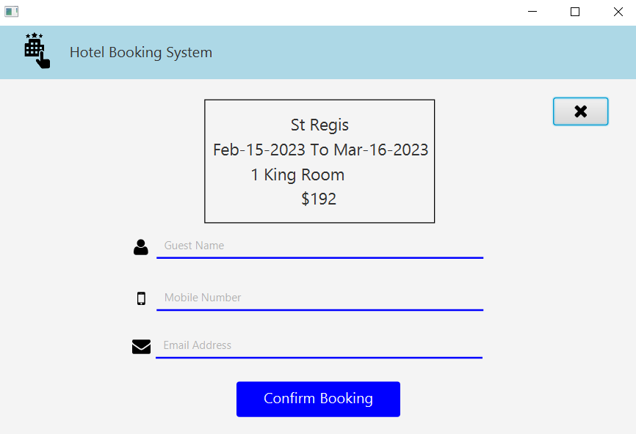
Booking page, upon “book” button clicked
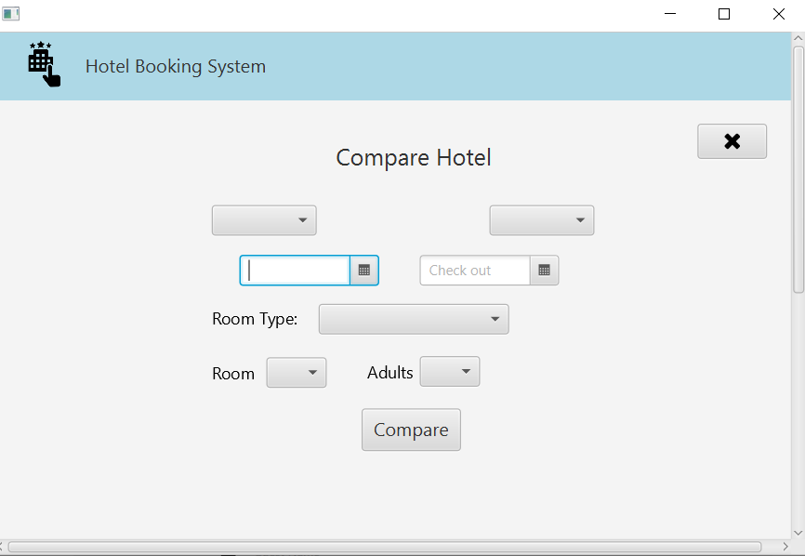
Compare hotel page
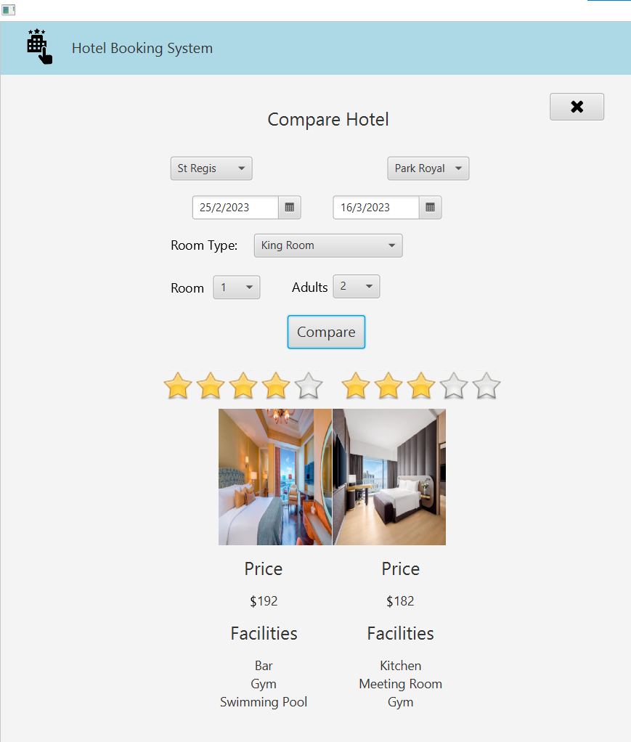
Continue from Compare page (Scrollable)
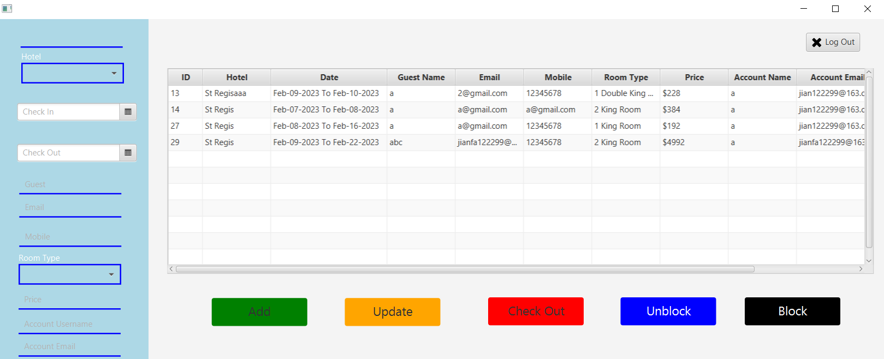
Admin page

Classes
Controller classes:
ControllerAdminPage -> implements Initializable
ControllerBookingPage -> implements Initializable
ControllerComparePage -> implements Initializable
ControllerForgotPasswordPage
ControllerLoginPage
ControllerMainPage
ControllerRegister
ControllerResultPage -> implements Initializable
ControllerSearchPage -> implements Initializable

Page classes:
PageAdmin
PageForgotPassword
PageLogin
PageRegister
PageResult

View classes:
ViewAdminPage
ViewBookingPage
ViewComparePage
ViewForgotPassword
ViewLoginPage
ViewMainPage
ViewRegisterPage
ViewResultPage
ViewSearchPage

Interface:
confirm
otp
SqlDataForTable

Other classes:
DisablePastDate
GeneratePDF
SendEmail
setEmailVariables
sendOTP -> extends setEmailVariables implements otp
sendConfirm -> extends setEmailVariables implements confirm
ShowPages
SqlConnection
SqlDataForTable
searchResultVariables
getDataForAdmin -> implements SqlDataForTable
getDataForSearchResult -> implements SqlDataForTable

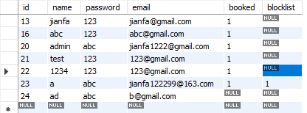
Database

‘login’ table
The "login" table serves as a repository for user information, including name, password, and email, after a successful sign-up process. The "booked" column serves as a status indicator, with a value of 1 indicating that a user has made a booking and a value of 0 indicating the opposite. Users are restricted to a single booking unless checked out by an administrator. The "blocklist" column enables administrators to restrict users from making any bookings and can be adjusted as necessary. This table is utilized during the login, sign-up, and password reset processes to verify user identity and keep information updated. Additionally, the booking function accesses this table to determine whether booking is approved or declined.

‘hotel_details’ table
The table stores all the information of hotels in the database and is used for the hotel search and comparison functions, where the data needs to be retrieved for display.
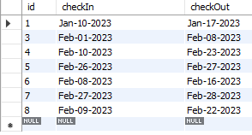
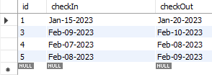

‘stregisbooking’ table ‘parkroyalbooking’ table
The implementation of these two tables is a crucial component in maintaining the integrity of the booking system by allowing only one user to check in and out each day. Once a booking is confirmed, the related information is immediately updated in the tables, effectively preventing any potential overbooking for the specific day. The utilization of these tables takes place through the date picker widget on the search and compare page.

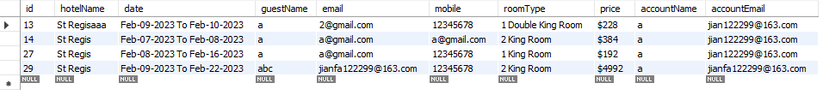
‘confirmbooking’ table
Upon a successful hotel booking by a user, all related information is saved in this table. The administrator can access this table on the admin page to perform tasks such as adding, updating, checking out, blocking, or unblocking a user.

Key Features Implemented
The "Export to PDF" and JavaMail API features are utilized in tandem to export a user's booking details into a PDF format and send it directly to their email. This legally binding document, in black and white, protects both parties from any potential conflicts by clearly stating all relevant details.

The implementation of an "SQL connection" helps streamline business operations by saving time and resources. When the volume of data is relatively small, local management is practical. However, as the data volume grows, transferring the data to a database server such as MySQL can lead to a reduction in management time and cost savings, as data management becomes more streamlined.

The provision of a "Login/Sign up" feature and distinct GUIs for both users and administrators are fundamental components in any business operation. The accurate storage of user information in the database is crucial for ensuring user identity and avoiding any mis-logins. Additionally, the ability to differentiate between users and administrators is important to prevent unauthorized access to sensitive business information.

Effective "Room Management" is achieved through the disabling of dates that have already been booked, thereby avoiding overbooking. Overbooking can lead to profit reduction, loss of customers, and the need for compensation. Good room management practices are essential to a successful business operation.

Conclusion/Reflection
In conclusion, this JavaFX Hotel Booking System has been created to simplify the process of booking and comparing hotels for travelers. The system includes a user-friendly interface and reduces the need for manual operation. The database is used to store important information about users and hotels. The "Export to pdf" and JavaMail API functions allow the system to send a PDF copy of the user's booking details to their email. A room management system has been implemented to prevent overbooking. While advanced features such as a map and payment system were not included due to time constraints, the basic features have been successfully implemented to fulfill the main purpose of the system.

