Software Requirements Specification


WPU Maintenance Request System
Western Pacific University

Table of Contents
1. Project Overview 4
1.1 Purpose 4
1.2 Objectives 4
2. Stakeholders 4
2.1 Primary Users 4
2.2 Secondary Stakeholders 4
3. Scope 5
3.1 In-Scope 5
3.2 Out-of-Scope 5
3.3 Tools Used 5
3.4 Timeline 5
3.5 Constraints 6
4. Functional Requirements 6
4.1 User Management 6
4.2 Maintenance Request Submission 7
4.3 Request Tracking 7
4.4 Assignment Management 7
4.5 Technician Features 7
4.6 Notifications 8
4.7 Reporting 8
5. Non-Functional Requirements 8
5.1 Security 8
5.2 Performance 8
5.3 Availability 9
5.4 Usability 9
5.5 Reliability 9
6. Interface / Dashboard Requirements 9
6.1 Home Page 9
6.2 Student Dashboard 9
6.3 Staff Dashboard 10
6.4 Academic Dashboard 10
6.5 Technician Dashboard 10
6.6 Supervisor Dashboard 11
6.7 Admin Dashboard 11
7. Database Requirements 11
7.1 Design Overview 11
7.2 Entity-Relationship Summary 12
7.3 Data Dictionary 12
7.3.1 roles 12
7.3.2 users 13
7.3.3 buildings 13
7.3.4 rooms 14
7.3.5 categories 14
7.3.6 maintenance_requests 14
7.3.7 assignments 15
7.3.8 request_status_history 16
7.3.9 attachments 17
7.3.10 work_comments 18
7.3.11 notifications 18
7.3.12 audit_logs 19
7.4 Constraints & Integrity Rules 20
7.5 Indexing Strategy 20
7.6 Reporting Support 20
7.7 Normalization Note 21
8. Recommended Technology Stack 22
9. Future Enhancements 22
Current Implementation Addendum 23
System Diagrams 24
Use Case Diagram 24
System Flowchart 25

1. Project Overview

1.1 Purpose
This document defines the full set of requirements for the WPU Maintenance Request System: a web-based platform that allows Western Pacific University students, staff, academics, and administrators to report maintenance issues, track their progress, and enable maintenance personnel to manage and resolve requests efficiently.

1.2 Objectives
- Replace paper/manual maintenance requests.
- Improve response and resolution times.
- Provide transparency and tracking for requesters.
- Generate maintenance reports and statistics.
- Improve communication between requesters and maintenance staff.

2. Stakeholders

2.1 Primary Users
- Students
- Academic & Administrative Staff
- Technicians & Supervisors
- System Administrators

2.2 Secondary Stakeholders
- University Management
- ICT Department
- Facilities Department

3. Scope

3.1 In-Scope
- Home page
- Sign in / create account
- Role-based dashboards: Student, Staff, Academic, Supervisor, Technician, Administrator
- Logout

3.2 Out-of-Scope
Not specified in the source requirements document. Suggested exclusions for v1.0, to be confirmed with stakeholders:
- Native mobile applications (Android/iOS) — listed under Future Enhancements.
- Integration with third-party facilities/asset-management systems.
- GIS campus map integration and QR-code based reporting.
- AI-based automatic categorization of requests.
- Email notifications

3.3 Tools Used
Frontend | Backend | Database
HTML, CSS, JavaScript | PHP | MySQL XAMPP (local hosting for now).
HTML, CSS, JavaScript | PHP | Microsoft SQL Server or PostgreSQL (For real online hosting)

3.4 Timeline
Not specified in the source requirements document. Suggested phased delivery, to be confirmed with stakeholders:
- Phase 1 — Requirements & Database Design
- Phase 2 — Core Backend (auth, requests, roles)
- Phase 3 — Dashboards & Frontend for all roles
- Phase 4 — Notifications & Reporting
- Phase 5 — Testing, UAT, and Deployment

3.5 Constraints
Not specified in the source requirements document. Suggested constraints, to be confirmed with stakeholders:
- Initial deployment is local (XAMPP); production hosting is not yet decided.
- Development team has committed to HTML/CSS/JS, PHP, and SQL only.
- University email and Student/Staff ID are the only supported identity sources for v1.0.

4. Functional Requirements

4.1 User Management
ID | Requirement
FR-01 | User Registration — users register using a university email; Student ID or Staff ID is verified at sign-up.
FR-02 | Authentication — users log in with username/Student ID/email and password; password reset is supported.
FR-03 | Role Management — the system supports six roles: Student, Staff, Academic, Technician, Supervisor, and Administrator.

4.2 Maintenance Request Submission
ID | Requirement
FR-04 | Create Request — users submit a request with title, description, building, room number (for dormitories/lecture buildings), category, priority level, and photo/attachments. Categories include Electrical, Plumbing, Air Conditioning, Furniture, IT Equipment, and Building Repair.

4.3 Request Tracking
ID | Requirement
FR-05 | Status Tracking — a request's status is one of Submitted, Assigned, Pending, Completed, or Rejected.
FR-06 | Request History — users can view submission date, assigned officer, status changes, and completion date.

4.4 Assignment Management
ID | Requirement
FR-07 | Assign Requests — a supervisor can view pending requests, assign maintenance personnel, and set due dates.
FR-08 | Reassign Requests — a supervisor can transfer a request to another technician.

4.5 Technician Features
ID | Requirement
FR-09 | Work Queue — maintenance staff can view assigned tasks, priority, and due date.
FR-10 | Update Status — a technician can accept an assignment, start work, pause work, and mark it completed.
FR-11 | Upload Work Evidence — a technician can upload before/after maintenance photos and add comments.

4.6 Notifications
ID | Requirement
FR-13 | Dashboard Alerts — the system displays notification alerts on dashboards.

4.7 Reporting
ID | Requirement
FR-14 | Reports — generated by month, building, category, technician, and status.
FR-15 | Dashboard Analytics — shows total requests, open requests, rejected requests, completed requests, and average resolution time.

5. Non-Functional Requirements

5.1 Security
- Role-based access control
- Password encryption
- Secure HTTPS
- Audit logs

5.2 Performance
- Response time under 2 to 3 seconds
- Support at least 1,000 concurrent users

5.3 Availability
- System uptime of 99.999%

5.4 Usability
- Responsive on mobile, tablet, laptop, and desktop devices
- Easy request submission
- Simple, user-friendly dashboards

5.5 Reliability
- Daily database backups
- Recovery mechanism

6. Interface / Dashboard Requirements

6.1 Home Page
- Welcome message
- About the system
- Sign in/Create Account

6.2 Student Dashboard
- Submit Request
- Title
- Description
- Building/Dormitory
- Room number
- Category (include Electrical, Plumbing, Air Conditioning, Furniture, IT Equipment, and Building Repair).
- Priority level
- Photo/attachments
- View My Requests
- Track Status

6.3 Staff Dashboard
- Submit Requests
- Title
- Description
- Area/Location (such as Area1)
- Building number
- Category (include Electrical, Plumbing, Air Conditioning, Furniture, IT Equipment, and Building Repair).
- Priority level
- Photo/attachments
- View My Requests
- Track Status

6.4 Academic Dashboard
- Submit Requests
- Title
- Description
- Building (includes lecture buildings, admin building, library)
- Room number
- Category (include Electrical, Plumbing, Air Conditioning, Furniture, IT Equipment, and Building Repair).
- Priority level
- Photo/attachments
- View My Requests
- Track Status

6.5 Technician Dashboard
- Assigned Jobs
- Update Job Progress
- Upload Work Photos

6.6 Supervisor Dashboard
- View All Requests
- Assign Jobs
- Generate Reports

6.7 Admin Dashboard
- Manage Users
- Manage Categories
- System Settings
- Audit Logs

7. Database Requirements
This section was not detailed in the source document and has been developed here to satisfy the functional and reporting requirements above (Sections 4 and 6). It defines a relational schema — normalized to Third Normal Form (3NF) — sized for PostgreSQL (or SQL Server, per Section 8) that supports every functional requirement, from registration (FR-01–FR-03) through analytics (FR-14–FR-15).

7.1 Design Overview
The schema is organized around five concerns: identity & access (roles, users), physical location (buildings, rooms), the request lifecycle (categories, maintenance_requests, request_status_history), work execution (assignments, attachments, work_comments), and system operations (notifications, audit_logs). Enumerated values (status, priority, attachment stage) are enforced with CHECK constraints so reporting queries can rely on a fixed vocabulary.

7.2 Entity-Relationship Summary
- roles (1) — (M) users
- buildings (1) — (M) rooms
- buildings (1) — (M) maintenance_requests
- rooms (1) — (M) maintenance_requests [optional — a request may reference a building only]
- categories (1) — (M) maintenance_requests
- users (1) — (M) maintenance_requests [as requester]
- maintenance_requests (1) — (M) attachments
- maintenance_requests (1) — (M) assignments
- users (1) — (M) assignments [as technician, and separately as assigning supervisor]
- maintenance_requests (1) — (M) request_status_history
- maintenance_requests (1) — (M) work_comments
- users (1) — (M) notifications
- users (1) — (M) audit_logs

7.3 Data Dictionary
Each table below lists its columns, data types, constraints, and purpose.

7.3.1 roles
Lookup table for the five system roles (FR-03).
Column | Type | Constraints | Description
role_id | SERIAL | PK | Unique role identifier
role_name | VARCHAR(30) | UNIQUE, NOT NULL | Student, Staff, Academic, Technician, Supervisor, or Administrator

7.3.2 users
All system accounts across every role (FR-01, FR-02).
Column | Type | Constraints | Description
user_id | SERIAL | PK | Unique user identifier
full_name | VARCHAR(100) | NOT NULL | User's full name
university_email | VARCHAR(150) | UNIQUE, NOT NULL | University email used for registration/login
id_number | VARCHAR(30) | UNIQUE, NOT NULL | Verified Student ID or Staff ID
password_hash | VARCHAR(255) | NOT NULL | Salted/hashed password
role_id | INT | FK -> roles.role_id, NOT NULL | Assigned role
phone_number | VARCHAR(20) | NULL | Optional contact number
is_active | BOOLEAN | NOT NULL, DEFAULT TRUE | Disables login without deleting the account
created_at | TIMESTAMP | NOT NULL, DEFAULT NOW() | Account creation time
updated_at | TIMESTAMP | NULL | Last profile update

7.3.3 buildings
Campus buildings referenced by requests (FR-04).
Column | Type | Constraints | Description
building_id | SERIAL | PK | Unique building identifier
building_name | VARCHAR(100) | NOT NULL | e.g. 'Main Lecture Block'
building_code | VARCHAR(20) | UNIQUE, NULL | Short code, e.g. 'MLB'

7.3.4 rooms
Rooms within a building, used for dormitories and lecture buildings (FR-04).
Column | Type | Constraints | Description
room_id | SERIAL | PK | Unique room identifier
building_id | INT | FK -> buildings.building_id, NOT NULL | Parent building
room_number | VARCHAR(20) | NOT NULL | e.g. 'B204'
room_type | VARCHAR(50) | NULL | Dormitory, Lecture Hall, Office, Lab, etc.

7.3.5 categories
Maintenance categories (FR-04).
Column | Type | Constraints | Description
category_id | SERIAL | PK | Unique category identifier
category_name | VARCHAR(50) | UNIQUE, NOT NULL | Electrical, Plumbing, Air Conditioning, Furniture, IT Equipment, Building Repair

7.3.6 maintenance_requests
The core request record (FR-04, FR-05).
Column | Type | Constraints | Description
request_id | SERIAL | PK | Unique request identifier
requester_id | INT | FK -> users.user_id, NOT NULL | User who submitted the request
title | VARCHAR(150) | NOT NULL | Short request title
description | TEXT | NOT NULL | Full description of the issue
building_id | INT | FK -> buildings.building_id, NOT NULL | Location — building
room_id | INT | FK -> rooms.room_id, NULL | Location — room (dormitory/lecture building)
category_id | INT | FK -> categories.category_id, NOT NULL | Maintenance category
priority | VARCHAR(10) | CHECK IN (Low, Medium, High, Urgent), NOT NULL | Priority level
status | VARCHAR(15) | CHECK IN (Submitted, Assigned, Pending, Completed, Rejected), DEFAULT 'Submitted' | Current status
submitted_at | TIMESTAMP | NOT NULL, DEFAULT NOW() | Submission timestamp
completed_at | TIMESTAMP | NULL | Completion timestamp

7.3.7 assignments
Assignment of a request to a technician, including reassignment history (FR-07, FR-08).
Column | Type | Constraints | Description
assignment_id | SERIAL | PK | Unique assignment identifier
request_id | INT | FK -> maintenance_requests.request_id, NOT NULL | Request being assigned
technician_id | INT | FK -> users.user_id, NOT NULL | Assigned maintenance officer
assigned_by | INT | FK -> users.user_id, NOT NULL | Supervisor who made the assignment
assigned_at | TIMESTAMP | NOT NULL, DEFAULT NOW() | When the assignment was made
due_date | DATE | NULL | Target completion date
is_current | BOOLEAN | NOT NULL, DEFAULT TRUE | Marks the active assignment when a request has been reassigned

7.3.8 request_status_history
Full audit trail of status changes for a request (FR-06).
Column | Type | Constraints | Description
history_id | SERIAL | PK | Unique history record identifier
request_id | INT | FK -> maintenance_requests.request_id, NOT NULL | Request whose status changed
old_status | VARCHAR(15) | NULL | Previous status
new_status | VARCHAR(15) | NOT NULL | New status
changed_by | INT | FK -> users.user_id, NOT NULL | User who made the change
changed_at | TIMESTAMP | NOT NULL, DEFAULT NOW() | When the change occurred
remarks | TEXT | NULL | Optional note on the change

7.3.9 attachments
Photos/files attached to a request, including technician before/after evidence (FR-04, FR-11).
Column | Type | Constraints | Description
attachment_id | SERIAL | PK | Unique attachment identifier
request_id | INT | FK -> maintenance_requests.request_id, NOT NULL | Related request
uploaded_by | INT | FK -> users.user_id, NOT NULL | User who uploaded the file
file_path | VARCHAR(255) | NOT NULL | Storage path/URL of the file
attachment_stage | VARCHAR(20) | CHECK IN (Request, Before-Work, After-Work), NOT NULL | Distinguishes initial photos from technician evidence
uploaded_at | TIMESTAMP | NOT NULL, DEFAULT NOW() | Upload timestamp

7.3.10 work_comments
Technician comments logged against a request (FR-11).
Column | Type | Constraints | Description
comment_id | SERIAL | PK | Unique comment identifier
request_id | INT | FK -> maintenance_requests.request_id, NOT NULL | Related request
technician_id | INT | FK -> users.user_id, NOT NULL | Author of the comment
comment | TEXT | NOT NULL | Comment text
created_at | TIMESTAMP | NOT NULL, DEFAULT NOW() | Comment timestamp

7.3.11 notifications
Email and dashboard alerts sent to users (FR-12, FR-13).
Column | Type | Constraints | Description
notification_id | SERIAL | PK | Unique notification identifier
user_id | INT | FK -> users.user_id, NOT NULL | Recipient
request_id | INT | FK -> maintenance_requests.request_id, NULL | Related request, if any
message | VARCHAR(255) | NOT NULL | Notification text
notification_type | VARCHAR(20) | CHECK IN (Email, Dashboard), NOT NULL | Delivery channel
is_read | BOOLEAN | NOT NULL, DEFAULT FALSE | Read status for dashboard alerts
sent_at | TIMESTAMP | NOT NULL, DEFAULT NOW() | When the notification was generated

7.3.12 audit_logs
Security and accountability trail for administrative and sensitive actions (Section 5.1).
Column | Type | Constraints | Description
log_id | SERIAL | PK | Unique log entry identifier
user_id | INT | FK -> users.user_id, NULL | User who performed the action
action | VARCHAR(100) | NOT NULL | e.g. 'Reassigned request', 'Deactivated user'
entity_type | VARCHAR(50) | NULL | Affected table/entity, e.g. 'maintenance_requests'
entity_id | INT | NULL | Affected record's primary key
ip_address | VARCHAR(45) | NULL | Origin IP of the action
created_at | TIMESTAMP | NOT NULL, DEFAULT NOW() | When the action occurred

7.4 Constraints & Integrity Rules
- All foreign keys enforce referential integrity; deleting a building/room/category is restricted (ON DELETE RESTRICT) while it is referenced by an existing request.
- Deleting a user is disallowed if they own requests, assignments, or audit history — deactivate via users.is_active instead.
- priority, status, and attachment_stage are constrained to a fixed set of values via CHECK constraints so reports and dashboards can rely on consistent categories.
- Every maintenance_requests row must resolve to a building; room_id is nullable to support issues that are not room-specific.
- Each request status transition additionally writes a row to request_status_history — the request's own status column always reflects the latest entry.

7.5 Indexing Strategy
To meet the 3-second response target (Section 5.2) and support reporting (FR-14, FR-15), indexes are recommended on:
- maintenance_requests(status), maintenance_requests(priority), maintenance_requests(submitted_at) — dashboard filters and analytics.
- maintenance_requests(building_id), maintenance_requests(category_id) — report-by-building and report-by-category (FR-14).
- assignments(technician_id, is_current) — a technician's active work queue (FR-09).
- users(university_email), users(id_number) — login lookups (FR-02).
- notifications(user_id, is_read) — dashboard alert badges (FR-13).

7.6 Reporting Support
FR-14 and FR-15 are best served by database views rather than ad-hoc queries scattered through the application:
- vw_request_summary — one row per request with building, room, category, requester, current technician, and status, for the supervisor/admin 'view all requests' screens.
- vw_dashboard_metrics — aggregated counts (total, open, rejected, completed) and average resolution time (completed_at − submitted_at), grouped by month, building, category, technician, and status, feeding FR-14 reports and FR-15 dashboard analytics directly.

7.7 Normalization Note
The schema is in Third Normal Form: lookup values (roles, buildings, rooms, categories) are extracted into their own tables rather than repeated as free text on maintenance_requests, and history/audit data is kept in separate append-only tables so the current-state tables (maintenance_requests, assignments) stay small and fast to query.

8. Recommended Technology Stack
Layer | Technology
Frontend | HTML, CSS, JavaScript
Backend | PHP
Database | SQL (SQL Server or PostgreSQL)  MySQL for local hosting via XAMPP for now
Authentication | JWT Authentication; Microsoft Entra ID (optional)
Hosting | Local for now, via XAMPP

9. Future Enhancements
- Mobile App (Android/iOS)
- QR Code reporting per room/building
- AI-based maintenance categorization
- GIS Campus Map integration
- Asset management integration
- Email notifications

Current Implementation Addendum
Updated 27 August 2026 to document the implemented system state.
- The system supports six roles: Student, Staff, Academic, Technician, Supervisor, and Administrator.
- All role dashboards use a consistent orange sidebar and wide main content panel with role-specific navigation.
- Phone and tablet layouts use hamburger menu icons for the global navigation and dashboard sidebars; desktop navigation remains visible.
- Requester forms accept a manually entered room number. Existing rooms are reused and new room records are created under the selected building when needed.
- Technicians can accept, start, pause, resume, and complete assigned jobs, upload Before-Work and After-Work evidence, and add work comments.
- Supervisors can assign and reassign requests, set due dates, view reports, visualize status/month/category data, and download PDF, Word-compatible, or Excel-compatible reports.
- State-changing forms use CSRF protection. Protected pages recheck active account status, and deactivated users lose access to existing sessions.
- Uploads are restricted by MIME type, size, and batch count, and failed file moves are rejected.
- Notifications are dashboard-only. Email notifications and email delivery are outside scope; email addresses are used for identity verification and contact links.
- The Home page includes the supplied footer structure and links.

System Diagrams
The following diagrams summarize the current role interactions and the end-to-end maintenance request workflow.

Use Case Diagram
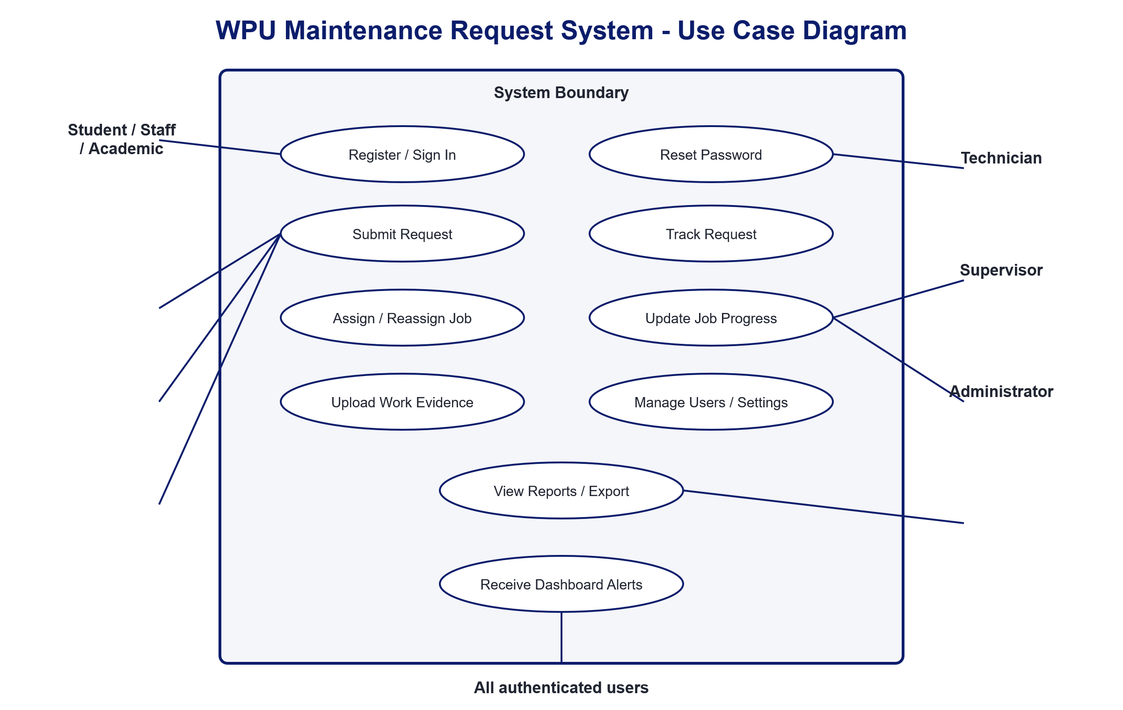
Figure 1. Current system actors and use cases.

System Flowchart
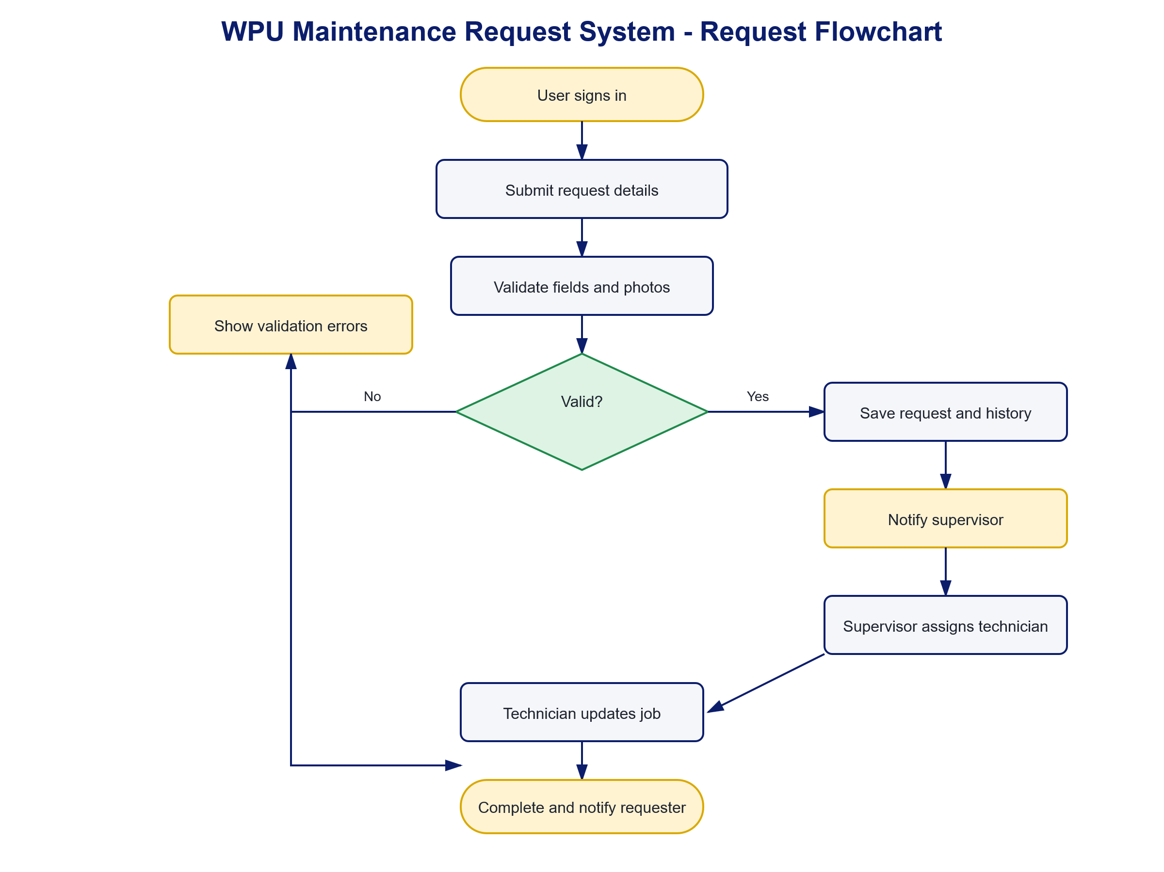
Figure 2. Maintenance request workflow from submission to completion.

