# Features

# Background

The branding “TM Works” is my friends company. He has an existing website which I have always been sceptical of and thought “this could be better”.

I was unable to come up with a unique idea outside of making my own CV online, which was about as entertaining and fun to write up as it sounds.

Whenever I go and see him he is extremely busy (maybe the website does work?) and I can often be found with some paint, masking tape or an electric sander.

I have, of course, cleared using his brand name, and photographs for this project. As I am not making any money from it directly, and long-term it could be a viable alternative to his website he is ok with it. The number and email address on the website are his contact details, feel free to ask him.

The social media links also link to his Facebook or Instagram.

# Features

## Existing Features

## Header / Navigation Bar

* Appears as a consistent element throughout the website; on all three current pages: Home page, Gallery page and Contact page
* This will allow easy navigation around the website. I am a big fan of underlining the page you are on, an “active” class being applied to it. It is a tiny thing that no user will notice outright, but it is very professional looking.

--------------------------------------------------------------------------------------------------------------------------

## - Middle section

* I realise now my design may have been affected by the size of my monitor. This is easily rectifiable of course with “@media screen and (max-width: )” css.
* Because I could see such a vast canvas in front of me, I put too much information early on, and the Home page had a complete re-design
* The sections in the middle are:

## Examples and text

* Initially taking up three equally sized columns the “examples”, and accompanying text are an easy overview of the three most popular jobs the company offers
* 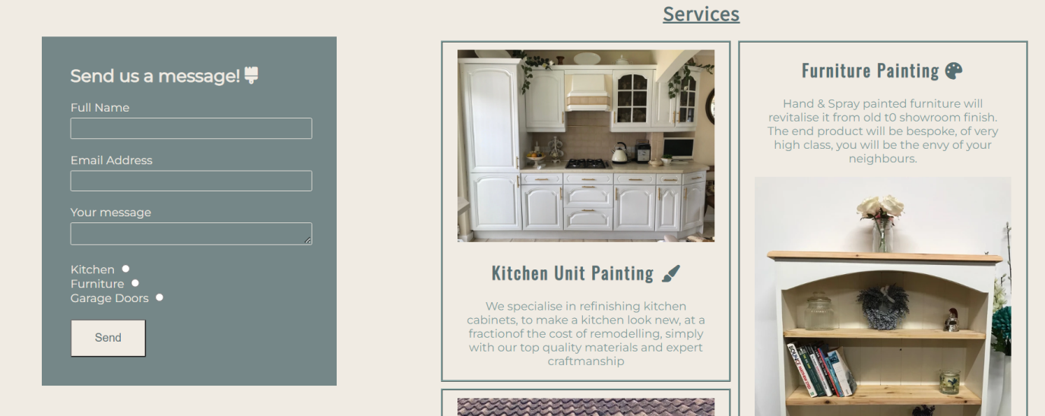They are now arranged so you know what is happening on that side of the page, and if you wish to know more you can scroll down for more

## Contact us form + details

* The contact form is designed to stand out – using a dark colour for the form, juxtaposed against the off-white background; all in keeping with the existing branding of earthy-dark-green
* In “real life” the radio buttons would be unnecessary (the customer would include it in their message” – that is intended to be a demonstration of skill
* The form a “ctrl+c, ctrl-v” straight off the Contact Page, with a few CSS tweaks to make it work on the home page.

--------------------------------------------------------------------------------------------------------------------------

## Gallery

* I know I would not suggest employing someone to do a job for me without seeing a record of previous projects
* It will allow customers to see a proof of work
* I also know I had to add a video, and the original TM Works as a sole trader doesn’t have any capability, or need at this stage, so film himself. As such I found a vdeo of Craig Phillips, the winner of the first ever Big Brother, demonstrating hwo a spray gun works.

--------------------------------------------------------------------------------------------------------------------------

## Contact page

* I made this before I decided the contact form could/should go on the home page. This ties into one of my biggest fears – I am not a marketing genius, I don’t know how to design anything that appeals to customers; I know what appeals to me. I am sure with a marketing team, or person, telling me what to do I will be fine.

--------------------------------------------------------------------------------------------------------------------------

## Footer

* Another consistency throughout the website.
* It provides the links to the social media pages, and also a final text about the area we/they cover

--------------------------------------------------------------------------------------------------------------------------

## Features left to implement

* I would like to include a page of “Testimonials”. Or “Reviews” as Google calls them.
  + However this doesn’t exist at the moment in real life, and I would feel incredibly uncomfortable and odd writing multiple reviews, meat to be from different people, having received different services… my creative efforts are better places elsewhere.
* A “Our Partners” page is viable long term. Whilst making this website he has been sub-contracted by several larger companies to do their painting for them (his spray gun turns a 3 hour paint job into a 10minute one… but you need the space to spray, store, dry etc. all the furniture, which he has.
* Possibly a “Careers” page. He has “employed” people on a contract basis when things have been very busy. But he doesn’t want full time employees with PAYE, furlough, holiday responsibilities etc.

# Deployment

This section should describe the process you went through to deploy the project to a hosting platform (e.g. GitHub)

The site was deployed to GitHub pages.

# Credits

**Content**

* The text for the Home Page was taken from the existing TM Works website
  + I then tweaked it to sound more professional or to the point
  + Ironically, I wrote a lot of the text on the original website. The owner is diagnosed dyslexic and as such anything that involves spelling he is massively under confident in performing.
* The code for the Sign Up form was initially Copy and Pasted form the Love Running Project into Atom editor
  + I used Atom editor to play around and figure out (remind myself) exactly what each line of code meant, what it did, why it was there etc.
  + I was then able to make it do what I wanted to do before copying it into my project
* The icons in the footer were taken from [Font Awesome](https://fontawesome.com/)

**Media**

* The photos used on the home and sign up page are from TM Works social media pages. Links found in the Footer of the website.
* The images used for the gallery page were taken from TM Works Instagram site