**NALLA MALLA REDDY ENGINEERING COLLEGE**

**Object oriented programming through Java**

**B.DEEPIKA**

**22B61A0572**

**CSE-2B**

**Unit-01**

**INHERITANCE IN JAVA**

Java, Inheritance is an important pillar of OOP(Object-Oriented Programming). It is the mechanism in Java by which one class is allowed to inherit the features(fields and methods) of another class. In Java, Inheritance means creating new classes based on existing ones. A class that inherits from another class can reuse the methods and fields of that class. In addition, you can add new fields and methods to your current class as well.

**How to Use Inheritance in Java?**

The **extends keyword**is used for inheritance in Java. Using the extends keyword indicates you are derived from an existing class. In other words, “extends” refers to increased functionality.

**Syntax :**

class DerivedClass extends BaseClass   
{   
 //methods and fields   
}

## ****Java Inheritance Types****

Below are the different types of inheritance which are supported by Java.

1. Single Inheritance
2. Multilevel Inheritance
3. Hierarchical Inheritance
4. Multiple Inheritance
5. Hybrid Inheritance

### **1.Single Inheritance**

In single inheritance, a sub-class is derived from only one super class. It inherits the properties and behavior of a single-parent class. Sometimes, it is also known as simple inheritance. In the below figure, ‘A’ is a parent class and ‘B’ is a child class. The class ‘B’ inherits all the properties of the class ‘A’.



*Single*

**2.Multilevel Inheritance**

In Multilevel Inheritance, a derived class will be inheriting a base class, and as well as the derived class also acts as the base class for other classes. In the below image, class A serves as a base class for the derived class B, which in turn serves as a base class for the derived class C. In Java, a class cannot directly are grand parents.

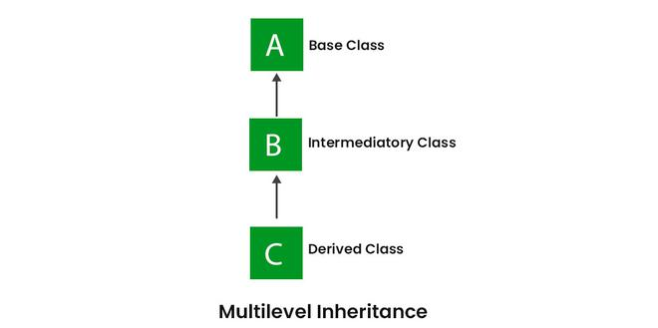

*Multilevel Inheritance*

**3.Hierarchial Inheritance**

In Hierarchical Inheritance, one class serves as a superclass (base class) for more than one subclass. In the below image, class A serves as a base class for the derived classes B, C, and D.

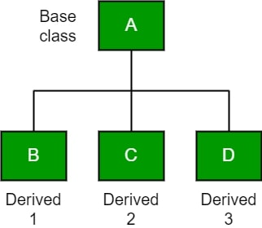

**4.Multiple Inheritance**

In Multiple Inheritance, one class can have more than one superclass and inherit features from all parent classes. Please note that Java does **not** support multiple inheritance with classes. In Java, we can achieve multiple inheritances only through Interfaces. In the image below, Class C is derived from interfaces A and B.

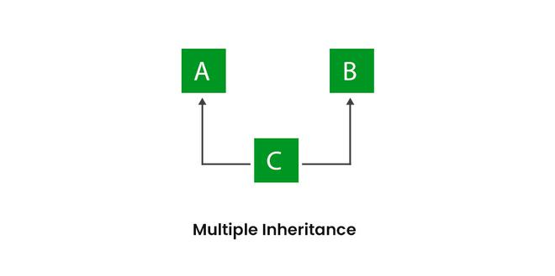

*Multiple Inheritance*

### **5. Hybrid Inheritance**

It is a mix of two or more of the above types of inheritance. Since Java doesn’t support multiple inheritances with classes, hybrid inheritance involving multiple inheritance is also not possible with classes. In Java, we can achieve hybrid inheritance only through Interfaces. if we want to involve multiple inheritance to implement Hybrid inheritance.  
However, it is important to note that Hybrid inheritance does not necessarily require the use of Multiple Inheritance exclusively. It can be achieved through a combination of Multilevel Inheritance and Hierarchical Inheritance with classes, Hierarchical and Single Inheritance with classes. Therefore, it is indeed possible to implement Hybrid inheritance using classes alone, without relying on multiple inheritance type.

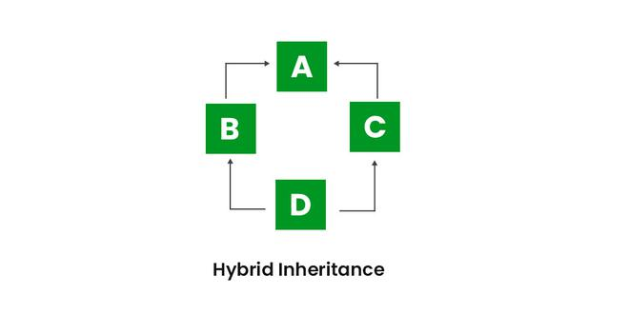

*Hybrid Inheritance*