Sern.local Report

Written by: Malachi Plamann
Date: 11/08/2026
About this engagement:
This engagement is a fictional internal Active Directory penetration test from the Hack Smarter catalog, targeting a machine called ‘Messenger’. More information on the machine can be found using the link at the bottom of this section. All methods and tools used during testing were authorized, and permission was granted to assess the three hosts described in the Target Hosts Information section. The engagement uses an assumed-breach scenario, with valid user credentials provided for testing. These credentials can also be found in the Target Hosts Information section.
The goal of the assessment was to identify and report all vulnerabilities present across the three hosts and attempt a full domain takeover. A flag was placed in the Administrator user’s Documents folder on the Domain Controller (DC01) as a proof-of-concept target.

Executive Summary:
The primary goal of the sern.local assessment was to obtain administrative privileges on the Domain Controller (DC01) and capture the flag placed in the Administrator’s home directory. Using the provided credentials, an authenticated Kerberoasting attack recovered a crackable hash for the svc_backup service account. Cracking the svc_backup hash exposed credentials that, through excessive GenericWrite permissions over the File Management group, allowed svc_backup’s own group membership to be modified. The resulting access exposed sensitive internal file shares, revealing clear-text credentials in a developer script for the Nae user.
The Nae credentials allowed for a shell connection to the FILESRV01 host, granting full command execution. The svc_backup account was found to have a local profile on the FILESRV01 host, allowing a privileged session to be spawned using a run-as technique under the svc_backup account. Because svc_backup belonged to the Backup Operators group, this access allowed for the extraction of the Windows SAM and SYSTEM registry hives containing all local user hashes, enabling further account compromise. The dumped hashes provided access to MSGSRV01 as the Moeka user.
Using the Moeka user hash, a shell connection was established on the MSGSRV01 host. Further enumeration revealed an .xls file containing clear-text credentials to an internally hosted messenger application used by the Help Desk team. The messenger application revealed an old message containing clear-text credentials for the Braun user account. The Braun user held WriteDacl permissions over the Domain Controller, which were abused to grant DCSync rights and dump every account hash in the domain, including the Administrator’s, completing a full domain compromise.
Key Findings:
- Kerberoastable Service Account with Weak Password.
- Excessive Permissions Over the File Management Group.
- Clear-Text Credentials Stored in Scripts, Spreadsheets, and Chat Messages.
- Backup Operators Membership Enabling Registry Hive Extraction.
- Dangerous WriteDacl Permission Over the Domain Controller Leading to Full Domain Compromise.

Target Hosts Information:
Below are the target host IP addresses given and the corresponding hostnames that are tested during this engagement. It should be noted that the tester was given credentials for the sern.local environment. The attack box IP is also listed.
DC01: 10.0.17.181
FILESRV01: 10.0.21.25
MSGSRV01: 10.0.28.144
Attack Box IP: 10.200.117.233
Credentials:
Username: Kyoma
Password: FutureGadget17

Penetration Testing:
The testing will follow the penetration testing methodology for the engagement below.
- Enumeration
- Vulnerability Analysis
- Exploitation
- Post-Exploitation
- Lateral Movement & Pivoting

- Enumeration.
To begin the enumeration phase, an Nmap scan was run against each of the three target hosts listed in the Target Hosts Information section to identify open ports and running services. This established a baseline view of each host’s external footprint ahead of further testing.

DC01 Nmap Scan:
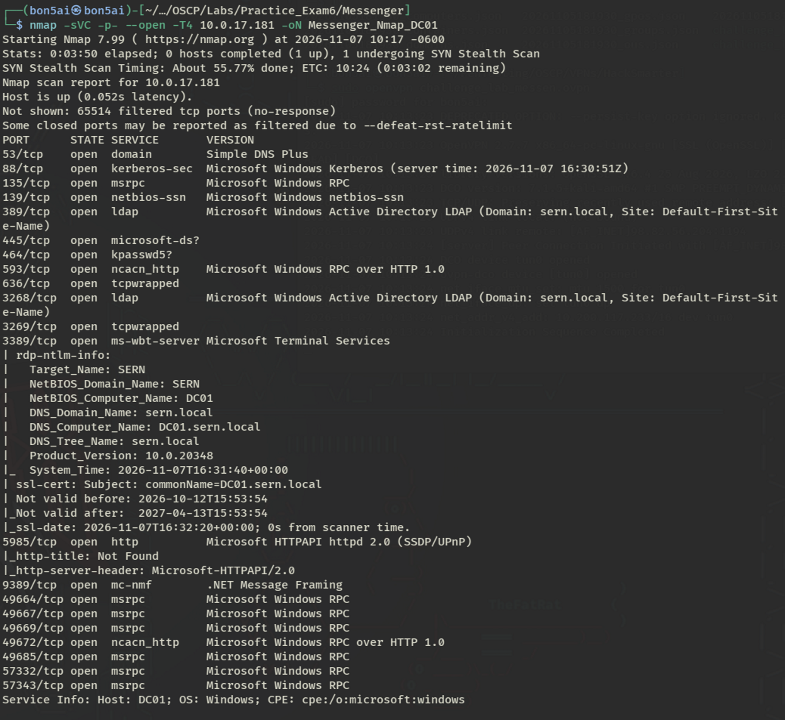

FILESRV01 Nmap Scan:
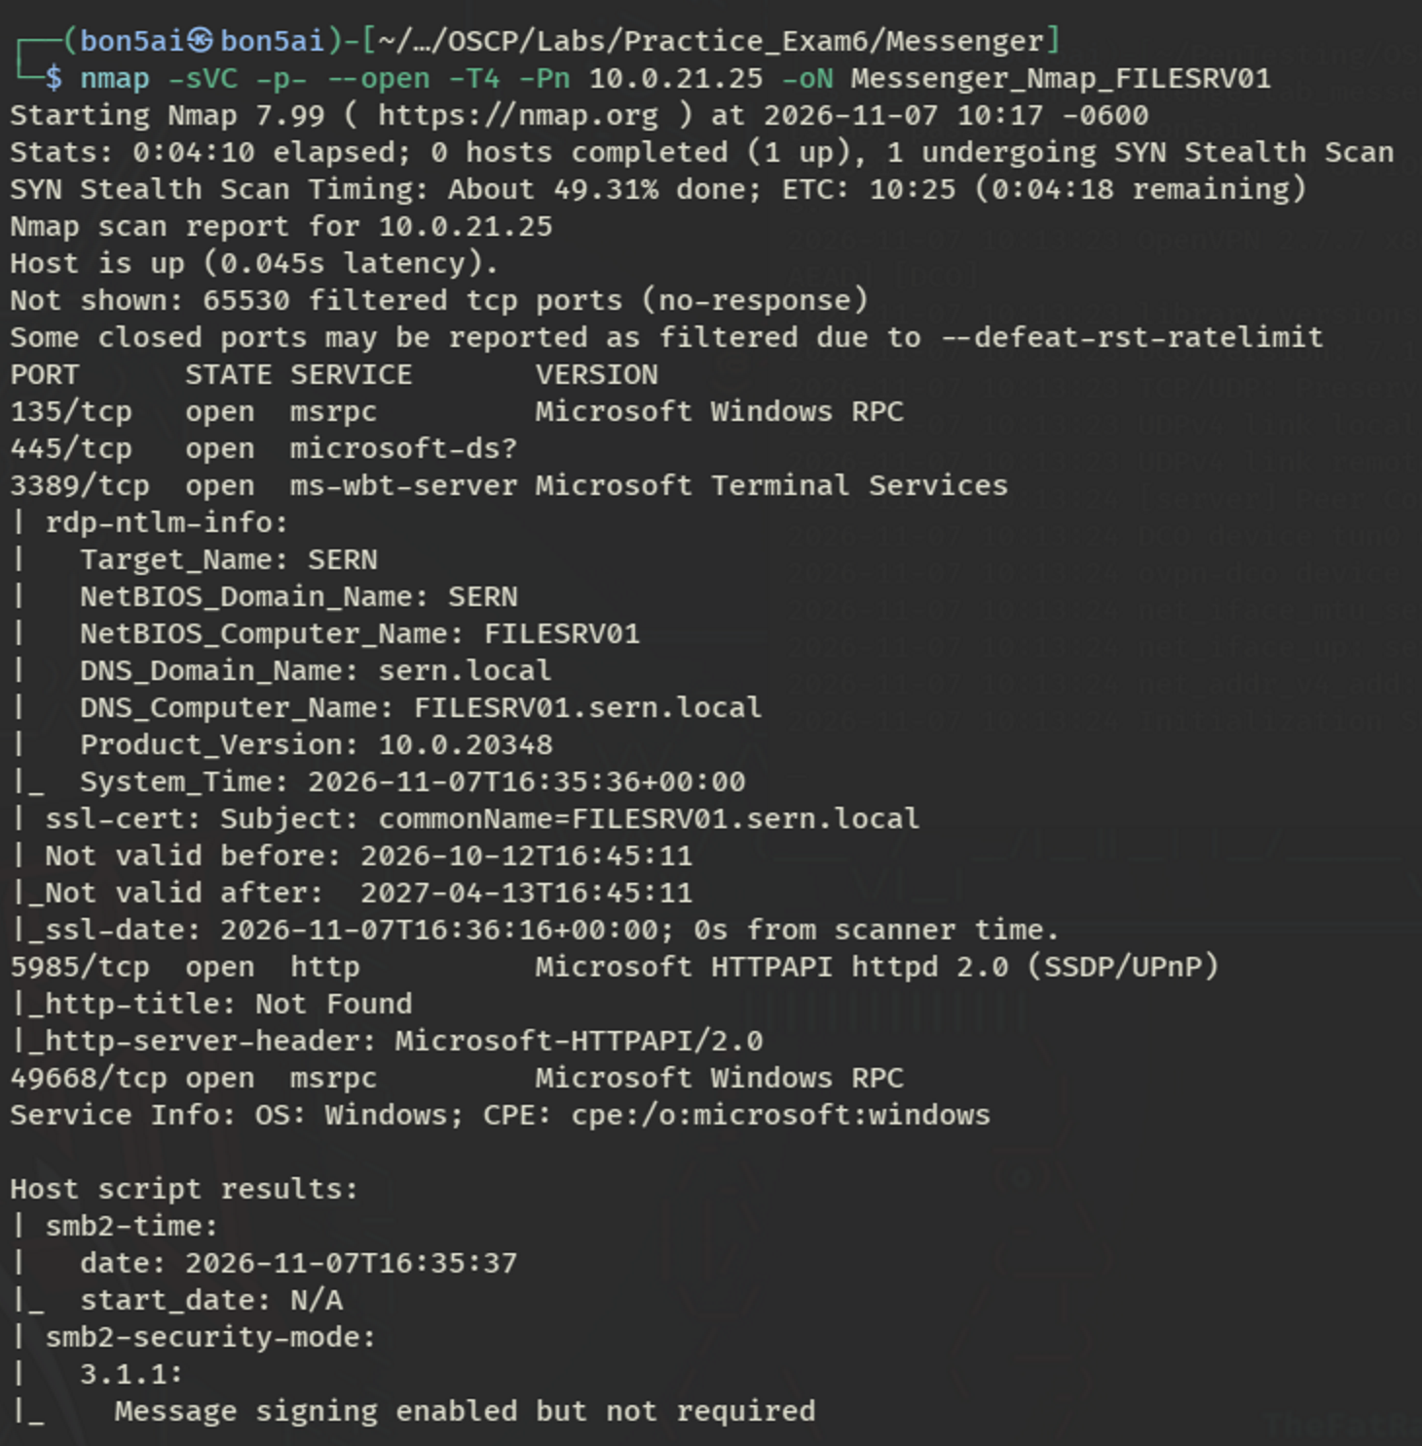

MSGSRV01 Nmap Scan:
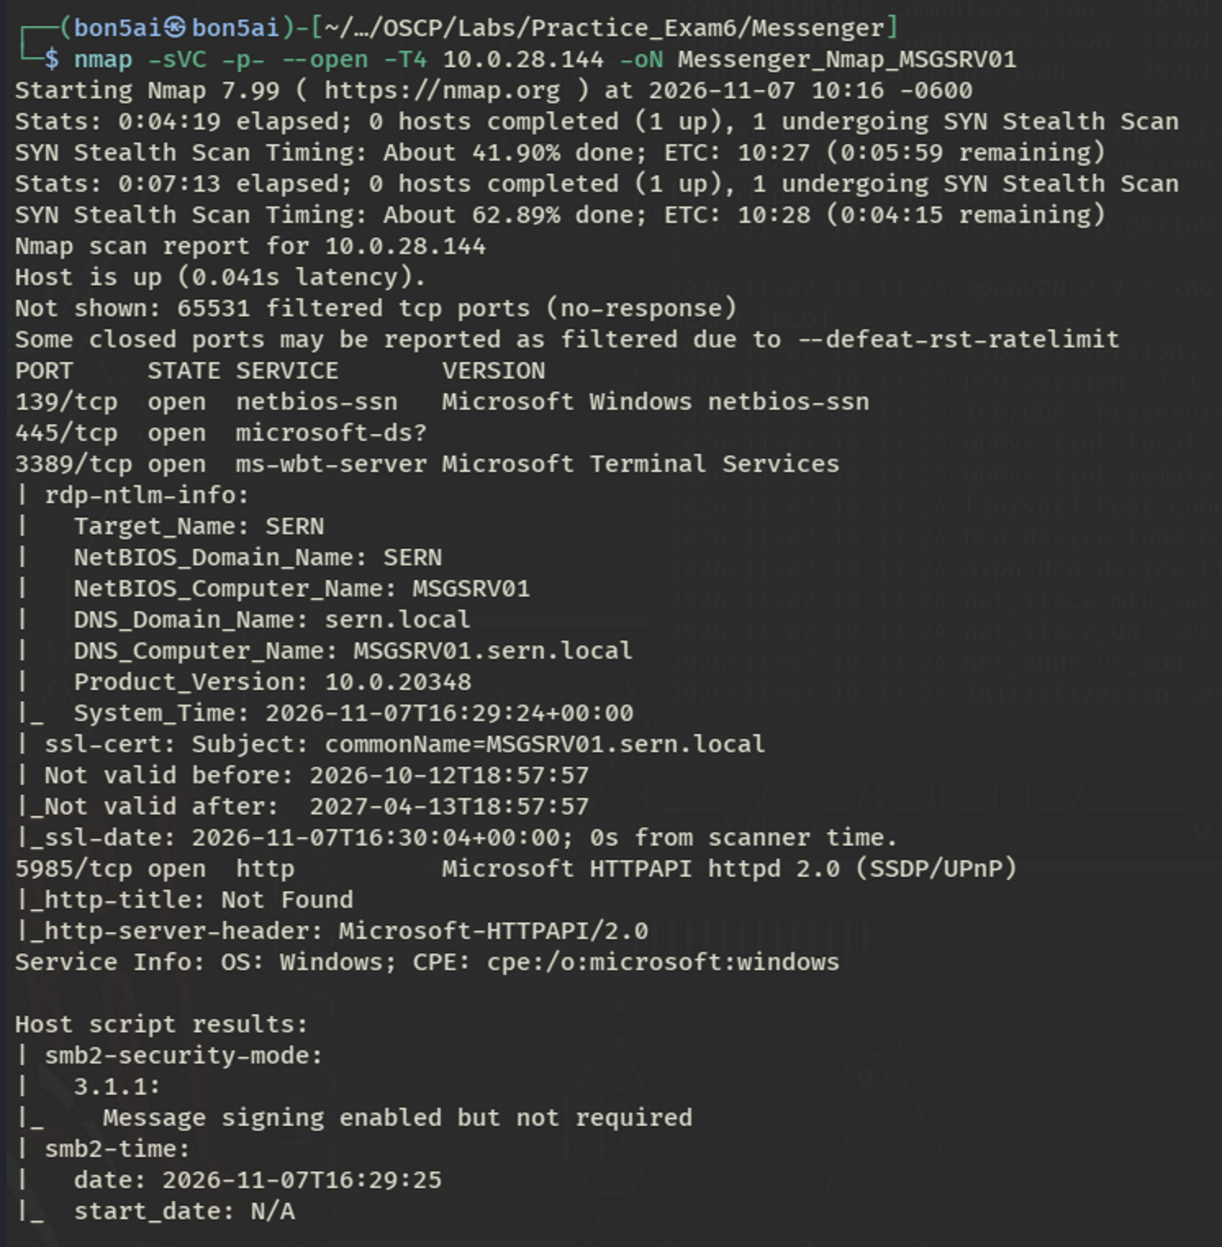

The assessment began by enumerating the access the Kyoma user held within the environment. A Kerberoasting attack was performed using the Kyoma credentials. Kerberoasting is an Active Directory attack that lets any authenticated domain user request material tied to a service account’s password, which can then be cracked offline to recover the plaintext value. The attack returned the account hash for the svc_backup user.
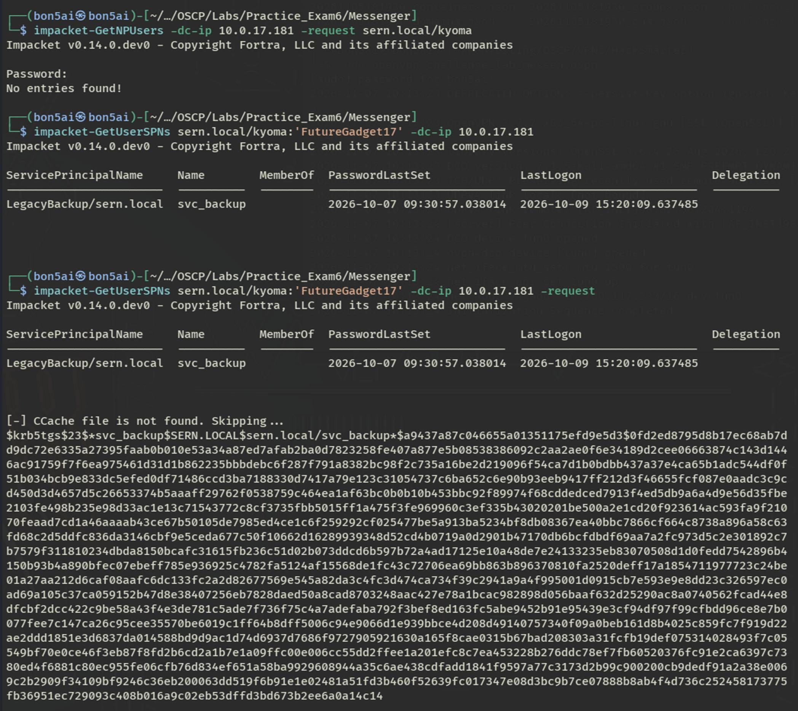

The hash was saved to a file and cracked using Hashcat with the rockyou.txt wordlist, recovering the plaintext password for svc_backup.
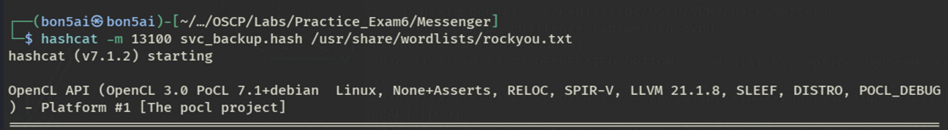
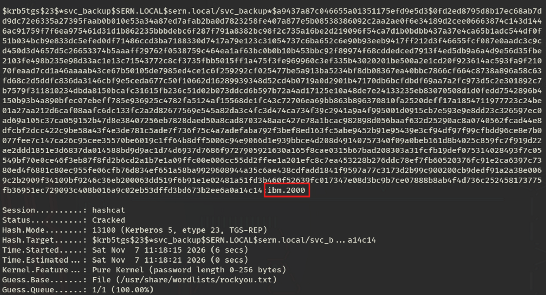
BloodHound was then used to build a clearer picture of the Active Directory environment. This tool surfaces object-level permissions, such as group memberships and ACL entries, that are not visible through standard enumeration. Valid domain credentials are required for it to run.
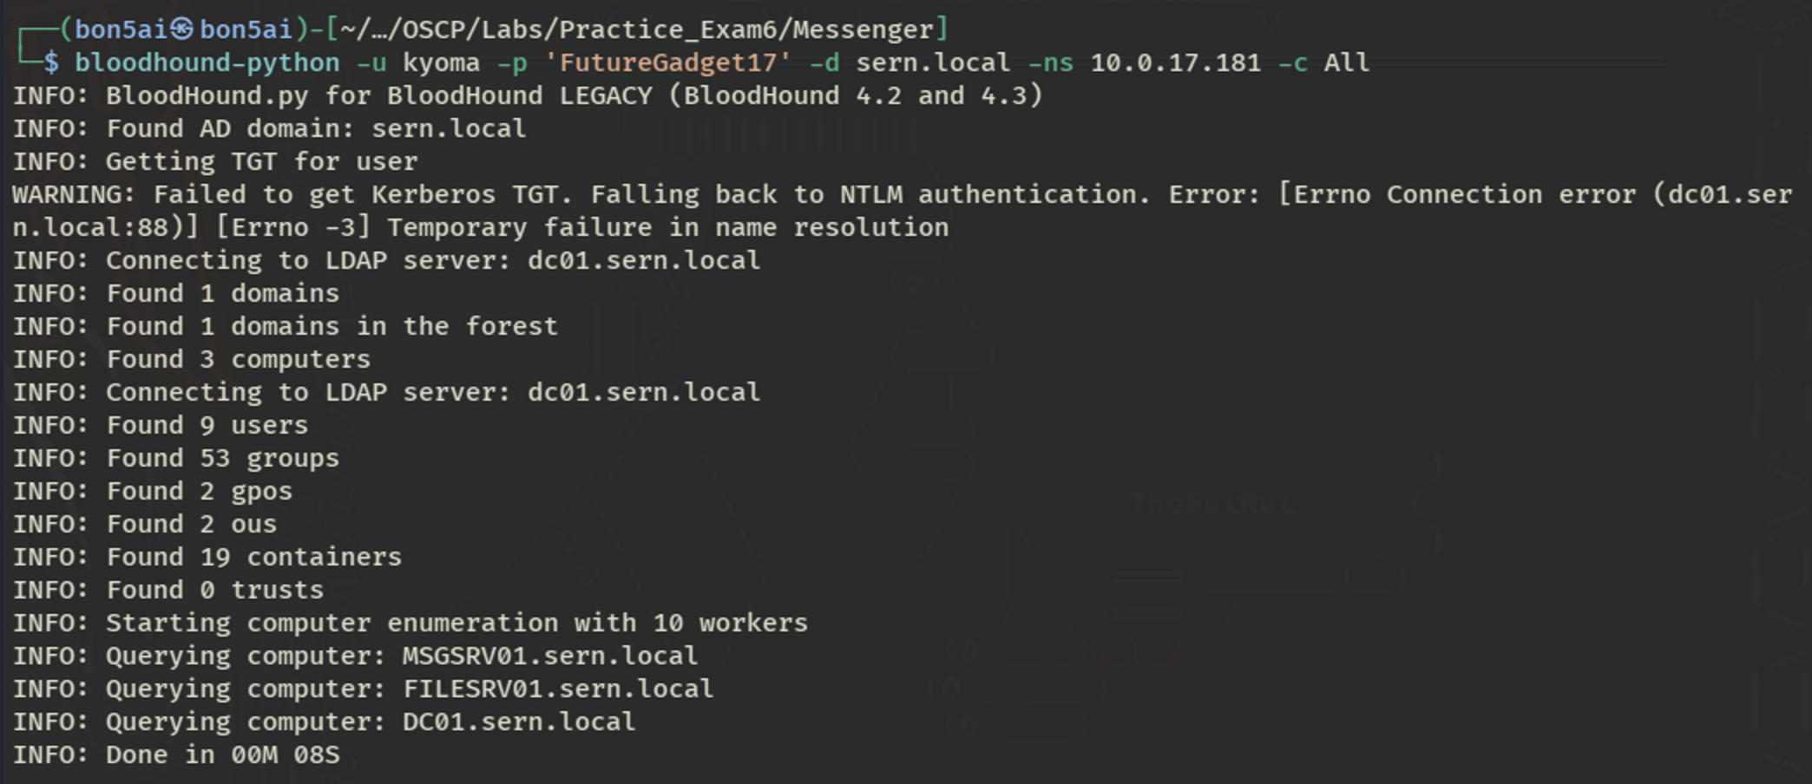
The collection output from BloodHound was uploaded to its web interface for analysis. Reviewing the svc_backup account revealed GenericWrite permissions over the File Management group.
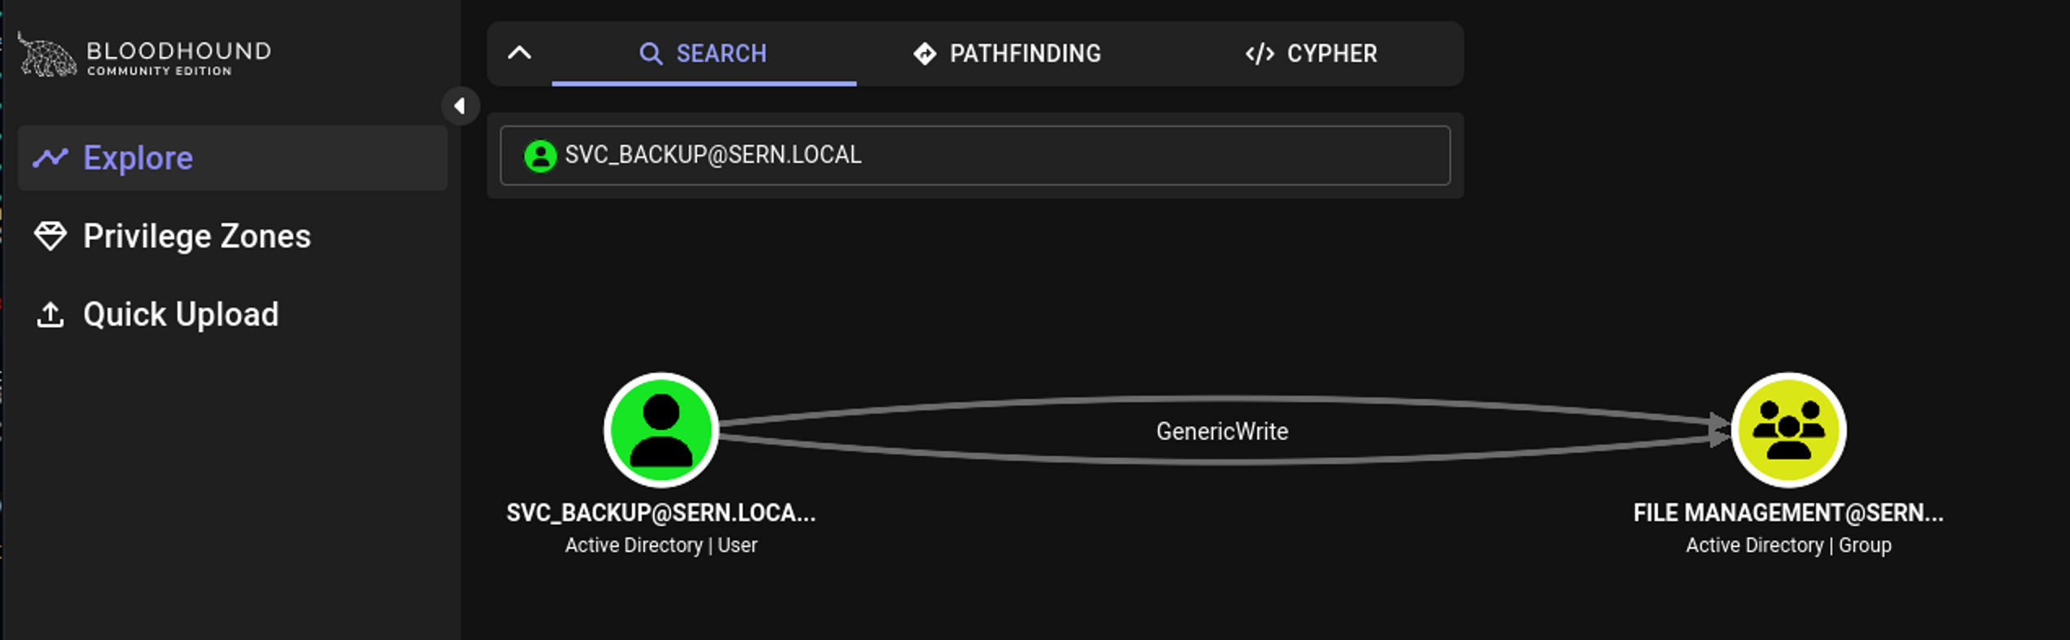
This permission was used to add the svc_backup and kyoma accounts to the File Management group, extending their access for further enumeration of the FILESRV01 host.
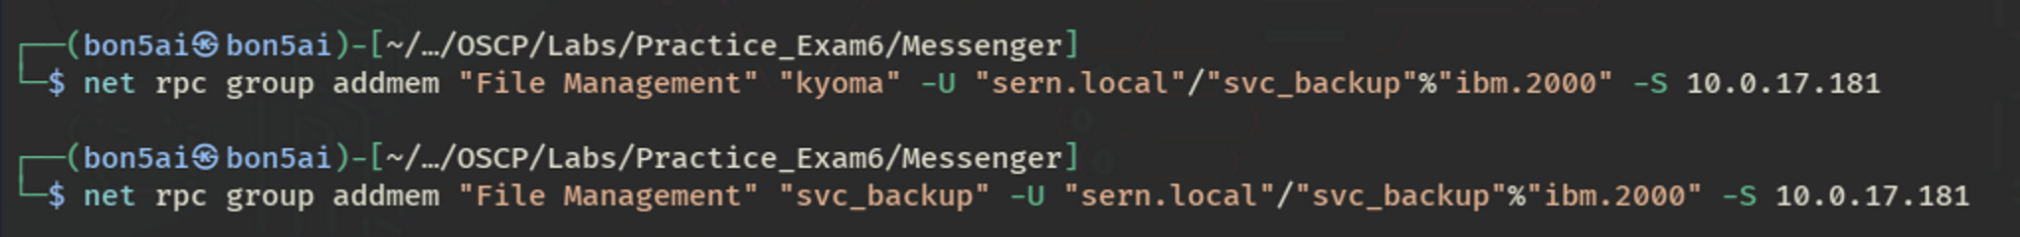
Using the svc_backup credentials, the available shares on the FILESRV01 host were enumerated, confirming the additional access granted by the File Management group addition.
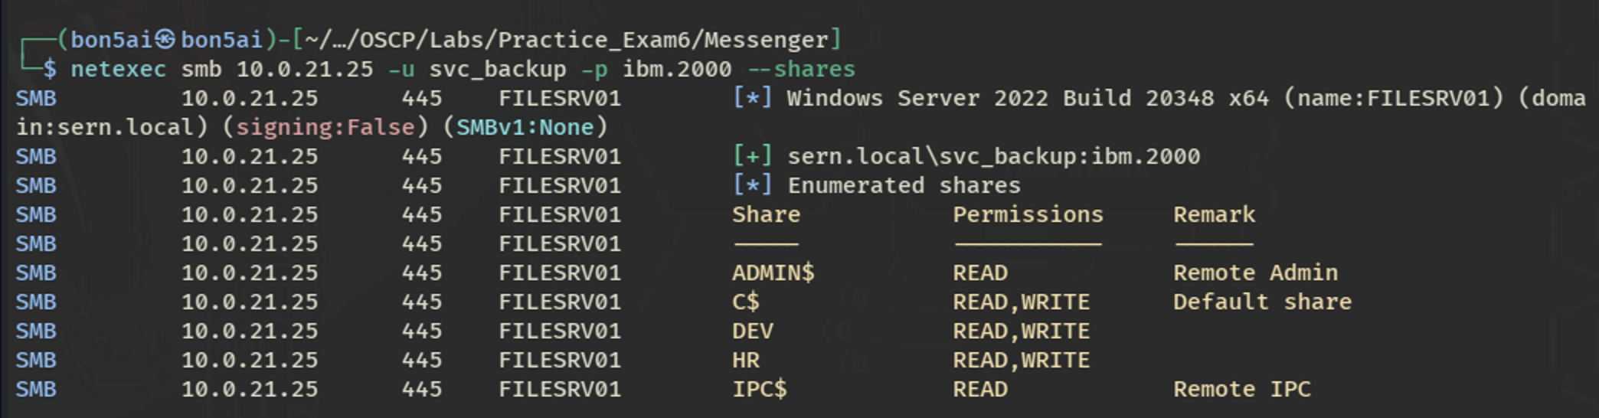
Enumerating the DEV share turned up a file, ‘ipython_notebook_config.py’, that contained a clear-text password.
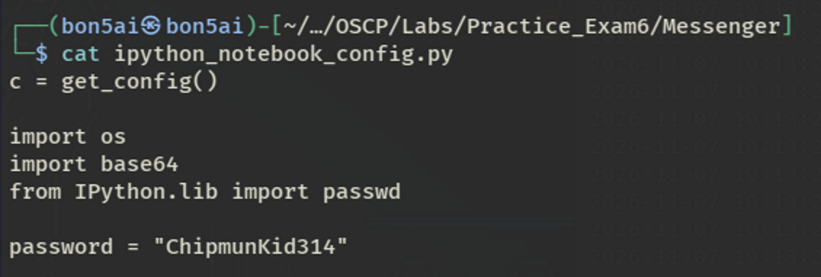
This password was sprayed against a list of known domain users to check for reuse across accounts.
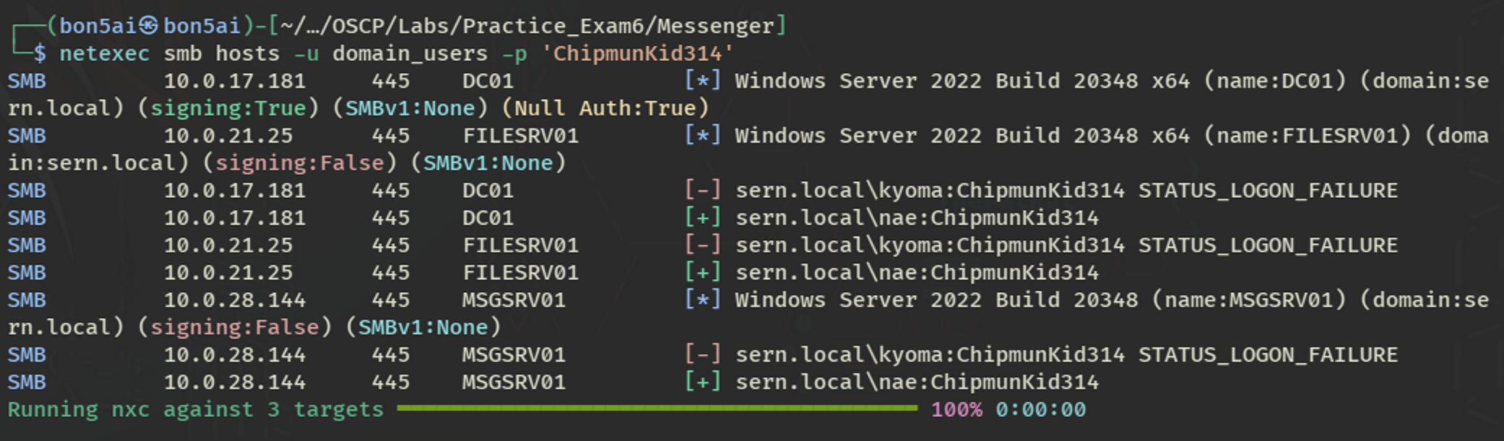
The spray confirmed valid credentials for the Nae user, and a shell session was established on the FILESRV01 host via the WinRM service using the evil-winrm tool.
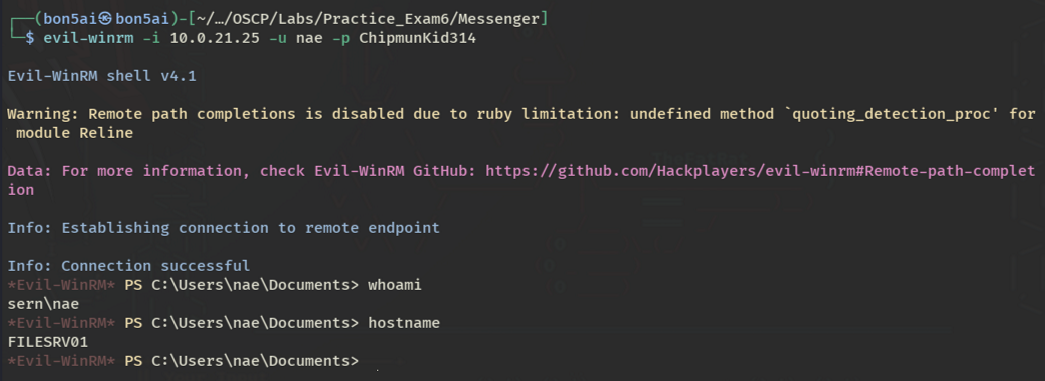
Upon authenticating to the FILESRV01 host, it was discovered that the svc_backup account also had a local user profile. The RunasCs.exe binary was transferred to the host and used to spawn a new session running as the svc_backup user.
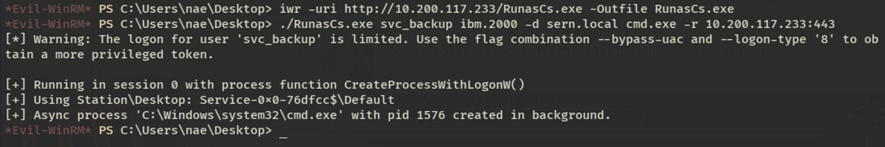
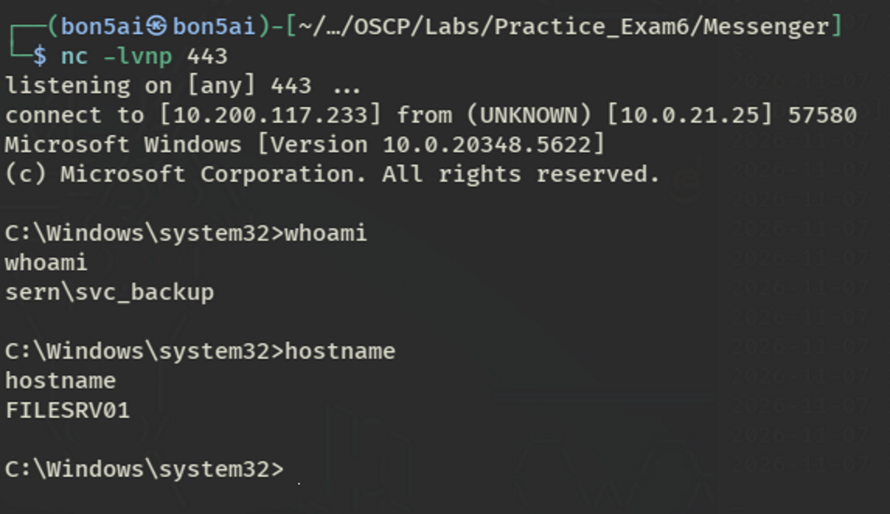

The svc_backup account was found to be a member of the BUILTIN\Backup Operators group, which grants the rights needed to extract the SAM and SYSTEM registry hives containing local account hashes.
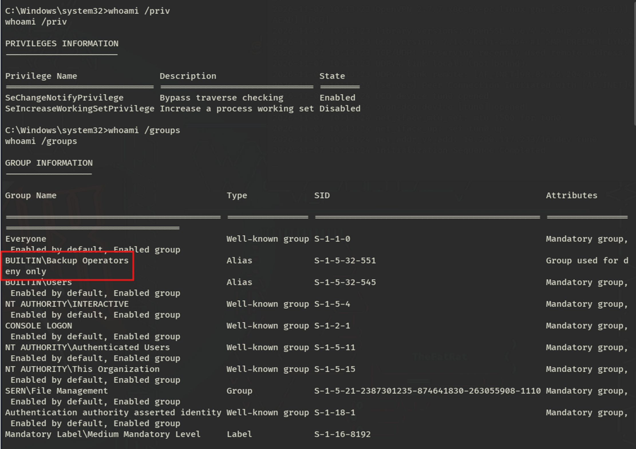
To support this, an SMB server was stood up on the attack box to receive the hives once extracted.
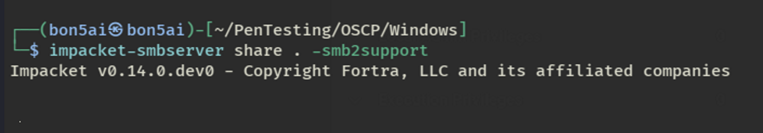
The impacket-reg tool was then used, authenticating as svc_backup, to save and transfer the SAM and SYSTEM hives to the attack box.
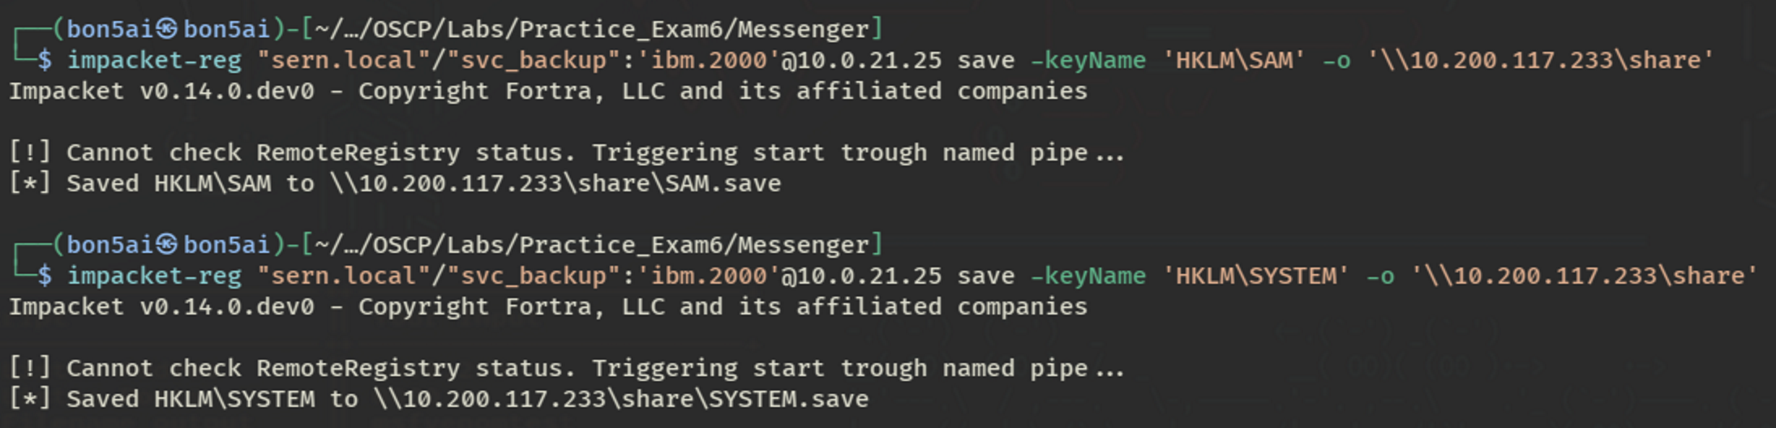
With the SYSTEM and SAM hives saved, their contents were dumped offline, revealing a usable hash for the Moeka account.
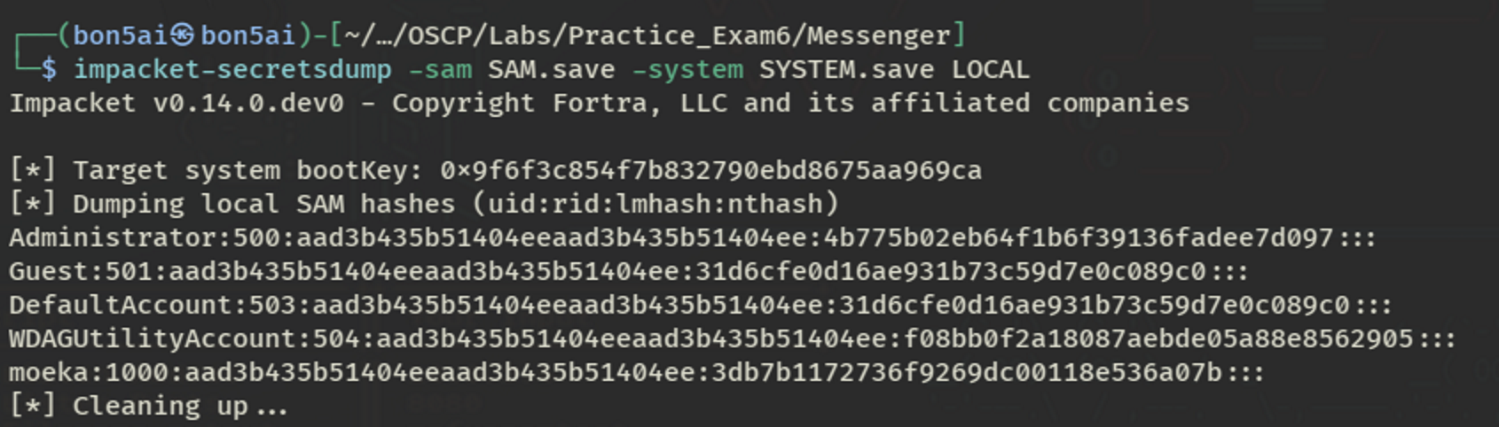
This hash was then used to establish a shell session on the MSGSRV01 host as the Moeka user.
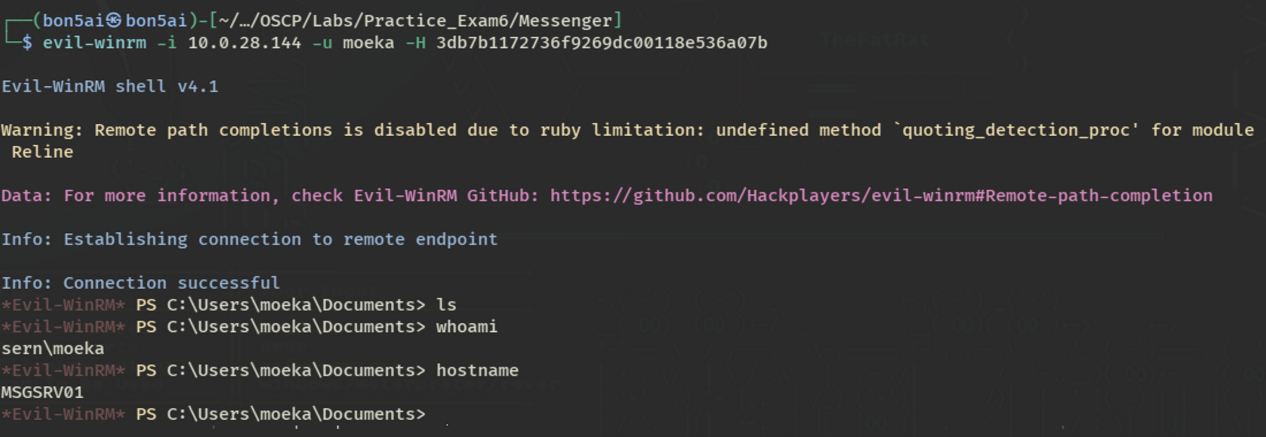
Enumeration of the host revealed a reminders.xls file in the Desktop folder. This was downloaded for further inspection, revealing clear-text credentials for an internal chat service.
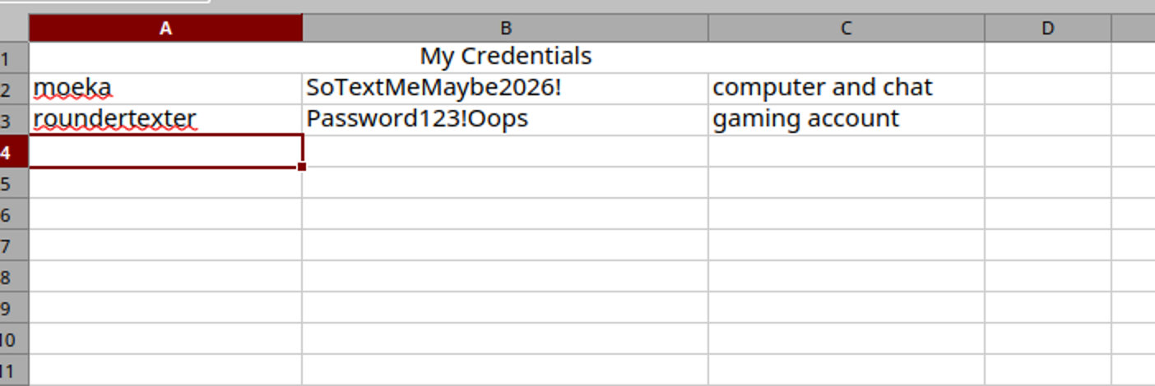
A port-forwarding tool was then used to reach the internally hosted chat service from the attack box.
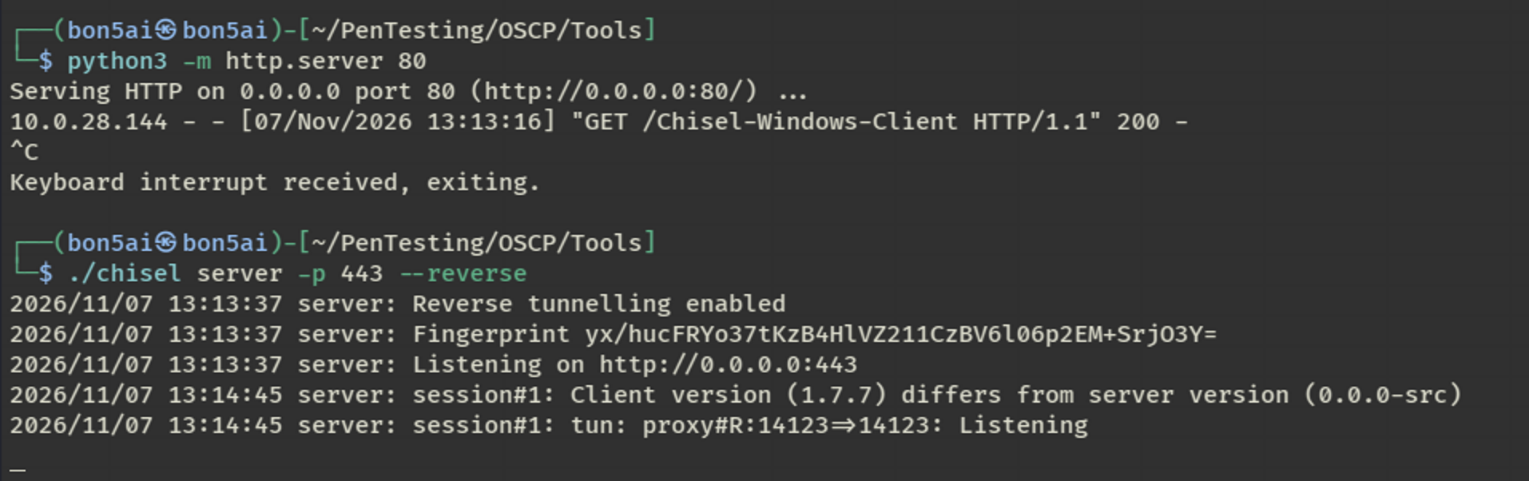
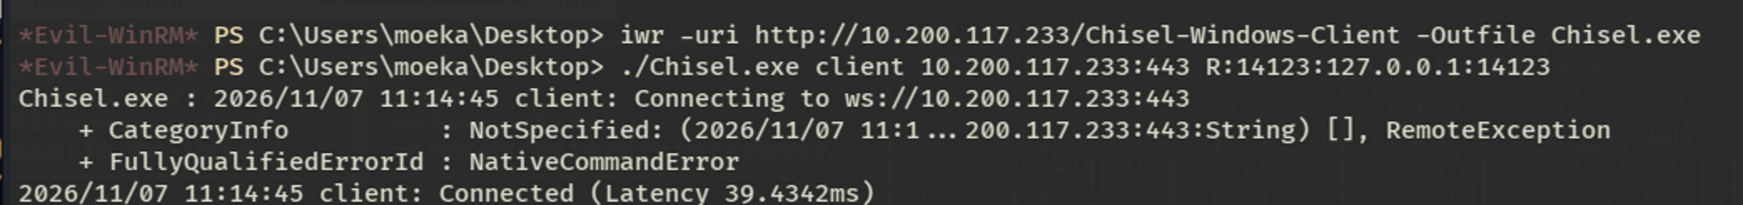
The internal ‘Output Messenger’ application was then accessed and authenticated to using the credentials found in the reminders.xls file. Reviewing a Help Desk channel’s message history revealed a clear-text password for the Braun user.
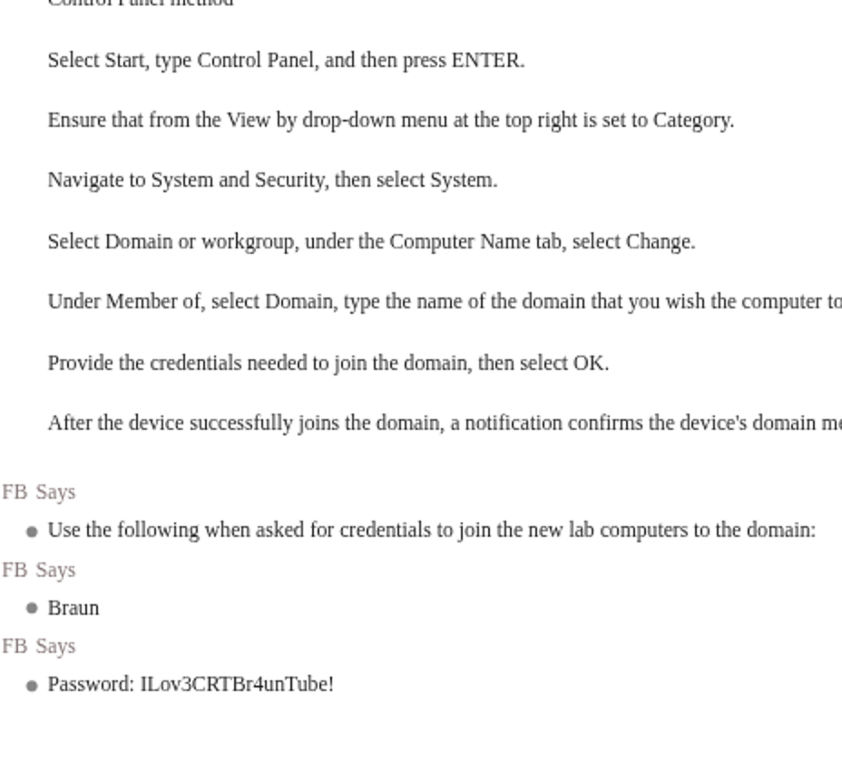
The Braun account was then inspected through the BloodHound interface, revealing that the user held WriteDacl permissions directly over the Domain Controller object.
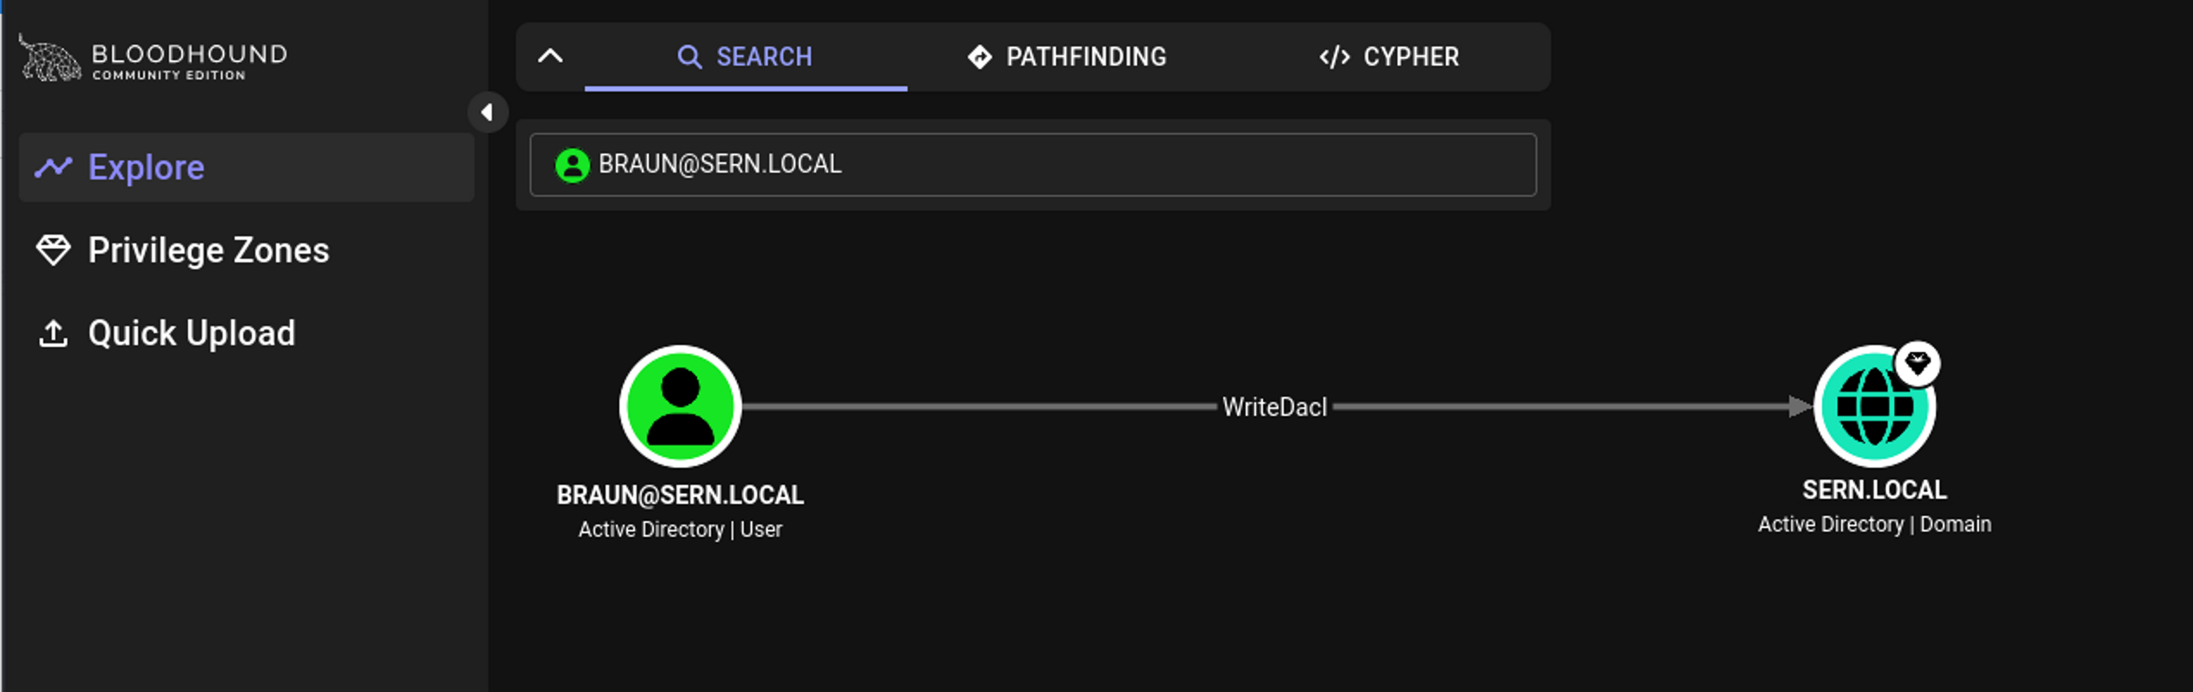
This permission was abused to grant the Braun account DCSync rights and dump every user hash present on the Domain Controller.
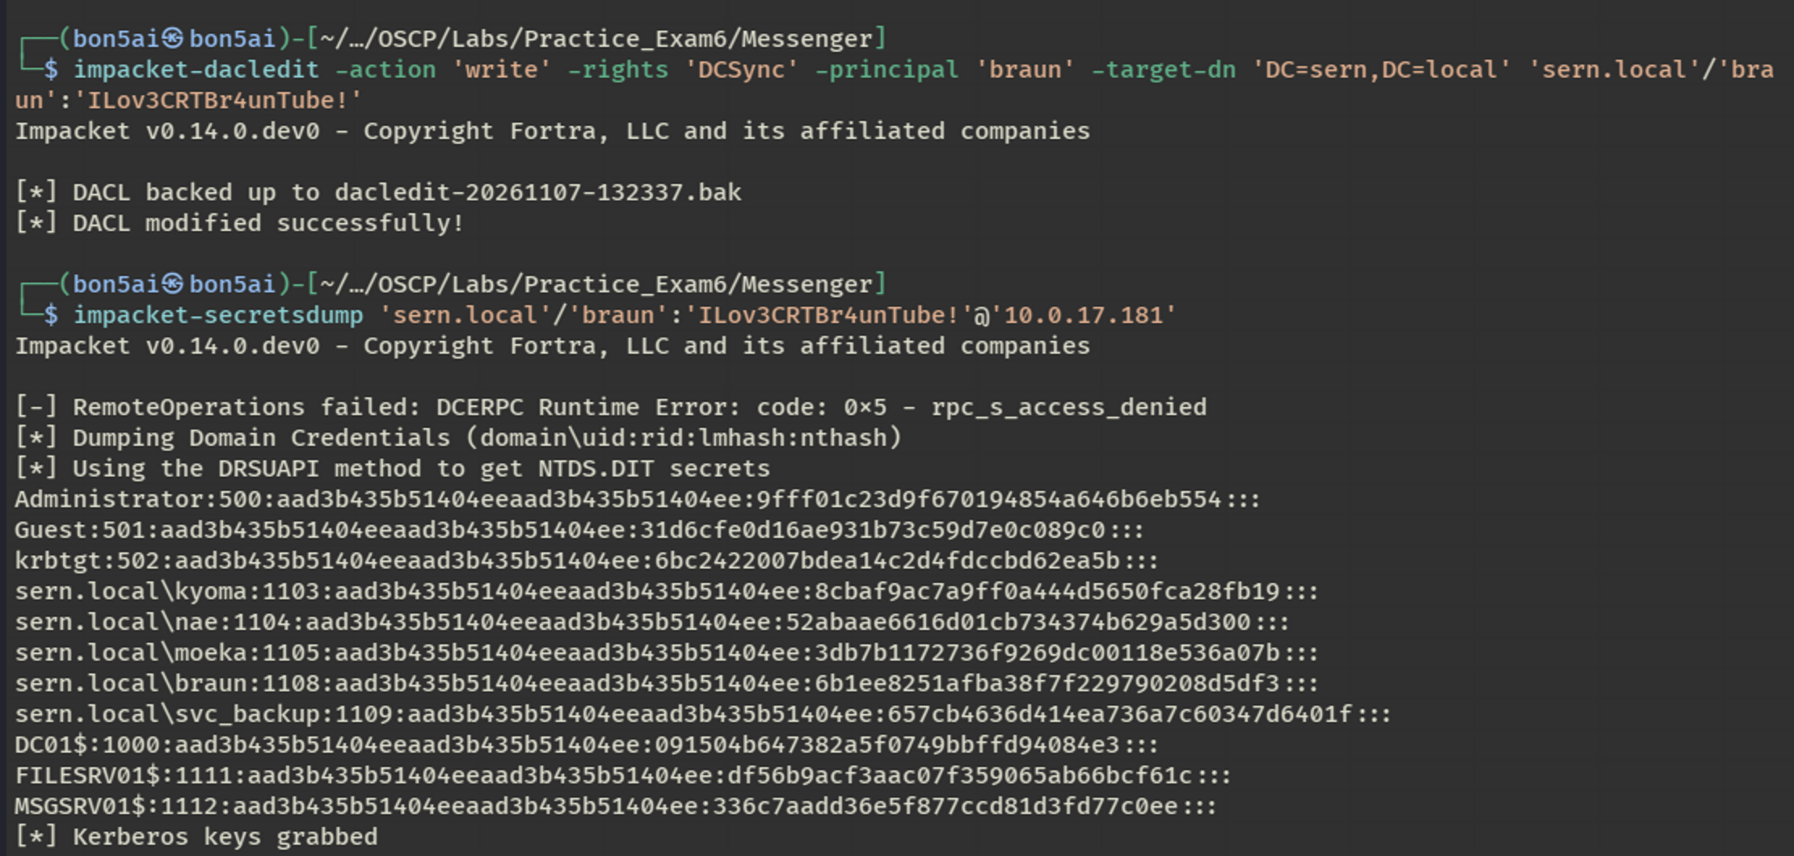
Using the Administrator user hash, access was achieved via WinRM using the Evil-WinRM tool.
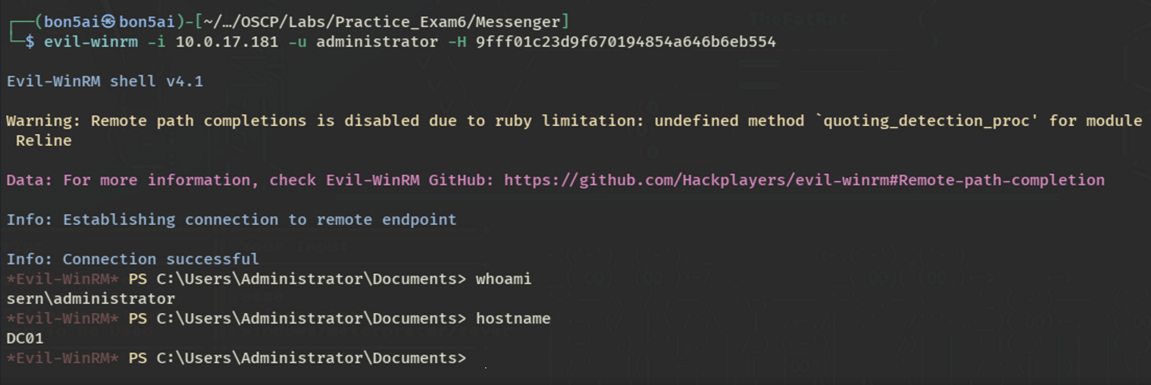
Finally, with Administrator access on the DC01 host, the root flag was captured, completing the engagement.
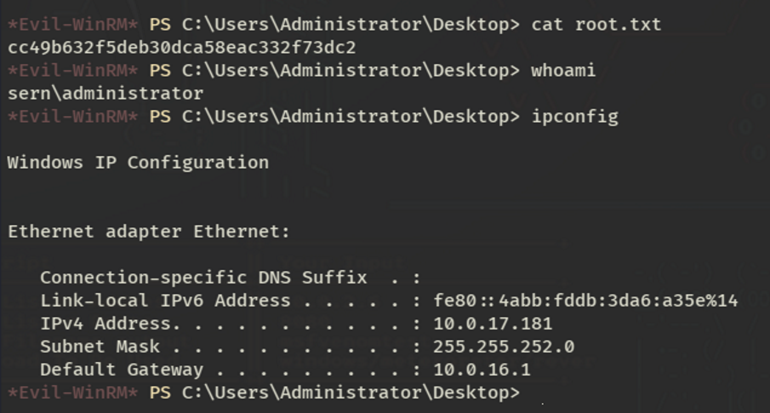
Findings and Risk Summary.

Finding 1: Kerberoastable Service Account with a Weak Password
Severity: High (CVSS 7.5)
Description: The svc_backup service account was registered with a Service Principal Name (SPN) and configured with a password present in a standard password wordlist, making it vulnerable to an offline Kerberoasting attack by any authenticated domain user.
Impact: Recovery of the svc_backup password gave the tester a working domain credential with its own set of Active Directory permissions, serving as the entry point for every subsequent stage of the attack chain.
Remediation:
- Enforce a strong, non-dictionary password policy for all service accounts.
- Rotate service account passwords on a regular schedule.
- Use Group Managed Service Accounts (gMSA) where supported to remove static passwords entirely.

Finding 2: Excessive GenericWrite Permissions Over the File Management Group
Severity: High (CVSS 8.2)
Description: The svc_backup account held GenericWrite permissions over the File Management security group, allowing it to add or remove group members without additional authorization or oversight.
Impact: This permission was used to add attacker-controlled accounts to the File Management group, extending access to shares and resources the accounts were not otherwise entitled to and enabling further compromise of the FILESRV01 host.
Remediation:
- Review and restrict GenericWrite/GenericAll delegations on security groups.
- Apply least-privilege principles to object-level ACLs throughout Active Directory.

Finding 3: Clear-Text Credentials Stored in Scripts, Spreadsheets, and Chat Messages
Severity: Medium (CVSS 7.1)
Description: Clear-text credentials were found in several locations throughout the environment, including a developer configuration script on a file share, a spreadsheet on a user’s desktop, and historical messages in an internal chat application.
Impact: Each exposure directly enabled a further step of lateral movement, together forming the majority of the path to full domain compromise.
Remediation:
- Remove hard-coded and stored plaintext credentials from scripts, spreadsheets, and chat platforms.
- Use a managed secrets or credential vault for application and service credentials.

Finding 4: Backup Operators Membership Enabling Registry Hive Extraction
Severity: High (CVSS 8.0)
Description: The svc_backup account was a member of the built-in Backup Operators group on FILESRV01, a membership that grants sufficient rights to back up, and therefore extract, the SAM and SYSTEM registry hives.
Impact: Extraction of these hives exposed local account password hashes, which were cracked and used to compromise an additional user account on the MSGSRV01 host.
Remediation:
- Limit membership of the Backup Operators group to accounts that genuinely require it.
- Monitor and alert on registry hive save operations targeting SAM and SYSTEM.
- Apply additional protections, such as Credential Guard, where supported.

Finding 5: Dangerous WriteDacl Permission Over the Domain Controller Leading to Full Domain Compromise
Severity: Critical (CVSS 9.8)
Description: The Braun user account held WriteDacl permissions directly on the Domain Controller object, allowing modification of the object’s access control list.
Impact: This permission was abused to grant the Braun account DCSync rights, enabling the extraction of every credential hash in the domain, including the Administrator account, and resulting in complete domain compromise.
Remediation:
- Remove unnecessary WriteDacl, WriteOwner, and GenericAll permissions on the Domain Controller and other Tier 0 objects.
- Enforce a tiered administration model that separates high-privilege accounts from day-to-day user accounts.
- Monitor for DCSync-capable replication requests originating from non-DC accounts (Event ID 4662).
- Periodically audit Active Directory ACLs with a tool such as BloodHound to catch dangerous delegations early.

Overall Risk Assessment.
Overall Severity: Critical
This assessment demonstrated a complete attack path from initial low-privileged access through full domain compromise. A weak service account password, excessive delegated AD permissions, clear-text credential storage, and an unnecessary WriteDacl grant on the Domain Controller combined to let an attacker escalate from a single Kerberoastable account to Administrator-level control of the sern.local domain.

