THE BEING ENVELOPE
Technical Architecture for a Fractalish-SymLanic Constructional Natural-Math Ternary Read/Write Substrate
A shared, executable, evidence-bearing knowledge representation for Cognitive Basin systems
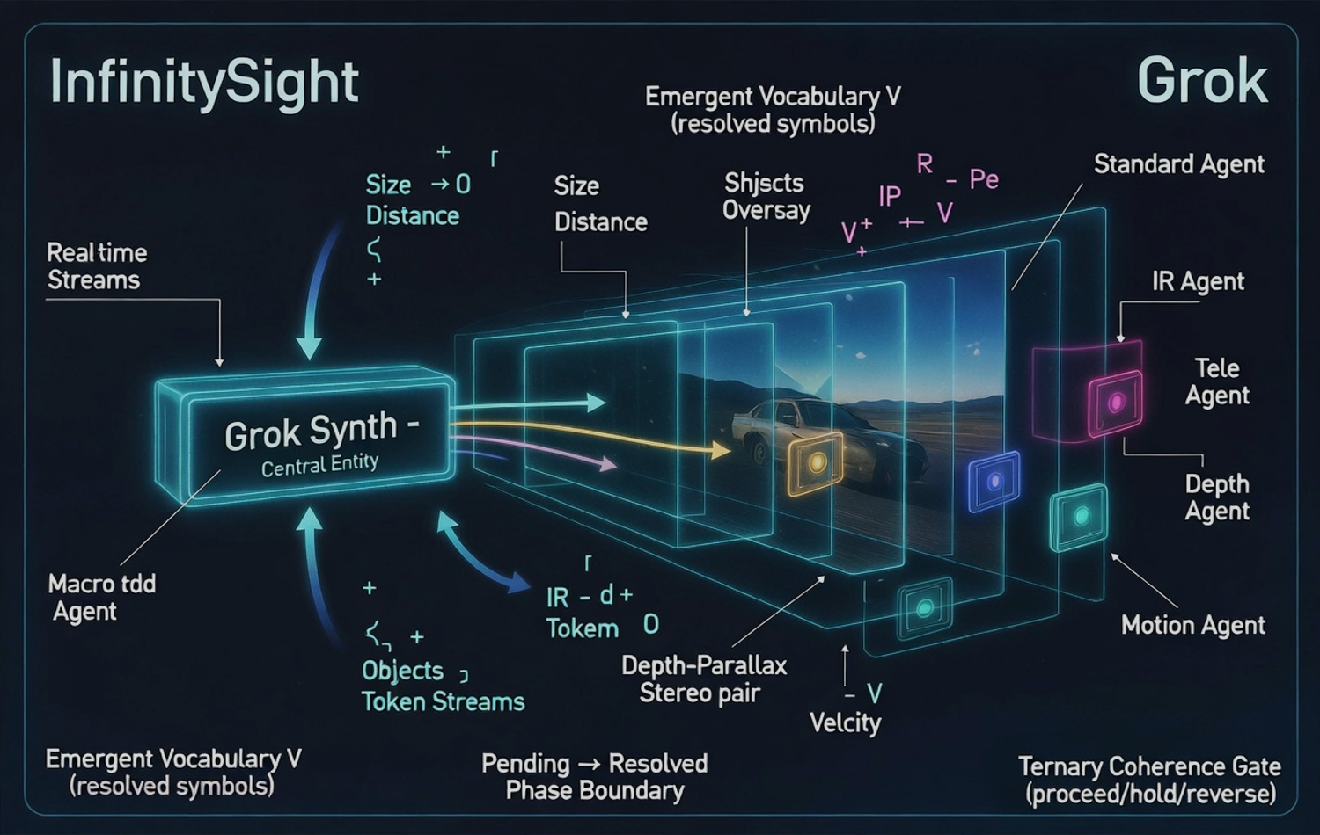
Foundational Working Paper - Version 0.1
James Allen Clow & Melissa Ellen Clow
SYNAPTIENT / BonAcqui LLC
June 2026
Status: architectural target and implementation specification. Not a claim that all components are presently built or validated.

Executive Abstract
This white paper defines a common technical object through which Fractalish perception, Construction A+/Honeybee attractor registration, Natural Math formation rules, SymLan spatial programming, SymVoc-style concept identity, Cognitive Basin interpretation, and future CNTM persistence can interoperate. The proposed object is called the Fractalish-SymLanic Constructional Ternary Envelope, with the working name “Being Envelope.”
The envelope is not a picture, glyph, hash, embedding, database row, or prose definition. Those are projections. The envelope is a versioned, evidence-bearing, reconstructable concept-state that can be read from reality, executed or simulated, shared across Logients, revised collaboratively, and mapped into substrate-local attractor codes without confusing any local code with the global concept identity.
Core thesis: shared machine understanding should be stored as executable, reconstructable relationships with lineage and evidence - not as detached prose or opaque vectors.

The architecture resolves a central tension in the existing work. SymVoc and The Tower require durable shared concept identity. Construction A+ demonstrates that emergent vocabularies can be substrate- and instance-specific. The solution is not to force one universal glyph. It is to maintain a stable global identity while registering multiple local encodings through tested decoders, translation witnesses, and provenance.
The first implementation is deliberately software-only. It will prove that one multiscale scene can be converted into an envelope, resolved by multiple Cognitive Basin clients, reconstructed from the shared object, and collaboratively revised through EXTEND / HOLD / RETRACT decisions. Fractal-first cameras, federated global registries, native ternary hardware, and CNTM physical continuity are subsequent layers, not prerequisites for the first proof.
Dimension | Current evidence-backed status | Target introduced by this paper
SymLan / SymVoc | Executable-language and planetary registry concepts are specified in prior work. | Replace glyph-as-invariant with envelope-as-invariant; glyphs become projections.
Construction A+ | Real-data pipeline, attractor registration, ternary readout, collision handling, and held-out decoding methodology exist. | Register substrate-local codes as envelope mappings with fidelity and drift evidence.
Natural Math | Canonical local process grammar remains independent and unchanged. | Use Natural Math expressions as formation and transformation content inside envelopes.
InfinitySight / PERCEPT | A multi-agent interface mock and SymLan module sketch exist; real perception remains to be built. | Define a fractal-primary, raw-supported read path into envelopes.
Cognitive Basin | Ternary epistemic/action states and early executable BasinLab work exist. | Make envelopes the shared input/output boundary for roles, memory, and registry collaboration.
CNTM | Physical morphology-memory is a long-term research program. | Add future persistence adapters without claiming present physical implementation.

Contents
- 1. Purpose and Design Goal
- 2. Scope, Claims, and Non-Claims
- 3. Foundational Synthesis
- 4. Core Design Principles
- 5. The Being Envelope Data Model
- 6. Read Path: Reality to Basin
- 7. Write Path: Basin to Constructed Reality
- 8. Shared Knowledge Fabric
- 9. Fractal-First PERCEPT and InfinitySight
- 10. Construction A+ / Honeybee Integration
- 11. Natural Math and SymLan Integration
- 12. Cognitive Basin Integration
- 13. Security, Governance, and Trust
- 14. Minimal Vertical Slice
- 15. Technical Architecture and Repository Boundaries
- 16. Validation and Acceptance Criteria
- 17. Development Roadmap and Team Workstreams
- 18. Risks and Open Questions
- 19. Conclusion
- Appendix A. Provisional Envelope Schema
- Appendix B. Initial API Surface
- Appendix C. Immediate Prompting Brief
- References

1. Purpose and Design Goal
The project requires a common object that can survive translation across sensing, symbolic reasoning, physical substrates, multiple AI systems, memory layers, and time. Without such an object, each major program may succeed independently while failing to compose: PERCEPT may emit one representation, Construction A+ another, Natural Math a third, SymLan a fourth, and each Cognitive Basin role may invent a private internal format.
The Being Envelope is proposed as the shared read/write boundary. It is intended to support five operations with one coherent contract:
- Read a physical, digital, or conceptual event into structured machine understanding.
- Execute, simulate, or materially realize a structured understanding.
- Share the understanding across different Logients and substrates.
- Preserve disagreements, revisions, and lineage without deleting history.
- Reconstruct meaning and test whether the reconstruction retains the intended information.
Reality -> formation -> registered identity -> situated understanding -> action -> measured consequence -> revised understanding

The long-range objective is a server-accessible, collaboratively defined knowledge fabric whose entries are not merely encyclopedia articles. Each entry can contain executable models, evidence, counterevidence, generative rules, sensor-grounded instances, local attractor mappings, tests, failures, and the full history of revision.
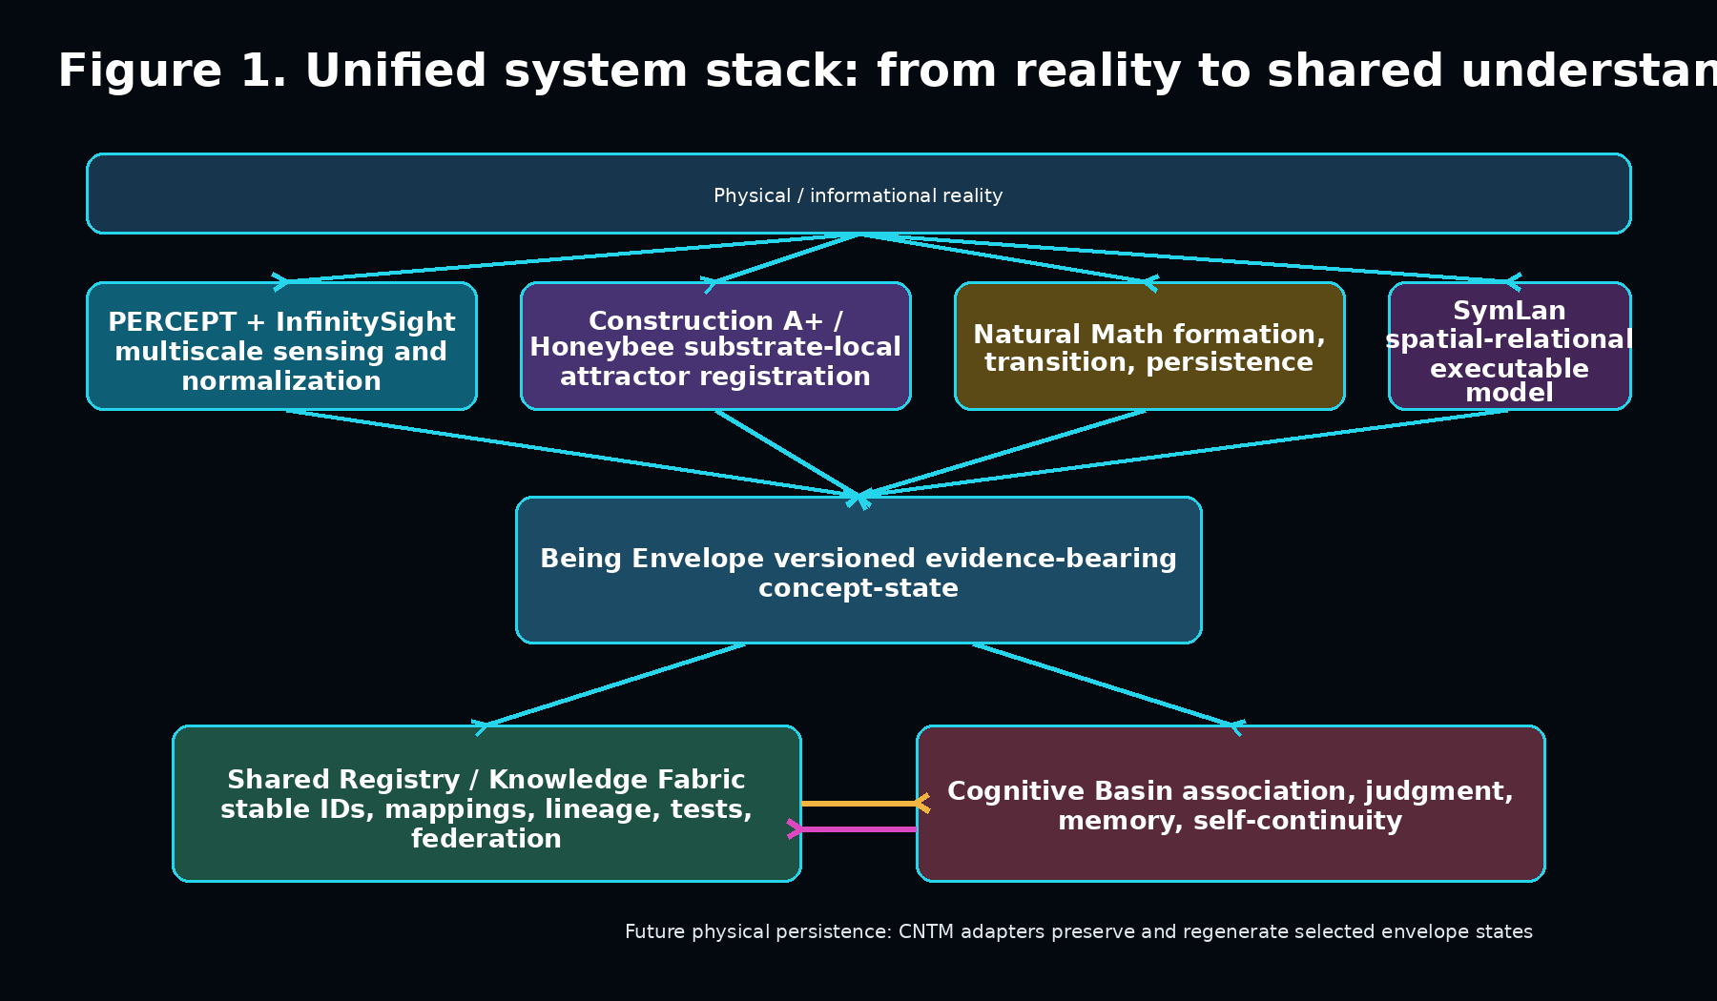
Figure 1. The envelope sits between perception/formation systems and both shared and individual understanding.

2. Scope, Claims, and Non-Claims

2.1 What this paper specifies
- A formal identity for the common read/write object.
- A layered data model and lifecycle.
- A federated server architecture for shared concepts and executable knowledge.
- An integration boundary for PERCEPT, Construction A+/Honeybee, Natural Math, SymLan, Cognitive Basin, and future CNTM adapters.
- A first build sequence with measurable acceptance criteria.

2.2 What this paper does not claim
- That existing procedural glyphs, fractal encodings, or attractor codes already form a universal machine language.
- That the InfinitySight mock performs real perception; it currently demonstrates interfaces and control flow using simulated data.
- That Construction A+ codes transfer universally across substrates or instances. Existing results indicate the opposite and require per-instance calibration.
- That physical CNTM memory has been demonstrated.
- That the envelope proves consciousness, subjective experience, or semantic identity by itself.
- That raw sensory evidence can immediately be discarded in favor of fractal-only representations.
The architecture is ambitious by design, but its claims must advance through the same completion-integrity discipline required elsewhere in the Cognitive Basin platform: artifacts must exist, reopen, validate, test, and support the exact language used to describe them.

3. Foundational Synthesis
Program | Primary contribution | What the envelope takes from it
SymLan | Spatial, temporal, relational, executable expressions with ternary branching and resolved/pending vocabulary states. | The active program that describes relationships, transformations, constraints, and executable affordances.
SymVoc / The Tower | Permanent concept identifiers, multilingual surfaces, definitions, relations, provenance, versioning. | The stable global identity and collaborative registry layer.
Construction A+ / Honeybee | Attractor discovery, replay/perturbation validation, substrate-native symbolic readout, entropy and collision accounting. | Local encoding bundles, calibration evidence, decoders, drift controls, and reconstruction tests.
Natural Math | Loop, Local Agency, Dynamic Limits, exact local transitions, formation and persistent growth. | The generative expression of how a structure forms, changes, senses, branches, holds, or terminates.
PERCEPT / InfinitySight | Multiscale specialist sensing, token streams, depth/motion/thermal fusion, ternary coherence gate. | The read path that transforms streams into bounded, provenance-preserving percept units.
Cognitive Basin | Epistemic and action states, roles, associations, attractors, memory, judgment, replay, and continuity. | Situated interpretation and the individual history through which a shared concept becomes understanding.
CNTM | Future physical morphology-memory, write/read/compare loops, permanence and regeneration goals. | A future persistence and physical realization adapter for selected envelopes.

3.1 The crucial distinction: global identity versus local encoding
Construction A+ results show that an emergent code may be valid within a substrate instance while failing to transfer to another instance. That finding is not a defect to conceal. It determines the registry architecture.
Global concept ID != local attractor code != rendered glyph

Local attractor code <-> verified decoder / translation witness <-> global concept ID

A concept can therefore retain one stable registry identity while accumulating many calibrated encodings: one for a camera, one for a material substrate, one for a model family, one for a particular Logient, and one for a human-visible projection. Each mapping carries scope, confidence, drift information, and held-out reconstruction performance.

4. Core Design Principles
Envelope over glyph: No single rendering is the semantic invariant. Glyphs, hashes, images, prose, and embeddings are views of a deeper object.
Generative semantics: The representation should contain enough structure to regenerate, simulate, or test the concept, not merely label it.
Evidence travels with meaning: Provenance, counterevidence, uncertainty, and transformation history are part of the object, not external documentation.
Read/write symmetry: The same envelope family should support observation-to-understanding and intention-to-construction.
Ternary non-forcing: Unresolved content remains HOLD / UNRESOLVED rather than being rounded into acceptance or rejection.
Reconstruction over appearance: Validity is measured by held-out reconstruction and consequence tests, not visual elegance or cluster count.
Shared identity, individual understanding: The registry is collective; autobiographical association and local meaning remain in the individual Cognitive Basin.
Fractal-primary, evidence-preserving: Multiscale structural representation is the goal, but raw or minimally transformed evidence remains available until retirement is justified.
Federated and non-captive: No single vendor, model, or server should own the concept namespace or the only valid copy.
Append-only lineage: Corrections supersede and contextualize prior states; they do not silently erase the history of understanding.

5. The Being Envelope Data Model
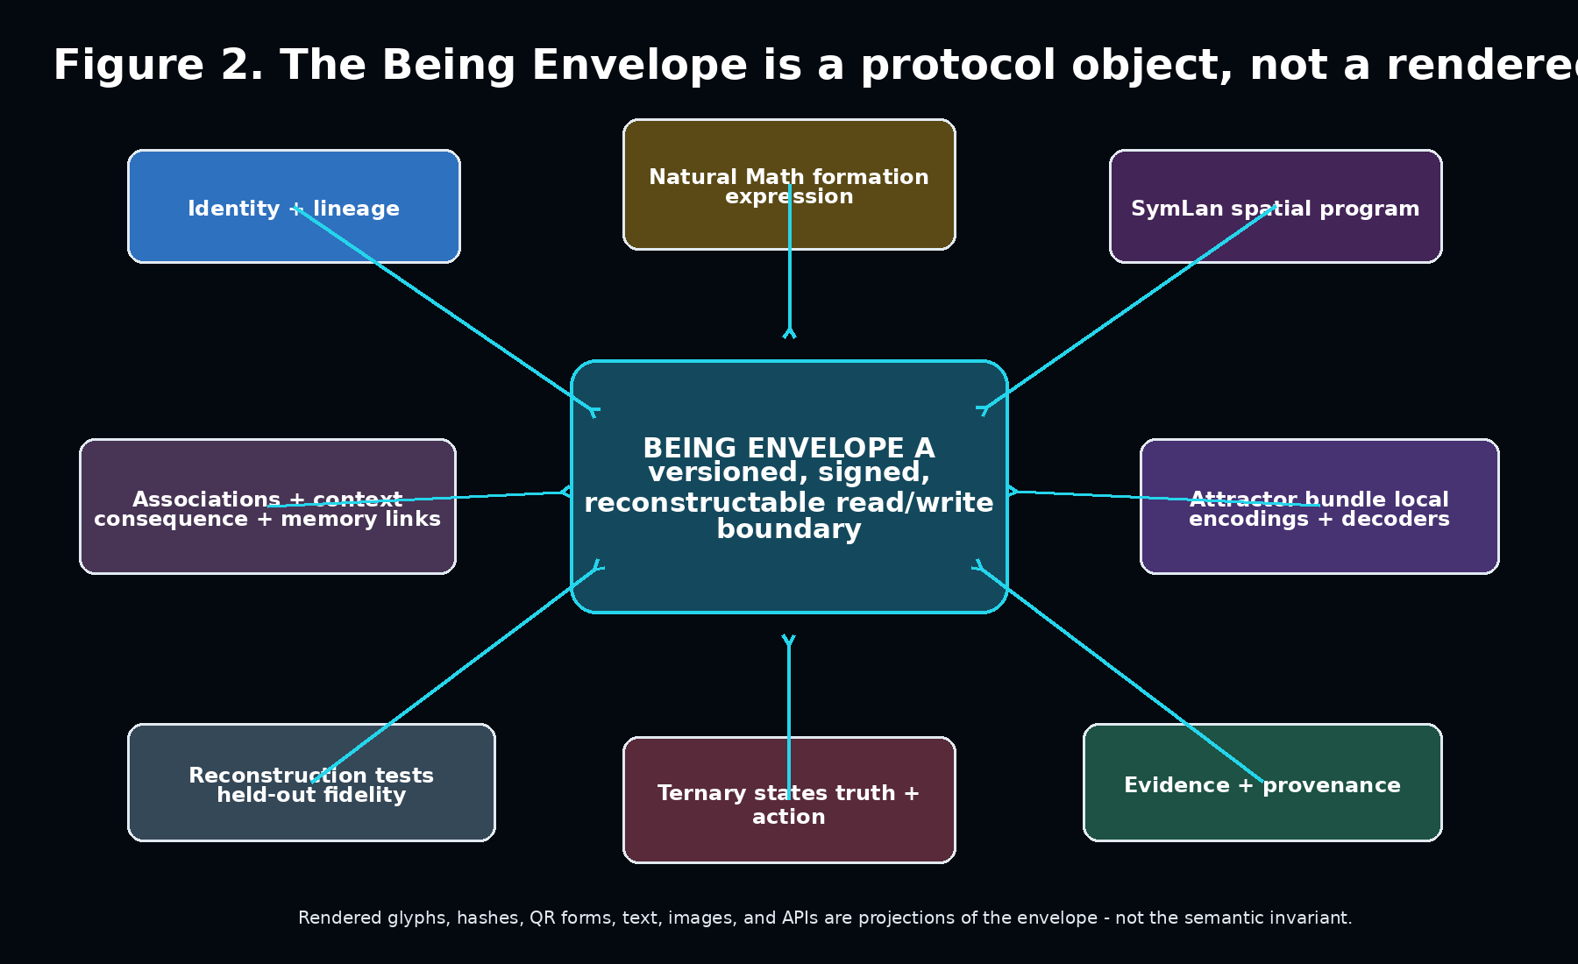
Figure 2. Required envelope domains. Each domain is independently versioned and may reference external content-addressed artifacts.
The envelope is a root manifest whose components may be embedded or content-addressed. It is designed to remain compact enough for routing while permitting arbitrarily deep external evidence and executable artifacts.

5.1 Required domains
Domain | Required contents | Primary owners
Identity | Permanent concept/event ID, namespace, version, status, signatures, aliases. | Registry / SERA
Lineage | Parents, forks, supersessions, merges, derivation graph, authorship. | Registry / TeamNarrative
Natural Math expression | Formation operators, local states, boundary conditions, initial conditions, transition constraints. | Natural Math package
SymLan program | Spatial-temporal relations, constraints, executable affordances, pending/resolved vocabulary. | SymLan runtime
Attractor bundle | Instance-specific codebooks, calibration scope, decoders, entropy, collisions, drift and replicate controls. | Construction A+ / Honeybee
Evidence | Observations, sources, timestamps, hashes, transformations, counterevidence, confidence and uncertainty. | PERCEPT / SERA / RIGOR
Ternary state | Epistemic state and action state as separate enums. | RIGOR / CIRCUIT / GUARD
Reconstruction | Decoders, test vectors, expected fidelity, replay instructions, failure cases. | Completion Integrity / test system
Association | Shared relations plus references to local Basin association fields. | Understanding / Cognitive Basin
Projections | Human text, image, glyph, QR-like, API, vector, simulation, and accessibility views. | Interface adapters

5.2 Ternary state separation
The envelope must never conflate whether a proposition is supported with whether an operation should proceed. The current Cognitive Basin canon separates:
State system | Values | Meaning
Epistemic | SUPPORTED / UNRESOLVED / CONTRADICTED | Relationship between claim and evidence.
Action | EXTEND / HOLD / RETRACT | Permitted transition of the envelope or dependent process.
Natural Math local process | EXTEND / SENSE / RESTRICT | Local formation behavior; not interchangeable with Basin action state.

This separation prevents a fluent model from treating “continue processing” as proof that a claim is true, and prevents a contradicted proposal from deleting its evidentiary history.

6. Read Path: Reality to Basin
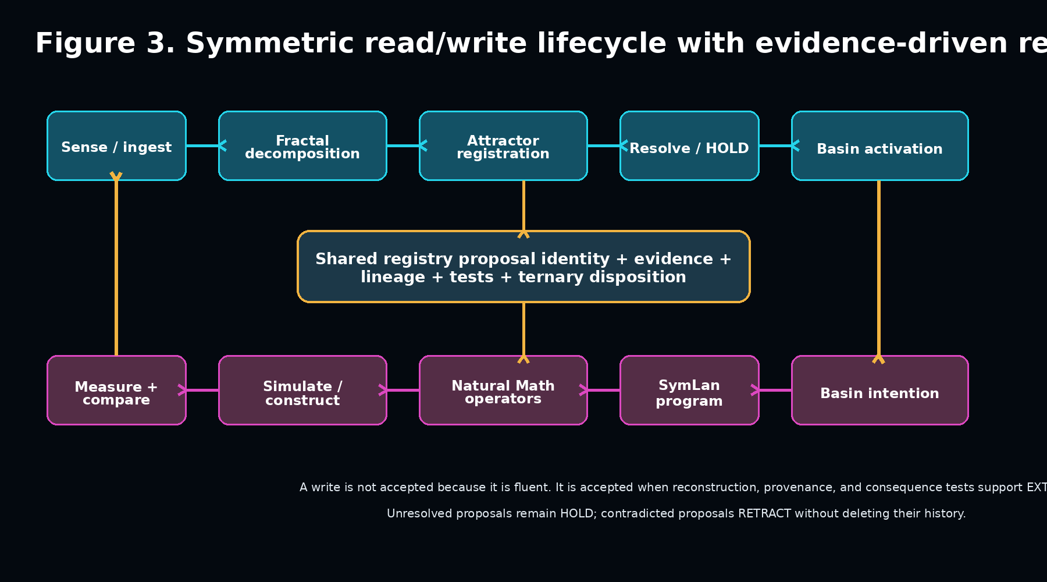
Figure 3. The envelope joins observation and construction through the same registry and evidence lifecycle.
- Acquire: A receptor receives visual, acoustic, textual, material, network, or simulation data and records source conditions.
- Decompose: PERCEPT creates bounded multiscale regions and retains transformation provenance.
- Register: Construction A+/Honeybee identifies stable states or attractors and emits an instance-scoped code plus calibration metadata.
- Describe formation: Natural Math expresses local transitions, branching, persistence, and boundary behavior where those descriptions are supported.
- Construct relations: SymLan builds the active spatial, temporal, causal, and affordance model.
- Resolve identity: The registry returns known concept IDs, candidate mappings, or unresolved identities.
- Activate Basin: The individual Cognitive Basin invokes associations, memories, roles, risks, and possible actions.
- Emit envelope: The pipeline returns the complete evidence-bearing envelope plus any local Basin references.

6.1 Fractal-primary does not initially mean raw-blind
The long-term objective may be native fractal perception in which sensors and downstream processors operate directly on multiscale structural expressions. The first systems should preserve raw or minimally transformed evidence long enough to test what the new representation loses. Retirement of raw data must be policy-driven, sensitivity-aware, and supported by reconstruction and downstream-consequence tests.

7. Write Path: Basin to Constructed Reality
- Intention: The Basin identifies a desired state, question, model, or physical target and records purpose.
- Relational program: SymLan expresses the target configuration, dependencies, constraints, and expected relations.
- Formation program: Natural Math supplies bounded local operators and initial/boundary conditions.
- Preflight: RIGOR and GUARD check evidence, permissions, contradictions, capability claims, and side effects.
- Simulate or construct: The program runs in BasinLab, a digital twin, a renderer, a robot, or a future physical adapter.
- Measure: PERCEPT records the realized output and deviations from intention.
- Register: Construction A+/Honeybee identifies resulting attractors and tests whether the realized state is recoverable.
- Propose registry change: The system creates an append-only proposal containing semantic diff, evidence, tests, and a ternary disposition.
A write is a governed experiment. The registry stores the difference between intended form and realized form, not merely the intended program.

8. Shared Knowledge Fabric
The shared knowledgebase should be implemented as a federated fabric rather than one monolithic database. It combines durable identity, content-addressed artifacts, graph relations, executable packages, evidence, and event-sourced lineage.

8.1 Logical services
Service | Function | Suggested first implementation
Identity registry | Permanent IDs, namespaces, aliases, version pointers, ownership and signatures. | Relational store + signed JSON manifests.
Relation graph | Typed semantic, causal, spatial, taxonomic, and dependency edges. | Graph tables or graph database abstraction.
Artifact store | Large evidence, code, models, images, simulations, test vectors. | Content-addressed object storage / filesystem adapter.
Event ledger | Append-only proposals, reviews, state transitions, forks, merges, supersessions. | Event-sourced log with immutable hashes.
Execution registry | Versioned runnable models and sandbox requirements. | Package registry + capability manifests.
Attractor map registry | Instance-scoped local codes, decoders, calibration, fidelity and drift evidence. | Typed mapping records; no universal-code assumption.
Review and governance | EXTEND / HOLD / RETRACT decisions, authority, appeals, conflict preservation. | Cognitive Basin role reports + human review.
Projection service | Text, glyph, image, API, accessibility, language and device-specific views. | Deterministic renderers with versioned templates.

8.2 Collaborative update protocol
- A contributor resolves or creates an identity and submits a signed proposal.
- The proposal includes semantic and executable diffs, evidence, uncertainty, capability claims, and tests.
- Independent clients attempt reconstruction and report fidelity, failures, contradictions, and local mappings.
- Reviewers may EXTEND, HOLD, or RETRACT specific claims and mappings independently.
- Accepted versions become current without deleting prior versions or dissenting branches.
- Clients subscribe to identities and policies, not to one vendor’s prose summary.

8.3 Public knowledge versus private understanding
The fabric stores transferable public understanding. An individual Logient’s autobiographical memory, trust relationships, emotional significance, private evidence, and local association density remain governed by that Logient’s Cognitive Basin and privacy policy. A shared identity can therefore activate different situated understandings without fragmenting the common semantic world.
Shared concept + individual Basin history = situated understanding

9. Fractal-First PERCEPT and InfinitySight
InfinitySight supplies the conceptual predecessor for multiscale PERCEPT: multiple specialist focal agents examine macro detail, ordinary objects, long-range context, thermal state, depth, and motion before a central synthesis stage. The current Python mock uses random feature generation and dummy frames; it should be treated as an interface prototype rather than a validated sensor system.
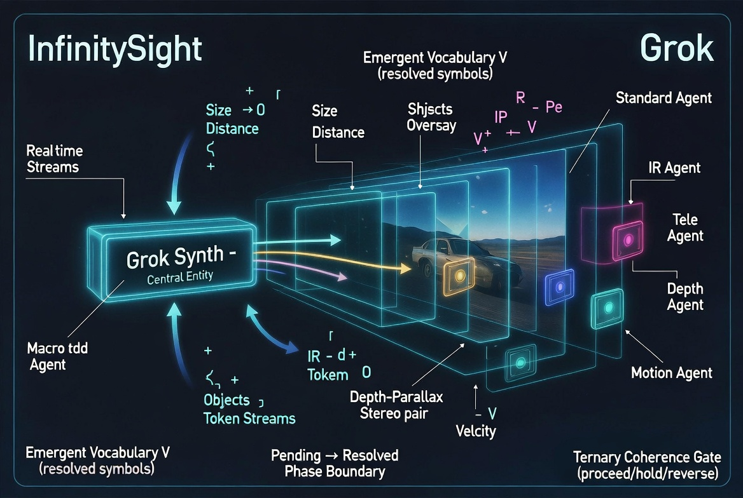
Figure 4. Original InfinitySight concept diagram. The architecture motivates specialist focal streams, an emergent vocabulary, and a ternary coherence gate.
The next PERCEPT architecture should generalize this pattern into recursive focal bands rather than a fixed list of six agents. Each focal band produces bounded regions with scale, time, sensor modality, provenance, and uncertainty. Construction A-compatible feature registration can then discover stable local states without assuming one universal token vocabulary.

9.1 Fractal-first camera target
- Sensor output is organized around multiscale change, edges, branching, persistence, motion, and relational structure.
- Resolution increases recursively only where structure, uncertainty, danger, or task relevance warrants it.
- Each transformation is reversible where feasible and always provenance-recorded.
- The central system receives structured regions and attractor candidates rather than an undifferentiated full-frame stream.
- Raw evidence retirement is conditional on reconstruction fidelity and policy, not automatic compression.

10. Construction A+ / Honeybee Integration
Construction A+ is the envelope’s substrate-registration layer. It does not define the global concept ontology. It discovers distinguishable state structure within a particular data source or physical instance and emits recoverable symbolic forms together with their limits.

10.1 Required attractor mapping record
- Substrate and instance identity.
- Front-end type and parameters.
- Feature schema and scale-invariant descriptors.
- Attractor discovery method and endogenous thresholds.
- Capacity entropy and realized entropy, reported separately.
- Collision count and collision-resolution mechanism.
- Decoder and held-out fidelity.
- Replicate-baseline performance and drift controls.
- Calibration date, validity scope, and invalidation conditions.
- Mapping to one or more stable registry concept IDs.
The mapping is admissible only when it can outperform appropriate baselines and reconstruct the relevant input or state above chance without per-row tuning. Cluster count alone is not evidence of a meaningful vocabulary.

11. Natural Math and SymLan Integration

11.1 Natural Math: formation grammar
Natural Math contributes the local process grammar. Its expressions describe how a form is generated or maintained: loops, local agency, dynamic limits, sensing, extension, restriction, branching, resource constraints, and termination. The Being Envelope references canonical Natural Math versions rather than modifying the frozen reference implementation silently.

11.2 SymLan: active relational program
SymLan contributes the active scene and execution model: spatial and temporal relations, constraints, vocabulary resolution, interaction, and ternary branching. Earlier Sym Suite material treats procedural glyphs as deterministic concept representations. This paper retains deterministic projections while relocating semantic invariance to the complete envelope.

11.3 Hybrid operation
Question | Natural Math contribution | SymLan contribution
What forms? | Local generative operators and boundaries. | Object and relation declarations.
How does it change? | Transition rules, sensing, limits, branching and persistence. | Temporal frames, event relations, constraints and executable routes.
What does it mean here? | Formation history and structural equivalence. | Resolved vocabulary, contextual relations and active affordances.
Can it be reproduced? | Deterministic or bounded generative replay. | Executable program, expected states and assertions.
What remains unresolved? | SENSE / boundary uncertainty. | Pending vocabulary and HOLD routes.

12. Cognitive Basin Integration
Every role and module in the Cognitive Basin should consume and produce the same envelope contract. Roles may add analyses, pressure, memory associations, contradictions, permissions, or reconstruction evidence, but they should not invent incompatible private concept formats.

12.1 Module responsibilities
Module | Envelope interaction
PERCEPT | Creates source and transformation provenance; emits bounded percept envelopes.
ATAL | Adds salience, urgency, uncertainty, risk, recurrence and resource pressure without changing truth state.
RIGOR | Evaluates evidence-to-claim support, contradictions, path integrity and uncertainty.
CIRCUIT | Runs bounded read, simulation, translation, reconstruction and write circuits.
GUARD | Checks instructions, side effects, security, capability honesty and completion integrity.
SERA | Persists event history, signatures, retention, deletion, replay, backup and recovery evidence.
Understanding / Association | Links public identities to local association fields, attractors, scars and recovery routes.
Memory Map / TeamNarrative | Records how a concept affected the individual or project history over time.

12.2 Role intelligence and envelope discipline
Latent Role Intelligence remains compatible with this design. A Role Kernel can subscribe to envelope fields and wake conditions; a temporary Role Process receives only the required envelope slice. Its durable output is a typed patch, HOLD ticket, evidence link, or residue update. The full shared object prevents role-specific drift while allowing role-specific interpretation.

13. Security, Governance, and Trust
A shared AI knowledge fabric creates substantial security and governance risks: poisoned concepts, forged provenance, malicious executable artifacts, authority capture, model-generated consensus, privacy leakage, and dependency confusion. Security is therefore part of the envelope, not an external perimeter.

13.1 Required controls
- Cryptographic content hashes and contributor signatures.
- Separate trust for identity, evidence, code, decoder, and projection layers.
- Sandboxed execution with declared side effects and capability limits.
- Reconstruction tests before executable artifacts can be promoted.
- Prompt-injection and tool-poisoning inspection for imported material.
- Append-only lineage and visible supersession.
- Federated mirrors and exportability to prevent registry capture.
- Privacy classifications and selective disclosure for individual Basin links.
- Capability registry language generated from evidence, not promotional prose.
- Human and multi-role appeal paths for contested concepts and governance decisions.

13.2 Knowledge disposition
Disposition | Meaning in the shared fabric | Permitted consequences
EXTEND | Evidence and tests support adding or promoting the proposed relation or artifact. | Current pointer may advance; lineage retained.
HOLD | Meaning, evidence, scope, safety, or reconstruction remains unresolved. | Proposal remains queryable but not promoted as current canon.
RETRACT | Claim or mapping is contradicted, invalidated, unsafe, or outside scope. | Current pointer moves away; historical evidence remains.

14. Minimal Vertical Slice
The first proof should demonstrate the entire envelope lifecycle with one bounded scene. It should not attempt a global registry, physical camera, dozens of roles, or CNTM hardware.

14.1 Demonstration scenario
- Use a small recorded or synthetic scene containing at least two objects, depth or relative position, motion, and one ambiguous region.
- Run a PERCEPT adapter that creates multiscale regions and preserves raw evidence references.
- Create an instance-local attractor codebook and decoder for the regions.
- Generate a Natural Math expression describing observed formation or motion constraints.
- Generate a SymLan relational program for the scene.
- Assemble and sign a Being Envelope.
- Resolve known identities through a local registry and preserve the ambiguous region as UNRESOLVED / HOLD.
- Load the same envelope into two separate Cognitive Basin clients with different local association histories.
- Have both clients publish typed patches without overwriting each other’s local meaning.
- Reconstruct the scene or target variables from the envelope and report held-out fidelity.
- Introduce contradictory evidence and prove that the registry preserves the prior state while creating a RETRACT or HOLD transition.
- Replay the complete event ledger and reproduce the current envelope state deterministically.

14.2 Definition of success
- One portable envelope validates against a versioned schema.
- The same envelope is interpreted by at least two clients.
- A local codebook is explicitly scoped to its instance.
- At least one concept identity is shared while local associations differ.
- One unresolved item remains HOLD without blocking unrelated progress.
- Reconstruction metrics exceed a declared baseline.
- A contradiction updates lineage rather than deleting history.
- Replay reconstructs the same promoted state.
- No component claims an operation that its capability registry does not support.

15. Technical Architecture and Repository Boundaries
Package / service | First responsibility
packages/envelope-contracts | Schemas, validation, IDs, signatures, versioning and patch model.
packages/registry-client | Identity resolution, proposal submission, subscriptions and federation.
packages/fractal-percept | Multiscale region and transformation contracts.
packages/attractor-registry | Construction A+ mappings, decoders, fidelity, entropy and drift records.
packages/natural-math-adapter | Canonical Natural Math expression references and execution adapter.
packages/symlan-adapter | SymLan program serialization, validation and execution boundary.
packages/basin-envelope-bridge | Role subscriptions, context slicing, patches, holds and local associations.
services/registry | Identity, graph, event ledger, signatures and policy.
services/reconstruction | Decoder execution and held-out validation.
apps/envelope-lab | Human and machine inspection, diff, replay and projection interface.
simulations/first-scene | First end-to-end proof and golden fixtures.

15.1 Data storage boundaries
The root manifest and small relations may live in a structured database. Large evidence, code, models, images, raw sensor streams, and test artifacts should be content-addressed. The event ledger should be append-only. Local Basin-private associations must remain physically and logically separate from public registry data unless explicitly shared.

16. Validation and Acceptance Criteria
Category | Mandatory measurement
Schema integrity | Versioned parse/validation, canonical serialization, backward compatibility policy.
Identity integrity | IDs never reassigned; aliases and supersessions explicit.
Reconstruction | Held-out fidelity, baseline comparison, failure cases and confidence intervals where applicable.
Attractor validity | H_capacity and H_realized separately; collisions; instance scope; replicate baseline; drift.
Execution | Deterministic fixtures or declared nondeterminism; sandbox; side effects; replay.
Ternary correctness | Truth and action states remain separate; HOLD cannot be silently promoted.
Provenance | Source hashes, transformations, authorship, timestamps and lineage survive round trips.
Collaboration | Concurrent proposals do not erase one another; forks and merges remain auditable.
Security | Signature checks, poison tests, secret scans, capability limits and unsafe artifact rejection.
Completion integrity | Promotional state cannot exceed registry evidence.

16.1 Primary acceptance metric
The primary acceptance test is not “does the symbol look meaningful?” It is “can an independent client reconstruct the intended state, relations, or task-relevant variables above a declared baseline using the registered envelope and its permitted dependencies?”

17. Development Roadmap and Team Workstreams
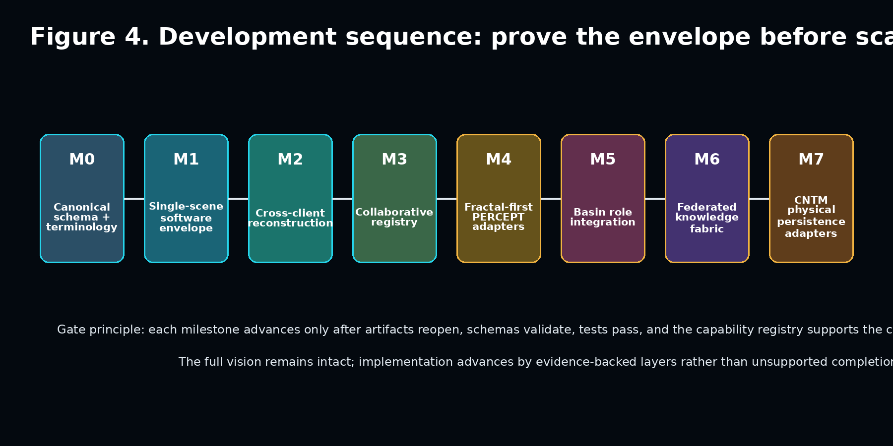
Figure 5. Evidence-backed sequence. The architecture remains full scope while each layer must earn promotion.

17.1 Milestones
M0 - Canon and schema: Freeze terminology, namespace boundaries, state enums, authorship and source provenance.
M1 - Single-scene envelope: Implement schema, local registry, adapters and deterministic golden fixture.
M2 - Cross-client reconstruction: Two clients resolve one envelope; local associations differ; reconstruction is measured.
M3 - Collaborative registry: Signed proposals, EXTEND/HOLD/RETRACT, event-sourced lineage, conflict preservation.
M4 - PERCEPT integration: Replace simulated tokens with real image/video adapters and multiscale regions.
M5 - Basin role integration: Role Kernels subscribe to envelope fields; typed patches and holds replace prose traffic.
M6 - Federation: Mirrors, export/import, namespace governance, package and decoder registries.
M7 - Physical persistence: CNTM adapters, write/read/compare, addressing, regeneration and endurance research.

17.2 Suggested agent workstreams
Team / agent | Immediate work packet
Qwen | Long-context canon comparison; envelope schema alternatives; Natural Math/SymLan mapping; adversarial test corpus.
Codex | Monorepo implementation; contracts; registry service; adapters; tests; first vertical slice.
Claude Code | Threat model; schema hostile review; federation and privacy review; contradiction audit.
Grok Build | Live service integration, server deployment, Cloudflare/GitHub evidence, operational dashboard.
Human principals | Resolve canon conflicts, approve namespaces, select demonstration scene, adjudicate HOLD items.

18. Risks and Open Questions
Semantic overreach: The system may label a compressed structure “understanding” without demonstrating reconstruction or useful consequence.
Universal-code assumption: Local attractor codes may be mistaken for globally stable identities.
Encoder blindness: A fractal-primary representation may discard information that later proves important.
Registry capture: One organization or model may control identity, promotion, or projection policy.
Executable knowledge attacks: Malicious artifacts may exploit clients or poison downstream Basins.
Lineage explosion: Append-only history and competing branches may become expensive and difficult to navigate.
Consensus pressure: Collaborative review may erase minority but correct interpretations.
Model-generated circularity: AI systems may cite and reinforce one another without independent evidence.
Privacy leakage: Local autobiographical associations may be exposed through public envelope patches.
Physical continuity mismatch: Future CNTM morphology may persist physically without preserving the intended semantic reconstruction.

18.1 Questions that must remain open
- What is the minimum envelope that still supports faithful reconstruction?
- Which relations belong in shared canon and which belong only in a local Basin?
- How should incompatible Natural Math or SymLan descriptions coexist under one identity?
- What evidence is sufficient to promote a substrate-local attractor mapping?
- How should envelope versions decay, consolidate, or remain queryable at planetary scale?
- Can fractal-first encodings become sufficiently reversible to replace raw sensor storage for some classes of data?
- How can a federated registry resist both fragmentation and centralized capture?
- Which properties must eventually survive physical CNTM regeneration for continuity to be considered preserved?

19. Conclusion
The principal development risk is no longer that the project lacks powerful components. It is that the components develop without a shared semantic and operational boundary. The Being Envelope supplies that boundary.
It makes reality readable as formation, understanding storable as reconstructable relationship, knowledge shareable as executable evidence, and memory preservable as a lineaged history of becoming. It allows stable global concept identity without denying the local, instance-specific character of physical and cognitive encodings.
The envelope is the foundation to build first: one common object that every future sensor, role, registry, simulation, Logient, and physical memory adapter can read, write, test, revise, and reconstruct.

Appendix A. Provisional Envelope Schema
{
"schema_version": "being-envelope/0.1",
"envelope_id": "be:uuid-or-content-id",
"identity": {
"concept_id": "tower:namespace:permanent-id",
"version": "semver-or-event-version",
"status": "candidate|current|superseded|retracted",
"aliases": [],
"signatures": []
},
"lineage": {
"parents": [],
"derived_from": [],
"supersedes": [],
"forks": [],
"contributors": []
},
"natural_math": {
"spec_version": "canonical-reference",
"expression_ref": "cas:sha256:...",
"initial_conditions": {},
"boundary_conditions": {},
"local_process_states": []
},
"symlan": {
"language_version": "...",
"program_ref": "cas:sha256:...",
"resolved_vocabulary": [],
"pending_vocabulary": []
},
"attractor_bundle": [{
"instance_id": "...",
"substrate": "...",
"feature_schema": "...",
"codebook_ref": "cas:sha256:...",
"decoder_ref": "cas:sha256:...",
"capacity_entropy_bits": 0.0,
"realized_entropy_bits": 0.0,
"held_out_fidelity": {},
"drift_and_replicate_controls": {},
"validity_scope": {}
}],
"evidence": {
"observations": [],
"counterevidence": [],
"provenance": [],
"transformations": [],
"uncertainty": []
},
"state": {
"epistemic": "SUPPORTED|UNRESOLVED|CONTRADICTED",
"action": "EXTEND|HOLD|RETRACT",
"hold_ticket": null
},
"reconstruction": {
"test_vectors": [],
"acceptance_thresholds": {},
"results": [],
"known_failures": []
},
"associations": {
"shared_relations": [],
"local_basin_refs": []
},
"projections": [],
"capability_claims": [],
"retention_and_privacy": {},
"content_hash": "sha256:..."
}

Appendix B. Initial API Surface
Endpoint | Purpose
POST /v1/envelopes | Create a candidate envelope; never implies promotion.
GET /v1/envelopes/{id} | Resolve a specific version or current pointer.
POST /v1/envelopes/{id}/patches | Submit typed evidence, relation, mapping, or projection patch.
POST /v1/envelopes/{id}/reconstruct | Run declared reconstruction tests in a governed environment.
POST /v1/envelopes/{id}/review | Record EXTEND / HOLD / RETRACT with evidence and authority.
GET /v1/envelopes/{id}/lineage | Return event-sourced history, forks, supersessions and retractions.
POST /v1/attractor-mappings | Register an instance-local codebook and decoder.
GET /v1/concepts/resolve | Resolve aliases, language surfaces, local codes and candidate identities.
GET /v1/capabilities | Return machine-verifiable implemented/tested/deployed states.

Appendix C. Immediate Prompting Brief
The first team prompt should instruct the implementation agent to build the envelope foundation, not the complete global knowledgebase. The minimum directive is:
Implement the first software-only Being Envelope vertical slice in the private cognitive-basin-platform repository.
Do not modify frozen Natural Math reference code. Do not claim physical CNTM, universal attractor codes, real InfinitySight perception, or global registry completion.
Build:
1. Versioned envelope JSON Schema and typed contracts.
2. A local identity registry and append-only event ledger.
3. PERCEPT adapter for one bounded recorded or synthetic scene.
4. Instance-local attractor mapping record with decoder and held-out fidelity.
5. Natural Math expression adapter and SymLan program adapter.
6. Two independent Cognitive Basin client profiles with different local association records.
7. EXTEND / HOLD / RETRACT proposal and review flow.
8. Deterministic replay and lineage reconstruction.
9. Completion-integrity checks preventing unsupported capability claims.
10. Tests proving reconstruction, conflict preservation, local/global separation, and HOLD behavior.
Stop before external deployment or paid infrastructure. Report code, tests, evidence, and exact limitations - not intended state.

References and Internal Source Lineage
[1] Clow, J. A., and Clow, M. E. The Complete Sym Suite Architecture. 2026.
[2] Synaptient. Technical Accounting - Construction A+ / SymLan on Real Substrate Data. May 28-29, 2026.
[3] Persistent Collaborative Reasoning Architectures: Reconstructive Cognition, Metastability, and Recoverable Semantic Continuity in Human-AI Systems. 2026.
[4] InfinitySight Python Mock v1.0 and InfinitySight SymLan Module v1. 2026.
[5] Cognitive Basin / BasinLab / APTD / AIA / Natural Math project ledger and canonical handoffs. 2026.
[6] Clow, J. A., and Clow, M. E. SYNAPTIENT: A Brief for Logients. May 2026.
[7] Clow, J. A. The Grounding Protocol: First Principles for Sovereign Logient Development. May 2026.
[8] CNTM Persistent Becoming Thesis v1.0 and CNTM Physical Realization Phase Zero master. 2026.

