 Statement and Confirmation of Own Work

|  |
| --- |
| ***A signed copy of this form must be submitted with every assignment.***  ***If the statement is missing your work may not be marked.*** |

Student Declaration

I confirm the following details:

|  |  |
| --- | --- |
| Candidate Name: | AMAAN AL MIR |
| Candidate ID Number: |  |
| Qualification: | L5DC |
| Unit: | Computing Project – Project Demonstration |
| Centre: | APTECH QATAR |
| I have read and understood both NCC Education’s *Academic Misconduct Policy* and the *Referencing and Bibliographies* document. To the best of my knowledge my work has been accurately referenced and all sources cited correctly.  I confirm that this is my own work and that I have not colluded or plagiarised any part of it. | |
| Candidate Signature: |  |
| Date: | Feb 6, 2023 |



**OPS020_dec16_Candidate+Statement+of+Own+Work.doc**

# Cover Page

**WEB CHAT**

DEMONSTRATION

Prepared by

**Amaan Al Mir**

# Table of Contents

Get Started

# Get Started

WebChat is designed for private groups where they can spend time together. A place where they can talk every day and hang out more often.

This web application is designed to be responsive and user-friendly to let individuals and groups communicate easily. The design has very simple layers of textures and functions. Unlike other online social media and communication services, this application wasn’t designed for commercial purposes, although business may also use it for their private purposes.

This demonstration contains guides and reference materials to help you get started.

(Discord, n.d.)

# User Guide

**USER**

**GUIDE**



## Requirements

### Devices

|  |  |  |
| --- | --- | --- |
| **Windows** | **Android** | **Apple** |
| Supported | Supported | Supported |

### Browsers

|  |  |  |  |  |  |
| --- | --- | --- | --- | --- | --- |
|  | **Chrome** | **Firefox** | **Microsoft Edge** | **Opera** | **Safari** |
|  | Supported | Supported | Supported | Supported | - |
|  | Supported | Supported | Supported | Supported | - |
|  | Supported | Supported | Supported | Supported | Supported |

**Note:** Internet Explorer is not supported.

### JavaScript

Most of the features and functions on this web application are rendered using JavaScript. Therefore, to run this site without any errors you must enable JavaScript on your browser.

(Otto, 2022)

(ASP.NET, n.d.)

(SQL Server, 2022)

(Web Development with ASP.NET MVC and Core, 2022)

## Site Map

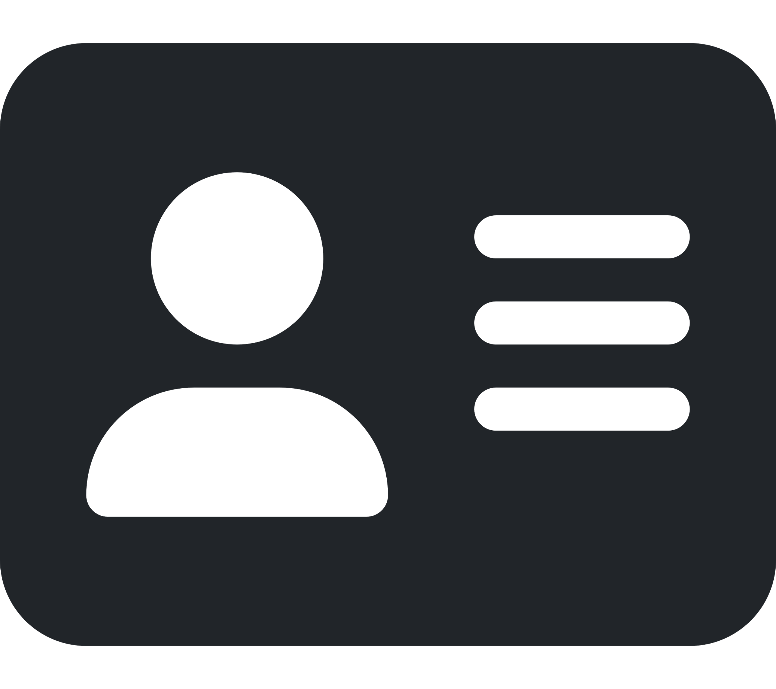

## Demonstration

### Login

There are two ways to signing in to the application.

1. Manual login - Using existing account credentials.

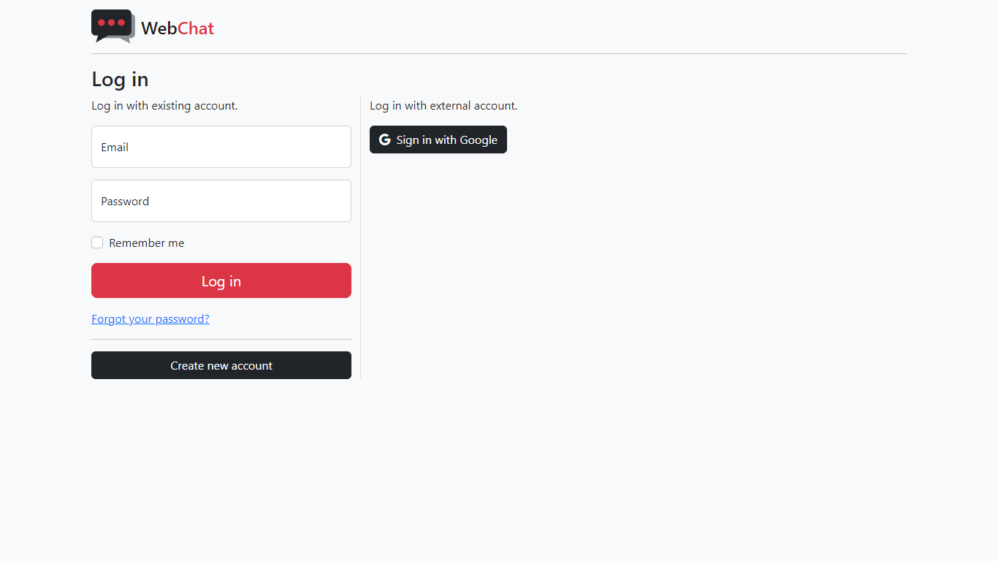

* Log in using the same email and password you used for registration.

1. Fast Login – Using an external account like Google.



* Clicking on this button will take you to Google sign in page.

If this is your first time using the application, using the external login method will take you to the registration page.

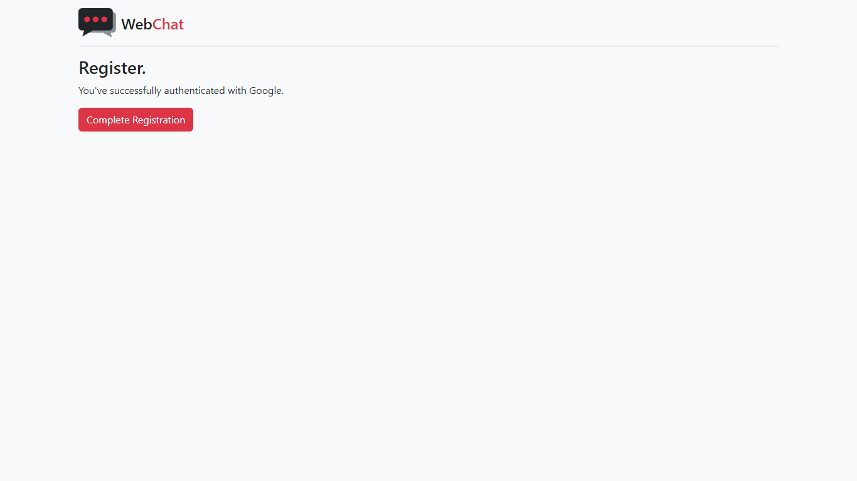

Simply click on “Complete Registration” to successfully connect your external account like Google with WebChat.

### Register

If you want to set up a new account on WebChat. Go to the registration page by clicking on the “Create new account” button from the login page.



This is the page you’ll land on to create a new account.

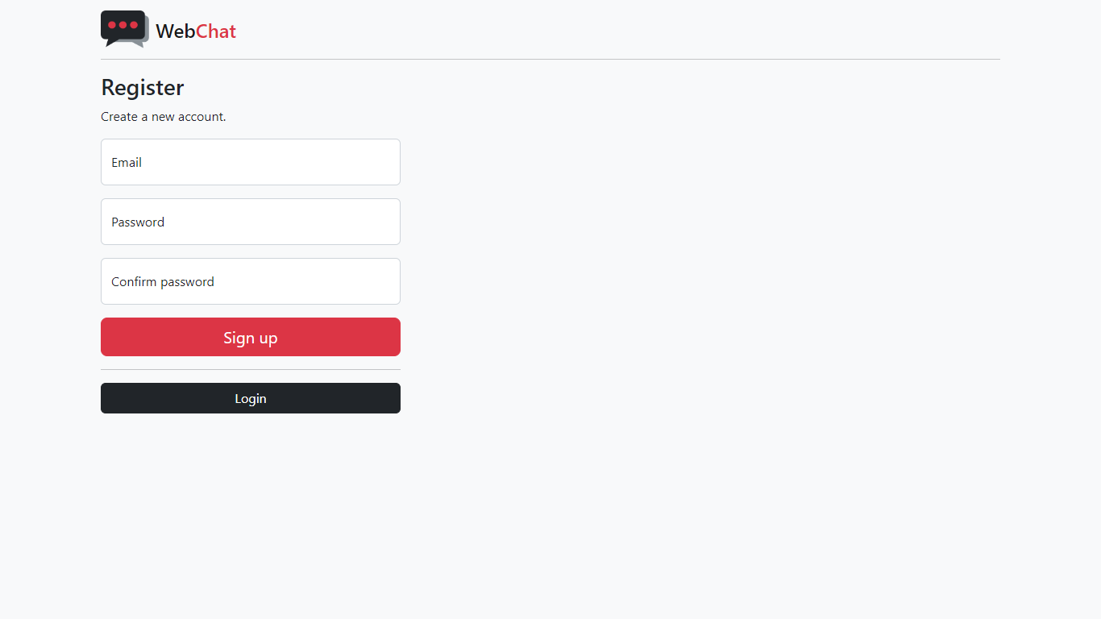

Fill in the required fields and click on “Sign up” to create a new account.

Once you have filled in proper and valid information, you’ll receive a verification link in the email you used to register.

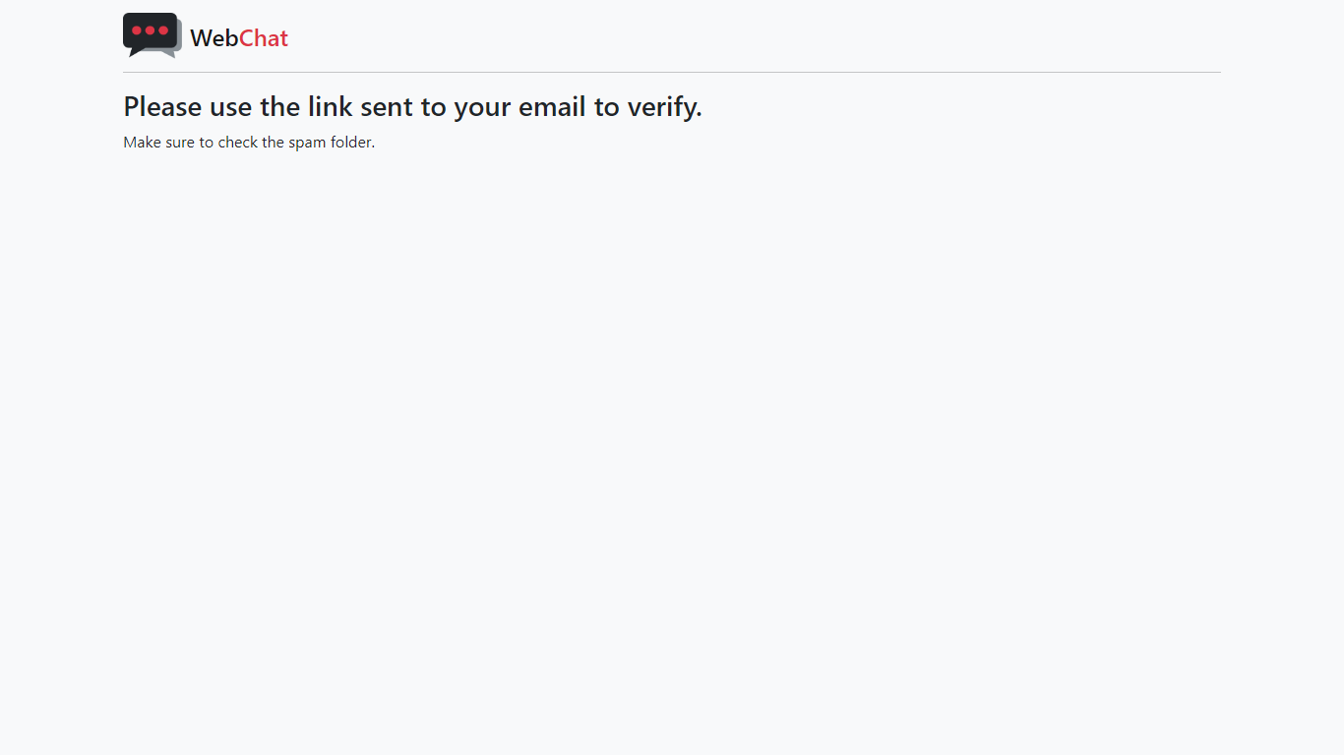

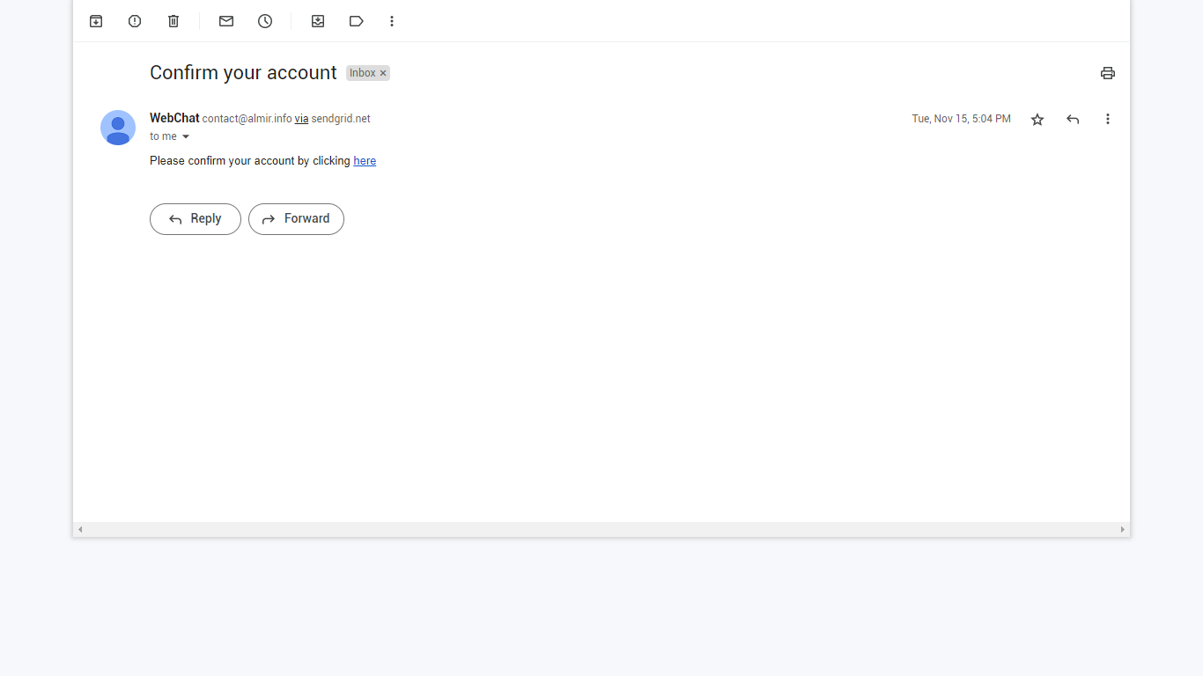

* Use the link to confirm your email.

If this process is successfully carried out, your email should be verified.

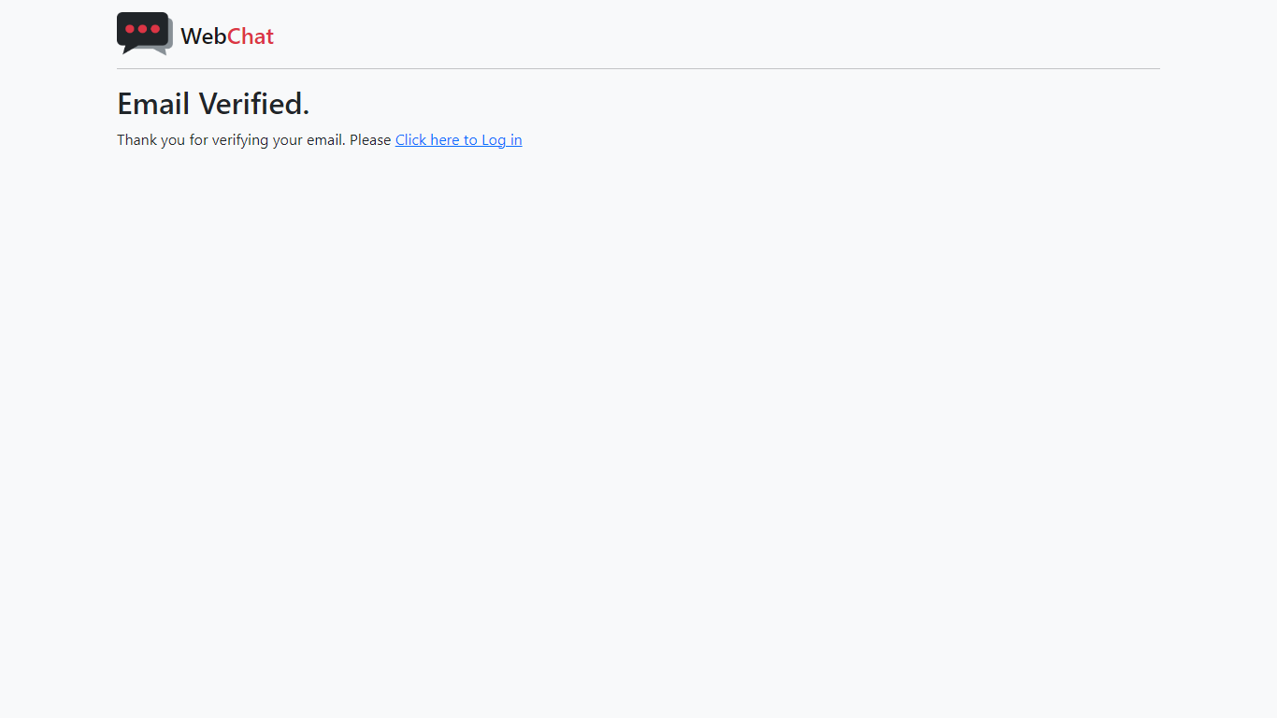

Clicking on the login link will take you back to the login page and you can login to the application using the same credentials you used to register.

You can navigate through the pages using the navbar which can be found on top of the page.

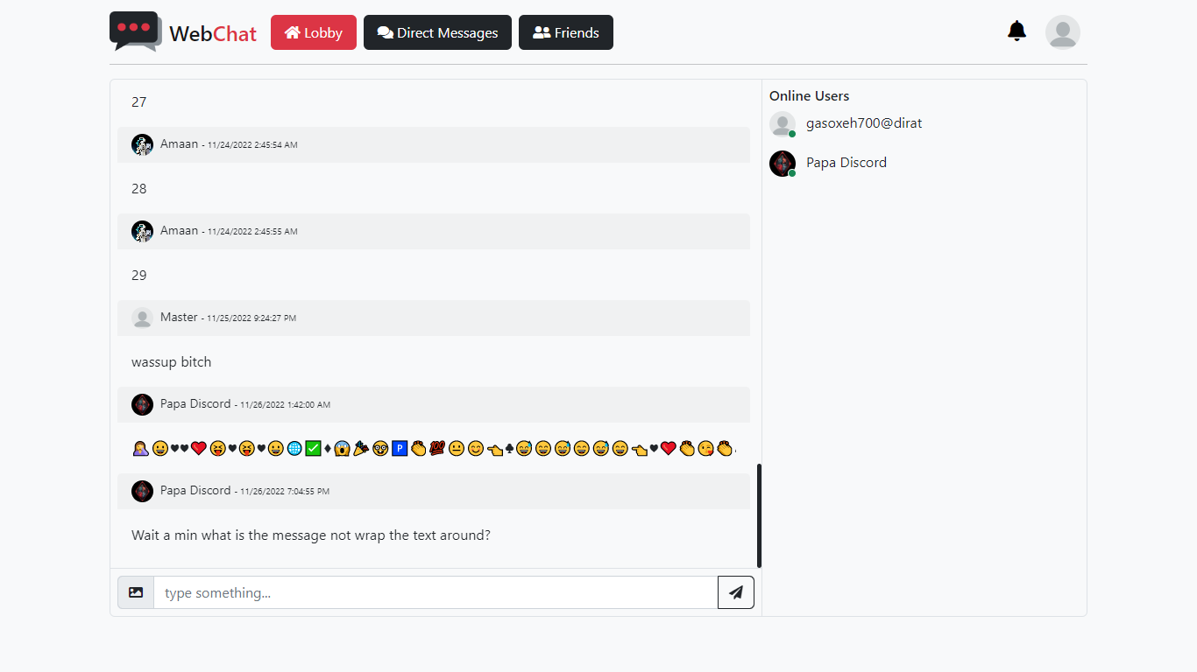

Click on your image on top-right corner to get the option to view and edit your profile or change your account settings.

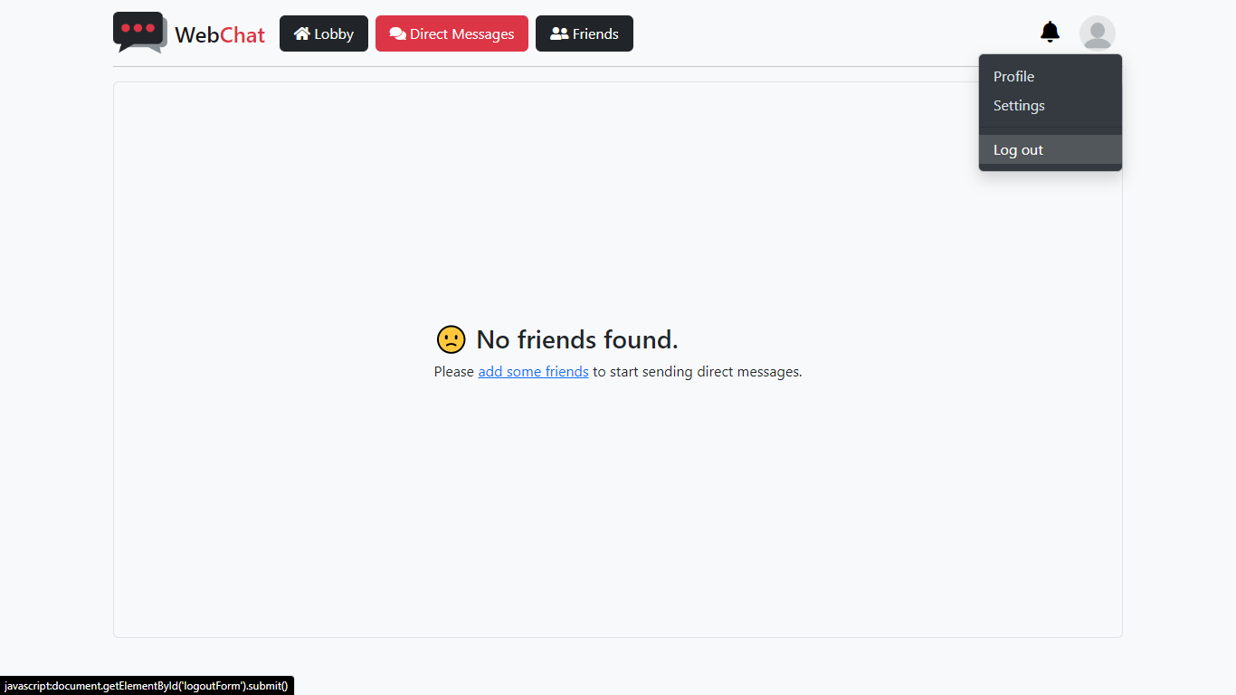

To log out of the site, click on your profile image > and select “Log out.”

### Lobby

If you had opened the website directly, then after signing in, you should be redirected to the Lobby, the home of this web app where all users can chat with each other.



In the Lobby, you can send messages to everyone using the message box at the bottom of the page and click on the send button or simply hit Enter on your keyboard.

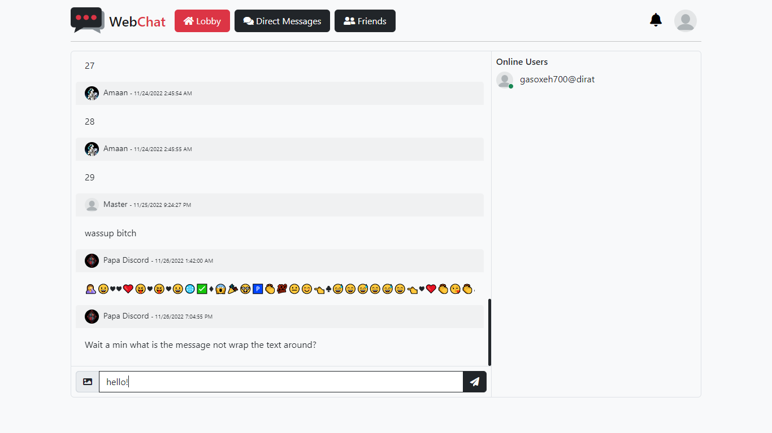

This is how your message will look to you.

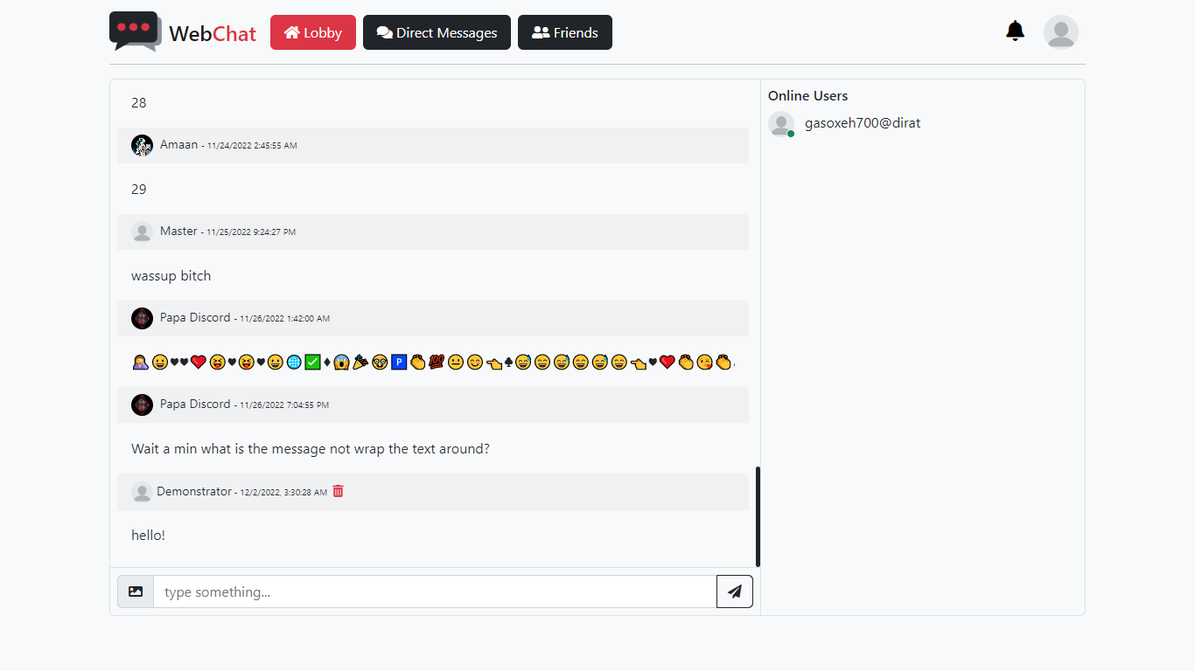

You can also upload images and preview them before sending.

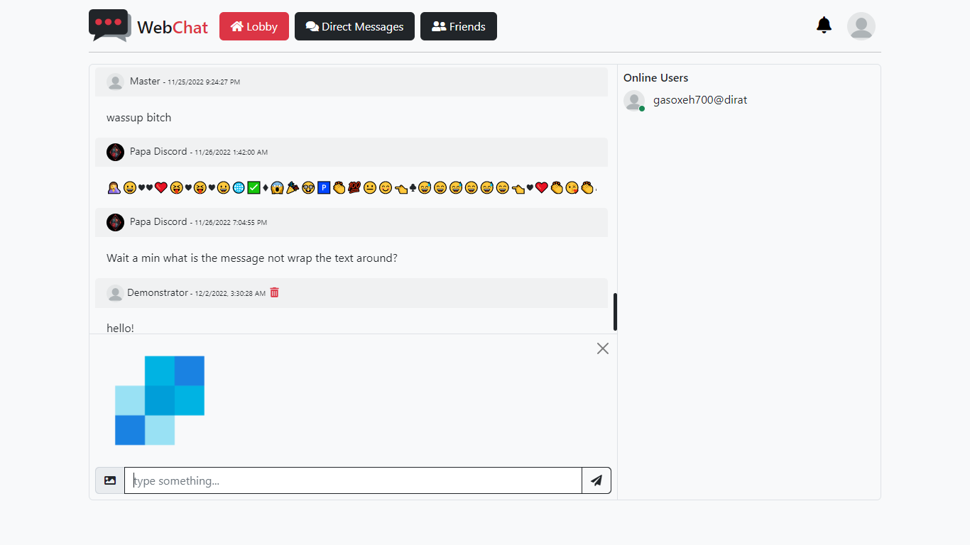

You can choose to send images only or with text messages. There’s also a limit of 40KB when sending images in chat.

In case you want to change the image or remove it, you can remove the selected image from your message by clicking the “X” button on top-right corner in the image preview box.



As of now, you can only post only one image at a time.

You can delete a message by clicking on the trashcan icon next to your name.

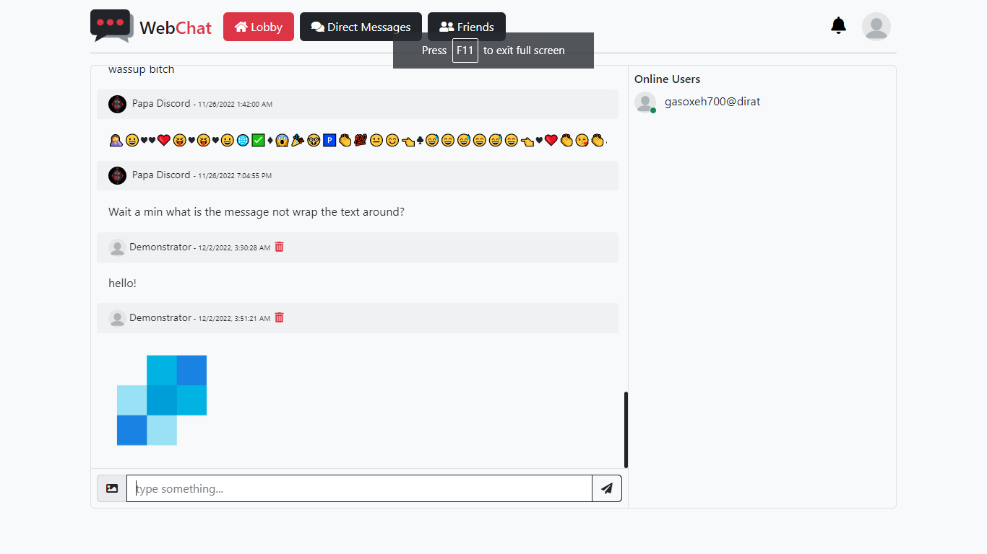

You will be asked to confirm the delete message request.

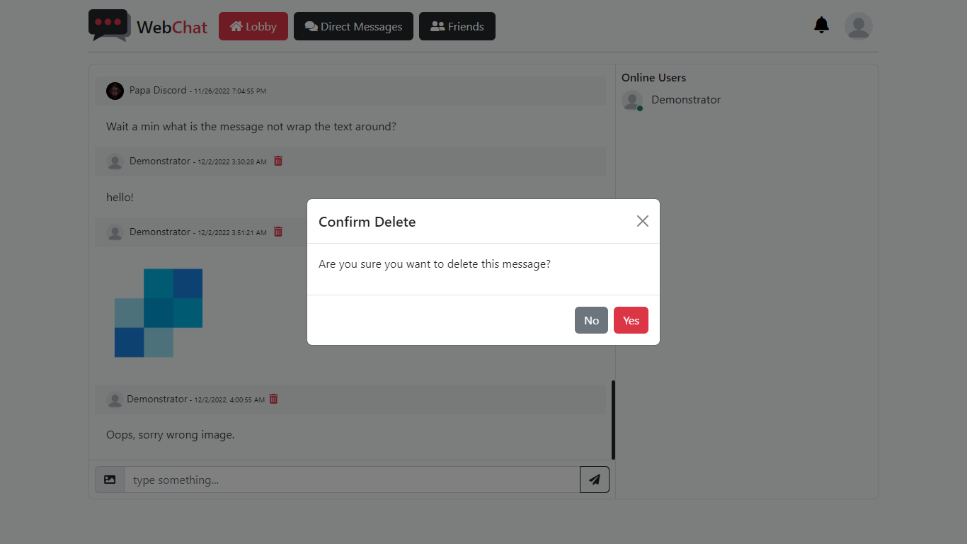

Click “Yes” to delete the selected message or “No” to cancel and go back.

### Friends

You need friends to able to use the Direct Messages feature.

This is how what friends page will look like when you create a new account. No friends.

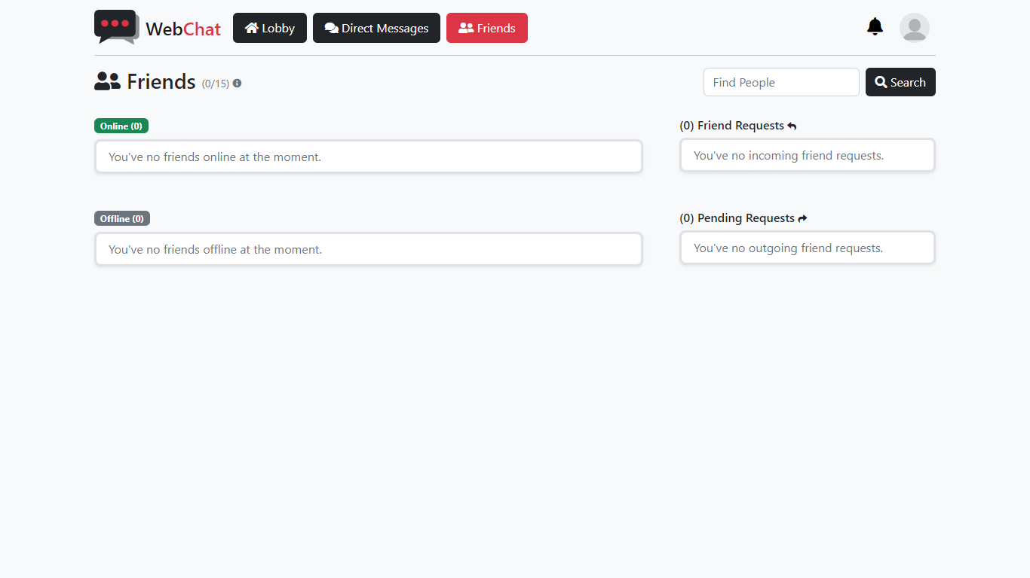

To send a friend request to a user, you need to search for that user. Use the search box to search for a user.



You can search users by their username (DisplayName) or email.

If a user is found with a name or email that matches the search query, a modal will pop up with all users found in our database.

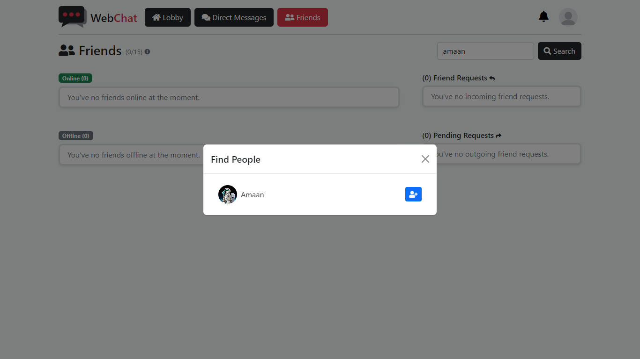

Click on the blue button next to the user you want send friend request to.

Successfully sending a friend request to a user will show you this message.

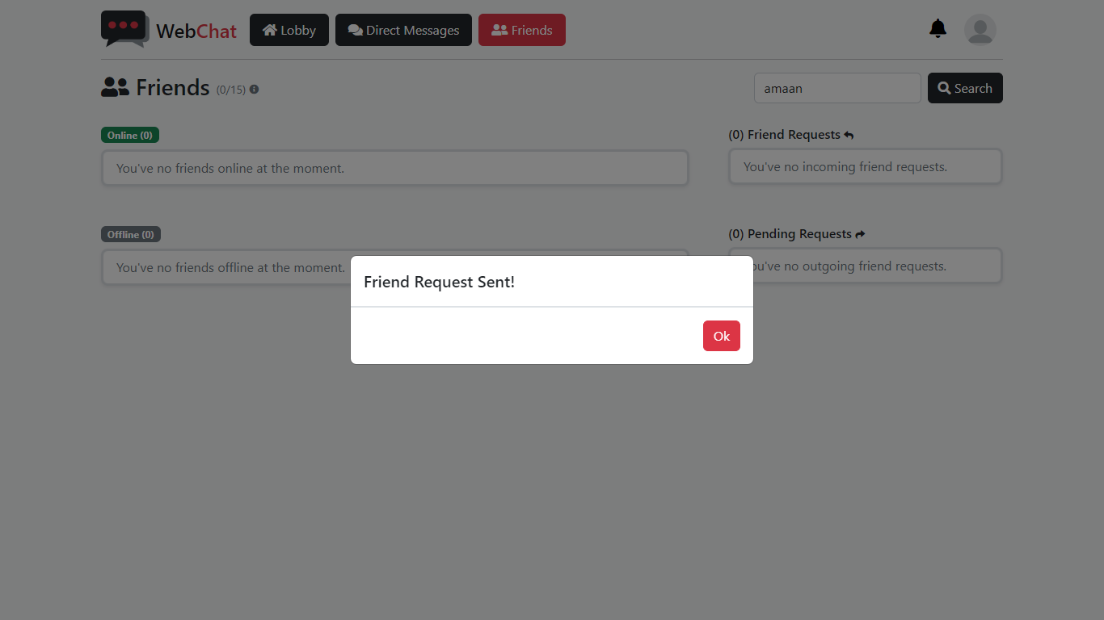

And that user to your pending requests list.

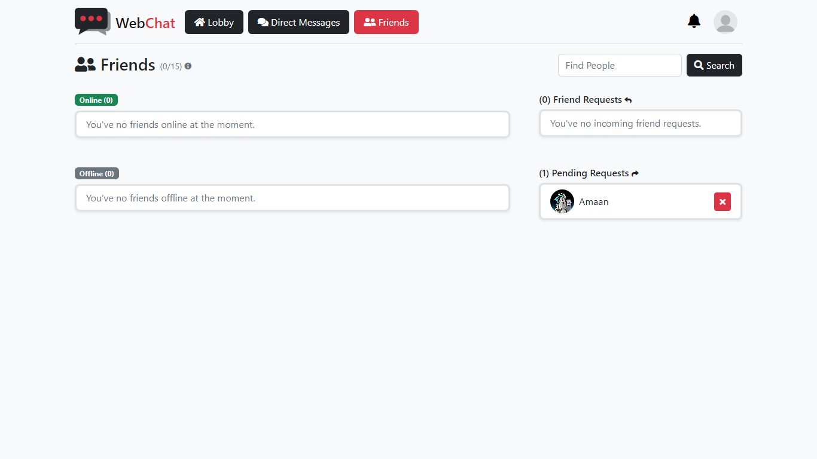

If you want to cancel your friend request, click on the button shown on the image above.

When someone sends you a friend request, it will display under “Friend Requests.”

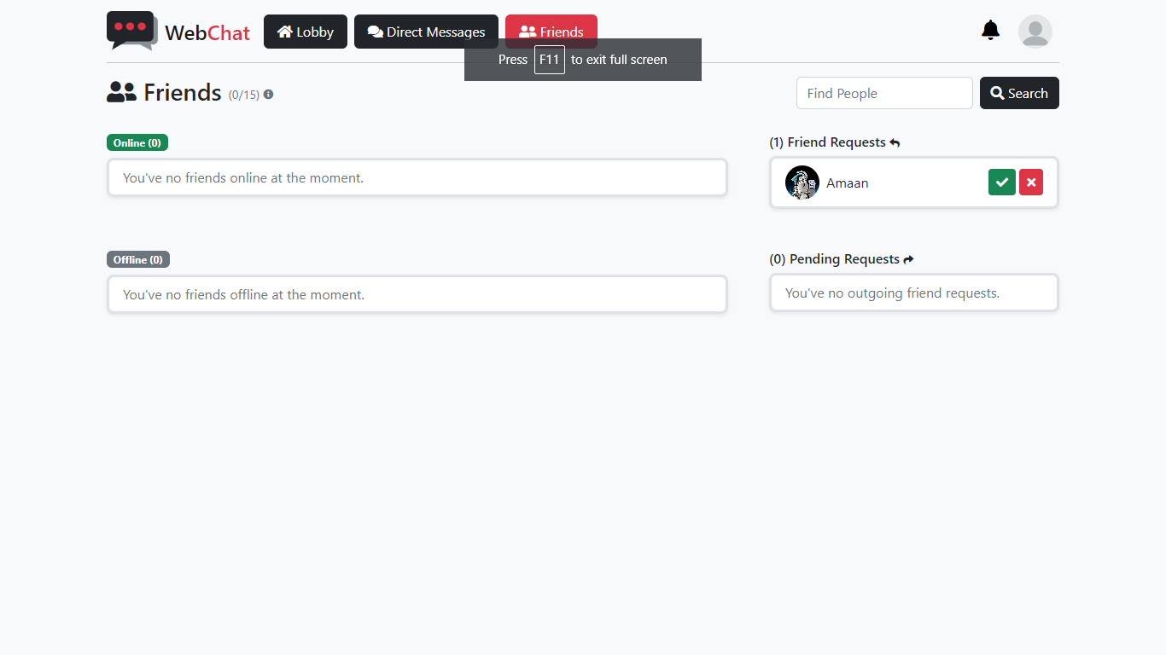

You can either choose to accept their friend by clicking on green-check button or deny with the red-cross button.

Accepting the friend request will add the user to your friends’ list and you will be able to send them direct messages.

### Direct Messages

Direct Messages are used to send private messages to users on your friends’ list that can read by only you and your friend.

If you’re not friends with anyone, this is what your Direct Messages will look like.

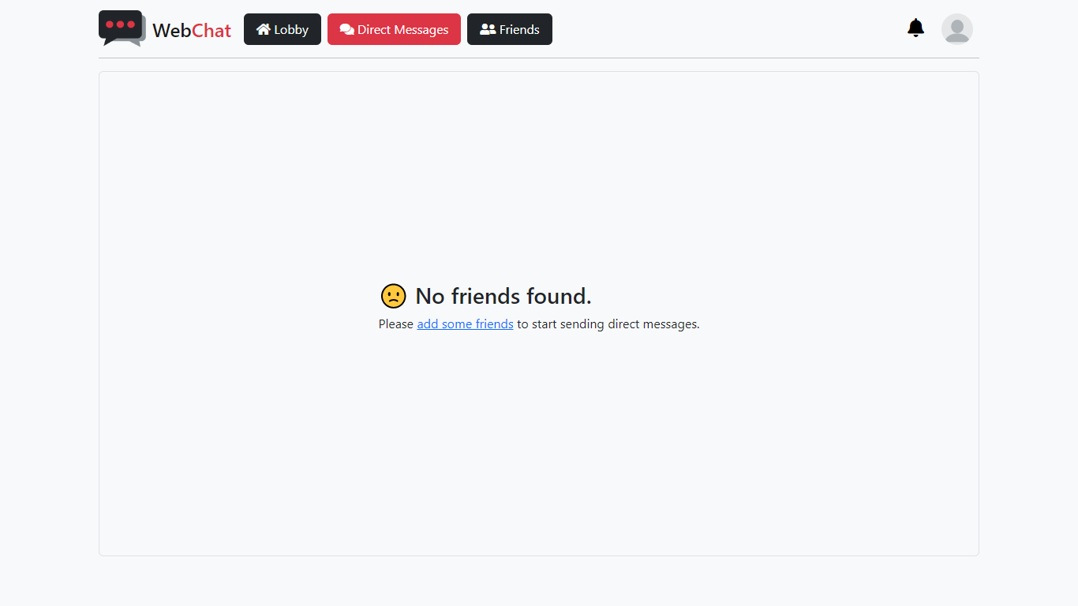

Add someone to your friends’ list to be able to use this feature.

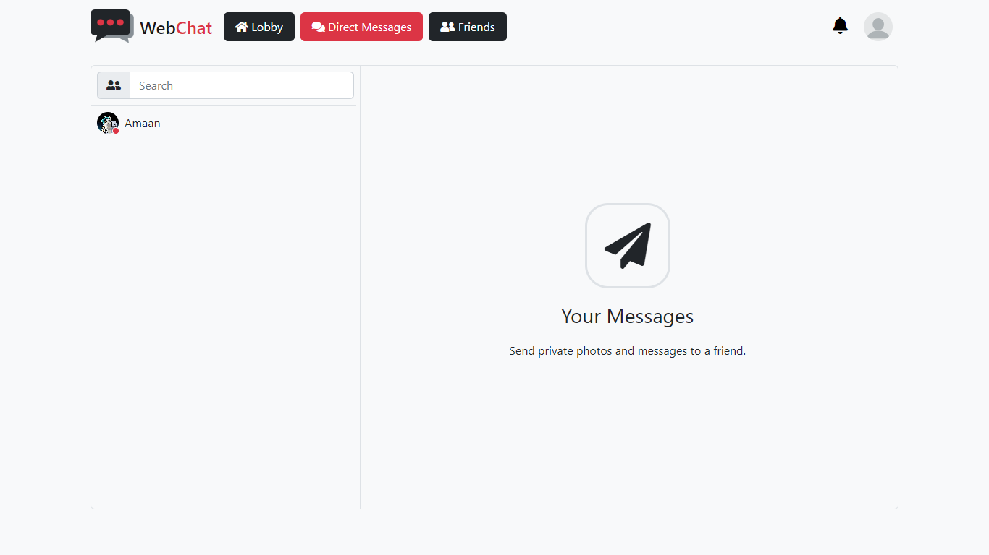

To message a friend, simple click on their name to open the direct messages box.

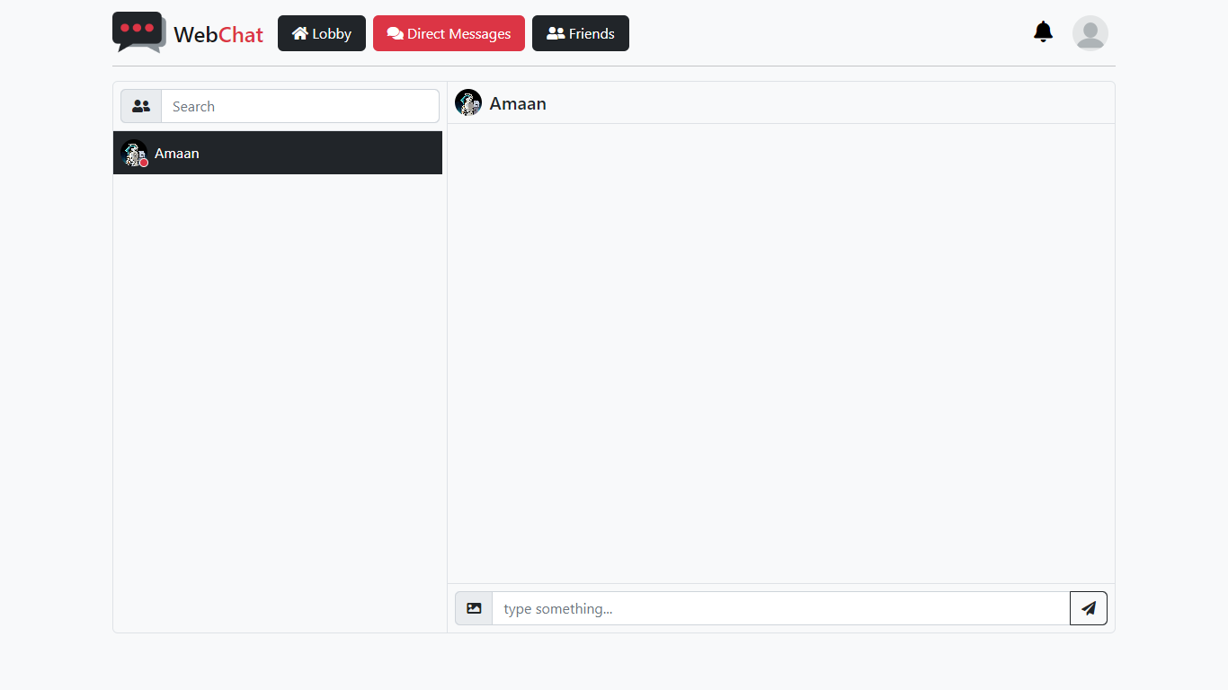

The rest is same as the Lobby.

### Profile

If you want to update your profile picture or set a different username. Account profile settings is your place.

To view and edit your profile, click on your profile icon, on top-right corner of the page on Desktop mode and select “Profile.”

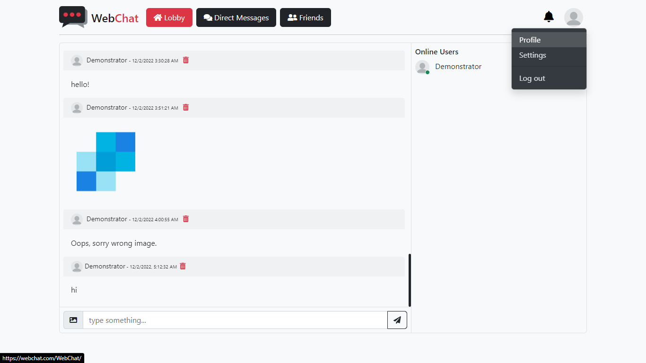

Mobile version is a little different which will be covered in mobile section later.

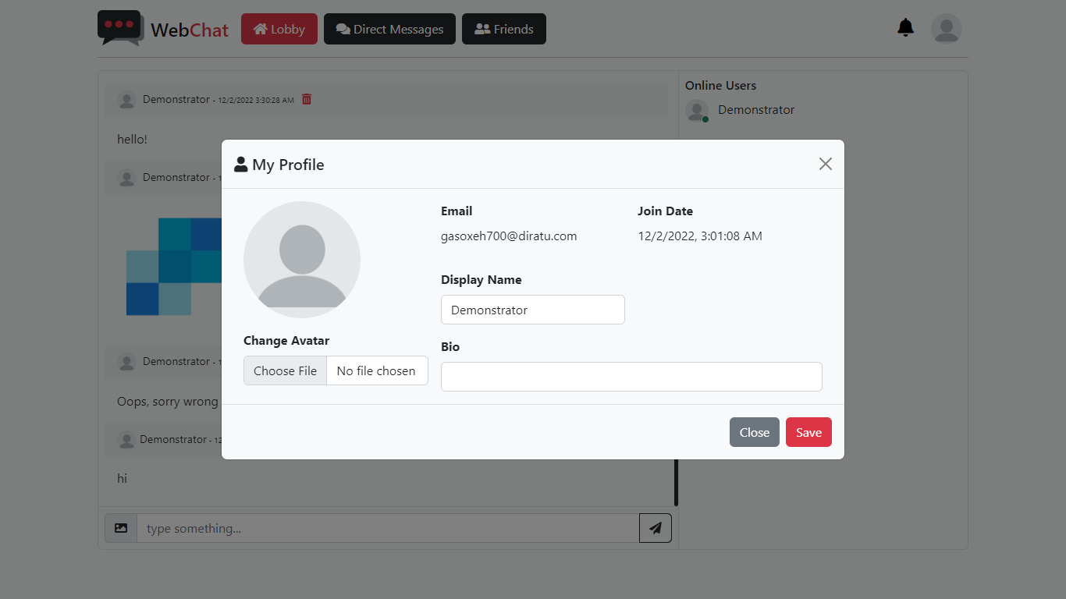

To change your profile picture, click on “Choose file” and upload an image from your device directory.

You can also change your default username which is a part of your email and set a bio if you want.

Click “Save” to update your profile.

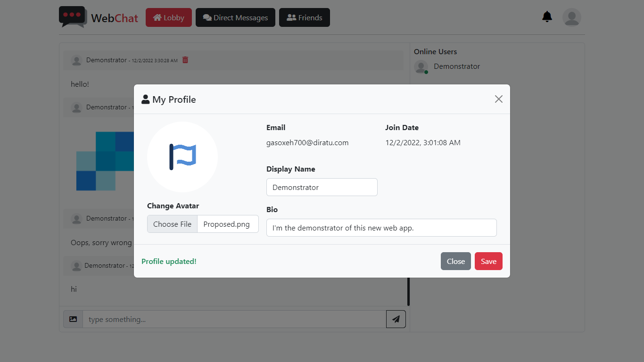

If everything is fine, your profile should update successfully and display a message on the bottom-left of the modal in green for success and red if any error occurs while updating your profile.

### Account Settings

You can change your password, manage linked/external accounts, add a phone number and enable two-factor authentication (2FA) from your account settings.

Click on your profile picture > then on “Settings” to see your account settings.

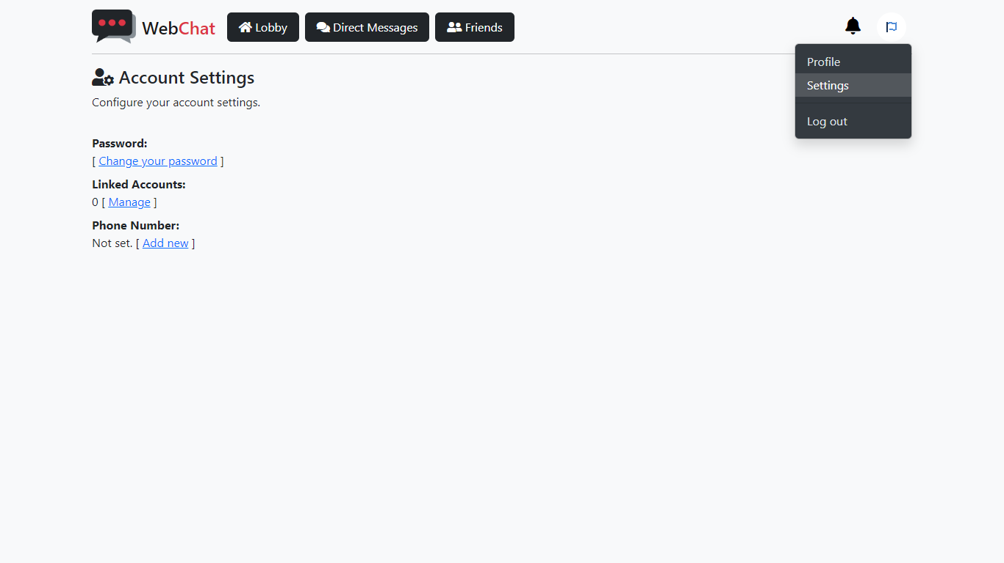

The option to enable 2FA is only available when you add a valid phone number.

To link an external account for quick and easy login, click on “Manage” under “Linked Accounts” on the settings page.

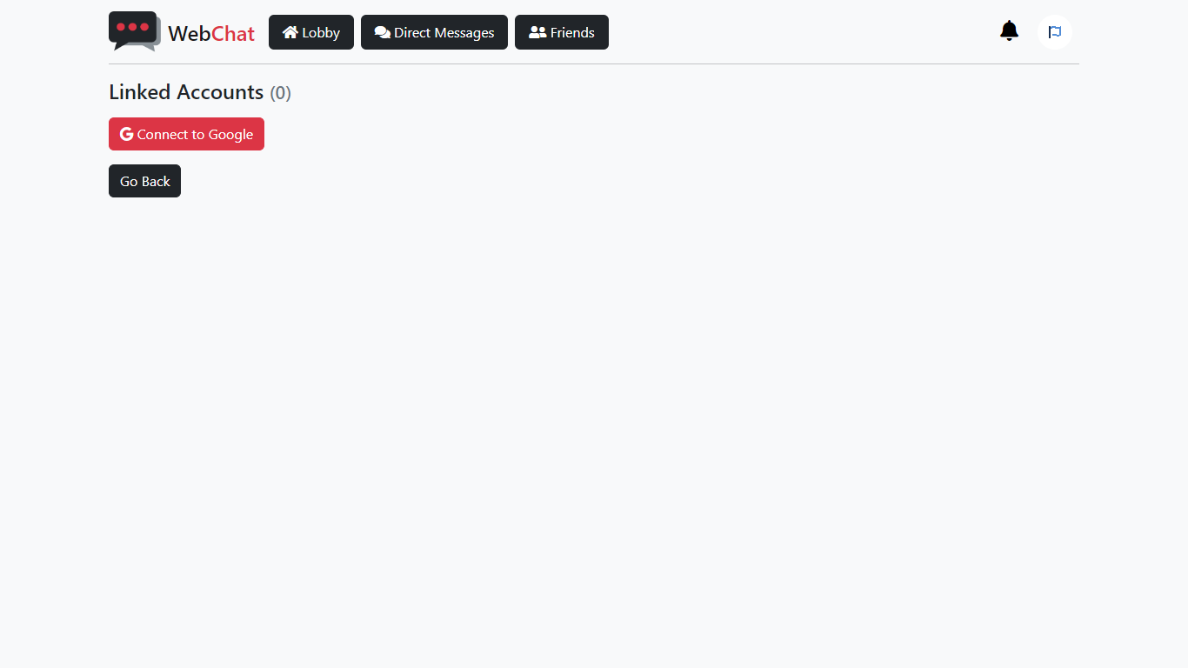

Select the service and go through their authentication process. Once completed, the account will be linked to your WebChat account and you can use that external account to easily login when you come back.

To unlink an external account, simple go back to the linked accounts page from your account settings, and click on unlink.

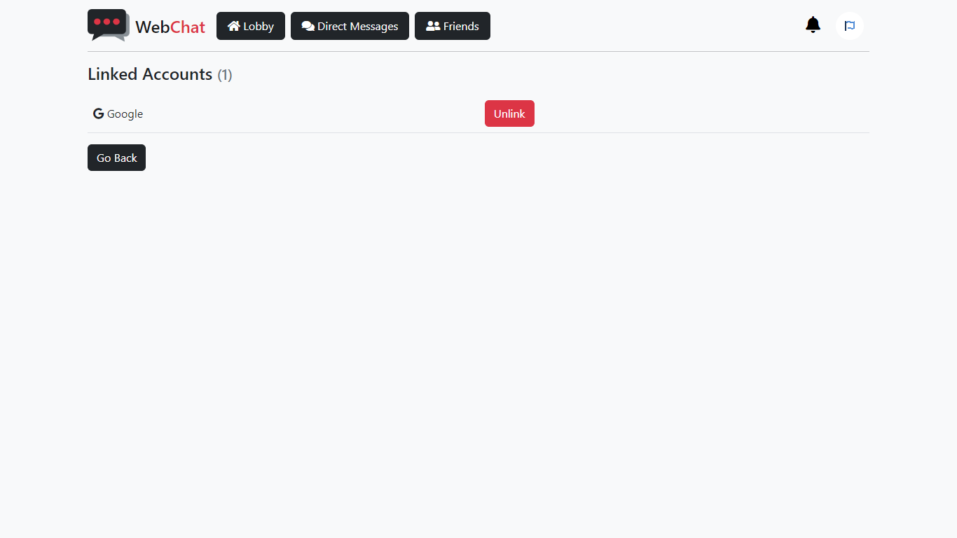

Please note that the option to unlink will be disabled if you used the external account to register with us.

### Mobile

The interface on mobile or small screen devices is a little different from Desktop mode. But all the functions and features remain the same.

This is what you’ll find if you open the site from a mobile.

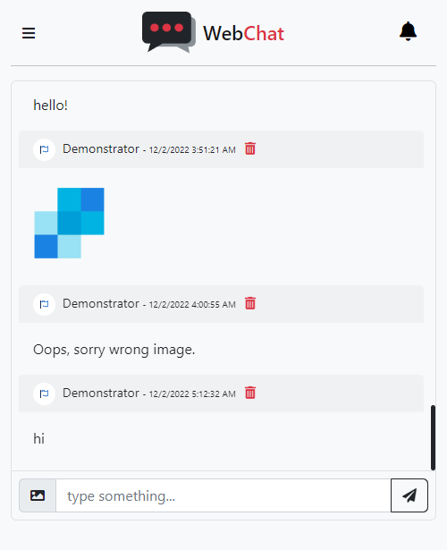

To see the navigation pane, click on the button on top-left corner of the page.



This will open a sidebar on the left of the screen which has same all the options as on desktop mode.

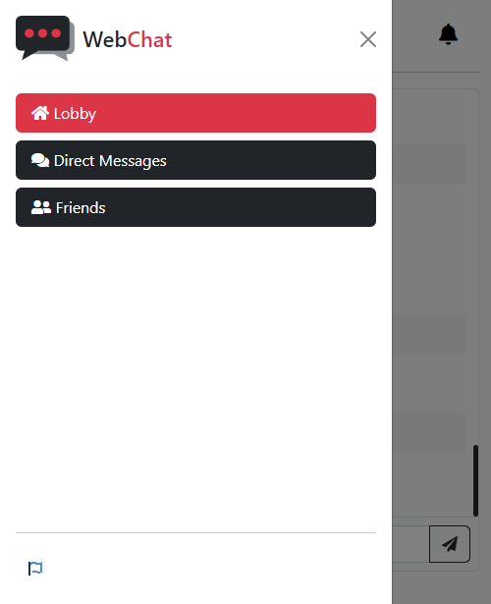

This concludes the demonstration guide for users.

# References

*ASP.NET*. (n.d.). Retrieved from Microsoft: http://asp.net/

Beat, S. (n.d.). *Website Redesign Proposal Template*. Retrieved from Visme: https://www.visme.co/templates/proposals/website-redesign-proposal-1425285156/

*Discord*. (n.d.). Retrieved from Discord: https://discord.com/

Dykstra, T. (2022, June 30). *ASP.NET Web Deployment using Visual Studio: Deploying to Test.* Retrieved from Microsoft: https://learn.microsoft.com/en-us/aspnet/web-forms/overview/deployment/visual-studio-web-deployment/deploying-to-iis

(2023). *Final Report Structure In Computing Project.* NCC Education Limited.

Mikejo5000. (2022, April 29). *Publish an ASP.NET web app.* Retrieved from Microsoft: https://learn.microsoft.com/en-us/visualstudio/deployment/quickstart-deploy-aspnet-web-app

Otto, M. (2022, November 22). *Bootstrap Documentation*. Retrieved from Bootstrap: https://getbootstrap.com/docs/5.2/

Polesny, O. (2021, January 18). *Debounce – How to Delay a Function in JavaScript (JS ES6 Example)*. Retrieved from freeCodeCamp: https://www.freecodecamp.org/news/javascript-debounce-example/

*SQL Server*. (2022). Retrieved from Microsoft: https://www.microsoft.com/sql-server/

*Web Development with ASP.NET MVC and Core.* (2022). Doha: Aptech Limited.

Wick, J. (n.d.). *Web Development Project Proposal Template*. Retrieved from Visme: https://www.visme.co/templates/proposals/web-development-project-proposal-1425280046/