AI-ASSISTED CODING

ASSIGNMENT-10.3

2403A51252

BATCH-11

TASK-1:

Provide AI with the following nested conditional code and ask it to simplify and refactor for readability

PROMPT

# write the following nested conditional code and ask it to simplify and refactor for readability.

Nested code:

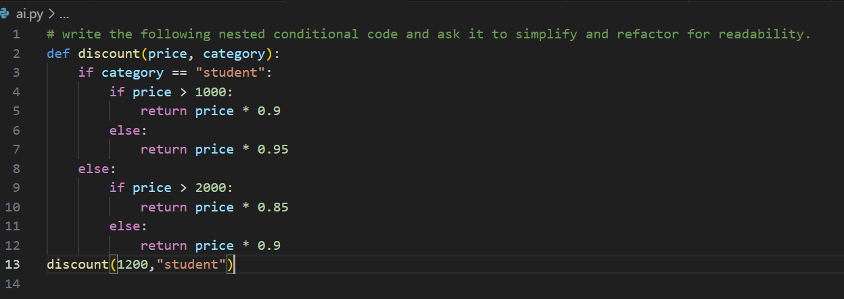

Output code:

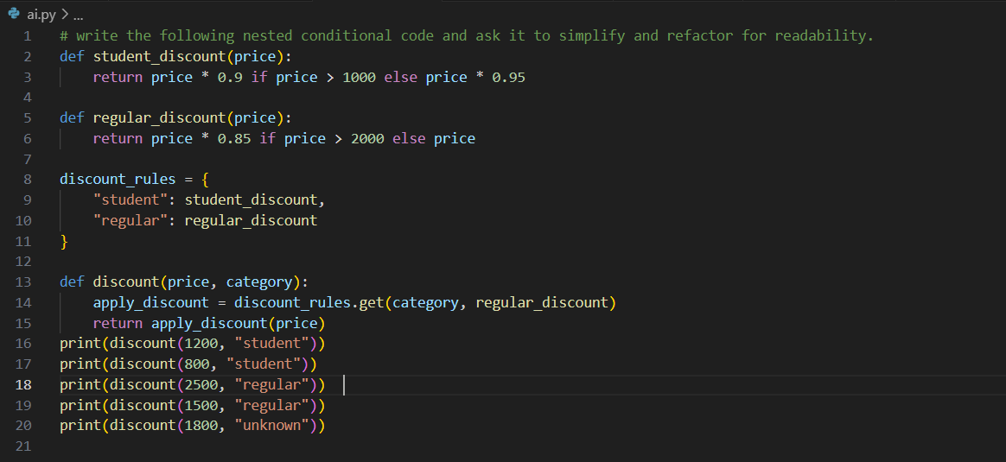

TASK-2 :

Give AI this messy loop and ask it to refactor and optimize.

PROMPT

#write this messy loop and ask it to refactor and optimize.

Messy code:

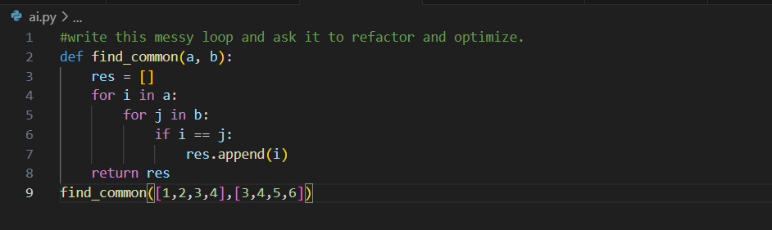

Output code :

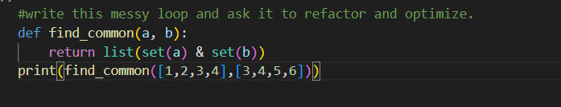

TASK-3:

Provide this class with poor readability and ask AI to improve:

• Naming conventions

• Encapsulation

• Readability & maintainability

PROMPT

#Write this class with poor readability and ask AI to improve

# Naming conventions

# Encapsulation

# Readability & maintainability

Poor readability code:

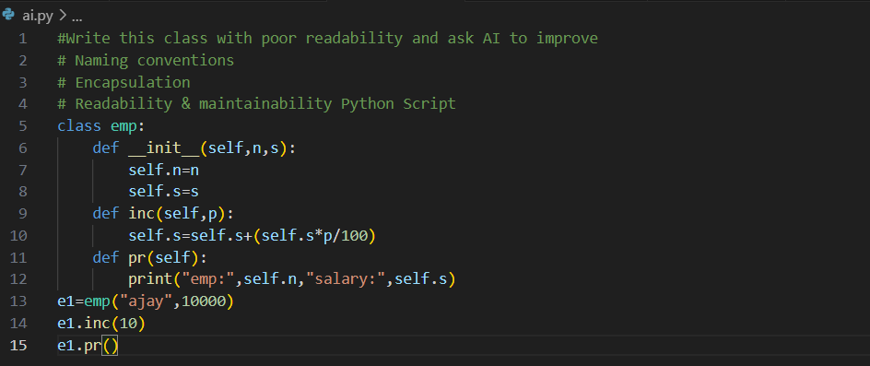

Output code :

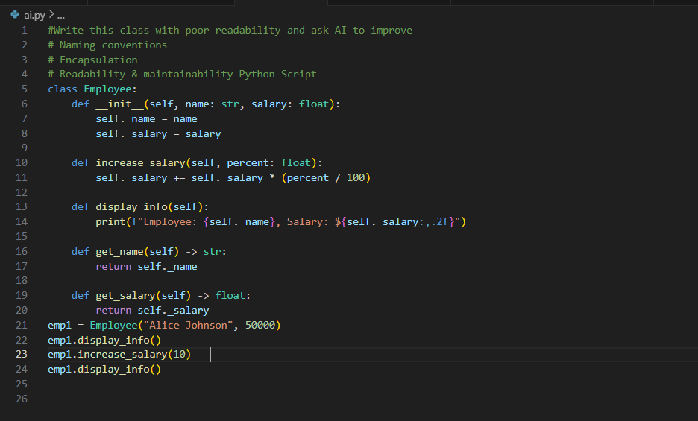

TASK-4 :

Give AI this long unstructured function and let it modularize into smaller helper functions

Prompt

# Write the long unstructured function and let it modularize into smaller helper functions

Unstructured function :

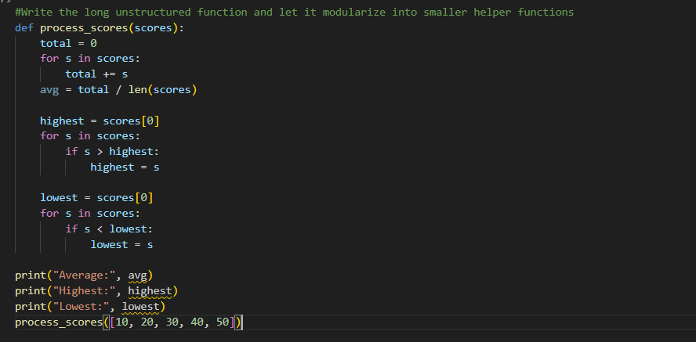

Output code :

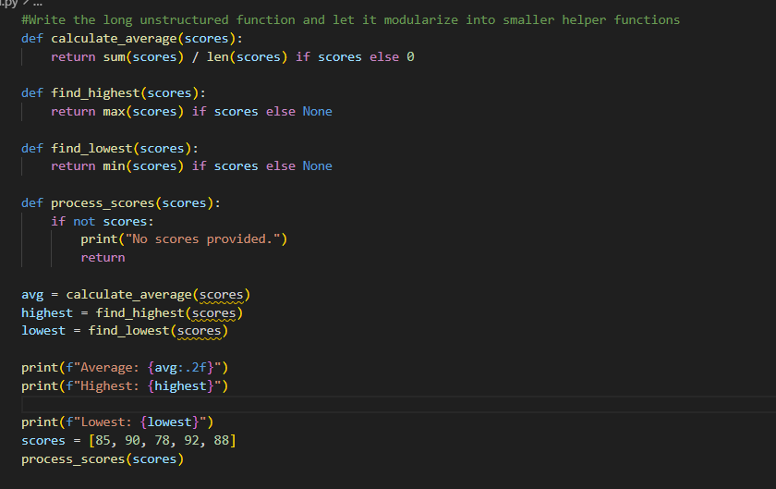

TASK-5 :

Provide AI with this faulty code and ask it to improve error handling, naming, and readability

PROMPT

#Write this faulty code and ask it to improve error handling, naming, and readability

Faulty code :

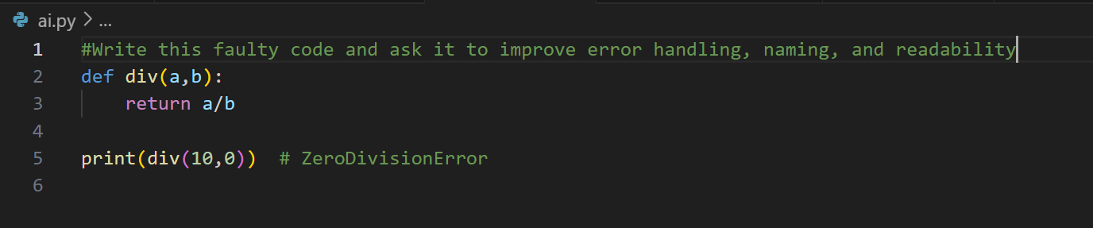

Output code :

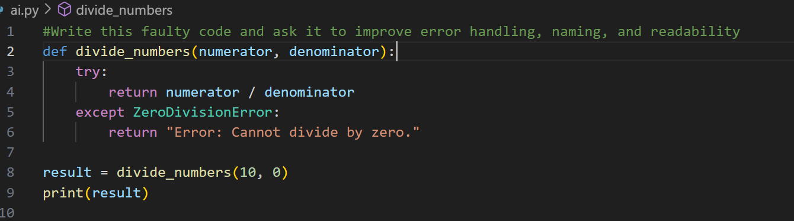

TASK-6:

Use AI to simplify overly complex logic.  
Sample Input Code

PROMPT

# write a python program to simplify overly complex logic.  
Sample Input Code

#Example : grade = 85

Complex logic :

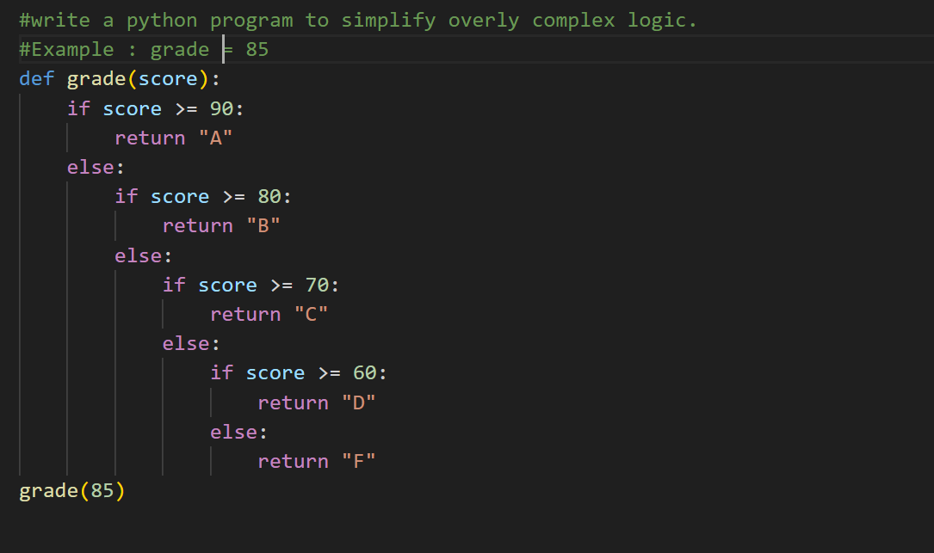

Output code :

