AI ASSISTED CODING

LAB TEST-1

2403A5152

Batch-11

TASK-1

Question –1:

Write a Python code to calculate the sum of odd and even numbers in a given list using GitHub Copilot along with VS Code. Use zero shot prompting..

PROMPT:

--> zero shot prompt

# **Write a Python function to calculate the sum of odd and even numbers in a given list**

**Code:**

**def sum_odd_even(numbers):**

**odd_sum = 0**

**even_sum = 0**

**for num in numbers:**

**if num % 2 == 0:**

**even_sum += num**

**else:**

**odd_sum += num**

**return odd_sum, even_sum**

**numbers = [1, 2, 3, 4, 5, 6]**

**odd_sum, even_sum = sum_odd_even(numbers)**

**print(f"Sum of odd numbers: {odd_sum}")**

**print(f"Sum of even numbers: {even_sum}")**

**Output :**

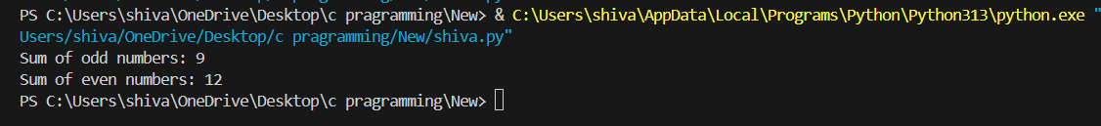

TASK-2

Question –2:

Write a Python code for given a list of integers, remove duplicates and print the sorted result. GitHub Copilot along with VS Code. Use one shot prompting.

PROMPT:

---> one shot prompt

# Write a Python code for a given list of integers, remove duplicates, and print the sorted result.

# Example: input = [5, 3, 1, 3, 2, 5], output = [1, 2, 3, 5]

CODE :

def remove_duplicates_and_sort(input_list):

unique_numbers = set(input_list)

sorted_numbers = sorted(unique_numbers)

return sorted_numbers

input_list = [5, 3, 1, 3, 2, 5]

result = remove_duplicates_and_sort(input_list)

print(result) # Output: [1, 2, 3, 5]

Output :



TASK-3

Question –3:

Write a Python function that converts the temperature between Celsius, Fahrenheit, and Kelvin based on user choice. Use the Cursor AI tool. Use few shot prompting.

PROMPT :

---> few shot prompt

# Write a Python function that converts the temperature between Celsius, Fahrenheit, and Kelvin based on user choice.

# Example 1: convert_temperature(0, "C", "F") → 32.0

# Example 2: convert_temperature(100, "C", "K") → 373.15

# Example 3: convert_temperature(212, "F", "C") → 100.0

# Example 4: convert_temperature(273.15, "K", "C") → 0.0

Code :

def convert_temperature(value: float, from_unit: str, to_unit: str) -> float:

"""Convert temperature between Celsius, Fahrenheit, and Kelvin.

Args:

value: The temperature value to convert.

from_unit: Unit of the input temperature ("C", "F", or "K").

to_unit: Unit of the output temperature ("C", "F", or "K").

Returns:

Converted temperature as a float.

"""

from_unit = from_unit.upper()

to_unit = to_unit.upper()

# Convert from input unit to Celsius first

if from_unit == "C":

celsius = value

elif from_unit == "F":

celsius = (value - 32) * 5 / 9

elif from_unit == "K":

celsius = value - 273.15

else:

raise ValueError(f"Unsupported from_unit: {from_unit}")

# Convert from Celsius to target unit

if to_unit == "C":

return celsius

elif to_unit == "F":

return celsius * 9 / 5 + 32

elif to_unit == "K":

return celsius + 273.15

else:

raise ValueError(f"Unsupported to_unit: {to_unit}")

# Example usage:

print(convert_temperature(0, "C", "F"))

print(convert_temperature(100, "C", "K"))

print(convert_temperature(212, "F", "C"))

print(convert_temperature(273.15, "K", "C"))

Output :

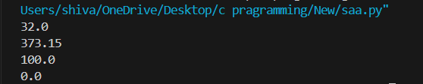

TASK-4

Question -4

Write a Python function to remove punctuation, convert to lowercase, and remove stop words from a given text. Use the Cursor AI tool. Use zero shot prompting.

PROMPT :

----> zero shot prompt

# Write a Python function to remove punctuation, convert to lowercase, and remove stop words from a given text.

Code :

import string

from typing import Iterable, Optional, Set

DEFAULT_STOP_WORDS: Set[str] = {

"a", "an", "the", "and", "or", "but", "if", "while", "with", "to", "from",

"of", "in", "on", "for", "at", "by", "is", "am", "are", "was", "were",

"be", "been", "being", "this", "that", "these", "those", "it", "its", "as",

"i", "you", "he", "she", "we", "they", "them", "him", "her", "my", "your",

"our", "their", "me", "us", "do", "does", "did", "doing", "not", "no",

}

def clean_text(text: str, stop_words: Optional[Iterable[str]] = None) -> str:

"""Lowercase text, remove punctuation, and drop stop words.

Args:

text: Input string to normalize.

stop_words: Optional iterable of stop words. If None, uses DEFAULT_STOP_WORDS.

Returns:

A space-joined string without punctuation and stop words, all lowercase.

"""

if not isinstance(text, str):

raise TypeError("text must be a string")

stop_set: Set[str] = set(DEFAULT_STOP_WORDS if stop_words is None else stop_words)

lowered = text.lower()

# Replace punctuation with spaces to avoid accidental word merges

translation_table = str.maketrans({ch: " " for ch in string.punctuation})

no_punct = lowered.translate(translation_table)

tokens = [tok for tok in no_punct.split() if tok and tok not in stop_set]

return " ".join(tokens)

__all__ = ["clean_text", "DEFAULT_STOP_WORDS"]

if __name__ == "__main__":

sample = "Hello, World! This is a sample sentence; with punctuation... and Stop Words."

print(clean_text(sample))

Output :

Input : sample = "Hello, World! This is a sample sentence; with punctuation... and Stop Words."

