GENERATED BY GITHUB COPILOT..

TASK-1 :

Code:

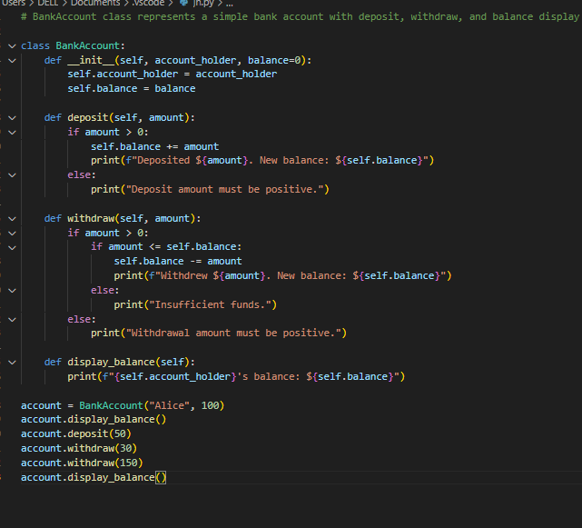

Output:

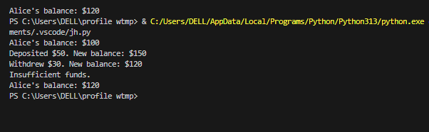

TASK-2:

Code:

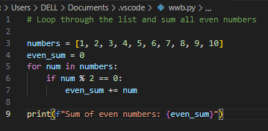

Output:

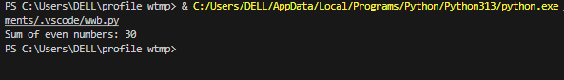

TASK-3

Code:

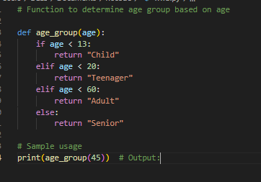

Output:

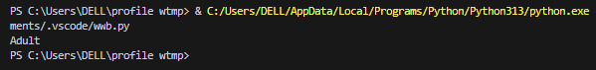

TASK-4:

CODE:

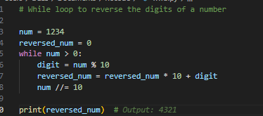

OUTPUT:

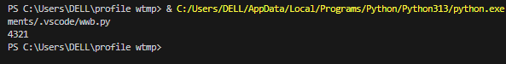

TASK-5:

CODE:

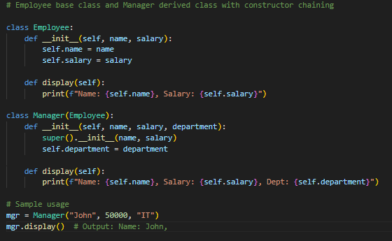

OUTPUT:

