Requirements Specification v1.0
Feature – Create Contributor Profile
Sawaka
Bond52

Table of Contents
1. Purpose of the Requirements Specification
1.1 Purpose
1.2 Distribution List
2. Requirements Specification Approvals
2.1 Version History
2.2 Review
3. Project Definition
4. Constraints, Assumptions & Dependencies
4.1 Constraints
4.2 Assumptions
4.3 Dependencies
5. Terms and Definitions
6. Requirements Specification
6.1 Conceptual Model
6.2 User Interface
6.3 Use Case
6.4 Profile Lifecycle
6.5 Conceptual Data Model
7. Requirements Traceability
7.1 Epic, Feature and User Stories
7.2 Business Requirements
7.3 Functional Requirements
7.4 Implementation Notes
8. References & Policies

1. Purpose of the Requirements Specification

1.1 Purpose
This Requirements Specification defines the business and solution requirements for the “Create Contributor Profile” feature within the Sawaka Contributor Ecosystem.
The purpose of this document is to:
- Formalize how an contributor/contributor establishes a professional identity on Sawaka.
- Provide traceability from the parent Feature and User Stories to Business, Functional, and Non-Functional Requirements.
- Serve as the baseline for development, QA, community validation, and future iterations.
The public-profile prototype is used in this document as a design reference for the information that a contributor profile is expected to support. It shows a contributor identity block with name, trade/domain, location, biography and skill tags, followed by reputation indicators, realizations, collaborations and community reviews.

1.2 Distribution List
Title | Name | Date Distributed
Product / Business Owner
Development / QA
Sawaka Review Group

2. Requirements Specification Approvals

2.1 Version History
Author | Version | Date | Summary of changes
Bond52 | 1.0 | 2026-09-12 | Initial Requirements Specification for Create Contributor Profile

2.2 Review
Name & Title | Review Date | Status / Comments

3. Project Definition
Item | Definition
Parent Feature | #340 — Feature — Create Contributor Profile
Epic | EPIC — Contributor Ecosystem
Problem | Contributors need a simple way to establish a visible identity, describe what they do, and be discoverable for future collaboration without exposing unnecessary private information.
Desired Outcome | A contributor can create a clear bilingual-ready profile containing identity, domain, skills, location and a short biography, which becomes the foundation for public profile, directory, projects, realizations, reputation and gamification.
Primary Actor | Contributor (contributor, maker, or individual entrepreneur)
Prototype Reference | Public contributor profile prototype supplied for this RD.

4. Constraints, Assumptions & Dependencies

4.1 Constraints
Constraint ID | Constraint
CO-01 | Must comply with Sawaka privacy and data-minimization principles.
CO-02 | Must use the existing Sawaka user authentication/account mechanism; contributor profile creation must not introduce a separate authentication model.
CO-03 | User-facing profile creation and validation messages must support French and English and must not be hard-coded.
CO-04 | The profile creation flow must remain simple and suitable for mobile use.
CO-05 | Skills selection must remain lightweight: select a domain and choose from simple skill tags; ESCO complexity must not be exposed to the contributor.
CO-06 | Private account/security data must not be exposed on the public profile.

4.2 Assumptions
Assumption ID | Assumption
AS-01 | The contributor has a Sawaka user account and is authenticated before creating a contributor profile.
AS-02 | A user can have at most one active contributor profile in the initial release.
AS-03 | The simplified Sawaka domain and skills taxonomy is available for profile creation.
AS-04 | A contributor may add custom skill tags when an appropriate predefined skill is unavailable.
AS-05 | Reputation, realizations, collaborations/projects, community reviews and gamification are separate capabilities that reference the contributor profile after creation.

4.3 Dependencies
Dependency ID | Dependency
DE-01 | Simplified Contributor Domain & Skills Taxonomy is validated sufficiently for implementation.
DE-02 | Contributor public profile / View Contributor Profile feature consumes profile information created here.
DE-03 | Edit and Deactivate Contributor Profile features manage the profile after creation.
DE-04 | Future Directory, Realizations, Project Participation, Ratings/Reviews and Gamification features depend on the contributor profile identifier.

5. Terms and Definitions
Term | Definition
Contributor | A Sawaka participant who presents skills and may collaborate in projects. This includes artisans, makers and individual entrepreneurs.
Domain | A broad activity area selected by the contributor, for example Construction, Jewelry, Agriculture, or Creative/Design.
Skill Tag | A short, user-friendly label describing something the contributor can do.
Custom Skill | A contributor-entered skill tag used when the predefined taxonomy does not contain an appropriate skill.
Public Profile | The profile information that other Sawaka users or visitors are allowed to view.
Biography | A short contributor-written description of their activity, experience, approach or value proposition.
Profile Status | Lifecycle state used to determine whether the contributor profile is available/active.
Realization | A piece of work or outcome used to showcase contributor know-how; managed by a separate feature.
Collaboration | Participation with other contributors through a Sawaka project; managed by the project-participation feature.

6. Requirements Specification

6.1 Conceptual Model
The contributor profile is the identity anchor for the Contributor Ecosystem. The contributor selects one primary domain and one or more skill tags. Profile information is then reused by discovery and other ecosystem capabilities. Supplier categories remain an independent taxonomy; contributors and suppliers interact through Projects rather than through a direct taxonomy mapping.
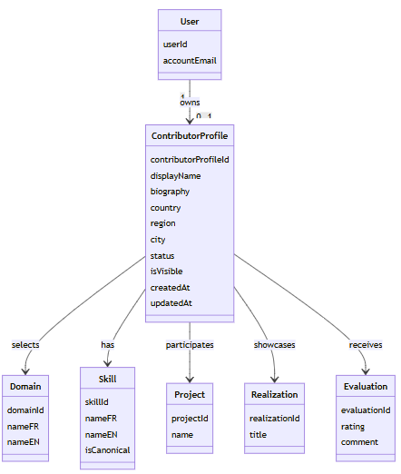

classDiagram
class User {
userId
accountEmail
}
class ContributorProfile {
contributorProfileId
displayName
biography
country
region
city
status
isVisible
createdAt
updatedAt
}
class Domain {
domainId
nameFR
nameEN
}
class Skill {
skillId
nameFR
nameEN
isCanonical
}
class Project {
projectId
name
}
class Realization {
realizationId
title
}
class Evaluation {
evaluationId
rating
comment
}

User "1" --> "0..1" ContributorProfile : owns
ContributorProfile --> Domain : selects
ContributorProfile --> Skill : has
ContributorProfile --> Project : participates
ContributorProfile --> Realization : showcases
ContributorProfile --> Evaluation : receives

6.2 User Interface
The supplied prototype represents the target public profile presentation. The creation form does not need to reproduce the public-profile layout, but it must capture the profile data needed to support the identity block visible in the prototype.
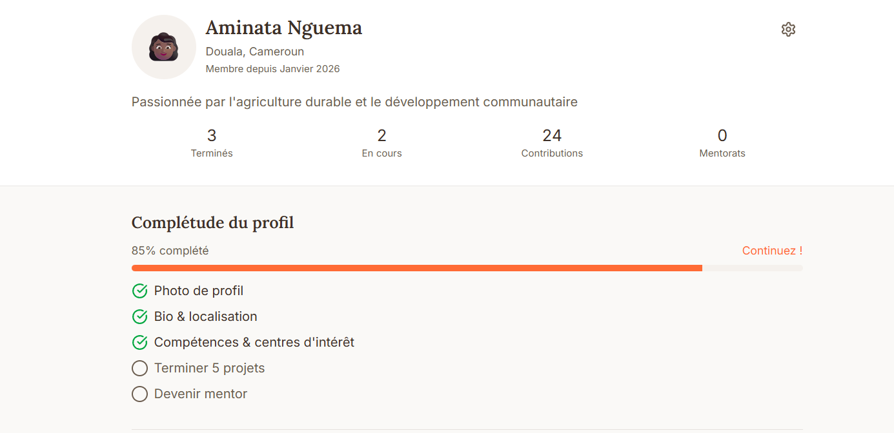
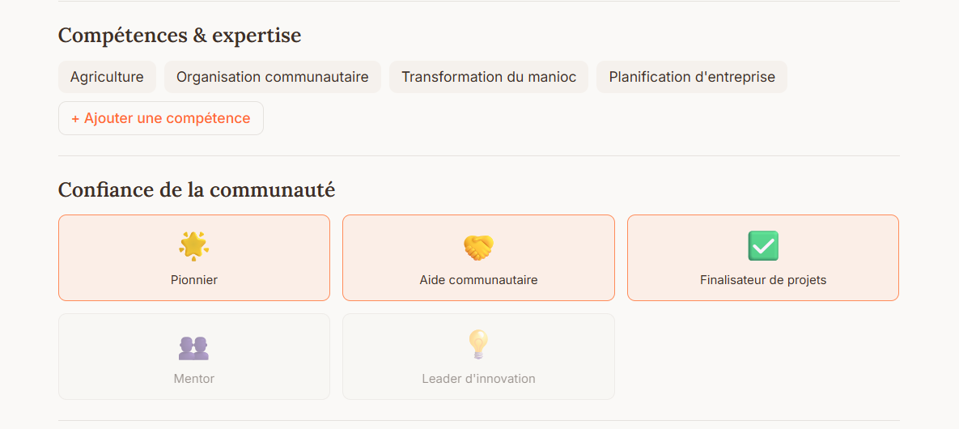
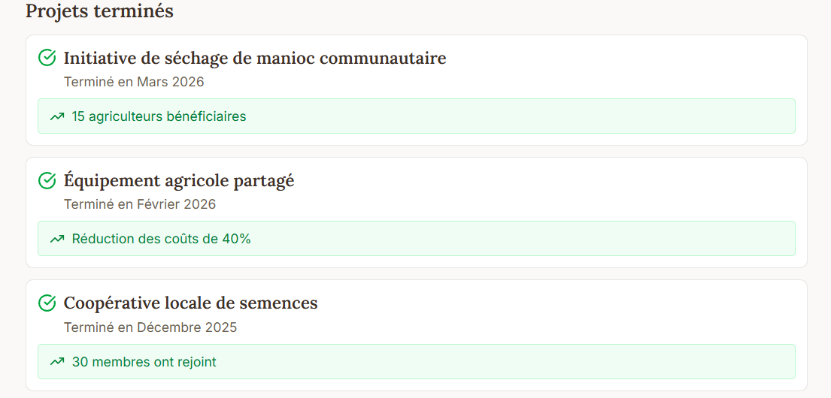
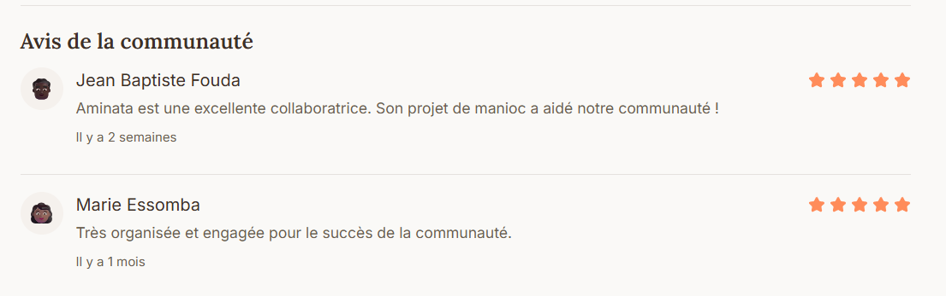
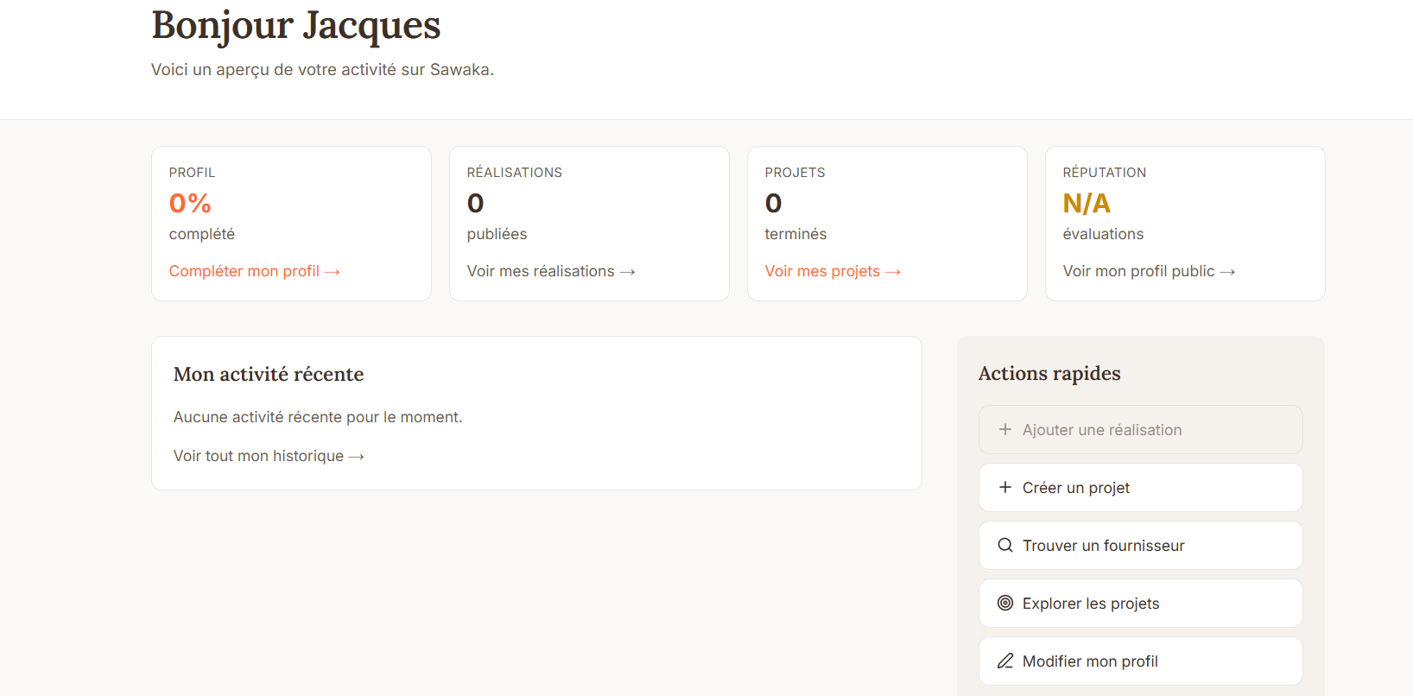
Section | Component | Type | Required | Behavior | Validation Rules | Public / Private
Identity | Display Name | Textbox | Yes | Pre-filled from account where available; contributor may provide the public profile name permitted by business rules. | Trim whitespace; 2–80 characters. | Public
Identity | Profile Photo / Avatar | Image | No (V1) | Allows a contributor image/avatar where supported. | Supported image types/size per platform standards. | Public
Professional Identity | Domain | Single-select | Yes | Contributor selects the primary activity domain from Sawaka taxonomy. | Must select one active domain. | Public
Professional Identity | Skills | Multi-select tags | Yes | Contributor checks/unchecks simple skill tags associated with the selected domain. | At least 1 skill; maximum 20 selected skills recommended for V1. | Public
Professional Identity | Custom Skill | Tag input | No | Contributor can add a missing skill as a custom tag. | Max 30 characters; trim whitespace; prevent exact duplicates; proposed max 5 custom tags/profile. | Public
Location | Country | Dropdown | Yes | Contributor selects country. | Must be selected. | Public at configured granularity
Location | Region | Dropdown/Text | No | Enabled/available according to selected country. | Valid value where controlled list exists. | Public at configured granularity
Location | City | Dropdown/Text | Recommended | Contributor identifies the city/locality used for discovery and profile display. | Trim whitespace; valid supported value where list exists. | Public
About | Biography | Textarea | Recommended | Contributor describes activity, know-how, approach or value proposition. | Trim whitespace; reasonable platform length limit; no executable markup. | Public
Contact | Account Email | Read-only / account data | System | Used for account/authentication and profile ownership. | Valid account email. | Private
System | Profile Status | System-managed | System | Initialized according to profile lifecycle rules. | Valid supported status only. | Private/System
System | Visibility | System-managed | System | Determines whether the profile can be displayed publicly. | Must align with profile status and minimum publication requirements. | System

6.3 Use Case
Use Case Attribute | Definition
Use Case Title | Create Contributor Profile
Use Case Description | Enables an authenticated Sawaka user to create a contributor profile by providing the minimum professional identity, domain, skills, location and descriptive information required to participate in the Contributor Ecosystem.
Primary Actor | Contributor
Organizational Benefits | Improves contributor visibility; creates a structured identity for discovery and collaboration; supports project matching, realizations, reputation and future community features; creates consistent domain/skill data without exposing ESCO complexity.
Frequency of Use | Low per contributor; normally executed once, with later changes handled by Edit Contributor Profile.
Trigger | Authenticated user chooses to create/activate their contributor profile.
Pre-conditions | User is authenticated; user does not already have an active contributor profile; required domain/skill taxonomy is available.
Post-conditions | Contributor profile is stored; linked to the authenticated user; profile receives its initial status/visibility; confirmation is displayed; profile data becomes available to authorized downstream features.

Main Scenario
- User selects the action to create a contributor profile.
- System displays the Create Contributor Profile form in the active language (FR/EN).
- User enters their email address and the required account/profile information.
- Contributor enters their public display name.
- Contributor selects a primary domain.
- System displays the skill tags available for the selected domain.
- Contributor selects the skills that describe what they can do.
- Contributor optionally adds missing custom skill tags.
- Contributor provides location information and a short biography/description.
- Contributor reviews the information and submits the profile.
- System validates the account and profile information.
- System creates the user account and stores the contributor profile associated with that account.
- System sends an email verification link.
- System sets the contributor profile to Pending Email Verification and keeps it not publicly visible.
- System displays a confirmation indicating that email verification is required before the profile can be activated.
- If the contributor returns to Sawaka before completing email verification, the system displays:
Email verification pending
Verify your email address to activate your contributor profile.
Resend verification email
- Contributor can select Resend verification email to request a new verification email.
- System sends a new verification email while keeping the profile in Pending Email Verification status.
- Contributor verifies their email address using the verification link.
- System validates the verification link and marks the email address as verified.
- If all other publication criteria are met, the system changes the contributor profile to Active and makes it eligible for public visibility.
- System confirms successful activation and the contributor can access their profile/dashboard.

Alternative Scenarios
Alternative 1 — Missing predefined skill
- Contributor cannot find an appropriate skill in the selected domain.
- Contributor enters a custom skill tag.
- System validates the custom tag and stores it distinctly from the canonical taxonomy.
- The custom tag is displayed on the contributor profile subject to normal visibility rules.

Exception Scenarios
Exception 1 — Required information missing
- System blocks submission.
- Missing/invalid fields are identified accessibly.
- System displays a localized validation message and preserves valid user-entered information.
Exception 2 — Contributor profile already exists
- System prevents creation of a duplicate active contributor profile for the same user.
- System directs the contributor to the existing profile or Edit Profile capability.
Exception 3 — Invalid or duplicate custom skill
- System rejects an invalid, over-length or exact duplicate custom skill.
- System explains the correction required without exposing internal implementation details.

6.4 Profile Lifecycle
The exact status names should reuse the existing Sawaka profile conventions where possible. For requirements purposes, the lifecycle below expresses business behavior rather than mandating new database enum names.
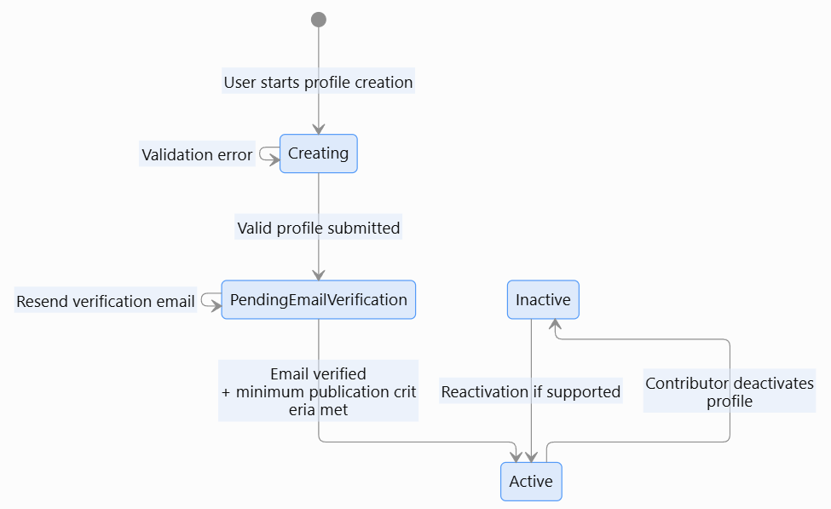
stateDiagram-v2
[*] --> Creating : User starts profile creation
Creating --> Creating : Validation error
Creating --> PendingEmailVerification : Valid profile submitted
PendingEmailVerification --> PendingEmailVerification : Resend verification email
PendingEmailVerification --> Active : Email verified<br/>+ minimum publication criteria met
Active --> Inactive : Contributor deactivates profile
Inactive --> Active : Reactivation if supported
Initial visibility rule: once the minimum profile requirements are satisfied and creation succeeds, the profile may be Active and publicly visible. If Sawaka later introduces a separate review/draft workflow, that change must be explicitly specified rather than inferred from this RD.

6.5 Class Diagram

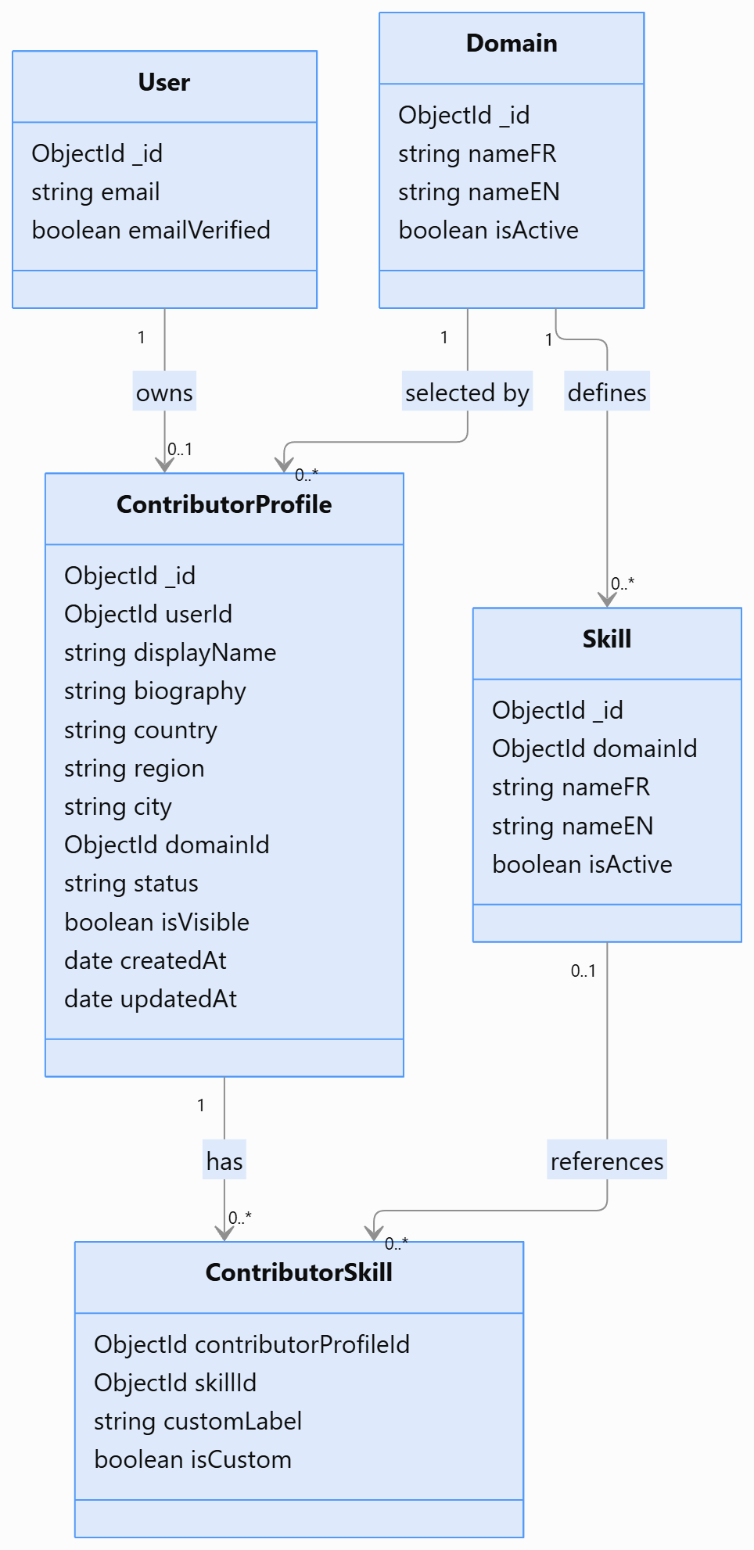
classDiagram
class User {
ObjectId _id
string email
boolean emailVerified
}

class ContributorProfile {
ObjectId _id
ObjectId userId
string displayName
string biography
string country
string region
string city
ObjectId domainId
string status
boolean isVisible
date createdAt
date updatedAt
}

class Domain {
ObjectId _id
string nameFR
string nameEN
boolean isActive
}

class Skill {
ObjectId _id
ObjectId domainId
string nameFR
string nameEN
boolean isActive
}

class ContributorSkill {
ObjectId contributorProfileId
ObjectId skillId
string customLabel
boolean isCustom
}

User "1" --> "0..1" ContributorProfile : owns
Domain "1" --> "0..*" ContributorProfile : selected by
Domain "1" --> "0..*" Skill : defines
ContributorProfile "1" --> "0..*" ContributorSkill : has
Skill "0..1" --> "0..*" ContributorSkill : references

7. Requirements Traceability

7.1 Epic, Feature and User Stories
Type / ID | Description | Priority
EPIC — Contributor Ecosystem | Enable contributors to showcase skills, services and availability and support discovery/collaboration. | High
#340 — Feature | Create Contributor Profile | High
US — Create Contributor Profile | As a contributor, I want to create a profile describing who I am and what I can do so that I can participate and be discovered within Sawaka. | High

Note: the exact GitHub User Story issue ID was not provided in the source material. It should be added to this traceability table once created/confirmed.

7.2 Business Requirements
Ref ID | Category | Description
BR-CAP-01 | Contributor Identity | Sawaka must enable contributors to establish a structured professional identity within the Contributor Ecosystem.
BR-CAP-02 | Simplicity | Profile creation must be understandable and quick for contributors without requiring knowledge of complex occupational taxonomies.
BR-CAP-03 | Privacy & Trust | Sawaka must minimize public exposure of private account information and clearly separate public profile data from private/system data.

7.3 Functional Requirements
Ref ID | Category | Description
FR-CAP-01 | Create Contributor Profile | The system must allow an authenticated user without an existing active contributor profile to create a contributor profile.
FR-CAP-02 | Capture Display Name | The system must capture or confirm the contributor display name used on the public profile.
FR-CAP-03 | Select Domain | The system must require the contributor to select one primary active domain.
FR-CAP-04 | Select Skills | The system must allow the contributor to select simple skill tags relevant to the selected domain.
FR-CAP-05 | Custom Skills | The system must allow a contributor to add a missing custom skill subject to configured validation limits.
FR-CAP-06 | Capture Location | The system must capture the minimum location information required for the contributor profile and future discovery.
FR-CAP-07 | Capture Biography | The system must allow the contributor to provide a short public biography/description.
FR-CAP-08 | Validate Profile | The system must validate required fields, formats, limits, duplicates and supported taxonomy values before creation.
FR-CAP-09 | Preventing Duplicate Profile | The system must prevent creation of more than one active contributor profile for the same user in the initial release.
FR-CAP-10 | Bilingual UI | The profile creation interface, labels, validation messages and controlled taxonomy labels must support French and English.
FR-CAP-11 | Preserve Data on Validation Error | The system should preserve valid entered information when submission is blocked by validation errors.
FR-CAP-12 | Provide Creation Confirmation | The system must confirm successful contributor profile creation and provide a path to the resulting profile or dashboard.
FR-CAP-13 | Expose Profile to Downstream Capabilities | The contributor profile identifier created must be available to authorized features such as View/Edit Profile, Directory, Projects, Realizations, Ratings and Gamification.

7.4 Implementation Notes
- These notes are guidelines, not a mandate to introduce new architecture.
- Current Sawaka stack should be reused: Next.js frontend, Express backend and MongoDB persistence where applicable.
- Development must inspect existing user/profile models, authentication, routes, services, validators, i18n and tests before implementation.
- Canonical skills and contributor-entered custom skills should remain distinguishable for future taxonomy maintenance.

8. References & Policies
Ref ID | Title | Location / Link
REF-01 | Feature — Create Contributor Profile #340 | https://github.com/Bond52/sawaka/issues/340
REF-02 | Sawaka Public Contributor Profile Prototype | Screenshots supplied with this Requirements Specification task
REF-03 | Sawaka Simplified Contributor Domain & Skills Taxonomy | Spike output / community-validation workbook

