Bond52

Requirements Specification v1.0
Feature – Add Supplier
Sawaka

Table of Contents
1. Purpose of the Requirements Specification 3
1.1 Purpose 3
1.2 Distribution List 3
2. Requirements Specification Approvals 3
2.1 Version History 3
2.2 Review 4
3. Project Definition 5
4. Constraints, Assumptions & Dependencies 5
4.1 Constraints 5
4.2 Assumptions 5
4.3 Dependencies 5
5. Terms and Definitions 5
Terms and Definitions Table 5
6. Requirements Specification 6
6.1 Conceptual Model 6
6.2 User Interface 8
6.3 Use Cases 11
6.4 Sequence Diagram 15
6.5 State Diagram 17
6.6 Class Diagram 18
6.7 Data Model 21
7. Requirements Specification 23
7.1 Epics and User Stories 23
7.2 Business Requirements 23
7.3 Functional Requirements 23
7.4 Non-Functional Requirements 24
7.5 Implementation Notes 25
8. References & Policies 26
Reference Table 26
Information Policies 26

Purpose of the Requirements Specification

Purpose
This Requirements Specification defines the business and solution requirements for the “Add Supplier (Community Contribution)” feature within the Sawaka platform.
The purpose of this document is to:
• Formalize the current problem related to fragmented and informal supplier discovery within artisan ecosystems
• Define the expected future state where community members can contribute structured supplier information
• Establish clear scope boundaries for the feature
• Ensure alignment between business intent, user stories, and implementation
• Provide traceability from Business Requirements to Functional Requirements
• Serve as a baseline reference for development, validation, and future iterations
This document ensures that the feature is implemented in a way that supports broader objective of strengthening community-based economic infrastructure and shared resource intelligence.

Distribution List

Title | Name | Date Distributed

Requirements Specification Approvals

Version History

Author | Version | Date | Summary of changes
Bond52 | 1.0 | 2026-02-24 | Creation

Review

Name & Title | Review Date

Project Definition

Constraints, Assumptions & Dependencies

Constraints

Constraint ID | Constraint
CO01 | Must comply with data protection policies
CO02 | Must use existing authentication system

Assumptions

Assumption ID | Assumption

Dependencies

Dependency ID | Dependency
DE-01 | Supplier Directory module exists
DE-02 | User authentication system implemented
DE-03 | Admin role management system available

Terms and Definitions

Terms and Definitions Table

Term | Definition
Activity | A specific task or operation within a trade.
Artisan | An individual who practices one or more trades.
Resource Type | A standardized type of consumable material. Defined materials used in activities (e.g., wood, cement).
Sector | A high-level economic or industry domain grouping multiple trades.
Supplier | An entity that provides tools and/or resources. Supports artisans by enabling access to required materials and equipment.
Tool Type | A standardized category of tools used in activities. Ensures consistency in tool classification (e.g., hammer, saw).
Trade | A profession or specialized skill area. Organizes related activities and competencies.

Requirements Specification

Conceptual Model

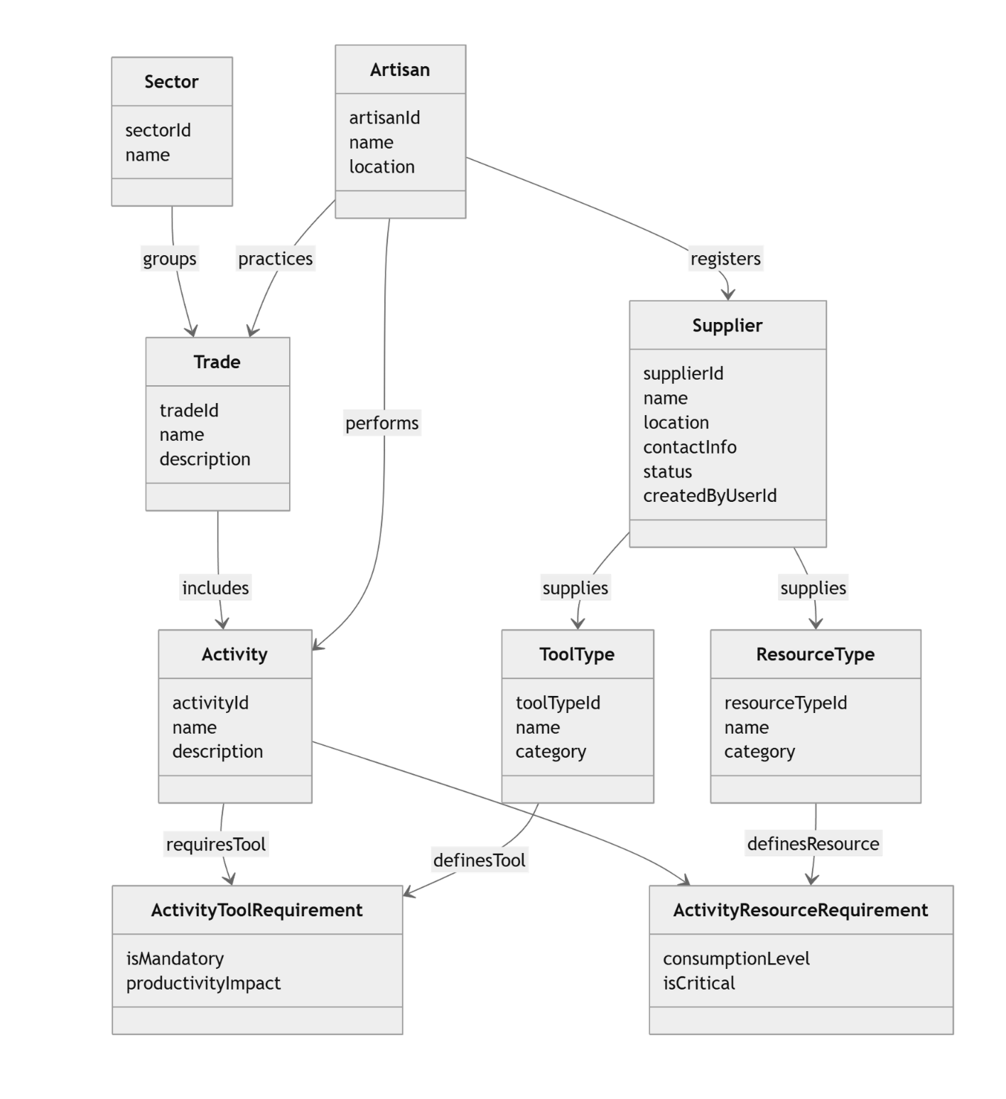

Mermaid code:

classDiagram

%% ========================
%% ENTITIES (CONCEPTUAL)
%% ========================

class Sector {
sectorId
name
}

class Artisan {
artisanId
name
location
}

class Trade {
tradeId
name
description
}

class Activity {
activityId
name
description
}

class Supplier {
supplierId
name
location
contactInfo
status
createdByUserId
}

class ToolType {
toolTypeId
name
category
}

class ResourceType {
resourceTypeId
name
category
}

class ActivityToolRequirement {
isMandatory
productivityImpact
}

class ActivityResourceRequirement {
consumptionLevel
isCritical
}

%% ========================
%% RELATIONSHIPS
%% ========================

Sector --> Trade : groups
Artisan --> Trade : practices

Trade --> Activity : includes
Artisan --> Activity : performs

Artisan --> Supplier : registers

Supplier --> ToolType : supplies
Supplier --> ResourceType : supplies

Activity --> ActivityToolRequirement : requiresTool
ToolType --> ActivityToolRequirement : definesTool

Activity --> ActivityResourceRequirement : requiresResource
ResourceType --> ActivityResourceRequirement : definesResource

User Interface

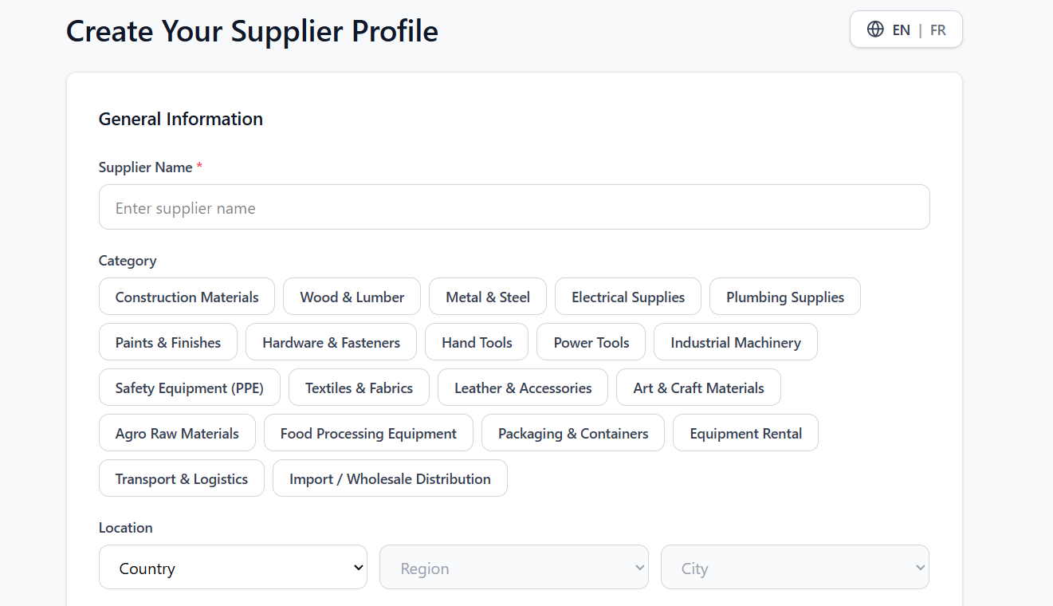

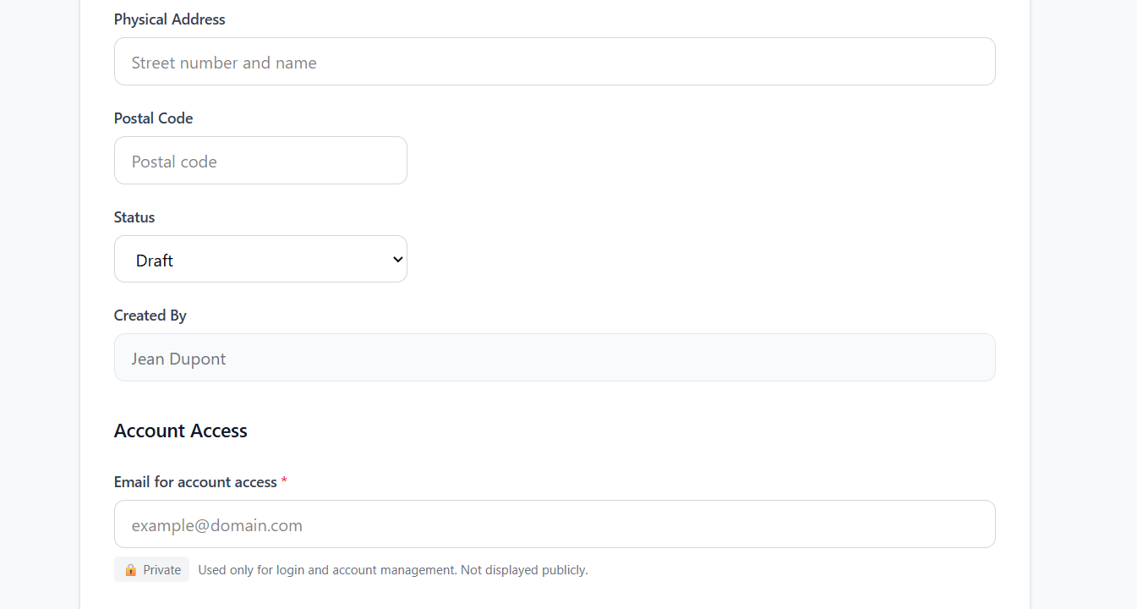

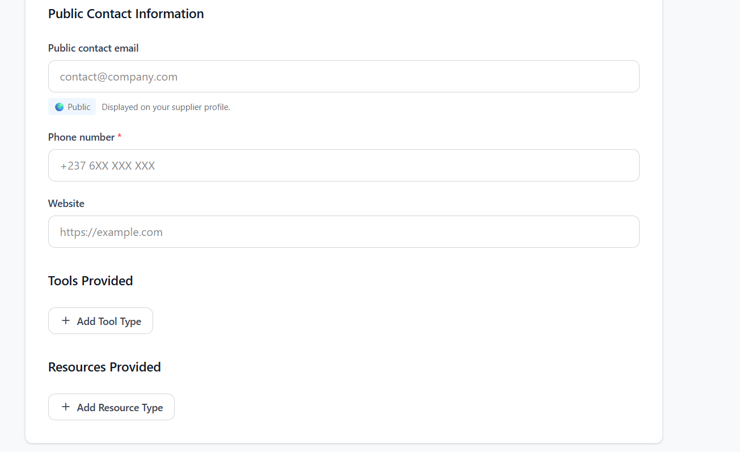

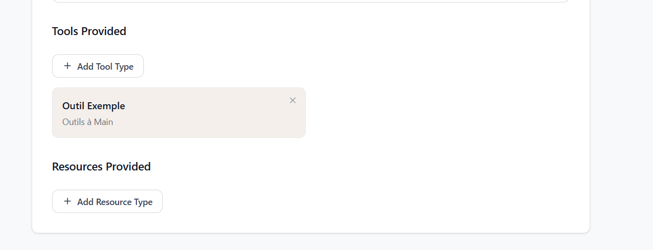

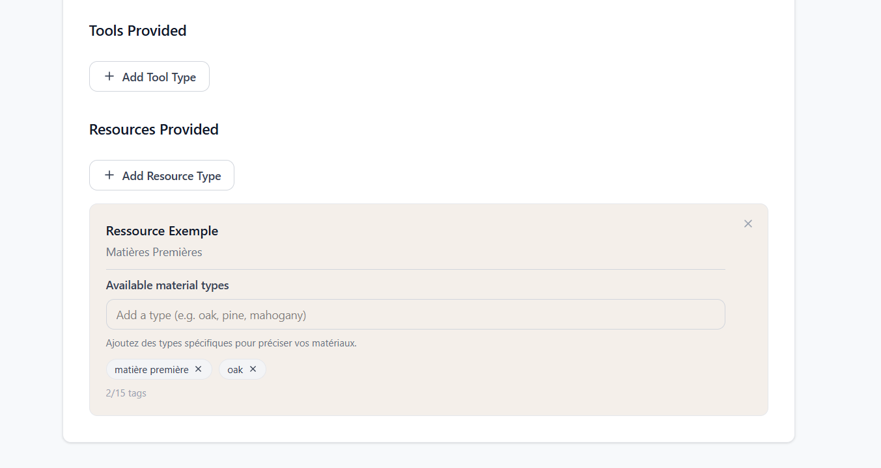

Section | Component | Type | Required | Behavior | Validation Rules | Notes
General Info | Supplier Name | Textbox | Yes | User inputs supplier name, auto-trim, autofocus | Min 2 chars, not empty | Duplicate detection (future)
General Info | Category | Multi-select Chips | Recommended | Toggle selection, multiple allowed | At least 1 recommended | Used for matching & suggestions
General Info | Country | Dropdown | Yes | Enables Region dropdown | Must be selected | Dependent field
General Info | Region | Dropdown | Optional | Enabled after country selection | None | Dependent field
General Info | City | Dropdown | Optional | Enabled after region selection | None | Dependent field
Address | Street Address | Textbox | No | Free text input | None
Address | Postal Code | Textbox | No | User inputs postal code | Country-specific pattern
Status | Status | Dropdown | Yes | Default = Draft, can switch to Published | Published requires full validation
System | Created By | Read-only | Auto | Auto-filled from logged user | None | Not editable
Account Access | Account Email | Textbox | Yes | Used for login / magic link | Valid email format | Private
Public Contact | Public Email | Textbox | No | Displayed on supplier profile | Valid email format | Public
Public Contact | Phone Number | Textbox | Yes | Input with mask formatting | Valid phone format | Public
Public Contact | Website | Textbox | No | User inputs URL | Valid URL format
Tools | Add Tool Button | Button | No | Opens selector to add tool type | No duplicates
Tools | Tool Item | Tag/Card | No | Displays selected tool, removable | No duplicates
Resources | Add Resource Button | Button | No | Opens selector to add resource type
Resources | Resource Card | Card | No | Displays resource type with tags
Resources | Material Tags Input | Tag Input | No | Enter to create tag, max 15 | No duplicates, min 2 chars | Used for precision

Use Cases

Use Case Title: | Add Supplier Entry
Use Case Description: | This use case enables a supplier (invited or pre-registered by a contributor/artisan) to complete and manage their own supplier profile using a secure magic link, ensuring higher data accuracy, ownership, and up-to-date supplier information in the Supplier Directory.
Actors: | Primary Actor:  - Supplier (Contributor Supplier)  Admin moderation is out of scope for V1
Organizational Benefits: | - Strengthens community-based resource intelligence  - Reduces supplier information asymmetry  - Improves artisan project feasibility  - Supports Business Requirement - Community-Based Resource Infrastructure  - Strengthens Supplier Intelligence Layer (Sawaka core)  - Supports scalable onboarding (no account creation friction)
Frequency of Use: | Moderate  Executed whenever a supplier completes or updates their profile
Triggers: | User clicks the “Add Supplier” button in the Supplier Directory.
Pre-conditions: | - Supplier Directory module must be accessible
Post-conditions: | - Supplier entry is stored in the system  - Entry is assigned a status = Invited → Active  - Confirmation message is displayed  - If moderation enabled → entry not publicly visible until approved
Main Scenario: | Step 1: User accesses a platform entry point where suppliers are displayed or managed (e.g., Marketplace, search results, or contribution interface).  Step 2: User clicks “Add Supplier”.  Step 3: System displays the Supplier Submission Form.  Step 4: User enters required information.  Step 5: User enters optional information.  Step 6: User clicks “Submit”.  Step 7: System validates required fields.  Step 8: System stores the supplier entry with status = Invited.  Step 9: System sends a magic link to the Account Email.  Step 10: System displays the message:  "Supplier profile created, but it is not yet accessible. Please check your email and click the confirmation link to complete your profile."  Step 11: Supplier receives the email containing the magic link.  Step 12: Supplier clicks the magic link.  Step 13: System validates the magic link:  • Checks token validity  • Checks expiration time  Step 14: If the link is valid:  • System authenticates the supplier (passwordless access)  Step 15: System marks the supplier email as verified.  Step 16: System updates the supplier profile:  • Assigns supplier ownership (ownerId)  • Updates status = Active (or Verified depending on workflow)  Step 17: System displays confirmation message:  "Your email has been confirmed. The supplier profile is now accessible."  Step 18: System redirects the supplier to the marketplace page.  Step 19: System updates the UI state:  • Supplier is now visible in the marketplace  • Status badge = Active / Verified
Alternative Scenarios: | Alternative 1: Supplier does not complete confirmation within validity period  Condition: Supplier does not complete profile confirmation within the magic link validity period.  Step 11: Supplier receives the email containing the magic link.  Step 12: Supplier clicks the magic link after the expiration period.  Step 13: System validates the magic link:  • Checks token validity  • Checks expiration time  Step 14: System detects that:  • The token is expired  • The associated supplier profile no longer exists (deleted or archived)  Step 15: System blocks access to the Supplier Profile interface.  Step 16: System displays message:  "This link has expired and the supplier profile is no longer available."  Step 17: System provides a direct recovery action:  • Button: "Create Supplier Profile"  Step 18: Supplier clicks "Create Supplier Profile".  Step 19: System redirects supplier to the Supplier Submission Form.  Step 20: Supplier restarts the process from Step 4 of the main scenario.
Exception Scenarios: | Exception 1: Required Fields Missing  Condition: One or more required fields are empty.  Step 7: System detects missing required fields.  Step 8: System blocks submission.  Step 9: System highlights missing fields.  Step 10: System displays validation error message:  "Please fill in all required fields before submitting."  Exception 2: Invalid Field Format  Condition: One or more fields have an invalid format (e.g., email, phone number).  Step 7: System validates field formats.  Step 8: System detects invalid field format.  Step 9: System blocks submission.  Step 10: System highlights invalid fields.  Step 11: System displays validation error message:  "Please enter valid information in the highlighted fields."  Exception 3: System Storage Failure  Condition: Database or server error occurs during supplier creation.  Step 8: System attempts to store the supplier entry.  Step 9: System fails to store the supplier entry.  Step 10: System logs the error.  Step 11: System displays error message:  "An error occurred while saving the supplier profile. Please try again."  Step 12: Supplier entry is not created.

Sequence Diagram

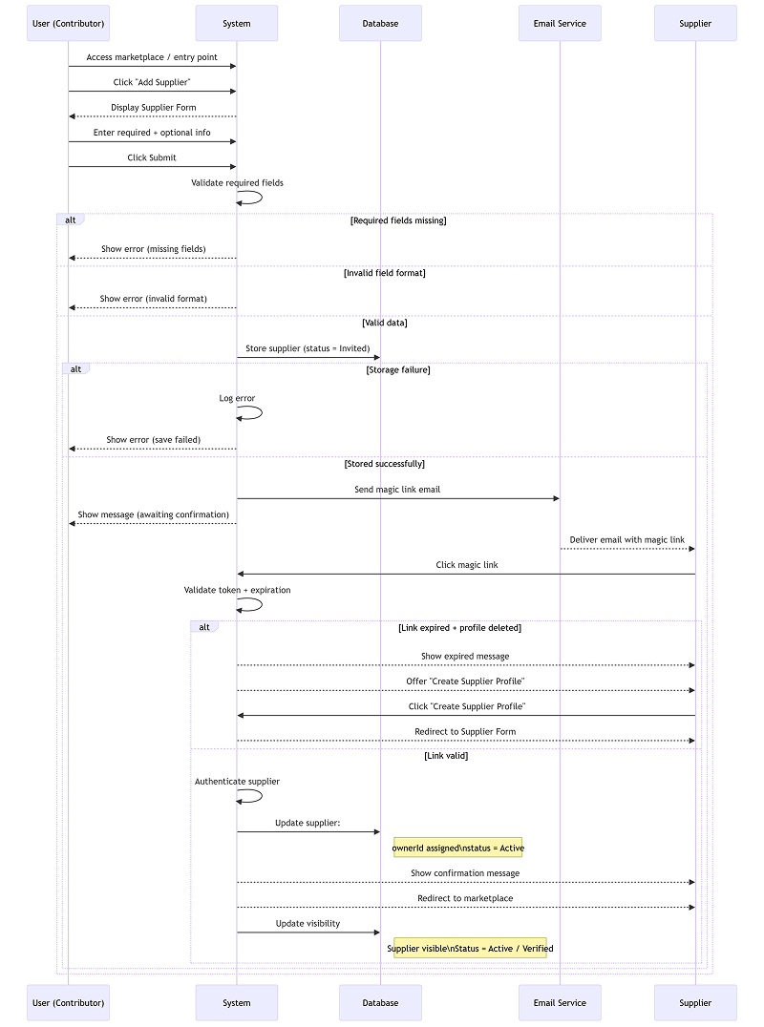

Mermaid code:

sequenceDiagram
participant U as User (Contributor)
participant S as System
participant DB as Database
participant E as Email Service
participant SUP as Supplier

%% --- MAIN FLOW ---
U->>S: Access marketplace / entry point
U->>S: Click "Add Supplier"
S-->>U: Display Supplier Form

U->>S: Enter required + optional info
U->>S: Click Submit

S->>S: Validate required fields

alt Required fields missing
S-->>U: Show error (missing fields)
else Invalid field format
S-->>U: Show error (invalid format)
else Valid data
S->>DB: Store supplier (status = Invited)

alt Storage failure
S->>S: Log error
S-->>U: Show error (save failed)
else Stored successfully
S->>E: Send magic link email
S-->>U: Show message (awaiting confirmation)

E-->>SUP: Deliver email with magic link

SUP->>S: Click magic link

S->>S: Validate token + expiration

alt Link expired + profile deleted
S-->>SUP: Show expired message
S-->>SUP: Offer "Create Supplier Profile"
SUP->>S: Click "Create Supplier Profile"
S-->>SUP: Redirect to Supplier Form
else Link valid
S->>S: Authenticate supplier
S->>DB: Update supplier:
Note right of DB: ownerId assigned\nstatus = Active

S-->>SUP: Show confirmation message
S-->>SUP: Redirect to marketplace

S->>DB: Update visibility
Note right of DB: Supplier visible\nStatus = Active / Verified
end
end
end

State Diagram

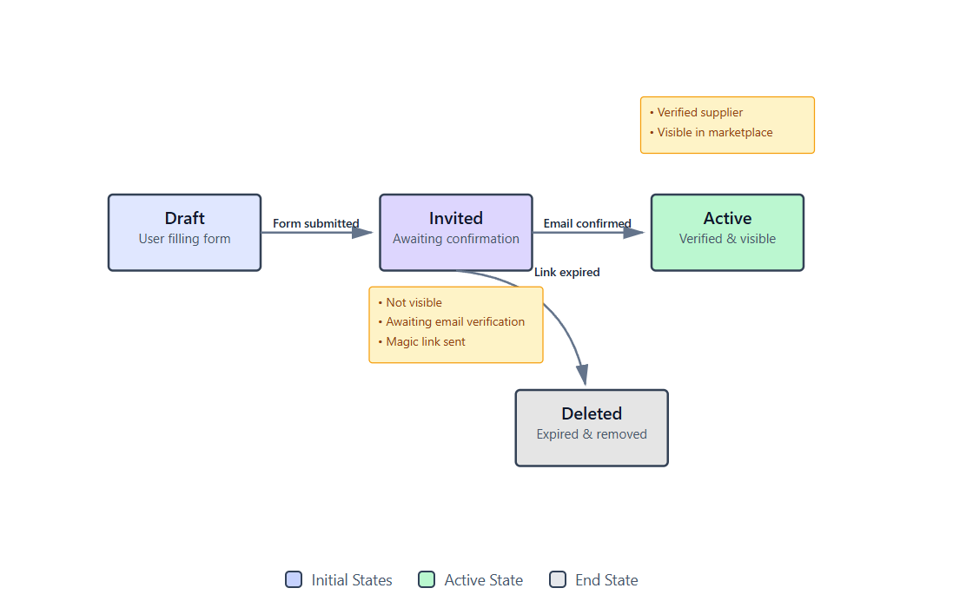

Mermaid code:

stateDiagram-v2
[*] --> Draft : User starts creation

Draft --> Invited : Submit valid form\n+ store supplier\n+ send magic link

%% --- INVITED STATE ---
Invited --> Active : Magic link valid\n+ email verified\n+ assign ownerId\n+ set visible

Invited --> Deleted : Link expired\n+ auto cleanup

%% --- TERMINAL ---
Deleted --> [*]

%% --- NOTES ---
note right of Invited
Supplier exists but:
- Not visible
- Not verified
- Awaiting email confirmation
end note

note right of Active
Supplier:
- Verified
- Owned
- Visible in marketplace
end note

note right of Deleted
Supplier:
- Removed after expiration
- Must restart creation flow
end note

Class Diagram

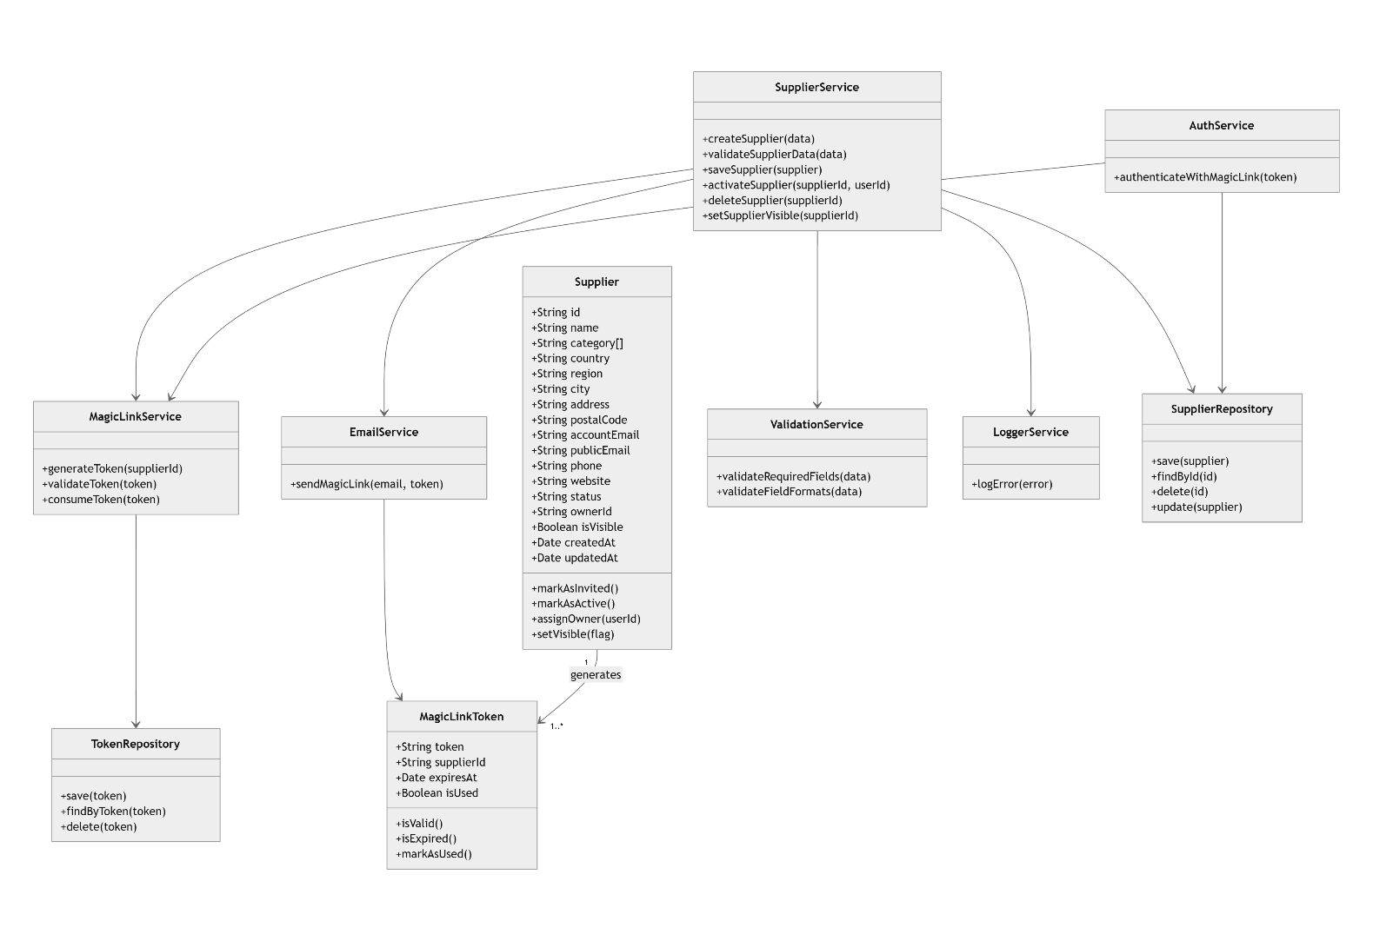

Mermaid code:

classDiagram

%% ========================
%% CORE ENTITIES
%% ========================

class Supplier {
+String id
+String name
+String category[]
+String country
+String region
+String city
+String address
+String postalCode
+String accountEmail
+String publicEmail
+String phone
+String website
+String status
+String ownerId
+Boolean isVisible
+Date createdAt
+Date updatedAt

+markAsInvited()
+markAsActive()
+assignOwner(userId)
+setVisible(flag)
}

class MagicLinkToken {
+String token
+String supplierId
+Date expiresAt
+Boolean isUsed

+isValid()
+isExpired()
+markAsUsed()
}

%% ========================
%% SERVICES
%% ========================

class SupplierService {
+createSupplier(data)
+validateSupplierData(data)
+saveSupplier(supplier)
+activateSupplier(supplierId, userId)
+deleteSupplier(supplierId)
+setSupplierVisible(supplierId)
}

class MagicLinkService {
+generateToken(supplierId)
+validateToken(token)
+consumeToken(token)
}

class EmailService {
+sendMagicLink(email, token)
}

class AuthService {
+authenticateWithMagicLink(token)
}

class ValidationService {
+validateRequiredFields(data)
+validateFieldFormats(data)
}

class LoggerService {
+logError(error)
}

%% ========================
%% REPOSITORIES
%% ========================

class SupplierRepository {
+save(supplier)
+findById(id)
+delete(id)
+update(supplier)
}

class TokenRepository {
+save(token)
+findByToken(token)
+delete(token)
}

%% ========================
%% RELATIONSHIPS
%% ========================

SupplierService --> SupplierRepository
SupplierService --> ValidationService
SupplierService --> MagicLinkService
SupplierService --> EmailService
SupplierService --> LoggerService

MagicLinkService --> TokenRepository

AuthService --> MagicLinkService
AuthService --> SupplierRepository

EmailService --> MagicLinkToken

Supplier "1" --> "1..*" MagicLinkToken : generates

Data Model

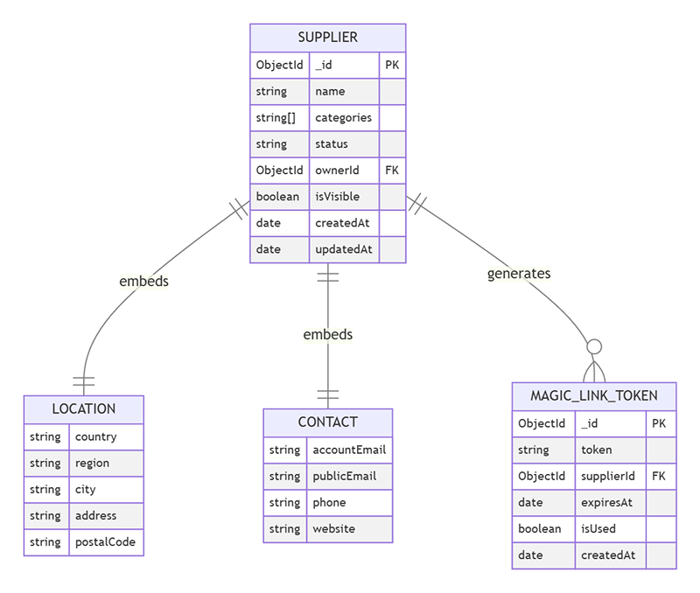

Mermaid code:

erDiagram

SUPPLIER {
ObjectId _id PK
string name
string[] categories
string status
ObjectId ownerId FK
boolean isVisible
date createdAt
date updatedAt
}

LOCATION {
string country
string region
string city
string address
string postalCode
}

CONTACT {
string accountEmail
string publicEmail
string phone
string website
}

MAGIC_LINK_TOKEN {
ObjectId _id PK
string token
ObjectId supplierId FK
date expiresAt
boolean isUsed
date createdAt
}

SUPPLIER ||--|| LOCATION : embeds
SUPPLIER ||--|| CONTACT : embeds
SUPPLIER ||--o{ MAGIC_LINK_TOKEN : generates

Requirements Specification

Epics and User Stories

7.1.1 Epics

Epic ID | Description | Priority
#29 | Supplier & Resource Directory | High

7.1.2 User Stories

Story ID | Description | Priority
#123 | As a contributor, I want to submit a new supplier entry so that the community can access useful supplier information. | High
#125 | As a platform administrator,  I want new supplier submissions to be queued for review,  So that inaccurate or inappropriate entries can be removed. | High

Business Requirements

Ref ID | Category | Description
#93 | Shared Resource Contribution | Sawaka must enable community groups and individual members to contribute, maintain, and update shared supplier and resource information within the platform.
#80 | Embed ethical and voluntary data protection practices | Sawaka must implement strong, voluntary data protection and privacy practices to ensure user trust, even in environments with limited regulatory enforcement.
#156 | Data Quality & Reliability | Sawaka must ensure high data quality and reliability across all shared resource information to maintain platform credibility and usability.

Functional Requirements

Ref ID | Category | Description
#132 | Create Supplier Entry | The system must allow users to create a supplier entry by submitting required and optional information through a structured form.
#133 | Validate Supplier Data | The system must validate that all required fields are completed and that field formats (e.g., email, phone number) are correct before submission.
#134 | Initialize Supplier Status | The system must store newly created suppliers with status set to "Invited", with no assigned owner and not visible.
#135 | Generate Magic Link Token | The system must generate a unique, time-limited magic link token associated with a supplier entry upon submission.
#137 | Validate Magic Link Token | The system must validate the magic link token by checking its validity, expiration, and usage status.
#138 | Activate Supplier | The system must activate the supplier upon successful token validation by assigning ownership, updating status to "Active", and making the supplier visible.
#139 | Automatic Publication | The system must automatically publish supplier entries upon activation without requiring prior approval.

Non-Functional Requirements

Ref ID | Category | Description
#155 | Email Idempotency | The system shall prevent duplicate email sending for the same action. One token → one email
#154 | Email Security | The system shall ensure that email content does not expose sensitive data. Token must be embedded securely (HTTPS link only). No sensitive data in plain text
#153 | Email Retry Mechanism | The system should retry sending emails in case of temporary failure. Retry up to 3 times. Use exponential backoff
#152 | Email Delivery Reliability | The system must ensure reliable email delivery for all critical user interactions, including authentication and notifications. Email delivery success rate ≥ 95% (measured as accepted by email provider). Email bounce rate ≤ 5%. Retry mechanism must be implemented for failed deliveries
#151 | Email Delivery Time | The system shall send the magic link email within an acceptable time after submission. Email sent within ≤ 30 seconds.
#149 | Audit & Logging | The system shall log key events for traceability and debugging. In this case, the system should log : Supplier creation, Token generation, Activation, Errors
#146 | Performance (Activation) | The system shall activate a supplier within acceptable response time after token validation. Activation response time < 2 seconds.
#145 | Performance (Submission) | The system shall process supplier submission requests within acceptable response time. Form submission response time < 2 seconds.
#144 | Security (Magic Link) | The system shall ensure that magic link tokens are secure and cannot be guessed or reused. Token must be cryptographically secure. Token must expire within 24 hours. Token must be single use only

Implementation Notes

The following technical assumptions and implementation guidelines are provided to support development. These are indicative and may evolve during implementation.

- Backend: Node.js (Express)
- Database: MongoDB
- Authentication: Magic Link (token-based, passwordless)
- Email Service: SMTP or third-party provider (e.g., SendGrid, Mailgun)
- Token Security: Cryptographically secure tokens with expiration and single-use enforcement

References & Policies

Reference Table

Ref ID | Title | Location / Link

Information Policies

Ref ID | Title | Location / Link

