Bond52

Requirements Specification v1.0
Feature – Edit Supplier
Sawaka

Table of Contents
1. Purpose of the Requirements Specification 3
1.1 Purpose 3
1.2 Distribution List 3
2. Requirements Specification Approvals 3
2.1 Version History 3
2.2 Review 4
3. Project Definition 5
4. Constraints, Assumptions & Dependencies 5
4.1 Constraints 5
4.2 Assumptions 5
4.3 Dependencies 5
5. Terms and Definitions 5
Terms and Definitions Table 5
6. Requirements Specification 6
6.1 Conceptual Model 6
6.2 User Interface 8
6.3 Use Cases 11
6.4 Sequence Diagram 15
6.5 State Diagram 17
6.6 Class Diagram 18
6.7 Data Model 21
7. Requirements Specification 23
7.1 Epics and User Stories 23
7.2 Business Requirements 23
7.3 Functional Requirements 23
7.4 Non-Functional Requirements 24
7.5 Implementation Notes 25
8. References & Policies 26
Reference Table 26
Information Policies 26

Purpose of the Requirements Specification

Purpose

This document defines the requirements for enabling a verified supplier contact to securely update or deactivate an existing supplier record in the Sawaka Supplier Directory.
Supplier management access is granted through a secure, temporary magic link sent to the private contact email associated with the supplier. A Sawaka user account is not required.

The solution must ensure that only a person with access to the verified private contact email can establish a temporary management session for the associated supplier. It must protect private supplier information, prevent unauthorized modifications, preserve system-controlled fields, and record supplier updates and deactivations for audit purposes.
Supplier deactivation is logical rather than permanent: the supplier record is retained in the database but removed from the public Supplier Directory and public profile.

The purpose of this document is to:

- Define how authorized users can update supplier information.
- Define how authorized users can delete or deactivate supplier records.
- Establish supplier ownership and role-based authorization rules.
- Define validation, confirmation, error-handling, and audit requirements.
- Protect supplier data against unauthorized modification or deactivation.
- Ensure updated supplier information is reflected consistently throughout the platform.
- Ensure deactivated suppliers are no longer publicly accessible.
- Provide traceability from Business Requirements to Functional and Non-Functional Requirements.
- Serve as a baseline reference for development, validation, and future enhancements.

This document ensures that supplier information can be maintained securely and accurately while protecting data integrity and preventing accidental or unauthorized changes.

Distribution List

Title | Name | Date Distributed

Requirements Specification Approvals

Version History

Author | Version | Date | Summary of changes
Bond52 | 1.0 | 2026-07-25 | Creation

Review

Name & Title | Review Date

Project Definition

Constraints, Assumptions & Dependencies

Constraints

Constraint ID | Constraint
CO01 | Only authenticated and authorized users may update or delete a supplier.
CO02 | Required audit information must be preserved after supplier deactivation.
CO03 | The feature must use the existing authentication, authorization, Supplier service, and Supplier data model.

Assumptions

Assumption ID | Assumption
AS01 | The supplier record has already been created through the Add Supplier process.
AS02 | The platform can determine whether the verified supplier contacts or is authorized to manage the supplier.
AS03 | Supplier update fields use the same validation rules as supplier creation unless explicitly stated otherwise.
AS04 | Deactivated suppliers are retained for audit purposes but excluded from public queries.

Dependencies

Dependency ID | Dependency
DE-01 | The Add Supplier feature and Supplier data model are implemented.
DE-02 | The Supplier Directory and Supplier Profile features are implemented.

Terms and Definitions

Terms and Definitions Table

Term | Definition

Requirements Specification

Conceptual Model

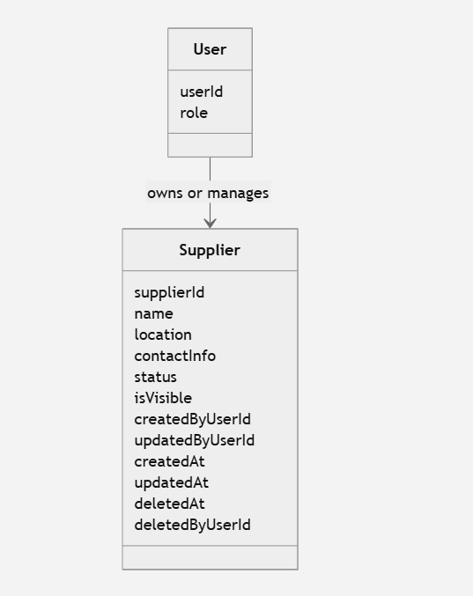

Mermaid code:

classDiagram
class Supplier {
supplierId
name
location
contactInfo
status
isVisible
createdByUserId
updatedByUserId
createdAt
updatedAt
deletedAt
deletedByUserId
}

class User {
userId
role
}

User --> Supplier : owns or manages

User Interface

Section | Component | Type | Required | Behavior | Validation Rules | Notes
Supplier Profile | Edit Supplier | Button | Yes | Opens the supplier management-link request form | Supplier must be active and publicly accessible | Does not require a Sawaka account
Access Verification | Contact Email | Email field | Yes | Collects the private contact email associated with the supplier | Required; valid email format | Must not display or reveal the stored address
Access Verification | Send Secure Link | Button | Yes | Requests a supplier-management magic link | Enabled when email format is valid | Response must not reveal whether the email matched
Feedback | Generic Confirmation Message | Notification | Conditional | Confirms that a link will be sent if the information matches | Same message for matching and non-matching addresses | Prevents email enumeration
Feedback | Request Failure Message | Notification | Conditional | Explains that the request could not be processed | User-friendly | No technical details
Contact Verification | Pending Verification Status | Status message | Conditional | Indicates that the new contact email awaits verification | Display only when a pending email exists | Current verified email remains active
Contact Verification | Verification Notice | Notification | Conditional | Explains that a verification link was sent to the new address | User-friendly | Other valid changes may already be saved
Contact Verification | Resend Verification Link | Button | Conditional | Sends a new verification link to the pending address | Rate-limited; valid management session required | Invalidates or supersedes the previous token
Contact Verification | Cancel Email Change | Button | Conditional | Cancels the pending contact-email change | Valid management session required | Keeps the current verified address
Feedback | Email Verified Message | Notification | Conditional | Confirms activation of the new contact email | None | Confirms that the new private contact email was successfully verified and is now active.
Feedback | Verification Link Error | Notification | Conditional | Explains that the link is invalid, expired, or already used | User-friendly | Provide an option to request another link
Access | Invalid Magic Link Message | Error state | Conditional | Denies access when the link is invalid, expired, altered, or used | None | Offer a new-link request
Access | Session Expired Message | Error state | Conditional | Explains that the management session expired | None | Do not submit pending changes
Access | Request New Link | Button/Link | Conditional | Returns to the secure-link request form | Supplier must still be active | Do not expose the stored contact email
Feedback | Supplier Unavailable Message | Error state | Conditional | Indicates that the supplier is unavailable or inactive | None | Do not expose internal status details

Section | Component | Type | Required | Behavior | Validation Rules | Notes
Navigation | Back | Link/Button | Yes | Returns to the previous supplier view | None | Returns to the public supplier profile. Display an unsaved-changes warning only if at least one field has been modified.
Supplier Information | Supplier Name | Textbox | Yes | Displays and updates supplier name | Required; approved length | Pre-populated
Supplier Information | Categories | Multi-select | Yes | Updates supplier categories | At least one valid category | Pre-populated
Location | Country | Select/Textbox | Yes | Updates country | Valid supported value | Pre-populated
Location | Region | Textbox/Select | No | Updates region | Approved format | Pre-populated
Location | City | Textbox | Yes | Updates city | Required; approved length | Pre-populated
Location | Address | Textbox | No | Updates address | Approved length | Pre-populated
Location | Postal Code | Textbox | No | Updates postal code | Valid format when provided | Pre-populated
Contact | Phone Number | Textbox | Yes | Updates public phone number | Valid phone format | Public
Contact | Contact Email | Email field | Yes | Updates the private email used to request future management access | Required; valid email format | Required; valid email format. Used for secure management access and never displayed publicly. A change requires verification of the new address.
Contact | Public Email | Email field | No | Updates the email displayed publicly | Valid email format when provided | Optional; valid email format when provided. Displayed publicly and managed independently from private contact email.
Contact | Website | URL field | No | Updates website | Valid HTTPS URL | Pre-populated
Actions | Save Changes | Button | Yes | Submits valid changes | Enabled after valid input | Enabled only when at least one field has changed and all fields are valid. Requires a valid supplier-management session.
Actions | Cancel | Button | Yes | Cancels update | None | If no changes exist, return directly to the public supplier profile. Otherwise, display a confirmation dialog before discarding changes.
Feedback | Validation Message | Inline message | Conditional | Explains invalid fields | User-friendly | No technical details
Feedback | Success Message | Notification | Conditional | Confirms successful update | None | Display after persistence
Feedback | Partial Success Message | Notification | Conditional | Confirms partial success | None | Confirms that other modifications were saved, but the new private contact email remains pending until verified.
Danger Zone | Deactivate Supplier | Button | Yes | Opens the deactivation confirmation dialog | Valid management session required | Replace Deactivate Supplier with Deactivate Supplier everywhere in the interface. Opens the supplier-deactivation confirmation dialog.
Confirmation | Supplier Name | Read-only text | Yes | Identifies the supplier being deactivated | Must match the selected supplier | Prevents ambiguity
Confirmation | Warning Message | Text | Yes | Explains that the supplier will disappear from public access | None | Clarify that this is not permanent database deactivation
Confirmation | Confirm Deactivation | Button | Yes | Deactivates the supplier | Requires explicit confirmation | Must not be the default focused action
Confirmation | Cancel | Button | Yes | Closes the dialog | None | Supplier remains active
Feedback | Success Message | Notification | Conditional | Confirms successful deactivation | None | Replace Confirm Deactivation with Confirm Deactivation. Sets the supplier to inactive and removes it from public visibility without permanently deleting its record.
Feedback | Error Message | Notification | Conditional | Explains that deactivation failed | User-friendly | No technical details

Use Cases

Use Case Title: | Edit Supplier
Use Case Description: | This use case enables a verified supplier contact to modify the editable information of an existing supplier through a temporary supplier-management session established using a secure magic link. From the update page, the supplier contact may alternatively initiate supplier deactivation
Actors: | Primary Actor:  - Verified Supplier Contact
Organizational Benefits: | - Maintains accurate and up-to-date supplier information in the directory.  - Enables suppliers to manage their information securely without requiring a Sawaka account.  - Reduces the administrative effort required from Sawaka to process supplier updates and deactivation requests.  - Improves the reliability and trustworthiness of the Supplier Directory by allowing outdated listings to be corrected or deactivated.
Frequency of Use: | Low  Executed whenever a supplier modifies his information in the Supplier Directory.
Triggers: | The verified supplier contact opens the secure magic link received by email.
Pre-conditions: | - The supplier exists and is active.  - The supplier contacts previously requested a management link from the supplier  - The magic-link token is valid, unexpired, unaltered, and associated with the requested supplier.  - The magic-link token has not already been used to establish a management session.  - The supplier contact does not need a Sawaka account.
Post-conditions: | - Valid changes persisted.  - Unchanged information is preserved.  - Restricted and system-controlled fields remain unchanged.  - The supplier updated At value is updated.  - The operation is recorded for audit purposes.  - Updated public information appears in the Supplier Directory and supplier profile.  - No additional magic link is required during the valid management session.
Main Scenario: | 1. The supplier contact opens the public supplier profile.  2. The supplier contact selects Edit Supplier.  3. The system displays an email verification form associated with the selected supplier.  4. The supplier contact enters the supplier contact email address.  5. The supplier contact selects Send Secure Link.  6. The system normalizes the submitted email address.  7. The system verifies that the submitted email matches the private contact email associated with the supplier.  8. The system generates a secure, temporary magic-link token associated with the supplier.  9. The system sends the magic link to the verified contact email address.  10. The system displays a generic confirmation message.  11. The supplier contact opens the magic link received by email.  12. The system validates that the token is valid, unexpired, unused, and associated with the requested supplier.  13. The system establishes a temporary supplier-management session limited to that supplier.  14. The system marks the magic-link token as used.  15. The system retrieves the supplier record.  16. The system displays the update form pre-populated with the supplier’s editable information.  17. The supplier contact modifies one or more fields.  18. The supplier contact selects Save Changes.  19. The system verifies that the supplier-management session is valid and associated with the supplier.  20. The system validates the submitted information.  21. The system updates only the permitted supplier fields.  22. The system preserves fields that were not modified.  23. The system records the update date.  24. The system displays a successful update confirmation.  25. The system displays the updated supplier information.
Alternative Scenarios: | Alternative 1 — Change Supplier Contact Email:  1. The supplier contact modifies the private contact email address.  2. The supplier contact selects Save Changes.  3. The system verifies the supplier-management session.  4. The system validates the submitted information.  5. The system detects that the private contact email has changed.  6. The system normalizes and validates the new contact email address.  7. The system stores the new address as a pending contact email without replacing the current verified contact email.  8. The system generates a secure, temporary email-verification link associated with the supplier and the pending contact email.  9. The system sends the verification link to the new contact email address.  10. The system saves the other valid supplier changes, if any.  11. The system informs the supplier contact that the other changes were saved, but that the new contact email must be verified before it becomes active.  12. The supplier contact opens the verification link received at the new email address.  13. The system validates that the verification token is valid, unexpired, unused, and associated with the supplier and pending contact email.  14. The system replaces the current contact email with the verified pending contact email.  15. The system removes the pending contact email and invalidates the verification token.  16. The system records the contact email change timestamp.  17. The system displays a successful email verification confirmation  Alternative 2 — Initiate Supplier Deactivation:  1. The supplier contact selects Deactivate Supplier.  2. The system displays a confirmation dialog identifying the supplier.  3. The system explains the consequences of deactivation.  4. The supplier contact selects Confirm Deactivation.  5. The system verifies the supplier-management session.  6. The system verifies that the supplier is still active.  7. The system sets the supplier status to Inactive.  8. The system sets is Visible to false.  9. The system records the deactivation timestamp.  10. The system invalidates the supplier-management session.  11. The system displays a successful deactivation confirmation.  12. The system redirects the supplier contact away from the update page.  Alternative 3 — Cancel Update:  1. The supplier contact modifies one or more fields.  2. The supplier contact selects Cancel.  3. If unsaved changes exist, the system requests confirmation.  4. The supplier contact confirms the cancellation.  5. The system leaves the supplier unchanged.  Alternative 4 — No Changes:  1. The supplier contact selects Save Changes without modifying any values.  2. The system informs the supplier contact that no changes were detected.  3. The supplier remains unchanged.
Exception Scenarios: | Exception 1 — Supplier Not Found or Inactive:  1. The supplier does not exist or has already been deactivated.  2. The system rejects the operation.  3. The system displays a friendly supplier-unavailable message.  Exception 2 — New Contact Email Not Verified:  1. The verification link expires before it is used.  2. The system keeps the current verified contact email unchanged.  3. The pending contact email does not grant supplier-management access.  4. The system allows a new verification link to be requested during a valid management session.  Exception 3 – System Retrieval Failure:  Condition:  A database or server error occurs while retrieving supplier information.  1.System attempts to retrieve the supplier profile.  2.System fails to retrieve the data.  3.System logs the error.  4.System displays the message:  "An error occurred while retrieving the supplier profile. Please try again later."

Sequence Diagram

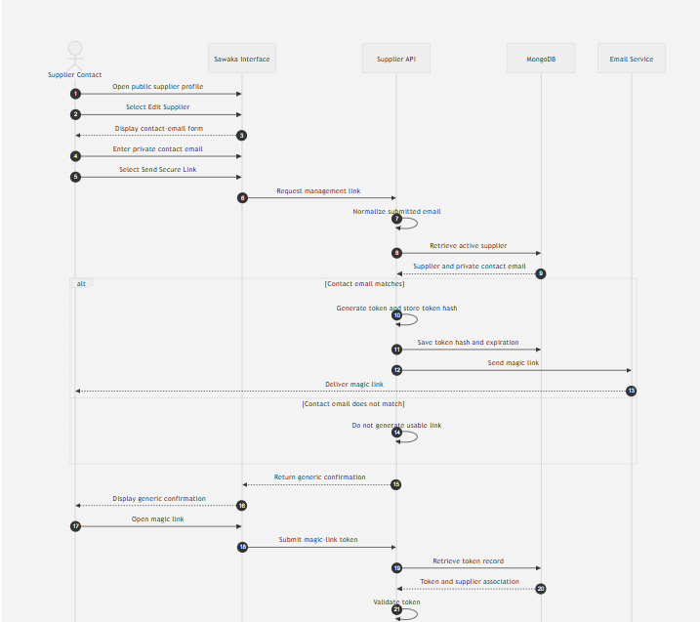

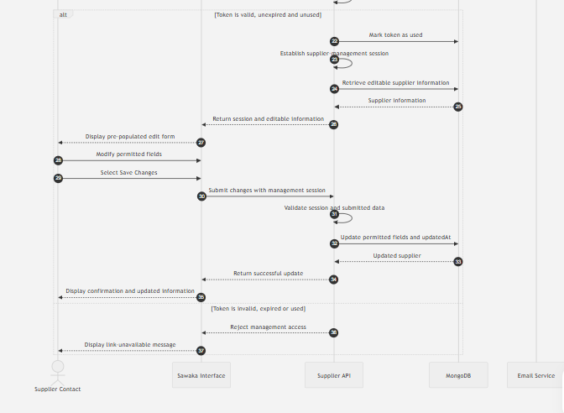

Mermaid code:

sequenceDiagram
autonumber
actor Contact as Supplier Contact
participant UI as Sawaka Interface
participant API as Supplier API
participant DB as MongoDB
participant Email as Email Service

Contact->>UI: Open public supplier profile
Contact->>UI: Select Edit Supplier
UI-->>Contact: Display contact-email form

Contact->>UI: Enter private contact email
Contact->>UI: Select Send Secure Link
UI->>API: Request management link

API->>API: Normalize submitted email
API->>DB: Retrieve active supplier
DB-->>API: Supplier and private contact email

alt Contact email matches
API->>API: Generate token and store token hash
API->>DB: Save token hash and expiration
API->>Email: Send magic link
Email-->>Contact: Deliver magic link
else Contact email does not match
API->>API: Do not generate usable link
end

API-->>UI: Return generic confirmation
UI-->>Contact: Display generic confirmation

Contact->>UI: Open magic link
UI->>API: Submit magic-link token
API->>DB: Retrieve token record
DB-->>API: Token and supplier association
API->>API: Validate token

alt Token is valid, unexpired and unused
API->>DB: Mark token as used
API->>API: Establish supplier-management session
API->>DB: Retrieve editable supplier information
DB-->>API: Supplier information
API-->>UI: Return session and editable information
UI-->>Contact: Display pre-populated edit form

Contact->>UI: Modify permitted fields
Contact->>UI: Select Save Changes
UI->>API: Submit changes with management session

API->>API: Validate session and submitted data
API->>DB: Update permitted fields and updatedAt
DB-->>API: Updated supplier
API-->>UI: Return successful update
UI-->>Contact: Display confirmation and updated information
else Token is invalid, expired or used
API-->>UI: Reject management access
UI-->>Contact: Display link-unavailable message
End

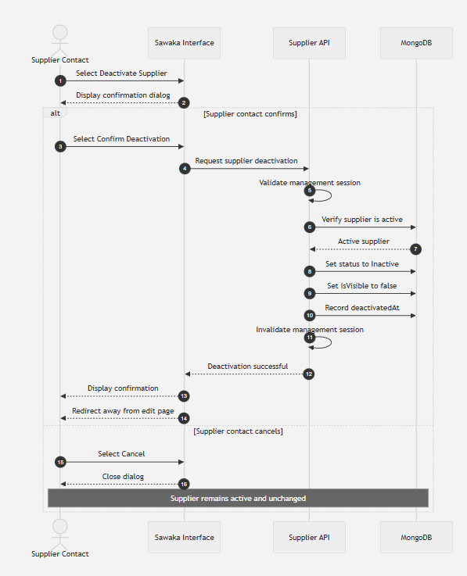

Mermaid code:

sequenceDiagram
autonumber
actor Contact as Supplier Contact
participant UI as Sawaka Interface
participant API as Supplier API
participant DB as MongoDB

Contact->>UI: Select Deactivate Supplier
UI-->>Contact: Display confirmation dialog

alt Supplier contact confirms
Contact->>UI: Select Confirm Deactivation
UI->>API: Request supplier deactivation

API->>API: Validate management session
API->>DB: Verify supplier is active
DB-->>API: Active supplier

API->>DB: Set status to Inactive
API->>DB: Set isVisible to false
API->>DB: Record deactivatedAt
API->>API: Invalidate management session

API-->>UI: Deactivation successful
UI-->>Contact: Display confirmation
UI-->>Contact: Redirect away from edit page
else Supplier contact cancels
Contact->>UI: Select Cancel
UI-->>Contact: Close dialog
Note over Contact,DB: Supplier remains active and unchanged
end

State Diagram

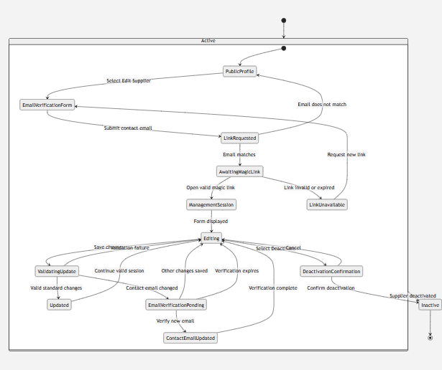

Mermaid code:

stateDiagram-v2
[*] --> Active

state Active {
[*] --> PublicProfile
PublicProfile --> EmailVerificationForm : Select Edit Supplier
EmailVerificationForm --> LinkRequested : Submit contact email
LinkRequested --> AwaitingMagicLink : Email matches
LinkRequested --> PublicProfile : Email does not match
AwaitingMagicLink --> ManagementSession : Open valid magic link
AwaitingMagicLink --> LinkUnavailable : Link invalid or expired
LinkUnavailable --> EmailVerificationForm : Request new link

ManagementSession --> Editing : Form displayed
Editing --> ValidatingUpdate : Save changes
ValidatingUpdate --> Editing : Validation failure
ValidatingUpdate --> Updated : Valid standard changes
Updated --> Editing : Continue valid session

ValidatingUpdate --> EmailVerificationPending : Contact email changed
EmailVerificationPending --> Editing : Other changes saved
EmailVerificationPending --> ContactEmailUpdated : Verify new email
EmailVerificationPending --> Editing : Verification expires
ContactEmailUpdated --> Editing : Verification complete

Editing --> DeactivationConfirmation : Select Deactivate
DeactivationConfirmation --> Editing : Cancel
}

DeactivationConfirmation --> Inactive : Confirm deactivation
Active --> Inactive : Supplier deactivated
Inactive --> [*]

Class Diagram

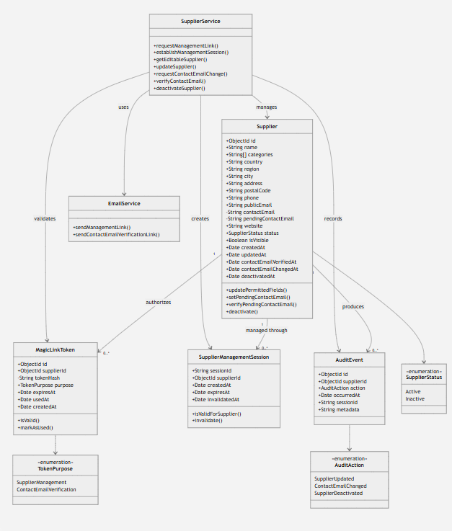

Mermaid code:

classDiagram
class Supplier {
+ObjectId id
+String name
+String[] categories
+String country
+String region
+String city
+String address
+String postalCode
+String phone
+String publicEmail
-String contactEmail
-String pendingContactEmail
+String website
+SupplierStatus status
+Boolean isVisible
+Date createdAt
+Date updatedAt
+Date contactEmailVerifiedAt
+Date contactEmailChangedAt
+Date deactivatedAt
+updatePermittedFields()
+setPendingContactEmail()
+verifyPendingContactEmail()
+deactivate()
}

class MagicLinkToken {
+ObjectId id
+ObjectId supplierId
-String tokenHash
+TokenPurpose purpose
+Date expiresAt
+Date usedAt
+Date createdAt
+isValid()
+markAsUsed()
}

class SupplierManagementSession {
+String sessionId
+ObjectId supplierId
+Date createdAt
+Date expiresAt
+Date invalidatedAt
+isValidForSupplier()
+invalidate()
}

class SupplierService {
+requestManagementLink()
+establishManagementSession()
+getEditableSupplier()
+updateSupplier()
+requestContactEmailChange()
+verifyContactEmail()
+deactivateSupplier()
}

class EmailService {
+sendManagementLink()
+sendContactEmailVerificationLink()
}

class AuditEvent {
+ObjectId id
+ObjectId supplierId
+AuditAction action
+Date occurredAt
+String sessionId
+String metadata
}

class SupplierStatus {
<<enumeration>>
Active
Inactive
}

class TokenPurpose {
<<enumeration>>
SupplierManagement
ContactEmailVerification
}

class AuditAction {
<<enumeration>>
SupplierUpdated
ContactEmailChanged
SupplierDeactivated
}

Supplier "1" --> "0..*" MagicLinkToken : authorizes
Supplier "1" --> "0..*" SupplierManagementSession : managed through
Supplier "1" --> "0..*" AuditEvent : produces
MagicLinkToken --> TokenPurpose
Supplier --> SupplierStatus
AuditEvent --> AuditAction
SupplierService --> Supplier : manages
SupplierService --> MagicLinkToken : validates
SupplierService --> SupplierManagementSession : creates
SupplierService --> AuditEvent : records
SupplierService --> EmailService : uses

Data Model
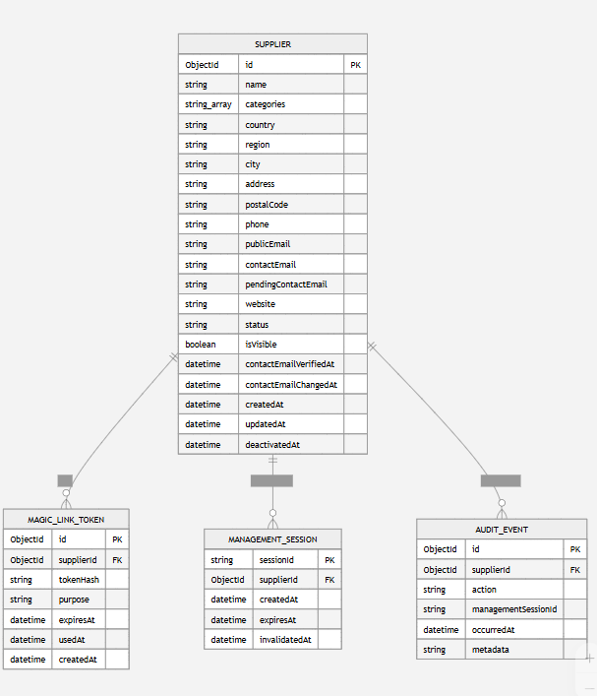

Mermaid code:

erDiagram
SUPPLIER {
ObjectId id PK
string name
string_array categories
string country
string region
string city
string address
string postalCode
string phone
string publicEmail
string contactEmail
string pendingContactEmail
string website
string status
boolean isVisible
datetime contactEmailVerifiedAt
datetime contactEmailChangedAt
datetime createdAt
datetime updatedAt
datetime deactivatedAt
}

MAGIC_LINK_TOKEN {
ObjectId id PK
ObjectId supplierId FK
string tokenHash
string purpose
datetime expiresAt
datetime usedAt
datetime createdAt
}

MANAGEMENT_SESSION {
string sessionId PK
ObjectId supplierId FK
datetime createdAt
datetime expiresAt
datetime invalidatedAt
}

AUDIT_EVENT {
ObjectId id PK
ObjectId supplierId FK
string action
string managementSessionId
datetime occurredAt
string metadata
}

SUPPLIER ||--o{ MAGIC_LINK_TOKEN : has
SUPPLIER ||--o{ MANAGEMENT_SESSION : authorizes
SUPPLIER ||--o{ AUDIT_EVENT : generates

Requirements Specification

Epics and User Stories

7.1.1 Epics

Epic ID | Description | Priority
#29 | Supplier & Resource Directory | High

7.1.2 User Stories

Story ID | Description | Priority
#284 | As a verified supplier contact, I want to update the supplier editable information so that the public Supplier Directory remains accurate and current.
#285 | As a verified supplier contact, I want to deactivate the supplier listing so that it is removed from public access without permanently deleting its record.

Business Requirements

Ref ID | Category | Description
#93 | Supplier  Discoverability | Sawaka must enable users to discover suppliers through a centralized and accessible Supplier Directory.
#80 | Data Privacy | Sawaka must ensure that only supplier information intended for public display is accessible through the Supplier Directory and supplier profile pages.
#156 | Data Quality & Reliability | Sawaka must ensure high data quality and reliability across all shared resource information to maintain platform credibility and usability.

Functional Requirements

Ref ID | Category | Description
#286 | Pre-populated Edit Form - Supplier | The system must retrieve the supplier's editable information and display it pre-populated when a valid supplier-management session is established.
#288 | Contact Email Change Detection - Supplier | The system must detect whether the private contact email has changed by comparing the submitted value with the currently verified address after trimming surrounding spaces and applying case-insensitive comparison.
#289 | Pending Contact Email - Supplier | The system must store a new valid private contact email as a pending contact email until ownership of the address has been verified.
#290 | Contact Email Verification - Supplier | The system must generate and send a secure verification link to a pending contact email and activate the new address only after successful verification.
#291 | Partial Success - Supplier | The system must inform the supplier when profile updates have been saved while a new private contact email remains pending verification.
#292 | Deactivation Confirmation - Supplier | The system must display a confirmation dialog before deactivating a supplier.
#293 | Logical Deactivation - Supplier | The system must logically deactivate a supplier after successful confirmation and session validation.
#294 | Public Visibility - Supplier | The system must prevent inactive suppliers from appearing in public supplier listings.

Non-Functional Requirements

Ref ID | Category | Description

Implementation Notes

The following technical assumptions and implementation guidelines are provided to support development. These are indicative and may evolve during implementation.
- Frontend: React (Next.js)
- Backend: Node.js (Express)
- Database: MongoDB
- Data Access: Supplier information retrieved through the existing Supplier service and repository.
- Search: Supplier search and category filtering should be performed using indexed supplier attributes where applicable.
- Visibility: Only suppliers with status = Active and isVisible = true should be returned for public display.
- Security: Private supplier information (e.g., Account Email, Owner ID) must not be exposed through public APIs.
- Communication: All requests for the Supplier Directory and Supplier Profile should be performed over HTTPS.
- Error Handling: The application should return user-friendly error messages while logging technical details for troubleshooting.

References & Policies

Reference Table

Ref ID | Title | Location / Link

Information Policies

Ref ID | Title | Location / Link

