Bond52

Requirements Specification v1.0
Feature – View Supplier
Sawaka

Table of Contents
1. Purpose of the Requirements Specification 3
1.1 Purpose 3
1.2 Distribution List 3
2. Requirements Specification Approvals 3
2.1 Version History 3
2.2 Review 4
3. Project Definition 5
4. Constraints, Assumptions & Dependencies 5
4.1 Constraints 5
4.2 Assumptions 5
4.3 Dependencies 5
5. Terms and Definitions 5
Terms and Definitions Table 5
6. Requirements Specification 6
6.1 Conceptual Model 6
6.2 User Interface 8
6.3 Use Cases 11
6.4 Sequence Diagram 15
6.5 State Diagram 17
6.6 Class Diagram 18
6.7 Data Model 21
7. Requirements Specification 23
7.1 Epics and User Stories 23
7.2 Business Requirements 23
7.3 Functional Requirements 23
7.4 Non-Functional Requirements 24
7.5 Implementation Notes 25
8. References & Policies 26
Reference Table 26
Information Policies 26

Purpose of the Requirements Specification

Purpose
This Requirements Specification defines the business and solution requirements for the "View Supplier Profile" feature within the Sawaka platform.
The purpose of this document is to:
- Define how supplier information is presented to users within the Supplier Directory.
- Establish the business and functional requirements for viewing supplier profiles.
- Define the scope and behavior of the supplier detail page.
- Ensure alignment between business objectives, user stories, and implementation.
- Provide traceability from Business Requirements to Functional Requirements.
- Serve as a baseline reference for development, validation, and future enhancements.
This document ensures that supplier information is presented in a consistent, user-friendly, and reliable manner while supporting Sawaka's objective of improving supplier discoverability and strengthening community-based resource intelligence.

Distribution List

Title | Name | Date Distributed

Requirements Specification Approvals

Version History

Author | Version | Date | Summary of changes
Bond52 | 1.0 | 2026-07-05 | Creation

Review

Name & Title | Review Date

Project Definition

Constraints, Assumptions & Dependencies

Constraints

Constraint ID | Constraint
CO01 | Must comply with data protection policies
CO02 | Must display only publicly available supplier information. Private fields  (e.g., Account Email, Owner ID) must never be exposed.
CO03 | Must use the existing Supplier data model without requiring additional  mandatory supplier information.
CO04 | Supplier profile must display only suppliers with status = Active and visible to the public.

Assumptions

Assumption ID | Assumption
AS01 | Supplier information has already been created and activated through  the Add Supplier process.
AS02 | Supplier contact information is accurate and maintained by the supplier or community contributor.

Dependencies

Dependency ID | Dependency
DE-01 | Supplier Directory module exists
DE-02 | User authentication system implemented
DE-03 | Admin role management system available
DE-04 | Supplier activation process has successfully published the supplier profile.
DE-05 | Existing navigation allows users to access supplier detail pages from the Supplier Directory or search results.

Terms and Definitions

Terms and Definitions Table

Term | Definition
Activity | A specific task or operation within a trade.
Artisan | An individual who practices one or more trades.
Resource Type | A standardized type of consumable material. Defined materials used in activities (e.g., wood, cement).
Sector | A high-level economic or industry domain grouping multiple trades.
Supplier | An entity that provides tools and/or resources. Supports artisans by enabling access to required materials and equipment.
Tool Type | A standardized category of tools used in activities. Ensures consistency in tool classification (e.g., hammer, saw).
Trade | A profession or specialized skill area. Organizes related activities and competencies.

Requirements Specification

Conceptual Model

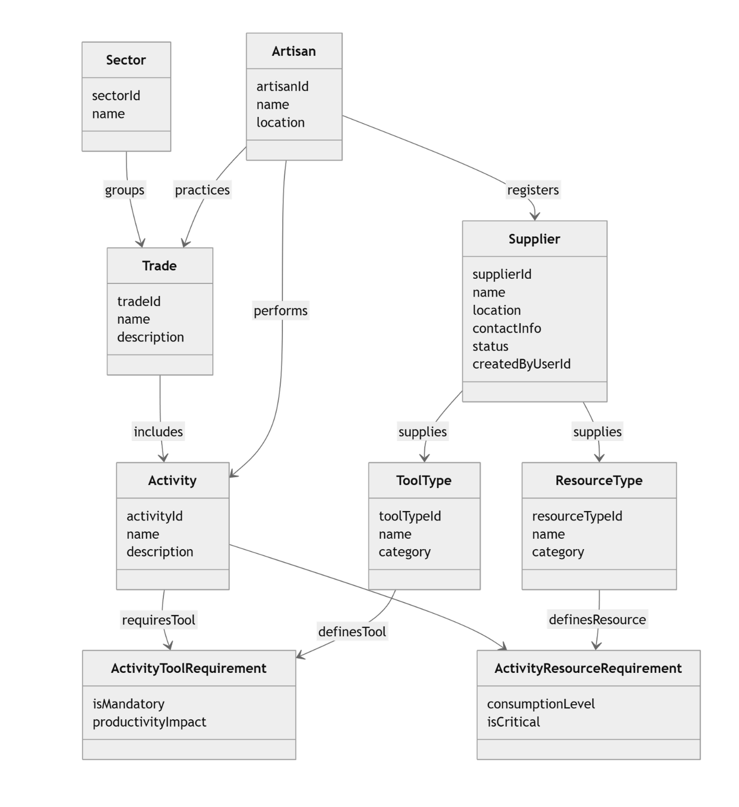

Mermaid code:

classDiagram

%% ========================
%% ENTITIES (CONCEPTUAL)
%% ========================

class Sector {
sectorId
name
}

class Artisan {
artisanId
name
location
}

class Trade {
tradeId
name
description
}

class Activity {
activityId
name
description
}

class Supplier {
supplierId
name
location
contactInfo
status
createdByUserId
}

class ToolType {
toolTypeId
name
category
}

class ResourceType {
resourceTypeId
name
category
}

class ActivityToolRequirement {
isMandatory
productivityImpact
}

class ActivityResourceRequirement {
consumptionLevel
isCritical
}

%% ========================
%% RELATIONSHIPS
%% ========================

Sector --> Trade : groups
Artisan --> Trade : practices

Trade --> Activity : includes
Artisan --> Activity : performs

Artisan --> Supplier : registers

Supplier --> ToolType : supplies
Supplier --> ResourceType : supplies

Activity --> ActivityToolRequirement : requiresTool
ToolType --> ActivityToolRequirement : definesTool

Activity --> ActivityResourceRequirement : requiresResource
ResourceType --> ActivityResourceRequirement : definesResource

User Interface

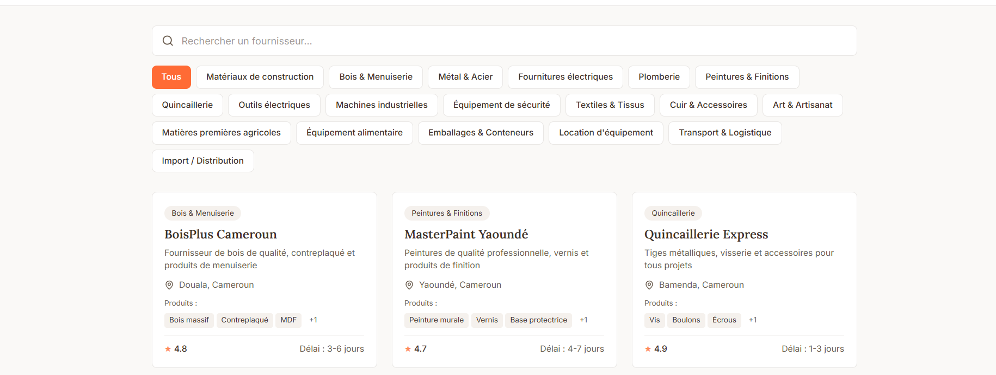

Section | Component | Type | Required | Behavior | Validation Rules | Notes
Search | Supplier Search | Search Box | No | Filters suppliers by name or keyword | None
Categories | Category Filter | Filter Chips | No | Filters suppliers by category | None | Multiple selection (future)
Supplier List | Supplier Card | Card | Yes | Displays supplier summary | None | One card per supplier
Supplier Card | Supplier Name | Read-only Text | Yes | Displays supplier name | None
Supplier Card | Supplier Categories | Tags / Chips | Yes | Displays supplier categories | None
Supplier Card | Location | Read-only Text | Yes | Displays City, Country | None
Supplier Card | Resources Supplied | Tags | No | Displays resource tags | None | Based on Resource Types / Material Tags
Supplier Card | View Supplier | Clickable Card | Yes | Opens Supplier Profile | None | Entire card clickable

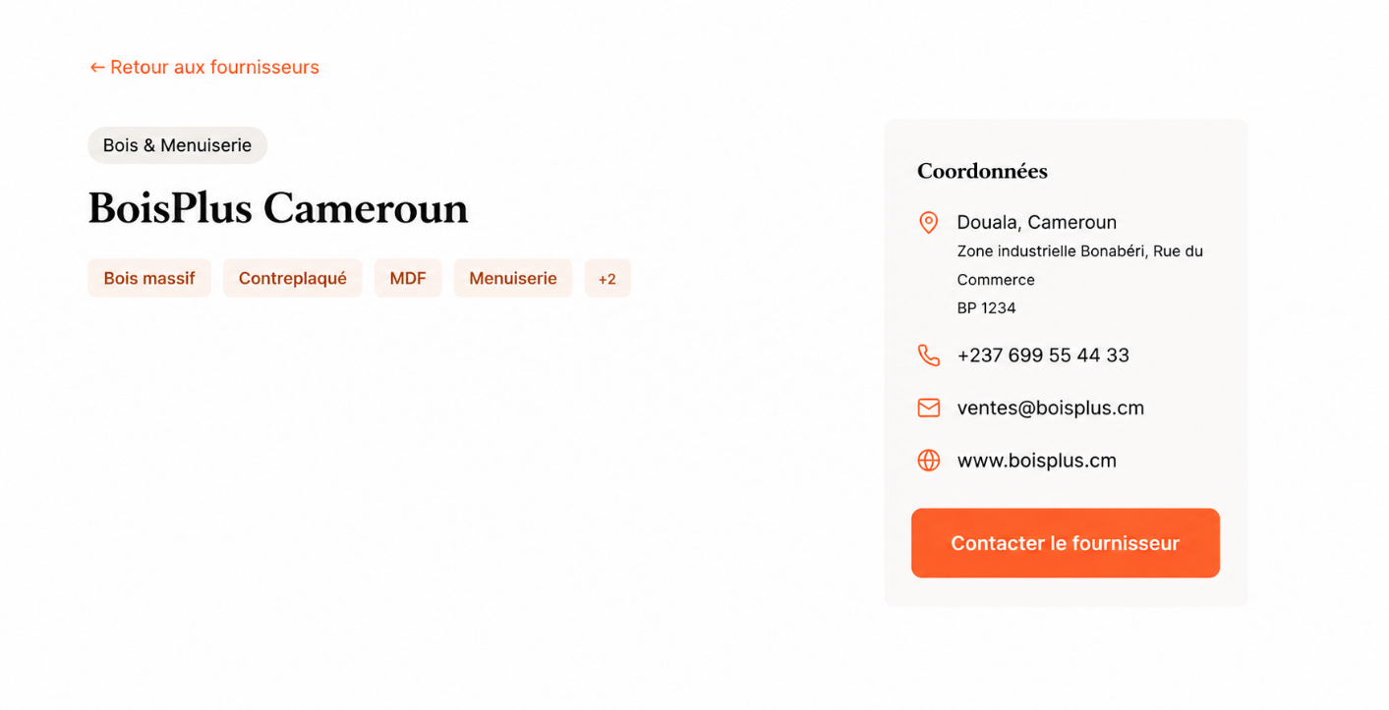

Section | Component | Type | Required | Behavior | Validation Rules | Notes
Navigation | Back to Suppliers | Link | Yes | Returns to Supplier Directory | None | Navigation
Supplier Information | Supplier Name | Read-only Text | Yes | Displays supplier name | None | Supplier Information
Supplier Information | Categories | Tags / Chips | Yes | Displays one or more supplier categories | None | Multiple categories supported
Supplier Information | Location | Read-only Text | Yes | Displays City, Region, Country | None
Contact Information | Street Address | Read-only Text | No | Displays supplier address | None
Contact Information | Street Address | Read-only Text | No | Displays supplier address | None
Contact Information | Postal Code | Read-only Text | No | Displays postal code | None
Contact Information | Phone Number | Read-only Text | Yes | Displays public phone number | None
Contact Information | Public Email | Read-only Text | No | Displays public email | None
Contact Information | Website | Hyperlink | No | Opens supplier website | Valid URL
Actions | Contact Supplier | Button | Yes | Opens email client or contact form | None
Public Contact | Phone Number | Textbox | Yes | Input with mask formatting | Valid phone format | Public
Public Contact | Website | Textbox | No | User inputs URL | Valid URL format

Use Cases

Use Case Title: | View Supplier Profile
Use Case Description: | This use case enables users to view the detailed profile of a supplier listed in the Supplier Directory. It provides access to public supplier information, including contact details, categories, location, and publicly available resources, allowing artisans and project owners to identify suitable suppliers for their needs.
Actors: | Primary Actor  - Platform User (Guest or Authenticated User)
Organizational Benefits: | - Improves supplier discoverability.  - Reduces supplier information asymmetry.  - Helps artisans identify appropriate suppliers for their projects.  - Supports Business Requirement – Community-Based Resource Infrastructure.  - Promotes visibility of community-contributed suppliers.  - Encourages collaboration within the artisan ecosystem.
Frequency of Use: | High  Executed whenever a user consults supplier information from the Supplier Directory.
Triggers: | User clicks a supplier card from the Supplier Directory or from search results.
Pre-conditions: | - Supplier Directory module is accessible.  - Supplier exists.  - Supplier status is Active.  - Supplier profile is publicly visible.
Post-conditions: | - Supplier profile is displayed.  - No supplier information is modified.  - User may contact the supplier using the available public contact information.
Main Scenario: | Step 1  User opens the Supplier Directory.  Step 2  System displays the list of available suppliers.  Step 3  User optionally searches or filters suppliers by category or keyword.  Step 4  System refreshes the supplier list according to the selected filters.  Step 5  User selects a supplier.  Step 6  System retrieves the supplier profile.  Step 7  System displays the supplier profile, including:  - Supplier name  - Supplier categories  - Public location  - Public address (if available)  - Public phone number  - Public email (if available)  - Website (if available)  Step 8  User reviews the supplier information.  Step 9  User may click Contact Supplier.  Step 10  System opens the appropriate communication method (email client, website, or contact page).
Alternative Scenarios: | Alternative 1 – Search or Category Filter  Condition:  User searches by keyword or selects one or more categories.  Step 3  User enters a keyword or selects category filters.  Step 4  System filters the supplier list.  Step 5  User selects one of the filtered suppliers.  The use case resumes at Step 6.
Exception Scenarios: | Exception 1 – Supplier Not Found  Condition:  The requested supplier does not exist or has been removed.  Step 6  System cannot retrieve the supplier profile.  Step 7  System displays the message:  "The requested supplier could not be found."  Step 8  System redirects the user to the Supplier Directory.  Exception 2 – System Retrieval Failure  Condition:  A database or server error occurs while retrieving supplier information.  Step 6  System attempts to retrieve the supplier profile.  Step 7  System fails to retrieve the data.  Step 8  System logs the error.  Step 9  System displays the message:  "An error occurred while retrieving the supplier profile. Please try again later."

Sequence Diagram

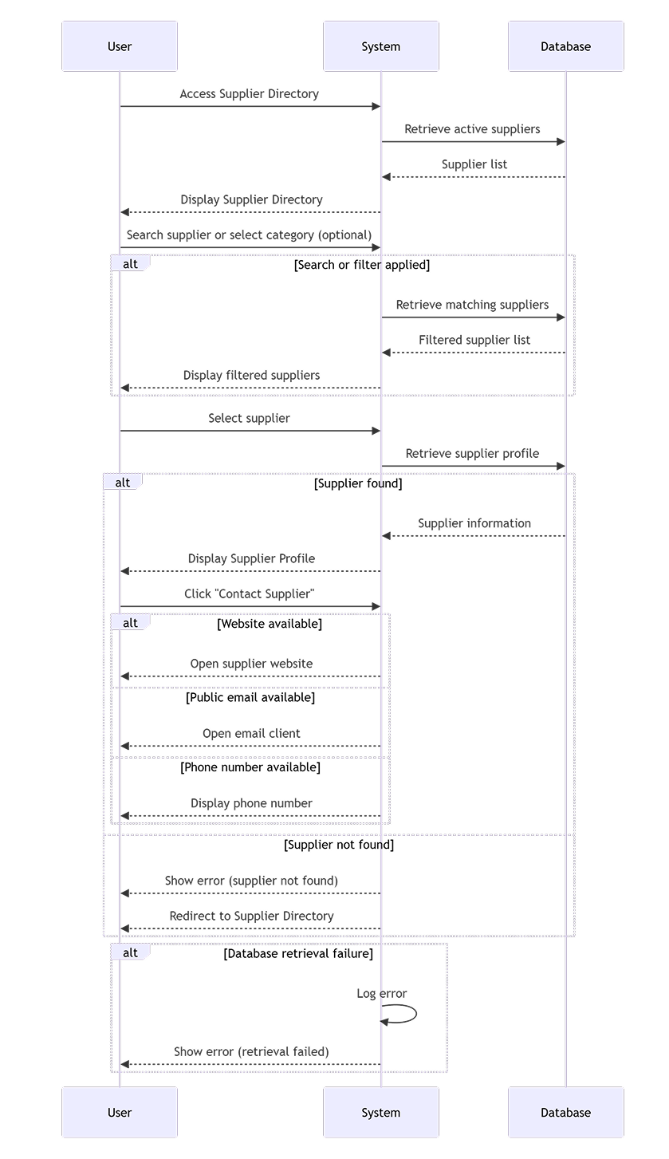

Mermaid code:

sequenceDiagram
participant U as User
participant S as System
participant DB as Database

%% --- MAIN FLOW ---
U->>S: Access Supplier Directory

S->>DB: Retrieve active suppliers
DB-->>S: Supplier list

S-->>U: Display Supplier Directory

U->>S: Search supplier or select category (optional)

alt Search or filter applied
S->>DB: Retrieve matching suppliers
DB-->>S: Filtered supplier list
S-->>U: Display filtered suppliers
end

U->>S: Select supplier

S->>DB: Retrieve supplier profile

alt Supplier found
DB-->>S: Supplier information
S-->>U: Display Supplier Profile

U->>S: Click "Contact Supplier"

alt Website available
S-->>U: Open supplier website
else Public email available
S-->>U: Open email client
else Phone number available
S-->>U: Display phone number
end

else Supplier not found
S-->>U: Show error (supplier not found)
S-->>U: Redirect to Supplier Directory
end

alt Database retrieval failure
S->>S: Log error
S-->>U: Show error (retrieval failed)
end

State Diagram

NA

Class Diagram

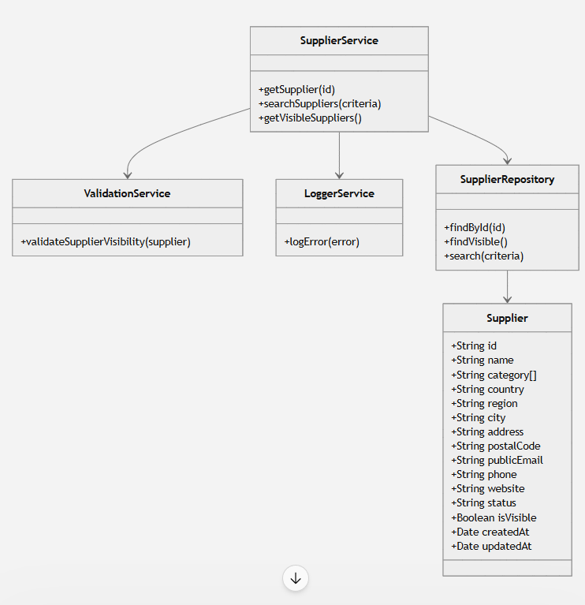

Mermaid code:

classDiagram

%% ========================
%% CORE ENTITIES
%% ========================

class Supplier {
+String id
+String name
+String category[]
+String country
+String region
+String city
+String address
+String postalCode
+String publicEmail
+String phone
+String website
+String status
+Boolean isVisible
+Date createdAt
+Date updatedAt
}

%% ========================
%% SERVICES
%% ========================

class SupplierService {
+getSupplier(id)
+searchSuppliers(criteria)
+getVisibleSuppliers()
}

class ValidationService {
+validateSupplierVisibility(supplier)
}

class LoggerService {
+logError(error)
}

%% ========================
%% REPOSITORIES
%% ========================

class SupplierRepository {
+findById(id)
+findVisible()
+search(criteria)
}

%% ========================
%% RELATIONSHIPS
%% ========================

SupplierService --> SupplierRepository
SupplierService --> ValidationService
SupplierService --> LoggerService

SupplierRepository --> Supplier

Data Model

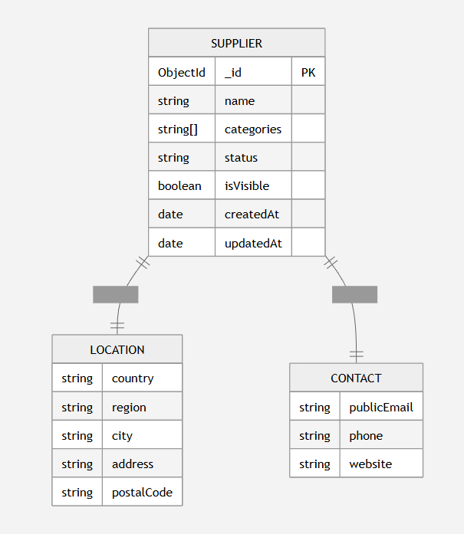

Mermaid code:

erDiagram

SUPPLIER {
ObjectId _id PK
string name
string[] categories
string status
boolean isVisible
date createdAt
date updatedAt
}

LOCATION {
string country
string region
string city
string address
string postalCode
}

CONTACT {
string publicEmail
string phone
string website
}

SUPPLIER ||--|| LOCATION : embeds
SUPPLIER ||--|| CONTACT : embeds

Requirements Specification

Epics and User Stories

7.1.1 Epics

Epic ID | Description | Priority
#29 | Supplier & Resource Directory | High

7.1.2 User Stories

Story ID | Description | Priority
#240 | As a platform user, I want to browse available suppliers so that I can identify suppliers relevant to my needs. | High
#242 | As a platform user, I want to view a supplier profile so that I can review its public information and contact details. | High

Business Requirements

Ref ID | Category | Description
#93 | Supplier  Discoverability | Sawaka must enable users to discover suppliers through a centralized and accessible Supplier Directory.
#80 | Data Privacy | Sawaka must ensure that only supplier information intended for public display is accessible through the Supplier Directory and supplier profile pages.

Functional Requirements

Ref ID | Category | Description
#254 | Display Supplier Directory | The system must display a list of suppliers that are active and publicly visible.
#255 | Search Suppliers | The system must allow users to search suppliers by supplier name or categories.
#256 | Display Supplier Profile | The system must display the selected supplier’s publicly available profile information
#257 | Supplier Not Found | When the requested supplier does not exist, the system must display an appropriate message and provide access back to the Supplier Directory.
#258 | Optional Field Handling | The system must hide optional supplier information that has not been provided instead of displaying empty values.

Non-Functional Requirements

Ref ID | Category | Description
#143 | Retrieval Error Handling | When supplier information cannot be retrieved because of a system error, the system must display an error message without exposing technical details.
#145 | Search and Filter Performance | The system shall update supplier search and filter results within 2 seconds under normal operating conditions

Implementation Notes

The following technical assumptions and implementation guidelines are provided to support development. These are indicative and may evolve during implementation.
- Frontend: React (Next.js)
- Backend: Node.js (Express)
- Database: MongoDB
- Data Access: Supplier information retrieved through the existing Supplier service and repository.
- Search: Supplier search and category filtering should be performed using indexed supplier attributes where applicable.
- Visibility: Only suppliers with status = Active and isVisible = true should be returned for public display.
- Security: Private supplier information (e.g., Account Email, Owner ID) must not be exposed through public APIs.
- Communication: All requests for the Supplier Directory and Supplier Profile should be performed over HTTPS.
- Error Handling: The application should return user-friendly error messages while logging technical details for troubleshooting.

References & Policies

Reference Table

Ref ID | Title | Location / Link

Information Policies

Ref ID | Title | Location / Link

