Requirements Specification v1.0
  - Feature – Manage Project
Sawaka

Bond52
Sprint 24 | Feature #479 | Epic #215

Table of Contents
1. Purpose of the Requirements Specification
1.1 Purpose
2. Requirements Specification Approvals
2.1 Version History
3. Project Definition
3.1 Business outcome
3.2 Scope boundaries
4. Constraints, Assumptions & Dependencies
4.1 Constraints
4.2 Assumptions
4.3 Dependencies
5. Terms and Definitions
6. Requirements Specification — Solution Views
6.1 Conceptual Model
6.1.1 Conceptual relationships
6.2 User Interface
6.3 Use Cases
6.3.1 UC-479-01 — Create and publish project
6.3.2 UC-479-02 — Maintain stages, needs, updates and media
6.4 Sequence Diagram
6.5 State Diagram
6.6 Class Diagram
6.7 Data Model
7. Requirements Specification — Traceability
7.1 Epics and User Stories
7.1.1 Epics
7.1.2 User Stories
7.2 Business Requirements
7.3 Functional Requirements
7.4 Non-Functional Requirements
7.5 Implementation Notes
7.6 Traceability Matrix
8. References & Policies
8.1 Information Policies

1. Purpose of the Requirements Specification

1.1 Purpose
Define how authenticated Sawaka members create, modify, publish and maintain community projects, their stages, needs, blockers, media and updates. This is lightweight community collaboration, not operational task management.

2. Requirements Specification Approvals

2.1 Version History
Author | Version | Date | Summary of changes
Bond52 / Sawaka – draft prepared with AI assistance | 1.0 | 2026-11-01 | Initial proposed requirements baseline for Sprint 24

3. Project Definition
A Project is a member-owned initiative described publicly when published. Its stages communicate broad progress; needs and blockers invite community assistance. Management actions are owned by this feature, while public discovery and conversations belong to Feature #479 - Manage Projects.

3.1 Business outcome
A member can publish a coherent project in minutes and keep its community-facing progress and needs accurate.

3.2 Scope boundaries
In Scope | Out of Scope
Project CRUD, draft/publish/archive, stages, needs, blockers, media, updates and owner views | Gantt, task assignment, timesheets, detailed resources and budgets, financial flows, public comments and subscriptions

4. Constraints, Assumptions & Dependencies

4.1 Constraints
CO ID | Description
CO-01 | Only authenticated owners or authorized administrators can mutate projects.
CO-02 | Unpublished or archived projects must not be indexed in the public directory.
CO-03 | No operational task management or automatic AI project creation.
CO-04 | Respect media privacy, licensing and upload constraints.

4.2 Assumptions
AS ID | Description
AS-01 | Existing Sawaka authentication and user/contributor identity can be reused.
AS-02 | Category taxonomy and image storage are available or selected during design.
AS-03 | Stages are optional when creating a project.

4.3 Dependencies
DE ID | Description
DE-01 | Feature #480 consumes public project data.
DE-03 | Administration/content moderation rules and media storage service.

5. Terms and Definitions
Term | Definition
Project | A community initiative with a creator and a lifecycle.
Stage | A broad milestone, not an individual assigned task.
Need | A specific resource, skill or advice requested.
Blocker | An obstacle that prevents or constrains a stage.
Update | A creator-authored news item about project progress.
Draft | Owner-visible unpublished project.
Archived | Retained project excluded from discovery.

6. Requirements Specification — Solution Views

6.1 Conceptual Model
User owns Project; Project aggregates ordered ProjectStages, ProjectNeeds, ProjectUpdates and ProjectMedia. A need can optionally refer to a stage; media may be added as an attachment to a project, stage or update. All child records inherit project visibility.

6.1.1 Conceptual relationships

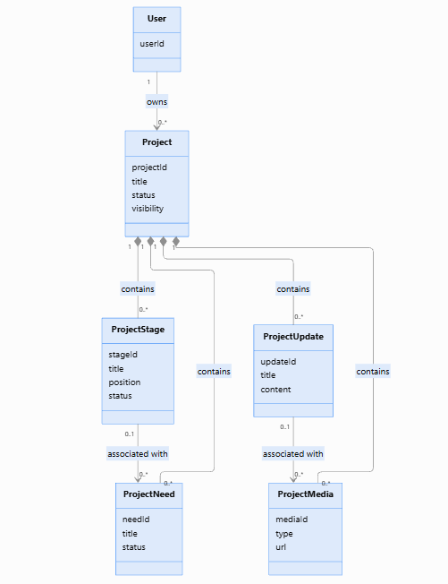

Proposed Mermaid source (diagram can be rendered in the engineering documentation):
classDiagram
direction TB

class User {
userId
}

class Project {
projectId
title
status
visibility
}

class ProjectStage {
stageId
title
position
status
}

class ProjectNeed {
needId
title
status
}

class ProjectUpdate {
updateId
title
content
}

class ProjectMedia {
mediaId
type
url
}

User "1" --> "0..*" Project : owns

Project "1" *-- "0..*" ProjectStage : contains
Project "1" *-- "0..*" ProjectNeed : contains
Project "1" *-- "0..*" ProjectUpdate : contains
Project "1" *-- "0..*" ProjectMedia : contains
ProjectStage "0..1" --> "0..*" ProjectNeed : associated with
ProjectUpdate "0..1" --> "0..*" ProjectMedia : associated with

6.2 User Interface
Section | Component | Type | Required | Behavior / validation
My Projects | Create Project | Button | Yes | Opens a draft creation form; login required.
Project editor | Title / summary / objective | Text | Yes | Trim and validate non-empty title and objective; enforce safe lengths.
Project editor | Category / country / city | Select/text | Conditional | Choose valid taxonomy and location; country/city required for public projects (proposed).
Project editor | Description / cover | Rich text / image | No | Sanitize text; validate upload size and media type.
Project editor | Save Draft / Publish | Buttons | Yes | Publish only after required public fields pass validation.
Stages | Add / reorder / status | List and controls | No | Manage milestone order and status without tasks.
Needs | Need + stage link | Form | No | Optional stage link, type, status, explanation.
Updates | Publish update | Composer | No | Creator can post contextual news; publish respects project visibility.

6.3 Use Cases

6.3.1 UC-479-01 — Create and publish project
Property | Definition
Primary actor | Authenticated member
Trigger | Select Create Project
Preconditions | Member session valid.
Postconditions | Persisted draft or published project tied to owner.
Frequency | As needed

6.3.1.1 Main Scenario
1. System displays lightweight project form.
2. Member enters title, summary and location.
3. Member saves a draft, or chooses Publish.
4. System validates permissions and publication-required fields.
5. System persists record and displays confirmation.

6.3.1.2 Alternative and Exception Scenarios
- Save incomplete content as a private draft.
- Invalid category or missing fields: show inline errors; preserve entered values.
- Database failure: keep editor state and show retry path.

6.3.2 UC-479-02 — Maintain stages, needs, updates and media
Property | Definition
Primary actor | Project owner
Trigger | Open Manage Project
Preconditions | Member owns a non-deleted project.
Postconditions | Changes are saved and visible according to project visibility.
Frequency | As needed

6.3.2.1 Main Scenario
1. Owner opens an existing project editor.
2. System retrieves editable project information, stages, and their associated needs.
3. Owner creates, edits, or reorders a project stage and defines its status.
4. Owner adds or updates a need within the selected stage, describing the required skill, resource, service, or assistance.
5. Owner optionally marks a need as Blocked and provides the reason preventing its fulfillment.
6. Owner uploads permitted media and publishes a project or stage update.
7. System validates the project hierarchy, ensuring every stage belongs to a project, and every need belongs to a stage.
8. System saves the changes and refreshes the project summary, including stage progress, needs, and blocked needs.

6.3.2.2 Alternative and Exception Scenarios
- Blocked stage can have an explanation without a public assistance request.
- Remove stage: avoid orphaned needs/comments; request confirmation or detach per policy.

6.4 Sequence Diagram

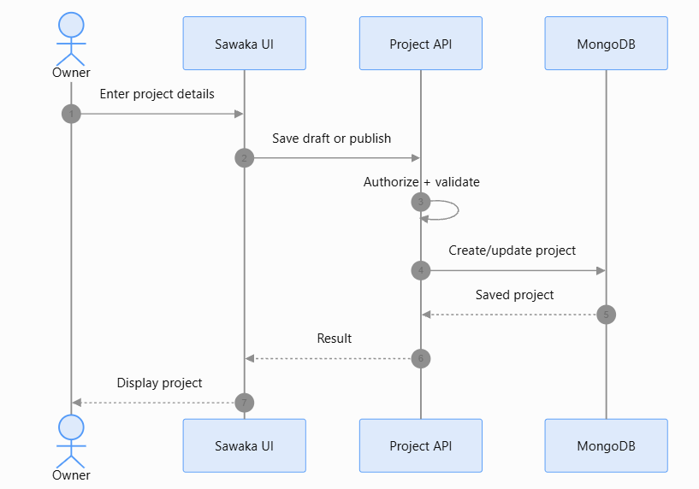
Proposed Mermaid source (diagram can be rendered in the engineering documentation):
sequenceDiagram
actor Owner
participant UI as Sawaka UI
participant API as Project API
participant DB as MongoDB
Owner->>UI: Enter project details
UI->>API: Save draft or publish
API->>API: Authorize + validate
API->>DB: Create/update project
DB-->>API: Saved project
API-->>UI: Result
UI-->>Owner: Display project

6.5 State Diagram

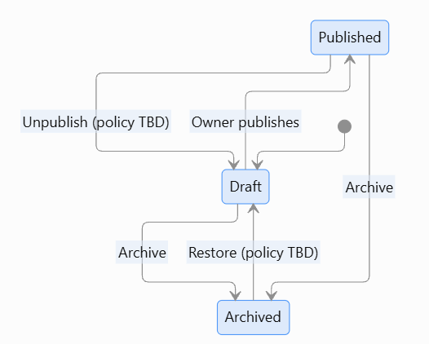
Proposed Mermaid state diagram:
stateDiagram-v2
[*] --> Draft
Draft --> Published: Owner publishes
Published --> Draft: Unpublish (policy TBD)
Published --> Archived: Archive
Draft --> Archived: Archive
Archived --> Draft: Restore (policy TBD)

6.6 Class Diagram
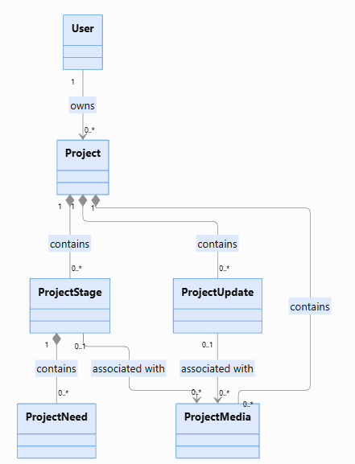
Conceptual class diagram, not a finalized implementation schema:
classDiagram
User "1" --> "0..*" Project : owns
Project "1" --> "0..*" ProjectStage
Project "1" --> "0..*" ProjectNeed
Project "1" --> "0..*" ProjectUpdate
Project "1" --> "0..*" ProjectMedia
ProjectStage "0..1" <-- "0..*" ProjectNeed

6.7 Data Model
Entity | Important attributes | Validation / relationships
Project | id, ownerId, title, summary, description, objective, categoryId, country, city, status, visibility, coverMediaId, createdAt, updatedAt, publishedAt, archivedAt | OwnerId FK; title required; distinct lifecycle and stage states.
ProjectStage | id, projectId, title, description, position, status, startedAt, completedAt | Position ordered within project; status NotStarted/InProgress/Blocked/Completed/Cancelled.
ProjectNeed | id, projectId, stageId?, title, description, type, status, createdAt, resolvedAt | Stage must belong to same project; Open/Resolved/Cancelled.
ProjectUpdate | id, projectId, stageId?, authorId, title, content, createdAt, updatedAt | Updates restricted to owner in MVP.
ProjectMedia | id, projectId, stageId?, updateId?, uploadedBy, url, mimeType, caption, createdAt | Permitted file type and authorized associations.

Cardinality and entity design above are proposed logical requirements; physical MongoDB collections, embedded arrays and indexes are implementation decisions.

7. Requirements Specification — Traceability

7.1 Epics and User Stories

7.1.1 Epics
Epic ID | Description | Priority
#215 | Project Lifecycle | High

7.1.2 User Stories
Story ID | Description | Priority
#488 | As a member, I want to create and save a project draft so that I can develop it before publishing. | High
#489 | As an owner, I want to edit, publish and archive my project so that information remains accurate. | High
#490 | As an owner, I want to manage high-level stages and their statuses so that progress is understandable. | High
#491 | As an owner, I want to publish needs and blockers so that others know how to help. | High
#492 | As an owner, I want to add media and updates so that the community sees progress. | Medium

7.2 Business Requirements
Ref ID | Category | Description
#487 | BR — Community Project & Initiative Management | Sawaka must enable community members to create, organize, share, and advance initiatives and projects collaboratively by providing visibility into their objectives, stages, needs, progress, and challenges while facilitating community participation and support.

7.3 Functional Requirements
Ref ID | Category | Description
#493 | Project Draft Creation | The system must allow an authenticated user to create and save a private project draft without publishing it to the community.
#494 | Project Publication Validation | The system must validate that all required project information is complete and valid before allowing an authorized owner to publish a project.
#495 | Project Information Update | The system must allow an authorized project owner to update editable project information and persist valid changes while preserving project ownership and system-controlled attributes.
#496 | Project Stage Management | The system must allow an authorized project owner to create, edit, reorder, and remove stages associated with an existing project, while preserving the integrity of their associated needs.
#497 | Stage Status Management | The system must allow an authorized project owner to assign and update project stage statuses, including Not Started, In Progress, Blocked, Completed, and Cancelled.
#498 | Project Progress Calculation | The system must calculate and display an understandable project progress summary based on completed eligible project stages.
#499 | Stage Need Management | The system must allow an authorized project owner to create, edit, and remove needs associated with a specific project stage. Every need must belong to exactly one existing stage.
#500 | Need Status Management | The system must allow an authorized project owner to manage the status of needs associated with project stages, including Open, Blocked, Fulfilled, and Cancelled.
#501 | Project Media Management | The system must validate, store, and associate approved media with a project, project stage, or project update, and allow authorized project owners to manage those media.
#502 | Need Blocker Explanation | The system must require an explanation when a project need is marked as Blocked and allow the authorized project owner to update or resolve the blocker.

7.4 Non-Functional Requirements
Ref ID | Category | Description

7.5 Implementation Notes
- Next.js frontend, Express API and MongoDB are current Sawaka platform choices; confirm current repository implementation before coding.
- Prefer project-owner authorization enforced at API and data-access layers.
- Keep media binaries outside MongoDB with authorized references; select provider before implementation.
- Reuse existing category, authentication, translation and audit capabilities.

7.6 Traceability Matrix
Business Req. | Functional Req. range | Candidate User Stories
s

8. References & Policies
Ref ID | Title | Location / Link
REF-01 | Sawaka Vision Document | https://github.com/Bond52/sawaka/wiki/Vision-Document
REF-02 | Parent Feature | https://github.com/Bond52/sawaka/issues/479
REF-03 | Parent Epic | https://github.com/Bond52/sawaka/issues/215

8.1 Information Policies
- Apply least-privilege access to personal and non-public profile data.
- Retain only necessary data; define retention/deletion and moderation policies before release.

