**APPENDIX S1**. Type I error rates of population- and individual-based methods when using the uniform selection surface (selection absent). Type I error rates are reported at 50 and 500 generations, and refer to the proportion of replicates where neutral loci were identified as under selection at the 95% and 99% confidence interval levels (LOSITAN, GLM, Samβada) and with FDR q value thresholds < 0.05 and 0.01(BayeScan), which are analogues of *P*-values (displayed under 95% and 99% columns).

|  |  |  |  |  |  |  |  |  |  |
| --- | --- | --- | --- | --- | --- | --- | --- | --- | --- |
| Selection surface | low *Nm*, high drift | | | low *Nm*, low drift | | high *Nm*, high drift | | high *Nm*, low drift | |
| Absent | 95% | | 99% | 95% | 99% | 95% | 99% | 95% | 99% |
| LOSITAN |  | |  |  |  |  |  |  |  |
| 50 | 0.3 | | 0.1 | 0 | 0 | 0.1 | 0 | 0 | 0 |
| 500 | 0.8 | | 0.1 | 0.1 | 0 | 0.2 | 0.1 | 0 | 0 |
| BayeScan |  |  |  |  |  |  |  |  |  |
| 50 | 0.1 | | 0.1 | 0.1 | 0.1 | 0 | 0 | 0 | 0 |
| 500 | 0.1 | | 0.1 | 0.1 | 0.1 | 0.1 | 0.1 | 0 | 0 |
| Samβada |  | |  |  |  |  |  |  |  |
| 50 | 1 | | 1 | 0.7 | 0.7 | 0.8 | 0.8 | 0.8 | 0.8 |
| 500 | 1 | | 1 | 0.7 | 0.7 | 0.3 | 0.3 | 0.7 | 0.7 |
| GLM |  | |  |  |  |  |  |  |  |
| 50 | 1 | | 1 | 1 | 1 | 1 | 1 | 1 | 1 |
| 500 | 1 | | 1 | 1 | 1 | 1 | 1 | 1 | 1 |

**APPENDIX S2**. *Dest* results depicting genetic differentiation for adaptive (selection-driven), neutral and combined loci. The selection gradient surface is shown with (a) selection strong (*s* = 0.5) and (b) weak (*s* = 0.1), for the i) low *Nm*, high drift, ii) high *Nm*, high drift, iii) low *Nm*, low drift, iv) high *Nm*, low drift scenarios. See Tables 1 and 2 for descriptions.

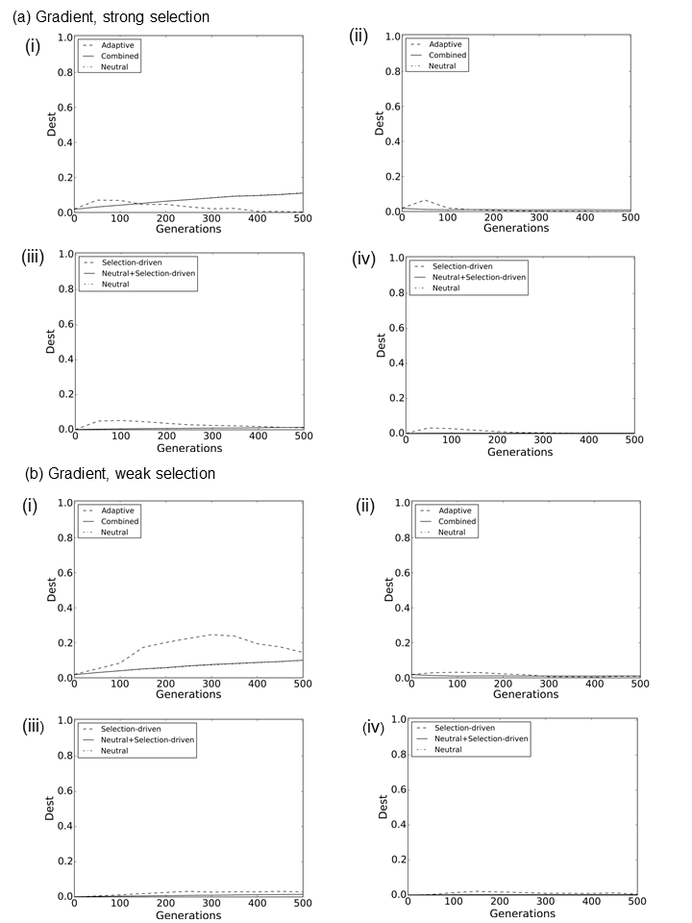

**APPENDIX S3**. *Dest* (a) and Mantel *r* (b) results depicting genetic differentiation for adaptive (selection-driven), neutral and combined loci in the uniform selection surface (selection absent) for the i) low *Nm*, high drift, ii) high *Nm*, high drift, iii) low *Nm*, low drift, iv) high *Nm*, low scenarios. See Tables 1 and 2 for descriptions.

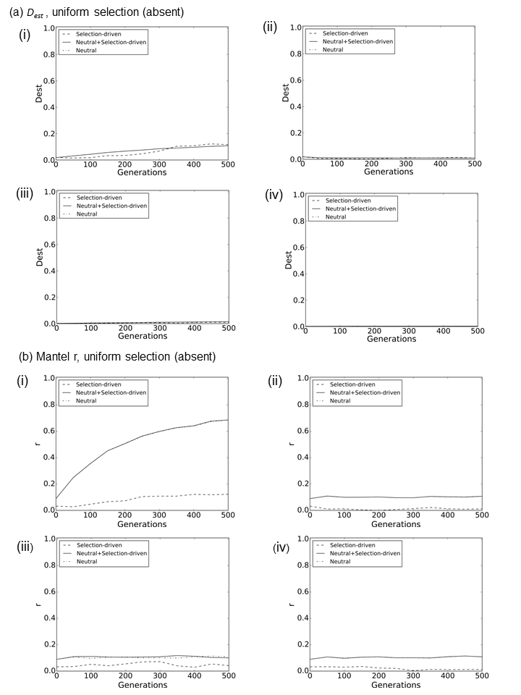

**APPENDIX S4**. Type II error rates of population- and individual-based methods to detect loci under selection after 50 generations, and the proportion of replicates where this occurred at the 95% and 99% confidence interval levels (LOSITAN, GLM, Samβada) and with FDR q value thresholds < 0.05 and 0.01(BayeScan), which are analogues of *P*-values (displayed under 95% and 99% columns). Type II error rates are shown for a.) selection present/absent surfaces, and b.) gradient surfaces, for both weak and strong selection scenarios.

|  |  |  |  |  |  |  |  |  |  |  |
| --- | --- | --- | --- | --- | --- | --- | --- | --- | --- | --- |
| a.) | | | Present/Absent | | | | | | | |
| Selection strength | Method | low *Nm*, high drift | | | low *Nm*, low drift | | high *Nm*, high drift | | high *Nm*, low drift | |
|  | CIs | | 95% | 99% | 95% | 99% | 95% | 99% | 95% | 99% |
| weak | LOSITAN | | 1 | 1 | 1 | 1 | 0.9 | 1 | 1 | 1 |
|  | BayeScan | | 1 | 1 | 0.6 | 0.6 | 1 | 1 | 0.7 | 0.7 |
|  | Samβada | | 0 | 0 | 0 | 0 | 0.2 | 0.2 | 0 | 0 |
|  | GLM | | 0 | 0 | 0 | 0 | 0.2 | 0.2 | 0 | 0 |
| strong | LOSITAN | | 0 | 0 | 0 | 0 | 0 | 0 | 0 | 0 |
|  | BayeScan | | 0 | 0 | 0 | 0 | 0 | 0 | 0 | 0 |
|  | Samβada | | 0 | 0 | 0 | 0 | 0.2 | 0.2 | 0 | 0 |
|  | GLM | | 0 | 0 | 0 | 0 | 0 | 0 | 0 | 0 |
|  |  | |  |  |  |  |  |  |  |  |
| b.) |  | | Gradient | | | | | | | |
| Selection strength | Method | | low *Nm*, high drift | | low *Nm*, low drift |  | high N *Nm*, high drift |  | high *Nm*, low drift |  |
|  | CIs | | 95% | 99% | 95% | 99% | 95% | 99% | 95% | 99% |
| weak | LOSITAN | | 1 | 1 | 1 | 1 | 0.9 | 1 | 1 | 1 |
|  | BayeScan | | 1 | 1 | 1 | 1 | 1 | 1 | 1 | 1 |
|  | Samβada | | 0.2 | 0.2 | 0.2 | 0.2 | 0.3 | 0.3 | 0 | 0 |
|  | GLM | | 0.3 | 0.3 | 0.1 | 0.1 | 0.3 | 0.3 | 0 | 0 |
| strong | LOSITAN | | 0.9 | 1 | 0.7 | 1 | 0.7 | 0.9 | 1 | 1 |
|  | BayeScan | | 1 | 1 | 0 | 0 | 0.9 | 1 | 0.1 | 0.1 |
|  | Samβada | | 0.2 | 0.2 | 0 | 0 | 0 | 0 | 0 | 0 |
|  | GLM | | 0 | 0 | 0 | 0 | 0.1 | 0.1 | 0 | 0 |

**APPENDIX S5**. Type I error rates of individual-based methods (Samβada and GLMs) defined as the mean number of neutral loci significantly correlated with the selection gradient (latitude) at the 95% and 99% confidence interval levels after 50 generations. The expected number of significantly correlated loci for 95% and 99% is 5 and 1, respectively (with 100 simulated loci).

|  |  |  |  |  |  |  |  |  |  |
| --- | --- | --- | --- | --- | --- | --- | --- | --- | --- |
| a.) |  | Present/absent | |  |  |  |  |  |  |
| Selection strength | Method | low *Nm*, high drift | | low *Nm*, low drift | | high *Nm*, high drift | | high *Nm*, low drift | |
|  | CIs | 95% | 99% | 95% | 99% | 95% | 99% | 95% | 99% |
| weak | Samβada | 27 | 24 | 30 | 21 | 16 | 13 | 21 | 17 |
|  | GLM | 28 | 26 | 25 | 22 | 18 | 14 | 22 | 19 |
| strong | Samβada | 29 | 25 | 25 | 21 | 16 | 13 | 20 | 17 |
|  | GLM | 31 | 27 | 26 | 23 | 16 | 14 | 22 | 19 |
| b.) |  | Gradient |  |  |  |  |  |  |  |
| Selection strength | Method | low *Nm*, high drift | | low *Nm*, low drift | | high *Nm*, high drift | | high *Nm*, low drift | |
|  | CIs | 95% | 99% | 95% | 99% | 95% | 99% | 95% | 99% |
| weak | Samβada | 26 | 22 | 27 | 22 | 15 | 12 | 22 | 18 |
|  | GLM | 27 | 24 | 29 | 25 | 17 | 14 | 23 | 20 |
| strong | Samβada | 27 | 23 | 26 | 22 | 15 | 12 | 23 | 19 |
|  | GLM | 35 | 29 | 27 | 25 | 17 | 14 | 25 | 22 |