Experimental Design for Automatic Egg Incubators Hatchability Rates Variability Using a $2^{2}$ factorial Design With RCBD.
STAT.BONVENTURE.M.MIRUKA
2026-09-23

OBJECTIVE
To determine whether Temperature, Humidity or their interaction is the primary factor driving variations in egg hatchability rate (Y) and quantify individual-level incubator variability.

EXPERIMENTAL DESIGN
We utilize a $2^{2}$ full Factorial Design in a Randomized Complete Block Design.
i). Factor A: Temperature (T) - Low (To): standard low (36.5℃)
- High (T1): standard optimal (37.8℃)
ii). Factor B: Relative Humidity (H) - Low (Ho): standard low (45% RH)
- High (H1): standard optimal (55% RH)

iii). Blocks: Incubator models- M1, M2, M3, M4
iv). Experimental units: Fertilized chicken eggs.
v). Replications: r = 3 runs per model treatment combination.

STATISTICAL ANALYSIS MODEL FRAMEWORK
Model : Two-way ANOVA with blocking Model equation : Yijk= μ + αi + βj + (αβ)ij + γk + εijk, where
μ: overall mean hatchability rate
αi: main effect of temp level i
βj: main effect of humidity level j
(αβ)ij: interaction effect
γk: blocking effect of model k
εijk: random error ~N(0,σ^2)

SAMPLE HEAD
incubator_model temp_level humidity_level hatchability_rate
M1 low low 62.4
M1 low low 60.8
M1 low low 63.1
M1 low high 68.5
M1 low high 67.2
M1 low high 69.0

ANOVA WITH RANDOMIZED COMPLETE BLOCK DESIGN

Step 1: Two_way anova table.
=== TWO_WAY ANOVA TABLE ===
Df Sum Sq Mean Sq F value Pr(>F)
temp_level 1 2962.6 2962.6 1605.77 < 2e-16 ***
humidity_level 1 1037.0 1037.0 562.04 < 2e-16 ***
incubator_model 3 1517.0 505.7 274.08 < 2e-16 ***
temp_level:humidity_level 1 120.7 120.7 65.39 5.04e-10 ***
Residuals 41 75.6 1.8
---
Signif. codes: 0 '***' 0.001 '**' 0.01 '*' 0.05 '.' 0.1 ' ' 1
NOTE:
- By the view of the Anova table, p-values of extremely less than 0.05 indicate that there is significant effect of the various factors towards hatchability rates.

Step 2: Calculating effect size (eta-squared) to identify primary factor.
=== EFFECT SIZE (ETA-SQUARED/ PROPORTION OF VARIANCE) ===
Eta_Squared
temp_level 0.5186
humidity_level 0.1815
incubator_model 0.2655
temp_level:humidity_level 0.0211
Residuals 0.0132
NOTE:
- Temperature levels account for the majority of total variance (51.86%) confirming it as the primary factor towards hatchability rates, if distorted its effect is massive.
- Humidity effect is suppressed by temperature as it accounts for minimal variance on hatchability rates.

Step 3: Post-hoc analysis for individual incubator models (Tukey HSD).
=== POST-HOC TUKEY HSD (Incubator model differences) ===
Tukey multiple comparisons of means
95% family-wise confidence level
Fit: aov(formula= hatchability_rate ~ temp_level * humidity_level + incubator_model, data = incubator_data)
$incubator_model
diff lwr upr p adj
M2-M1 -4.158333 -5.643131 -2.673536 0.0e+00
M3-M1 -12.050000 -13.534798 -10.565202 0.0e+00
M4-M1 2.883333 1.398536 4.368131 3.4e-05
M3-M2 -7.891667 -9.376464 -6.406869 0.0e+00
M4-M2 7.041667 5.556869 8.526464 0.0e+00
M4-M3 14.933333 13.448536 16.418131 0.0e+00
NOTE:
- Incubator model 1 and 4 show a significant difference in hatchability rates from the rest of the models (2&3).
- We will proceed for plot diagnostics to depict whether M1 and M4 differences suggest lower or higher hatchability rates.

PLOT DIAGNOSTICS
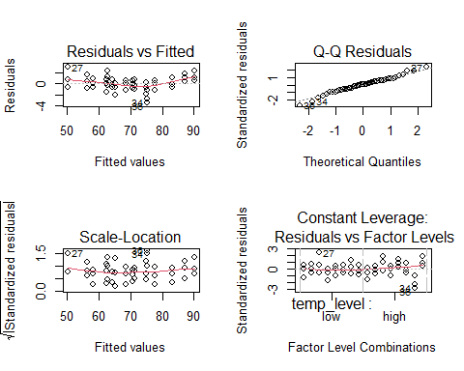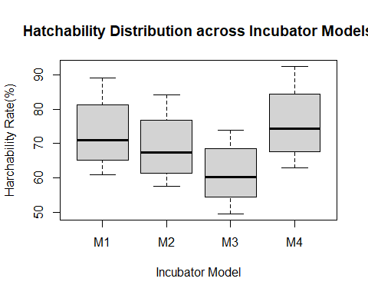
NOTE:
- M1 and M4 clearly display a possibility for higher hatchability rates generally with a median rate of 70% and 75.10% respectively.

CONCLUSIONS
- The experimental design is adoptable and meets the objective’s needs.
- Temperature accounts for the most of the variance with a score of 0.5186/1.0000. thus, it is the primary factor for distorted hatchability rates.
- There is significant difference in hatchability across the 4 incubator models with model 1 and 4 showing potential higher productivity than the rest after a post-hoc thorough analysis.
- Significantly model 4 is the best incubator accounted by the middle 50% of hatchability rates ranging above 67%, a shorter lower whisker end and a median of ≈75% (highest across incubator models).

