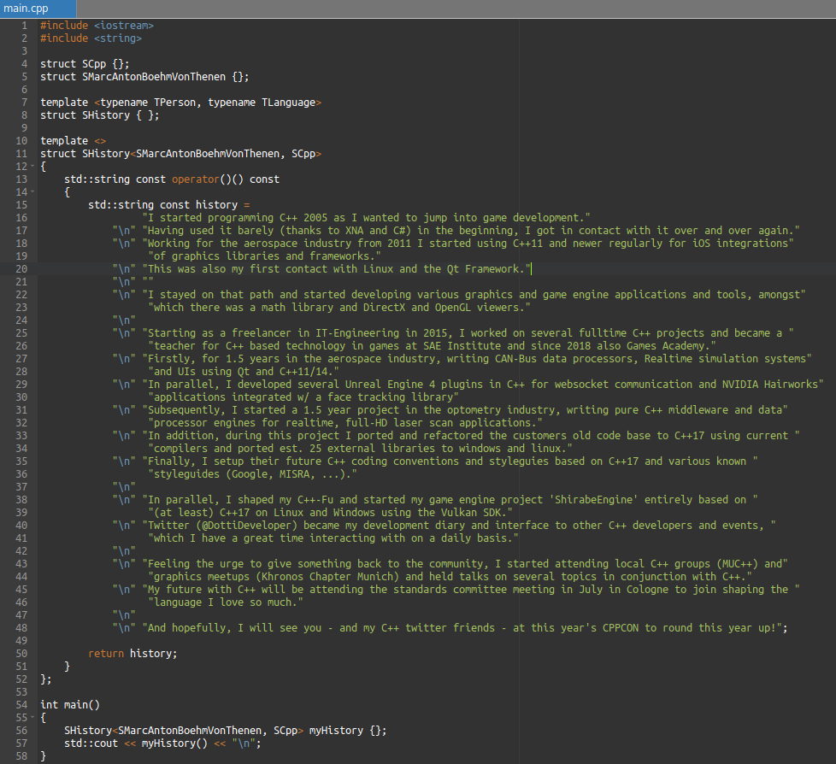
Executable:

https://onlinegdb.com/HJaie9WaN

