XML)До манипуляций

<Catalog>

    <Students>

        <Student id="0">

            <Surname>Minakov</Surname>

            <Exams>

                <Math>75</Math>

                <RusLang>100</RusLang>

                <Inform>75</Inform>

            </Exams>

        </Student>

        <Student id="1">

            <Surname>Emelyanov</Surname>

            <Exams>

                <Math>100</Math>

                <RusLang>90</RusLang>

                <Inform>82</Inform>

            </Exams>

        </Student>

        <Student id="2">

            <Surname>Kovalchuk</Surname>

            <Exams>

                <Math>34</Math>

                <RusLang>56</RusLang>

                <Inform>100</Inform>

            </Exams>

        </Student>

    </Students>

</Catalog>

Main)import tkinter

from tkinter import ttk

from tkinter.ttk import Radiobutton

from tkinter.ttk import Checkbutton

import matplotlib.pyplot

import LAB6EX1

import LAB6EX2

import LAB6EX3

from tkinter import *

window = Tk()

tab_control = ttk.Notebook(window)

tab1 = ttk.Frame(tab_control)

tab2 = ttk.Frame(tab_control)

tab3 = ttk.Frame(tab_control)

tab_control.add(tab1, text='EX1')

tab_control.add(tab2, text='EX2')

tab_control.add(tab3, text='EX3')

tab_control.pack(expand=1, fill='both')

#TAB1

TAB1txt1 = Entry(tab1, width=10)

TAB1txt1.grid(column=0, row=0)

TAB1txt2 = Entry(tab1, width=10)

TAB1txt2.grid(column=1, row=0)

TAB1txt3 = Entry(tab1, width=10)

TAB1txt3.grid(column=2, row=0)

#TABLables

TAB1Lbl1 = Label(tab1, text="Xmin")

TAB1Lbl1.grid(column=0, row=1)

TAB1Lbl2 = Label(tab1, text="Xmax")

TAB1Lbl2.grid(column=1, row=1)

TAB1Lbl3 = Label(tab1, text="Function")

TAB1Lbl3.grid(column=2, row=1)

#TAB1Func

def Ex1():

    LAB6EX1.MakeGraph(TAB1txt3.get(), int(TAB1txt1.get()), int(TAB1txt2.get()))

btn = Button(tab1, text="Make Graph", command = Ex1)

btn.grid(column=3, row=0)

#TAB2

NumberStud = LAB6EX2.ReturnNumber()

Buttonlist = list()

Radval = IntVar()

Radval.set(0)

for i in range(0,NumberStud):

    Buttonlist.append(Radiobutton(tab2, text = LAB6EX2.ReturnName(i), value = i, variable = Radval))

    Buttonlist[i].grid(column=0, row=i)

MathCheck = BooleanVar()

InfaCheck = BooleanVar()

RusslangCheck = BooleanVar()

MathCheck.set(0)

InfaCheck.set(0)

RusslangCheck.set(0)

MathCheckbutton = Checkbutton(tab2, text = 'Math',variable = MathCheck, offvalue=0, onvalue=1)

MathCheckbutton.grid(column=1,row=0)

InfaCheckbutton = Checkbutton(tab2, text = 'Informatics',variable=InfaCheck, offvalue=0, onvalue=1)

InfaCheckbutton.grid(column=1,row=1)

RussLangCheckbutton = Checkbutton(tab2, text = 'Russian Language',variable=RusslangCheck, offvalue=0, onvalue=1)

RussLangCheckbutton.grid(column=1,row=2)

TAB2txt1 = Entry(tab2, width=10)

TAB2txt1.grid(column=3, row=0)

TAB2txt2 = Entry(tab2, width=10)

TAB2txt2.grid(column=3, row=1)

TAB2txt3 = Entry(tab2, width=10)

TAB2txt3.grid(column=3, row=2)

def Ex2():

    if MathCheck.get() == 1:

        LAB6EX2.RewriteScore(Radval.get(),'Math',TAB2txt1.get())

    if InfaCheck.get() == 1:

        LAB6EX2.RewriteScore(Radval.get(),'Inform',TAB2txt2.get())

    if RusslangCheck.get() == 1:

        LAB6EX2.RewriteScore(Radval.get(),'RusLang',TAB2txt3.get())

btn2 = Button(tab2, text="UDP XML", command = Ex2)

btn2.grid(column=0, row=5)

#TAB3

TAB3Lbl1 = Label(tab3, text="Surname")

TAB3Lbl1.grid(column=0, row=0)

TAB3Lbl2 = Label(tab3, text="Math")

TAB3Lbl2.grid(column=0, row=1)

TAB3Lbl3 = Label(tab3, text="Informatics")

TAB3Lbl3.grid(column=0, row=2)

TAB3Lbl4 = Label(tab3, text="Russian Language")

TAB3Lbl4.grid(column=0, row=4)

TAB3txt1 = Entry(tab3, width=10)

TAB3txt1.grid(column=2, row=0)

TAB3txt2 = Entry(tab3, width=10)

TAB3txt2.grid(column=2, row=1)

TAB3txt3 = Entry(tab3, width=10)

TAB3txt3.grid(column=2, row=2)

TAB3txt4 = Entry(tab3, width=10)

TAB3txt4.grid(column=2, row=3)

def Ex3():

    LAB6EX3.AddStudent(str(NumberStud),TAB3txt1.get(),TAB3txt2.get(),TAB3txt3.get(),TAB3txt4.get())

btn3 = Button(tab3, text="UDP XML", command = Ex3)

btn3.grid(column=0, row=5)

window.mainloop()

EX1)

import matplotlib.pyplot as plt

def MakeGraph(TextBarText, Xmin, Xmax):

    print(TextBarText)

    x = float()

    y = float()

    Xdots = []

    Ydots = []

    for x in range(Xmin, Xmax):

        Xdots.append(x)

        y = eval(TextBarText)

        print(y)

        Ydots.append(y)

    plt.plot(Xdots, Ydots, 'b.-')

    plt.show()

EX2)

import xml.etree.ElementTree as ET

tree = ET.parse('C:/PyProgs/Lab6/tsstN1.xml') #Парсим

root = tree.getroot()

def ReturnNumber():

    Number = 0

    for Student in root.findall('Students/Student'):

        Number = Number + 1

    return Number

def ReturnName(StudentID):

    STRFORM = "Students/Student[@id='{0}']".format(StudentID)

    for Student in root.findall(STRFORM):

        return Student.find('Surname').text

def RewriteScore(StudentID, ExamName, NewScore):

    print('FuncWork')

    print(StudentID)

    print(ExamName)

    print(NewScore)

    STRFORM = "Students/Student[@id='{0}']".format(StudentID)

    for Student in root.findall(STRFORM):

        for Exam in Student.findall("Exams"):

            Exam.find(ExamName).text = NewScore

            print(Exam.find(ExamName).text)

            tree.write('C:/PyProgs/Lab6/tsstN1.xml',encoding="UTF-8")

EX3)

import xml.etree.ElementTree as ET

tree = ET.parse('C:/PyProgs/Lab6/tsstN1.xml') #Парсим

root = tree.getroot()

def AddStudent(Id, Surname, MathScore, InfaScore, LangScore):

    print('1')

    Student = ET.Element('Student')

    Student.set("id",Id)

    print('2')

    ET.SubElement(Student, "Surname").text = Surname

    Exams = ET.SubElement(Student,"Exams")

    ET.SubElement(Exams, "Math").text = MathScore

    ET.SubElement(Exams, "RusLang").text = LangScore

    ET.SubElement(Exams, "Inform").text = InfaScore

    root.find("Students").append(Student)

    print('3')

    tree.write("C:/PyProgs/Lab6/tsstN1.xml",encoding="UTF-8")

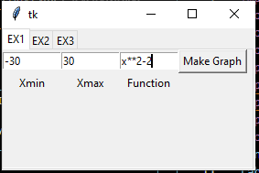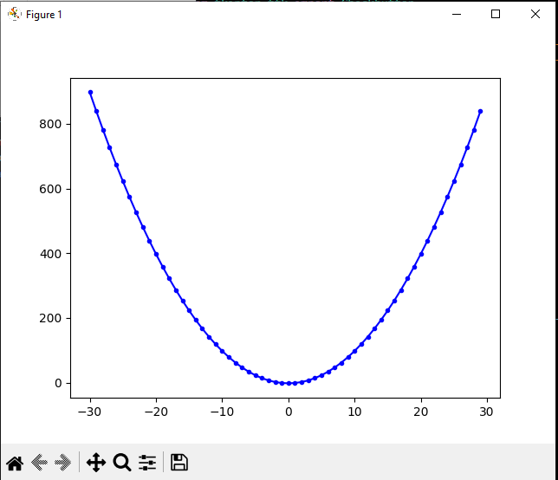

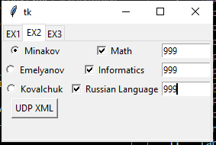

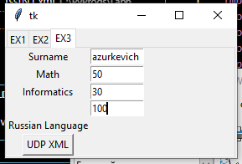

XML) После изменения

<Catalog>

    <Students>

        <Student id="0">

            <Surname>Minakov</Surname>

            <Exams>

                <Math>999</Math>

                <RusLang>999</RusLang>

                <Inform>999</Inform>

            </Exams>

        </Student>

        <Student id="1">

            <Surname>Emelyanov</Surname>

            <Exams>

                <Math>100</Math>

                <RusLang>90</RusLang>

                <Inform>82</Inform>

            </Exams>

        </Student>

        <Student id="2">

            <Surname>Kovalchuk</Surname>

            <Exams>

                <Math>34</Math>

                <RusLang>56</RusLang>

                <Inform>100</Inform>

            </Exams>

        </Student>

    <Student id="3"><Surname>Mazurkevich</Surname><Exams><Math>50</Math><RusLang>100</RusLang><Inform>30</Inform></Exams></Student></Students>

</Catalog>