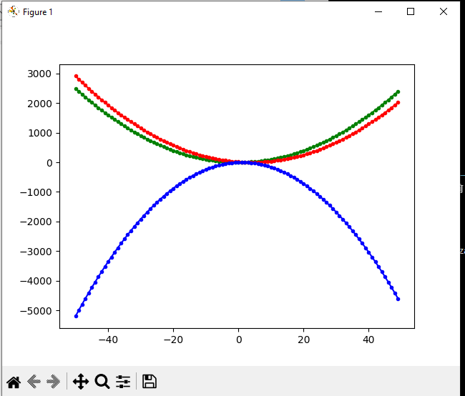1)

import matplotlib.pyplot as plt

#A

x = float()

y = float()

Xdots = []

Ydots = []

for x in range(-50, 50):

    Xdots.append(x)

    y = (x**2) - 1

    Ydots.append(y)

plt.plot(Xdots, Ydots, 'g.-')

#B

x = float()

y = float()

Xdots = []

Ydots = []

for x in range(-50, 50):

    Xdots.append(x)

    y = (x**2) - 8*x + 15

    Ydots.append(y)

plt.plot(Xdots, Ydots, 'r.-')

#C

x = float()

y = float()

Xdots = []

Ydots = []

for x in range(-50, 50):

    Xdots.append(x)

    y = (-2)*(x**2) + 4*x

    Ydots.append(y)

plt.plot(Xdots, Ydots, 'b.-')

plt.show()

2)

import matplotlib.pyplot as 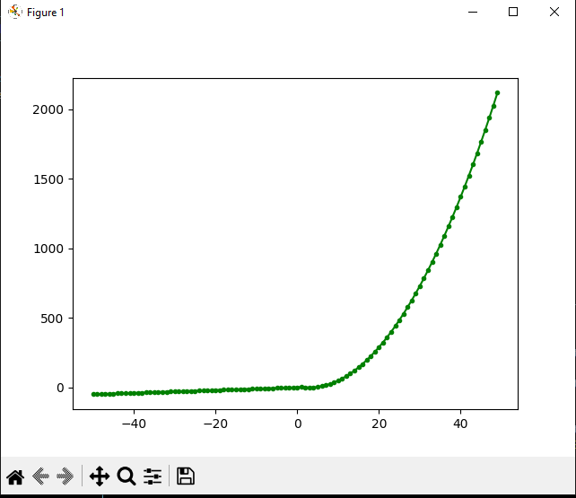plt

#A

x = float()

y = float()

Xdots = []

Ydots = []

for x in range(-50, 50):

    if x < 1:

        Xdots.append(x)

        y = x + 2

        Ydots.append(y)

    if x >= 1:

        Xdots.append(x)

        y = (x**2) - 6*x + 10

        Ydots.append(y)

plt.plot(Xdots, Ydots, 'g.-')

plt.show()

Json)

{

"staff":[

{

    "Number": "11",

    "FIO": "Иванов Иван Иванович",

    "Department": "Администрация",

    "Payments": [

    {

    "Year": "2010",

    "Month": "1",

    "Payment value": "150000"

    },

    {

    "Year": "2010",

    "Month": "2",

    "Payment value": "130000"

    },

    {

    "Year": "2010",

    "Month": "3",

    "Payment value": "135000"

    },

    {

    "Year": "2011",

    "Month": "1",

    "Payment value": "131000"

    },

    {

    "Year": "2011",

    "Month": "2",

    "Payment value": "137000"

    },

    {

    "Year": "2011",

    "Month": "3",

    "Payment value": "140000"

    },

    {

    "Year": "2012",

    "Month": "1",

    "Payment value": "135000"

    },

    {

    "Year": "2012",

    "Month": "2",

    "Payment value": "137000"

    }

    ]

},

{

    "Number": "12",

    "FIO": "Зверев Лев Моисеевич",

    "Department": "Отдел кадров",

    "Payments": [

    {

    "Year": "2011",

    "Month": "1",

    "Payment value": "150000"

    },

    {

    "Year": "2011",

    "Month": "2",

    "Payment value": "130000"

    },

    {

    "Year": "2011",

    "Month": "3",

    "Payment value": "230000"

    },

    {

    "Year": "2011",

    "Month": "4",

    "Payment value": "210000"

    },

    {

    "Year": "2012",

    "Month": "1",

    "Payment value": "135000"

    },

    {

    "Year": "2012",

    "Month": "2",

    "Payment value": "137000"

    },

    {

    "Year": "2012",

    "Month": "3",

    "Payment value": "140000"

    },

    {

    "Year": "2012",

    "Month": "4",

    "Payment value": "135000"

    }

    ]

},

{

    "Number": "13",

    "FIO": "Филатов Борис Николаевич",

    "Department": "Отдел кадров",

    "Payments": [

    {

    "Year": "2012",

    "Month": "1",

    "Payment value": "235000"

    },

    {

    "Year": "2012",

    "Month": "2",

    "Payment value": "437000"

    },

    {

    "Year": "2012",

    "Month": "3",

    "Payment value": "340000"

    },

    {

    "Year": "2012",

    "Month": "4",

    "Payment value": "235000"

    }

    ]

}

]

}

3)

import matplotlib.pyplot as plt

import json

with open ('C:/PyProgs/Lab5/Data.json', 'r', encoding = "utf-8") as j:

    json_data = json.load(j)

#Выбор

ChNum = 12

ChYear = '2012'

PayMonthNums = []

PayValues = []

for Employs in json_data['staff']:

        if int(Employs['Number']) == ChNum:

            for Payments in Employs['Payments']:

                if ChYear == Payments['Year']:

                    PayMonthNums.append(int(Payments['Month']))

                    PayValues.append(int(Payments['Payment value']))

plt.bar(PayMonthNums ,PayValues ,width = 0.4, color = 'green', edgecolor= 'black')

plt.xlabel('Год')

plt.ylabel('Количество'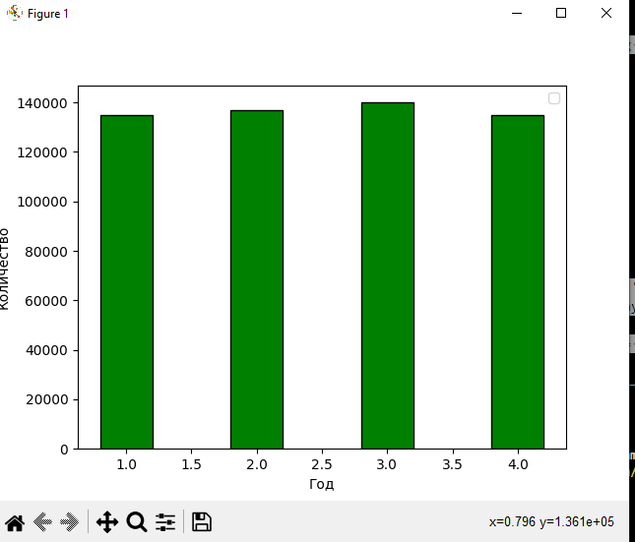)

plt.legend()

plt.show()

4)

import matplotlib.pyplot as plt

import json

with open ('C:/PyProgs/Lab5/Data.json', 'r', encoding = "utf-8") as j:

    json_data = json.load(j)

#Выбор

ChYear = '2012'

EmplList = list()

PayValuesMidList = list()

for Employs in json_data['staff']:

    PaySum = int()

    Years = int()

    for Payments in Employs['Payments']:

        if ChYear == Payments['Year']:

            PaySum = PaySum + int(Payments['Payment value'])

            Years = Years + 1

    if Years != 0:

        PayValuesMidList.append(PaySum/Years)

        EmplList.append(Employs["FIO"])

print(EmplList)

print(PayValuesMidList)

plt.pie(PayValuesMidList, labels = EmplList)

plt.show()

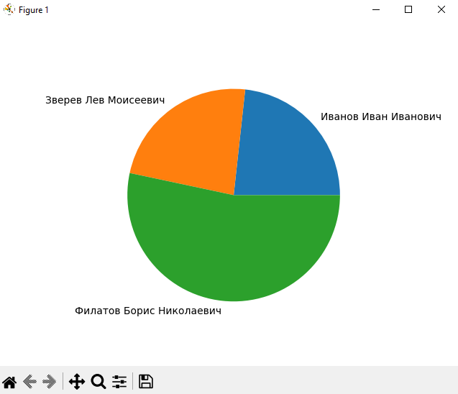

5)

import matplotlib.pyplot as plt

import json

with open ('C:/PyProgs/Lab5/Data.json', 'r', encoding = "utf-8") as j:

    json_data = json.load(j)

#Выбор

ChYear = '2012'

EmplList = list()

PayValuesMaxList = list()

PayValuesMinList = list()

for Employs in json_data['staff']:

    PayValuesList = list()

    Years = int()

    for Payments in Employs['Payments']:

        if ChYear == Payments['Year']:

            PayValuesList.append(int(Payments['Payment value']))

            Years = Years + 1

    if Years != 0:

        PayValuesMaxList.append(max(PayValuesList))

        PayValuesMinList.append(min(PayValuesList))

        EmplList.append(Employs["FIO"])

print(EmplList)

width = 0.4

plt.bar([x-width/2 for x in range(0, len(EmplList))],PayValuesMaxList , width, color = 'green', edgecolor = 'black')

plt.bar([x+width/2 for x in range(0, len(EmplList))],PayValuesMinList, width, color = 'red', edgecolor = 'black')

plt.xticks([x for x in range(0, len(EmplList))], EmplList)

plt.xlabel('Cотрудники'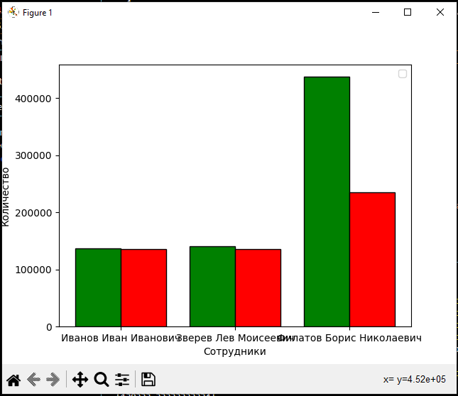)

plt.ylabel('Количество')

plt.legend()

plt.show()