Barroc-IT

Method of Approach

**Company details**

Address: Terheijdenseweg 350, 4826 AA, Breda  
Phone nummer: +31 06 38 32 42 62  
E-mail: Group10Radius@gmail.com

**Project promoter:** Fer van Krimpen

**Group number:** 10

**Group members:** Nico Steenvoorden

Mike van Nieuwburg

Anthony Carincotte

Cem Dursun

**Class:** RIO4-APO2A & RIO4-APO2B

**Version:** 1.7

Contents

Revision History 2

1. Backgrounds 3

2. Project Assignment 4

3. Project Activities 5

4. Project Borders 6

5. Products 6

6. Quality 7

7. Project Organization 8

8. Planning 9

9. Costs and Benefits 11

10. Risk analysis 12

11. Finally 13

# Revision History

|  |  |  |  |
| --- | --- | --- | --- |
| **Version** | **Date** | **Description** | **By** |
| 1.0 | 15-09-16 | Creation | Anthony |
| 1.1 | 15-09-16 | Backgrounds, Assigment, Borders, Product, Risk | Anthony |
|  | 19-09-16 | Whole document checked for errors. | Cem |

|  |  |  |  |
| --- | --- | --- | --- |
| **Versie** | **Datum** | **Beschrijving** | **Door** |
| 1.0 | 15-09-16 | Creation ,… | Anthony |
| 1.1 | 15-09-16 | Backgrounds, /Assignment, Borders, Product, Risk | A |
| 1.2-1.3 | 16-09-16 | Activities, /Quality, /Cost, Risk, Organization | A, Cem, Mike |
| 1.4 | 18-09-16 | /Quality, | A |
|  | 19-09-16 | Doc reckeck for errrors | C |
| 1.4.1 | 21-09-16 | /Cost, /Assignment | A |
| 1.7 | 28-09-16 | Borders, revision history | A |
|  |  |  |  |
|  |  |  |  |
|  |  |  |  |
|  |  |  |  |
|  |  |  |  |

Note:

# Backgrounds

The project is assigned to us by Barroc-IT a software development and maintenance organization. The organization develops and maintains software for their client companies.

The organization started with approximately 10 employees but according to the CEO the organization grew hard. This could be one of the causes for the problems that have to be solved within the organization. The organization exists of several departments each with their own responsibilities. The next departments will be described for this project. The department of Sales is responsible for fetching new and potential customers and maintains the customer data. The department of Finance is responsible for investigating and determining the credibility of customers. The department of Development is responsible for the projects for the clients of Barroc-IT. This department is also responsible for any project related data.

The current situation is described as an organization that grew too fast. The departments used to communicate well with each other. Right now miscommunications happen between them. Each of the departments keeps their files separate from other departments and use different tools. An example of a result from this cause is that invoices are not being paid while work is still being continued.

This is why the CEO of Barroc-IT, H. van Bueren, has assigned GreenByte to this problem.

This provides a need for an application which connects all the departments within the organization to automatically sent notifications and alerts to each department. If invoices are sent but not paid after some time work should be halted.

GreenByte will provide a solution which will optimize the communication and workflow within the company. The solution will be available for long term use so that the company may grow even more.

# Project Assignment

Barroc-IT acknowledges that there are several problems within the organization. The organization is divided by the departments. The communication within the organization fails sometimes. One of the follow-ups is that parts of the organization are not being notified when clients haven’t paid on time. In such situations projects should put on hold while the clients haven’t completed their payment.

The project assignment will be the following:

The application will be accessible to each employee of the department of Sales, Finance and Development. A single login account will be made for each department of the organization.

The communication line between the departments within the organization will be automated. Employees will not have to manually notify other departments when clients have breached the limit of nonpayment. This will happen automatically. When a limit breach has occurred, the client’s projects will be suspended until an employee of the department of Finance says it can continue or be cancelled.

The department of Development will have an instant overview of project details and meetings. An employee of Development will be able to view project details such as client details by clicking one of the projects in the overview. An employee will also be able to create, change and delete a project. An employee will also be able to create a new client meeting date with actions to do for that date.

An employee of the department of Sales will see an overview of customers that haven’t paid yet on time. A history will be stored of clients that have failed to meet the requirements of payment. An employee will be notified when a project is being worked on for such clients.

Overall the application’s main responsibilities will be showing an easy and quick overview for all employees and automating the communications between departments.

# Project Activities (mike)

**Internal tasks**  
 - Collaboration Contract

**Interviewing the company executive and head of departments**  
 - Preparation for interviews - Interview with the owner  
 - Interview with the head of Sales  
 - Interview with the head of Finance  
 - Interview with the head of Development & Research

**Planning and approach**  
- Global planning  
- Method of approach  
- Making wireframes (prototypes)

**Functional Design** - Designing a Use-Case  
 - Making a Use-Case template  
 - Making an activities diagram

**Technical Design**  
 - Making a class diagram  
 - Designing a data dictionary  
 - Making a sequence diagram  
 - Collecting all the soft- and hardware  
 - Building and normalizing the database  
 - Creating the data dictionary  
 - Building a working solution (application wise)

**Test Phase**  
 - Creating a test and testing the Dataset  
 - Creating a test and executing a technical test  
 - Creating a test and executing a functional test  
 - Creating a test and executing an acceptation test

**Final Phase**  
 - Writing a user manual (English and Dutch)  
 - Presenting the application  
 - Presenting a time registration of tasks

**4. Project Borders**

First of all, the project begins Monday, September 12 2016 and need to be finished before ??? Past this deadline, the product will not be altered.

If we want to achieve this product without any disturbing delay, we firstly need to plan a meeting 2-3 weeks before the deadline. This can be a really important reunion, we need to look what is done and what is clearly not. Take a look at our current priorities, then divide them by importance. Of course take note, looking for project needs. And if needful, tasks can be swap among group members. So we can easily manage our motivation: if one of us got bored/stuck with his project task(s), we can swap at any time.

After the finalization of the project, unless problems or even ‘bugs’ with the application appears, our work with the application will be finish.

# 5.Products

Working on this project will produce several necessary products. This document will be included to the list of products that will be produced. This project will be the sum of all these described products.

Following will be a list of to be produced products:

* Method of Approach
* Summary of interviews
* Document of proposal
* Dynamic planning
* Use-case diagram and templates
* Activity and sequence diagrams
* Normalized database design
* Database
* Functional solution
* Documents of prepared and taken tests.
  + Test of approval
  + Functional test
  + Interface test
* User Manual
* Final report

# 6.Quality

This chapter will describe how the quality of the products will be protected. GreenByte will make sure to follow a set of rules and perform a set of tasks in order to keep the client satisfied with the products that will be produced. These rules will apply to GreenByte during the process of this project.

Within GreenByte a number of rules have been set that concern team effort:

* In case of a team member not being able to be present or on time, team member will notify the team before the start of a work day.
* In case of a team member being sick, the team will decide which tasks has to be finished first and if necessary tasks will be taken over.
* In case of a deadline being at risk, the team will work overtime until the risk will be lowered enough to be considered safe.
* All files will be uploaded and shared with an online tool named GitHub. All team members will have access to these files.

For the sake of this project a few things will be expected from the client as well from GreenByte:

* GreenByte will interview the client for information
* Every one or two weeks a meeting with the client

In order to keep this project organized a number of rules will be followed:

* Online storage of files
* Planning made with a professional tool
* Meeting once every week with the team
* All produced documents follow the corporate identity of GreenByte.

The team will hold a meeting. During this meeting the progress of the project will be discussed. The team will check how work is being done and if anywhere can be assisted. During these checks the team will check several important things.

*Lijst met normen voor controles.*

# 7.Project Organization

This chapter will describe how this project is organized. Also positions within the project will be explained and details of project members will be available.

These are the positions that play a role in the project with the person that takes the position:

**Project leader: Nico Steenvoorden**

One member has been chosen to be the leader of this project. The leader will be responsible to maintain the whole project. Meaning that tasks should be finished on time and the leader will also lead any meetings that will be kept. The leader will also make the final decisions.

**Secretary: Mike van Nieuwburg**

The secretary is responsible for saving documents of meetings or interviews. The secretary is also responsible for storing project documents and making them available to anyone that should have access to these documents.

**The Client: CEO of Barroc-IT**

To be sure the project is run smoothly there will be some expectations from the client. Once every week a meeting will be kept to keep the client up to date. Expected will be that the client should participate to these meetings.

**Member: Cem Dursun, Anthony Carincotte**

Members will perform tasks and report daily to the project leader. The project leader in this case is also a member. All members will gather once every week to a meeting led by the project leader. All members are responsible for the tasks appointed to them.



**Project member details:**

|  |  |  |  |  |
| --- | --- | --- | --- | --- |
| Naam | Email | Telefoonnummer | Adress | Skype |
| Mike van Nieuwburg | D215937@outlook.com | +31681092854 | Terheijdenseweg 350 | D215937 |
| Nico Steenvoorden | D180941@edu.rocwb.nl | +31653696821 | Terheijdenseweg 350 | drawolf999 |
| Anthony Carinotte | D208326@edu.rocwb.nl | +31638324262 | Boschstraat 170a | cclvii |
| Cem Dursun | cemdursun@msn.com | +31620439975 | … |  |



# 8.Planning

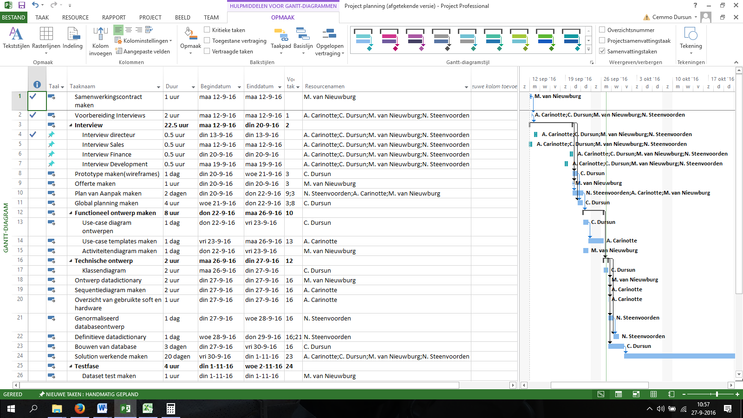

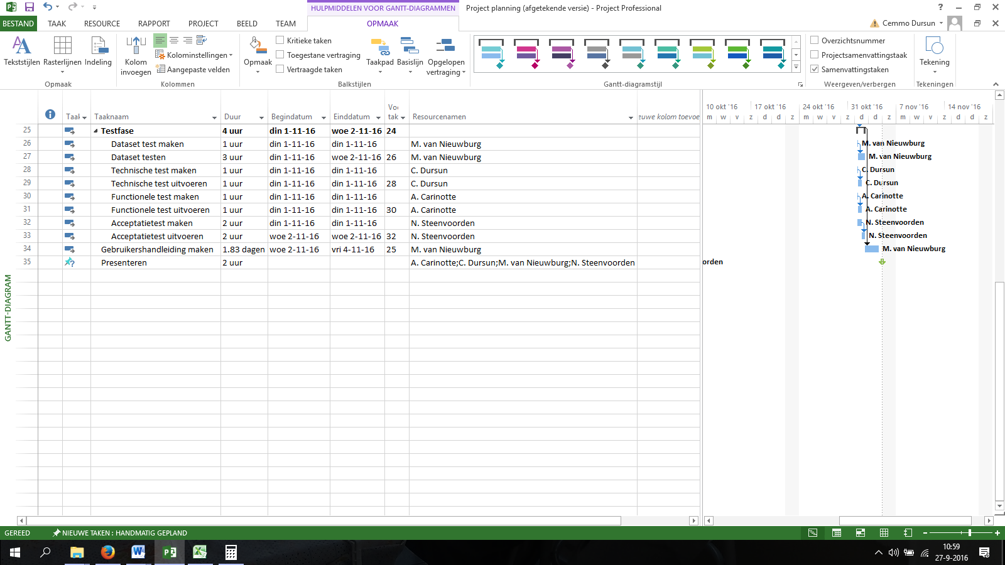

In order to keep all the work efficient and effective a planning will be made for all project members. The planning is made by project member Cem Dursun with the use of the planning tool MS-Project. Tasks will be appointed to members that will be responsible for completing the tasks before their deadlines. The total work and work per tasks will be shown in the tool.

For the whole planning see document Project Planning.

# 9.Costs and Benefits

This chapter will describe the costs of this project and the benefits for the client. Like most projects this project will be an investment for the client. This investment will mean a cost for a long term improvement for the client. For the completion of the project members will work hours to prepare the project group for the project, the project members will build a working solution that will contain all the needs and requirements of the client and the project members will present the products of this project to the client.

The whole project will be an approximate investment of €17.829,35, including preparing, building, testing and travel expenses.

The outcome will be an organization with an automated system. This system will ensure that all workflow will be efficient and very effective. This system will also ensure that no project for clients will be worked on while the clients have failed to complete payments. This way the cost savings for the organization will be large. Employees will also save a lot of time by the system that can perform some of their tasks automated.

# 10.Risk analysis

|  |  |  |  |  |
| --- | --- | --- | --- | --- |
| Risk | How can we avoid these risks? | How frequently can this happen? | How big is the impact of this? | How important is this risk (1-10)? |
| Someone being sick. | working at home or helping out a team member by sharing the work. | Occasionally | Large | 4 |
| Computer crashes. | Save back-up online or on hardware. (online preferred) | Rarely | Big | 3 |
| Internet problems | Working on paper and notifying a teacher. | Often | Medium/Big | 7 |
| Disagreement between group members | Have a meeting. If a unanimous decision is not possible. The group leader has the final word. | Rarely | Big | 8 |
| Miscommunication | Making clear rules and talk about it. If it doesn’t work use a second opinion. | Rarely | Medium | 2 |
| Lack of time | working at home or speeding up the process by making agreements to work longer. | Often | Medium/Big | 9 |

# 11.Finaly

The whole project will be run by four members and will take 8 weeks to complete. The deadline is a requirement set by the project client. The goal of this project will be improving the intern communications of Barroc-IT. The organization makes an investment to save in costs.