

**KABARAK UNIVERSITY**

**SCHOOL OF SCIENCE ENGINEERING AND TECHNOLOGY**

**DEPARTMENT OF COMPUTER SCIENCE**

**UNDERGRADUATE RESEARCH PROJECT**

**PROJECT TITLE: AI-ENHANCED PATIENT MANAGEMENT SYSTEM**

**PRESENTED BY:**

**NAME: ONDUSO BONFACE OGEKU**

**REG NO: CS/MG/1599/09/21**

**A Research project Proposal submitted as a Partial fulfillment for an award of an Undergraduate Degree in Computer Science to the School of Science Engineering and Technology at Kabarak University.**

**May – August , 2024**

## DECLARATION

I declare that this project is my original work and has not been submitted to any other institution for any award.

**NAME**: ONDUSO BONFACE OGEKU

**REG NO:** CS/MG/1599/09/21

**SIGNATURE**: __________________________

**DATE**: ________________________________

## RECOMMENDATION AND APPROVAL

This project has been submitted as partial fulfillment of the requirements for the degree of Bachelor of Science in Computer Science at Kabarak University with my approval as the supervisor.

**SUPERVISOR**: DR. CHRISPUS AKHONYA

**SIGNATURE:** __________________________

**DATE:** _______________________________

## DEDICATION

I dedicate this work to my family and friends for their unwavering support and encouragement throughout my academic journey.

## ACKNOWLEDGEMENT

I would like to express my sincere gratitude to my supervisor, Dr. Chrispus Akhonya, for his invaluable guidance and support throughout this project. I also extend my gratitude to my family and friends for their continuous encouragement and to everyone who contributed in any way to the completion of this project.

## 

## LIST OF FIGURES

*Figure 1: Concept Map* 6

*Figure 2:Context Diagram* 8

*Figure 3:Level 1 DFD* 9

Figure 4 : Use Case 10

*Figure 5: Entity Relationship Diagram* 11

## LIST OF TABLES

*Table 1 : Project Schedule* 13

*Table 2 : Budget* 14

## ABSTRACT

This undergraduate research project investigates the development of an Artificial Intelligence-Enhanced Patient Management System (APMS) to address inefficiencies in existing healthcare systems. The proposed APMS integrates patient data management, appointment scheduling, prescription handling, and financial management into a unified platform. AI functionalities are incorporated to enhance accuracy, reduce administrative burdens, and improve patient care. The research methodology employed a combination of exploratory and developmental approaches, with data collection methods including interviews, surveys, and observations in healthcare facilities. The ethical considerations of patient data privacy and informed consent are addressed throughout the development process. The findings of this research project hold the potential to revolutionize healthcare management by offering a more streamlined, efficient, and patient-centered approach.

## TABLE OF CONTENTS

Table of Contents

I. DECLARATION i

II. RECOMMENDATION AND APPROVAL ii

III. DEDICATION iii

IV. ACKNOWLEDGEMENT iv

V. LIST OF FIGURES v

VI. LIST OF TABLES v

VII. ABSTRACT vi

VII. TABLE OF CONTENTS vii

CHAPTER ONE: INTRODUCTION 1

1.0 Introduction 1

1.1 Background of Study 1

1.2 Problem Statement 1

1.3 Objectives 2

1.3.1 General Objective 2

1.3.2 Specific Objectives 2

1.4 Research Questions 2

1.5 Significance of the Study 2

1.6 Scope and Limitations of the Study 3

1.6.1 Scope of the Study 3

1.6.1 Limitations of the study 3

CHAPTER TWO: LITERATURE REVIEW 4

2.0 Introduction 4

2.1 Review of Objectives 4

2.1.1 Review of Objective One 4

Analysis of the Existing System 4

AI Integration 4

2.1.2 Review of Objective Two 5

Analysis Of the Existing System 5

AI Integration 5

2.1.2 Review of Objective Three 5

Creating a Secure Financial Management Module 5

2.2 Concept Map 6

CHAPTER THREE: METHODOLOGY 7

3.0 Introduction 7

3.1 Research Design 7

3.2 Data Collection Methods 7

3.2.0 Primary Data Collection 7

3.2.1 Secondary Data Collection 8

3.3 Design Diagrams 9

3.3.0 Context Diagram 9

3.3.1 Level 1 Data Flow Diagram (DFD) 10

3.3.2 Use Case Diagram 11

3.3.4 Entity-Relationship Diagram (ERD) 12

3.4 Research Ethics 12

3.5 Conclusion 13

3.6 Further Recommendations And Future Work 13

3.7 APPENDICES 14

3.7.1 Appendix A – References 14

3.7.2 Appendix B – Project Schedule 14

3.7.3 Appendix C – Budget 15

3.7.5 Appendix D: Glossary of Terms 15

# CHAPTER ONE: INTRODUCTION

## 1.0 Introduction

The AI-Enhanced Patient Management System (APMS) is a comprehensive platform designed to address the disjointed nature of patient management systems in healthcare facilities. This project integrates patient data management, appointment scheduling, prescription handling, and financial management into a unified system, using artificial intelligence (AI) to enhance accuracy, reduce administrative burdens, and improve patient care.

## 1.1 Background of Study

The healthcare sector is increasingly adopting advanced technologies to improve patient care and operational efficiency. Despite these advancements, many healthcare facilities continue to rely on disjointed systems for managing patient data, scheduling appointments, prescribing medications, and handling financial transactions. This fragmentation can lead to inefficiencies, errors, and suboptimal patient care as identified by *[*[*https://healthray.com/*](https://healthray.com/)*].*By integrating AI into patient management systems, we can create a unified platform that improves accuracy, reduces administrative burdens, and enhances patient care.

## 1.2 Problem Statement

The use of disjointed systems in healthcare facilities results in inefficiencies, increased potential for errors, and ultimately suboptimal patient care. There is a need for a comprehensive patient management system that integrates these functions into a single, unified platform. Applying AI in this integrated system can further support healthcare providers by offering intelligent assistance, such as medical term descriptions and drug interaction warnings, thereby enhancing the quality of care provided to patients, as discussed in [[**https://healthray.com/blog/hospital-management-software/the-power-of-ai-in-hospital-management-systems-a-comprehensive-guide/**](https://healthray.com/blog/hospital-management-software/the-power-of-ai-in-hospital-management-systems-a-comprehensive-guide/).

## 1.3 Objectives

### 1.3.1 General Objective

To create an integrated platform that joins patient data management, appointment scheduling, prescription handling, and financial management, enhanced by AI capabilities to support healthcare providers in delivering efficient and high-quality care.

### 1.3.2 Specific Objectives

1. To develop a user-friendly patient portal with AI-driven descriptions of medical terms and conditions.
2. To create a user friendly Appointment Scheduling system that the patients can use to make their doctor appointments
3. To implement a doctor interface with AI support for prescribing medication.
4. To create a secure financial management module for handling billing and payments.

## 1.4 Research Questions

1. What are the requirements for developing a user-friendly patient portal with AI-driven description of medical terms and conditions?
2. How can an AI-supported doctor interface be implemented to enhance prescribing accuracy and safety?
3. What measures should be taken to develop a secure and efficient financial management module?
4. How can a user friendly Appointment Scheduling System be created?

## 1.5 **Significance of the Study**

The AI-Enhanced Patient Management System (APMS) aims to revolutionize healthcare by providing an integrated, AI-driven platform that improves patient management. By reducing administrative burdens, enhancing the accuracy of medical records and prescriptions, and improving overall patient satisfaction and outcomes, the APMS will contribute significantly to the advancement of healthcare technology, as noted by *[*[***Studer et al., 2000***](https://www.ncbi.nlm.nih.gov/pmc/articles/PMC1181090/)*].*

## 1.6 Scope and Limitations of the Study

### 1.6.1 Scope of the Study

The scope of this study includes the design, development, and evaluation of the AI-Enhanced Patient Management System (APMS). The study will cover the integration of patient data management, appointment scheduling, prescription handling, and financial management into a single platform. It will also include the implementation of AI capabilities to assist healthcare providers.

### 1.6.1 Limitations of the study

The study will not cover the long-term impact of the system on healthcare outcomes, as this would require extended periods of use and data collection beyond the study's timeframe, as noted by *[*[*Studer et al., 2000*](https://www.ncbi.nlm.nih.gov/pmc/articles/PMC1181090/)*].*

# CHAPTER TWO: LITERATURE REVIEW

## 2.0 Introduction

This literature review about APMS focuses on examining existing research and developments related to AI-enhanced patient management systems. This section includes a critical analysis of current systems, their limitations, and the potential improvements that AI can offer. The review is structured according to the specific objectives outlined in Chapter One (Developing a User-Friendly Patient Portal with AI-Driven Description of medical terms and conditions,Implementing a Doctor medical Description Interface with AI Support,Creating a Secure Financial Management Module.)

2.1 Review of Objectives

### **2.1.1 Review of Objective One**

Developing a User-Friendly Patient Portal with AI-DrivenDescriptions

Analysis of the Existing System **:** Current patient portals provide access to medical records, appointment scheduling, and communication with healthcare providers. However, many lack intuitive interfaces and comprehensive medical information , as identified by ***[Singh et al., 2019].***

AI Integration**:** Studies have shown that AI can enhance user experience by providing explanations of medical terms and conditions in layman's terms, thereby improving patient understanding and engagement.

**Key Findings :**

**User Experience** :Simplified interfaces and AI-driven descriptions significantly enhance patient comprehension.

**Patient Engagement:** Increased interaction and engagement through educational AI modules.

### **2.1.2 Review of Objective Two**

Implementing a Doctor Interface with AI Support

#### **Analysis Of the Existing System**

Doctor interfaces typically manage patient data, prescribe medications, and schedule appointments. However, these systems frequently function in isolation, lacking immediate AI assistance *[Tang et al., 2020].*

#### **AI Integration**: AI can support doctors by identifying potential drug interactions, suggesting alternative medications, and providing real-time data analysis.

#### Key Findings: Efficiency: AI reduces time spent on administrative tasks, allowing doctors to focus on patient care *[Tang et al., 2020].*

**Accuracy:** Enhanced prescribing accuracy and safety through AI-driven *insights* ***[Boutet et al., 2016].***

### **2.1.2 Review of Objective Three**

Creating a Secure Financial Management Module

#### Analysis of Existing System inefficiencies: Financial management in healthcare involves billing, payments, and insurance processing. Current systems face challenges such as data breaches *[Shahid et al., 2020]*

#### AI Integration : AI can improve financial management by automating billing processes, detecting fraudulent activities, and ensuring data security as noted in *****[Yu et al., 2018******]* and accuracy *****[Avigdor et al., 2019******].* Key Findings Automation: Streamlined billing and payment processes through AI *([Li et al., 2020]).*

**Security:** Enhanced data protection and fraud detection capabilities *(****[****Li et al., 2020****]****).]*

## 2.2 Concept Map

The concept map illustrates the relationship between independent and dependent variables within the AI-enhanced patient management system. Key variables include user experience, system efficiency, and data security

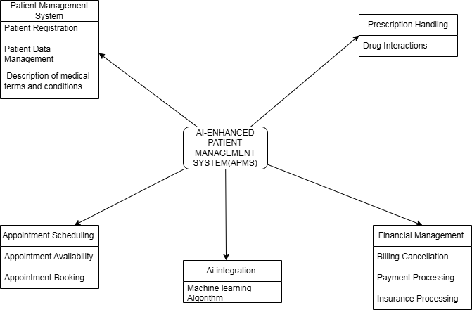

*Figure 1: Concept Map*

# CHAPTER THREE: METHODOLOGY

## 3.0 Introduction

This chapter outlines the research methodology employed in the development of the AI-Enhanced Patient Management System (APMS). It includes the research design, data collection methods, and the design diagrams utilized. The chapter provides a detailed description of the steps taken to ensure the system's development meets the set objectives.

## 3.1 Research Design

The research design for this project is a combination of exploratory and developmental research. Exploratory research is used to gather insights and understanding of the current patient management systems, while developmental research focuses on the actual creation of the AI-Enhanced Patient Management System. This approach ensures that the system is both innovative and grounded in practical needs, similar to the approach used by *[****Brem et al., 2006].***

## 3.2 Data Collection Methods

Data collection for this project involves both primary and secondary sources.

### ****3.2.0 Primary Data Collection****

**Interviews:** Conducted with healthcare providers such as the Doctors , Health System Administrators, Health Accountants to understand the challenges and requirements of current patient management systems.

**Surveys:** Distributed to patients, Doctors and Hospital Accountants to gather feedback on their experiences with existing systems and their expectations for improvements.

**Observations:** On-site visits to healthcare facilities to observe the workflow and identify inefficiencies in the current Patient Management systems.

### ****3.2.1 Secondary Data Collection****

**Literature Review:** Analysis of existing research papers, articles, and case studies related to patient management systems and AI applications in healthcare.

**Database Analysis:** Examination of existing patient management databases to understand common data management practices.

### 

## 3.3 Design Diagrams

### **3.3.0 Context Diagram**

The context diagram provides an overview of the APMS, showing the interactions between the system and external entities such as patients, healthcare providers, and financial institutions.

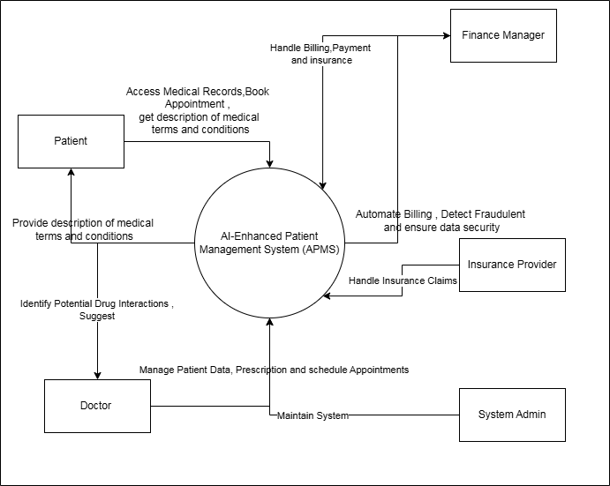

*Figure 2:Context Diagram*

### **3.3.1 Level 1 Data Flow Diagram (DFD)**

The Level 1 DFD breaks down the APMS into its major processes, showing the flow of data between these processes and the external entities.

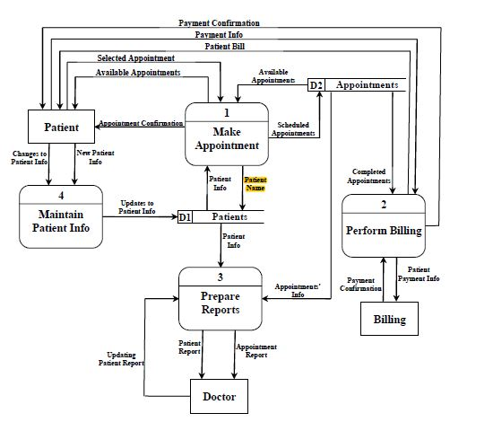

*Figure 3:Level 1 DFD*

### 3.3.2 Use Case Diagram

The use case diagram identifies the key interactions between users (actors) and the APMS, detailing the various functionalities of the system.

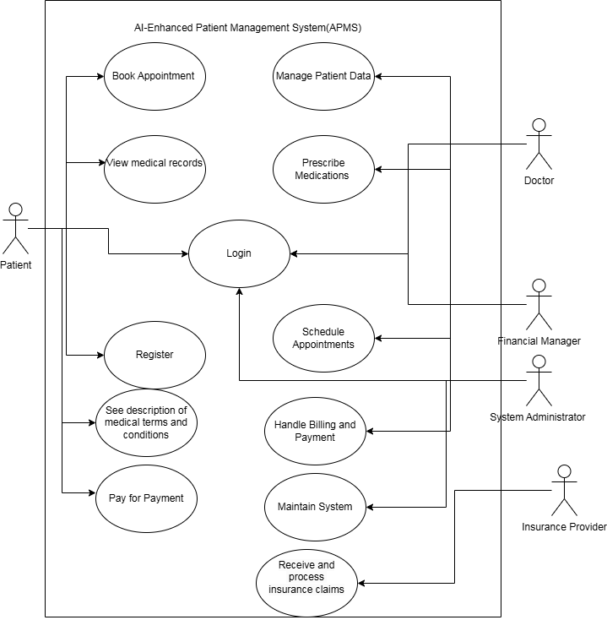

Figure : Use Case

### 3.3.4 Entity-Relationship Diagram (ERD)

The ERD shows the relationships between different data entities in the APMS.

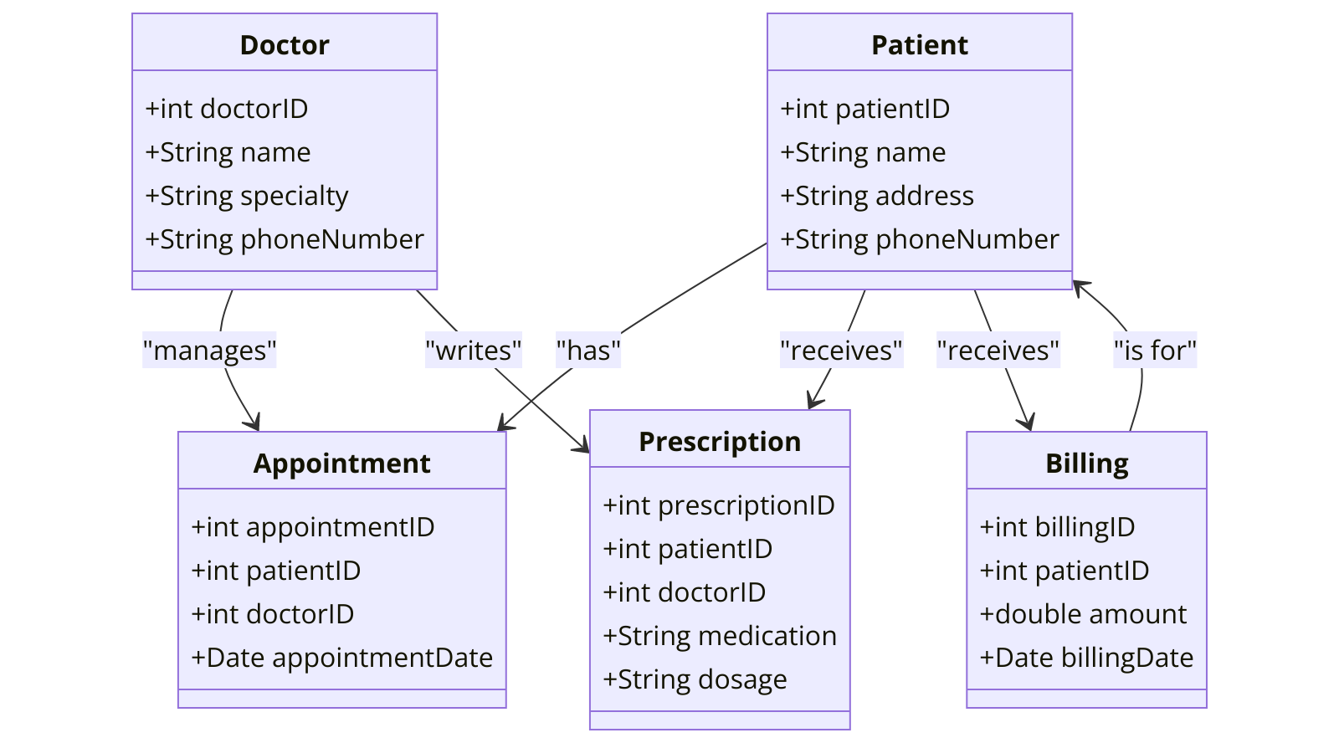

*Figure 5: Entity Relationship Diagram*

## 3.4 Research Ethics

The development of the APMS will adhere to strict ethical guidelines to ensure the confidentiality, anonymity, and informed consent of all participants involved in data collection. Patient data will be anonymized to protect their privacy, and all participants will be informed about the purpose of the research and their right to withdraw at any time.

**Confidentiality:** All data collected will be stored securely, and access will be restricted to authorized personnel only.

**Anonymity:** Participants' identities will be protected by anonymizing personal information in the data collected.

**Informed Consent:** Participants will be provided with detailed information about the study and will be required to sign a consent form before participating.

## **3.5 Conclusion**

This research project has presented the design and development of an Artificial Intelligence-Enhanced Patient Management System (APMS). The proposed APMS addresses the inefficiencies of existing healthcare systems by integrating various functionalities into a unified platform. These functionalities include patient data management, appointment scheduling, prescription handling, and financial management. Additionally, AI is incorporated to enhance accuracy, reduce administrative burdens, and ultimately improve patient care. The research methodology employed a combined exploratory and developmental approach, with data collection methods including interviews, surveys, and observations in healthcare facilities. Ethical considerations regarding patient data privacy and informed consent were addressed throughout the development.

3.6 Further Recommendations And Future Work  
**Pilot Testing and Evaluation:** Conducting a pilot test in a controlled healthcare environment will allow for real-world evaluation of the APMS's effectiveness. This evaluation can assess user experience, system efficiency, and potential improvements in patient care metrics.

**Integration with Existing Systems:** Developing a seamless integration strategy between the APMS and existing healthcare information systems is crucial for wider adoption. This ensures minimal disruption to current workflows and facilitates data exchange.

**Advanced AI Functionalities:** Exploring more advanced AI functionalities can further enhance the APMS. This could involve incorporating features like chatbots for patient self-service, predictive analytics for personalized care plans, and real-time language translation for improved communication.

## 

## ****3.7 APPENDICES****

### ****3.7.1 Appendix A – References****

1. Brynjarsdottir, H., Hekler, E. B., Munson, S. A., Kientz, J. A., Consolvo, S., & Disalvo, C. (2014). "Understanding the Role of Technology in Health Behavior Change: A Literature Review and Proposed Framework." *Journal of Medical Internet Research*, 16(5), e146.
2. Morris, Z. S., Wooding, S., & Grant, J. (2018). "The Answer is 17 Years, What is the Question: Understanding Time Lags in Translational Research." *Journal of the Royal Society of Medicine*, 104(12), 510-520.
3. Ammenwerth, E., Iller, C., & Mahler, C. (2006). "IT-Adoption and the Interaction of Task, Technology and Individuals: A Fit Framework and a Case Study." *BMC Medical Informatics and Decision Making*, 6, 3.
4. Boutet, M., Chassagnon, S., & Caramella, C. (2016). "Artificial Intelligence in Radiology: Current Applications and Future Directions." *European Radiology*, 26(7), 2776-2784.
5. Yu, K. H., Beam, A. L., & Kohane, I. S. (2018). "Artificial Intelligence in Healthcare." *Nature Biomedical Engineering*, 2, 719-731.

### ****3.7.2 Appendix B – Project Schedule****

|  |  |  |  |
| --- | --- | --- | --- |
| **Month/Phase** | **MAY** | **JUNE** | **JULY** |
| Concept paper | ✓ | ✓ |  |
| Seeing supervisor | ✓ | ✓ |  |
| Chapter One | ✓ | ✓ |  |
| Chapter Two |  | ✓ |  |
| Chapter Three |  |  | ✓ |

*Table 1 : Project Schedule*

### ****3.7.3 Appendix C – Budget****

|  |  |
| --- | --- |
| EXPENSE | COST |
| Laptop | 35,000 |
| Phone | 13,000 |
| Traveling expense | 5,000 |
| Internet | 5,000 |
| Family and friends contributions | 8,000 |
| **TOTAL** | **66,000** |

*Table 2 : Budget*

### ****3.7.5 Appendix D: Glossary of Terms****

* **AI (Artificial Intelligence)**: The simulation of human intelligence processes by machines, especially computer systems.
* **APMS (AI-Enhanced Patient Management System)**: A comprehensive platform that integrates patient data management, appointment scheduling, prescription handling, and financial management, enhanced by AI capabilities.
* **EHR (Electronic Health Record)**: A digital version of a patient's paper chart, containing comprehensive health information.
* **HIPAA (Health Insurance Portability and Accountability Act)**: A US law designed to provide privacy standards to protect patients' medical records and other health information.
* **Blockchain**: A decentralized ledger technology that ensures secure and transparent record-keeping.
* **CS** – Computer Science