**KABARAK UNIVERSITY**



SCHOOL OF SCIENCE ENGINEERING AND TECHNOLOGY

DEPARTMENT OF COMPUTER SCIENCE

RESEARCH PROJECT PROPOSAL

AI-ENHANCED PATIENT MANAGEMENT SYSTEM (APMS)

PRESENTED BY;  
ONDUSO BONFACE OGEKU   
CS/MG/1599/09/21

This research project paper is submitted to the School of Science Engineering and Technology in partial fulfillment of the requirements for the Degree of Bachelor of Science in Computer Science at Kabarak University.

MAY-AUGUST, 2024

Table of Contents

I. **DECLARATION** iv

**II.** **RECOMMENDATION PAGE** iv

**III.** **DEDICATION** v

**IV.** **ACKNOWLEDGEMENT** vi

V. **ABBREVIATIONS AND ACRONYMS** vii

**VI.** **LIST OF FIGURES** viii

**CHAPTER ONE: INTRODUCTION** 1

**1.0 Introduction** 1

**1.1** **Background of the Study** 1

The healthcare sector is increasingly adopting advanced technologies to improve patient care and operational efficiency. Despite these advancements, many healthcare facilities continue to rely on disjointed systems for managing patient data, scheduling appointments, prescribing medications, and handling financial transactions. This fragmentation can lead to inefficiencies, errors, and suboptimal patient care. By integrating AI into patient management systems, we can create a unified platform that improves accuracy, reduces administrative burdens, and enhances patient care. The healthcare sector is increasingly adopting advanced technologies to improve patient care and operational efficiency. Despite these advancements, many healthcare facilities continue to rely on disjointed systems for managing patient data, scheduling appointments, prescribing medications, and handling financial transactions. This fragmentation can lead to inefficiencies, errors, and suboptimal patient care, as identified by [**https://healthray.com/**]. By integrating AI into patient management systems, we can create a unified platform that improves accuracy, reduces administrative burdens, and enhances patient care. 1

**1.2 Problem Statement** 1

**1.3 Objectives** 3

**1.3.1 General Objective** 3

**1.3.2 Specific Objectives** 3

**1.4 Research Questions** 3

**1.5 Significance of the Study** 3

**1.6 Scope and Limitation of the Study** 4

**1.6.1 Scope of the Study** 4

**1.6.2 Limitation of the Study** 4

[Potential limitations of the study include the availability of data, the complexity of integrating existing systems, and the acceptance of the new system by healthcare providers. Data availability might limit the scope of AI training and accuracy **[**Brynjarsdottir et al., 2014 **]**. The complexity of integrating the APMS with existing systems in healthcare facilities could pose technical challenges **[**Morris et al., 2018]. Additionally, the acceptance and adoption of the system by healthcare providers will depend on its usability and perceived benefits ****Ammenwerth et al., 2009 **.** These limitations will be addressed through thorough testing, user training, and iterative development based on feedback from healthcare providers. 4

**CHAPTER TWO: LITERATURE REVIEW** 5

**2.0 Introduction** 5

The literature review focuses on examining existing research and developments related to AI-enhanced patient management systems. This section includes a critical analysis of current systems, their limitations, and the potential improvements that AI can offer. The review is structured according to the specific objectives outlined in Chapter One (Developing a User-Friendly Patient Portal with AI-Driven Descriptions,Implementing a Doctor Interface with AI Support,Creating a Secure Financial Management Module. 5

**2.1 Review of Objective One -** Developing a User-Friendly Patient Portal with AI-DrivenDescriptions 5

**2.2 Review of Objective Two -** Implementing a Doctor Interface with AI Support 5

**Accuracy:** Enhanced prescribing accuracy and safety through AI-driven insights [Boutet et al., 2016]. 6

**2.3 Review of Objective Three -** Creating a Secure Financial Management Module 6

**2.4 Concept Map** 7

CHAPTER THREE: METHODOLOGY 8

3.0 Introduction 8

3.1 Research Design 8

3.2 Data Collection Methods 8

Design Diagrams 9

3.3.1 Context Diagram 9

3.3.2 Level 1 Data Flow Diagram (DFD) 10

APPENDICES 14

1. **DECLARATION**

This project, as presented in this report, is my original work and has not been presented for any other award in any other University.

**Name:**  
Onduso Bonface – CS/MG/1599/09/21  
**Sign:** ____________________

**Date:** ____________________

1. **RECOMMENDATION PAGE**

This project has been submitted as partial fulfillment of the requirements for the degree of Bachelor of Science in Computer Science at Kabarak University with my approval as the supervisor.

**Name:**

Dr. Chrispus Akhonya

**Sign:** ____________________

**Date:** ____________________

1. **DEDICATION**

I dedicate this work to my family and friends for their unwavering support and encouragement throughout my academic journey.

1. **ACKNOWLEDGEMENT**

I would like to express my sincere gratitude to my supervisor, Dr. Chrispus Akhonya, for his invaluable guidance and support throughout this project. I also extend my thanks to my family and friends for their continuous encouragement and to everyone who contributed in any way to the completion of this project.

1. **ABBREVIATIONS AND ACRONYMS**
2. CS - Computer Science
3. MG - Matriculation Number Group
4. APMS – Artifical Intelligence- Enhanced Patient Management System
5. DFD - Data Flow Diagram
6. **EHR - Electronic Health Record**
7. **HIPAA -Health Insurance Portability and Accountability**
8. **LIST OF FIGURES**
   1. Figure 1: Concept Map
      * Illustrates the interrelation between dependent and independent variables in the proposed AI-Enhanced Patient Management System(APMS)
   2. Figure 2**:** Context Diagram
      * Provides a visual representation of the context and interactions within the AI-Enhanced Patient Management System.
   3. Figure 3: Level 1 Data Flow Diagram (DFD)
      * Depicts the flow of data within the AI-Enhanced Patient Management System at a high level.
   4. Figure 4: **Use Case Diagram** 
      * Presents the various use cases and actors involved in the AI-Enhanced Patient Management System.
   5. Figure 5: Entity-Relationship Diagram
      * shows the relationships between different data entities in the APMS.

**CHAPTER ONE: INTRODUCTION**

**1.0 Introduction**

The AI-Enhanced Patient Management System (APMS) is a comprehensive platform designed to address the disjointed nature of patient management systems in healthcare facilities. This project integrates patient data management, appointment scheduling, prescription handling, and financial management into a unified system, using artificial intelligence (AI) to enhance accuracy, reduce administrative burdens, and improve patient care.

* 1. **Background of the Study**

The healthcare sector is increasingly adopting advanced technologies to improve patient care and operational efficiency. Despite these advancements, many healthcare facilities continue to rely on disjointed systems for managing patient data, scheduling appointments, prescribing medications, and handling financial transactions.

This fragmentation can lead to inefficiencies, errors, and suboptimal patient care. By integrating AI into patient management systems, we can create a unified platform that improves accuracy, reduces administrative burdens, and enhances patient care. The healthcare sector is increasingly adopting advanced technologies to improve patient care and operational efficiency. Despite these advancements, many healthcare facilities continue to rely on disjointed systems for managing patient data, scheduling appointments, prescribing medications, and handling financial transactions.

This fragmentation can lead to inefficiencies, errors, and suboptimal patient care, as identified by [[**https://healthray.com/**](https://healthray.com/)]. By integrating AI into patient management systems, we can create a unified platform that improves accuracy, reduces administrative burdens, and enhances patient care.

**1.2 Problem Statement**

Healthcare facilities often struggle with disjointed systems for managing patient data, scheduling appointments, prescribing medications, and handling financial transactions. This fragmentation results in inefficiencies, increased potential for errors, and ultimately suboptimal patient care. There is a need for a comprehensive patient management system that integrates these functions into a single, unified platform. Applying AI in this integrated system can further support healthcare providers by offering intelligent assistance, such as medical term descriptions and drug interaction warnings, thereby enhancing the quality of care provided to patients, as discussed in [[**https://healthray.com/blog/hospital-management-software/the-power-of-ai-in-hospital-management-systems-a-comprehensive-guide/**](https://healthray.com/blog/hospital-management-software/the-power-of-ai-in-hospital-management-systems-a-comprehensive-guide/).

**1.3 Objectives**

**1.3.1 General Objective**

To create an integrated platform that streamlines patient data management, appointment scheduling, prescription handling, and financial management, enhanced by AI capabilities to support healthcare providers in delivering efficient and high-quality care.

**1.3.2 Specific Objectives**

1. To develop a user-friendly patient portal with AI-driven descriptions of medical terms and conditions.
2. To implement a doctor interface with AI support for prescribing medication.
3. To create a secure financial management module for handling billing and payments.

**1.4 Research Questions**

1. What are the requirements for developing a user-friendly patient portal with AI-driven medical descriptions?
2. How can an AI-supported doctor interface be implemented to enhance prescribing accuracy and safety?
3. What measures should be taken to develop a secure and efficient financial management module?

**1.5 Significance of the Study**

The AI-Enhanced Patient Management System (APMS) aims to revolutionize healthcare by providing an integrated, AI-driven platform that improves patient management. By reducing administrative burdens, enhancing the accuracy of medical records and prescriptions, and improving overall patient satisfaction and outcomes, the APMS will contribute significantly to the advancement of healthcare technology. This study will demonstrate the potential of AI in healthcare management and encourage the adoption of smarter, more efficient patient management practices across healthcare facilities, as noted by [[**Studer et al., 2000**](https://www.ncbi.nlm.nih.gov/pmc/articles/PMC1181090/)].

**1.6 Scope and Limitation of the Study**

**1.6.1 Scope of the Study**

The scope of this study includes the design, development, and evaluation of the AI-Enhanced Patient Management System (APMS). The study will cover the integration of patient data management, appointment scheduling, prescription handling, and financial management into a single platform. It will also include the implementation of AI capabilities to assist healthcare providers. However, the study will not cover the long-term impact of the system on healthcare outcomes, as this would require extended periods of use and data collection beyond the study's timeframe, as noted by [[Studer et al., 2000](https://www.ncbi.nlm.nih.gov/pmc/articles/PMC1181090/)].

**1.6.2 Limitation of the Study**

Potential limitations of the study include the availability of data, the complexity of integrating existing systems, and the acceptance of the new system by healthcare providers. Data availability might limit the scope of AI training and accuracy **[Brynjarsdottir et al., 2014 ]**. The complexity of integrating the APMS with existing systems in healthcare facilities could pose technical challenges **[Morris et al., 2018**]. Additionally, the acceptance and adoption of the system by healthcare providers will depend on its usability and perceived benefits **[Ammenwerth et al., 2009 .** These limitations will be addressed through thorough testing, user training, and iterative development based on feedback from healthcare providers.

**CHAPTER TWO: LITERATURE REVIEW**

**2.0 Introduction**

The literature review focuses on examining existing research and developments related to AI-enhanced patient management systems. This section includes a critical analysis of current systems, their limitations, and the potential improvements that AI can offer. The review is structured according to the specific objectives outlined in Chapter One (Developing a User-Friendly Patient Portal with AI-Driven Descriptions,Implementing a Doctor Interface with AI Support,Creating a Secure Financial Management Module.

**2.1 Review of Objective One -** Developing a User-Friendly Patient Portal with AI-DrivenDescriptions

**Analysis of the Existing System -** Current patient portals provide access to medical records, appointment scheduling, and communication with healthcare providers. However, many lack intuitive interfaces and comprehensive medical information , as identified by **[Singh et al., 2019 ].**

**AI Integration -** Studies have shown that AI can enhance user experience by providing explanations of medical terms and conditions in layman's terms, thereby improving patient understanding and engagement.

**Key Findings**

* **User Experience:** Simplified interfaces and AI-driven descriptions significantly enhance patient comprehension.
* **Patient Engagement:** Increased interaction and engagement through educational AI modules.

**2.2 Review of Objective Two -** Implementing a Doctor Interface with AI Support

**Analysis Of the Existing System -** Doctor interfaces typically manage patient data, prescribe medications, and schedule appointments. However, these systems frequently function in isolation, lacking immediate AI assistance [Tang et al., 2020].

**AI Integration -** AI can support doctors by identifying potential drug interactions, suggesting alternative medications, and providing real-time data analysis.

**Key Findings**

**Efficiency:** AI reduces time spent on administrative tasks, allowing doctors to focus on patient care [Tang et al., 2020].

**Accuracy:** Enhanced prescribing accuracy and safety through AI-driven insights **[Boutet et al., 2016].**

**2.3 Review of Objective Three -** Creating a Secure Financial Management Module

**Analysis of Existing System -** Financial management in healthcare involves billing, payments, and insurance processing. Current systems face challenges such as data breaches and inefficiencies [Shahid et al., 2020]

**AI Integration -** AI can improve financial management by automating billing processes, detecting fraudulent activities, and ensuring data security as noted in **[Yu et al., 2018]** and accuracy **[Avigdor et al., 2019 ].**

**Key Findings**

**Automation**: Streamlined billing and payment processes through AI (**[**Li et al., 2020**]**).

**Security:** Enhanced data protection and fraud detection capabilities (**[**Li et al., 2020**]**).

**2.4 Concept Map**

The concept map illustrates the relationship between independent and dependent variables within the AI-enhanced patient management system. Key variables include user experience, system efficiency, and data security

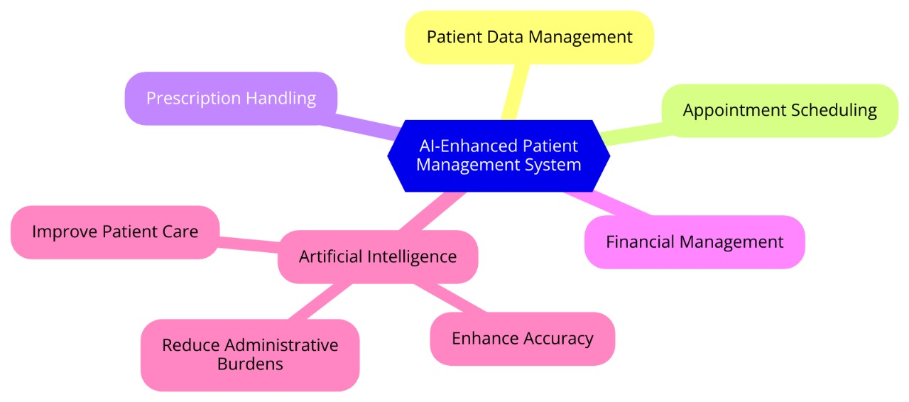

Figure 1: Concept Map

**CHAPTER THREE: METHODOLY**

### 3.0 Introduction

This chapter outlines the research methodology employed in the development of the AI-Enhanced Patient Management System (APMS). It includes the research design, data collection methods, and the design diagrams utilized. The chapter provides a detailed description of the steps taken to ensure the system's development meets the set objectives.

### 3.1 Research Design

The research design for this project is a combination of exploratory and developmental research. Exploratory research is used to gather insights and understanding of the current patient management systems, while developmental research focuses on the actual creation of the AI-Enhanced Patient Management System. This approach ensures that the system is both innovative and grounded in practical needs, similar to the approach used by [**Brem et al., 2006].**

### 3.2 Data Collection Methods

Data collection for this project involves both primary and secondary sources.

**Primary Data Collection:**

* **Interviews:** Conducted with healthcare providers such as the Doctors , Health System Administrators, Health Accountants to understand the challenges and requirements of current patient management systems.
* **Surveys:** Distributed to patients, Doctors and Hospital Accountants to gather feedback on their experiences with existing systems and their expectations for improvements.
* **Observations:** On-site visits to healthcare facilities to observe the workflow and identify inefficiencies in the current Patient Management systems.

**Secondary Data Collection:**

* **Literature Review:** Analysis of existing research papers, articles, and case studies related to patient management systems and AI applications in healthcare.
* **Database Analysis:** Examination of existing patient management databases to understand common data management practices.

### Design Diagrams

3.3.1 Context Diagram The context diagram provides an overview of the APMS, showing the interactions between the system and external entities such as patients, healthcare providers, and financial institutions.  
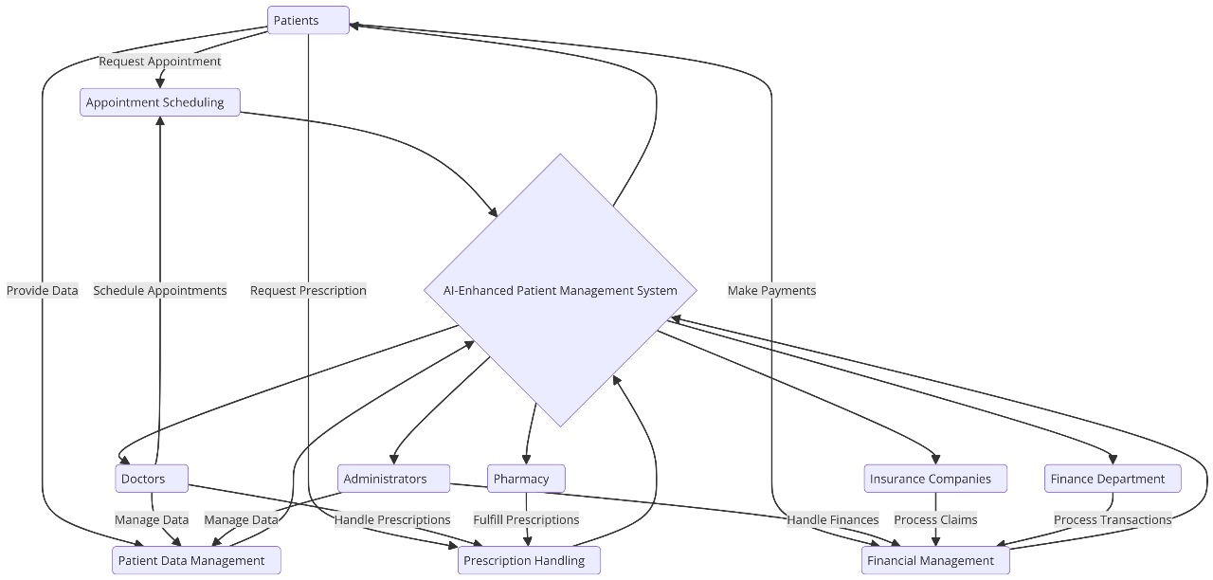

Figure 2: Context Diagram

3.3.2 Level 1 Data Flow Diagram (DFD) The Level 1 DFD breaks down the APMS into its major processes, showing the flow of data between these processes and the external entities.  


Figure 3: Dataflow Diagram

**3.3.3 Use Case Diagram** The use case diagram identifies the key interactions between users (actors) and the APMS, detailing the various functionalities of the system.

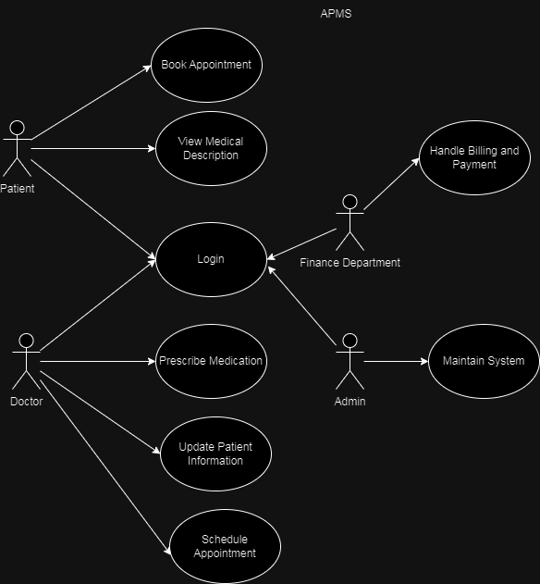

Figure 4: Use case Diagram

**3.3.4 Entity-Relationship Diagram (ERD)** The ERD shows the relationships between different data entities in the APMS.

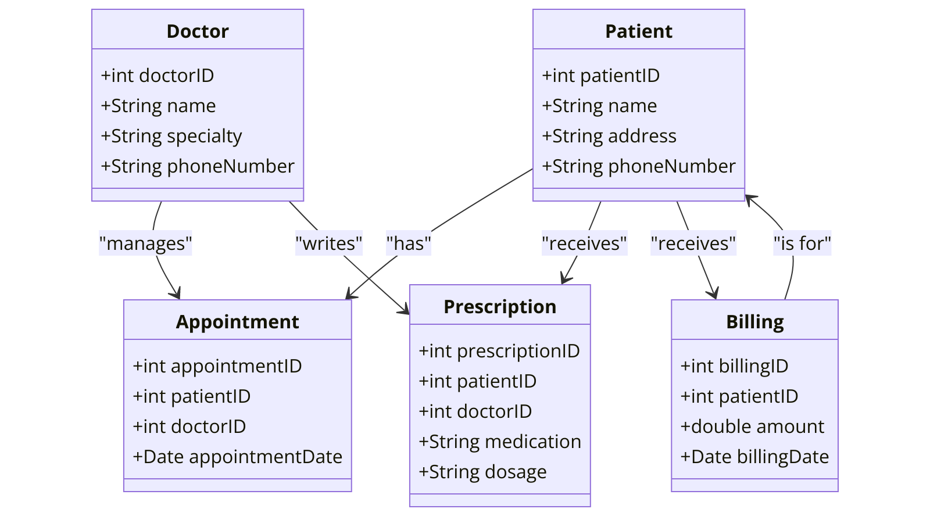

Figure 5: Entity Relationship Diagram

#### 3.4 Research Ethics

The development of the APMS will adhere to strict ethical guidelines to ensure the confidentiality, anonymity, and informed consent of all participants involved in data collection. Patient data will be anonymized to protect their privacy, and all participants will be informed about the purpose of the research and their right to withdraw at any time.

* **Confidentiality:** All data collected will be stored securely, and access will be restricted to authorized personnel only.
* **Anonymity:** Participants' identities will be protected by anonymizing personal information in the data collected.
* **Informed Consent:** Participants will be provided with detailed information about the study and will be required to sign a consent form before participating.

**References**

1. Brynjarsdottir, H., Hekler, E. B., Munson, S. A., Kientz, J. A., Consolvo, S., & Disalvo, C. (2014). "Understanding the Role of Technology in Health Behavior Change: A Literature Review and Proposed Framework." *Journal of Medical Internet Research*, 16(5), e146.
2. Morris, Z. S., Wooding, S., & Grant, J. (2018). "The Answer is 17 Years, What is the Question: Understanding Time Lags in Translational Research." *Journal of the Royal Society of Medicine*, 104(12), 510-520.
3. Ammenwerth, E., Iller, C., & Mahler, C. (2006). "IT-Adoption and the Interaction of Task, Technology and Individuals: A Fit Framework and a Case Study." *BMC Medical Informatics and Decision Making*, 6, 3.
4. Boutet, M., Chassagnon, S., & Caramella, C. (2016). "Artificial Intelligence in Radiology: Current Applications and Future Directions." *European Radiology*, 26(7), 2776-2784.
5. Yu, K. H., Beam, A. L., & Kohane, I. S. (2018). "Artificial Intelligence in Healthcare." *Nature Biomedical Engineering*, 2, 719-731.

**Online Sources**

* Healthray. (n.d.). The Power of AI in Hospital Management Systems. Retrieved from Healthray Blog.
* Studer, Q., Haggy, J., & Kobernick, M. (2000). Advanced Health System Models. *Health Services Research*.

## APPENDICES

### ****Appendix A: Interview Questions for Healthcare Providers****

1. **Patient Management Systems**
   * How do you currently manage patient data in your facility?
   * What challenges do you face with the current system?
   * How do you ensure the accuracy and security of patient information?
2. **Appointment Scheduling**
   * What methods do you use to schedule patient appointments?
   * Are there any inefficiencies or issues with the current scheduling process?
3. **Prescription Handling**
   * How do you manage and track patient prescriptions?
   * What are the common issues you encounter with prescription management?
4. **Financial Management**
   * How do you handle billing and payments in your facility?
   * What are the main challenges you face with financial transactions and record-keeping?
5. **AI Integration**
   * How familiar are you with AI applications in healthcare?
   * What potential benefits do you see in integrating AI into patient management systems?

### ****Appendix B: Survey Questionnaire for Patients****

1. **Demographics**
   * Age:
   * Gender:
   * Location:
2. **Patient Portal Usage**
   * Do you use an online patient portal to manage your health records and appointments? (Yes/No)
   * How would you rate the user-friendliness of the current patient portal? (1-5 scale)
3. **Medical Information**
   * How easy is it for you to understand medical terms and conditions provided in the portal? (1-5 scale)
   * Would you find it helpful if the portal included AI-driven descriptions of medical terms? (Yes/No)
4. **Appointment Scheduling**
   * How do you typically schedule appointments with your healthcare provider? (Online/Phone/In-Person)
   * Are you satisfied with the current appointment scheduling process? (1-5 scale)
5. **Prescription Management**
   * How do you manage and track your prescriptions? (Online/Phone/In-Person)
   * Have you experienced any issues with prescription management? (Yes/No)
6. **Overall Experience**
   * How satisfied are you with the overall management of your healthcare? (1-5 scale)
   * What improvements would you like to see in the patient management system?

### ****Appendix C: Observation Checklist for Healthcare Facilities****

1. **Patient Data Management**
   * Observe how patient data is recorded and stored.
   * Note any inefficiencies or potential errors in the process.
2. **Appointment Scheduling**
   * Observe the methods used to schedule appointments.
   * Identify any delays or issues in the scheduling process.
3. **Prescription Handling**
   * Observe how prescriptions are managed and tracked.
   * Note any common issues or inefficiencies in the process.
4. **Financial Management**
   * Observe the billing and payment processes.
   * Identify any challenges or potential security issues in financial transactions.
5. **System Integration**
   * Observe how different systems (patient data, appointments, prescriptions, financials) interact.
   * Identify any disjointed processes or lack of integration.

### ****Appendix D: Technical Specifications of the AI-Enhanced Patient Management System****

1. **System Architecture**
   * Overview of the system architecture, including hardware and software components.
   * Diagram of the system architecture.
2. **Technology Stack**
   * List of programming languages, frameworks, and tools used.
   * Justification for the selection of each technology.
3. **AI Capabilities**
   * Description of AI algorithms and models used.
   * Details on how AI is integrated into different system modules.
4. **Security Measures**
   * Overview of data encryption methods used.
   * Description of authentication and authorization mechanisms.
   * Details on data backup and recovery procedures.
5. **Scalability and Performance**
   * Strategies for ensuring system scalability.
   * Performance benchmarks and testing results.

### ****Appendix E: Glossary of Terms****

* **AI (Artificial Intelligence)**: The simulation of human intelligence processes by machines, especially computer systems.
* **APMS (AI-Enhanced Patient Management System)**: A comprehensive platform that integrates patient data management, appointment scheduling, prescription handling, and financial management, enhanced by AI capabilities.
* **EHR (Electronic Health Record)**: A digital version of a patient's paper chart, containing comprehensive health information.
* **HIPAA (Health Insurance Portability and Accountability Act)**: A US law designed to provide privacy standards to protect patients' medical records and other health information.
* **Blockchain**: A decentralized ledger technology that ensures secure and transparent record-keeping.