Print / Save as PDF
alteram we listen

DCE Assistant (Agent Pro & Admin Studio)
Operational Floor Training Manual
Department of Employment and Labour (DEL) Contact Centre Operations
Universal Ticket Automation, SOP v5.1 Decision Matrix & Verification Architecture
System: DCE Assistant (Universal Browser Extension)
SOP Baseline: UIF & Compensation Fund SOP v5.1
Target Platforms: DEL CRM, Telviva One, AltDesk, WSSTS
Release Version: v5.1.0 (Zero-Passcode / Clean Floor Edition)
Publication Date: 22 September 2026
Designed & Developed by Bonga Manzini | Alteram Solutions Floor Technical Operations
1144, 16th Road Randjespark Midrand | Postnet Suite 551, Private Bag X1, Melrose Arch, 2076
T 010 900 4075 | www.alteram.co.za | info@alteram.co.za
alteram we listen
2 | P a g e

1. System Overview & Table of Contents
The DCE Assistant Extension is the official contact center operational companion built for Alteram floor agents and team leaders servicing the Department of Employment and Labour (DEL). It automates CRM ticket indexing, enforces strict POPI Act inbound verification protocols, standardizes 1-tap call note generation, and connects with telephony queues.
Module | Training Section | Key Agent Competency
Section 2 | Launching DCE Assistant & Telephony Status | Chrome Side Panel, Mic Permissions, Telephony Availability
Section 3 | Active Web Connection & Ticket History Navigation | Live CRM Site Detection, Fast Ticket Reopen, Notes Log
Section 4 | Inbound Caller Verification (SOP §1.2 & POPI Act) | 3-Role Vetting (Employee/Employer/Practitioner), Compulsory Checks
Section 5 | 1-Tap Categorization & SOP v5.1 Routing Card | Department Presets, Probing Questions, Document Checklists
Section 6 | Call Notes Staging Area & Dropdown Toolbar | Standard Notes Format, Dynamic Dates (TODAY/+7DAYS), Tokens
Section 7 | Flag Incomplete & Straight-to-Save Directive | Handling Incomplete Records, TL Escalation, Quick Save
Section 8 | HQ Admin Switchboard & Dev Support Helpdesk | Real-Time Policy Toggles, Auto-Screenshot Bug Dispatch

2. Launching DCE Assistant & Telephony Status
- Open Google Chrome and locate the DCE Assistant icon on the browser toolbar.
- Click the extension icon to dock the assistant in the Chrome Side Panel alongside DEL CRM (delcrmprod.alteram.co.za).
- Select your preferred interface theme from the header dropdown (Corporate Light recommended for floor operations).
- Verify Telephony Presence: Observe the presence indicator in the top green bar. When logged in and ready for calls, the badge will display AVAILABLE (NOT ON CALL) in solid green.
IMPORTANT: Microphone Site Permissions & Telephony Sync If Chrome microphone access is toggled off or blocked, the extension will flag an alert: Disconnected (Microphone Required). Ensure site permissions in Chrome allow microphone access for telephony routing.
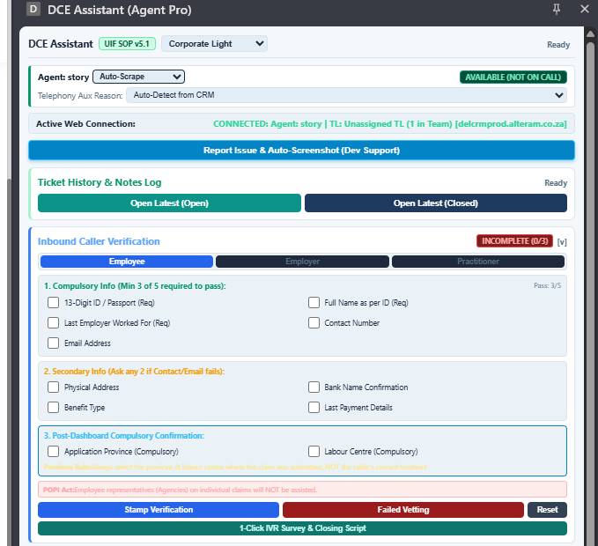
Figure 2.1: DCE Assistant Agent Pro Top View showing Telephony Presence & Web Connection
1144, 16th Road Randjespark Midrand | Postnet Suite 551, Private Bag X1, Melrose Arch, 2076
T 010 900 4075 | www.alteram.co.za | info@alteram.co.za
alteram we listen
3 | P a g e

3. Active Web Connection & Ticket History
The DCE Assistant maintains a persistent background heartbeat with the active CRM tab.
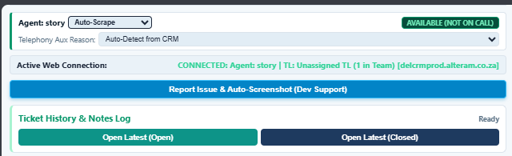
Figure 3.1: Live CRM Heartbeat & Ticket Navigation Buttons
- Active Web Connection Banner: Verifies the logged-in agent identity, assigned Team Leader, and active host (delcrmprod.alteram.co.za).
- Open Latest (Open): Automatically queries DEL CRM datatable and launches the caller's most recent active open ticket on screen with one click.
- Open Latest (Closed): Instantly pulls the caller's previous resolved case to review past resolution notes and historical agent advice.

4. Inbound Caller Verification & POPI Act (SOP §1.2)
Prior to disclosing any claim, payment, or profile details on DEL CRM, every agent is legally mandated to complete caller identity authentication.
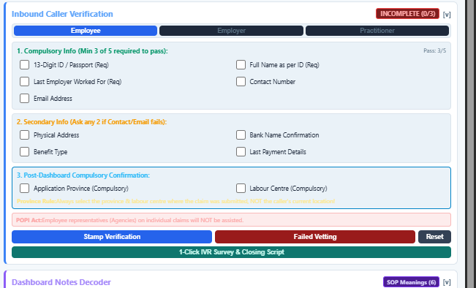
Figure 4.1: Standardized 3-Role Inbound Caller Verification Engine

Standard Authentication Protocol:
- Role Switcher: Click Employee, Employer, or Practitioner depending on the caller's capacity.
- Compulsory Info (Step 1): Must satisfy at least 3 out of 5 compulsory questions (SA ID, Full Name, Last Employer, Contact Number, Email Address).
- Secondary Info (Step 2): If contact number or email fails, ask 2 secondary verification questions (Physical Address, Bank Name, Benefit Type, Last Payment Details).
- Post-Dashboard Confirmation (Step 3): Verify Application Province and Labour Centre. Province Rule: Always select the province & centre where the claim was lodged, NOT the caller's current location!
POPI ACT LEGAL DIRECTIVE: Employee representatives (Agencies, third-party brokers) calling on behalf of individual employee claims will NOT be assisted telephonically. Directed to have the claimant call directly.
1144, 16th Road Randjespark Midrand | Postnet Suite 551, Private Bag X1, Melrose Arch, 2076
T 010 900 4075 | www.alteram.co.za | info@alteram.co.za
alteram we listen
4 | P a g e

5. 1-Tap SOP Categorization & Case Routing
The 1-Tap Categorization Matrix contains complete presets spanning UIF, Compensation Fund (CF), and Inspection services aligned with SOP v5.1.
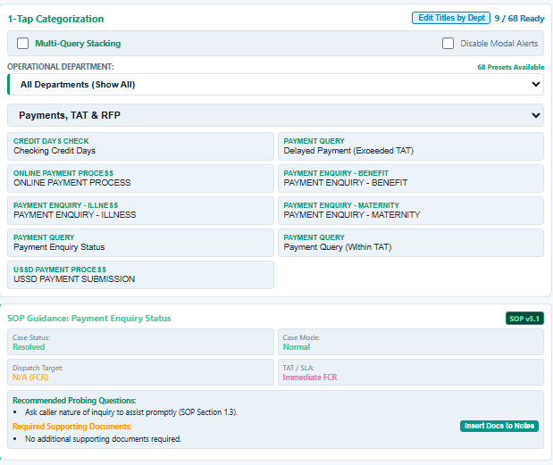
Figure 5.1: Category Filter, 1-Tap Preset Chips & Live SOP Guidance Card

Step-by-Step Categorization Flow:
- Select Department: Choose UIF, Compensation Fund (CF), or All Departments from the top selector.
- Filter Category: Use the category dropdown to filter presets (e.g. Payments, TAT & RFP, Claims Application, Normal Claims Appeals).
- Click Relevant Preset Chip: Instantly sets the Case Title, Service, Category, Sub-Category, and Issues in the CRM ticket.
- Inspect Live SOP Guidance Card:
  - Case Status: Displays mandatory case status (e.g., Resolved (FCR) vs Open).
  - Case Mode: Dictates mode (e.g., Normal vs UIF Complaint).
  - Dispatch Target: Identifies target workgroup (e.g., CC Admin Complaints workgroup).
  - TAT / SLA: Specifies standard turnaround time.
  - Recommended Probing Questions: Prompts questions agents must ask during the call.
  - Insert Docs to Notes: Click to inject the mandatory supporting documents checklist directly into call notes.
OFFICIAL SOP v5.1 TURN-AROUND TIMES (TAT):
• Normal Claims Application: 25 working days.
• Request for Payment (RFP): 7 to 15 working days.
• UIF Complaints & Escalations: 14 working days (CC Admin Complaints).
• BAU Online Escalation (Credentials): 4 working days.
• Document Verification Reminders: Day 1, 2, 3 reminders; auto-close on Day 10.
1144, 16th Road Randjespark Midrand | Postnet Suite 551, Private Bag X1, Melrose Arch, 2076
T 010 900 4075 | www.alteram.co.za | info@alteram.co.za
alteram we listen
5 | P a g e

6. Call Notes Staging & Smart Number/Date Toolbar
The Call Notes Staging Area eliminates manual typing errors by generating compliant, standardized call notes. It features a streamlined single dropdown for all numbers, tokens, and dates.
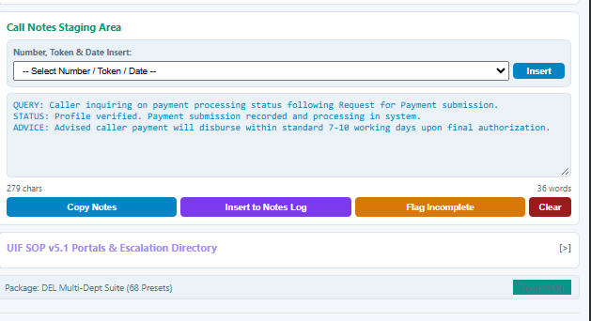
Figure 6.1: Call Notes Staging Area with Single Number/Token/Date Insert Dropdown

Using the Single Number, Token & Date Dropdown:
- Click the -- Select Number / Token / Date -- dropdown.
- Insert Current Date: Select TODAY and click Insert. It immediately replaces [Insert Date] or [DATE] with today's standard date (e.g. 22 Sep 2026).
- Insert Follow-up Date: Select +7DAYS to calculate and insert a 7-day follow-up date.
- Insert Specific Amounts or Numbers: Select 1000, 5000, 10000, or choose Custom Input Field... to type an exact benefit amount or claim number.
- Entity Tokens: Supports [NUMBER], [ID_NUMBER], [REF_NUMBER], [AMOUNT], and [W.CL_FORM].

Standard Operational Notes Templates (Examples):
Client called to follow up on his payment. RFP was done on the 22 Sep 2026 and the status is submitted. I advised the client to call us after 14 working days if no payment because they are still within the turn around time.
Client called in the follow up on their application which was submitted online. Application submitted on the 22 Sep 2026. Advised the client wait for feedback between 25 working days.
Copy Notes: Copies structured text to clipboard for manual use.
Insert to Notes Log: Directly commits the drafted notes into DEL CRM notes box.
1144, 16th Road Randjespark Midrand | Postnet Suite 551, Private Bag X1, Melrose Arch, 2076
T 010 900 4075 | www.alteram.co.za | info@alteram.co.za
alteram we listen
6 | P a g e

7. Flagging Incomplete Tickets & Straight-to-Save
To prevent non-compliant tickets from being prematurely closed, the assistant incorporates a live QA guardrail.
- Flag Incomplete Button: If a caller disconnects prematurely or required documents/fields are missing, click Flag Incomplete. This tags the ticket on the Supervisor Console in real-time.
- Straight to Save Case Directive: When an incomplete ticket is reopened, a high-visibility guidance banner appears. Agents fix the missing ticket fields manually on screen, then click Straight to Save Case to automatically inject notes and save the case directly.

8. HQ Admin & Team Leader Feature Switchboard
Supervisors and Operations Admins can configure floor-wide policy enforcement in real-time via the DCE Master Automator console without reloading agents' browsers.
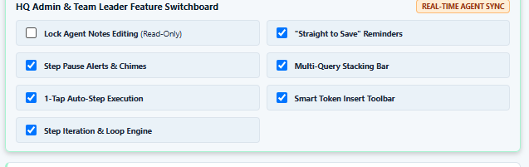
Figure 8.1: HQ Admin & Team Leader Feature Switchboard (Real-Time Agent Sync)
Switchboard Control | Operational Effect on Floor Agents
Lock Agent Notes Editing (Read-Only) | Locks the notes textarea to read-only, preventing manual edits and enforcing 100% adherence to SOP presets.
"Straight to Save" Reminders | Activates guidance banners and the fast-save action bar on flagged incomplete tickets.
Step Pause Alerts & Chimes | Audible chime alert when automation pauses on a screen waiting for agent manual input.
Multi-Query Stacking Bar | Enables multi-query stacking for complex calls covering multiple unrelated enquiries.
1-Tap Auto-Step Execution | Automates robotic field selection and dropdown choices on DEL CRM forms.
Smart Token Insert Toolbar | Controls the visibility of the Number, Token & Date Insert dropdown toolbar.

9. Technical Support & Auto-Screenshot
If an agent encounters a system error or field lag, click Report Issue & Auto-Screenshot (Dev Support). The assistant captures a screen snapshot and pre-fills an escalation report to bonga.manzini@alteram.co.za and floor IT.
1144, 16th Road Randjespark Midrand | Postnet Suite 551, Private Bag X1, Melrose Arch, 2076
T 010 900 4075 | www.alteram.co.za | info@alteram.co.za
alteram we listen
7 | P a g e
alteram we listen

Key Operational Portals & Contact Directory
UIF Online Portal: https://uifonline.labour.gov.za/uifOnline/
WSSTS Ticketing Portal: https://ccselfservice.labour.gov.za
General Documents Submission: uifcallcenter@labour.gov.za
Employer Registrations: Newui8registerations@labour.gov.za
Declarations Department: uif.declarations@labour.gov.za
Debtors & Contributions: enquiries.debtors@labour.gov.za
DCE Extension Floor Lead: Bonga Manzini (bonga.manzini@alteram.co.za)
This document is proprietary to Alteram Solutions (Pty) Ltd.
Developed for Department of Employment and Labour Contact Centre Floor Operations.
All rights reserved © 2026 Alteram Solutions.
1144, 16th Road Randjespark Midrand | Postnet Suite 551, Private Bag X1, Melrose Arch, 2076
T 010 900 4075 | www.alteram.co.za | info@alteram.co.za

