Name: Mlungisi Bongani Ndaba
Student Number: 202321243
Phase :2
Title: Requirements Engineering

1. Introduction
This document covers Phase 2 of the Moderated LMS project. The purpose of this phase is to understand the needs of the people who will use or manage the system, resolve unclear or conflicting requirements, write the Software Requirements Specification (SRS), and describe the main use cases.

2. Stakeholder Analysis
A stakeholder is a person or group affected by the system or able to influence its requirements. An actor is a role that directly interacts with the system. The principal is an important stakeholder, but the four actors in the use case model are Administrator, Lecturer, HoD and Student, as required by the case study.
Stakeholder | Main interest or statement | What the system should address
Principal | Wants a simple system and does not want marks released before the HoD checks them. | Ease of use; controlled release of marks.
Lecturer | Wants to release marks immediately after marking and needs to grant individual extensions. | Efficient marking, feedback and extension handling.
Head of Department (HoD) | Needs to see all departmental marks before release; specifies the late-penalty rule. | Moderation, fairness and departmental oversight.
Student representative / Students | Wants resubmission before the deadline, written feedback, and late work not to be simply rejected. | Fair submission process, feedback and visibility of released marks.
IT Officer | Says computers are old, internet is unreliable, passwords must be protected and the system should respond quickly with 800 and more students. | Offline operation, security and performance.
Administrator | Needs to manage users, roles and courses so the system can be used by the school. | Accurate user/course records and controlled access.

2.1 Stakeholder needs and system actors
The four system actors are Administrator, Lecturer, HoD and Student. Each actor has different permissions. The system should not assume that every user can view or change all information. For example, a student should see their own released marks and feedback, while the HoD needs access to departmental marks for moderation.

2.2 Conflicts, ambiguities and proposed resolutions
Issue | Conflict or ambiguity | Resolution
Marks release timing | The Lecturer wants marks released immediately after marking. The Principal and HoD require HoD checking/approval before release. | Use a workflow where lecturers mark submissions and enter feedback, then the HoD reviews departmental marks and approves release. Marks become visible to students immediately after approval.
Late submissions | The student representative says late work should not simply be rejected. The HoD says 10% of the available mark is deducted per day for up to three days; after that the mark is zero. | The system should accept and record late submissions and apply the stated penalty. The penalty of the reduction of 10% should be done until the student gets a 0%, not that after three days the work gets given an automatic zero.
Resubmission | Students want to correct mistakes and resubmit before the deadline, but it is not stated whether the old version should be kept. | Allow resubmission before the deadline. For accountability, keep a record of the latest submission and its time; confirm whether earlier versions must also be retained.
Individual extensions | Lecturers want to give individual students extensions, but the statement does not explain whether extensions change the original deadline or how they affect penalties. | Allow a lecturer to set an individual revised deadline for a student and apply the penalty rule relative to the approved deadline. Confirm how extensions are recorded and whether only authorised lecturers can grant them.
Meaning of 'fast' and 'simple' | The IT Officer asks for quick response and the principal asks for a simple system, but neither phrase gives a measurable target. | Use measurable response-time targets for performance and a short usability test for common tasks. The numerical targets in the SRS are proposed targets that need agreement before Gate 1.

2.3 Decisions and assumptions to confirm at Gate 1
- The HoD must approve marks before they are released to students.
- The late penalty is 10% of the available mark per day for up to three days; after that the mark is zero. The HoD should confirm how the system treats submissions received after the three-day limit and how a 'day' is counted.
- Students may resubmit before the approved deadline. The stakeholders should confirm whether all earlier versions need to be retained.
- Lecturers may grant individual extensions. The system should use the approved extended deadline when deciding whether work is late.
- Core functions must operate without an internet connection. The deployment arrangement (single computer or local network) needs confirmation.
- Performance and usability targets below are initial measurable targets, not values explicitly stated by every stakeholder.

3. Software Requirements Specification (SRS)

3.1 User classes
User class | Main permitted activities
Administrator | Manage user accounts, assign roles and manage course records.
Lecturer | Create assignments, view submissions, grant individual extensions, mark work and provide written feedback.
HoD | Review departmental marks and approve or withhold release.
Student | View available assignments, submit or resubmit work before the applicable deadline, and view released marks and feedback.

3.2 Functional requirements
Each functional requirement has a unique ID, a MoSCoW priority and a verification method.
Functional Requirements | Functional requirement | MoSCoW | Verification
1 | The system shall allow an Administrator to create, update, deactivate and view user accounts. | Must | Test each account-management action using an Administrator account.
2 | The system shall assign each user one of the supported roles: Administrator, Lecturer, HoD or Student. | Must | Create users for all four roles and check the stored role.
3 | The system shall restrict each user to functions permitted for that user's assigned role. | Must | Attempt permitted and forbidden actions with each role; verify forbidden actions are denied.
4 | The system shall allow an Administrator to create and update course records and associate lecturers and students with courses. | Must | Create a course and check the associated lecturer/student records.
5 | The system shall allow a Lecturer to create an assignment with a title, description, course and submission deadline. | Should have | Create an assignment with required fields and verify it is saved.
6 | The system shall display assignments available to a student for that student's course or courses. | Should have | Log in as a student and verify that only relevant assignments are listed.
7 | The system shall allow a Student to submit an assignment before the applicable deadline and record the submission time. | Must | Submit before the deadline and verify that the submission and timestamp are saved.
8 | The system shall allow a Student to resubmit an assignment before the applicable deadline. | Should have | Submit once, resubmit before the deadline and verify that the latest submission is recorded.
9 | The system shall apply an approved individual extension when checking the deadline for the relevant student. | Must | Grant an extension and verify that a submission before the revised deadline is treated as on time.
10 | The system shall calculate the late penalty as 10% of the available mark per late day for up to when the student finally gets zero. | Must | Test on-time work and work one, two, three up to when the student finally gets a zero.
11 | The system shall allow a Lecturer to record a mark and written feedback for a student's submission. | Must | Enter a mark and feedback and verify that both are saved against the correct submission.
12 | The system shall allow the HoD to review departmental marks before authorising their release. | Must | Verify that the HoD can view the relevant marks and approve or withhold release.
13 | The system shall prevent students from viewing marks until the HoD has approved their release. | Must | Attempt to view marks before and after approval; verify visibility changes only after approval.
14 | The system shall display released marks and written feedback to the relevant student. | Must | Approve release and verify that the student can view their own mark and feedback.
15 | The system shall record every mark change with the user responsible, date/time, old mark, new mark and reason. | Must | Change a mark and verify that all required audit fields are saved.

3.3 Non-functional requirements
The performance figures below are proposed acceptance targets to make the requirements testable. They should be checked against the available school computers and confirmed with stakeholders.
Non-Functional | Quality | Requirement | Verification | Priority
1 | Offline operation | The core functions—user login, assignment creation, submission, marking, moderation and mark release—shall be usable on the configured school computer/local environment without an internet connection. | Disconnect internet access and test each listed function; all should complete without requiring an external service. | Must
2 | Performance | With 800 student records stored, a valid login shall complete within 10 seconds in at least 95% of 20 repeated tests on the target school computer. | Run 20 login tests against the test dataset and record response times. | Must
3 | Performance | With 800 student records stored, the assignment list for a student shall display within 3 seconds in at least 95% of 20 repeated tests on the target school computer. | Run 20 assignment-list tests and record response times. | Should
4 | Password security | The system shall not store passwords in plaintext; each stored password value shall be a hash generated using a recognised password-hashing method. | Inspect the database and authentication implementation; verify that plaintext passwords are not stored. | Must
5 | Access control | All tests of actions that are not permitted for a user's role shall be denied, and no unauthorised role shall be able to view unreleased marks. | Run role-permission tests for all four roles, including attempts to access unreleased marks. | Must
6 | Auditability | Every successful mark change shall produce a persistent audit record containing actor, timestamp, old value, new value and reason before the operation is considered complete. | Change marks, restart the application and verify that each audit record remains available with all required fields. | Must
7 | Usability | After no more than 30 minutes of introductory training, a lecturer with basic computer skills shall be able to create an assignment and record a mark without assistance in a usability test. | Give a short training session and observe the lecturer completing both tasks without help. | Should

4. Use Case Model

4.1 Actors
Actor | Description
Administrator | Manages user accounts, roles and course information.
Lecturer | Creates assignments, views submissions, marks work, gives written feedback and grants individual extensions.
HoD | Reviews departmental marks and approves or withholds release.
Student | Views assignments, submits/resubmits work, and views released marks and feedback.

4.2 Use case diagram
The diagram below shows the four required actors and the main use cases. The include relationship indicates that a submission must go through validation of the deadline and submission rules. The mark-change audit is a required part of recording a changed mark. Some detailed relationships may be refined during the design phase. The diagram also shows resubmission as an extension of submission, because resubmission only applies when a student already has a submission. The include relationship represents validation that is required during submission. Actor generalisation is not used because the four roles have distinct permissions; their common authentication behaviour is represented as a shared use case instead.
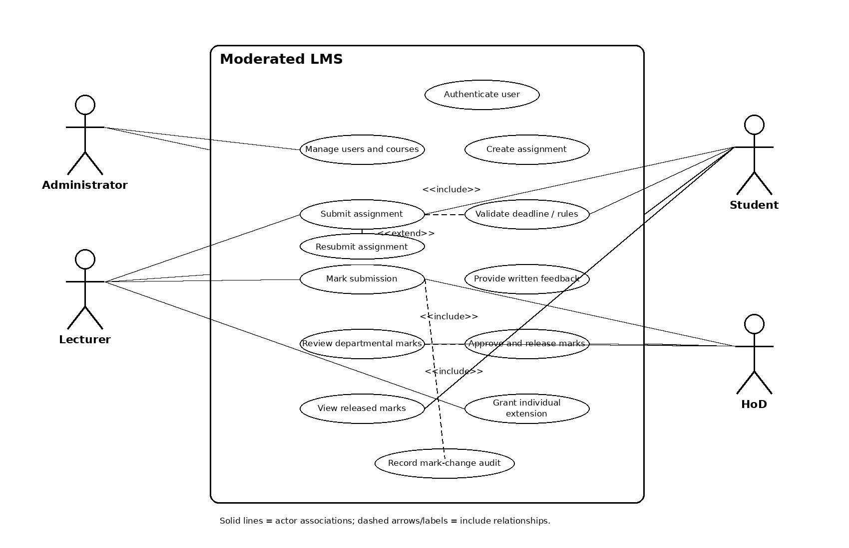
Note: This is a readable overview diagram. The detailed specifications below define the main and exceptional flows more precisely. The use case model should be kept consistent with the class, sequence, activity and database designs in Phase 3.

4.3 Fully dressed use case 1: Submit assignment
Field | Specification
Use case | UC-01 — Submit assignment
Primary actor | Student
Supporting system behaviour | Authenticate user; validate assignment deadline and submission rules.
Goal | Allow a student to submit assignment work and receive confirmation.
Preconditions | The student has an active account and is logged in. The assignment exists and is available to the student. The applicable deadline is known.
Trigger | The student selects an assignment and chooses to submit work.
Main flow | 1. The student opens the assignment. 2. The system displays the assignment details and applicable deadline. 3. The student selects the work to submit and confirms. 4. The system validates that the student is allowed to submit and that the applicable deadline has not passed, including any approved extension. 5. The system stores the submission and submission time. 6. The system displays a confirmation.
Alternative flow A1 — Resubmission | At step 3, if a previous submission exists and the deadline has not passed, the student selects a replacement submission. The system validates it, records the new submission time and identifies the latest submission. Whether earlier versions are retained is a stakeholder decision to confirm.
Alternative flow A2 — Approved extension | At step 4, if an individual extension exists, the system uses the approved revised deadline when checking whether the submission is on time.
Exception flow E1 — Deadline passed | At step 4, if the deadline has passed, the system checks the agreed late-submission rule. If the submission is within the permitted three-day late period, it records the submission as late for penalty calculation. If it is more than three days late, the system follows the HoD-approved rule and records a zero mark where applicable. The exact policy for accepting or recording files after the three-day limit must be confirmed.
Exception flow E2 — Invalid or missing file | If the selected file is missing or cannot be accepted, the system explains the problem and asks the student to select a valid file. No successful submission is recorded until validation succeeds.
Exception flow E3 — Save failure | If the system cannot save the submission, it displays an error and does not show a success confirmation. The student can retry.
Postconditions | On success, the submission and its timestamp are saved and available to the lecturer. On failure, the system does not falsely report a successful submission.
Business rules | Students may resubmit before the applicable deadline. An approved individual extension changes the applicable deadline. Late penalties follow the HoD's stated rule.

4.4 Fully dressed use case 2: Mark submission and provide feedback
Field | Specification
Use case | UC-02 — Mark submission and provide feedback
Primary actor | Lecturer
Goal | Record a mark and written feedback for a student's submission.
Preconditions | The lecturer is logged in, has permission for the course, and a student submission exists.
Trigger | The lecturer opens a submission to mark it.
Main flow | 1. The lecturer opens the course submission list. 2. The system displays the submissions the lecturer is permitted to mark. 3. The lecturer selects a submission. 4. The system displays the submitted work and relevant assignment details. 5. The lecturer enters a mark and written feedback. 6. The system validates the mark against the available mark and required fields. 7. The system saves the mark and feedback. 8. The system confirms that the marking has been saved.
Alternative flow A1 — Correcting a mark | If the lecturer changes a previously recorded mark, the system records the old mark, new mark, user, time and reason in the audit record.
Exception flow E1 — Invalid mark | If the mark is below zero or above the available mark, the system rejects it and explains the valid range.
Exception flow E2 — Missing feedback | If written feedback is required by the agreed policy and has not been entered, the system prompts the lecturer to provide it before saving.
Exception flow E3 — Save failure | If saving fails, the system reports the error and does not claim the mark was saved.
Postconditions | The mark and written feedback are saved against the correct submission. Any mark change has a persistent audit record. The mark is not visible to the student before HoD approval.
Business rules | The late penalty is applied according to the HoD-approved rule. Mark release is a separate controlled process and requires HoD approval.

4.5 Fully dressed use case 3: Moderate and release marks
Field | Specification
Use case | UC-03 — Moderate and release marks
Primary actor | HoD
Goal | Review departmental marks and approve their release to students.
Preconditions | The HoD is logged in and authorised for the department. Lecturers have entered the marks that are ready for review.
Trigger | The HoD opens the departmental marks awaiting moderation.
Main flow | 1. The HoD selects the department/course assessment. 2. The system displays the relevant marks and their status. 3. The HoD reviews the marks. 4. If satisfied, the HoD chooses approve release. 5. The system records the approval and time. 6. The system changes the marks' status to released. 7. The system allows the relevant students to view their released marks and feedback.
Alternative flow A1 — Approval withheld | At step 4, if the HoD is not satisfied, the HoD withholds approval and records a reason or requests correction. The marks remain hidden from students.
Alternative flow A2 — Some marks not ready | If some submissions have not been marked, the HoD can leave the assessment awaiting completion rather than releasing an incomplete set. The exact policy for partial release should be confirmed.
Exception flow E1 — Unauthorised access | If a user without the HoD role attempts the moderation function, the system denies access and records the attempt if required by the security policy.
Exception flow E2 — Save failure | If approval or release cannot be saved, the system reports an error and leaves the marks unreleased.
Postconditions | If approved, the release status and approval record are saved and students can view the relevant marks and feedback. If withheld, marks remain unreleased.
Business rules | Marks must not be visible to students before HoD approval. The HoD must be able to see departmental marks before release. Any later mark changes must be audited.

5. Requirements traceability starter table
This starter table links key functional requirements to the use cases and initial verification ideas. In later phases, it should be expanded to include the related design classes, diagrams, database tables, source files and test-case IDs.
Requirement ID | Requirement area | Use case link | Initial test idea
FR-05 | Create assignment | Create assignment (shown in diagram) | Create an assignment with required fields and verify it is saved.
FR-07 | Submit assignment | UC-01 | Test successful submission and timestamp.
FR-08 | Resubmit assignment | UC-01 alternative flow A1 | Test resubmission before deadline.
FR-09 | Individual extension | UC-01 alternative flow A2 | Test submission against revised deadline.
FR-10 | Late penalty | UC-01 exception flow E1 / marking rules | Boundary tests for on-time, 1, 2, 3 and >3 days late.
FR-11 | Mark and feedback | UC-02 | Test mark validation and feedback saving.
FR-12 / FR-13 | Moderation and release | UC-03 | Test that marks remain hidden until approval.
FR-15 | Mark-change audit | UC-02 alternative flow A1 | Test required audit fields and persistence.

6. Conclusion
This Phase 2 document identifies the main stakeholders, records the important conflicts and ambiguities, sets out an initial SRS and describes three important use cases. The proposed workflow allows lecturers to mark work and provide written feedback while ensuring that the HoD checks marks before students can see them. The late-penalty, resubmission, extension, offline operation and performance rules are included so they can be tested rather than left as vague statements.
Before Gate 1, the stakeholders should confirm the assumptions listed in Section 2.3, especially how late days are counted, what happens after the three-day late period, whether earlier submissions are retained, the exact offline deployment setup, and the proposed performance/usability targets. After approval, these requirements should be used consistently in the Phase 3 design and the later tests.

References
National University of Lesotho. (2026). CS4433 Final Project — Individual Assignment (course assignment brief).
National University of Lesotho. (2026). Phase 1: Project Management and Planning (student project document).
ISO/IEC/IEEE. (2018). ISO/IEC/IEEE 29148:2018 Systems and software engineering — Life cycle processes — Requirements engineering.
Sommerville, I. (2016) Software engineering. 10th edn, Global edn. Harlow: Pearson Education Limited.
Valacich, J.S., George, J.F. and Valacich, J.S. (2017) Modern systems analysis and design. 8th edn. Boston: Pearson

