Name: Mlungisi Bongani Ndaba
Student Number: 202321243
Phase-3
Title: System Design

Abstract
This document presents the Phase 3 system design for a Moderated Learning Management System for a secondary school. The proposed system is a C++17 application using SQLite for local persistent storage and is intended to operate without an internet connection. It supports four user roles: Administrator, Lecturer, Head of Department (HoD) and Student. The design covers the selected architecture, design-level classes, behavioural UML models and a normalised database design. Important rules include individual deadline extensions, resubmission before the applicable deadline, late penalties, mark auditing and HoD approval before marks are released to students. The design is intended to guide implementation in Phase 4 and to remain consistent with the requirements identified in Phase 2.

Contents
- 1. Introduction and design scope
- 2. Architecture design
- 3. Detailed class design
- 4. Behavioural models
- 5. Database design
- 6. Requirements traceability
- 7. Design risks and open decisions
- 8. Conclusion
- References

1. Introduction and design scope

1.1 Purpose
The purpose of this document is to turn the Phase 2 requirements into a design that can be implemented and tested in C++17. It describes the major software components, the classes and their relationships, the main workflows, and the SQLite database structure.

1.2 System context
The LMS is designed for a school that may have older computers and unreliable internet access. Core operations therefore run locally, with SQLite storing user, course, assignment, submission, marking, moderation and audit data. The design should support records for at least 800 students, with actual performance to be measured during testing.

1.3 User roles
Role | Main responsibilities
Administrator | Create, update, deactivate and view user accounts; manage departments and courses; assign lecturers and enrol students.
Lecturer | Create assignments, set deadlines and maximum marks, grant individual extensions, review submissions, record marks and feedback.
Head of Department (HoD) | Review departmental marks, request corrections or approve release; students must not see marks before approval.
Student | View enrolled-course assignments, submit and resubmit work before the applicable deadline, and view released marks and feedback.

1.4 Design assumptions and scope
- The selected interface is a simple console or desktop interface. A web/mobile interface is outside the project scope.
- SQLite is accessed only through the data-access layer, using parameterised queries.
- Passwords are never stored as plain text. A recognised password-hashing library such as libsodium Argon2id is proposed for implementation.
- Individual extensions change the applicable deadline for the specified student and assignment.
- Earlier submission versions are retained, while one version is identified as current. This is a design assumption because Phase 2 identified version retention as a point to confirm.
- Submissions more than three late days are recorded rather than silently rejected, but receive zero under the stated penalty rule. The exact late-day counting method must be confirmed with the stakeholders.
- The assignment's later maintenance change request adds whole-class extensions in Phase 8. It is not treated as a Phase 3 baseline feature.

1.5 Design principles
The design aims for separation of responsibilities, simple role-based access, maintainable business rules, database consistency, auditability and traceability to the SRS. It follows the project instruction that implementation must not begin until the design passes Gate 2.

2. Architecture design

2.1 Selected approach: MVC with a separate data-access layer
The proposed architecture uses Model–View–Controller (MVC) to organise user interaction, while separating application services and database access into their own components. MVC and layered design are not mutually exclusive. MVC helps structure views and user actions; a data-access layer keeps SQLite queries away from the user interface and business rules.
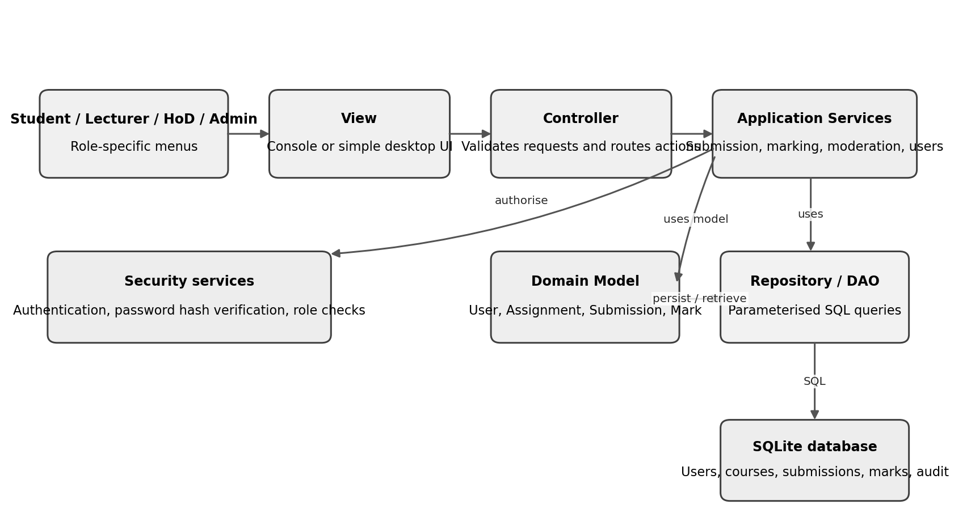
Figure 1. Proposed component architecture for the offline LMS.

2.2 Component responsibilities
Component | Responsibilities | Examples
View | Display menus and results; collect user input; show errors without applying business rules. | Student assignment list; lecturer marking screen; HoD moderation screen.
Controller | Receive user actions, validate basic input and call the relevant application service. | SubmissionController; MarkingController; ModerationController.
Application services | Coordinate use cases and enforce workflow rules. | SubmissionService; MarkingService; ModerationService; AccountService.
Domain model | Represent core entities and business behaviour. | User, Assignment, Submission, Mark, Course.
Security services | Authenticate users and check role permissions before restricted actions. | AuthenticationService; AuthorisationService.
Repository / DAO | Read and write domain data using parameterised SQL and transactions. | UserRepository; SubmissionRepository; MarkRepository.
SQLite | Persist data locally with keys, constraints and relationships. | users, courses, assignments, submissions, marks, mark_audit_log.

2.3 Rationale
- The four roles use different actions and views, so separating views from controllers helps keep the interface manageable.
- Business rules such as late penalties and mark release can be tested independently from menus and SQL queries.
- SQLite access is isolated, which makes it easier to use parameterised queries, transactions and foreign-key constraints consistently.
- The design can remain offline on a school computer or local network and does not depend on internet-hosted services for core functionality.
- The design separates authentication from authorisation: verifying a password is different from checking whether a role may perform an action.

2.4 Alternative considered and rejected
A purely layered architecture was considered. It is also a valid option for this application and does not require an existing system or multi-level security. The reason for selecting MVC as the main interaction structure is that the LMS has four user roles and several user-facing workflows. MVC makes the view/controller split explicit. The design still uses layered separation for business services and SQLite access, so it gains the benefits of both approaches rather than claiming layered architecture is unsuitable.

2.5 Security and reliability decisions
- Role checks are performed in the service layer, not only by hiding menu options.
- Student-facing queries return only released marks and feedback.
- Mark changes, moderation decisions and releases are saved with the responsible user and timestamp.
- Database updates that must succeed together, such as mark release and its moderation record, are wrapped in a transaction.
- Database errors and invalid input are handled through validation and exceptions; a failed release must leave the mark unreleased.
- The implementation should use a salted password hash from a recognised library and parameterised SQL. The hash algorithm and library version should be documented in Phase 4.

3. Detailed class design

3.1 Main domain classes
The class diagram includes domain classes and service/repository classes. Attributes use UML visibility symbols: '+' public, '-' private and '#' protected. Types and method return values are shown so that the diagram can guide C++ implementation.
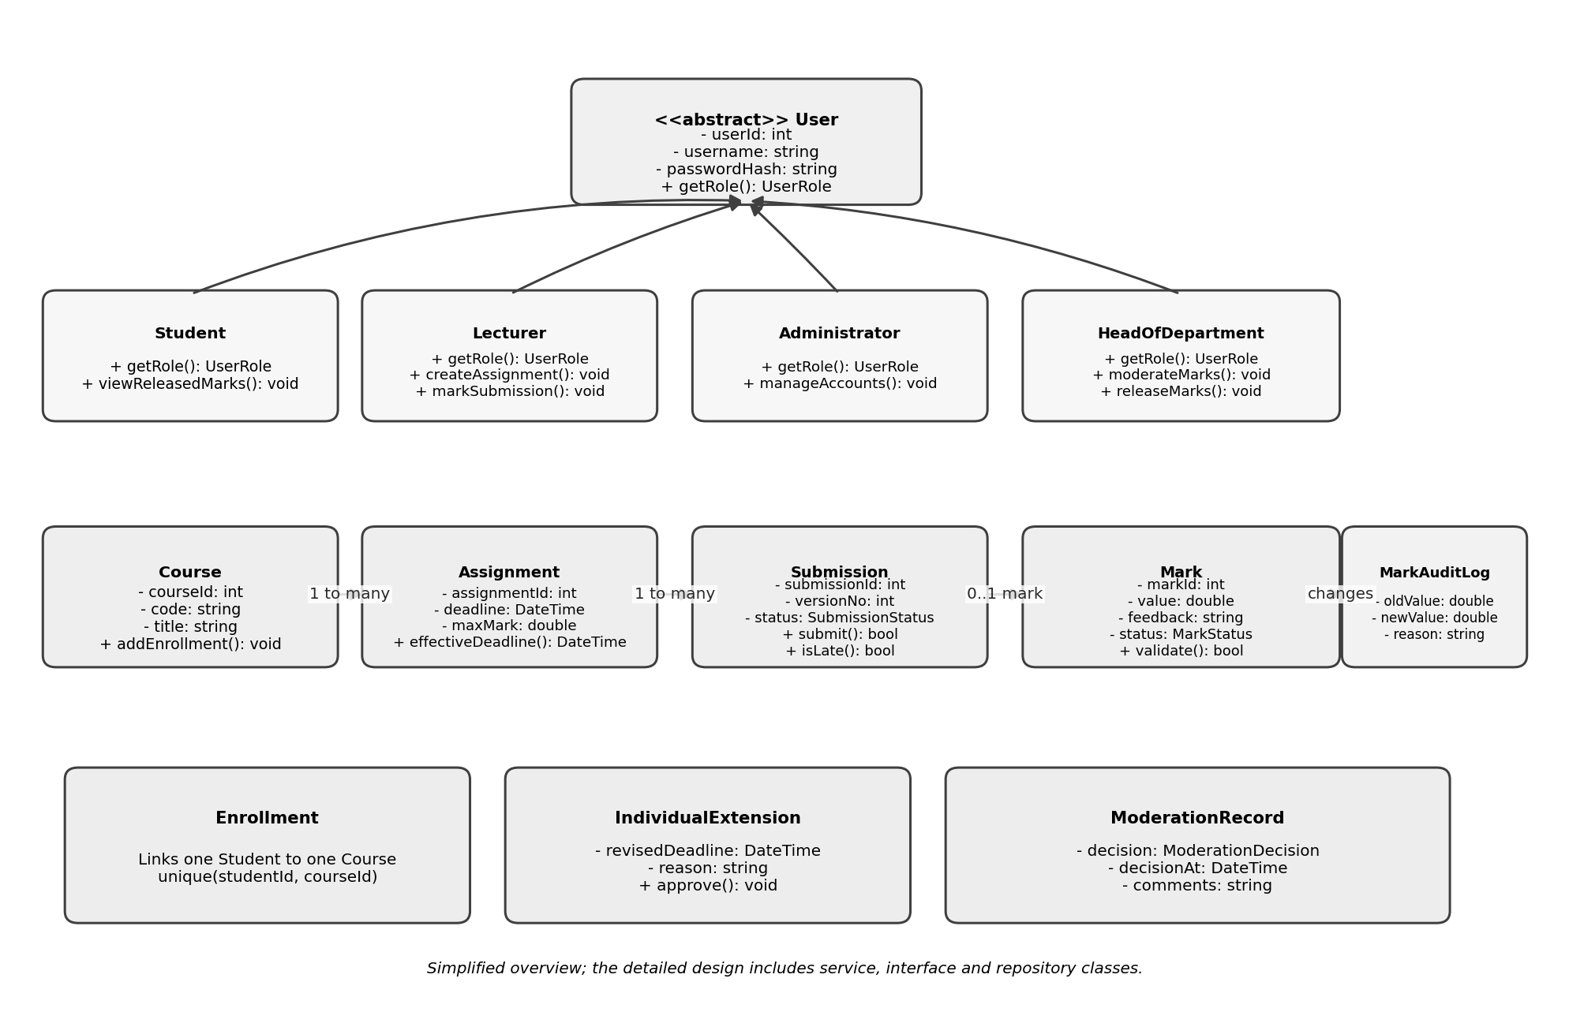
Figure 2. Domain-class overview, including user inheritance and core LMS entities.
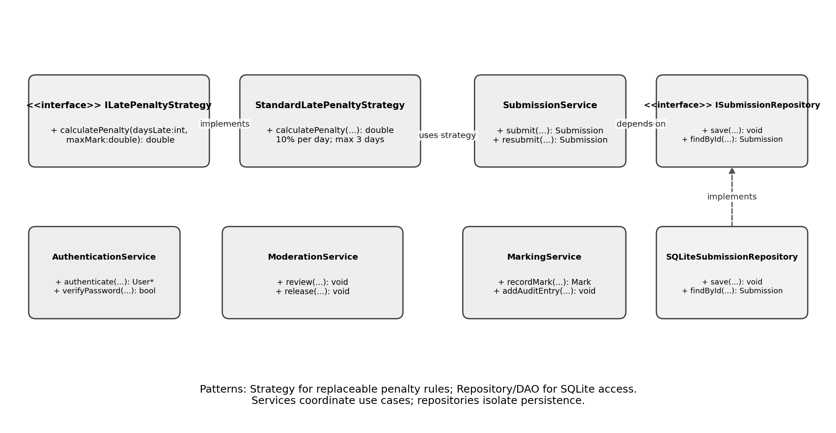
Figure 3. Service and interface design showing Strategy and Repository/DAO.
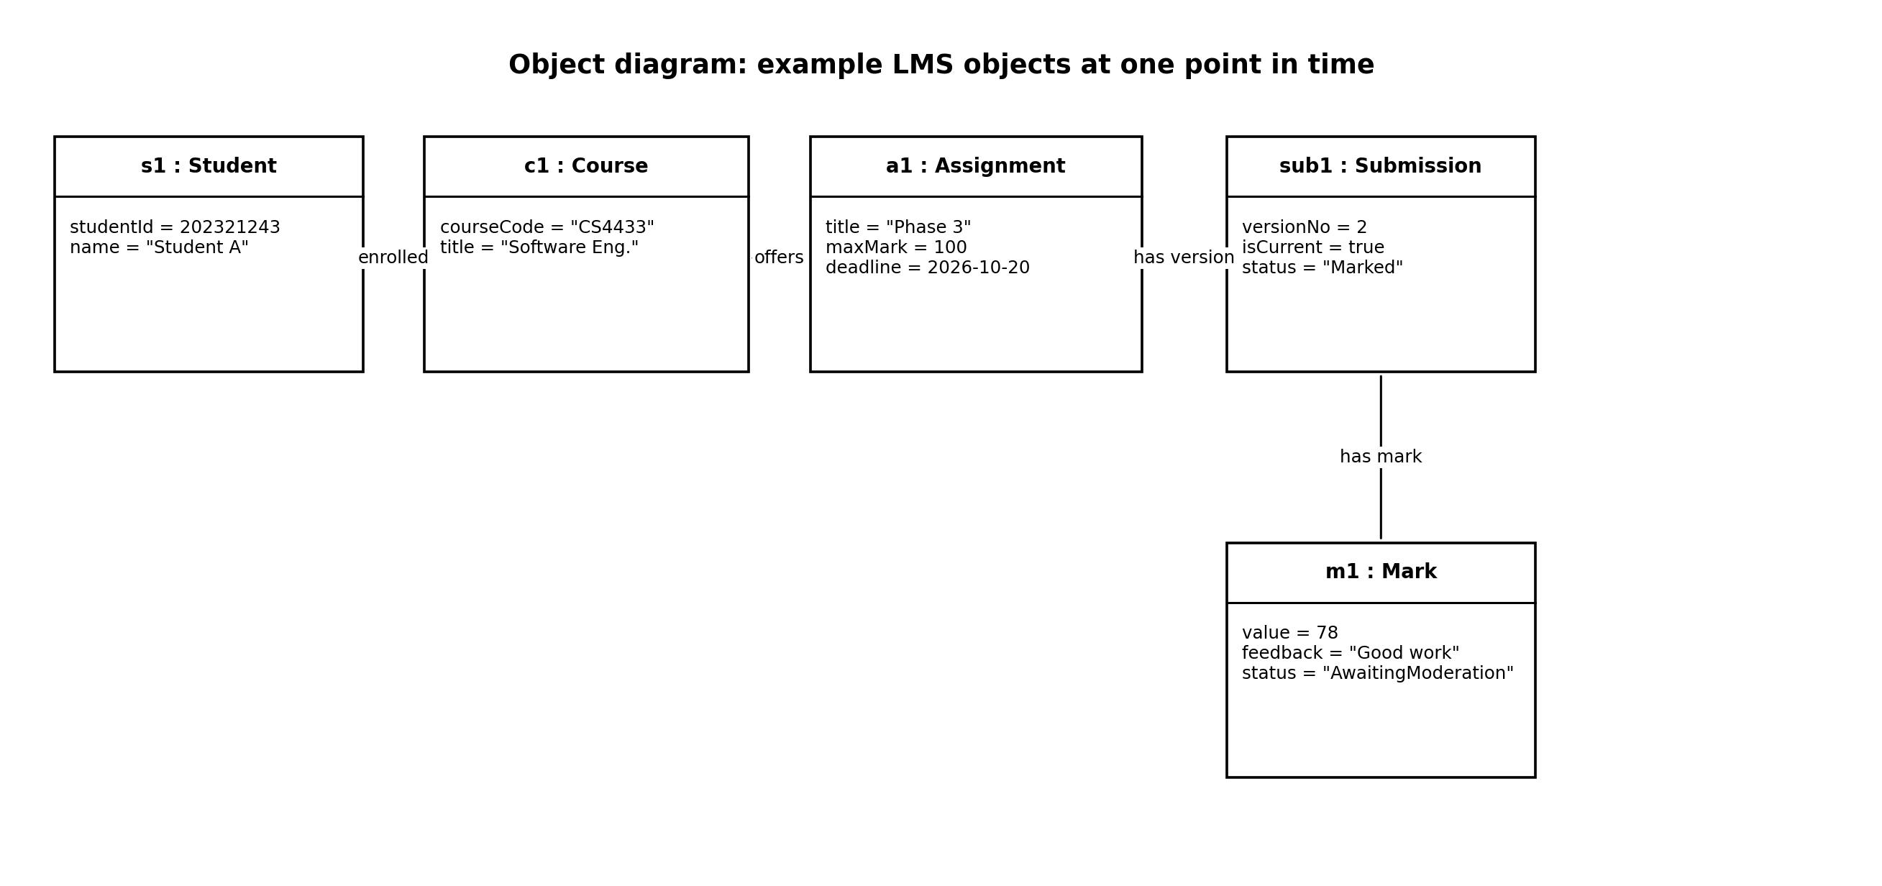
Figure 4. Object diagram showing example instances and attribute values.
The object values are illustrative examples, not actual student records.

3.2 Class responsibilities and key members
Class | Selected attributes | Selected operations / responsibility
User (abstract) | - userId: int; - username: string; - passwordHash: string; - role: UserRole; - departmentId: optional<int> | + getRole(): UserRole; + hasPermission(action: Action): bool (or delegated authorisation). Common identity; abstract base class.
Student : User | - studentNumber: string | + getRole(): UserRole; + listAssignments(courseId: int): vector<Assignment>; + viewReleasedMarks(): vector<Mark>.
Lecturer : User | - staffNumber: string | + getRole(): UserRole; + createAssignment(...): Assignment; + grantIndividualExtension(...): void; + markSubmission(...): Mark.
Administrator : User | -workerid: string | + getRole(): UserRole; + createUser(...): User; + updateCourse(...): void; + enrolStudent(...): void.
HeadOfDepartment : User | -workerid: string | + getRole(): UserRole; + reviewMarks(departmentId: int): vector<Mark>; + approveRelease(...): void; + requestCorrection(...): void.
Department | - departmentId: int; - name: string | + getCourses(): vector<Course>. Represents an academic department.
Course | - courseId: int; - courseCode: string; - title: string; - departmentId: int | + addEnrollment(studentId: int): void; + listAssignments(): vector<Assignment>.
Enrollment | - enrollmentId: int; - studentId: int; - courseId: int; - enrolledAt: DateTime | Connects a student to a course; unique student/course pair.
Assignment | - assignmentId: int; - title: string; - description: string; - deadline: DateTime; - maxMark: double; - courseId: int; - lecturerId: int | + effectiveDeadline(studentId: int): DateTime; + validate(): bool.
IndividualExtension | - extensionId: int; - assignmentId: int; - studentId: int; - revisedDeadline: DateTime; - reason: string | + approve(lecturerId: int): void. Stores the approved individual deadline.
Submission | - submissionId: int; - assignmentId: int; - studentId: int; - versionNo: int; - filePath: string; - submittedAt: DateTime; - isCurrent: bool; - status: SubmissionStatus | + isLate(deadline: DateTime): bool; + markAsCurrent(): void. One row represents a submission version.
Mark | - markId: int; - submissionId: int; - value: double; - feedback: string; - status: MarkStatus | + validate(maxMark: double): bool; + update(...): void. Status controls visibility.
ModerationRecord | - moderationId: int; - markId: int; - hodUserId: int; - decision: ModerationDecision; - decisionAt: DateTime; - comments: string | Records approval or correction request and its author.
MarkAuditLog | - auditId: int; - markId: int; - changedByUserId: int; - changedAt: DateTime; - oldValue: optional<double>; - newValue: optional<double>; - reason: string | Append-only record for mark changes. Every change records who, when, old/new values and reason.

3.3 Service and repository classes
Class / interface | Main methods | Reason
SubmissionService | + submit(...): Submission; + resubmit(...): Submission; + calculateEffectiveDeadline(...): DateTime | Coordinates validation, deadline checks, versioning and persistence.
ILatePenaltyStrategy (interface) | + calculatePenalty(daysLate: int, maxMark: double): double | Allows penalty policy to be changed without rewriting submission workflow.
StandardLatePenaltyStrategy | + calculatePenalty(...): double | Implements the stated 10% of maximum mark per late day for up to three days, and zero after that.
ISubmissionRepository (interface) | + save(submission: Submission): void; + findById(id: int): optional<Submission> | Abstracts submission persistence from the service.
SQLiteSubmissionRepository | + save(...): void; + findById(...): optional<Submission> | Implements the repository interface using SQLite and parameterised queries.
MarkingService | + recordMark(...): Mark; + addAuditEntry(...): void | Validates marks and feedback, records changes and writes audit entries.
ModerationService | + review(...): vector<Mark>; + release(...): void; + requestCorrection(...): void | Enforces HoD workflow and prevents release before approval.
AuthenticationService | + authenticate(username: string, password: string): optional<User>; + verifyPassword(...): bool | Verifies credentials using a recognised salted password-hashing library.
AuthorisationService | + canPerform(user: User, action: Action, resourceId: int): bool | Checks role and resource permissions before restricted operations.

3.4 Relationships and multiplicities
Relationship | Multiplicity / rule | Reason
User — Department | Department 1 to 0..* Users; a user may have 0..1 department | Users may belong to a department; department assignment is optional for some accounts.
Department — Course | Department 1 to 0..* Courses; each Course belongs to 1 Department | Courses are grouped by department.
Student — Enrollment — Course | Student 1 to 0..* Enrollments; Course 1 to 0..* Enrollments | Many-to-many student/course relationship resolved through Enrollment.
Course — Assignment | Course 1 to 0..* Assignments; each Assignment belongs to 1 Course | Assignments are created for a course.
Lecturer — Assignment | Lecturer 1 to 0..* Assignments; each Assignment has 1 creator | The creator is responsible for the assignment.
Assignment — Submission | Assignment 1 to 0..* Submission versions | Students can submit and resubmit; versions are retained.
Student — Submission | Student 1 to 0..* Submission versions | Each submission version is associated with one student.
Submission — Mark | Submission 1 to 0..1 Mark | A version may be unmarked or have one current mark record.
Mark — ModerationRecord | Mark 1 to 0..* ModerationRecords | A mark may be reviewed more than once if corrections are requested.
Mark — MarkAuditLog | Mark 1 to 0..* audit entries | A mark can have a history of changes.

3.5 Interfaces and polymorphism
User is an abstract base class with role-specific derived classes. A pure virtual method such as getRole() can be implemented by each derived class, supporting polymorphism. The Phase 4 implementation should not rely on inheritance alone for security: the AuthorisationService must still check each operation and relevant resource.
ILatePenaltyStrategy and ISubmissionRepository are interfaces expressed as abstract C++ classes with pure virtual functions. They allow services to depend on contracts instead of concrete implementations.

3.6 Design patterns

3.6.1 Strategy pattern
The Strategy pattern is used for late-penalty calculation. SubmissionService depends on ILatePenaltyStrategy rather than embedding the penalty formula throughout the code. StandardLatePenaltyStrategy applies the current policy. If the school later changes the policy, another strategy can be added and selected without rewriting the whole submission process.
The policy is: no penalty for a submission received by the applicable deadline; 10% of the assignment's maximum mark per late day for up to three days; after three late days the awarded mark is zero. For example, with a maximum mark of 100, one late day means a 10-mark deduction, and three late days mean a 30-mark deduction. The final awarded mark must not be below zero. The definition of a 'day' should be confirmed.

3.6.2 Repository / DAO pattern
The repository/data-access pattern isolates SQL and SQLite-specific code. SubmissionService uses ISubmissionRepository, while SQLiteSubmissionRepository implements the interface. This prevents controllers and business services from building SQL strings directly, supports parameterised queries, and makes it easier to test business logic independently.

3.6.3 Why other patterns may be added later
A Factory could centralise creation of the correct User subtype after authentication. Observer could be used for notifications if the project later needs event-driven notifications. The design uses Strategy and Repository/DAO as its required two patterns because they address explicit requirements: changeable penalty rules and controlled SQLite access.

3.7 SOLID principles
Principle | Application in this design
Single Responsibility (S) | SubmissionService coordinates submission workflow; StandardLatePenaltyStrategy calculates penalties; repositories handle persistence; MarkAuditLog represents audit history.
Open/Closed (O) | New late-penalty policies can be added through ILatePenaltyStrategy implementations.
Liskov Substitution (L) | Student, Lecturer, Administrator and HeadOfDepartment implement the User contract and can be used wherever a User is expected without breaking the base contract.
Interface Segregation (I) | Interfaces are small and purpose-specific. A Student is not forced to implement HoD-only operations such as releaseMarks().
Dependency Inversion (D) | High-level services depend on abstractions such as ISubmissionRepository and ILatePenaltyStrategy rather than directly on SQLite classes.

3.8 Encapsulation and validation
Core attributes should generally be private. Public methods validate input before changing state. A mark must be between zero and the assignment's maximum mark. A deadline extension must be authorised and recorded. A student must not be able to change a mark or release it. Database foreign keys and unique constraints provide additional protection but do not replace application-level validation.

4. Behavioural models

4.1 Submission state machine
The state machine models the lifecycle of a submission version and the moderation/release process. The status names preserve the terms used in the project brief and Phase 2. A resubmission creates a new version and makes it the current version; the earlier version is retained for traceability.
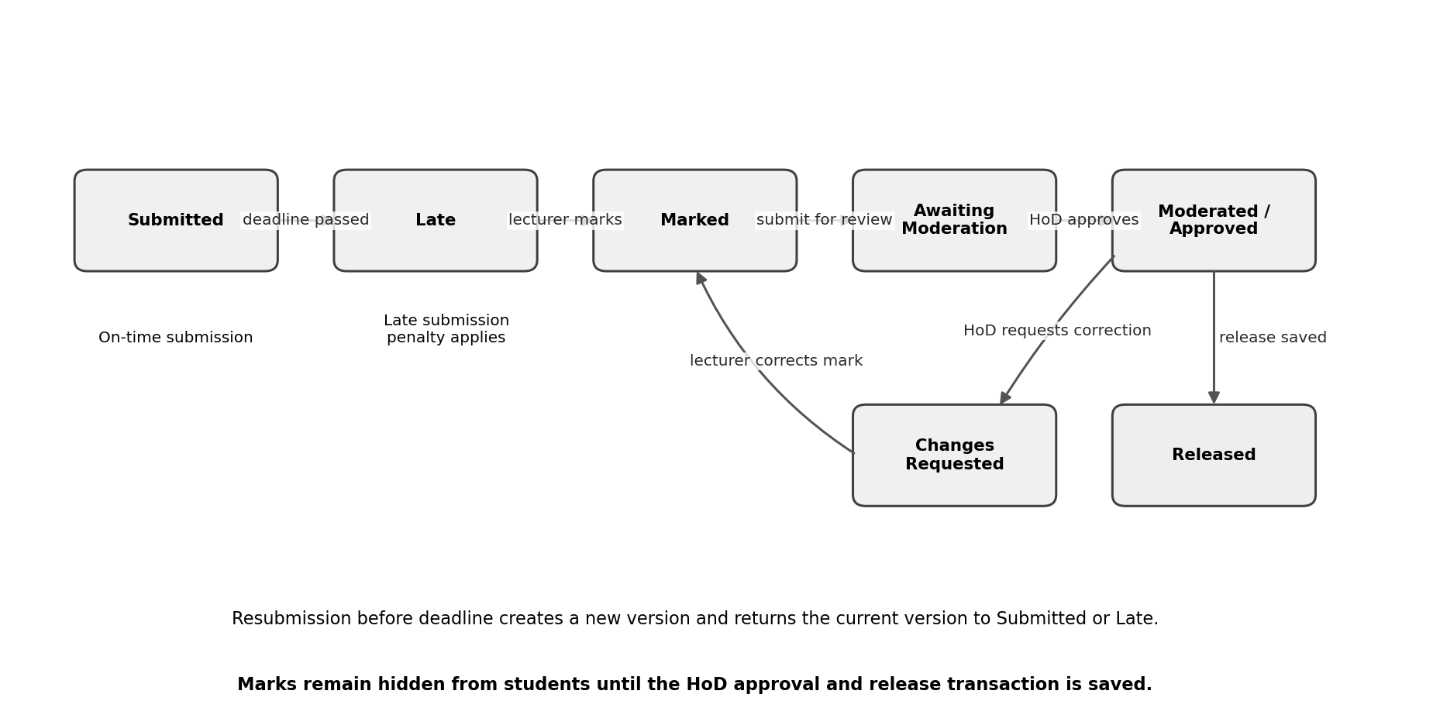
Figure 4. Submission lifecycle state machine.
State | Meaning / transition condition
Submitted | Submission was received by the effective deadline.
Late | Submission was received after the effective deadline; the late rule applies.
Marked | Lecturer has entered a valid mark and feedback.
Awaiting Moderation | Mark is ready for the HoD to review; student visibility remains disabled.
Changes Requested | HoD has withheld approval and recorded a reason; lecturer must correct or review the mark.
Moderated / Approved | HoD approved the mark for release and the decision has been saved.
Released | Release status is saved; the student may view the mark and feedback.

If the database save for moderation or release fails, the transaction is rolled back and the mark remains unreleased. A change to a mark after moderation must be audited and returned to the appropriate review state before students see the changed mark.

4.2 Activity diagram with swimlanes
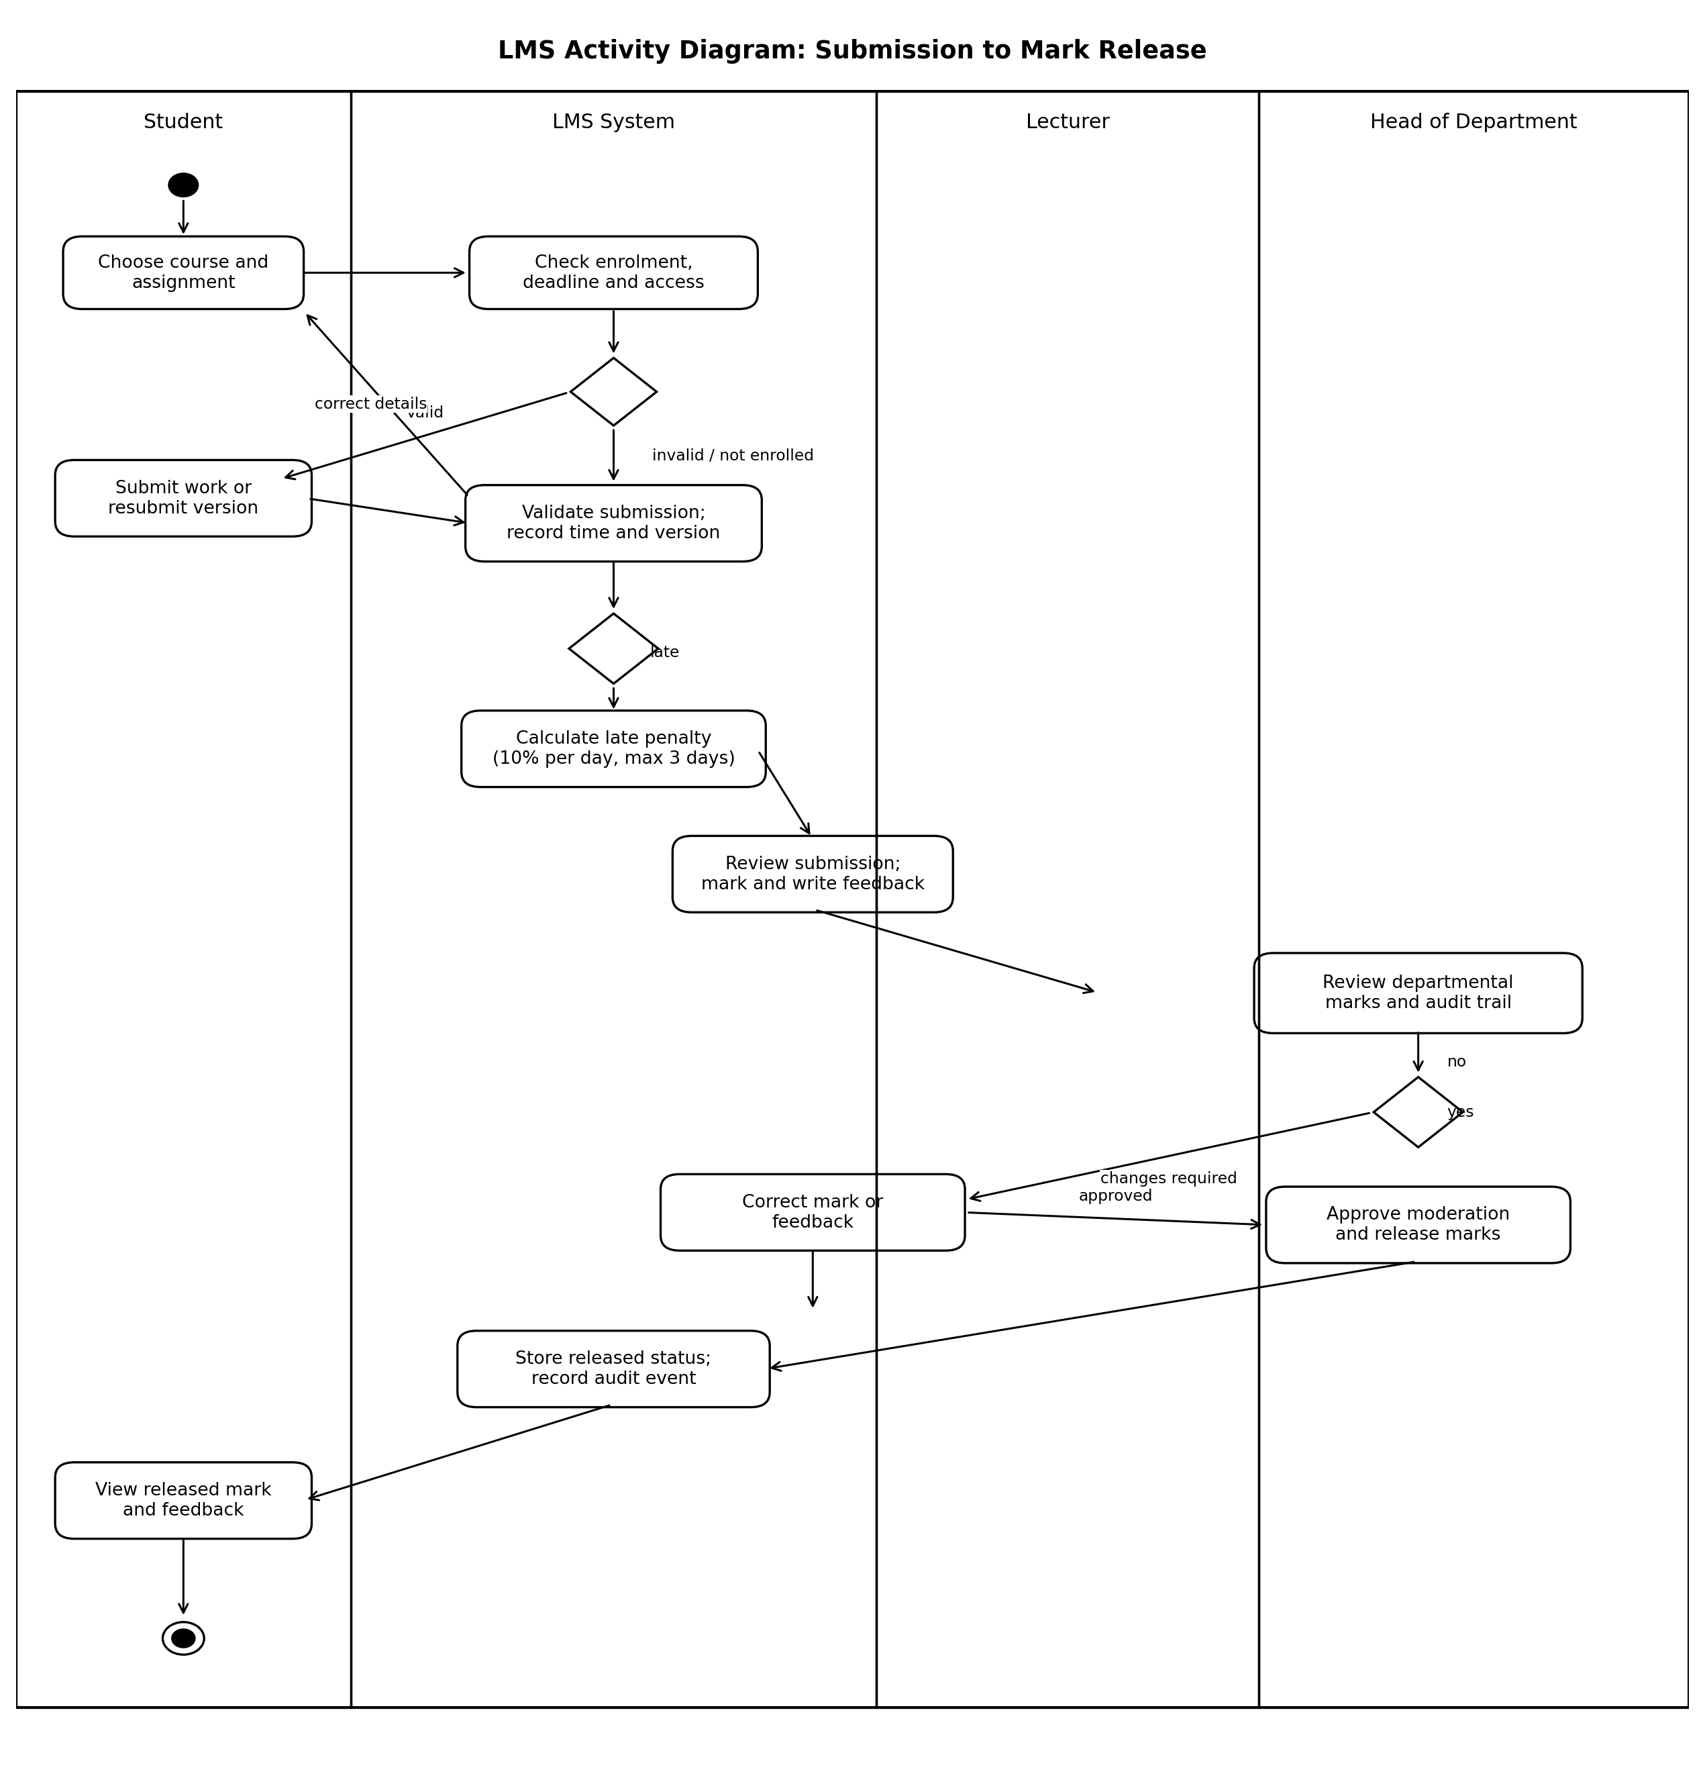
Figure 5. Activity diagram showing the process from student submission to released mark.
The activity starts when a student selects an assignment. The system checks the student's role, the applicable deadline and any approved individual extension. The submission is stored with its timestamp and version. The lecturer marks it and provides feedback. The HoD reviews departmental marks. If approval is withheld, the marks remain hidden and the lecturer is asked to correct them. If approval is saved successfully, the relevant marks become visible to students.

4.3 Sequence diagram: Submit assignment
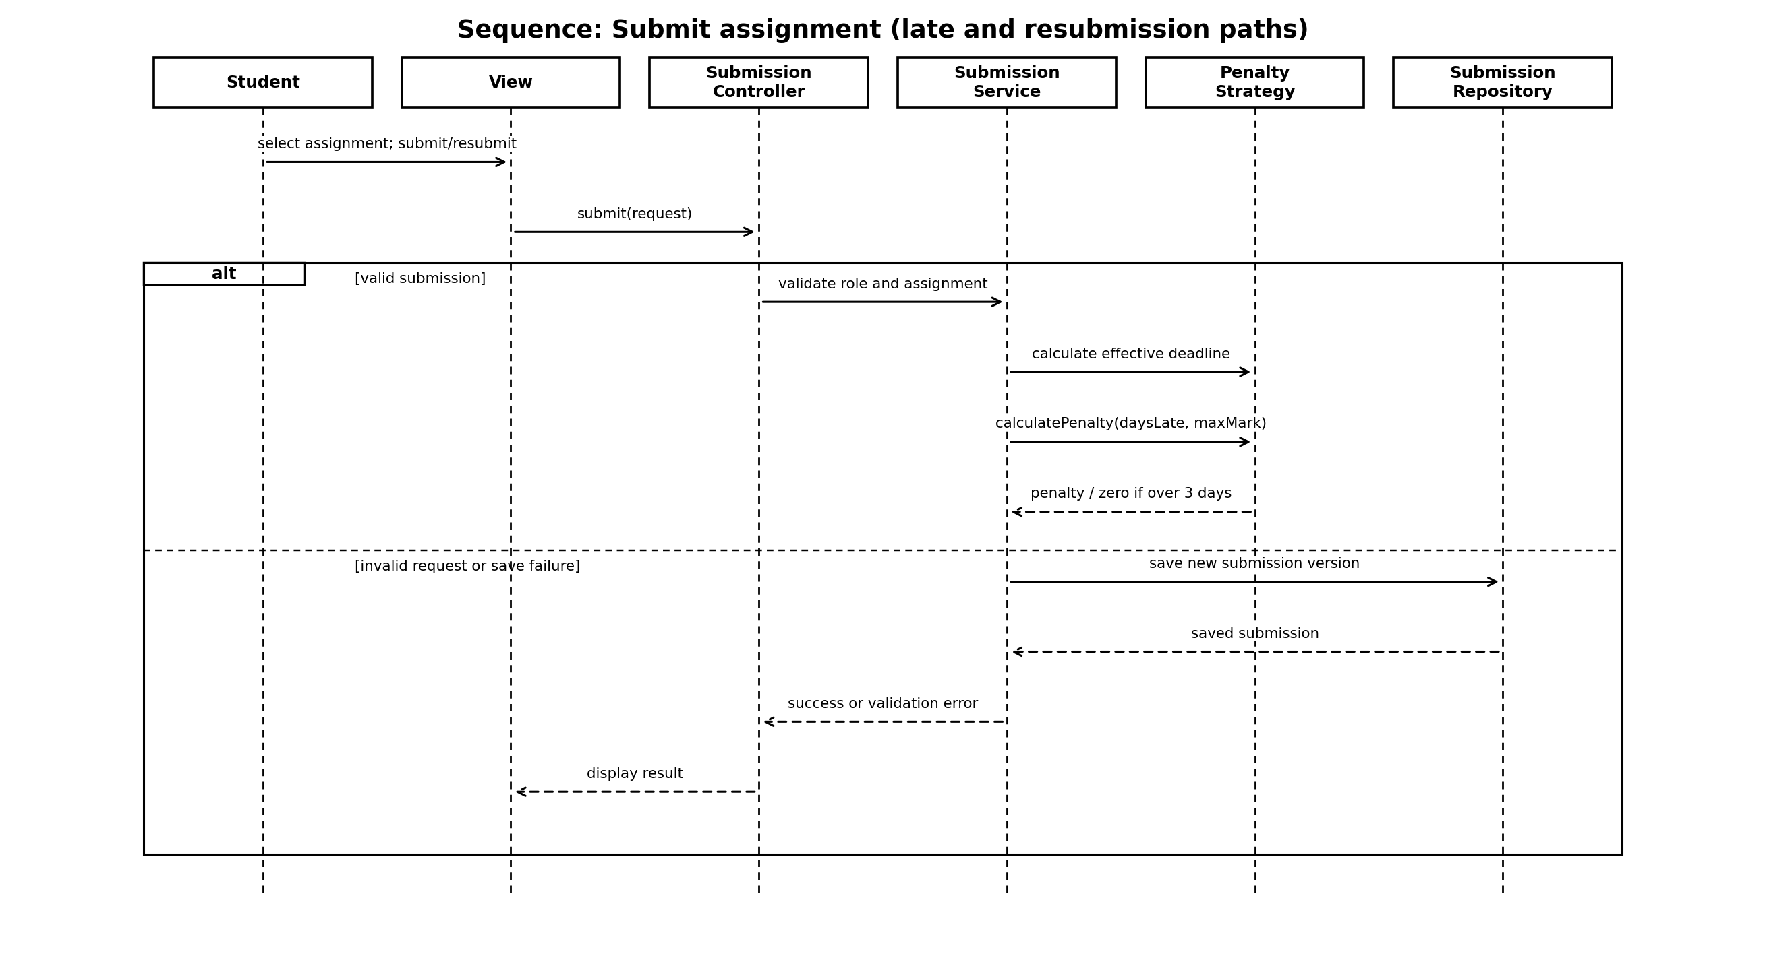
Figure 6. Submit assignment sequence, including late and resubmission paths.
The controller sends the request to SubmissionService after collecting the student's input. The service validates permissions and assignment state, calculates the effective deadline, invokes the penalty strategy and persists a new submission version through the repository. A late submission receives a status and penalty handling according to the rule. A resubmission marks the previous version as not current and saves the new version. If validation or persistence fails, the service reports the error and does not show a false success message.

4.4 Sequence diagram: Moderate and release marks
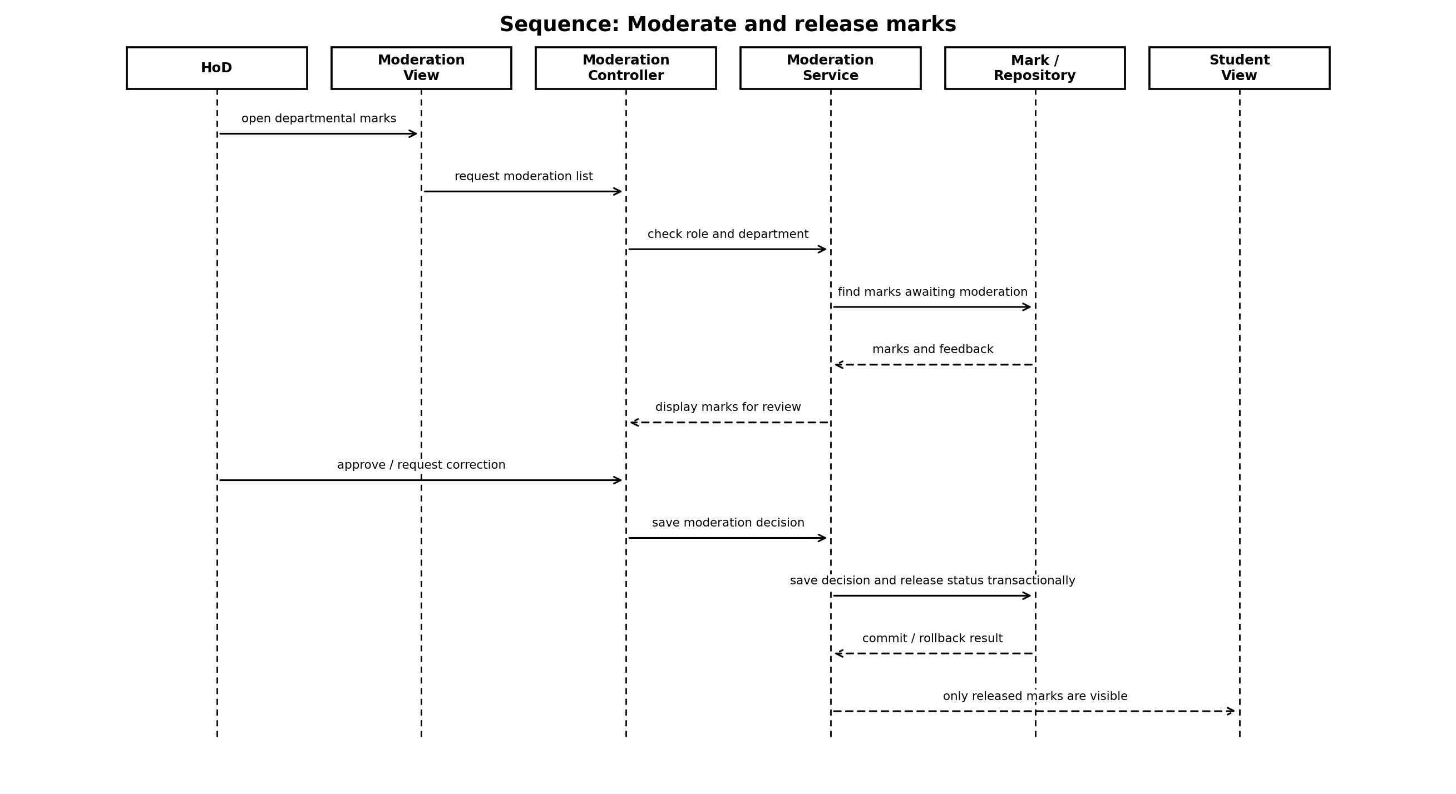
Figure 7. Moderate and release marks sequence.
The HoD requests departmental marks awaiting moderation. The system checks the HoD's role and department permissions, retrieves the marks, and displays them for review. If approval is given, the system saves the moderation record and release status within a transaction. If the HoD requests correction, the decision and reason are saved but the mark remains hidden. Students can retrieve a mark only when its status is Released.

4.5 Behavioural rules and exception paths
- Unauthorised users are denied access to restricted operations.
- A failed submission save must not create a success confirmation.
- A failed mark or moderation save must not partially release marks.
- The HoD can withhold approval and record a reason.
- A resubmission is allowed only before the applicable deadline, including an approved individual extension.
- Late days are calculated consistently by one policy component; the counting method needs stakeholder confirmation.
- A mark update after an earlier approval creates an audit entry and requires the mark to go through the appropriate moderation/release workflow again.

5. Database design

5.1 ERD and normalisation
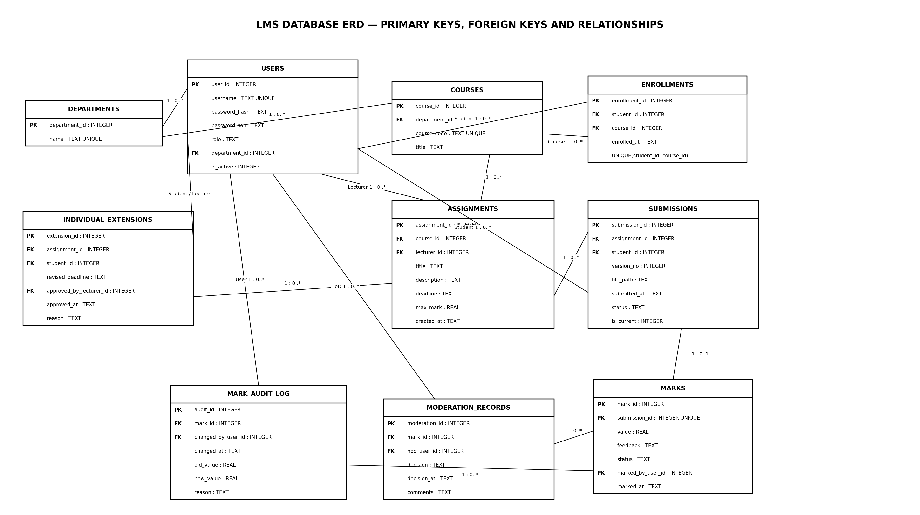
Figure 8. Logical ERD for the proposed SQLite database.
The database is designed to reach at least Third Normal Form (3NF). Each table represents one main entity or relationship. Each table has a primary key; related records use foreign keys. Repeating groups are separated into related tables, and the many-to-many relationship between students and courses is resolved through Enrollments.

5.2 Normalisation rationale
- First Normal Form (1NF): each field stores one value, and repeating lists such as course enrolments, submission versions, audit entries and moderation decisions are stored as separate rows.
- Second Normal Form (2NF): non-key attributes depend on the whole key. Enrollments use a surrogate primary key and a unique constraint on (student_id, course_id); course-specific and student-specific details are not mixed into the enrolment row.
- Third Normal Form (3NF): non-key fields depend on the key, the whole key and nothing but the key. Department names are stored in Departments rather than repeated in every course or user record. Course titles are stored in Courses, not repeated in assignments. Audit details are stored in MarkAuditLog, and moderation decisions are stored in ModerationRecord.

5.3 Data dictionary
Table | Column | Type | Constraints / meaning
users | user_id | INTEGER | PK; auto-increment identifier.
users | username | TEXT | NOT NULL, UNIQUE; login name.
users | password_hash | TEXT | NOT NULL; salted hash output, never plain text.
users | password_salt | TEXT | NOT NULL; salt if required separately by selected library/format.
users | role | TEXT | NOT NULL; Administrator, Lecturer, HoD or Student.
users | department_id | INTEGER | FK to departments; nullable for roles not assigned to a department.
departments | department_id | INTEGER | PK; auto-increment identifier.
departments | name | TEXT | NOT NULL, UNIQUE.
courses | course_id | INTEGER | PK.
courses | department_id | INTEGER | FK to departments, NOT NULL.
courses | course_code | TEXT | NOT NULL, UNIQUE.
courses | title | TEXT | NOT NULL.
enrollments | enrollment_id | INTEGER | PK.
enrollments | student_id | INTEGER | FK to users, NOT NULL; must be a Student role at application level.
enrollments | course_id | INTEGER | FK to courses, NOT NULL.
enrollments | enrolled_at | TEXT | NOT NULL; ISO-8601 timestamp.
enrollments | (student_id, course_id) | — | UNIQUE; prevents duplicate enrolment.
assignments | assignment_id | INTEGER | PK.
assignments | course_id | INTEGER | FK to courses, NOT NULL.
assignments | lecturer_id | INTEGER | FK to users, NOT NULL; must be a Lecturer.
assignments | title / description | TEXT | Title NOT NULL; description may be empty.
assignments | deadline | TEXT | NOT NULL; ISO-8601 date-time.
assignments | max_mark | REAL | NOT NULL; must be greater than zero.
individual_extensions | extension_id | INTEGER | PK.
individual_extensions | assignment_id / student_id | INTEGER | FKs; unique pair to hold current approved extension.
individual_extensions | revised_deadline | TEXT | NOT NULL; approved revised deadline.
individual_extensions | approved_by_lecturer_id | INTEGER | FK to users, NOT NULL.
individual_extensions | reason | TEXT | NOT NULL; reason for extension.
submissions | submission_id | INTEGER | PK; identifies one version.
submissions | assignment_id / student_id | INTEGER | FKs to assignments and users, NOT NULL.
submissions | version_no | INTEGER | NOT NULL; starts at 1 and increases per student/assignment.
submissions | file_path | TEXT | NOT NULL; local path or controlled storage reference.
submissions | submitted_at | TEXT | NOT NULL; timestamp used for deadline checks.
submissions | status | TEXT | NOT NULL; Submitted or Late initially, then workflow state.
submissions | is_current | INTEGER | NOT NULL; 0 or 1; one current version per student/assignment.
submissions | (assignment_id, student_id, version_no) | — | UNIQUE; prevents duplicate version numbers.
marks | mark_id | INTEGER | PK.
marks | submission_id | INTEGER | FK to submissions, UNIQUE; at most one current mark record per version.
marks | value | REAL | Nullable until marked; between 0 and assignment maximum.
marks | feedback | TEXT | Nullable until marking; written feedback.
marks | status | TEXT | NOT NULL; Draft, Marked, AwaitingModeration, Approved or Released.
moderation_records | moderation_id | INTEGER | PK.
moderation_records | mark_id | INTEGER | FK to marks, NOT NULL.
moderation_records | hod_user_id | INTEGER | FK to users, NOT NULL.
moderation_records | decision | TEXT | NOT NULL; Approved or ChangesRequested.
moderation_records | decision_at | TEXT | NOT NULL.
moderation_records | comments | TEXT | Reason/comments; required when changes are requested.
mark_audit_log | audit_id | INTEGER | PK.
mark_audit_log | mark_id | INTEGER | FK to marks, NOT NULL.
mark_audit_log | changed_by_user_id | INTEGER | FK to users, NOT NULL.
mark_audit_log | changed_at | TEXT | NOT NULL.
mark_audit_log | old_value / new_value | REAL | Old value may be NULL when first recorded; new value may be NULL only for a valid correction/removal case.
mark_audit_log | reason | TEXT | NOT NULL; why the mark changed.

5.4 SQL schema
The following SQLite schema implements the main entities, keys and constraints. Additional application-level checks are still required for role membership, access permissions, deadline rules and cross-table maximum-mark validation.
PRAGMA foreign_keys = ON;

CREATE TABLE departments (
department_id INTEGER PRIMARY KEY AUTOINCREMENT,
name TEXT NOT NULL UNIQUE
);

CREATE TABLE users (
user_id INTEGER PRIMARY KEY AUTOINCREMENT,
username TEXT NOT NULL UNIQUE,
password_hash TEXT NOT NULL,
password_salt TEXT NOT NULL,
role TEXT NOT NULL CHECK (role IN
('Administrator','Lecturer','HoD','Student')),
department_id INTEGER,
is_active INTEGER NOT NULL DEFAULT 1 CHECK (is_active IN (0,1)),
FOREIGN KEY (department_id) REFERENCES departments(department_id)
);

CREATE TABLE courses (
course_id INTEGER PRIMARY KEY AUTOINCREMENT,
department_id INTEGER NOT NULL,
course_code TEXT NOT NULL UNIQUE,
title TEXT NOT NULL,
FOREIGN KEY (department_id) REFERENCES departments(department_id)
);

CREATE TABLE enrollments (
enrollment_id INTEGER PRIMARY KEY AUTOINCREMENT,
student_id INTEGER NOT NULL,
course_id INTEGER NOT NULL,
enrolled_at TEXT NOT NULL,
UNIQUE (student_id, course_id),
FOREIGN KEY (student_id) REFERENCES users(user_id),
FOREIGN KEY (course_id) REFERENCES courses(course_id)
);

CREATE TABLE assignments (
assignment_id INTEGER PRIMARY KEY AUTOINCREMENT,
course_id INTEGER NOT NULL,
lecturer_id INTEGER NOT NULL,
title TEXT NOT NULL,
description TEXT NOT NULL DEFAULT '',
deadline TEXT NOT NULL,
max_mark REAL NOT NULL CHECK (max_mark > 0),
created_at TEXT NOT NULL,
FOREIGN KEY (course_id) REFERENCES courses(course_id),
FOREIGN KEY (lecturer_id) REFERENCES users(user_id)
);

CREATE TABLE individual_extensions (
extension_id INTEGER PRIMARY KEY AUTOINCREMENT,
assignment_id INTEGER NOT NULL,
student_id INTEGER NOT NULL,
revised_deadline TEXT NOT NULL,
approved_by_lecturer_id INTEGER NOT NULL,
approved_at TEXT NOT NULL,
reason TEXT NOT NULL,
UNIQUE (assignment_id, student_id),
FOREIGN KEY (assignment_id) REFERENCES assignments(assignment_id),
FOREIGN KEY (student_id) REFERENCES users(user_id),
FOREIGN KEY (approved_by_lecturer_id) REFERENCES users(user_id)
);

CREATE TABLE submissions (
submission_id INTEGER PRIMARY KEY AUTOINCREMENT,
assignment_id INTEGER NOT NULL,
student_id INTEGER NOT NULL,
version_no INTEGER NOT NULL CHECK (version_no >= 1),
file_path TEXT NOT NULL,
submitted_at TEXT NOT NULL,
status TEXT NOT NULL CHECK (status IN
('Submitted','Late','Marked','AwaitingModeration',
'ChangesRequested','Approved','Released')),
is_current INTEGER NOT NULL DEFAULT 1 CHECK (is_current IN (0,1)),
UNIQUE (assignment_id, student_id, version_no),
FOREIGN KEY (assignment_id) REFERENCES assignments(assignment_id),
FOREIGN KEY (student_id) REFERENCES users(user_id)
);

CREATE UNIQUE INDEX one_current_submission_version
ON submissions(assignment_id, student_id) WHERE is_current = 1;

CREATE TABLE marks (
mark_id INTEGER PRIMARY KEY AUTOINCREMENT,
submission_id INTEGER NOT NULL UNIQUE,
value REAL CHECK (value IS NULL OR value >= 0),
feedback TEXT,
status TEXT NOT NULL CHECK (status IN
('Draft','Marked','AwaitingModeration','Approved','Released')),
marked_by_user_id INTEGER,
marked_at TEXT,
FOREIGN KEY (submission_id) REFERENCES submissions(submission_id),
FOREIGN KEY (marked_by_user_id) REFERENCES users(user_id)
);

CREATE TABLE moderation_records (
moderation_id INTEGER PRIMARY KEY AUTOINCREMENT,
mark_id INTEGER NOT NULL,
hod_user_id INTEGER NOT NULL,
decision TEXT NOT NULL CHECK (decision IN ('Approved','ChangesRequested')),
decision_at TEXT NOT NULL,
comments TEXT NOT NULL DEFAULT '',
FOREIGN KEY (mark_id) REFERENCES marks(mark_id),
FOREIGN KEY (hod_user_id) REFERENCES users(user_id)
);

CREATE TABLE mark_audit_log (
audit_id INTEGER PRIMARY KEY AUTOINCREMENT,
mark_id INTEGER NOT NULL,
changed_by_user_id INTEGER NOT NULL,
changed_at TEXT NOT NULL,
old_value REAL,
new_value REAL,
reason TEXT NOT NULL,
FOREIGN KEY (mark_id) REFERENCES marks(mark_id),
FOREIGN KEY (changed_by_user_id) REFERENCES users(user_id)
);

CREATE INDEX idx_assignments_course ON assignments(course_id);
CREATE INDEX idx_submissions_assignment_student
ON submissions(assignment_id, student_id);
CREATE INDEX idx_marks_status ON marks(status);
CREATE INDEX idx_audit_mark_time ON mark_audit_log(mark_id, changed_at);

5.5 Important constraints implemented in application logic
- SQLite CHECK constraints cannot conveniently enforce that a mark does not exceed the maximum mark in a different table. MarkingService must load the assignment maximum and validate the mark before saving.
- Application logic must verify that an enrolment's user has the Student role, the assignment creator is a Lecturer, and moderation is performed by an authorised HoD for the relevant department.
- The service must update the previous submission version to is_current = 0 before inserting the new current version, within a transaction.
- When a mark changes, update the mark and insert a mark_audit_log row in the same transaction.
- When a mark is released, save the HoD moderation decision and released status transactionally. If any step fails, roll back.
- Password hashes should be generated and verified through a recognised library. Do not implement a home-made hash function.

5.6 Mapping between classes and tables
Class | Database table(s) | Explanation
User and subclasses | users | One users table stores common identity and role data. Role-specific behaviour is represented through C++ inheritance; separate role tables are not needed unless role-specific fields require them.
Department | departments | Stores department name and identifier.
Course | courses | References its department.
Enrollment | enrollments | Resolves the many-to-many relationship between students and courses.
Assignment | assignments | Stores assignment content, deadline, maximum mark, course and lecturer.
IndividualExtension | individual_extensions | Stores approved individual deadline changes and their reason.
Submission | submissions | Each row represents a version; is_current identifies the current version.
Mark | marks | Stores mark and feedback for a submission version, with status controlling visibility.
ModerationRecord | moderation_records | Stores each HoD approval or correction decision.
MarkAuditLog | mark_audit_log | Append-only history of mark changes.
SubmissionService / ModerationService | No direct table | Service classes coordinate multiple domain objects and database operations; they are not persistent entities.
Repositories / DAOs | No direct table | Repositories are data-access components, not business records.

5.7 Why classes and tables do not map one-to-one
Domain classes describe behaviour and responsibilities, while tables store persistent records. Service classes and repository classes do not need tables because they are not business records. The four user subclasses share one users table because their common identity and role are stored together; polymorphic behaviour exists in the C++ object model. Conversely, the database has tables such as enrollments and moderation_records to represent relationships and historical decisions that may not need to be treated as separate long-lived service objects. Submission versions are stored as multiple rows so that resubmission history is retained.

5.8 Transaction and query considerations
All SQL that includes user input must be parameterised. The implementation should enable foreign-key enforcement for each SQLite connection. Transactions are required for multi-step operations that must be consistent, particularly resubmission version switching, mark changes with audit entries, and mark release with moderation records. Indexes are added for common lookups by course, assignment/student, mark status and audit history.

6. Requirements traceability
The following matrix links important Phase 2 requirements to the Phase 3 design. It can be expanded during implementation to include source file names and automated test IDs.
Requirement | Design elements | Database elements | Verification focus
FR-01 / FR-02: account and role management | User hierarchy; AuthenticationService; AuthorisationService | users | Test all four roles and role-restricted actions.
FR-03: role-based access | AuthorisationService; controllers call services | users.role | Attempt permitted and forbidden operations for each role.
FR-04: course management and enrolment | Administrator; Course; Enrollment | departments, courses, enrollments | Create course and enrol student; check duplicate enrolment.
FR-05: create assignment | Lecturer; Assignment; assignment controller/service | assignments | Validate required fields, deadline and maximum mark.
FR-07: submit assignment | Submission; SubmissionService; repository | submissions | Successful save and timestamp.
FR-08: resubmit before deadline | SubmissionService; versionNo and isCurrent | submissions; unique index | Resubmit before deadline; verify current version changes and history remains.
FR-09: individual extension | IndividualExtension; effectiveDeadline() | individual_extensions | Approved extension changes effective deadline only for that student/assignment.
FR-10: late penalty | ILatePenaltyStrategy; StandardLatePenaltyStrategy | submission status; marks | Boundary tests: on time, 1, 2, 3 and more than 3 days late.
FR-11: mark and feedback | MarkingService; Mark | marks; mark_audit_log | Validate mark range and persist feedback and audit data.
FR-12 / FR-13: moderation and release | ModerationService; HeadOfDepartment; ModerationRecord | moderation_records; marks | Marks remain hidden before approval; approval enables visibility.
FR-15: mark-change audit | MarkAuditLog; MarkingService transaction | mark_audit_log | Every mark change records actor, timestamp, old/new values and reason.

7. Design risks and open decisions
Issue | Design treatment | Decision / confirmation needed
Definition of a late day | One penalty strategy calculates days late consistently. | Confirm calendar days versus completed 24-hour periods and the time zone.
Submissions after three late days | The design records the submission and applies a zero mark under the current interpretation. | Stakeholders should confirm whether the system accepts these submissions for record purposes and exactly when the zero rule applies.
Resubmission history | Previous versions are retained; one version is current. | Confirm the retention period and whether lecturers can view earlier versions.
Individual extensions | A revised deadline is stored for one student and assignment. | Confirm whether multiple extensions replace the previous approved deadline and how the reason is recorded.
Offline file storage | Submission rows store a local file path or controlled storage reference. | Choose a protected directory, backup method and file naming policy for the school computer.
800+ students | Indexes, transactions and simple queries support reasonable local performance. | Run tests with at least 800 student records and document actual response times.
Password hashing | Use a recognised library, with parameters and algorithm documented. | Select and configure the library during Phase 4; do not store plain-text passwords.
Marks changed after approval | A change is audited and returns through moderation before the changed mark is visible. | Confirm whether the entire assessment or only the changed mark must be reviewed again.

8. Conclusion
This Phase 3 design proposes an MVC-based user interaction structure with separate application services and a SQLite data-access layer. The class model uses an abstract User class, role-specific subclasses, domain entities and service interfaces. Strategy is used for the late-penalty policy, while Repository/DAO isolates SQLite access. Behavioural diagrams describe submission, resubmission, marking, moderation and release. The database is organised into related tables with keys, constraints and audit history, and is designed to satisfy Third Normal Form. The most important control is that marks remain hidden from students until an authorised HoD approval and release have been saved successfully. The design provides a basis for implementation after Gate 2 and identifies the assumptions that should be confirmed before coding.

References
Sommerville, I. (2016). Software Engineering (10th ed.). Pearson.
Valacich, J.S., George, J.F. and Valacich, J.S. (2017) Modern systems analysis and design. 8th edn. Boston: Pearson

