Part 1 — Read Me
Municipal Services Application
Student Name: | NOKUBONGA THABEDE
Student Number: | ST10523034
GitHub Repository Link: | https://github.com/BongwaThabede/MunicipalServicesApp.git

1. What This Submission Contains
- This Read Me document — an overview of the work, with supporting screenshots of the source code and the running application.
- Task1_Research.docx — the Task 1 research write-up (five user engagement strategies, the 500-word justification, and references).
- The MunicipalServicesApp Visual Studio project (solution file, project file, and full source code).
- A link to the GitHub repository containing the same source code (see the cover table above).

3. How to Run the Application
Open MunicipalServicesApp.sln in Visual Studio 2022 (with the ".NET desktop development" workload installed) and press F5. Full instructions, including the demo municipal staff login, are in the README.md file included in the project folder.

4. Solution Overview
Screenshot of the Visual Studio Solution Explorer, showing the full project structure (forms, Models, Data folders).

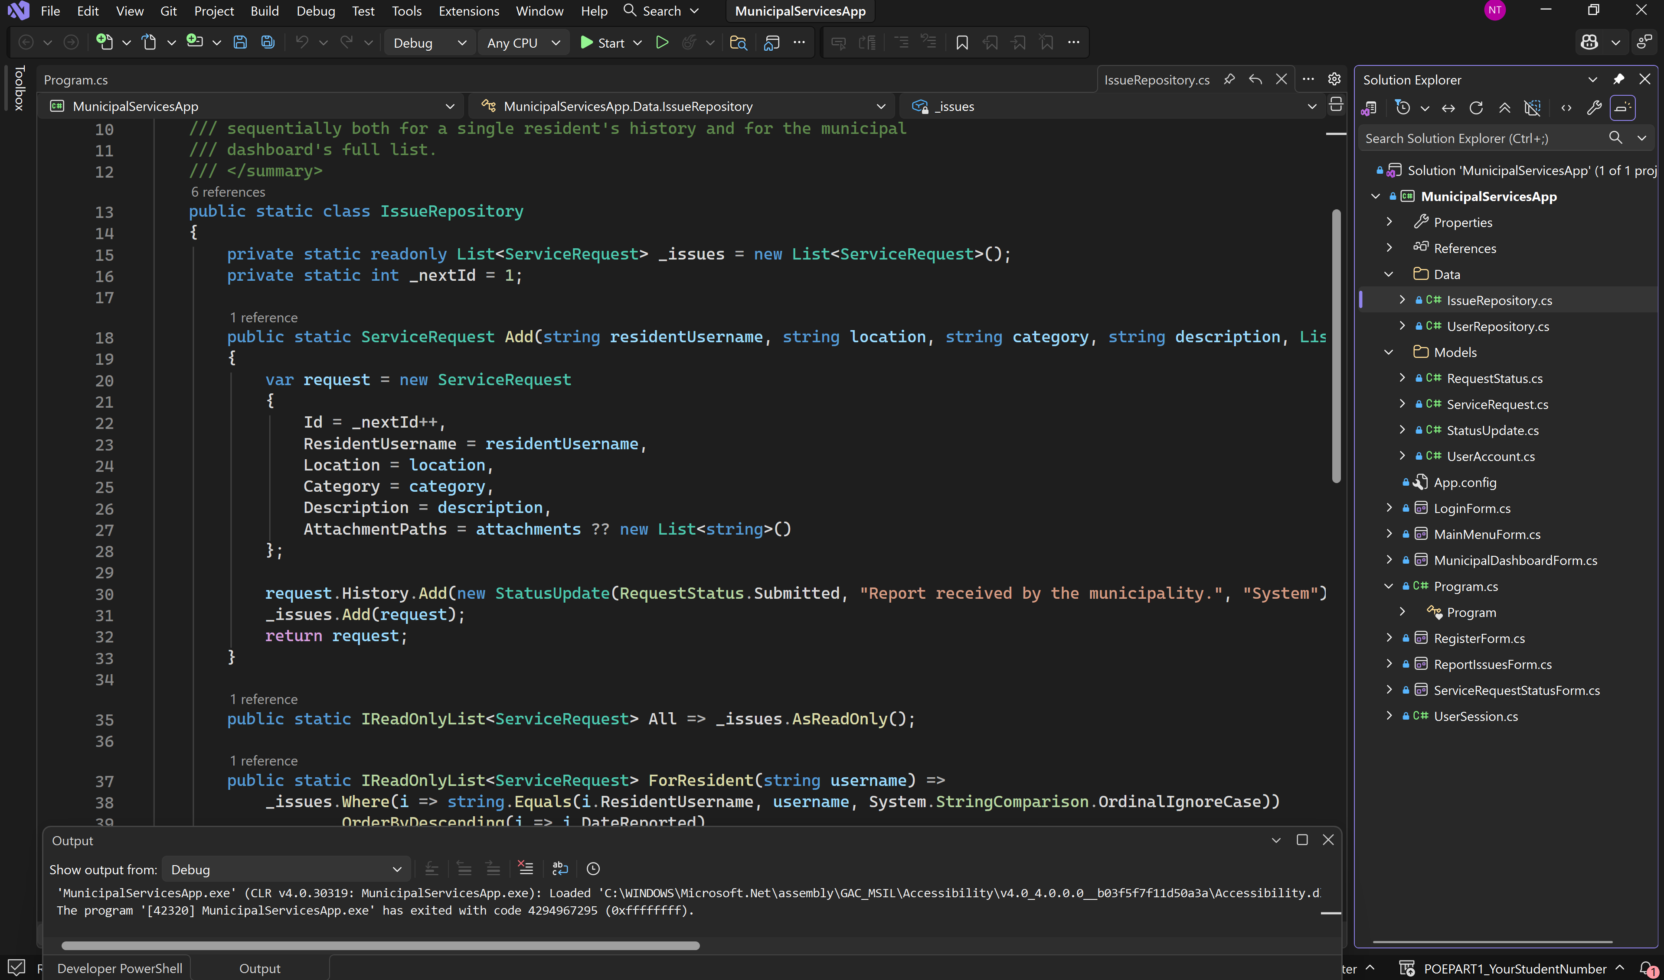

5. Application Walkthrough

5.1 Login and Registration
Residents register an account and log in. The is a a separate demo account is used for municipal staff.
Screenshot here shows Source code and output for Register and login Page

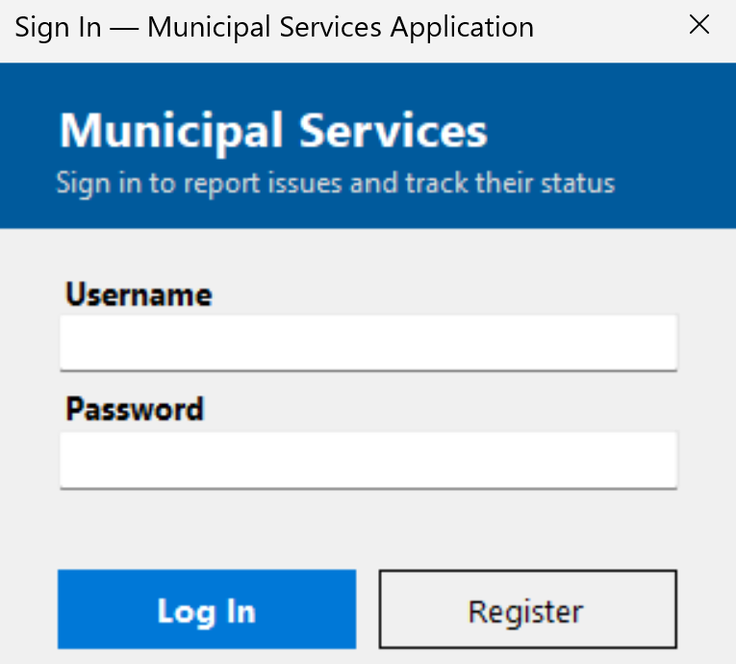
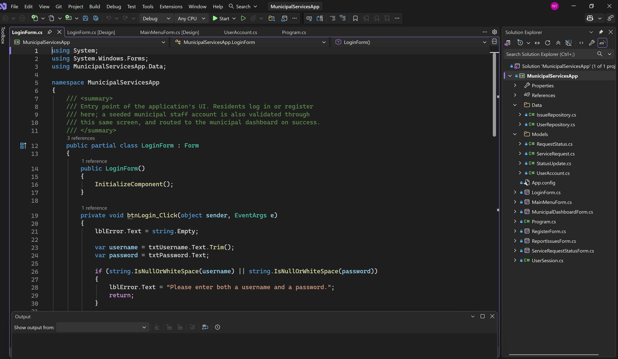
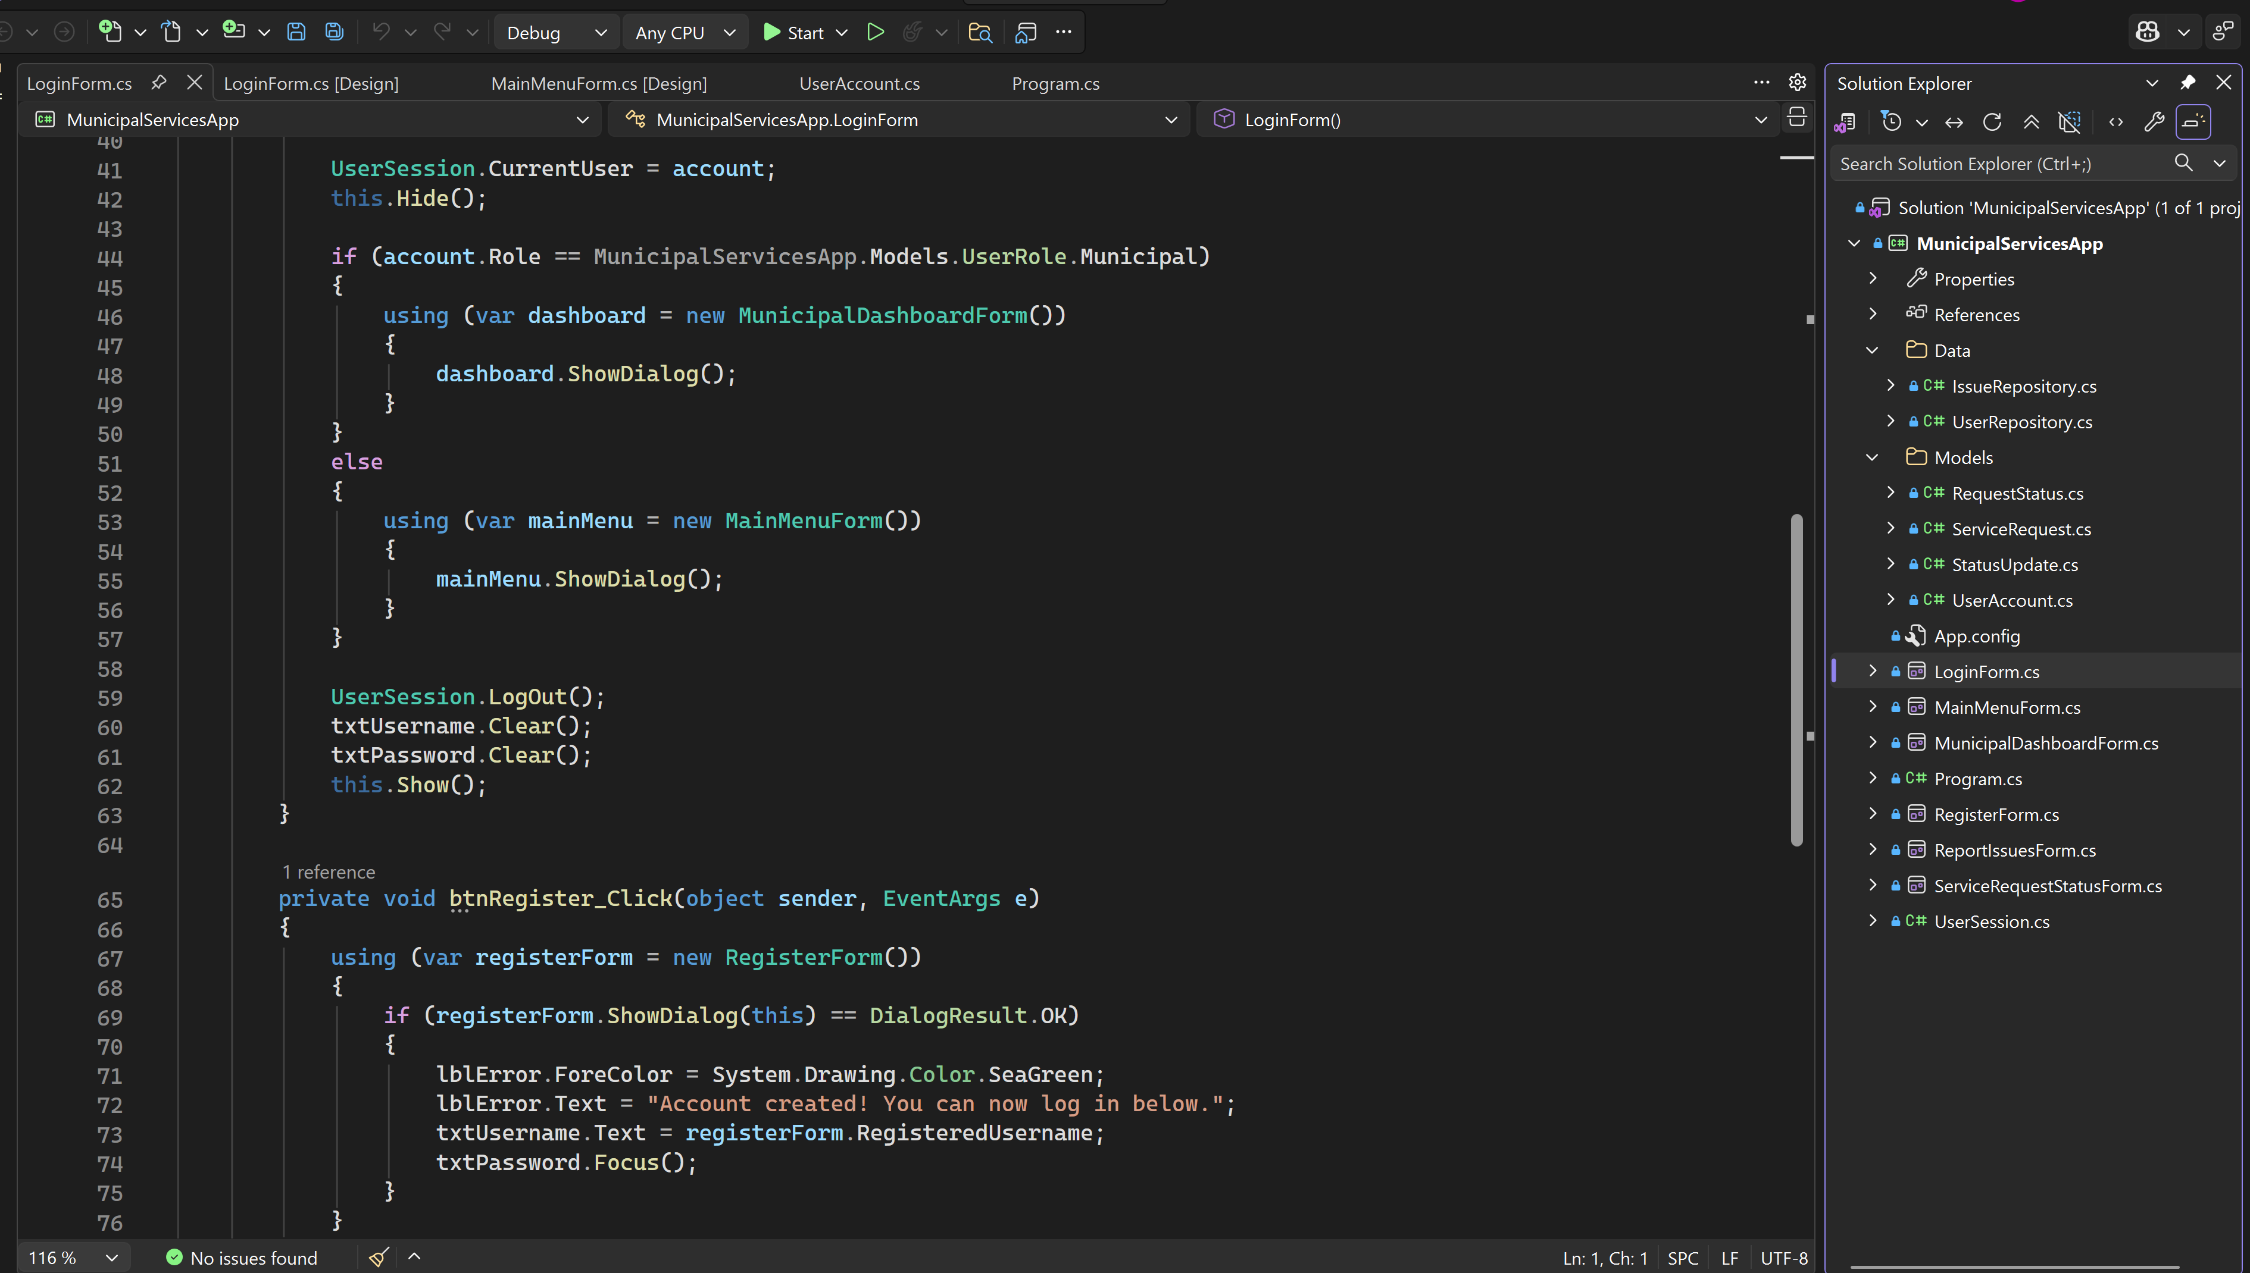

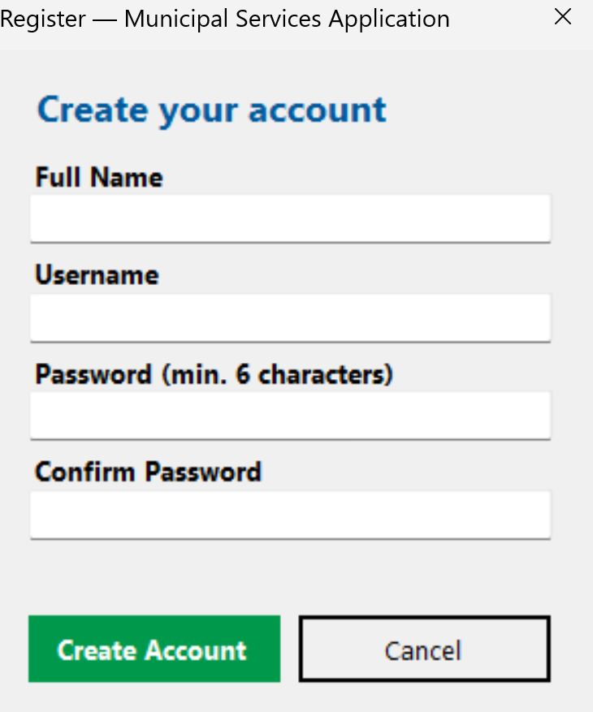

5.2 Main Menu
- Screenshot here shows the MainMenu for the residents. They can report an issue and track their service requests status.
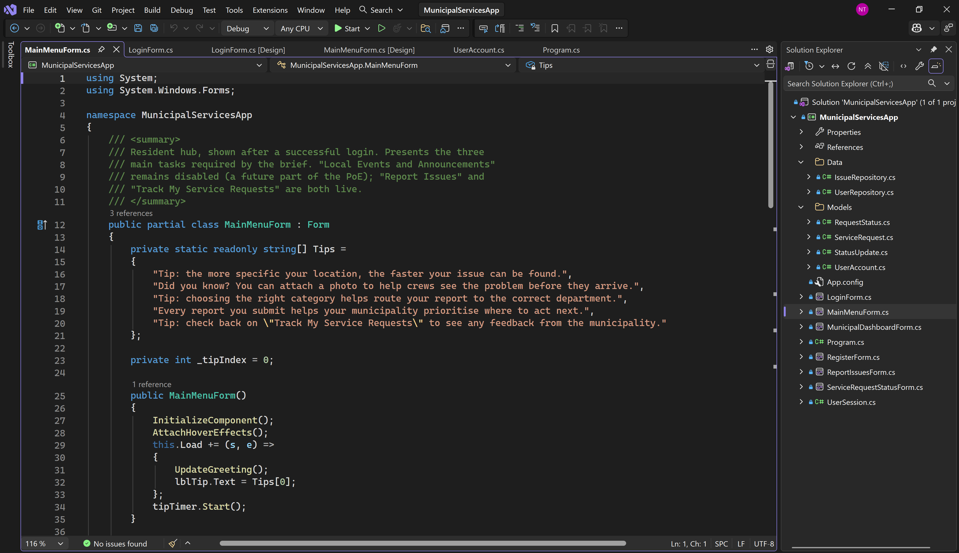
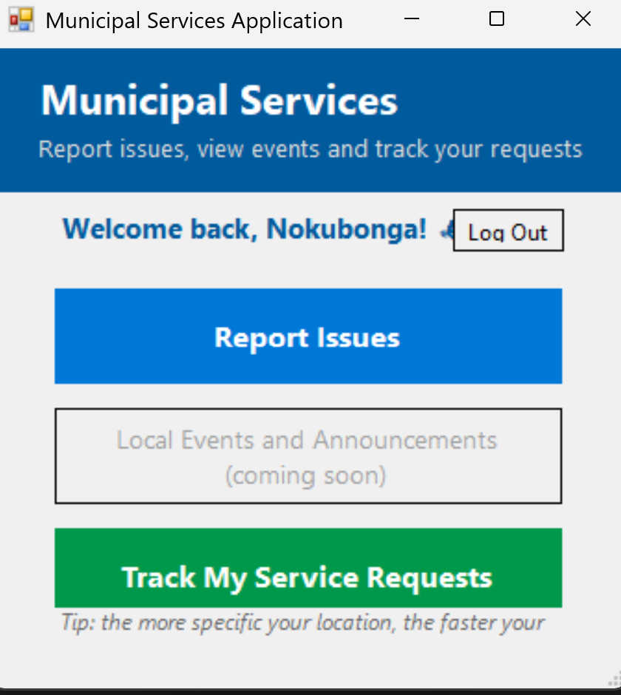

- Screenshot here shows the Municipality Staff dashboard. They can Change status and Give feedback massages to Residents service requests.
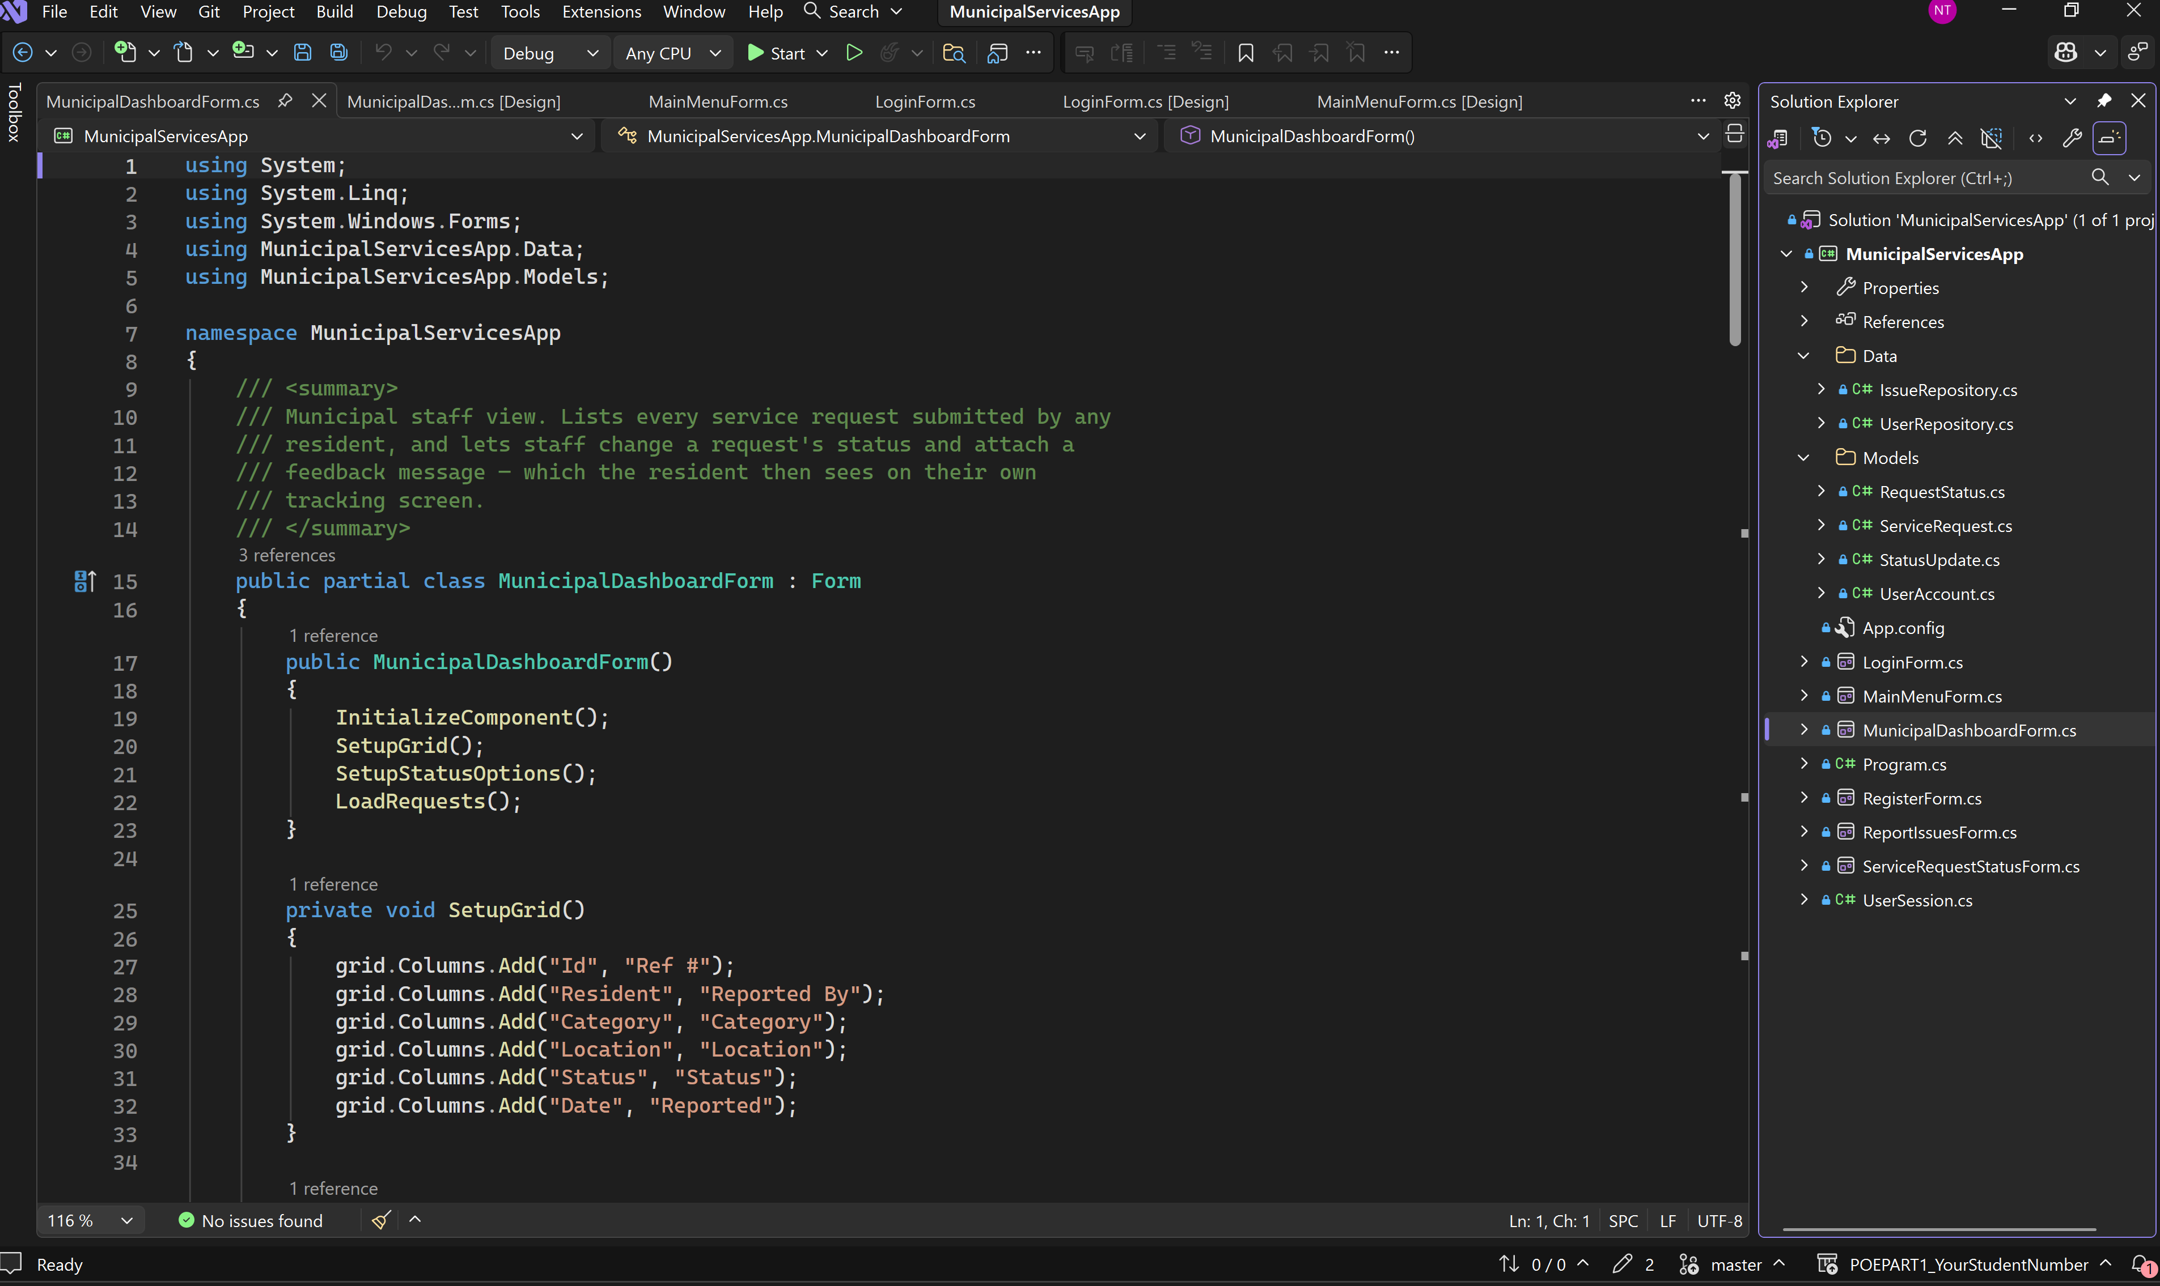
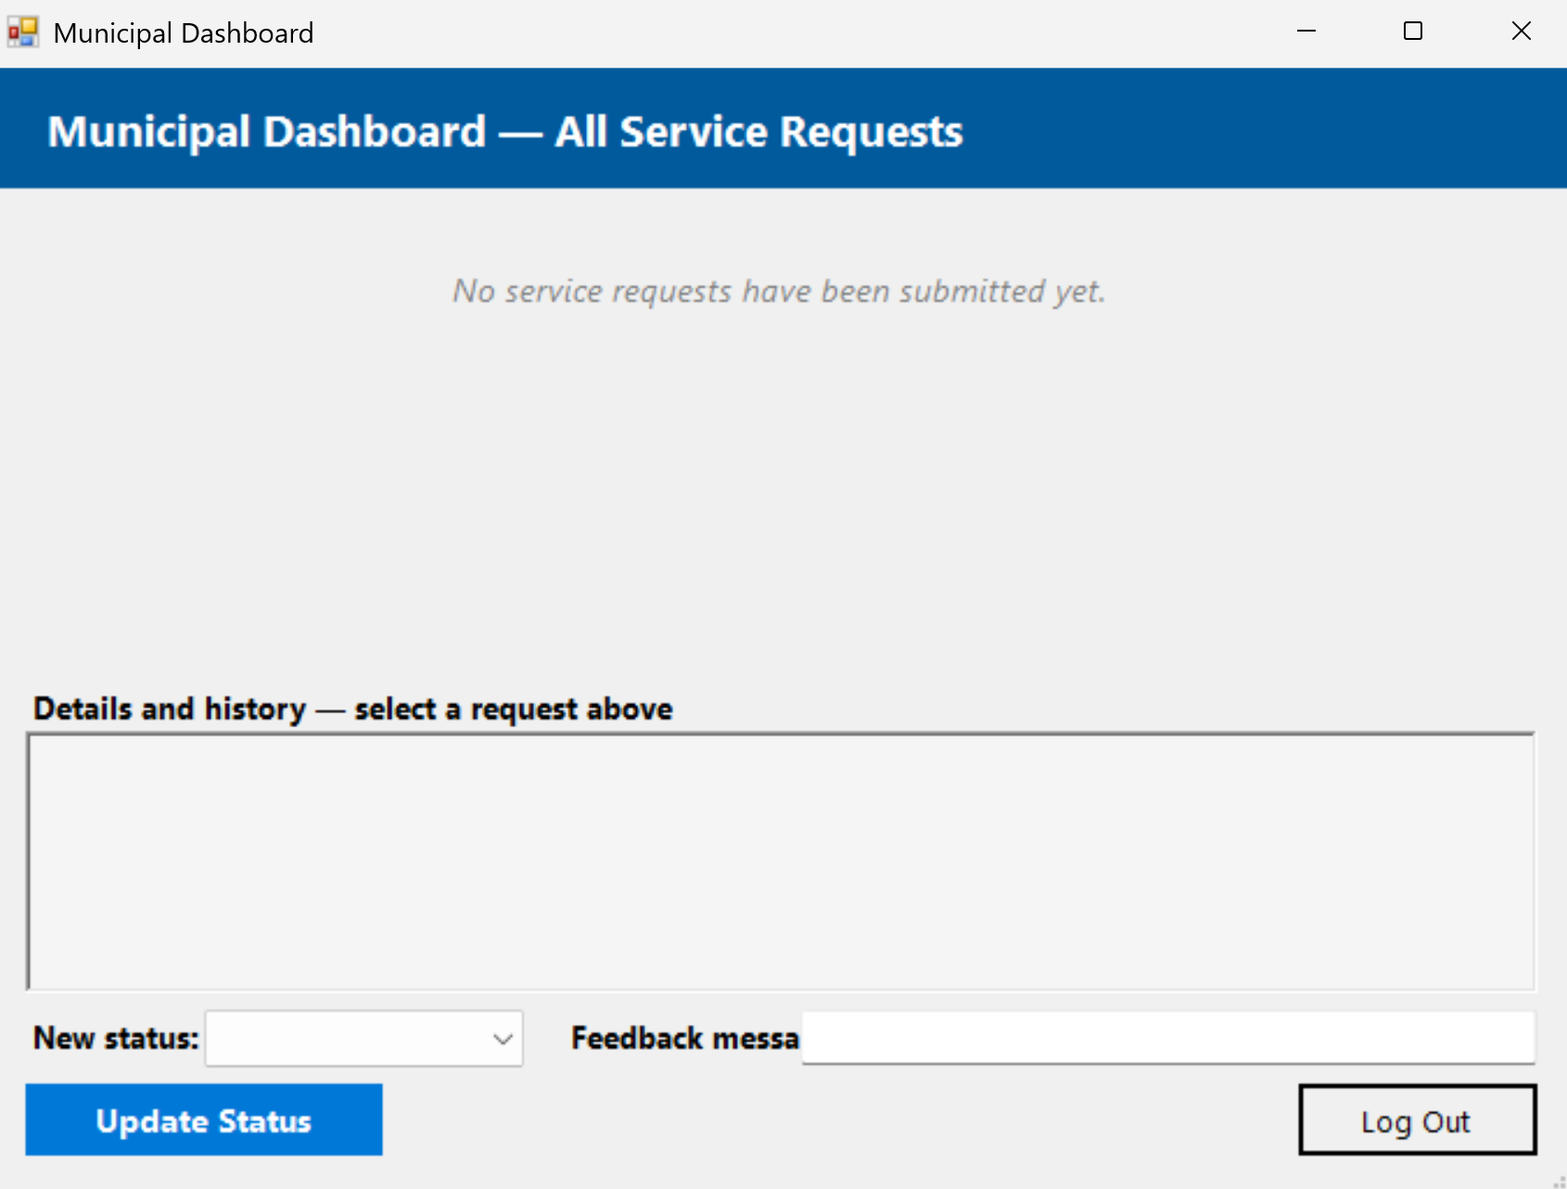

5.3 Report Issues (with the user engagement strategy)
Show the progress bar, checkmarks and encouraging messages updating as fields are filled in. This is the engagement strategy.
- The screenshot shows the Report an issue Page.
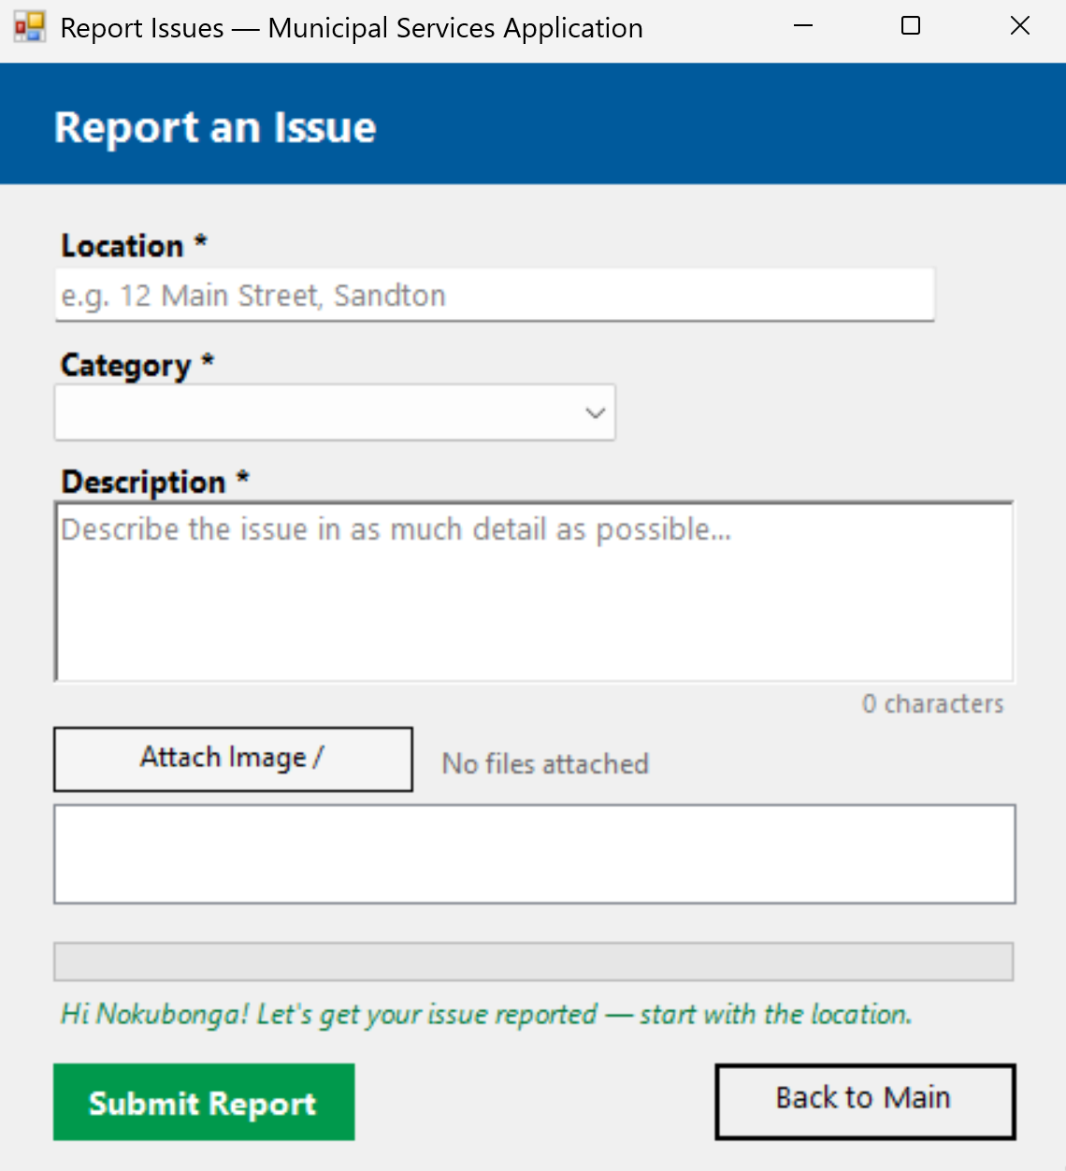

- Screenshot here showing Report Issues screen that is filled in, with progress bar and checkmark

- 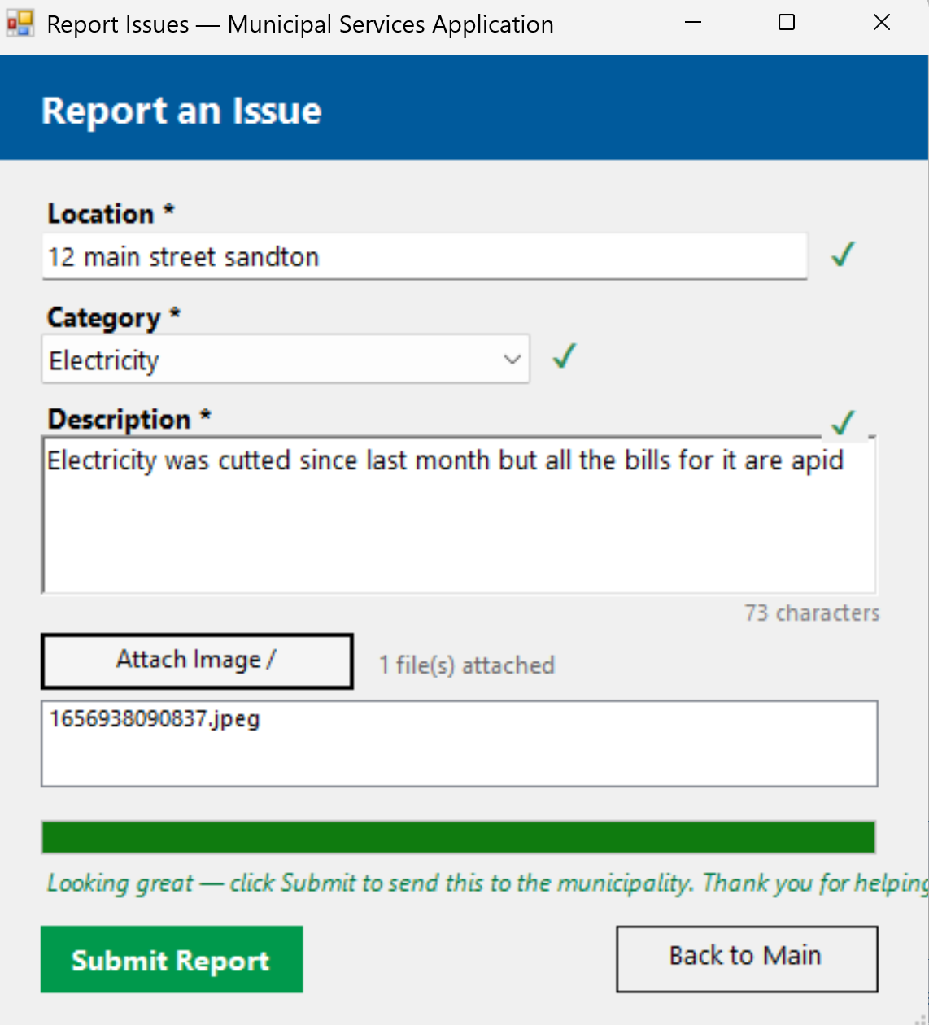
- Screenshot here showing Report Issues screen with a success Message Box after submitting
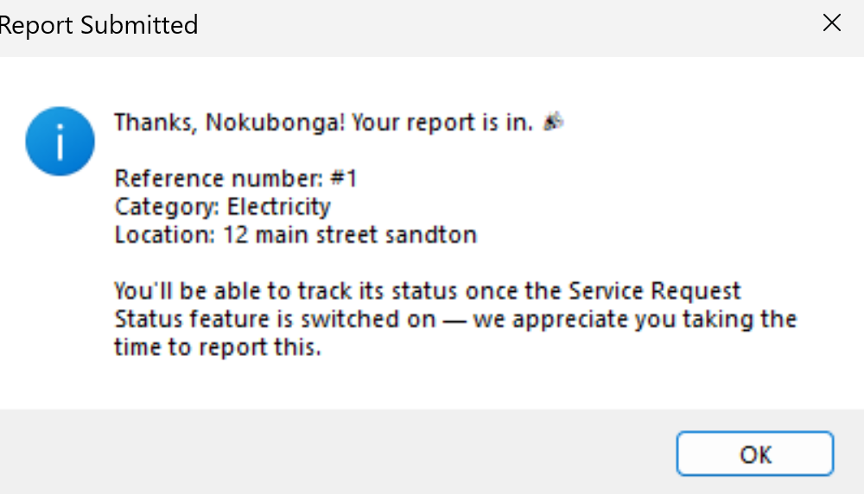

5.4 Track My Service Requests

- Screenshot here shows the ServiceRequestStatus

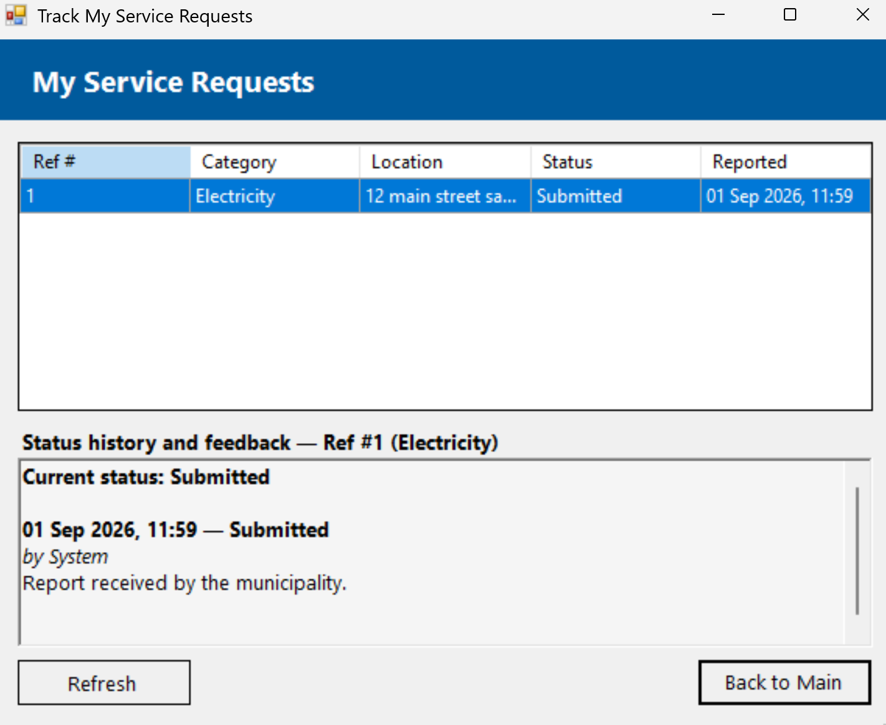

- Screenshot here showing Track My Service Requests screen with list of a resident's own requests

5.5 Municipal Dashboard (staff status updates)

Municipal Dashboard Page

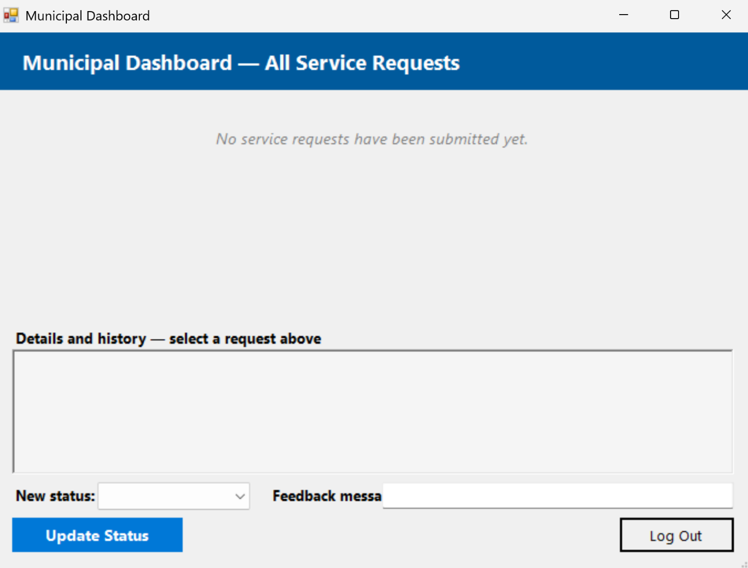

- Screenshot here shows the Municipal Dashboard with list of all requests

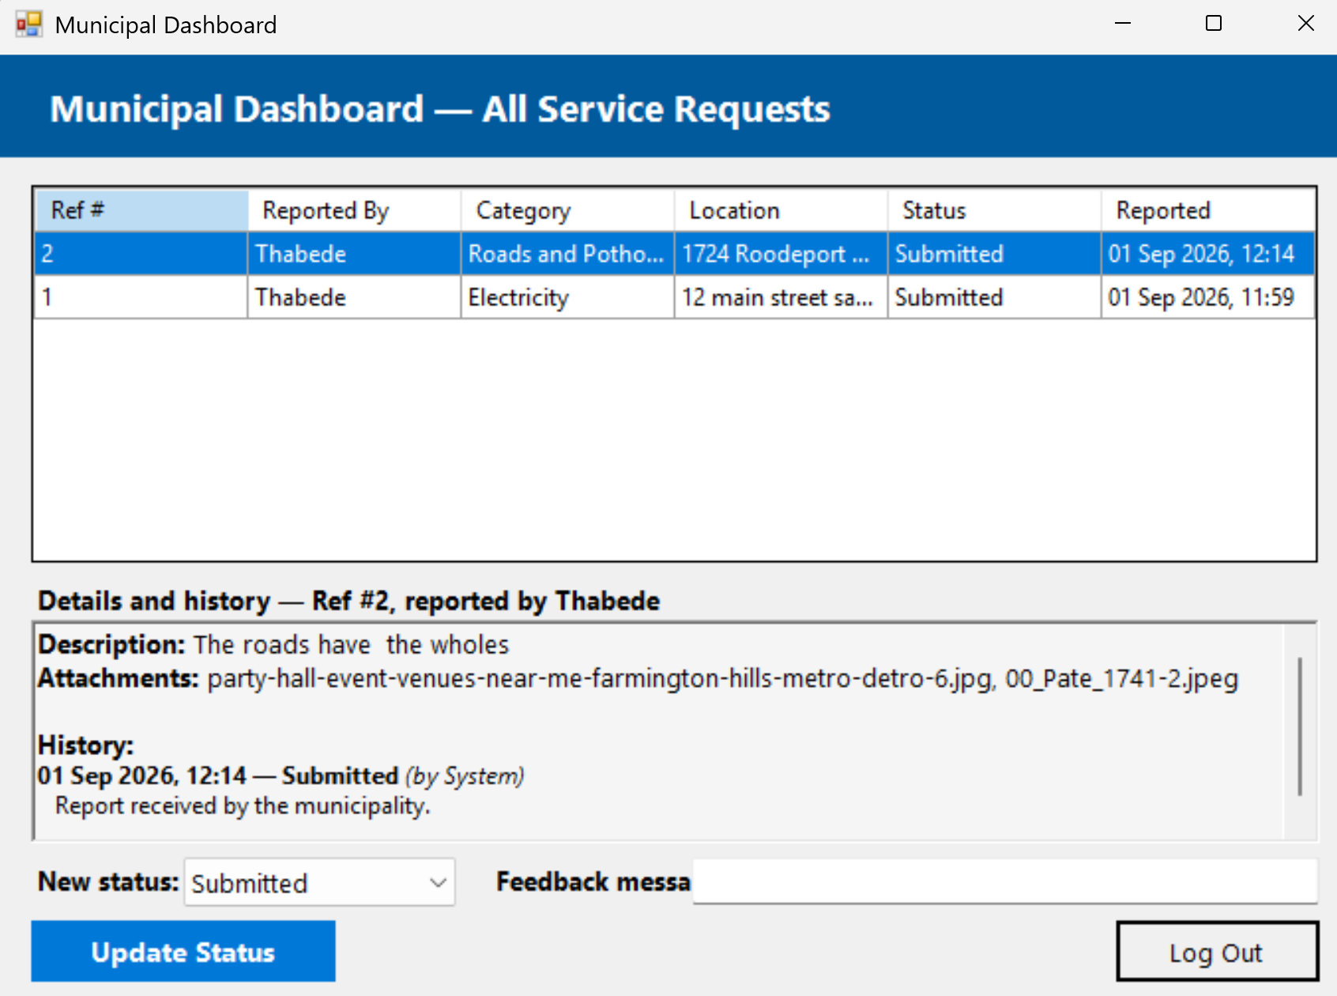

- Screenshoot here showing Municipal Dashboard updating a request's status with feedback, and the confirmation MessageBox

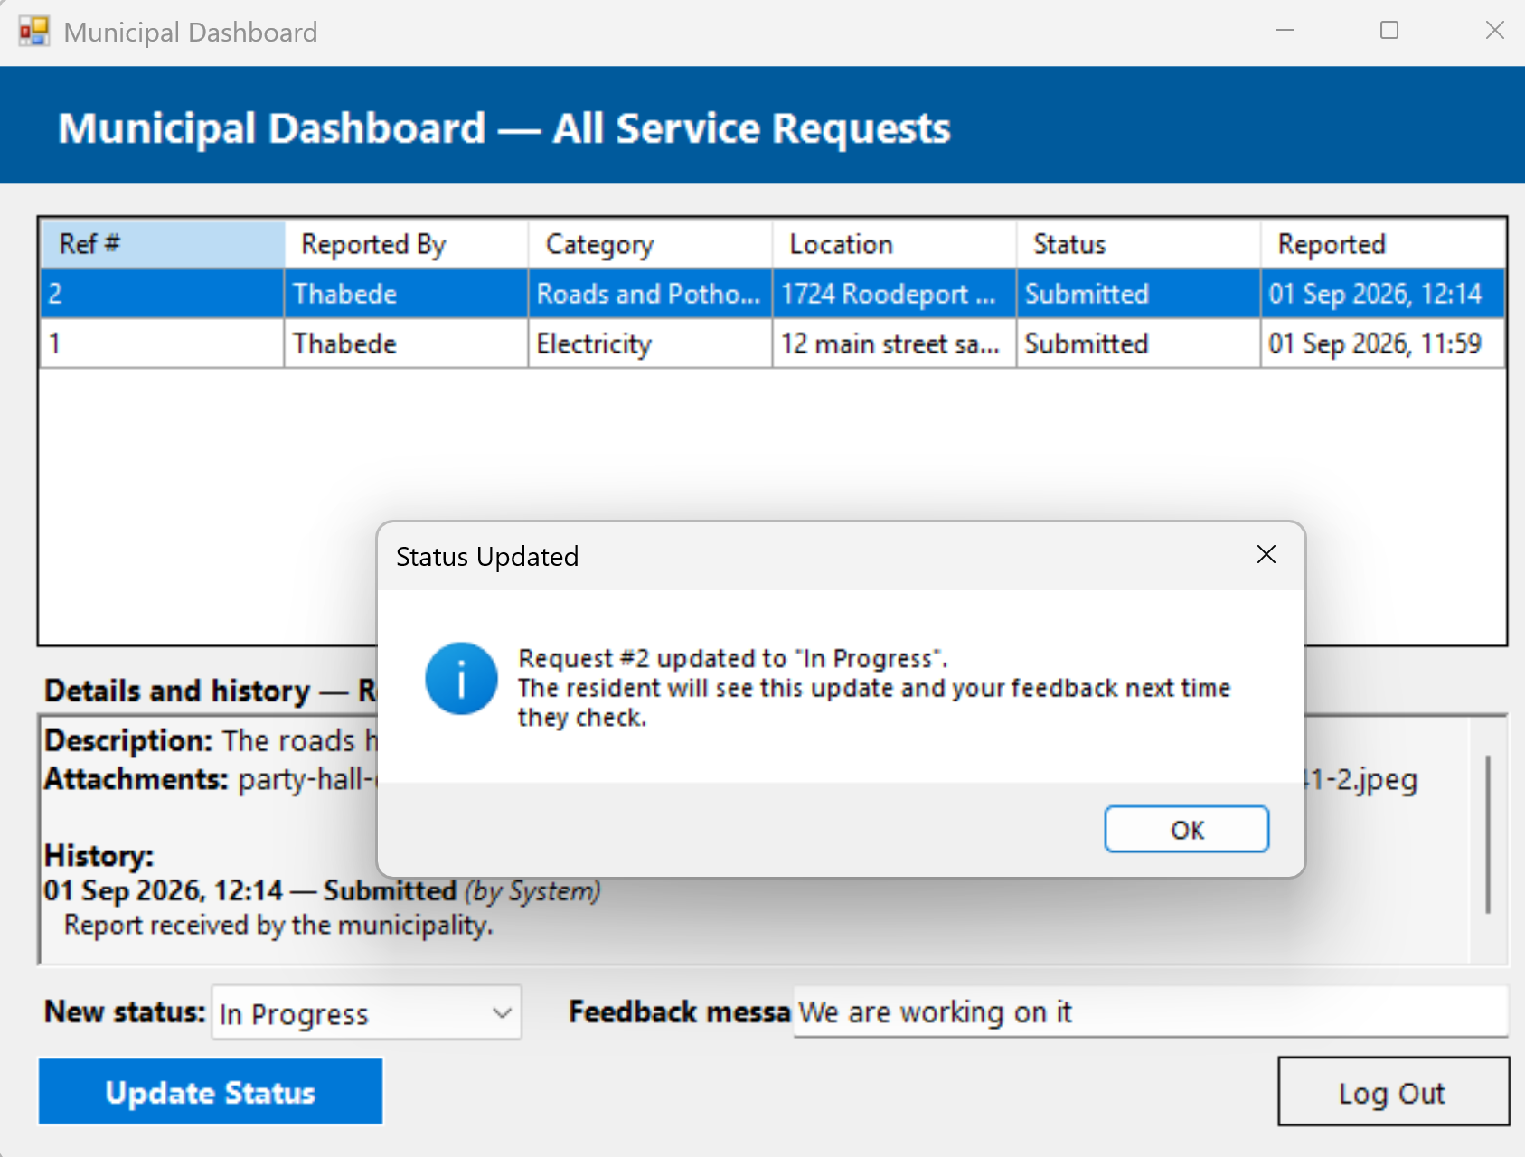

- Screenshot here showing Track My Service Requests screen (as the resident) showing the new status/feedback after the staff update

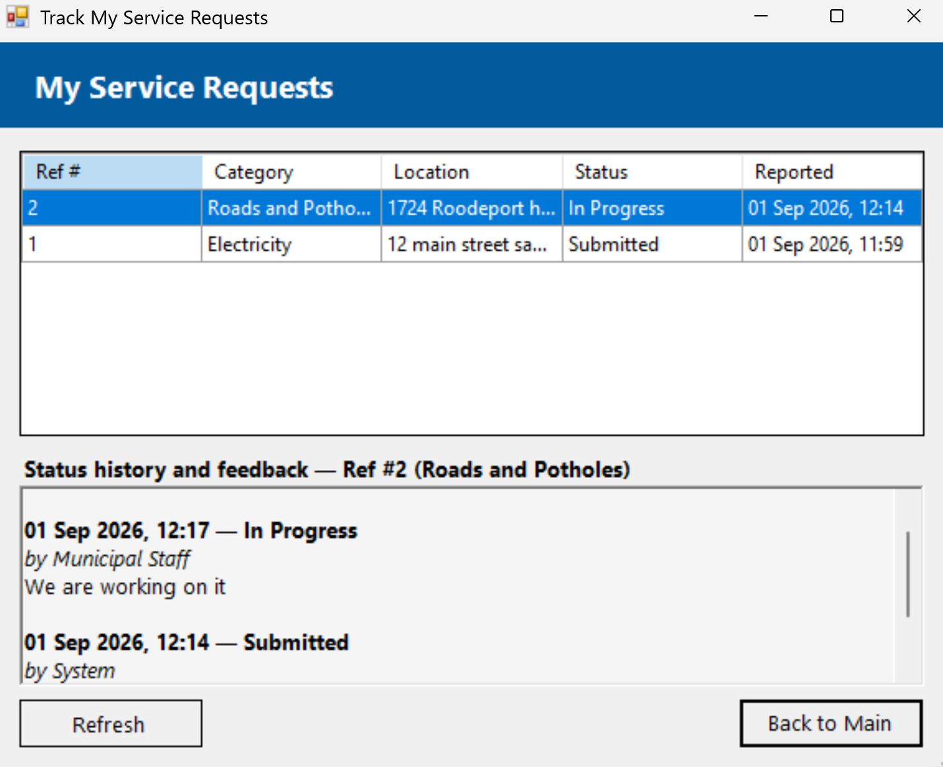

7. References
[1] T. G. B. Hart et al., "Innovation for development in South Africa: Experiences with basic service technologies in distressed municipalities," Forum for Development Studies, vol. 47, no. 1, pp. 23–47, Aug. 2019.
[2] R. Mofokeng, "Assessing the impact of digital technologies on service delivery in local government," Journal of Local Government Research and Innovation, 2024.
[3] H. Thinyane, "Power participation in digital citizen engagement in South African local government: The case of MobiSAM," arXiv preprint arXiv:2108.09798, 2021.
[4] D. Nel-Sanders and A. Malomane, "Examining e-services and citizen engagement for sustainable local governance," Africa's Public Service Delivery and Performance Review, 2022.

