Name: MWUNGERI Bonheur Date: 24/09/2025

ID: 29337

AUCA

PL/SQL ASSIGNMENT 1

**WINDOW FUNCTIONS MASTERY PROJECT**

1. **Problem definition.**

Business context.

A business of drinks (soft drinks and coffee) and snacks in Rwanda wants to analyze its sales data.

The problem is that the manager can’t know the sales in each region and therefore it’s hard to know most sold products in business. So we going to analyze the sales trends per region to identify the best product.

The expected outcome is to help the managers to target the market by knowing top product and improving customer service. How sales grow month to month,

1. **Success criteria.**

Here we are going to use window functions.

1. Top 5 products per region/quarter → RANK()

* Use RANK() to identify the **best-selling drinks** (like Coca-Cola, Coffee, Green Tea) in each region.
* Helps management know which drinks are most popular locally.

1. Running monthly sales totals → SUM() OVER()

* Use SUM(amount) OVER() to calculate **cumulative sales month by month.**
* Shows how overall revenue is growing during the year.

1. Month-over-month growth → LAG()/LEAD()

* Use LAG() or LEAD() to compare **current month vs. previous month sales.**
* Helps detect growth trends or sales drops (e.g., after promotions).

1. Customer quartiles → NTILE(4)

* Use NTILE(4) to divide customers into **4 groups** based on their total spending.
* Identifies **top spenders vs. occasional buyers**.

1. 3-month moving averages → AVG() OVER()

* Use AVG(amount) OVER (ROWS BETWEEN 2 PRECEDING AND CURRENT ROW) to find **3-month rolling averages.**
* Smooths out short-term fluctuations and highlights long-term sales trends.

1. **Database schema.**

We are going to create tables.

1. Customer table.

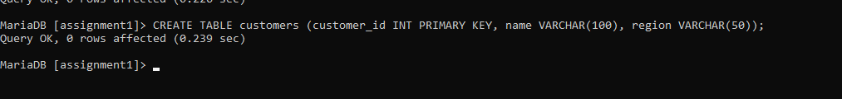

1. Product table.



1. Transaction table.



Lets insert some data in tables samples.

Customer table.



Product table.



Lastly transaction table.



The ER diagram of my data base below.

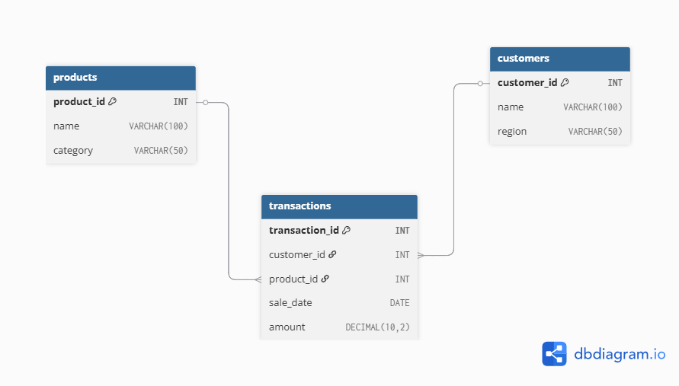

The ER diagram shows the customer table its primary key is customer_id, the product table with its primary key(product_id) and lastly transactions table with its primary key transaction_id. So the relationship here is one customer can make many transactions and one product can appear in many transactions.

1. **The window function implementation.**

Implementing the 4 categories:

1. Ranking

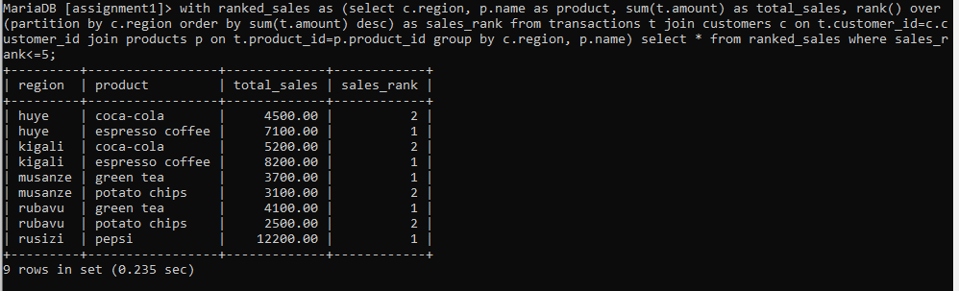

This query shows the top 5 best-selling products in each region ranked by total sales amount. It helps managers see which drinks or snacks are most popular locally. Like here coca cola is more popular in Huye and Musanze while snaks like potato chips is popular in Rubavu and musanze.

1. Aggregate

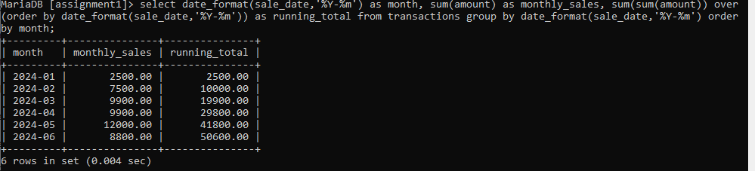

This query calculates the total sales for each month and the cumulative running total across months. It provides insight into how revenue is growing over time. Managers can track seasonal trends and check whether sales targets are being met month by month.

1. Navigation

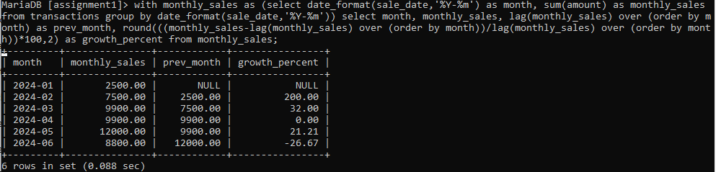

This query compares each month’s sales to the previous month and calculates the growth percentage. It highlights periods of increase or decline in sales performance. Managers can use this to evaluate the effect of promotions, events, or changes in demand.

1. Distribution

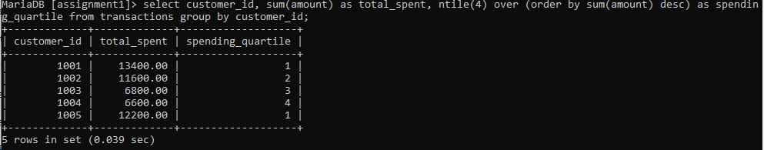

This query divides customers into four categories based on their total spending. The first category includes the highest spenders, while the fourth category has occasional or low-spending customers. This segmentation helps the business identify loyal customers and target marketing campaigns effectively.