Statistical study of backpain

s1899215

February 10, 2019

# 1 Introduction

The purpose of this study is to understand the medical conditions causing the pain. Two seperate datasets were gathered for this study. One dataset contains the general details of patients and a survey rating their pain at inclusion and at 12 month follow-up. This dataset is called “Covariates”. The other dataset contains the levels of certain proteins taken from the blood sample of the patients. This dataset is called “Biomarkers”. These two datasets are analyzed in order to further understand the relationship between biomarkers and pain.

# 2 Exploring Raw data

## 2.1 Biomarker data

Biomarker raw data

|  |  |  |  |  |  |  |  |  |  |
| --- | --- | --- | --- | --- | --- | --- | --- | --- | --- |
| Biomarker | IL-8 | VEGF-A | OPG | TGF-beta-1 | IL-6 | CXCL9 | CXCL1 | IL-18 | CSF-1 |
| 126-0weeks | 7.63 | 11.51 | 10.20 | 8.83 | 3.52 | 6.16 | 9.45 | 7.91 | 8.41 |
| 126-6weeks | 7.12 | 11.59 | 10.41 | 8.87 | 3.89 | 6.12 | 9.06 | 7.92 | 8.39 |
| 127-0weeks | 6.93 | 10.92 | 10.30 | 6.59 | 2.73 | 6.14 | 7.31 | 7.95 | 8.40 |
| 127-6weeks | 7.16 | 11.58 | 10.39 | 8.61 | 2.60 | 6.35 | 8.61 | 7.94 | 8.51 |
| 127-12months | 6.87 | 11.13 | 10.25 | 7.44 | 3.92 | 6.15 | 8.79 | 7.94 | 8.46 |

Table 1 displays first 5 rows of Biomarker dataset. There are total of 351 observations and 10 columns. Column 1 contains both the patientID and the time(week) when the blood sample was tested. The other coulmns contains the protein levels from the blood sample.

Missing data in Biomarker dataset

|  |  |  |  |  |  |  |  |  |  |
| --- | --- | --- | --- | --- | --- | --- | --- | --- | --- |
| Biomarker | IL-8 | VEGF-A | OPG | TGF-beta-1 | IL-6 | CXCL9 | CXCL1 | IL-18 | CSF-1 |
| 4 | 3 | 4 | 4 | 4 | 4 | 4 | 4 | 4 | 4 |

Table 2 summarizes the missing data in each column. Since missing data can prevent us from carrying on to the next step of analysis, we have removed any rows that are missing data. Total of 4 rows were removed from Biomarker dataset.

## 2.2 Covariate Data

Covariates raw data

|  |  |  |  |  |  |
| --- | --- | --- | --- | --- | --- |
| PatientID | Age | Sex (1=male, 2=female) | Smoker (1=yes, 2=no) | VAS-at-inclusion | Vas-12months |
| 1 | 56 | 1 | 2 | 3.0 | 4.0 |
| 3 | 32 | 1 | 2 | 7.2 | 0.5 |
| 4 | 43 | 2 | 2 | 2.7 | 0.5 |
| 5 | 25 | 2 | 2 | 3.0 | 3.9 |
| 6 | 39 | 1 | 2 | 3.5 | 5.0 |

Table 3 displays first 5 rows of Covariate dataset. There are total of 118 observations and 6 columns. Each column are self explainatory. Last two column contains rating of their pain(VAS) at inclusion and pain at 12 months. VAS 0 means no pain and VAS 10 is the worst imaginable pain. In this dataset 2 rows were missing data and they were removed.

Missing data in Covariate dataset

|  |  |  |  |  |  |
| --- | --- | --- | --- | --- | --- |
| PatientID | Age | Sex (1=male, 2=female) | Smoker (1=yes, 2=no) | VAS-at-inclusion | Vas-12months |
| 0 | 0 | 0 | 0 | 0 | 2 |

### 2.2.1 Covariate Data - Simple Analysis

First lets explore the age, sex and smokers of the patients. This will give us an insight on whether any of these variables are unequally represented in the dataset. Unequal representation shapes the question we formulate for the hypothesis testing. Based on figures 1 and 2, all these variables are almost equally represented.

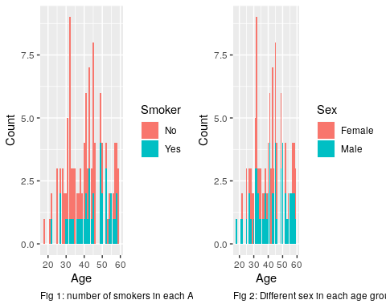

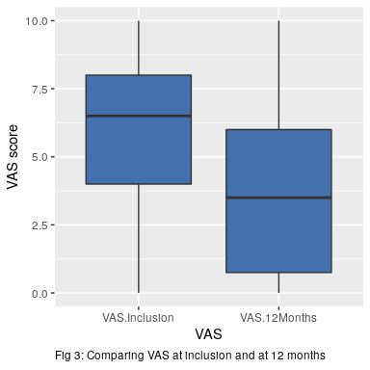

Second we explore whether there was an change in VAS. Based on the histograms provided in figure 3, the VAS at 12 months appears to be significantly lower than VAS at inclusion. We need to explore further to under how VAS changed based on sex and smokers. Both figure 4 and 5 clearly shows that there is a significant change in the VAS for each category.

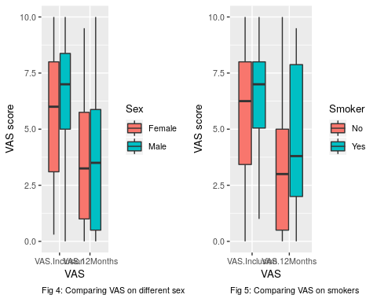

# 3 Cleaning/Manipulating Data

As per Table 1, we see that time of observation and patientID needs to be seperated from column 1. Also, the 12 months needs to be changed to 52 weeks in order to keep everything in the same units. Table 5 displays first 10 observations of dataset with the modification.

Biomarker data after seperating the patient ID and week of observation

|  |  |  |  |  |  |  |  |  |  |  |
| --- | --- | --- | --- | --- | --- | --- | --- | --- | --- | --- |
| PatientID | WeeksObs | IL-8 | VEGF-A | OPG | TGF-beta-1 | IL-6 | CXCL9 | CXCL1 | IL-18 | CSF-1 |
| 126 | 0 | 7.63 | 11.51 | 10.20 | 8.83 | 3.52 | 6.16 | 9.45 | 7.91 | 8.41 |
| 126 | 6 | 7.12 | 11.59 | 10.41 | 8.87 | 3.89 | 6.12 | 9.06 | 7.92 | 8.39 |
| 127 | 0 | 6.93 | 10.92 | 10.30 | 6.59 | 2.73 | 6.14 | 7.31 | 7.95 | 8.40 |
| 127 | 6 | 7.16 | 11.58 | 10.39 | 8.61 | 2.60 | 6.35 | 8.61 | 7.94 | 8.51 |
| 127 | 52 | 6.87 | 11.13 | 10.25 | 7.44 | 3.92 | 6.15 | 8.79 | 7.94 | 8.46 |
| 128 | 0 | 8.62 | 12.51 | 10.56 | 8.51 | 3.71 | 7.34 | 9.90 | 8.72 | 8.72 |
| 128 | 6 | 6.94 | 11.50 | 10.51 | 7.46 | 3.84 | 7.14 | 8.57 | 8.62 | 8.51 |
| 128 | 52 | 6.47 | 11.05 | 10.14 | 6.45 | 4.65 | 8.00 | 8.18 | 8.71 | 8.56 |
| 129 | 0 | 8.16 | 11.16 | 10.61 | 8.76 | 3.85 | 5.81 | 9.18 | 7.49 | 8.39 |
| 129 | 6 | 6.57 | 10.72 | 10.23 | 6.82 | 2.98 | 6.11 | 6.69 | 7.23 | 8.16 |

Box plots of each biomarker compared with each week of observation revealed that there are some changes to biomarker over the period of time. Figure 6 shows that almost all except “IL-6” have had changes between the weeks of observation.

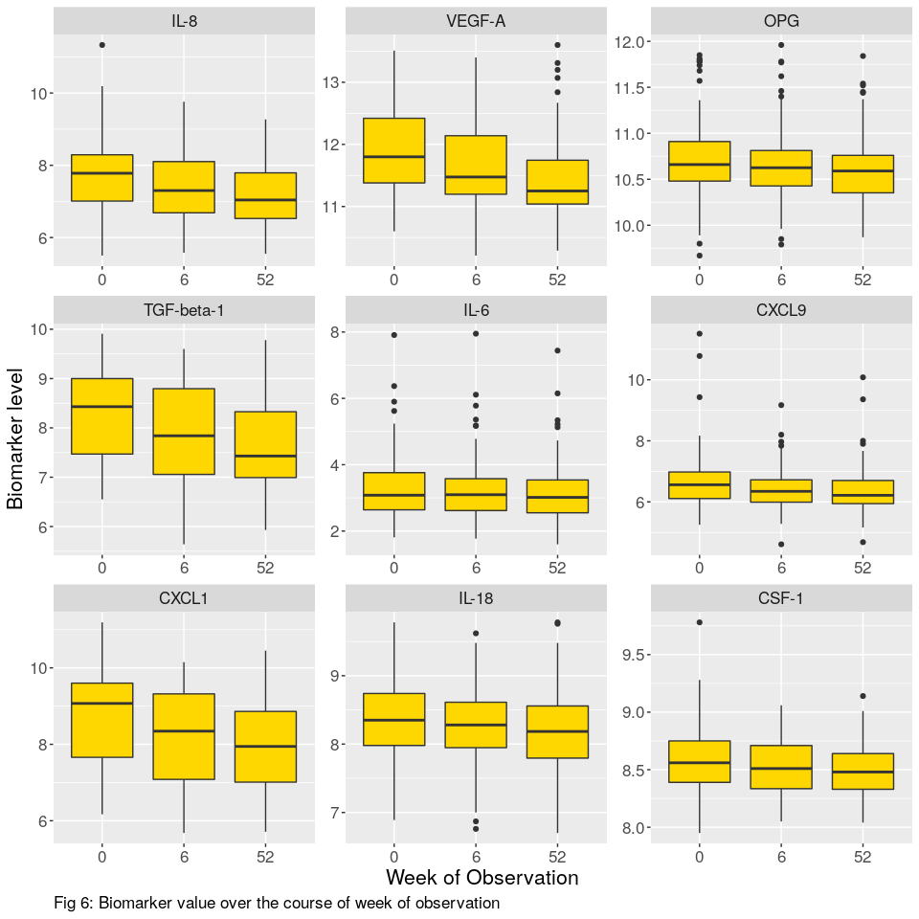

# 4 Question 1: Statistical Hypothesis Testing

## 4.1 Choosing a question

Simple analysis on the datasets revealed that there is a change in most biomarker levels and improvement of VAS on some patients. During this research we are interested in finding change of biomarker level among the patients whose VAS levels have been reduced. Total of 116 patients reported that their VAS at 12 months is lower than inclusion. In order to conduct this research, both datasets are merged together. Any patientID that did not contain all of three different observations (Week 0, 6 and 52) were removed and only 79 patient’s data are remaining for the test. Studying these patient’s biomarker level may reveal a better understanding of relationship between biomarker levels and pain.

## 4.2 Formulate the question as hypotheses

* Hypothesis: Did the of each biomarker remain constant between week 0 and week 52.
* Random variables: Biomarker levels at each observation week.
* Distribution: Since these are continious random variables and the population is unknown, the distribution is assumed to be t-distribution. Furthermore, the biomarkers are measured twice during this test. Therefore these samples are paired.

## 4.3 Perform suitable hypothesis test

Hypothesis:

* H0: =
* Ha: (two-tailed)

The p-values of paired sample t.test for biomarkers for week 0 and week 52 with = 0.05 is posted in table 6. Based on the results, p.values of IL-8, VEGF-A, OPG, TGF-beta-1, CXCL9, CXCL1, IL-18, CSF-1 are below 0.05. Therefore these H0s will be rejected. In other words, of these biomarkers have changed between week 0 and week 52. Therefore we can make an assumption that pain can be explained through these biomarkers.

p.values for each hypothesis test

|  |  |
| --- | --- |
| Biomarker | Week 0 and Week 52 |
| IL-8 | 0.0000110 |
| VEGF-A | 0.0000034 |
| OPG | 0.0234495 |
| TGF-beta-1 | 0.0000483 |
| IL-6 | 0.3552379 |
| CXCL9 | 0.0149160 |
| CXCL1 | 0.0000329 |
| IL-18 | 0.0209696 |
| CSF-1 | 0.0021744 |

### 4.4.1 Potential Problem of Multiple Testing

When many hypotheses are tested, and each test has a specified Type I error probability, the probability that at least some Type I errors are committed increases, often sharply, with the number of hypotheses. This may have serious consequences if the set of conclusions must be evaluated as a whole [[1]](https://www-annualreviews-org.ezproxy.is.ed.ac.uk/doi/pdf/10.1146/annurev.ps.46.020195.003021). The probability of making at least one type I error assuming that our tests are independent and that null hypotheses are true is given by formula[[2]](https://www-tandfonline-com.ezproxy.is.ed.ac.uk/doi/pdf/10.1080/17457300.2016.1270401?needAccess=true) below:

Pr(at least one significant result | all k H0’s are true)

= 1 - Pr(no significant results | all k H0’s are true)

=

Where = 0.05 and k = number of tests = 9

Therefore:

Pr(at least one significant result | all k H0’s are true) = 0.6302494

Therefore the probability of making at least one type I error is 0.63

### 4.4.2 Bonferroni Correction

Bonferroni correction is a classical approach to limit the possibility of getting a Type I error when testing multiple hypotheses[[3]](https://www-bmj-com.ezproxy.is.ed.ac.uk/content/bmj/349/bmj.g6284.full.pdf). This is achieved by adjusting the level by dividing the by the number of tests. In our test, the below:

Where = 0.05 and = 9

Therefore = 0.01

p.values for each hypothesis test

|  |  |  |
| --- | --- | --- |
| Biomarker | p.values of alpha | p.values of adjusted alpha |
| IL-8 | 0.0145484 | 0.0000110 |
| VEGF-A | 0.0847731 | 0.0000034 |
| OPG | 0.3927919 | 0.0234495 |
| TGF-beta-1 | 0.0328849 | 0.0000483 |
| IL-6 | 0.9194881 | 0.3552379 |
| CXCL9 | 0.0731432 | 0.0149160 |
| CXCL1 | 0.0161861 | 0.0000329 |
| IL-18 | 0.2004710 | 0.0209696 |
| CSF-1 | 0.0742271 | 0.0021744 |

We will now run the test again with the and reject null hypotheses when the p.value is below the value. The table 7 compares p.values from both hypotheses tests( and = 0.0055556). The results shows that with the Bonferroni Correction, IL-8, VEGF-A, TGF-beta-1, CXCL1, CSF-1 reject the null hypotheses. Using this results we can conclude that biomarkers IL-8, VEGF-A, TGF-beta-1, CXCL1, CSF-1 can be used to understand the patient’s pain level.

# 5 Question 2: Regression modelling

In section 2.2.1 we were able to find that both datasets displayed some sort of correlation. We will now model using VAS 12 using biomarkers at inclusion and covariates as explanatory variables. The model will be trained on 80% of data and it will be tested on the 20% of the data.

## 5.1 Model Description

* Explnatory variables : There are 13 number of explanatory variables in the data set. They are Age, Male, Smoker, VAS.Inclusion, IL-8, VEGF-A, OPG, TGF-beta-1, IL-6, CXCL9, CXCL1, IL-18, CSF-1, VAS.12Months. Both “Sex” and “Smoker” variables are categorical and the rest are numerical variables. These variables are represented by
* Response variable: VAS.12Months is a numerical variable which we will try to predict using the explanatory variables.
* General formula:

The values from training data are presented in table 8. These will be substituted in the general formula above to predict the y value (VAS.12Months).

Model description

|  |  |  |  |  |
| --- | --- | --- | --- | --- |
|  | beta | Std. Error | t value | Pr(>|t|) |
| (Intercept) | 11.9456227 | 11.3320639 | 1.0541436 | 0.2950716 |
| Age | 0.0085684 | 0.0340677 | 0.2515104 | 0.8020810 |
| Male | 0.0178643 | 0.6477933 | 0.0275771 | 0.9780699 |
| Smoker | 0.3628821 | 0.6974263 | 0.5203161 | 0.6043171 |
| VAS.Inclusion | 0.2548550 | 0.1234032 | 2.0652231 | 0.0422240 |
| IL-8 | 0.7562968 | 0.6746334 | 1.1210486 | 0.2657068 |
| VEGF-A | 0.6833993 | 0.7688247 | 0.8888883 | 0.3767963 |
| OPG | -2.5147641 | 0.8179296 | -3.0745485 | 0.0029053 |
| TGF-beta-1 | -1.1061791 | 0.6985479 | -1.5835409 | 0.1173447 |
| IL-6 | 1.3184344 | 0.3333348 | 3.9552857 | 0.0001672 |
| CXCL9 | -0.0490029 | 0.3695518 | -0.1326008 | 0.8948506 |
| CXCL1 | 0.0947077 | 0.6113298 | 0.1549208 | 0.8772839 |
| IL-18 | -0.7844854 | 0.5622477 | -1.3952666 | 0.1668955 |
| CSF-1 | 1.5412070 | 1.4573327 | 1.0575533 | 0.2935235 |

## 5.2 Model Fit

* Residual Standard Error: 2.71
* R-Squared: 0.34
* Adjusted R-Squared: 0.23

According to the table 9, VAS.Inclusion, OPG, IL-6 displaying a statistically significant relationship at the p < 0.05 cut-off level. According to the R-squared value, the regression explains 34% of the variablity of the y[[3]](https://www.springer.com/gp/book/9781461403906). Based on figure 7, the residuals does not display any sign of Normal distribution. Also according figure 8 the residuals seems to be independent. Figure 9 assures that there are no patterns between residuals and fitted values.

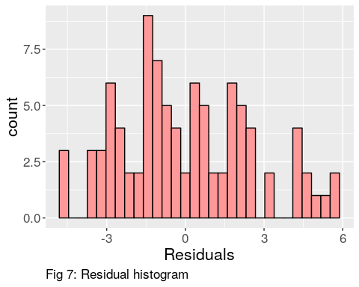

NULL

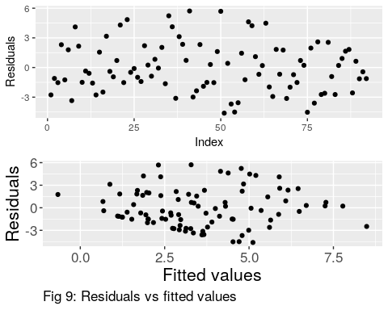

We run build the prediction model again using only VAS.Inclusion, OPG, IL-6 as the variables. Therefore our new equation would be:

Model fit parameters are calculated again using the latest formula and results are displayed in table 9.

Model description

|  |  |  |  |  |
| --- | --- | --- | --- | --- |
|  | beta | Std. Error | t value | Pr(>|t|) |
| (Intercept) | 18.2698149 | 7.2391916 | 2.523737 | 0.0134065 |
| VAS.Inclusion | 0.2674902 | 0.1069125 | 2.501954 | 0.0142001 |
| OPG | -1.9905502 | 0.7016747 | -2.836856 | 0.0056538 |
| IL-6 | 1.4723280 | 0.2901399 | 5.074545 | 0.0000021 |

Summary of the model fit:

* Residual Standard Error: 2.69
* R-Squared: 0.27
* Adjusted R-Squared: 0.24

Based on the results, the new Residual Standard Error and Adjusted R-Squared displayed some improvement, but not significant. The latest R-Squared is lower than previously calculated R-Squared value. R-Squared value increase when we add more explanatory variable. Since the new equation contains less explanatory variables compared to previous formula, the R-Squared value is reduced.

## 5.3 Testing the Model (out of sample)

VAS.Inclusion, OPG, IL-6 will be used as explanatory variables to test the model as these variables displayed statistical significance and improvement in model fit. Since the

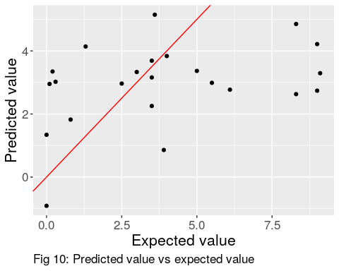

The regression model appears to be weak predictor. According to figure 10, the points are dispersed and does not follow a pattern. Ideally the scatter plot should be closely following the red line. Residual Sum of Squares (RSS) is 210.83. If we were to run this test with all the variables, the RSS would result in 197.25.

## 5.4 Conclusion

In conclusion, the linear model we derived in section 5.2 is not useful to predict VAS at 12 months. Linear model with all 13 variables had a lower RSS compared to the linear model with only statistically significant variables. The statistical significane of the each explanatory variables change significally depending on the selected training data. Maybe more training data might give us a model that can predict with better accuracy. It is also possible that these variables could have no linear relationship.

# 6 Final Remarks

In this paper, we were able to identify the biomarkers that are associated with pain level in the patients. Since the probability of commiting type I error increases with multiple testing, the biomarkers were identified using Bonferroni Correction method. Biomarkers IL-8, VEGF-A, TGF-beta-1, CXCL1, CSF-1 displayed statistical significance in the test. Therefore it can be concluded that these biomarkers can be tested to understand the pain level of a patient.

The linear regression prediction model was weaker in prediction. VAS.Inclusion, OPG, IL-6 were used as the explanatory variables to build the linear regression model. Eventhough these variables displayed statistical significance, their RSS and Adjusted R-Squared values were not far off from the model with all 13 variables. It maybe possible that these explanatory variables might have non-linear relationship or sample size of training data was not adequate to build a better model. The current results may not be favourable, but the future research may include non-linear prediction model to provide more accuracy.

# References

[1] Shaffer J. “Multiple Hypothesis Testing” Annual Rev. Physchol, 46 (1995), 561-584.

[2] Bangdiwala S. “Multiple Hypothesis Testing” International Journal of Injury Control and Safety Promotion, 24:1 (2017), 140-142.

[3] Devore J. and Berk K. “Modern Mathematical Statistics With Applications” Second edition, 2012, 707-710.

[4] Folsentein J. “Lecture 9: Multiple tests, Bonferroni correction, FDR” lecture notes, Washington University, delivered 2011.

[5] Goldman M. “Statistics for Bioinformatic” lecture notes, STATC141, UC Berkeley, delieverd 2008 Spring.

[6] Sedgwick P. “Multiple hypothesis testing and Bonferroni’s correction” BMJ, 349 (2014), g6284.

[7] Akey J. “Lecture 10: Multiple Testing” lecture notes, Washington University, delievered 2008 April.

[8] Fan Z. “Lecture 11: Testing Multiple Hypotheses” lecture notes, STATS 200, Stanford University, delievered 2016 Fall.

[9] Austin S, Dialsingh I and Altman N. “Mutiple Hypothesis Testing: A Review” Journal of the Indian Society of Agricultural Statistics, 68 (2014), 303-314.

[10] Teetor P. “R Cookbook” First edition, 2011

[11] Chang W. “R Graphics Cookbook” First edition, 2012

# Appendix

#name the data files  
biomarkerFile <- "biomarkers.xlsx"  
covariateFile <- "covariates.xlsx"  
  
#Set file paths  
biomarkerFilePath <- paste0(getwd(),"/data/",biomarkerFile)  
covariateFilePath <- paste0(getwd(),"/data/",covariateFile)  
  
#Read the files  
biomarkerData <- read_xlsx(biomarkerFilePath)  
covariateData <- read_xlsx(covariateFilePath)  
  
#Convert to data.table  
biomarkerData <- as.data.table(biomarkerData)  
covariateData <- as.data.table(covariateData)

#Number of observations in raw file  
BioMarkerNumOfObservationsRaw <- nrow(biomarkerData)  
  
#Sample display of the raw file  
kable(biomarkerData[1:5,], caption = " Biomarker raw data")

#Table with NAs in the data  
kable(biomarkerData[, lapply(.SD, function(x) sum(is.na(x))),   
 .SDcols = 1:ncol(biomarkerData)],   
 caption = "Missing data in Biomarker dataset")  
  
#Remove rows that contains NA  
biomarkerData <- na.omit(biomarkerData)

#Number of observations from Covariate data  
CovNumOfObservationsRaw <- nrow(covariateData)  
  
#Sample display of covariate data  
kable(covariateData[1:5,], caption = " Covariates raw data")

#Summary table of NAs in the data  
kable(covariateData[,lapply(.SD, function(x) sum(is.na(x))),   
 .SDcols = 1:ncol(covariateData)],   
 caption = "Missing data in Covariate dataset")  
  
#Remove the rows that contains NAs  
covariateData <- na.omit(covariateData)  
  
#Convert PatientID into  
covariateData[,PatientID := factor(PatientID)]

#Change the column names of the data  
setnames(covariateData, c("Sex (1=male, 2=female)",   
 "Smoker (1=yes, 2=no)",  
 "VAS-at-inclusion",   
 "Vas-12months"),   
 c("Sex", "Smoker", "VAS.Inclusion", "VAS.12Months"))  
  
#Saving the names of the columns  
covariateColNames <- names(covariateData)  
  
#Change the Sex and Smoker columns from 1 and 2 into corresponding categorical variable  
covariateData[,Sex := factor(ifelse(Sex == 1, "Male", "Female"))]  
covariateData[,Smoker := factor(ifelse(Smoker == 1, "Yes", "No"))]  
  
#Reshape the data in order to plot easily  
covariateDataMelt <- melt(covariateData, id.vars = c("PatientID", "Age",   
 "Sex", "Smoker"))

#Plot number of smokers in each age group  
g1 <- ggplot(data = covariateData, aes(x = Age)) +  
 geom_bar(aes(fill = Smoker)) +   
 xlab("Age") +  
 ylab("Count") +  
 labs(caption= "Fig 1: number of smokers in each Age group") +  
 theme(plot.caption = element_text(hjust = 0))  
  
g2 <- ggplot(data = covariateData, aes(x = Age)) +  
 geom_bar(aes(fill = Sex)) +  
 xlab("Age") +  
 ylab("Count") +  
 labs(caption= "Fig 2: Different sex in each age group") +  
 theme(plot.caption = element_text(hjust = 0))  
  
grid.arrange(g1,g2,ncol = 2)

#Box plot of VAS at inclusion and VAS at months  
ggplot(covariateDataMelt, aes(x = variable, y = value)) +  
 geom_boxplot(fill = "#4271AE") +  
 xlab("VAS") +  
 ylab("VAS score") +   
 labs(caption= "Fig 3: Comparing VAS at inclusion and at 12 months") +  
 theme(plot.caption = element_text(hjust = 0))

#VAS comparrison for sex  
VAS.ComparrisonSexGraph <- ggplot(covariateDataMelt,   
 aes(x = variable, y = value, fill = Sex)) +  
 geom_boxplot() +  
 xlab("VAS") +  
 ylab("VAS score") +   
 labs(caption= "Fig 4: Comparing VAS on different sex") +  
 theme(plot.caption = element_text(hjust = 0), text = element_text(size=10))  
  
#VAS comparrison for smokers  
VAS.ComparrisonSmokersGraph <- ggplot(covariateDataMelt, aes(x = variable,   
 y = value,   
 fill = Smoker)) +  
 geom_boxplot() +  
 xlab("VAS") +  
 ylab("VAS score") +   
 labs(caption= "Fig 5: Comparing VAS on smokers") +  
 theme(plot.caption = element_text(hjust = 0), text = element_text(size=10))  
  
#Plpot the last two graphs side by side  
grid.arrange(VAS.ComparrisonSexGraph,VAS.ComparrisonSmokersGraph,ncol = 2)

#Extract the biomarkers   
biomarkerNames <- colnames(biomarkerData)[2:ncol(biomarkerData)]  
#Extract the PatientID from Biomarker Column. Every character before the "-"  
biomarkerData[,PatientID :=as.factor(sub("\\-.*", "", biomarkerData$Biomarker))]  
#Extracting the characters right of "-" on Biomarker column  
extractedTime <- sub(".*-", "", biomarkerData$Biomarker)  
#Extract the number from the previous string  
extractedTime <- gsub("[^0-9.]", "", extractedTime)  
#Replace 12 months with 52 weeks  
extractedTime[which(extractedTime == 12)] <- 52  
#Create a new column called WeeksObs which contains the extracted time  
biomarkerData[,WeeksObs := factor(extractedTime, levels = c("0","6","52"))]  
#Re-arrange the columns  
biomarkerData <- setcolorder(biomarkerData, c("PatientID", "WeeksObs", biomarkerNames))  
#Remove biomarker column  
biomarkerData[,Biomarker := NULL]  
#Table of the biomarkerData  
kable(head(biomarkerData,10),   
 caption = "Biomarker data after seperating the patient ID and week of observation")

#Reshape the data for ease of plotting  
biomarkerDataMelt <- melt(biomarkerData, id.vars = c("PatientID", "WeeksObs"))  
#Biomarker box plot of each biomarker at each week  
ggplot(data = biomarkerDataMelt, aes(x = WeeksObs, y = value)) +   
 geom_boxplot(fill = "#FFD700") +  
 facet_wrap(~variable, scales = "free") +  
 xlab("Week of Observation") +  
 ylab("Biomarker level") +   
 labs(caption= "Fig 6: Biomarker value over the course of week of observation") +  
 theme(plot.caption = element_text(hjust = 0), text = element_text(size=16))

#Create a new column to get the difference of VAS at inclusion and 12 mos  
covariateData[,PainDiff := VAS.Inclusion - VAS.12Months]  
  
VAS.improvement <- covariateData[,Improved := ifelse(PainDiff > 0,  
 "Pain improved","Pain did not improve")]  
  
painImproved <- length(VAS.improvement$PainDiff > 0)

#Left Join on PatientID  
mergedCovBioDT <- covariateData[biomarkerData, on = .(PatientID)]  
#Count number of observation for each PatientID   
mergedCovBioDT <- mergedCovBioDT[,Count := .N,by = PatientID]  
#Exclude any PatientID that does not contain 3 different weeks of observation  
mergedCovBioDT <- mergedCovBioDT[Count == 3 & Improved == "Pain improved",]  
#Remove the column Count and Improved  
mergedCovBioDT[,`:=`(Count = NULL, Improved = NULL)]  
#Number of patients to conduct hypothesis test  
numOfPatientsForTest <- length(unique(mergedCovBioDT$PatientID))

#Seperate biomarkers according to week of observation  
  
#Seperate week 0  
Week0 <- mergedCovBioDT[WeeksObs == 0]  
#Remove unwanted columns  
Week0 <- Week0[,`:=`(PatientID = NULL, Age = NULL, Sex = NULL, Smoker = NULL,   
 VAS.Inclusion = NULL, VAS.12Months = NULL,   
 PainDiff = NULL, WeeksObs = NULL)]  
  
#Seperate week 6  
Week6 <- mergedCovBioDT[WeeksObs == 6]  
#Remove unwanted columns  
Week6 <- Week6[,`:=`(PatientID = NULL, Age = NULL, Sex = NULL, Smoker = NULL,   
 VAS.Inclusion = NULL, VAS.12Months = NULL,   
 PainDiff = NULL, WeeksObs = NULL)]  
  
#Seperate week 52  
Week52 <- mergedCovBioDT[WeeksObs == 52]  
#Remove unwanted columns  
Week52 <- Week52[,`:=`(PatientID = NULL, Age = NULL, Sex = NULL, Smoker = NULL,   
 VAS.Inclusion = NULL, VAS.12Months = NULL,   
 PainDiff = NULL, WeeksObs = NULL)]

t.test.Biomarkers <- function(data1,data2, biomarker,alpha = 0.05,...) {  
 #Extract the data of the biomarker from both data sets as a vector  
 data1 <- data1[, get(biomarker)]  
 data2 <- data2[, get(biomarker)]  
 #Calculate the confidence interval  
 confInterval <- 1-alpha  
 #Run the t-test   
 res <- t.test(data1, data2, alternative = "two.sided",   
 paired = TRUE, conf.level = confInterval)  
 #Extract the p.value  
 pValue <- res$p.value  
 #return p.value  
 return(pValue)  
}  
  
alpha <- 0.05  
#Running t-test for different combination of weeks for each biomarker  
list1 <- lapply(biomarkerNames, FUN = t.test.Biomarkers,   
 data1 = Week0, data2 = Week52, alpha = alpha)  
  
#Amulgamate p.values with the biomarker  
p.values <- data.table(Biomarker = biomarkerNames, C1 = do.call(rbind,list1))   
  
#Remaning the columns  
setnames(p.values, c("C1.V1"), c("Week 0 and Week 52"))  
  
#Biomarker that have p.value lower than alpha  
rejectedBiomarkersTest1 <- p.values[`Week 0 and Week 52` < alpha,Biomarker]

#Display the table  
kable(p.values, caption = "p.values for each hypothesis test")

#Calculating the pr of at least 1 type I error  
Pr <- (1- alpha)^nrow(p.values)

alphaAdjusted = alpha/nrow(p.values)

#Saving the p.values from test into a new data.frame  
p.valuesTest1 <- as.data.frame(p.values)  
  
#Running t-test for different combination of weeks for each biomarker  
list1 <- lapply(biomarkerNames, FUN = t.test.Biomarkers,   
 data1 = Week0, data2 = Week6, alpha = alphaAdjusted)  
  
#Amulgamate p.values with the biomarker  
p.values <- data.table(Biomarker = biomarkerNames,  
 C1 = do.call(rbind,list1))   
  
  
#Join p.values from alpha and adjusted alpha  
p.values <- p.values[p.valuesTest1, on = .(Biomarker)]  
  
#Remaning the columns  
setnames(p.values, 2:3, c("p.values of alpha", "p.values of adjusted alpha"))  
  
#Display the table  
kable(p.values, caption = "p.values for each hypothesis test")  
  
#Extract the biomarkers that were rejected  
rejectedBiomarkersTest2 <- p.values[`p.values of adjusted alpha` < alphaAdjusted,Biomarker,]

#Remove columns that are not required for regression modeling  
covariateData[,`:=` (PainDiff = NULL, Improved = NULL,   
 Male = factor(ifelse(Sex == "Male", 1,0)),   
 Smoker = factor(ifelse(Smoker == "Yes",1,0)), Sex = NULL)]  
  
  
#Rearrange the columns  
setcolorder(covariateData, c("PatientID", "Age", "Male",   
 "Smoker","VAS.Inclusion", "VAS.12Months"))  
  
#Left join data  
mergedData <- covariateData[biomarkerData, on = .(PatientID)]  
  
#Extract only week 0 of the data  
mergedData <- mergedData[WeeksObs == 0]  
  
#Remove unwanted columns  
mergedData[,`:=` (WeeksObs = NULL, PatientID = NULL)]  
  
#Remove NAs  
mergedData <- mergedData[complete.cases(mergedData),]  
#Reaggraning the columns  
colNames <- colnames(mergedData)  
colNames <- colNames[-which(colNames == "VAS.12Months")]  
colNames <- c(colNames, "VAS.12Months")  
  
#Reaggrange the data.table  
setcolorder(mergedData, colNames)

#Splitting the data into train and test data set  
set.seed(5)  
train_i <- sample(1:NROW(mergedData), size = round(0.8*NROW(mergedData)),   
 replace = FALSE)  
  
y_trn <- mergedData[train_i, ]  
  
y_test <- mergedData[-train_i, ]  
  
#Linear modeling  
mod1 <- lm(`VAS.12Months`~., y_trn)  
  
#Covering the parameters into a table  
fm1.table <- xtable(mod1)  
#Renaming some rows - happens to be a bug which is adding 1 infront of categorical variables  
rownames(fm1.table)[3:4] <- c("Male", "Smoker")  
#Rename the first column  
colnames(fm1.table)[1] <- "beta"  
#Print the table  
kable(fm1.table, caption = "Model description")

#Extract residuals  
res <- as.data.frame(mod1$residuals)  
colnames(res) <- "Residuals"  
  
#Plot histogram of the residuals  
ggplot(res, aes(x = Residuals)) +  
geom_histogram(fill = "#FF9999", colour="black") +  
labs(caption= "Fig 7: Residual histogram") +  
theme(plot.caption = element_text(hjust = 0), text = element_text(size=16))  
  
#Scatter plot of residuals  
g1 <- ggplot(res, aes(x = 1:nrow(res),y = Residuals)) +   
geom_point() +  
xlab("Index") +  
ylab("Residuals")  
labs(caption= "Fig 8: Residual scatter plot") +  
theme(plot.caption = element_text(hjust = 0), text = element_text(size=16))  
  
#Extract residuals and fitted values  
df <- augment(mod1)  
  
#Plot residuals vs fitted values  
g2 <- ggplot(df, aes(x = .fitted, y = .resid)) +   
geom_point() +  
xlab("Fitted values") +  
ylab("Residuals") +  
labs(caption= "Fig 9: Residuals vs fitted values") +  
theme(plot.caption = element_text(hjust = 0), text = element_text(size=16))  
  
#Plot two graphs together  
grid.arrange(g1,g2, nrow = 2)

#Extracting the columns that have statistical significance  
y_trainData <- y_trn[,c("VAS.Inclusion", "OPG","IL-6", "VAS.12Months")]  
  
#Linear modeling  
mod2 <- lm(`VAS.12Months`~., y_trainData)  
  
#Covert mod2 to a table  
fm2.table <- xtable(mod2)  
  
#Rename the first column  
colnames(fm2.table)[1] <- "beta"  
#Print the table  
kable(fm2.table, caption = "Model description")

y_hat1 <- predict(mod1, y_test)  
y_hat2 <- predict(mod2, y_test)  
  
  
y <- data.table(y.hat.1 = y_hat1, y.hat.2 = y_hat2, y = y_test[,VAS.12Months])  
  
RSS1 <- sum((y$y - y$y.hat.1)^2)  
RSS2 <- sum((y$y - y$y.hat.2)^2)  
  
ggplot(y, aes(x = y, y=y.hat.2)) +  
geom_point() +  
geom_abline(slope = 1, intercept = 0, color = "red") +  
xlab("Expected value") +  
ylab("Predicted value") +  
labs(caption= "Fig 10: Predicted value vs expected value") +  
theme(plot.caption = element_text(hjust = 0), text = element_text(size=16))