**MIGORI COUNTY:** 16 DAYS OF ACTIVISM AGAINST GBV - 2022

**GLOBAL THEME:** UNiTE

**COUNTY THEME:** ACCELERATING MALE INVOLVEMENT IN ENDING GBV

**FRONT**



**UNiTE**

**RIGHT SLEEVE**



**LEFT SLEEVE**



**BACK**

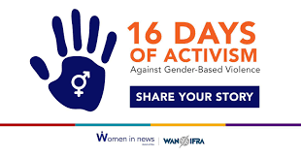

Upscaling Male Involvement is ending GBV