**Introduction**

This experiment will look at the speed of a parallel program compared to serial implementation for the same inputs. It will use image processing to test the speedup and the code will be written in java.

**Method**

I created four java programs, MeanFilterSerial, MeanFilterParallel, MedianFilterSerial and MeanFilterParalle. I ran each serial program with its parallel implementation and compared the results and plotted the results on excel. The graphs for speed up of my programs can be found below.

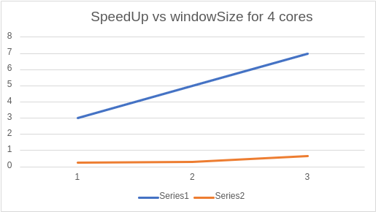

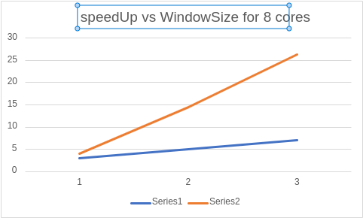

**Discussion**

I had some difficulties with producing the expected results, in some cases my serial programs were faster than parallel programs. And the MeanFilterSerial and MeanFilterParallel were producing wrong results. I exepected was the graphs that look more like the graph of scaling