Multimodal Leaderboard: [Open VLM Leaderboard - a Hugging Face Space by opencompass](https://huggingface.co/spaces/opencompass/open_vlm_leaderboard)

Open Ai – GPT 4o

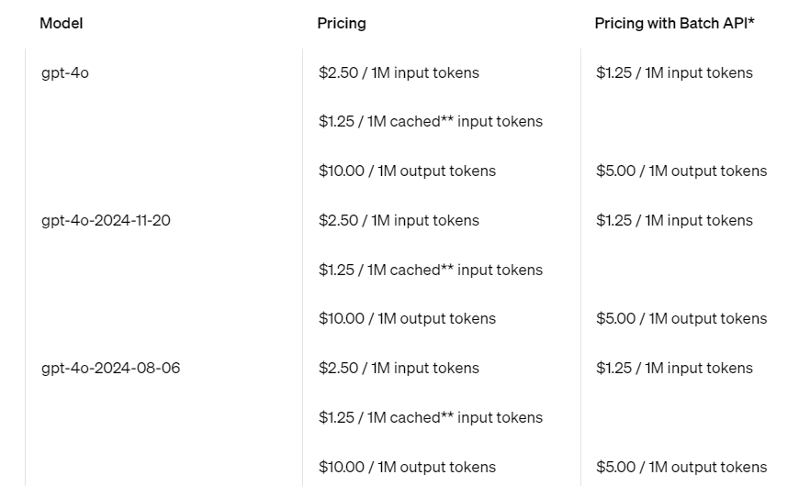

Anthropic – Claude 3.5 Sonnet

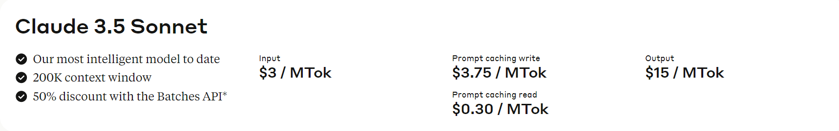

Google Gemini on Vertex AI: Gemini-1.5-flash and gemini-1.5-pro

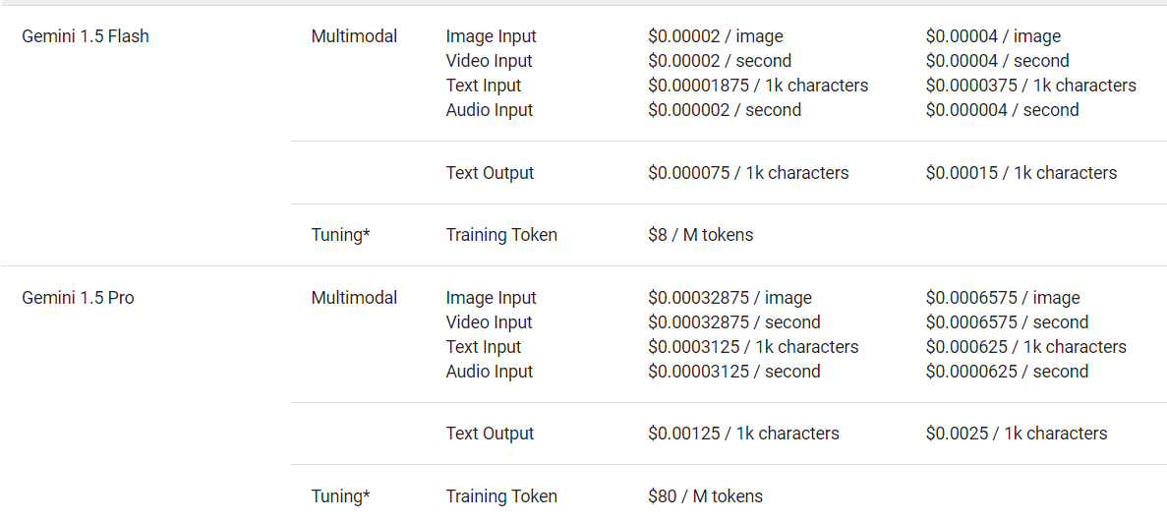

Mistral : Pixtral- Large

