Bonita Properties

February 2017

Sommaire

1. Introduction 3

2. Get / put 3

3. Administration 3

4. REST API 3

4.1. Usage 3

4.2. Admin REST 4

4.3. Security 5

# Introduction

# Get / put

# Administration

# REST API

## Usage

Two rest API is available to get and write a key.

In the parameter are (GET):

Name : the name is mandatory

Domain : the domain is optional

Key : the key of the value

When only the name is given, all keys attached to the name is returned (but not the domain).

When a domain is given, then the all keys attached to the name + domain is returned

When a key is give, then the value of the key is returned

GET: /bonita/API/extension/bonitaproperties?name=REST

{

"airport": "south",

"color": "rootblue",

"base": "Z57",

"REST": "low",

"jam": "strawberry",

"size": "low3"

}

GET: /bonita/API/extension/bonitaproperties?name=REST&domain=sfo

{

"": "yellow",

"color": "blue",

"size": "medium"

}

GET: /bonita/API/extension/bonitaproperties?name=REST&domain=sfo&key=color

{

"color": "blue"

}

A variable can be write using the PUT attributes

PUT : /bonita/API/extension/bonitaproperties?name=REST&domain=663&key=color&value=green663

PUT : /bonita/API/extension/bonitaproperties?name=REST&key=color&value=orange

It’s possible to put a JSON (then multiple variable at the same time)

PUT [/bonita/API/extension/bonitaproperties?name=REST&domain=sfo&set={%22state%22:%20%22California%22,%22country%22%20:%22Sacramento%22,%22maincity%22:%22Los%20Angeles,%20San%20Francisco%22}](http://localhost:8080/bonita/API/extension/bonitaproperties?name=REST&domain=sfo&set=%7b%22state%22:%20%22California%22,%22country%22%20:%22Sacramento%22,%22maincity%22:%22Los%20Angeles,%20San%20Francisco%22%7d)

## Admin REST

The administration REST is used to get information

Action=initialize : the database is checked. This method should be call at initialization

PUT /bonita/API/extension/bonitapropsadmin?action=initialize

Action=readall

All variables are read.

Action=readall [&name=:name] [&domain=:domain] [&hierarchy=true]

PUT /bonita/API/extension/bonitapropsadmin?action=readall

{

"values": {

"custompage_AegrotatList": {

"walter.bates": {

"accessTask": "WINDOW",

"showFilterContent": "false",

"datasource": "NotManagedBizDataDS",

"accesstask": "FRAME",

"examinerName": "bmal002",

"maxResult": "2000",

"profiledisplay": "MODERATOR",

"myCourseSynthesis": "true"

},

"datasource": "NotManagedBizDataDS",

"bmal002": {

"accessTask": "WINDOW",

"showFilterContent": "true",

"datasource": "NotManagedBizDataDS",

"accesstask": "FRAME",

"examinerName": "bmal002",

"maxResult": "2000",

"profiledisplay": "ALL",

"myCourseSynthesis": "false"

},

"hran821": {

"accessTask": "WINDOW",

"showFilterContent": "false",

"datasource": "NotManagedBizDataDS",

"accesstask": "FRAME",

"examinerName": "bmal002",

"maxResult": "2000",

"profiledisplay": "ALL",

"myCourseSynthesis": "false"

},

},

"custompage_AegrotatAdmin": {

"datasource": "NotManagedBizDataDS",

"showFilterFee": "false"

},

},

"listevents": "<table></table>",

"status": "OK"

}

If a name is given, only the data from this name is returned. Same for the domain.

When hierarchy is given, and a domain the result gives the name of not.

GET: /bonita/API/extension/bonitapropsadmin?action=readall&name=custompage_AegrotatList&hierarchy=false

|  |
| --- |
| { "values": { "accessTask": "WINDOW", "showFilterContent": "false", "datasource": "NotManagedBizDataDS", "accesstask": "FRAME", "examinerName": "bmal002", "maxResult": "2000", "profiledisplay": "MODERATOR", "myCourseSynthesis": "true" }, "listevents": " |

", "status": "OK" }

GET: /bonita/API/extension/bonitapropsadmin?action=readall&name=custompage_AegrotatList&hierarchy=true

|  |
| --- |
| { "values": { "custompage_AegrotatList": { "walter.bates": { "accessTask": "WINDOW", "showFilterContent": "false", "datasource": "NotManagedBizDataDS", "accesstask": "FRAME", "examinerName": "bmal002", "maxResult": "2000", "profiledisplay": "MODERATOR", "myCourseSynthesis": "true" } } }, "listevents": " |

", "status": "OK" }

## Security

You can protect the REST API by creating rule.

* If no rule is defined for the name, then all REST API GET/PUT are allowed
* The rule is used only by the REST API, not via the JAVA.

The rule can be created by some REST API or via the Custom page.

The rule has different parameters:

* RuleName : the name of the rule.
* Name : this parameter is mandatory. The rule apply on this name.
* Domain : if a domain is given, the rule apply only for the domain
* DomainIsUser : if true, then the rule apply only if the domain is equal to the userId.
* ReadOnly : the rule apply only for the GET api
* Admin : apply only if the user is register in the Administrator profile
* ApplyAllDomaines : apply whatever the domain (the parameter is not used)
* profileName : apply only when the user is register in this profile
* roleName : apply only when the user is register in the role
* GroupPath : apply if the user is register in the group
* username : apply only for the user.

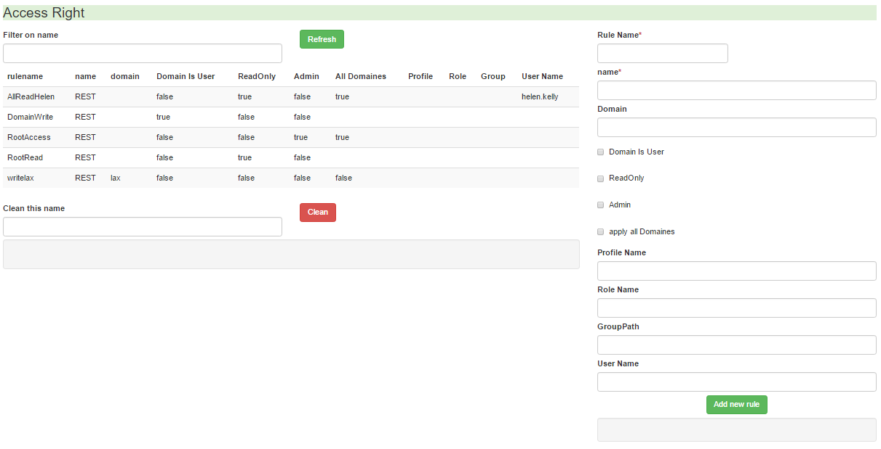

For example, for the rule :

Name

|  |  |  |  |  |  |  |  |  |  |  |
| --- | --- | --- | --- | --- | --- | --- | --- | --- | --- | --- |
| **Rule Name** | **Name** | **Domain** | **DomainIsuser** | **ReadOnly** | **Admin** | **All Domaines** | **Profile** | **Role** | **Group** | **UserName** |
| DomainWrite | REST |  | True | False | False | false |  |  |  |  |
| RootRead | REST |  | False | True |  | false |  |  |  |  |
| RootAccess | REST |  | False | False | True | true |  |  |  |  |
|  |  |  |  |  |  |  |  |  |  |  |

When the user Helen.Kelly (which is not an administrator) access by the REST API :

“name=REST&key=datasource”

|  |  |  |
| --- | --- | --- |
| **Type** | **RESTAPI** | **Access ?** |
| GET | name=REST&key=datasource | Yes (RootRead) |
| PUT | name=REST&key=datasource&value=AA | No (RootRead is only valable in ReadOnly |
| GET | Name=REST&domain=sfo&key=color | No |
| GET | Name=REST&domain=657&key=color | True (DomainWrite) when userid=657 |
| PUT | Name=REST&domain=657&key=color&value=blue | True |

d

HEADQUARTERS

PARIS, FRANCE

76 boulevard de la République

92100 Boulogne-Billancourt

EMEA, ASIA & LATIN AMERICA

GRENOBLE, FRANCE

32, rue Gustave Eiffel  
38000 Grenoble

NORTH AMERICA

SAN FRANCISCO, USA

44 Tehama Street  
San Francisco, CA 94105

NEW YORK, USA

33 Nassau Avenue

Brooklyn NY 11222