Nguyễn Văn Vũ 12CNTT4
MSSV : 1250080238

SQL> CREATE USER BAITHI IDENTIFIED BY 123;
User created.
SQL> CREATE TABLE "USER" (
2 UID_USER VARCHAR2(10) CONSTRAINT PK_USER PRIMARY KEY,
3 USERNAME VARCHAR2(50),
4 PASS VARCHAR2(50),
5 REGDAY DATE,
6 NATIONALITY NVARCHAR2(50)
7 );

Table created.

SQL>
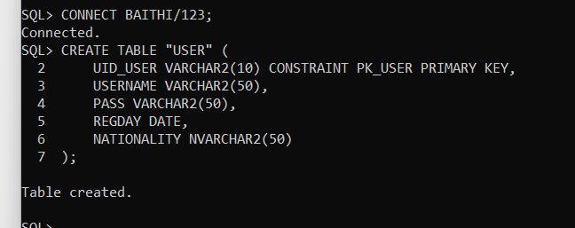

SQL> CREATE TABLE CHANNEL (
2 CHANNELID VARCHAR2(10) CONSTRAINT PK_CHANNEL PRIMARY KEY,
3 CNAME NVARCHAR2(100),
4 SUBSCRIBES NUMBER,
5 OWNER VARCHAR2(10),
6 CREATED DATE,
7 CONSTRAINT FK_CHANNEL_USER FOREIGN KEY (OWNER) REFERENCES "USER"(UID_USER)
8 );

Table created.

SQL>
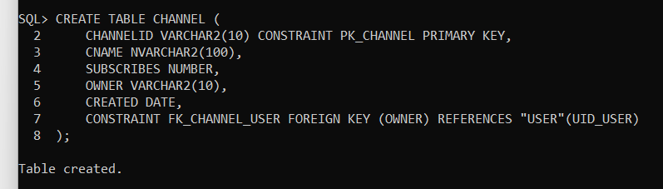

SQL> CREATE TABLE VIDEO (
2 VIDEOID VARCHAR2(10) CONSTRAINT PK_VIDEO PRIMARY KEY,
3 TITLE NVARCHAR2(100),
4 DURATION NUMBER,
5 AGE NUMBER
6 );

Table created.

SQL>
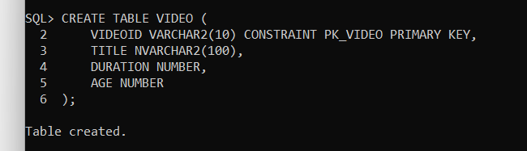

SQL> CREATE TABLE "SHARE" (
2 VIDEOID VARCHAR2(10),
3 CHANNELID VARCHAR2(10),
4 CONSTRAINT PK_SHARE PRIMARY KEY (VIDEOID, CHANNELID),
5 CONSTRAINT FK_SHARE_VIDEO FOREIGN KEY (VIDEOID) REFERENCES VIDEO(VIDEOID),
6 CONSTRAINT FK_SHARE_CHANNEL FOREIGN KEY (CHANNELID) REFERENCES CHANNEL(CHANNELID)
7 );

Table created.

SQL>
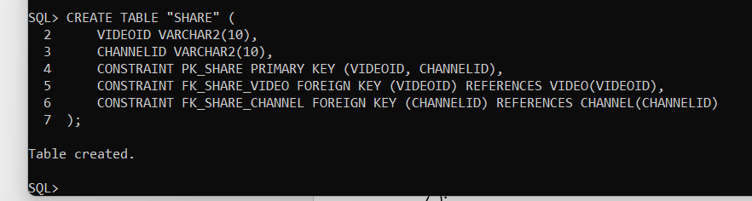

SQL> ALTER SESSION SET NLS_DATE_FORMAT = 'DD/MM/YYYY';

Session altered.

SQL> INSERT INTO "USER" VALUES ('001', 'faptv', '123456abc', '01/01/2014', 'Việt Nam');

1 row created.

SQL> INSERT INTO "USER" VALUES ('002', 'kemxoitv', '@147869iii', '05/06/2015', 'Campuchia');

1 row created.

SQL> INSERT INTO "USER" VALUES ('003', 'openshare', 'qwertyuiop', '12/05/2009', 'Việt Nam');

1 row created.

SQL>
SQL> INSERT INTO CHANNEL VALUES ('C120', 'FAP TV', 2343, '001', '02/01/2014');

1 row created.

SQL> INSERT INTO CHANNEL VALUES ('C905', 'Kem xôi TV', 1032, '002', '09/07/2015');

1 row created.

SQL> INSERT INTO CHANNEL VALUES ('C357', 'OpenShare Cáfe', 5064, '003', '10/12/2010');

1 row created.

SQL>
SQL> INSERT INTO VIDEO VALUES ('V100229', 'FAPtv Cơm Nguội Tập 41 - Đột Nhập', 469, 18);

1 row created.

SQL> INSERT INTO VIDEO VALUES ('V211002', 'Kem xôi: Tập 31 - Mẩy Kool tình yêu của anh', 312, 16);

1 row created.

SQL> INSERT INTO VIDEO VALUES ('V400002', 'Nơi tình yêu kết thúc - Hoàng Tuấn', 378, 0);

1 row created.

SQL>
SQL> INSERT INTO "SHARE" VALUES ('V100229', 'C905');

1 row created.

SQL> INSERT INTO "SHARE" VALUES ('V211002', 'C120');

1 row created.

SQL> INSERT INTO "SHARE" VALUES ('V400002', 'C357');

1 row created.

SQL>
SQL> COMMIT;
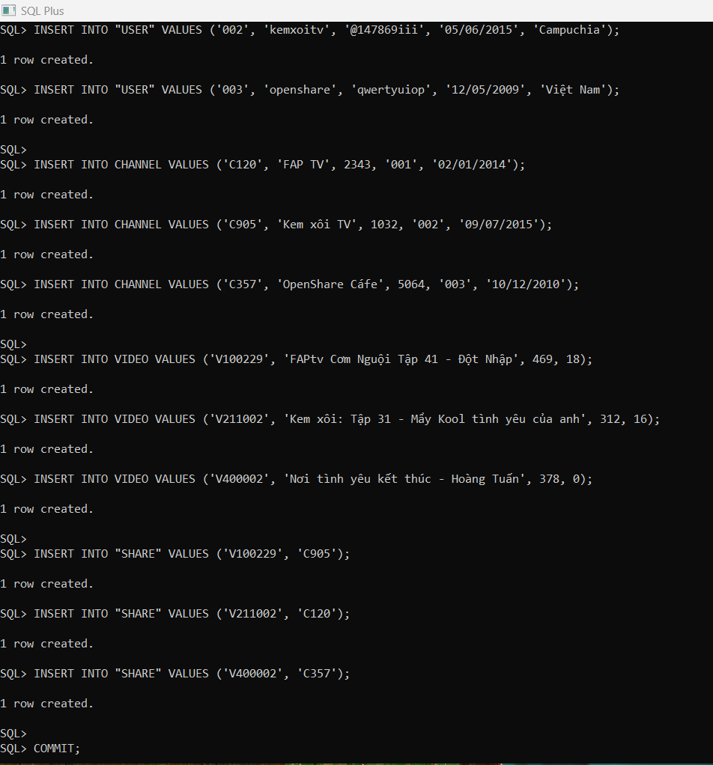

SQL> ALTER TABLE "USER" MODIFY REGDAY DEFAULT SYSDATE;

Table altered.

SQL> CREATE OR REPLACE TRIGGER TRG_CHECK_CREATED
2 BEFORE INSERT OR UPDATE ON CHANNEL
3 FOR EACH ROW
4 DECLARE
5 v_regday DATE;
6 BEGIN
7 SELECT REGDAY INTO v_regday
8 FROM "USER"
9 WHERE UID_USER = :NEW.OWNER;
10
11 IF :NEW.CREATED < v_regday THEN
12 RAISE_APPLICATION_ERROR(-20001, 'Error: Created date must be after User registration date');
13 END IF;
14 END;
15 /

Trigger created.

SQL>
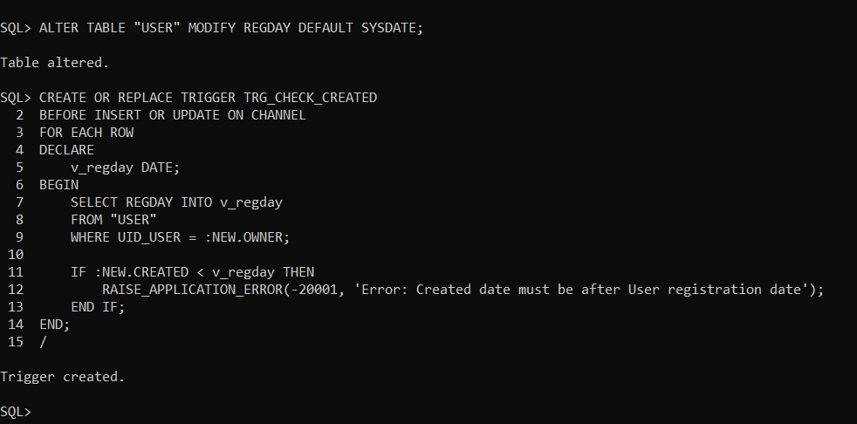

SQL> SELECT * FROM VIDEO
2 WHERE AGE >= 16;

VIDEOID
----------
TITLE
--------------------------------------------------------------------------------
DURATION AGE
---------- ----------
V100229
FAPtv Com Ngu?i T?p 41 - D?t Nh?p
469 18

V211002
Kem xôi: T?p 31 - M?y Kool tình yêu c?a anh
312 16

VIDEOID
----------
TITLE
--------------------------------------------------------------------------------
DURATION AGE
---------- ----------
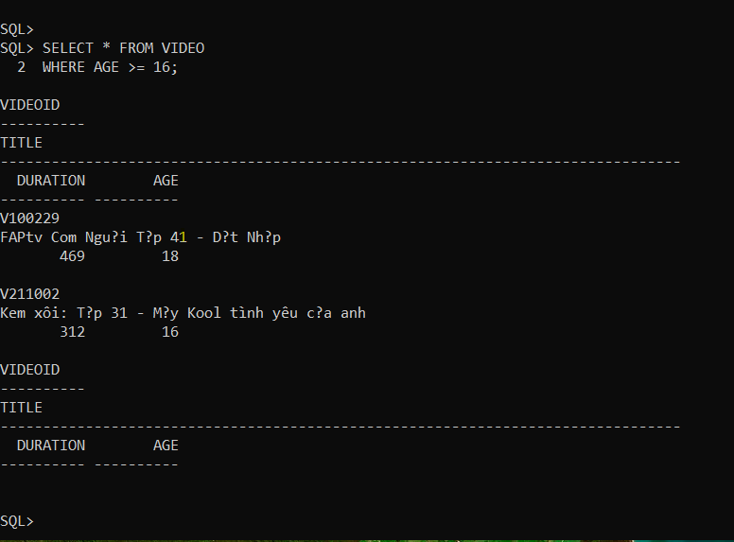
SQL> SELECT *
2 FROM CHANNEL
3 WHERE SUBSCRIBES = (SELECT MAX(SUBSCRIBES) FROM CHANNEL);

CHANNELID
----------
CNAME
--------------------------------------------------------------------------------
SUBSCRIBES OWNER CREATED
---------- ---------- ----------
C357
OpenShare Cáfe
5064 003 10/12/2010

SQL>
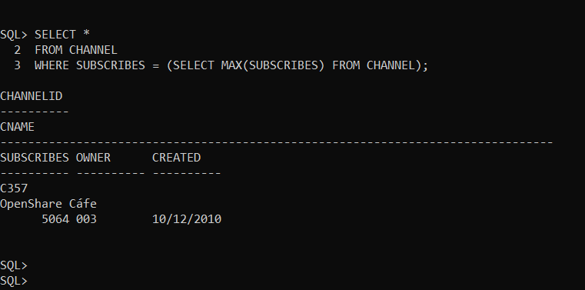

SQL> SELECT V.VIDEOID, V.TITLE, COUNT(S.CHANNELID)
2 FROM VIDEO V
3 JOIN "SHARE" S ON V.VIDEOID = S.VIDEOID
4 WHERE V.AGE = 18
5 GROUP BY V.VIDEOID, V.TITLE;

VIDEOID
----------
TITLE
--------------------------------------------------------------------------------
COUNT(S.CHANNELID)
------------------
V100229
FAPtv Com Ngu?i T?p 41 - D?t Nh?p
1

SQL>
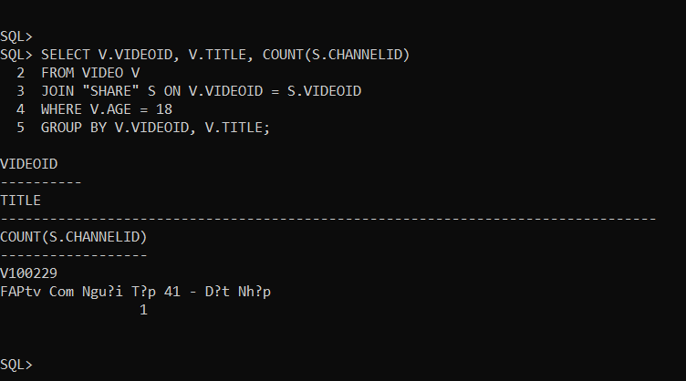

SQL> SELECT V.TITLE
2 FROM VIDEO V
3 WHERE NOT EXISTS (
4 SELECT *
5 FROM CHANNEL C
6 WHERE NOT EXISTS (
7 SELECT *
8 FROM "SHARE" S
9 WHERE S.VIDEOID = V.VIDEOID
10 AND S.CHANNELID = C.CHANNELID
11 )
12 );

no rows selected

SQL>

