Họ và Tên : Nguyễn Văn Vũ
Lớp : 12_ĐH_CNTT4
MSSV :1250080238

SQL*Plus: Release 19.0.0.0.0 - Production on Mon Jan 19 10:40:09 2026
Version 19.3.0.0.0
Copyright (c) 1982, 2019, Oracle. All rights reserved.
Enter user-name: system
Enter password:
Last Successful login time: Mon Jan 19 2026 10:33:37 +07:00
Connected to:
Oracle Database 19c Enterprise Edition Release 19.0.0.0.0 - Production
Version 19.3.0.0.0
SQL> connect vu/123
Connected.
SQL> CREATE TABLE PHONGBAN (
2 MaPhong VARCHAR2(50) PRIMARY KEY,
3 TenPhong VARCHAR2(50),
4 TruongPhong VARCHAR2(50),
5 NgayNhanChuc DATE
6 );

Table created.
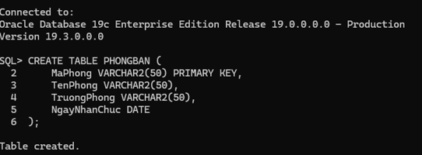

SQL> CREATE TABLE NHANVIEN (
2 MaNV VARCHAR2(50) PRIMARY KEY,
3 HoNV VARCHAR2(50),
4 TenNV VARCHAR2(50),
5 NgaySinh DATE,
6 DiaChi VARCHAR2(50),
7 Phai VARCHAR2(50),
8 Luong INT,
9 MaNQL VARCHAR2(50),
10 Phong VARCHAR2(50),
11 FOREIGN KEY (Phong) REFERENCES PHONGBAN(MaPhong),
12 FOREIGN KEY (MaNQL) REFERENCES NHANVIEN(MaNV)
13 );

Table created.
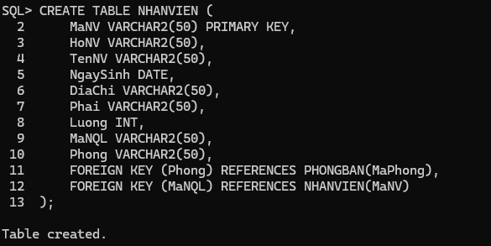
SQL> ALTER TABLE PHONGBAN
2 ADD CONSTRAINT FK_TruongPhong
3 FOREIGN KEY (TruongPhong) REFERENCES NHANVIEN(MaNV);

Table altered.
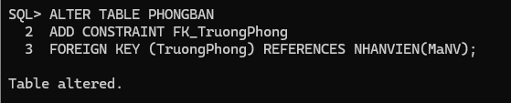
SQL> CREATE TABLE DIADIEMPHONG (
2 MaPhong VARCHAR2(50),
3 DiaDiem VARCHAR2(50),
4 PRIMARY KEY (MaPhong, DiaDiem),
5 FOREIGN KEY (MaPhong) REFERENCES PHONGBAN(MaPhong)
6 );

Table created.
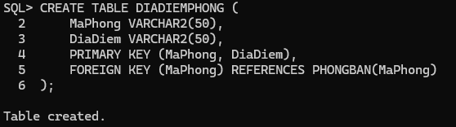
SQL> CREATE TABLE DEAN (
2 MaDA VARCHAR2(50) PRIMARY KEY,
3 TenDA VARCHAR2(50),
4 DdiemDA VARCHAR2(50),
5 Phong VARCHAR2(50),
6 FOREIGN KEY (Phong) REFERENCES PHONGBAN(MaPhong)
7 );

Table created.
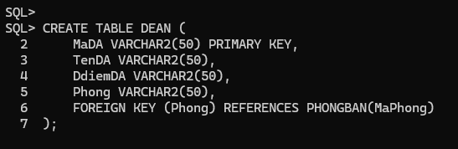
SQL> CREATE TABLE PHANCONG (
2 MaNV VARCHAR2(50),
3 MaDA VARCHAR2(50),
4 ThoiGian INT,
5 PRIMARY KEY (MaNV, MaDA),
6 FOREIGN KEY (MaNV) REFERENCES NHANVIEN(MaNV),
7 FOREIGN KEY (MaDA) REFERENCES DEAN(MaDA)
8 );

Table created.
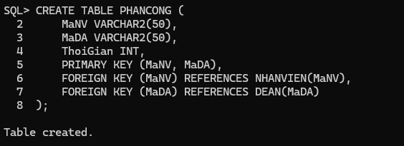
SQL> CREATE TABLE THANNHAN (
2 MaTN VARCHAR2(50) PRIMARY KEY,
3 HoTN VARCHAR2(50),
4 TenTN VARCHAR2(50),
5 Phai VARCHAR2(50),
6 NgaySinh DATE
7 );

Table created.
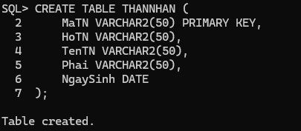
SQL> CREATE TABLE NVIEN_TNHAN (
2 MaNV VARCHAR2(50),
3 MaTN VARCHAR2(50),
4 QuanHe VARCHAR2(50),
5 PRIMARY KEY (MaNV, MaTN),
6 FOREIGN KEY (MaNV) REFERENCES NHANVIEN(MaNV),
7 FOREIGN KEY (MaTN) REFERENCES THANNHAN(MaTN)
8 );

Table created.
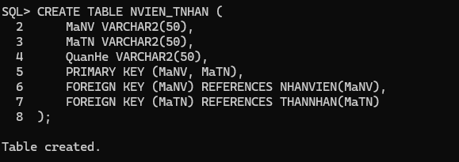

SQL> INSERT INTO NHANVIEN VALUES ('NV01', 'Nguyễn', 'An', TO_DATE('1980-05-15', 'YYYY-MM-DD'), 'TP.HCM', 'Nam', 8000000, NULL, NULL);
1 row created.
SQL> INSERT INTO NHANVIEN VALUES ('NV02', 'Trần', 'Bình', TO_DATE('1985-08-20', 'YYYY-MM-DD'), 'Hà Nội', 'Nam', 7000000, 'NV01', NULL);
1 row created.
SQL> INSERT INTO NHANVIEN VALUES ('NV03', 'Lê', 'Cúc', TO_DATE('1990-03-10', 'YYYY-MM-DD'), 'Đà Nẵng', 'Nữ', 6500000, 'NV01', NULL);
1 row created.
SQL> INSERT INTO NHANVIEN VALUES ('NV04', 'Phạm', 'Huynh', TO_DATE('1982-12-05', 'YYYY-MM-DD'), 'TP.HCM', 'Nam', 9000000, NULL, NULL);
1 row created.
SQL> INSERT INTO NHANVIEN VALUES ('NV05', 'Võ', 'Huynh', TO_DATE('1988-07-25', 'YYYY-MM-DD'), 'Cần Thơ', 'Nữ', 5500000, 'NV04', NULL);
1 row created.
SQL> INSERT INTO NHANVIEN VALUES ('NV06', 'Hoàng', 'Dũng', TO_DATE('1987-03-12', 'YYYY-MM-DD'), 'TP.HCM', 'Nam', 7500000, 'NV04', NULL);
1 row created.
SQL> INSERT INTO NHANVIEN VALUES ('NV07', 'Ngô', 'Mai', TO_DATE('1992-09-18', 'YYYY-MM-DD'), 'Hà Nội', 'Nữ', 6000000, 'NV01', NULL);
1 row created.
SQL> INSERT INTO NHANVIEN VALUES ('NV08', 'Đặng', 'Long', TO_DATE('1989-11-25', 'YYYY-MM-DD'), 'Đà Nẵng', 'Nam', 450000, 'NV02', NULL);
1 row created.
SQL> INSERT INTO NHANVIEN VALUES ('NV09', 'Bùi', 'Lan', TO_DATE('1991-06-30', 'YYYY-MM-DD'), 'Cần Thơ', 'Nữ', 400000, 'NV02', NULL);
1 row created.
SQL> INSERT INTO NHANVIEN VALUES ('NV10', 'Phan', 'Nam', TO_DATE('1986-02-14', 'YYYY-MM-DD'), 'TP.HCM', 'Nam', 8500000, 'NV04', NULL);
1 row created.
SQL> INSERT INTO PHONGBAN VALUES ('PB01', 'Hành Chính', 'NV01', TO_DATE('2020-01-01', 'YYYY-MM-DD'));
1 row created.
SQL> INSERT INTO PHONGBAN VALUES ('PB02', 'Tài Vụ', 'NV04', TO_DATE('2019-06-15', 'YYYY-MM-DD'));
1 row created.
SQL> INSERT INTO PHONGBAN VALUES ('PB03', 'Kỹ Thuật', 'NV02', TO_DATE('2021-03-20', 'YYYY-MM-DD'));
1 row created.
SQL> UPDATE NHANVIEN SET Phong = 'PB01' WHERE MaNV IN ('NV01', 'NV02', 'NV07');

3 rows updated.
SQL> UPDATE NHANVIEN SET Phong = 'PB02' WHERE MaNV IN ('NV04', 'NV05', 'NV06', 'NV10');
4 rows updated.
SQL> UPDATE NHANVIEN SET Phong = 'PB03' WHERE MaNV IN ('NV03', 'NV08', 'NV09');
3 rows updated.
SQL> INSERT INTO DIADIEMPHONG VALUES ('PB01', 'Quận 1, TP.HCM');
1 row created.
SQL> INSERT INTO DIADIEMPHONG VALUES ('PB01', 'Quận 2, TP.HCM');
1 row created.
SQL> INSERT INTO DIADIEMPHONG VALUES ('PB02', 'Quận 3, TP.HCM');
1 row created.
SQL> INSERT INTO DIADIEMPHONG VALUES ('PB03', 'Quận Thủ Đức, TP.HCM');
1 row created.
SQL> INSERT INTO DEAN VALUES ('DA01', 'Dự án A', 'TP.HCM', 'PB01');
1 row created.
SQL> INSERT INTO DEAN VALUES ('DA02', 'Dự án B', 'Hà Nội', 'PB02');
1 row created.
SQL> INSERT INTO DEAN VALUES ('DA03', 'Dự án C', 'Đà Nẵng', 'PB03');
1 row created.
SQL> INSERT INTO DEAN VALUES ('DA04', 'Dự án D', 'Cần Thơ', 'PB01');
1 row created.
SQL> INSERT INTO PHANCONG VALUES ('NV01', 'DA01', 35);
1 row created.
SQL> INSERT INTO PHANCONG VALUES ('NV01', 'DA02', 32);

1 row created.
SQL> INSERT INTO PHANCONG VALUES ('NV01', 'DA03', 28);
1 row created.
SQL> INSERT INTO PHANCONG VALUES ('NV01', 'DA04', 30);
1 row created.
SQL> INSERT INTO PHANCONG VALUES ('NV02', 'DA01', 25);
1 row created.
SQL> INSERT INTO PHANCONG VALUES ('NV02', 'DA03', 20);
1 row created.
SQL> INSERT INTO PHANCONG VALUES ('NV03', 'DA02', 40);
1 row created.
SQL> INSERT INTO PHANCONG VALUES ('NV03', 'DA03', 35);
1 row created.
SQL> INSERT INTO PHANCONG VALUES ('NV04', 'DA02', 30);
1 row created.
SQL> INSERT INTO PHANCONG VALUES ('NV05', 'DA03', 20);
1 row created.
SQL> INSERT INTO PHANCONG VALUES ('NV05', 'DA04', 25);
1 row created.
SQL> INSERT INTO PHANCONG VALUES ('NV06', 'DA01', 38);
1 row created.
SQL> INSERT INTO PHANCONG VALUES ('NV06', 'DA02', 28);
1 row created.
SQL> INSERT INTO PHANCONG VALUES ('NV07', 'DA01', 15);
1 row created.
SQL> INSERT INTO PHANCONG VALUES ('NV10', 'DA02', 33);
1 row created.

SQL> INSERT INTO THANNHAN VALUES ('TN01', 'Nguyễn', 'Huynh', 'Nữ', TO_DATE('2010-01-15', 'YYYY-MM-DD'));
1 row created.
SQL> INSERT INTO THANNHAN VALUES ('TN02', 'Trần', 'Bình', 'Nam', TO_DATE('2012-05-20', 'YYYY-MM-DD'));
1 row created.
SQL> INSERT INTO THANNHAN VALUES ('TN03', 'Phạm', 'Mai', 'Nữ', TO_DATE('2015-08-10', 'YYYY-MM-DD'));
1 row created.
SQL> INSERT INTO THANNHAN VALUES ('TN04', 'Võ', 'Dũng', 'Nam', TO_DATE('2008-03-22', 'YYYY-MM-DD'));
1 row created.
SQL> INSERT INTO THANNHAN VALUES ('TN05', 'Lê', 'Lan', 'Nữ', TO_DATE('2013-07-05', 'YYYY-MM-DD'));
1 row created.
SQL> INSERT INTO NVIEN_TNHAN VALUES ('NV01', 'TN01', 'Con gái');
1 row created.
SQL> INSERT INTO NVIEN_TNHAN VALUES ('NV02', 'TN02', 'Con trai');
1 row created.
SQL> INSERT INTO NVIEN_TNHAN VALUES ('NV04', 'TN03', 'Con gái');
1 row created.
SQL> INSERT INTO NVIEN_TNHAN VALUES ('NV05', 'TN01', 'Cháu gái');
1 row created.
SQL> INSERT INTO NVIEN_TNHAN VALUES ('NV06', 'TN04', 'Con trai');
1 row created.
SQL>
SQL> COMMIT;
Commit complete.

SQL> SET LINESIZE 200
SQL> SET PAGESIZE 100
SQL> SET WRAP OFF
SQL> COLUMN MANV FORMAT A10
SQL> COLUMN HONV FORMAT A15
SQL> COLUMN TENNV FORMAT A15
SQL> COLUMN NGAYSINH FORMAT A12
SQL> COLUMN DIACHI FORMAT A20
SQL> COLUMN PHAI FORMAT A5
SQL> COLUMN LUONG FORMAT 99,999,999
SQL> COLUMN MANQL FORMAT A10
SQL> COLUMN PHONG FORMAT A10
SQL> COLUMN MAPHONG FORMAT A10
SQL> COLUMN TENPHONG FORMAT A20
SQL> COLUMN TRUONGPHONG FORMAT A15
SQL> COLUMN NGAYNHANCHUC FORMAT A15
SQL> COLUMN MADA FORMAT A10
SQL> COLUMN TENDA FORMAT A20
SQL> COLUMN DDIEMDA FORMAT A20
SQL> COLUMN THOIGIAN FORMAT 999
SQL> COLUMN MATN FORMAT A10
SQL> COLUMN HOTN FORMAT A15
SQL> COLUMN TENTN FORMAT A15
SQL> COLUMN QUANHE FORMAT A15
SQL> PROMPT ===== CÂU 1: THÔNG TIN NHÂN VIÊN CÓ TÊN 'Huynh' =====
===== CAU 1: THONG TIN NHAN VIEN CO TEN 'Huynh' =====
SQL> SELECT *
2 FROM NHANVIEN
3 WHERE TenNV = 'Huynh';
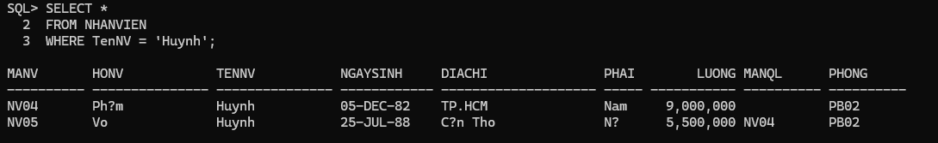
SQL> SELECT NV.MaNV, NV.HoNV, NV.TenNV, NV.DiaChi
2 FROM NHANVIEN NV
3 JOIN PHONGBAN PB ON NV.Phong = PB.MaPhong
4 WHERE PB.TenPhong = 'Hành Chính';

MANV HONV TENNV DIACHI
---------- --------------- --------------- --------------------
NV01 Nguy?n An TP.HCM
NV02 Tr?n Bình Hà N?i
NV07 Ngô Mai Hà N?i
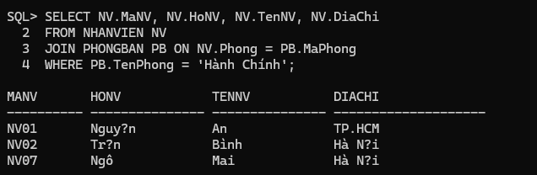
SQL> SELECT NV.MaNV, NV.HoNV, NV.TenNV, NV.DiaChi
2 FROM NHANVIEN NV
3 JOIN PHONGBAN PB ON NV.Phong = PB.MaPhong
4 WHERE PB.TenPhong IN ('Hành Chính', 'Tài Vụ');

MANV HONV TENNV DIACHI
---------- --------------- --------------- --------------------
NV01 Nguy?n An TP.HCM
NV02 Tr?n Bình Hà N?i
NV04 Ph?m Huynh TP.HCM
NV05 Vo Huynh C?n Tho
NV06 Hoàng Dung TP.HCM
NV07 Ngô Mai Hà N?i
NV10 Phan Nam TP.HCM

7 rows selected.
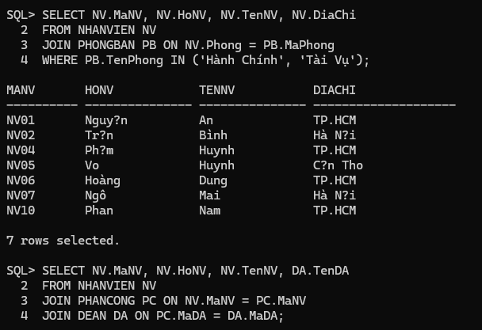
SQL> SELECT NV.MaNV, NV.HoNV, NV.TenNV, DA.TenDA
2 FROM NHANVIEN NV
3 JOIN PHANCONG PC ON NV.MaNV = PC.MaNV
4 JOIN DEAN DA ON PC.MaDA = DA.MaDA;

MANV HONV TENNV TENDA
---------- --------------- --------------- --------------------
NV01 Nguy?n An D? án A
NV01 Nguy?n An D? án B
NV01 Nguy?n An D? án C
NV01 Nguy?n An D? án D
NV02 Tr?n Bình D? án A
NV02 Tr?n Bình D? án C
NV03 Lê Cúc D? án B
NV03 Lê Cúc D? án C
NV04 Ph?m Huynh D? án B
NV05 Vo Huynh D? án C
NV05 Vo Huynh D? án D
NV06 Hoàng Dung D? án A
NV06 Hoàng Dung D? án B
NV07 Ngô Mai D? án A
NV10 Phan Nam D? án B

15 rows selected.
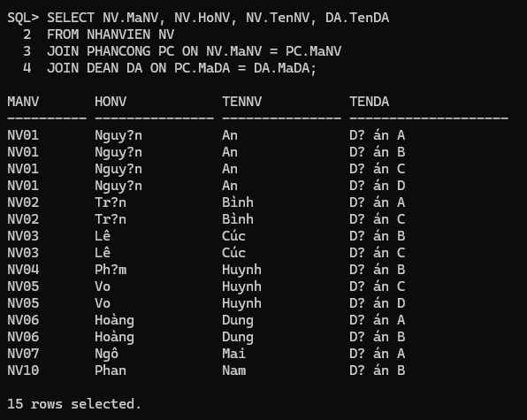
SQL> SELECT DA.MaDA, DA.TenDA, PB.TenPhong, PB.TruongPhong,
2 TP.HoNV, TP.TenNV
3 FROM DEAN DA
4 JOIN PHONGBAN PB ON DA.Phong = PB.MaPhong
5 JOIN NHANVIEN TP ON PB.TruongPhong = TP.MaNV;

MADA TENDA TENPHONG TRUONGPHONG HONV TENNV
---------- -------------------- -------------------- --------------- --------------- ---------------
DA01 D? án A Hành Chính NV01 Nguy?n An
DA02 D? án B Tài V? NV04 Ph?m Huynh
DA03 D? án C K? Thu?t NV02 Tr?n Bình
DA04 D? án D Hành Chính NV01 Nguy?n An
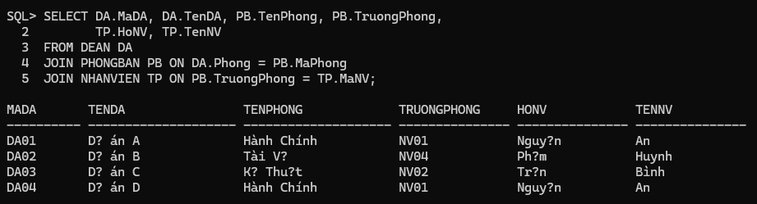
SQL> SELECT NV.MaNV, NV.HoNV, NV.TenNV
2 FROM NHANVIEN NV
3 JOIN PHANCONG PC ON NV.MaNV = PC.MaNV
4 WHERE PC.MaDA = 'DA01' AND PC.ThoiGian > 30;

MANV HONV TENNV
---------- --------------- ---------------
NV01 Nguy?n An
NV06 Hoàng Dung
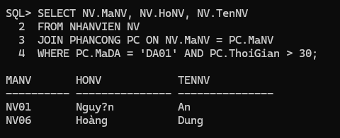
SQL> SELECT DISTINCT NV.MaNV, NV.HoNV, NV.TenNV
2 FROM NHANVIEN NV
3 JOIN NVIEN_TNHAN NT ON NV.MaNV = NT.MaNV
4 JOIN THANNHAN TN ON NT.MaTN = TN.MaTN
5 WHERE NV.TenNV = TN.TenTN;

MANV HONV TENNV
---------- --------------- ---------------
NV02 Tr?n Bình
NV05 Vo Huynh
NV06 Hoàng Dung
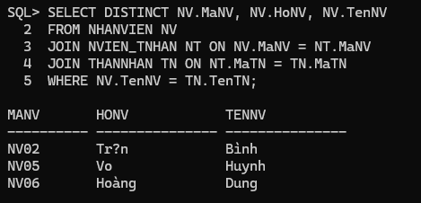

SQL> SELECT NV.MaNV, NV.HoNV, NV.TenNV
2 FROM NHANVIEN NV
3 JOIN PHONGBAN PB ON NV.Phong = PB.MaPhong
4 JOIN NHANVIEN TP ON PB.TruongPhong = TP.MaNV
5 WHERE TP.HoNV = 'Phạm' AND TP.TenNV = 'Huynh';

MANV HONV TENNV
---------- --------------- ---------------
NV04 Ph?m Huynh
NV05 Vo Huynh
NV06 Hoàng Dung
NV10 Phan Nam
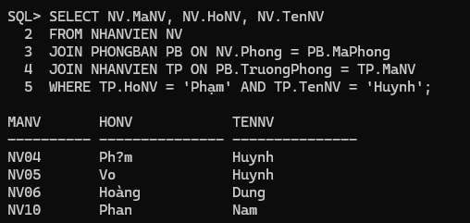

SQL> SELECT NV.MaNV, NV.HoNV, NV.TenNV
2 FROM NHANVIEN NV
3 JOIN NHANVIEN QL ON NV.MaNQL = QL.MaNV
4 WHERE QL.HoNV = 'Phạm' AND QL.TenNV = 'Huynh';

MANV HONV TENNV
---------- --------------- ---------------
NV05 Vo Huynh
NV06 Hoàng Dung
NV10 Phan Nam
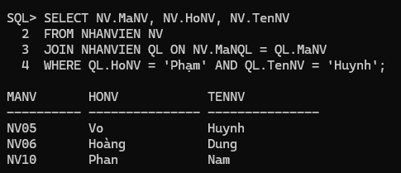
SQL> SELECT NV.MaNV, NV.HoNV, NV.TenNV
2 FROM NHANVIEN NV
3 WHERE NOT EXISTS (
4 SELECT MaDA
5 FROM DEAN
6 WHERE NOT EXISTS (
7 SELECT *
8 FROM PHANCONG PC
9 WHERE PC.MaNV = NV.MaNV AND PC.MaDA = DEAN.MaDA
10 )
11 );

MANV HONV TENNV
---------- --------------- ---------------
NV01 Nguy?n An
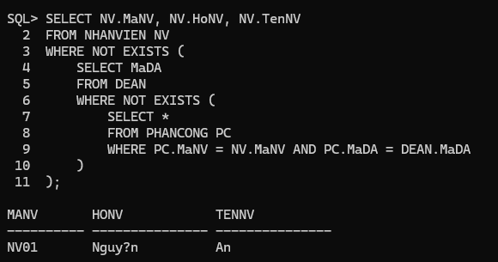
SQL> SELECT NV.MaNV, NV.HoNV, NV.TenNV
2 FROM NHANVIEN NV
3 WHERE NOT EXISTS (
4 SELECT *
5 FROM PHANCONG PC
6 WHERE PC.MaNV = NV.MaNV
7 );

MANV HONV TENNV
---------- --------------- ---------------
NV08 D?ng Long
NV09 Bùi Lan
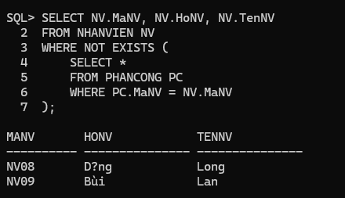
SQL> SELECT NV.MaNV, NV.HoNV, NV.TenNV
2 FROM NHANVIEN NV
3 LEFT JOIN PHANCONG PC ON NV.MaNV = PC.MaNV
4 WHERE PC.MaNV IS NULL;

MANV HONV TENNV
---------- --------------- ---------------
NV08 D?ng Long
NV09 Bùi Lan
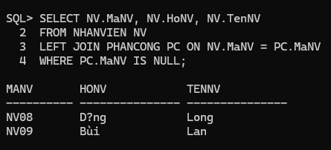
SQL> SELECT AVG(Luong) AS LuongTrungBinh
2 FROM NHANVIEN;

LUONGTRUNGBINH
--------------
5885000
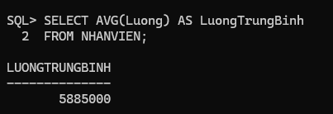
SQL> SELECT AVG(Luong) AS LuongTrungBinhNam
2 FROM NHANVIEN
3 WHERE Phai = 'Nam';

LUONGTRUNGBINHNAM
-----------------
6741666.67
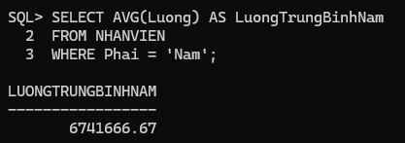
SQL> SELECT COUNT(*) AS TongSoDeAn
2 FROM DEAN;

TONGSODEAN
----------
4
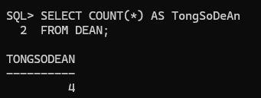
SQL> SELECT DA.MaDA, DA.TenDA, COUNT(PC.MaNV) AS SoNhanVien
2 FROM DEAN DA
3 LEFT JOIN PHANCONG PC ON DA.MaDA = PC.MaDA
4 GROUP BY DA.MaDA, DA.TenDA;

MADA TENDA SONHANVIEN
---------- -------------------- ----------
DA04 D? án D 2
DA03 D? án C 4
DA02 D? án B 5
DA01 D? án A 4
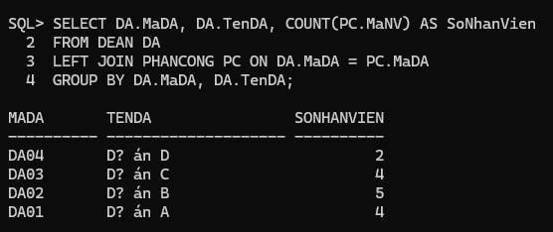
SQL> SELECT DA.MaDA, DA.TenDA, COUNT(NV.MaNV) AS SoNhanVienNu
2 FROM DEAN DA
3 LEFT JOIN PHANCONG PC ON DA.MaDA = PC.MaDA
4 LEFT JOIN NHANVIEN NV ON PC.MaNV = NV.MaNV AND NV.Phai = 'Nữ'
5
SQL> GROUP BY DA.MaDA, DA.TenDA;
SP2-0734: unknown command beginning "GROUP BY D..." - rest of line ignored.
SQL> SELECT DA.MaDA, DA.TenDA, COUNT(NV.MaNV) AS SoNhanVienNu
2 FROM DEAN DA
3 LEFT JOIN PHANCONG PC ON DA.MaDA = PC.MaDA
4 LEFT JOIN NHANVIEN NV ON PC.MaNV = NV.MaNV AND NV.Phai = 'Nữ'
5 GROUP BY DA.MaDA, DA.TenDA;

MADA TENDA SONHANVIENNU
---------- -------------------- ------------
DA04 D? án D 1
DA03 D? án C 2
DA02 D? án B 1
DA01 D? án A 1
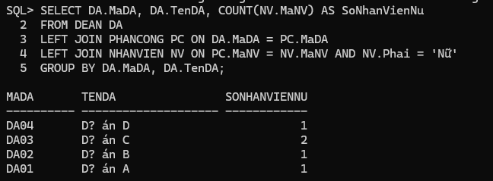
SQL> UPDATE PHANCONG
2 SET ThoiGian = ThoiGian + 4
3 WHERE MaNV IN (
4 SELECT MaNV
5 FROM NHANVIEN
6 WHERE Phai = 'Nam'
7 );

10 rows updated.
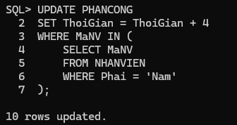
SQL> DELETE FROM NHANVIEN
2 WHERE Luong < 500000;

2 rows deleted.

SQL>
