**Deriving ontologies from OPC UA Standards(Specifications)**

**1. Introduction**

**1. OPC Unified Architecture**

**1.1 General Description[1]**

**OPC Unified Architecture** (shortly, OPC UA) is a platform-independent standard through which various kinds of systems and devices can communicate by sending Messages between Clients and Servers over various types of networks. OPC UA defines a common infrastructure model to facilitate this information exchange.

OPC UA is applicable to manufacturing software in application areas such as Field Devices, Control Systems, Manufacturing Execution Systems and Enterprise Resource Planning Systems. These systems are intended to exchange information and to use command and control for industrial processes.

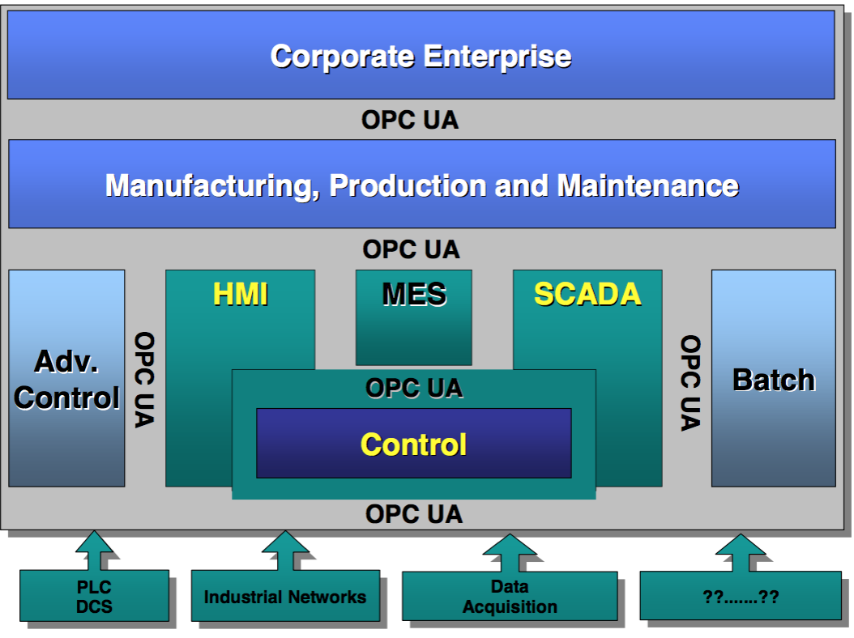  
OPC UA Target applications

**2. OPC UA specifications**

The OPC UA specifications are layered to isolate the core design from the underlying computing technology and network transport. This allows OPC UA to be mapped to future technologies as necessary, without negating the basic design. Two data encodings are defined:

* XML/text
* UA Binary

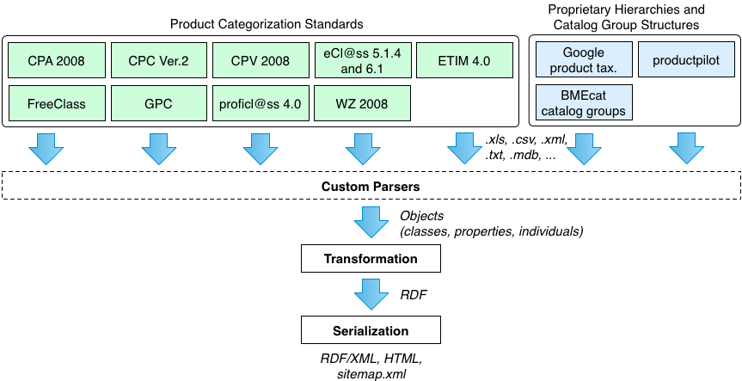

In this project, OPC UA Standard would be parsed by the Custom Parser. *(image needs to be changed)*

**1. Parse**

To parse the schema into objects which are consist of classes, properties and individuals.

**1.1 OPC Unified Architecture**

**1.1.1 OPC UA Data Model**

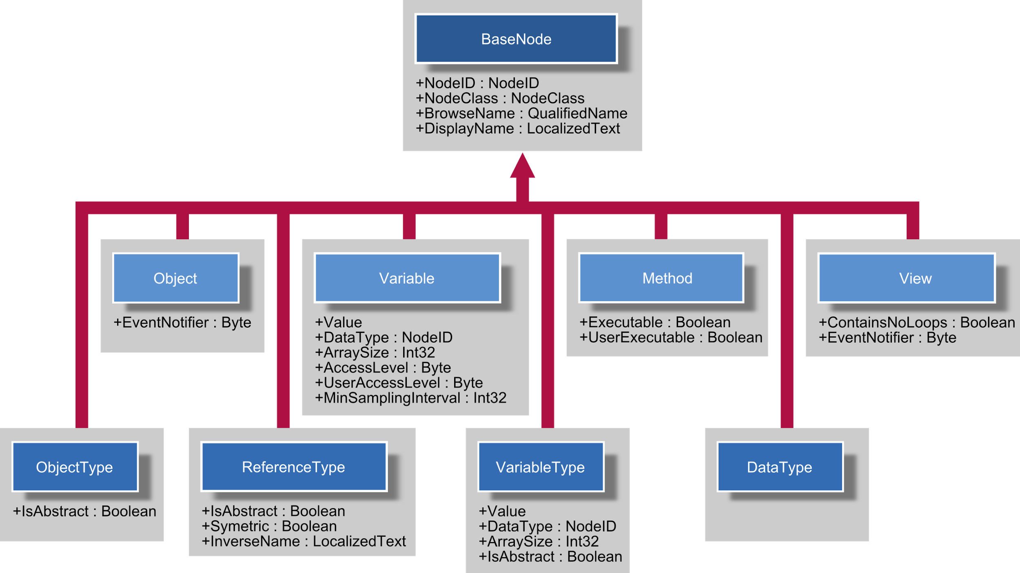

**1.1.2 OPC UA specifications**

The OPC UA Specification is a multi-part specification and consists of the following parts:

* Core Specifications
* Access Type Specifications
* Utility Type Specifications

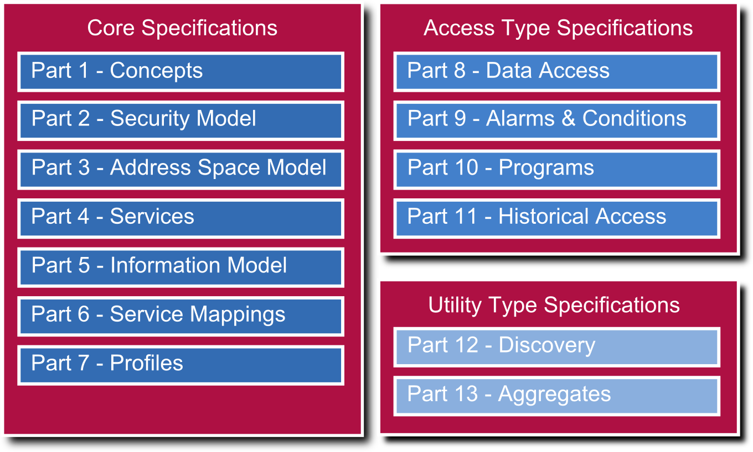

In particular, there are the following parts:

* Concepts
* Security Model
* **Address Space Model**
* **Services**
* **Information Model**
* Service Mappings
* Profiles
* **Data Access**
* Alarms and Conditions
* **Programs**
* **Historical Access**
* Discovery
* Aggregates

**1.2 Parsing Rule**

Need to be developed - by analyzing all the specifications.

**2. Transformation**

**2.1 Transformation of a Product Classification System**

Creation of the classes in the resulting ontology based on the source OPC UA being processed. To create the ontology classes, the tool relies on the **GenTax approach\***, whereby it is possible to generate a consistent OWL ontology while preserving the taxonomic structure of the original categories in the OPC UA. In order to do so, the GenTax method creates two OWL classes in the target ontology from each category in the OPC UA. The first is a broader taxonomic class that represents the category from the OPC UA in the target ontology. The second is a context-specific class, in our case in the domain of products and services.

* GenTax approach  
 (http://www.heppnetz.de/files/hepp-de-bruijn-ESWC2007-gentax-CRC.pdf)

**2.2 Converting Property Types and Related Values**

converts features and feature values of PCS, thus contributing additional semantics to categories.

Custom rules and heuristics guide the distinction of the property types and related values. They have to be provided as part of the parser modules in order they can be applied in the subsequent transformation step where respective OWL properties are generated automatically.

Thus, the quality of the conversion strongly depends on the correctness of these logics: As a general rule of thumb, a numerical value accompanied by a unit code in the classification system yields a quantitative value in the resulting product ontology, and not a qualitative value or a datatype literal.

**3. Serialization**

The product classes and related entities in the ontologies obey a common URI pattern, which is comprised of (1) the base URI of the ontology; (2) a prefix to help humans distinguish URIs of different entity types, namely C for classes, P for properties, and V for values; (3) an identifier unique in the context of the category system, that for categories is typically the hierarchy code; and, for classes, (4) a suffix to distinguish generic (-gen) from taxonomic (-tax) classes.

Generates a single comprehensive dump of the RDF graph, which is serialized as RDF/XML

**References**

[1] PCS2OW: <http://wiki.goodrelations-vocabulary.org/Tools/PCS2OWL>

RDF : Resource Description FrameworkSPARQL: Semantic query language for databasesOWL 2.0: Web Ontology LanguageRDFS: Schema provides a data-modelling vocabulary for RDF data

1. OPC UA Specifications: Part 1: Overview and Concepts <http://www.opcfoundation.org/UA/Part1/>