Software Requirements Specifications Document

From Standards to Ontologies - A Web-based tool to semantify/ontologize the knowledge of a standards with semantic technologies

Team:
Aleksandr Korovin
Shinho Kang
Alexey Karpov
Omar Gutiérrez

Supervisor
Irlán Grangel

Project overview

Description

Industry 4.0 (i4.0) is a term to describe contemporary automation, data exchange and manufacturing technologies. Under this concept we can find the term Machine to Machine (M2M) which refers to the communication between devices using an specific communication channel. One of the protocols created to implement M2M interoperability is OPC Unified Architecture (OPC UA)

A web tool will be developed to read and analyze OPC UA standard specification documents, these will be imported and the system will provide the functionality of parsing to create a vocabulary allowing the user the edition of this vocabulary.

The development is intended to be done using web technologies such as Node.js, Express, React.js, Bootstrap etc.

Software requirements

Requirements | Description | Priority
Functional

Translation of OPC UA Schema files into OWL vocabularies/ontologies | Load and read OPC UA Schema files and translate it into OWL vocabularies/ontologies.  The load of the file could be done specifying the URL of the file or directly uploading the file. | Very high
Visualization of ontologies | The translated file will be visualized graphically in a form of graph/tree | High
Edition of vocabularies/ontologies | Once it has been obtained the ontology the user will be able to modify and update it using a visual editor | High
Management and storage of vocabularies | The user will be able to store and handle the vocabularies, having functionalities such as save, delete, save as, etc. | High
Identify Malformed XML files | The system will be able to detect XML files that not comply with the OPC UA Schema and alert the user about it | Low
SPARQL queries support | The system will be able to execute SPARQL queries on the vocabularies/ontologies. | Very low
Non-functional

Handle different format files | Manage different format files:  - RDF/XML (.xml)  - Turtle (.ttl)  - JSON-LD (.jsonld)  - RDF-JSON (.rj)  - OWL (.owl, .owx, .rdf)  - N-Triples (.nt)  - N-Quads (.nq)  - Notation3 (.n3) | Medium
Handle files with a large number of triples | The system will be able to load large OPC UA Schema files, that is, those files with large number of triples and efficiently handle and visualize them keeping a constant time performance. | Medium
Responsive interface | The system will be able to be visualized in different devices such as smart-phones, tablets and computers | Low

Use cases

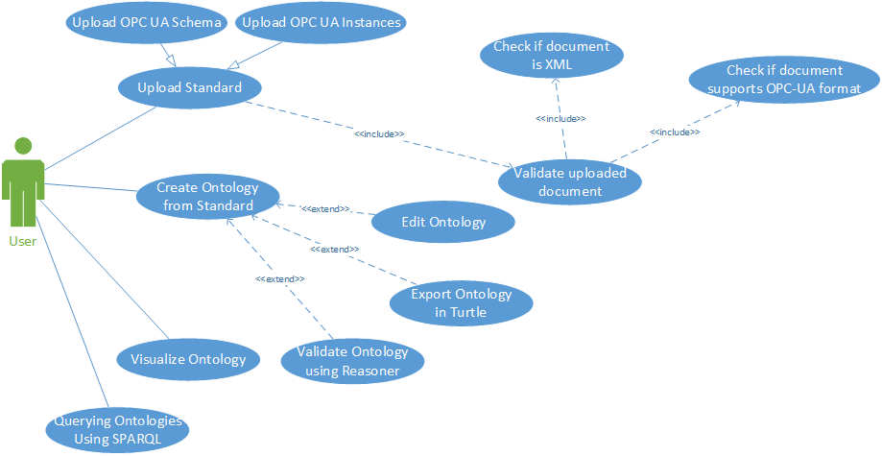

Use case templates

Title | Create Ontology
ID | UC1
Description | Create an ontology file. There are sub-tasks as editing and exporting.
Precondition | The user is logged into the system
Postcondition | A personalized ontology is obtained
Main course | - The system shows an interface with the graph of the ontology.  - The user modify the ontology with help of an editor.  - The user press the button “Save” to store the ontology.  - The system validates the ontology.  - The ontology is saved.
Alternate course (a) | - The system shows an interface with the graph of the ontology.  - The user modify the ontology with help of an editor.  - The user press the button “Save” to store the ontology.  - The system validates the ontology.  - The system shows the next error message to the user: “The ontology is not valid”.
Alternate course (b) | - The system shows an interface with the graph of the ontology.  - The user chooses a format.  - The user press the button “Export”.  - The system exports the ontology to the format that the user chose.

Title | Upload Standard
ID | UC2
Description | Upload OPC UA Schema or OPC UA instance files to the system.
Precondition | The user is logged into the system
Postcondition | A graph visualizing the ontology is obtained
Main course | - User selects the option “Upload OPC UA Schema” or “Upload OPC UA Instance” from the interface.  - The system validates the uploaded document and create an ontology from the Standard file  - The system shows an interface with the graph of the correspondent ontology
Alternate course | - User selects the option “Upload OPC UA Schema” or “Upload OPC UA Instance” from the interface.  - The system validates the uploaded file and shows an error message to the user stating that the file is not a valid schema file.

Title | Query Ontology
ID | UC3
Description | Execute SPARQL queries on the vocabularies stored in the system.
Precondition | The user is logged into the system
Postcondition | The system returns the result in form of queries
Main course | - The system shows an interface with a text box giving the user the possibility to introduce SPARQL queries  - The user writes the SPARQL query and press the button “Execute”  - The system executes the query  - The system returns the result in form of triples
Alternate course | - The system shows an interface with a text box giving the user the possibility to introduce SPARQL queries  - The user writes the SPARQL query and press the button “Execute”  - The system executes the query  - The system shows the next error “the query is not valid”

