<Parking Simulator>

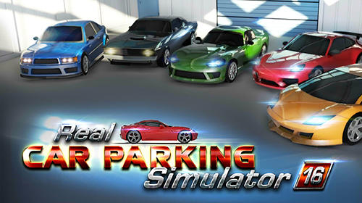

Revision: 0.0.0

GDD Template Written by: Benjamin “HeadClot” Stanley

Special thanks to Alec Markarian

Otherwise this would not have happened

License

If you use this in any of your games. Give credit in the GDD (this document) to Alec Markarian and Benjamin Stanley. We did work so you don’t have to.

Feel free to Modify, redistribute but **not sell** this document.

TL;DR - Keep the credits section of this document intact and we are good and do not sell it.

Overview

Theme / Setting / Genre

Core Gameplay Mechanics Brief

Targeted platforms

Monetization model (Brief/Document)

Project Scope

Influences (Brief)

- <Influence #1>

- <Influence #2>

- <Influence #3>

- <Influence #4>

The elevator Pitch

Project Description (Brief):

Project Description (Detailed)

What sets this project apart?

Core Gameplay Mechanics (Detailed)

- <Core Gameplay Mechanic #1>

- <Core Gameplay Mechanic #2>

- <Core Gameplay Mechanic #3>

- <Core Gameplay Mechanic #4>

Story and Gameplay

Story (Brief)

Story (Detailed)

Gameplay (Brief)

Gameplay (Detailed)

Assets Needed

- 2D

- 3D

- Sound

- Code

- Animation

Schedule

- <Object #1>

- <Object #2>

- <Object #3>

- <Object #4>

# Overview

## Theme / Setting / Genre

- <Parking/Cars>

## Core Gameplay Mechanics Brief

- <use arrow keys to choose direction>

- <Park car in correct spot without hitting any obstacles>

- <Gameplay Mechanic #3>

- <Gameplay Mechanic #4>

## Targeted platforms

- All Ages

- People that are interested in learning how to drive, it could help them  
 - People that are bored and want to play a fun, free game

## Monetization model (Brief/Document)

- <Monetization Type> Alpha

## Project Scope

- <Game Time Scale>

- $0 (How much will it cost?)

- Approx. 2 Months

- <Team Size>

Only me working on project

- <Licenses / Hardware / Other Costs>

No Costs

- <Total Costs with breakdown>

$0

## The elevator Pitch

<My game is a simple parking simulator, using the arrow keys for direction and have objectives that you can do as a bonus.You will be able to upgrade cars the further you go in the game (by beating a level)>

## Project Description (Brief):

Start off with simple cars and simple levels and as you beat the levels by parking in the correct spot and collecting upgrades you will progress in levels. The levels will get harder and you will earn more points to upgrade your car. If you crash the level will restart and you will have to go back to the beginning.

There will also be a time limit, starting at 1 minute each round you will be able to collect power ups that reset the times. If time runs out the game will reset you back at the beginning and you will have to restart.

## 

## Project Description (Detailed)

Start off with very simple cars and as you progress you get cars such as police cars, rolls royce, tank etc. To unlock these cars you will have to be many levels and collect as many () as you can. You can unlock up to 15 cars, and play up to 50 levels. The levels get harder and harder each time.

# 

# 

# 

# Story and Gameplay

## Story (Brief)

Park in the correct spots, progress in levels and upgrade cars; don’t crash or run out of time

## Gameplay (Brief)

<The Summary version of below>

## Gameplay (Detailed)

<Go into as much detail as needs be>

<Spare no detail>

<Combine this with the game mechanics section above>

# 

## - Animation

- Environment Animations

- Pylons, Parking lines, (coins), random obstacles

- etc.

# Schedule

### - <Object #1>

-Finish by due date