My article

Bonnie McLean

2021-04-07

# Introduction

Cite articles like this (Johansson et al. 2020), or like this: Johansson et al. (2020) found that blah di blah. Where @johansson_typology_2020 is the name of the bibtex entry in your file references.bib, where you have all your articles that you are citing in bibtex format.

Cross-referencing is done like this: See section 2.1 for a discussion of the materials. See Figure 1 for a plot of some cars.

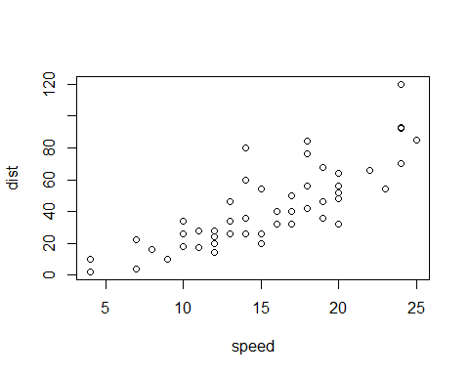

Figure 1: A plot of some cars.

See table 1 for some stuff about cars.

Table 1: Table about cars

|  |  |  |  |  |  |
| --- | --- | --- | --- | --- | --- |
|  | mpg | cyl | disp | hp | drat |
| Mazda RX4 | 21.0 | 6 | 160 | 110 | 3.90 |
| Mazda RX4 Wag | 21.0 | 6 | 160 | 110 | 3.90 |
| Datsun 710 | 22.8 | 4 | 108 | 93 | 3.85 |
| Hornet 4 Drive | 21.4 | 6 | 258 | 110 | 3.08 |
| Hornet Sportabout | 18.7 | 8 | 360 | 175 | 3.15 |

Blah blah blah

# Method

## Materials

## Participants

## Procedure

# Results

# Discussion

# Conclusion

# References

Johansson, Niklas Erben, Andrey Anikin, Gerd Carling, and Arthur Holmer. 2020. “The Typology of Sound Symbolism: Defining Macro-Concepts via Their Semantic and Phonetic Features.” *Linguistic Typology* -1 (ahead-of-print). <https://doi.org/10.1515/lingty-2020-2034>.