Technical Specification Document

Interface : : Common Interface for Mail Alerts
Contents

Business Context 1
Stakeholders 1
GO-Live 1
Solution Design 1
Implementation & Configuration 2
Sample mail 2
Configurations 3

Business Context
This Interface is used to give the mail alerts to the business if any of the interfaces failed.

Stakeholders

Role | System | Contact
SAP CPI | Integration Lead | Surekha Genji  surekha.genji@motiveminds.com

GO-Live
December 8th, 2025

Solution Design

Below is the flow for this specific Integration.

Flow in which exception raised(ProcessDirect) -->SAP CI -->Mail system.
Package: CPI Common details for Integrations
Flow: Common Interface for Mail Alerts
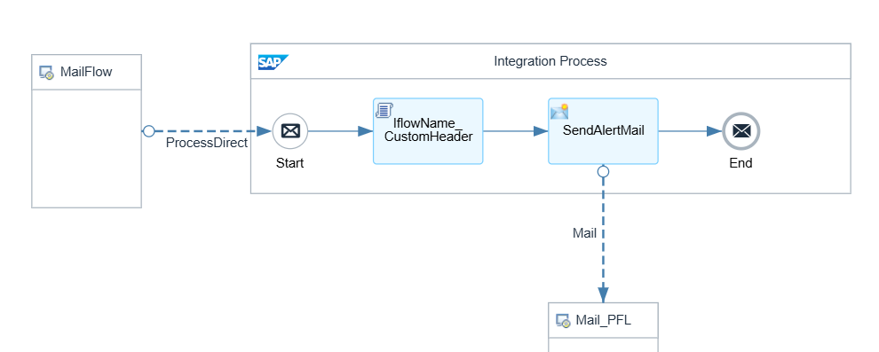

Implementation & Configuration

- MailFlow: If any of the other interfaces fail then the trigger is coming from that interface to this interface via processdirect adapter.
- IflowName_CustomHeader(Groovy script – MPLCustomHeader): To give the failed iflow name as a monitoring custom header.
- SendAlertMail(Request reply): Accessing the mail receiver system to give the alert mail to the business.

Sample mail
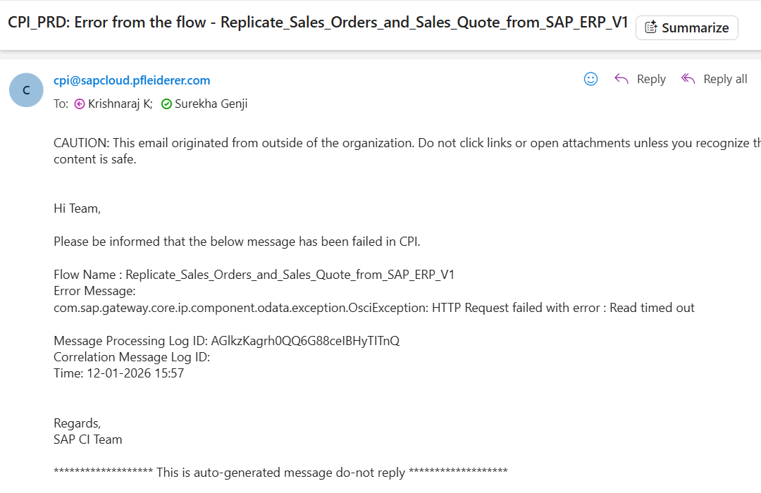

Configurations
Sender :
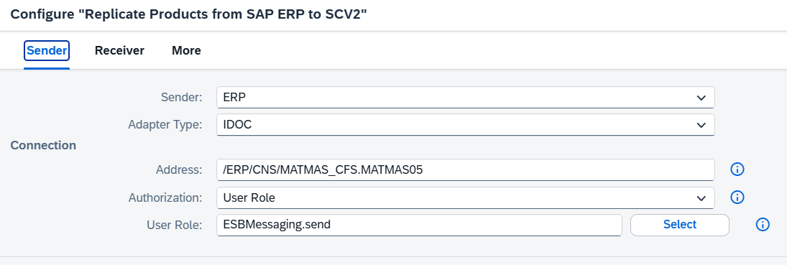
Receivers :
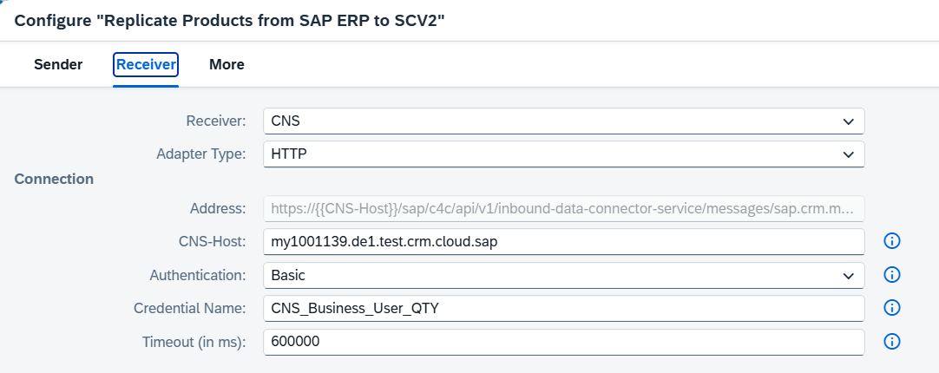
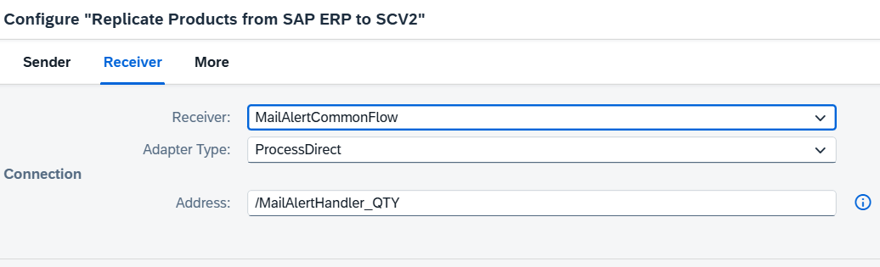

More :
