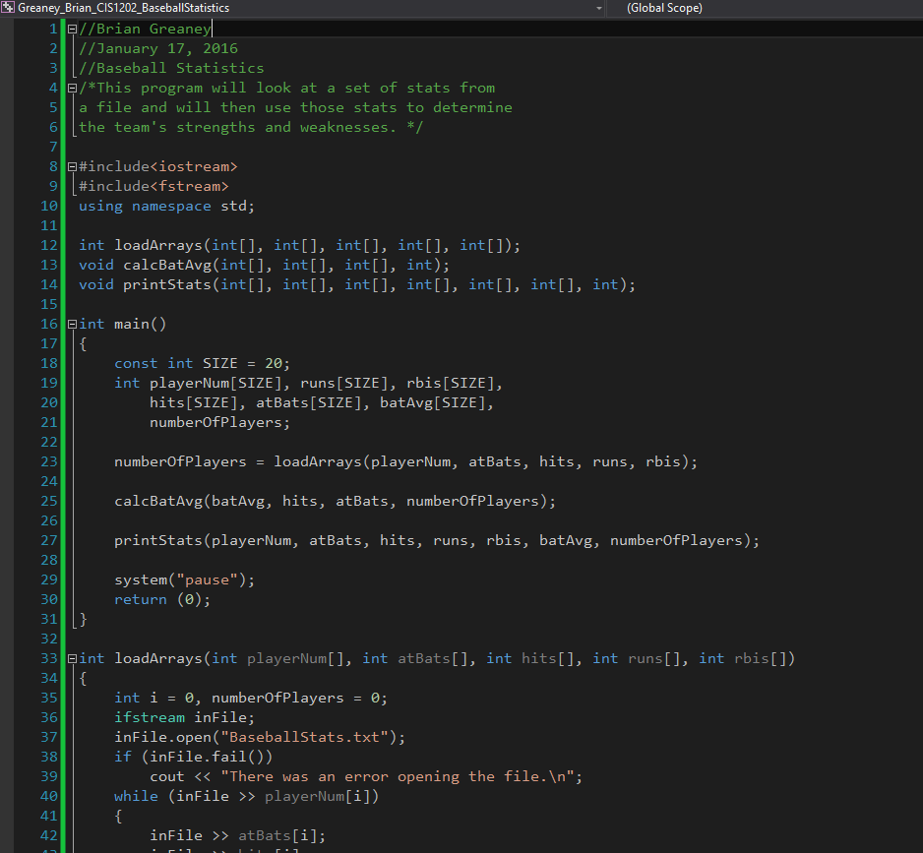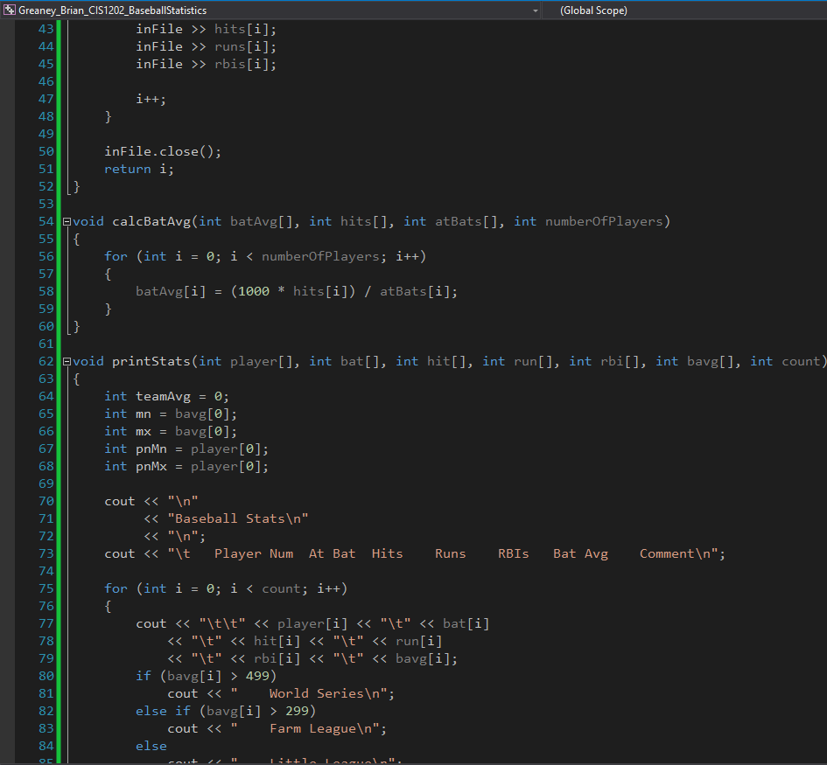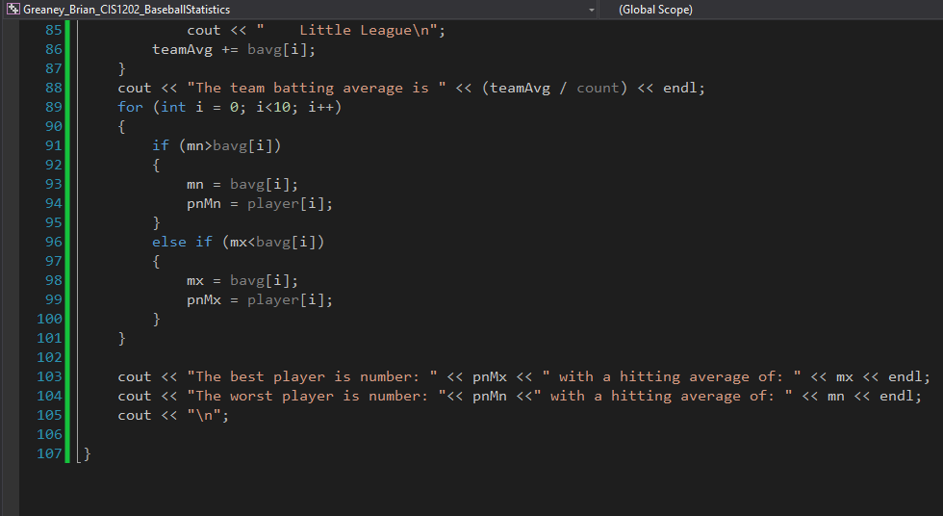

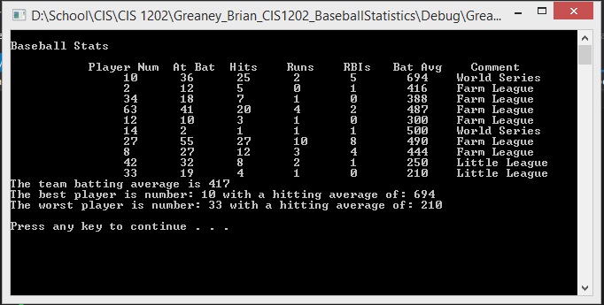

I’d like to say it’s perfect, but some of my numbers are just one off from the sample output included in the instructions. Figure something went screwy with the integer division. It’s been a whole semester plus since I took CIS 1111 with you and it took a whole lot of reading and review on my part to get this working. Hopefully it’ll all come spilling back to me after then next few lectures.