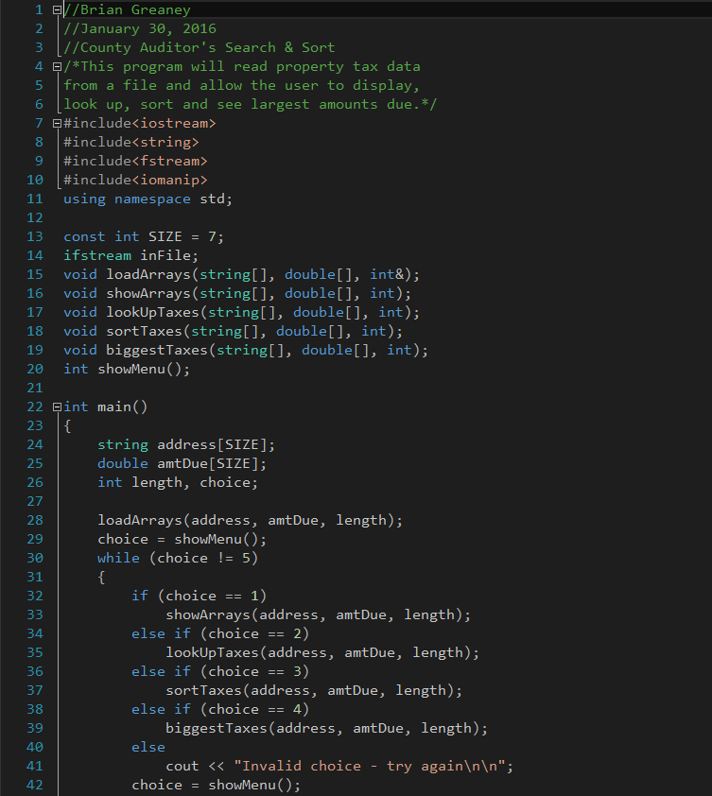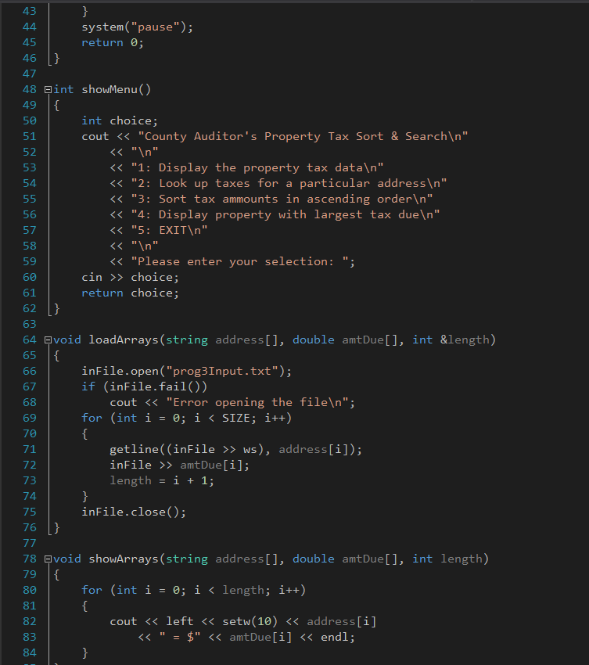

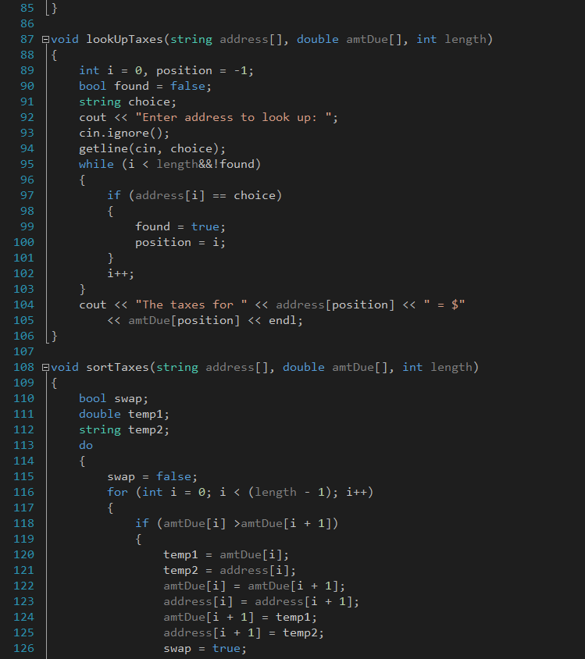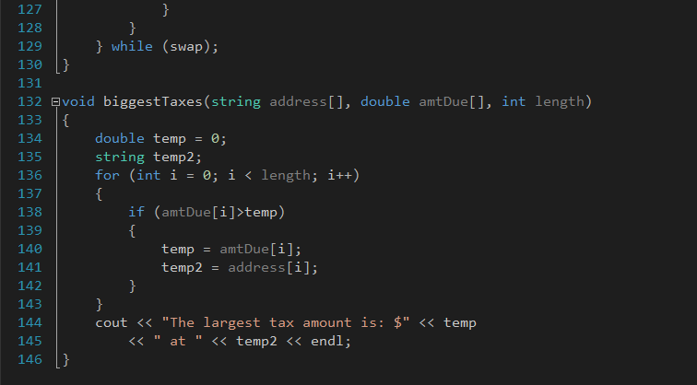



A very strange thing occurred with this one. I originally wrote this and got it working in xCode on my Mac. When bringing the cpp over to Visual Studio I had some very odd things happen.

In xCode, in my loadArrays function, I had to use ‘getline((inFile>>ws), address[i], ‘\r’)’ to get the strings and doubles loaded properly. For some reason unknown to me, I had to drop the ‘\r’ to get it to work right in Visual Studio.

My question is why in the world would the two compilers compile so differently? Isn’t the language universal?

Very odd…..