InventoryClass.h  
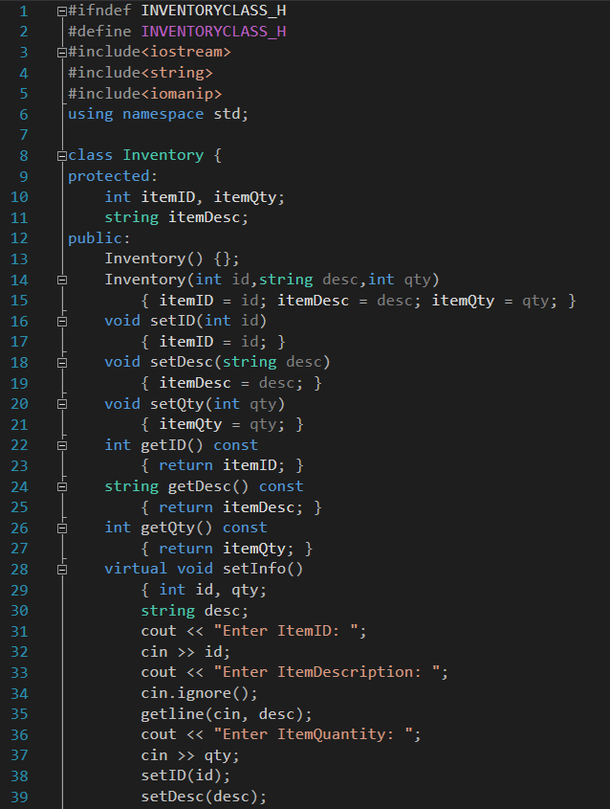  
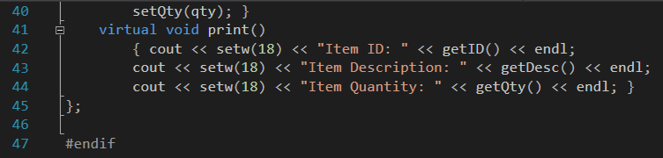  
InventoryCostClass.h  
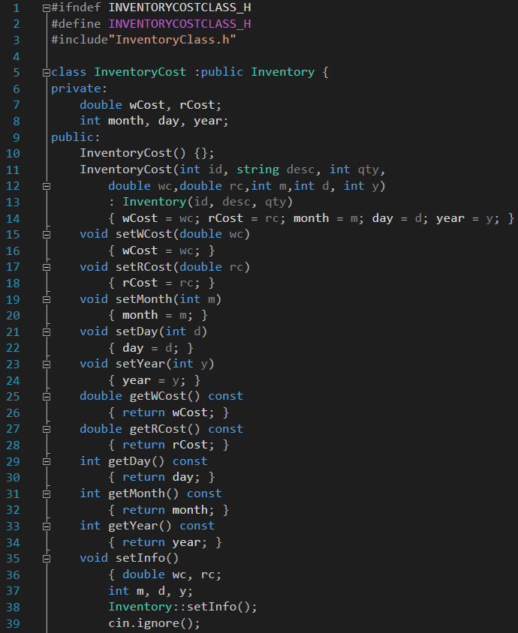

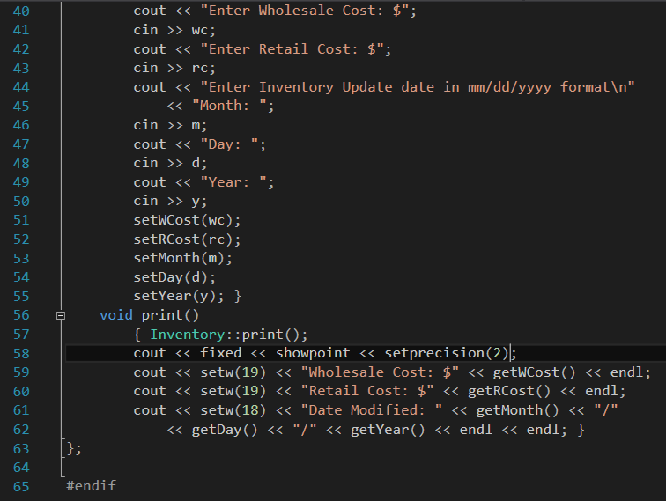  
Main.cpp  
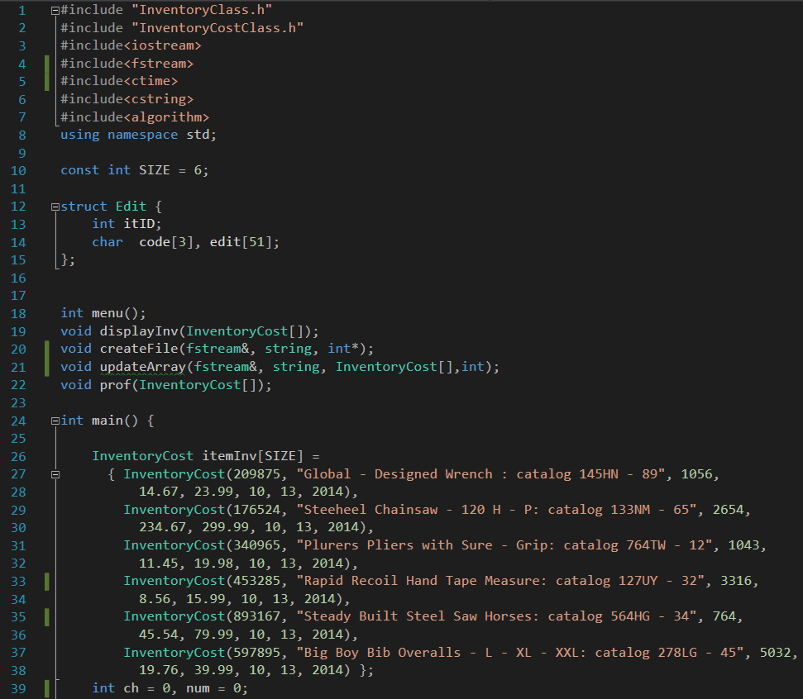

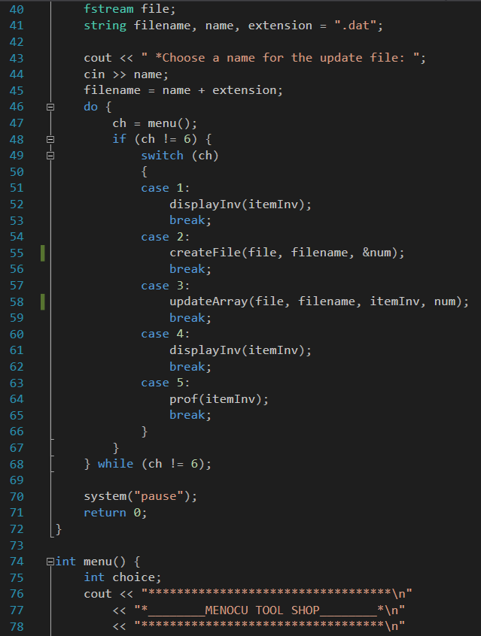  
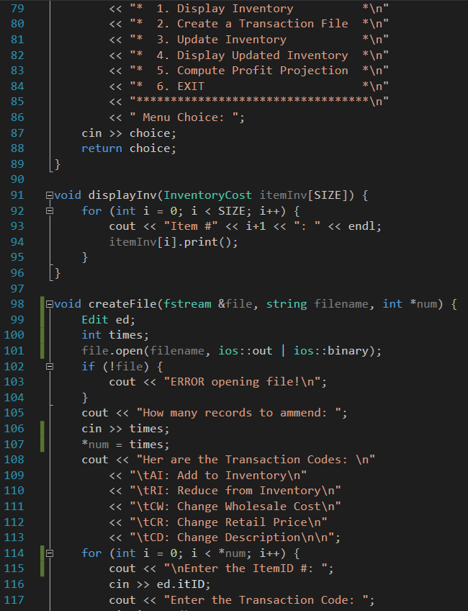

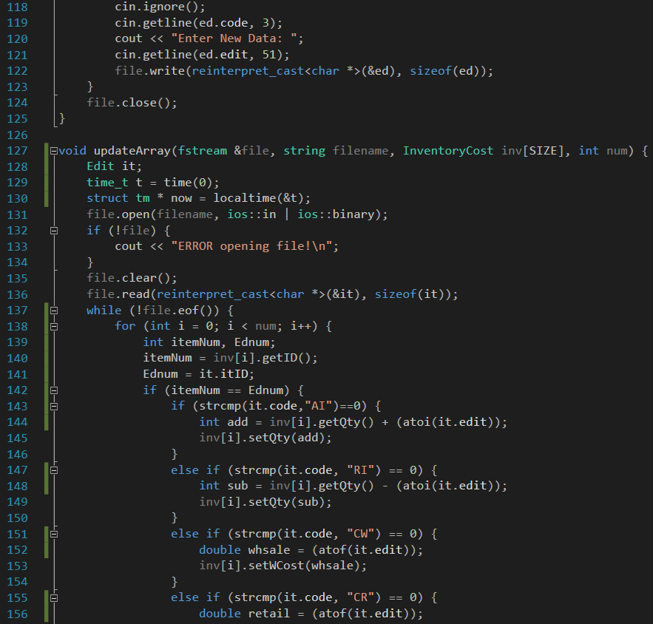  
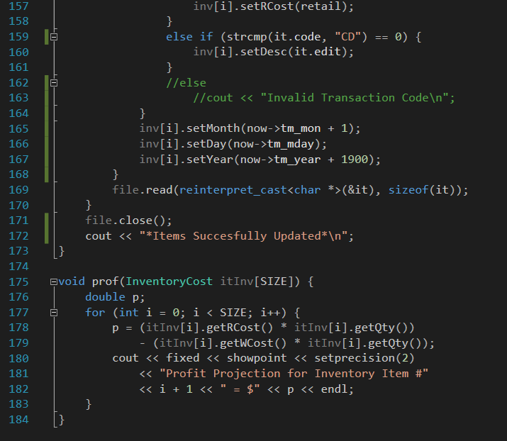

*special note*

To get this to compile using M$ Visual Studio I had to

Go to VS context menu Project>Properties.

Click Configuration>Properties>C/C++>Preprocessor.

Edit Preprocessor Definitions and add _CRT_SECURE_NO_WARNINGS last empty line.

Apparently M$ does not like ‘localtime’ it told me to use ‘localtime_s’ instead but this ran fine and dandy in Xcode.

Console Output  
