 BONS REALTY  TRUSTED LOCAL GUIDANCE | LISTING PACKET · HOMEOWNER RESOURCE  Property Improvement Brief

HEATING & COOLING · EDUCATIONAL OVERVIEW
Potential HVAC Upgrade Option for This Home
Efficient whole-home heating and cooling — without existing ductwork.
— Considering Central Air?
Homes without existing ductwork can be difficult and costly to fit for traditional central air. A ductless mini-split system may offer an alternative worth exploring. A mini-split pairs one compact outdoor unit with one or more slim indoor units, delivering both heating and cooling year-round. Because refrigerant lines run through a small opening rather than bulky ducts, no existing ductwork is required—which can make it a practical consideration for older homes. Whether it is the right fit here depends on the property and should be confirmed by a licensed contractor.

 No Existing Ductwork Needed Installs where ducts don’t exist or aren’t practical. |  Minimal Disruption Typically installed in a day or two with little demolition.
 Energy Efficient Inverter heat-pump technology can lower energy use. |  Quiet Operation Indoor units run softly—often near a whisper.
 Individual Room Control Set each zone’s temperature independently. |  Great Retrofit for Ranch Homes Often an excellent fit for older single-story layouts.

  OUTDOOR CONDENSER | 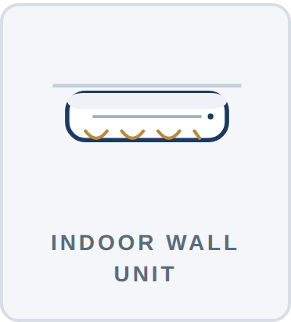  INDOOR WALL UNIT | 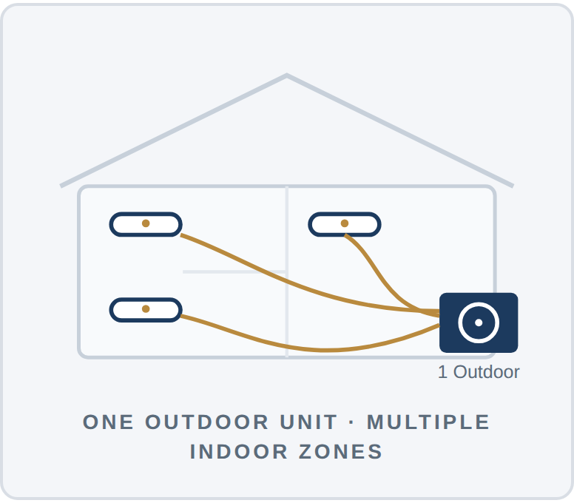  ONE OUTDOOR UNIT · MULTIPLE INDOOR ZONES
— Typical Installed Costs — Chicago Area
CONFIGURATION | WHAT IT COMMONLY SERVES | TYPICAL INSTALLED RANGE
Single Zone | One room or open area — e.g., a primary bedroom or living room | $2,500 – $7,000
Three Zones | Several rooms on one system — common for a small home or main level | $7,000 – $12,000
Four Zones | Whole-home coverage across four separate areas | $9,000 – $18,000
Pricing varies with equipment brand, efficiency (SEER2), line-set length, electrical work, permits, and site conditions. Figures are general estimates for illustration only, not a quote.
— Popular Manufacturers
  Mitsubishi Electric  mitsubishicomfort.com |   Daikin  daikincomfort.com |   Fujitsu (AIRSTAGE)  fujitsugeneral.com/us |   LG  lg.com/us/residential-hvac
Scan a code (or click a link) to explore each manufacturer’s official ductless line-up. Listed alphabetically by category; not an endorsement.

IMPORTANT DISCLAIMER
This information is provided solely for general educational purposes to illustrate one potential HVAC upgrade option. Bons Realty and its agents are not licensed HVAC contractors and make no representation or warranty regarding suitability, installation feasibility, costs, savings, permits, or code compliance. Buyers should obtain an independent evaluation and written estimate from a qualified, licensed HVAC contractor.

SOURCES & REFERENCES
1. U.S. Dept. of Energy, “Ductless Mini-Split Heat Pumps,” energy.gov — system operation, efficiency, and zoning. | 2. EnergySage, “How Much Does a Mini-Split Cost?” (2025) — single-zone installed-cost ranges.
3. HomeGuide & Angi mini-split cost guides (2025–2026) — multi-zone installed-cost ranges. | 4. Carrier / manufacturer cost guides — per-zone pricing and installation factors.
5. Manufacturer sites: mitsubishicomfort.com, daikincomfort.com, fujitsugeneral.com, lg.com. | 6. ENERGY STAR, “Ductless Heating & Cooling,” energystar.gov — efficiency & comfort benefits.

BONS REALTY · sean@bonsrealty.com | Educational homeowner resource · Not an offer, appraisal, or contractor estimate · Rev. 2026

