STANDARD OPERATING PROCEDURES (SOPs)
African Foods Company (Ltd)
XITM5229 – Task 2
Student: Bontle Lindiwe Maloka
Student Number: ST10486239
Academic Year: 2026

1. Introduction
African Foods Company (Ltd) (AFC) markets and exports South African food products to customers living overseas. The company has two branches, with its head office in Cape Town and a branch in Durban. Because the business depends on computers, network connectivity, a database server, Sage ERP Payroll, Microsoft Office 365 and its customer-facing website, clear Standard Operating Procedures (SOPs) are important for keeping the business secure, available and consistent.
The purpose of this report is to provide practical IT procedures that fit the AFC scenario. The procedures cover the IT department structure, information security, acceptable use, technology acquisition, service desk support and disaster recovery. The recommendations are written for a small organisation and are designed to be understandable to ordinary employees, not only IT specialists.

2. Reasons for Standard Operating Procedures (SOPs)
SOPs give employees a consistent way of performing important tasks. At AFC, this is especially important because the company operates from two locations and uses shared technology, a central database server and online services. Without clear procedures, employees may respond differently to the same problem, security controls may be missed and an IT incident may take longer to resolve.
- Consistency: Employees follow the same approved process when handling IT equipment, information and support requests.
- Security: Security rules reduce the chance of weak passwords, unauthorised access, malware infections and accidental disclosure of company information.
- Accountability: SOPs identify who is responsible for approving, performing and recording an activity.
- Faster support: A service desk procedure gives staff a clear route for reporting problems and allows IT staff to prioritise incidents.
- Business continuity: Recovery procedures help AFC restore systems and continue important operations after a failure or cyber incident.
- Cost control: Acquisition and approval procedures reduce unnecessary purchases and help the company select suitable technology.
- Training: New employees can use the SOPs as a practical guide instead of depending only on informal instructions.
- Compliance and good governance: Documented procedures provide evidence that the organisation has considered risks and has defined controls.
These reasons are consistent with recognised cybersecurity practice. NIST describes cybersecurity risk management as a process for identifying, protecting, detecting, responding to and recovering from risks and incidents (Pascoe, Quinn and Scarfone, 2024).

3. IT Department Staff Structure and Reporting Lines
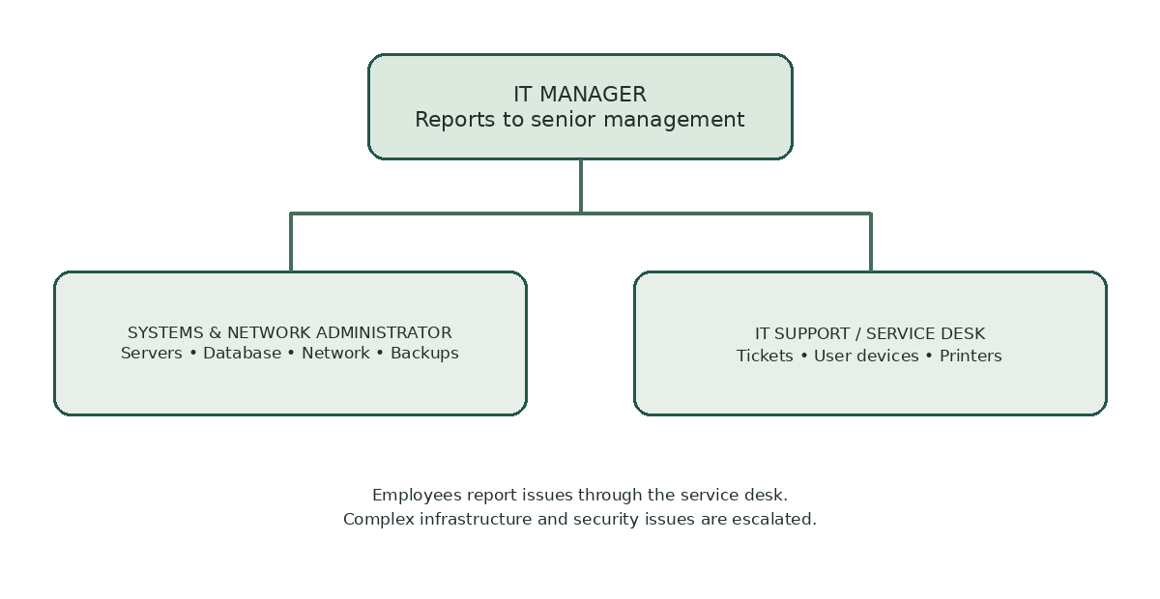
Figure 1: Proposed IT department structure and reporting lines for AFC.
The scenario does not specify the number of IT employees. The following structure is therefore a proposed IT department for AFC. It is intentionally small so that it is realistic for an organisation with two sites. The IT Manager has overall responsibility and assigns technical work to the appropriate staff member.
IT MANAGER
Overall IT governance, budget, security, suppliers and approvals
│
├── Systems & Network Administrator
│ Networks, database/server support, backups, Microsoft 365 and endpoint management
│
└── IT Support / Service Desk Technician
First-line support, tickets, user accounts, devices, printers and basic troubleshooting

- IT Manager → reports to senior management/operations management and provides IT performance and risk reports.
- Systems & Network Administrator → reports to the IT Manager and handles infrastructure, servers, networking, backups and system administration.
- IT Support / Service Desk Technician → reports to the IT Manager, with technical escalation to the Systems & Network Administrator.
- All employees → report IT problems through the service desk procedure rather than attempting unauthorised repairs.
- The IT Manager approves major technology purchases, access changes, security exceptions and recovery decisions.

3.1 Responsibility and approval matrix
The matrix below clarifies who may perform or approve common IT activities. It is a proposed control for a small two-branch business and should be approved by AFC management before implementation.
Activity | IT Support Technician | Systems & Network Administrator | IT Manager / Management
Log and classify user incidents | Responsible | Consulted / escalation | Informed for major incidents
Create standard user account after approved request | Performs setup | Consulted for technical access | Approves access request or delegates approval
Change server, firewall or network configuration | No independent changes | Performs and documents change | Approves high-risk changes
Approve new IT purchases | Provides requirements | Assesses technical suitability | Approves within delegated budget; management approves high-value spend
Declare major security incident / activate recovery plan | Reports and assists | Investigates and contains technically | Leads decision and management communication
Close routine service ticket | Records fix and user confirmation | Supports escalated cases | Reviews recurring/high-impact incidents

4. IT Security Policy Guidelines
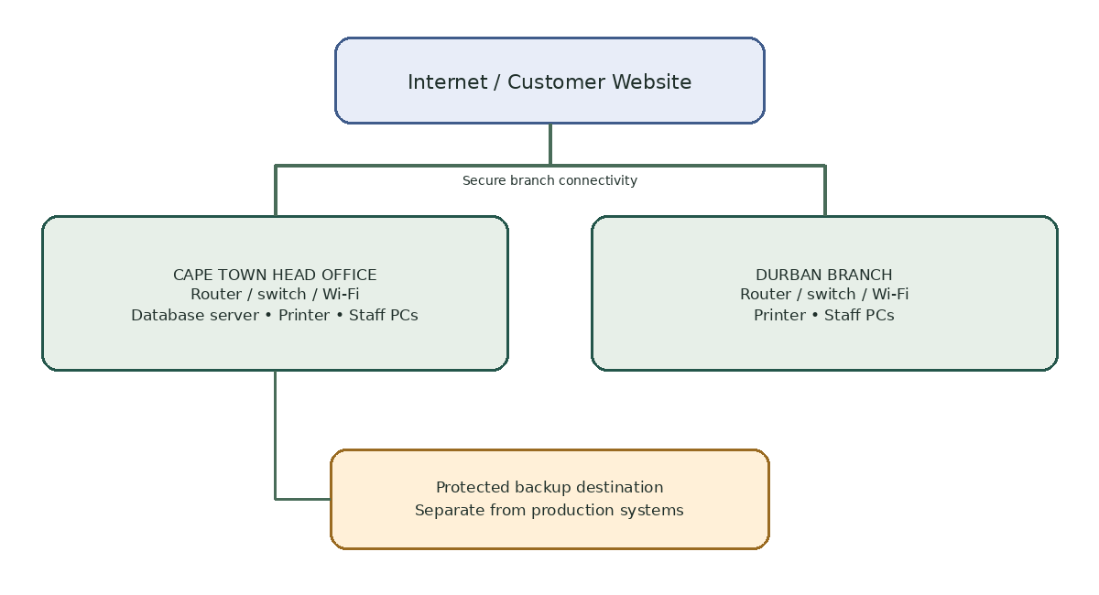
Figure 2: Proposed high-level overview of AFC's two-site IT infrastructure.
The security policy protects AFC's computers, network, database, payroll information, customer information and website. The controls below are based on the principle that users should only have the access required for their jobs. NIST recommends unique accounts, controlled access, strong authentication, protection of sensitive information, regular backups, device protection, patching and staff training (NIST, 2023).
- Every employee must use an individual user account. Shared accounts are not permitted unless specifically approved by the IT Manager.
- Passwords must be unique, difficult to guess and never shared with another employee.
- Multi-factor authentication should be enabled for Microsoft 365, administrator accounts and other services that support it.
- Employees must lock their computers when leaving their work area and must not leave confidential documents unattended.
- Only authorised IT staff may install software, change network settings or modify server/database configurations.
- Windows, Microsoft 365 and approved applications must be kept updated with security patches.
- Anti-malware/endpoint protection must remain enabled on company devices.
- Company information must not be copied to personal email, personal cloud storage or unauthorised USB devices.
- Customer, payroll, financial and employee information must only be accessed by staff who need it for their work.
- Important data must be backed up regularly and backups must be protected from unauthorised access.
- Suspicious emails, malware warnings, lost devices, unusual account activity and possible data leaks must be reported immediately.
- Remote access must use approved secure methods and must not be performed from unsafe public computers.
- IT must maintain an inventory of computers, printers, network equipment, software and important accounts.
- Employees must complete basic security awareness training and follow the company's incident reporting procedure.
- Security incidents must be recorded and escalated. The organisation should contain the incident before attempting normal recovery.

5. Acceptable Use Policy
AFC's technology resources are provided mainly for business purposes. Reasonable personal use may be permitted if it does not interfere with work, create security risks or consume excessive company resources.
- Use company computers, internet access, email and Microsoft 365 mainly for legitimate business activities.
- Do not use AFC systems to access, store or distribute illegal, threatening, discriminatory, abusive or inappropriate content.
- Do not download pirated software, copyrighted material without permission or unapproved applications.
- Do not disable antivirus, firewall, security controls or system updates.
- Do not share passwords, authentication codes or another employee's account.
- Do not attempt to bypass access controls or access files belonging to another employee without authorisation.
- Do not use company systems for fraud, harassment, unauthorised commercial activity or activities that could damage AFC's reputation.
- Use social media responsibly and do not represent personal opinions as official AFC statements unless authorised.
- Do not connect unknown USB drives or other devices to company computers without checking with IT.
- Protect company laptops when travelling; do not leave them unattended in public places or visible in an unattended vehicle.
- Report suspected phishing, lost devices, accidental disclosure and other security incidents to the service desk immediately.
- AFC may monitor use of company systems where permitted by law and company policy for security, support and compliance purposes.

6. Technology Acquisition Procedures and Approvals
AFC should use a controlled purchasing process so that technology is compatible with the existing environment and provides value for money. This is particularly important because both branches use wired and wireless networks, each employee has a computer, each site has a shared printer, and the Cape Town office hosts the database server.
- Step 1 – Identify the need: The employee or department records the business problem and explains why new or replacement technology is required.
- Step 2 – IT assessment: The IT Manager or delegated IT staff member checks compatibility, security, specifications, licensing and support requirements.
- Step 3 – Obtain quotations: For significant purchases, suitable suppliers should be compared on price, warranty, support, delivery time and technical suitability.
- Step 4 – Approval: The relevant department manager and IT Manager approve the request. High-value purchases must follow AFC's financial approval limits.
- Step 5 – Purchase: Only an authorised person places the order with an approved supplier.
- Step 6 – Receive and inspect: IT checks the equipment/software against the order and records serial numbers, licences and warranty details.
- Step 7 – Configure securely: IT installs approved software, applies updates, enables security controls and creates the required user access.
- Step 8 – Asset register: The new device or software is recorded in the IT asset register and assigned to a responsible user/location.
- Step 9 – Handover and training: The employee receives the equipment and basic guidance on secure use.
- Step 10 – Review: The IT Manager reviews major purchases after implementation to confirm that the technology meets the business need.

7. Service Desk / Help Desk Procedures
The service desk is the first point of contact for IT problems. A ticket-based process prevents requests from being lost and allows the IT team to prioritise business-critical problems.
- Report the issue through the approved service desk channel, providing the employee's name, branch, device, time of problem and a short description.
- The service desk technician creates a ticket and assigns a priority.
- Critical incidents include a major network outage, database failure, suspected cyberattack, widespread malware infection or another issue affecting essential business operations.
- High-priority incidents are escalated quickly to the Systems & Network Administrator and IT Manager.
- The technician performs safe first-line troubleshooting, such as checking connectivity, restarting approved services, checking cables and confirming account status.
- Do not delete evidence, reset systems unnecessarily or install unapproved software while investigating a security incident.
- If first-line support cannot resolve the issue, it is escalated with the troubleshooting already performed documented in the ticket.
- The employee is kept informed when the issue affects normal work or is expected to take significant time to resolve.
- Once fixed, the technician records the cause, solution and any follow-up action.
- The employee confirms that the service is working before the ticket is closed, where practical.
- Recurring problems are reviewed by the IT Manager so that the root cause can be addressed rather than repeatedly fixing symptoms.

7.1 Incident priority and response targets
The following targets are proposed internal service goals, not existing AFC commitments. The IT Manager should review them against staffing, supplier contracts and business hours. Response time means the time to acknowledge and begin assessing a ticket; it is not a guarantee that the fault will be fully resolved within that period.
Priority | Example | Target first response | Escalation
P1 – Critical | Database/server unavailable at both branches; suspected ransomware; major data exposure | Within 15 minutes during covered hours | Notify IT Manager immediately; Systems & Network Administrator leads technical response
P2 – High | One branch loses core network access; payroll or shipping system unavailable to a team | Within 1 business hour | Escalate to administrator; inform IT Manager if business operations are affected
P3 – Normal | Single user cannot access an application; printer unavailable to a small group | Within 4 business hours | Service desk investigates; escalate if not resolved or issue repeats
P4 – Low / Request | Software request, routine setup or general how-to question | Within 1 business day | Schedule according to workload and approval requirements

8. Disaster Recovery Plans
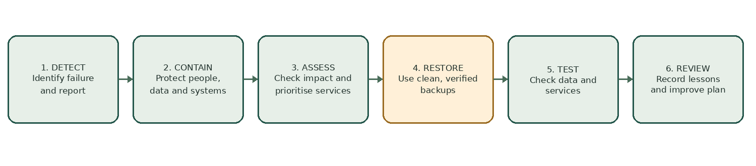
Figure 3: Recommended disaster recovery sequence for AFC.
AFC has two branches, but its database server is located at the Cape Town head office. This creates a major dependency: a serious incident at Cape Town could affect systems used by the wider business. Disaster recovery therefore needs to cover power/network failures, hardware failure, cyberattacks, fire, theft and loss of access to the Cape Town office.
The plans below follow a practical Identify–Protect–Detect–Respond–Recover approach. NIST recommends regular backups, tested response plans, clear responsibilities, communication and updating recovery plans after exercises or incidents (NIST, 2023; Nelson et al., 2025).

8.1 Hardware or Server Failure
- Detect and record the failure through the service desk.
- The Systems & Network Administrator checks whether the failure affects the database, website, payroll or other critical services.
- Isolate failed hardware if necessary to prevent further damage.
- Restore critical services using the latest verified backup or approved redundancy mechanism.
- Prioritise the database and essential business services before lower-priority systems.
- Test data integrity and user access before returning the system to normal operation.
- Document the cause, downtime and corrective action.

8.2 Cyberattack or Ransomware
- Immediately report the incident to the IT Support Technician and IT Manager.
- Disconnect affected devices from the network where safe to do so, without destroying evidence.
- Identify affected accounts, devices, servers and services.
- Disable compromised accounts and block malicious connections as appropriate.
- Preserve relevant logs and incident information for investigation.
- Escalate serious incidents to management and appropriate external specialists/authorities where required.
- Restore from clean, verified backups only after the cause has been contained.
- Reset credentials and patch the vulnerability that allowed the incident.
- Monitor restored systems for signs of continued compromise.
- Record lessons learned and update the security and recovery procedures.

8.3 Network or Internet Outage
- Confirm whether the outage affects one device, one branch or both branches.
- Check network equipment, power, cabling and service-provider status.
- If Cape Town is affected, confirm whether Durban can continue essential work using available services.
- Contact the internet/network service provider when the fault is outside AFC's control.
- Prioritise restoration of connectivity required for sales, shipping, stock control, finance and the website.
- Document downtime and the final cause.

8.4 Fire, Flood, Theft or Loss of Site
- Put staff safety first and follow emergency evacuation procedures.
- Do not re-enter an unsafe building to retrieve IT equipment.
- Notify management, emergency services and relevant insurers where appropriate.
- Activate the business continuity/recovery plan.
- Use the alternate branch or approved remote working arrangements where possible.
- Restore critical systems from protected backups and replace essential equipment.
- Communicate clearly with employees and customers about service availability when necessary.
- Review the incident and improve physical security and recovery arrangements.

8.5 Backup and Recovery Schedule
AFC should maintain regular backups of the database, critical documents and configuration information. At least one backup copy should be separated from the production environment so that a ransomware incident cannot easily destroy every copy. Backups must also be tested rather than simply assumed to work (NIST, 2023).
- Daily: automated backup of critical operational data.
- Weekly: full backup and review of backup status.
- Monthly: test restoration of selected files/database data.
- Quarterly: disaster recovery exercise involving the IT team and relevant business users.
- After a major system change: verify that backups and recovery procedures still work.
- After an incident: review the recovery process and update the plan using lessons learned.

8.6 Proposed recovery objectives and dependencies
Recovery Time Objective (RTO) is the target time to restore a service. Recovery Point Objective (RPO) is the maximum targeted period of data loss measured in time. The values below are planning assumptions for discussion, not measured capabilities or approved business commitments. AFC must confirm them with management and test whether its backup, server, internet and supplier arrangements can meet them.
Service / information | Proposed RTO | Proposed RPO | Reason / recovery priority
Central database and core operational records | 8 hours | 4 hours | Needed for coordination between Cape Town and Durban; restore and validate data integrity before normal use
Sage ERP Payroll and payroll records | 1 business day | 24 hours | Important for payroll processing; restrict access during recovery and reconcile any transactions after restoration
Microsoft 365 email and collaboration | 8 hours | 24 hours | Supports staff communication and document access; use provider status information and approved account recovery
Customer-facing website | 12 hours | 24 hours | Customer information channel; restore clean site files and verify links, forms and contact details
Individual user computer | 1 business day | Last successful approved file backup / cloud sync | Replace or rebuild from approved configuration; recover business files from authorised storage
Recovery order: (1) staff safety and incident containment; (2) restore the network and identity/access services needed for recovery; (3) restore and validate the central database and critical business records; (4) restore payroll and other operational applications; (5) restore the website and lower-priority user services; and (6) confirm service owners can use each service before closing the incident. The order may change if the incident affects safety, legal obligations or data integrity.

9. Static Website Design and Development
The AFC website should be a simple, professional static website that allows employees to find the relevant SOPs quickly. It should also communicate basic company information and provide a clear way to navigate to the procedures.
Recommended main navigation:
- Home – short introduction to African Foods Company (Ltd) and its purpose.
- About AFC – branches, business activities and contact information.
- IT Structure – IT department roles and reporting lines.
- Security Policy – employee security guidelines.
- Acceptable Use – rules for using company technology.
- Acquisition – technology request and approval procedure.
- Help Desk – how to report and escalate IT problems.
- Disaster Recovery – what employees should do during major IT incidents.
Website design requirements:
- Responsive layout so that the pages remain usable on desktops, laptops, tablets and mobile phones.
- Clear navigation menu visible on every page.
- Readable headings, short paragraphs and bullet lists so employees can find procedures quickly.
- Consistent typography, spacing and colours across all pages.
- Accessible contrast and descriptive labels for links and controls.
- No sensitive passwords, database credentials or confidential customer information stored in the static website.
- A clear emergency/help-desk contact area on the relevant pages.
- The website should be tested for broken links, spelling, layout, mobile responsiveness and ease of navigation before release.
The accompanying static website created for this assignment follows this structure and provides a main SOP navigation area. The website is intended as an employee reference point; sensitive operational information should remain in approved secure systems.

9.1 Website quality assurance and evidence checklist
Before submission, the website should be checked in a browser and the results recorded. Do not mark a test as passed until it has actually been performed. Include dated screenshots of the homepage and key SOP sections where the rubric asks for website evidence.
Check | How to verify | Status before final submission
Navigation | Open each menu item and confirm it reaches the correct section/page | To be tested
Responsive layout | Check the site at desktop and mobile widths; confirm text and menus remain usable | To be tested
Images and diagrams | Confirm each supplied image loads and has meaningful alternative text where appropriate | To be tested
Readability and accessibility | Check heading order, colour contrast, link wording and keyboard navigation | To be tested
Content accuracy | Confirm Cape Town and Durban are the only branches in scope; check contact details and procedure wording | To be tested
Security and privacy | Confirm no real passwords, customer records or confidential operational credentials appear in the static site | To be tested
Evidence and packaging | Capture dated screenshots; ensure the website folder and README are included in the final ZIP | To be tested
Keep a short test record with the date, browser/device, test performed, result, issue found and corrective action. This makes it clear which features have been verified and which still require work.

9.2 Suggested implementation plan
A phased rollout reduces disruption and allows AFC to check that the procedures work in practice. The timeline below is indicative and should be adjusted to the company’s staffing and budget.
Phase | Indicative timing | Key activities | Completion evidence
1. Approve and assign ownership | Week 1 | Management reviews policies, names owners and confirms escalation contacts | Approved SOP version and responsibility list
2. Prepare controls | Weeks 2–3 | Review user access, asset register, endpoint updates, backup jobs and service desk ticket fields | Access review, asset list and backup status records
3. Publish and train | Week 4 | Publish static SOP site internally and brief staff on reporting, acceptable use and security incidents | Training attendance and website screenshots
4. Test recovery and support | Weeks 5–6 | Run a restore test, service desk scenario and branch connectivity checks | Test results, issues and corrective actions
5. Review and improve | Quarterly | Review tickets, incidents, backup tests, access changes and policy updates | Review minutes and updated SOP version history

10. Conclusion
AFC's two-site structure and dependence on its Cape Town database server make clear IT procedures necessary. The proposed SOPs give employees a practical way to protect company information, use technology responsibly, request new equipment, report technical problems and respond to serious incidents. The disaster recovery plans also recognise that technology failures can directly affect sales, shipping, stock control, finance and customer service. Together with the static SOP website, these procedures provide AFC with a more organised and consistent approach to IT management.

11. References – IIE Harvard Style
- Institute of Education (IIE) (2026) IIE Library: Referencing and plagiarism. Available at: https://iielibraryconnect.iie.ac.za/e-shelf/referencing-and-plagiarism (Accessed: 4 October 2026).
- National Institute of Standards and Technology (NIST) (2023) CSF 1.1 Quick Start Guide. Available at: https://www.nist.gov/cyberframework/csf-11-quick-start-guide (Accessed: 4 October 2026).
- Pascoe, C., Quinn, S. and Scarfone, K. (2024) The NIST Cybersecurity Framework (CSF) 2.0. National Institute of Standards and Technology. Available at: https://doi.org/10.6028/NIST.CSWP.29 (Accessed: 4 October 2026).
- Nelson, A., Rekhi, S., Souppaya, M. and Scarfone, K. (2025) SP 800-61 Rev. 3: Incident Response Recommendations and Considerations for Cybersecurity Risk Management: A CSF 2.0 Community Profile. National Institute of Standards and Technology. Available at: https://doi.org/10.6028/NIST.SP.800-61r3 (Accessed: 4 October 2026).

Note: The IIE Library confirms that IIE uses a Harvard-style referencing guide for academic writing. The reference list above has been formatted in a practical IIE Harvard/Anglia-style format; the final submission should be checked against the exact IIE guide supplied for your module.

