Assessment System Design
Revision History
Date | Issue | Description | Author
07/17/2015 | 1.0 | Draft version | Janardhan Bonu
07/17/2015 | 1.1 | Login and register user | Michael Fayez
07/17/2015 | 1.2 | Create Assessment | Bharat Tappa
07/17/2015 | 1.3 | Create Questions | Amrit Kadhka
07/18/2015 | 1.4 | Take Assessment | Janardhan Bonu
07/17/2015 | 1.5 | Review – Final Version | Team

Table of Contents
1. Introduction 4
1.1 Purpose 4
2. Requirements - Use-Case – Usage Scenarios 4
3. Use Case # 1: Login 5
3.1 GENERAL CHARACTERISTICS 5
3.2 MAIN FLOW 5
3.3 ALTERNATIVE FLOWS 5
3.4 RELATED INFORMATION 5
4. Use Case # 2: Register 6
4.1 GENERAL CHARACTERISTICS 6
4.2 MAIN FLOW 6
4.3 ALTERNATIVE FLOWS 6
4.4 RELATED INFORMATION 6
5. Use Case # 3: Create Assessment 7
5.1 GENERAL CHARACTERISTICS 7
5.2 MAIN FLOW 7
5.3 ALTERNATIVE FLOWS 7
5.4 RELATED INFORMATION 7
Use Case # 4: Create Question and Answer 8
5.5 GENERAL CHARACTERISTICS 8
5.6 MAIN FLOW 8
5.7 ALTERNATIVE FLOWS 8
5.8 RELATED INFORMATION 8
Use Case # 5: Take Assessment 9
5.9 GENERAL CHARACTERISTICS 9
5.10 MAIN FLOW 9
5.11 ALTERNATIVE FLOWS 9
5.12 RELATED INFORMATION 9
6. Use Case # 6: View Assessments by Student 10
6.1 GENERAL CHARACTERISTICS 10
6.2 MAIN FLOW 10
6.3 ALTERNATIVE FLOWS 10
6.4 RELATED INFORMATION 10
7. High Level Design 11
8. Technology Stack 12
9. Detailed Design 13
9.1 <Object.Name> Usage 13
9.2 Sequence Diagram 13
10. Design Alternatives 15
11. Issues, Risk and Dependencies 15
12. Future Considerations 15
13. References 15

Introduction
Assessment System is assessment creating and assessment taking tool.
1. User can login with username and password.
2. Professor users can create questions. Question types: Multiple choice, true false, multiple select (choose many)
3. Professor users can add questions into assessment.
4. Students (users) can take the test.
5. Tests submitted by students are graded and the grades are displayed to the student.
6. Grades are ratio numbers displayed as (points scored/total points)

Purpose
This application helps professor to manage the assessments and students to take the assessment

Requirements - Use-Case – Usage Scenarios

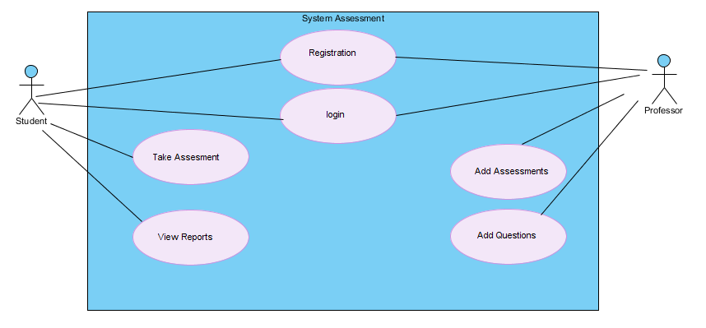

- Login to the application
- Register users like students and professor and also assign the roles in the system for authorization
- Manage Assessment.
- Assign/Manage Questions to Assessment
- Take Assessment
- View assessment List

Use Case # 1: Login

GENERAL CHARACTERISTICS
Intent
Author |  | Janardhan Bonu
Last Update:
Primary Actor |  | User (Student/professor)
Secondary Actors
Description |  | User logins
Preconditions |  | The user must have registered before
Trigger |  | Click on login link in homepage
Success Post Condition |  | The user is redirected to the home page
Failed Post Condition |  | The user has entered wrong credentials

MAIN FLOW
Step | Action
1 | The user clicks on login link
2 | The user is redirected to the login page
3 | User enters the username and password
4 | If correct credentials, user is redirected to homepage and view the links available to his role
 | Use case ends

ALTERNATIVE FLOWS
Step | Branching Action
3.1 | If wrong credentials, user remains within the login page with error message displayed
3.2 | The user will be in the login page with error message displayed till correct credentials are entered.
3.3 | No errors dispalyed

RELATED INFORMATION
Performance
Frequency
NOTES & ISSUES
Future Considerations

Use Case # 2: Register

GENERAL CHARACTERISTICS
Intent
Author |  | Michael Saleeb
Last Update:
Primary Actor |  | Student/Professor
Secondary Actors
Description |  | User creates an account in the website
Preconditions |  | None
Trigger |  | Click on register in homepage
Success Post Condition |  | Account is created successfully
Failed Post Condition |  | Error messages appear beside fields

MAIN FLOW
Step | Action
1 | The user clicks on register in homepage
2 | The user is redirected to register page
3 | The user fills the fields of the registration form
4 | User clicks submit
5 | The user gets redirected to the success page
 | Use case ends

ALTERNATIVE FLOWS
Step | Branching Action
3.1 | The user enter fields in incorrect format
3.2 | The user gets messages for validation errors

RELATED INFORMATION
Performance
Frequency
NOTES & ISSUES
Future Considerations

Use Case # 3: Create Assessment

GENERAL CHARACTERISTICS
Intent |  | To let the professor/admin to add the assessment in a particular date.
Author |  | Bharat Thapa
Last Update: |  | 6/17/2015
Primary Actor |  | Professor
Secondary Actors
Description |  | The professor manages the Assessment generation.
Preconditions |  | The professor is admin.
Trigger |  | The professor clicks the Add Assessment button to add assessment fields.
Success Post Condition |  | The application saves the assessment in the database and finally shows the list of the added assessments.
Failed Post Condition |  | Error Message is Displayed

MAIN FLOW
Step | Action
1 | The professor clicks the add assessment button.
2 | The System shows the add assessment form with name , description and date fields in it.
3 | The professor fills the fields and clicks save.
4 | The system validates using the validation annotation and throws error if any constraints are not met.
5 | Finally the data is saved to the database.
 | Use case ends

ALTERNATIVE FLOWS
Step | Branching Action
2.A | The list of assessment page is displayed with the option of edit , delete and navigate to the question generation form.

RELATED INFORMATION
Performance
Frequency
NOTES & ISSUES
Future Considerations |  |  | Add RESTful Ajax , that dynamically pops the adding function without refreshing/navigating to the another page.

Use Case # 4: Create Question and Answer

GENERAL CHARACTERISTICS
Intent |  | To let the professor create question and answer.
Author |  | Amrit Khadka
Last Update: |  | 6/18/2015
Primary Actor |  | Professor
Secondary Actors |  | Student
Description |  | To let the professor create question and answer.
Preconditions |  | Assessment is created
Trigger |  | Click on the assessment from the list of assessment
Success Post Condition |  | Question and answer is added to Database
Failed Post Condition |  | Error message is displayed

MAIN FLOW
Step | Action
1 | Professor goes to question list page, and clicks a button to add question.
2 | The assessment create form is displayed. Professor selects the type of question to be added. And submits the form.
3 | Based on the question type answer fields are displayed specific to the type of question.
4 | Answer form is filled and submitted.
 | Use case ends

ALTERNATIVE FLOWS
Step | Branching Action
2.A

RELATED INFORMATION
Performance
Frequency
NOTES & ISSUES |  |  | Lazy loading is tricky.
Future Considerations

Use Case # 5: Take Assessment

GENERAL CHARACTERISTICS
Intent
Author |  | Janardhan Bonu
Last Update:
Primary Actor |  | Student
Secondary Actors
Description |  | Student take assessment
Preconditions |  | Open Assessment available to take by student and sign-in
Trigger |  | Click on TakeAssessment
Success Post Condition |  | TakeAssessment created
Failed Post Condition |  | Assessment already created

MAIN FLOW
Step | Action
1 | The logged in student will click on the open assessment link
2 | A new page with questions will be displayed
3 | Fill answers to the questions
4 | Submit the assessment
5 | View assessment result
 | Use case ends

ALTERNATIVE FLOWS
Step | Branching Action
3.1 | The system validates if the all the questions are answered. Show error if no answered
3.2 | Fill the answers and check if there are no errors.
3.3 | No errors dispalyed

RELATED INFORMATION
Performance
Frequency
NOTES & ISSUES
Future Considerations

Use Case # 6: View Assessments by Student

GENERAL CHARACTERISTICS
Intent
Author |  | Janardhan Bonu
Last Update:
Primary Actor |  | Student
Secondary Actors
Description |  | Student view open assessments
Preconditions |  | Open Assessment available to take by student and sign-in
Trigger |  | Click on view all assessments
Success Post Condition |  | View all assessments
Failed Post Condition |  | Empty Assessment list.

MAIN FLOW
Step | Action
1 | The logged in student will click on the Show Assessments link
2 | A new page with List of all assessments is shown in a table format
3 | Each row has the link to take the assessment by student
4 | Student takes the assessment by clicking on related assessment link
5
 | Use case ends

ALTERNATIVE FLOWS
Step | Branching Action
3.1

RELATED INFORMATION
Performance
Frequency
NOTES & ISSUES
Future Considerations

High Level Design
[In this section, explain in a few sentences what each entity does. Describe your reasoning for defining the entities in your diagram and what their roles are.]
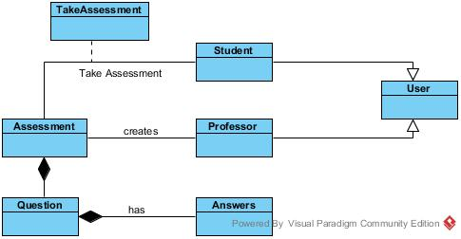

Figure 1 Domain Object Model

Technology Stack
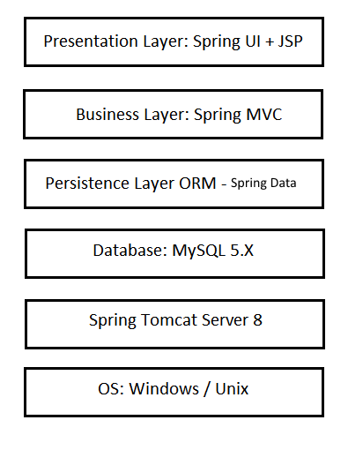

Detailed Design
[This section is where your objects and object relationships are defined.

<Object.Name> Usage
[This section is where your objects and object relationships are defined. Describe how the object is used and what function it serves. If an object will interface with an external object or system, it is a good idea to show the interface for the object. Most importantly, you must again describe your thought process for defining the object as you did. List the benefits and risks. If an object provides an encapsulation, describe in a sentence why the encapsulation adds value. Use your descriptions to give meaning to the diagrams.

Figure 2 <ClassDiagram.Name>

Sequence Diagram
[An Sequence diagram shows how a set of objects or entities communicate with each other to perform a complex task.]
Register new User
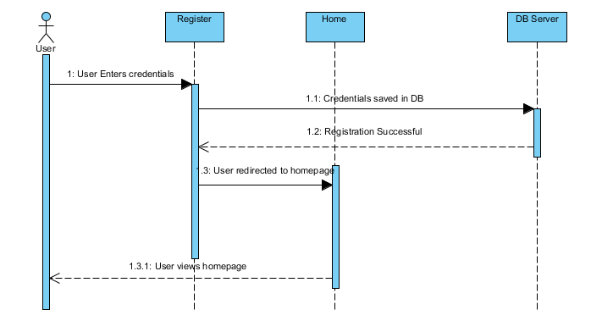

Create Assessment
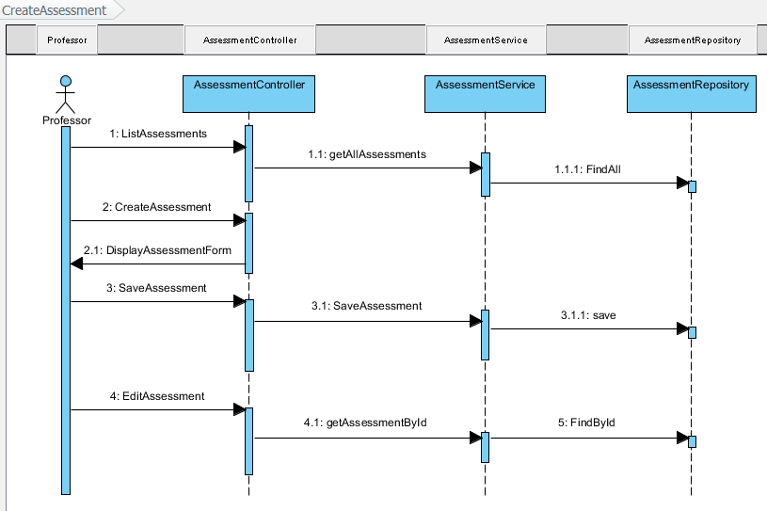

Create Question
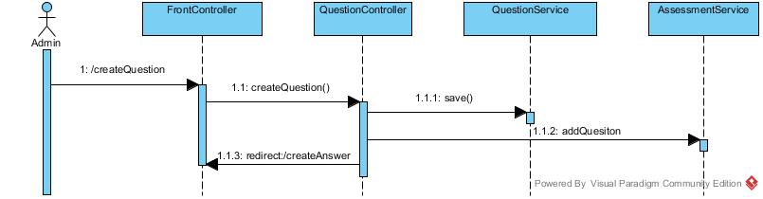

Create Answer

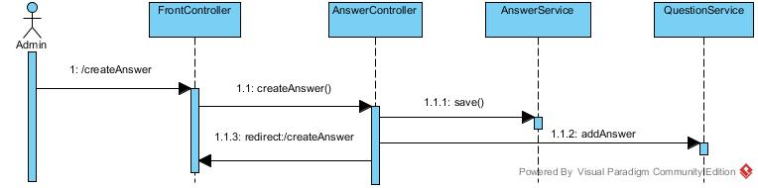

Create Assessment

Design Alternatives
[This section describes alternative designs that were considered. ]

Issues, Risk and Dependencies
[All known risks/issues and a list of all assumptions/Dependencies. Some of this may simply be rehashing what you wrote in a previous section of the document.
What’s important is getting all of these items into one section so that the reader doesn’t have to read the whole document to understand what the benefits, risks and assumptions are.

Future Considerations
Deploy the application to Red Hat cloud service using Open Shift apache tomcat server.

References
[This subsection provides a complete list of all documents referenced. Identify each document by title, report number (if applicable), date, and publishing organization. Specify the sources from which the references can be obtained. This information may be provided by reference to an appendix or to another document.]

