**Exercise on GitHub and Git**

**Part 3:**

What is GitHub? When was it created? Why? By who? What similar platforms exist? Why would you use such a platform? (Answer between 5 and 10 lines)

* GitHub is a web-based version-control and collaboration platform for software developers.
* GitHub was started in 2008 and was founded on Git, an open source code management system created by Linus Torvalds to make software builds faster.
* Bitbucket, Sourceforge, GitLab, Codeplane and many others are the similar platforms to GitHub.
* I would use GitHub for Software development and for my group projects which would help me track the changes without affecting the original copy.

**Part 4:**

Go through the Git tutorial here: <https://try.github.io>.

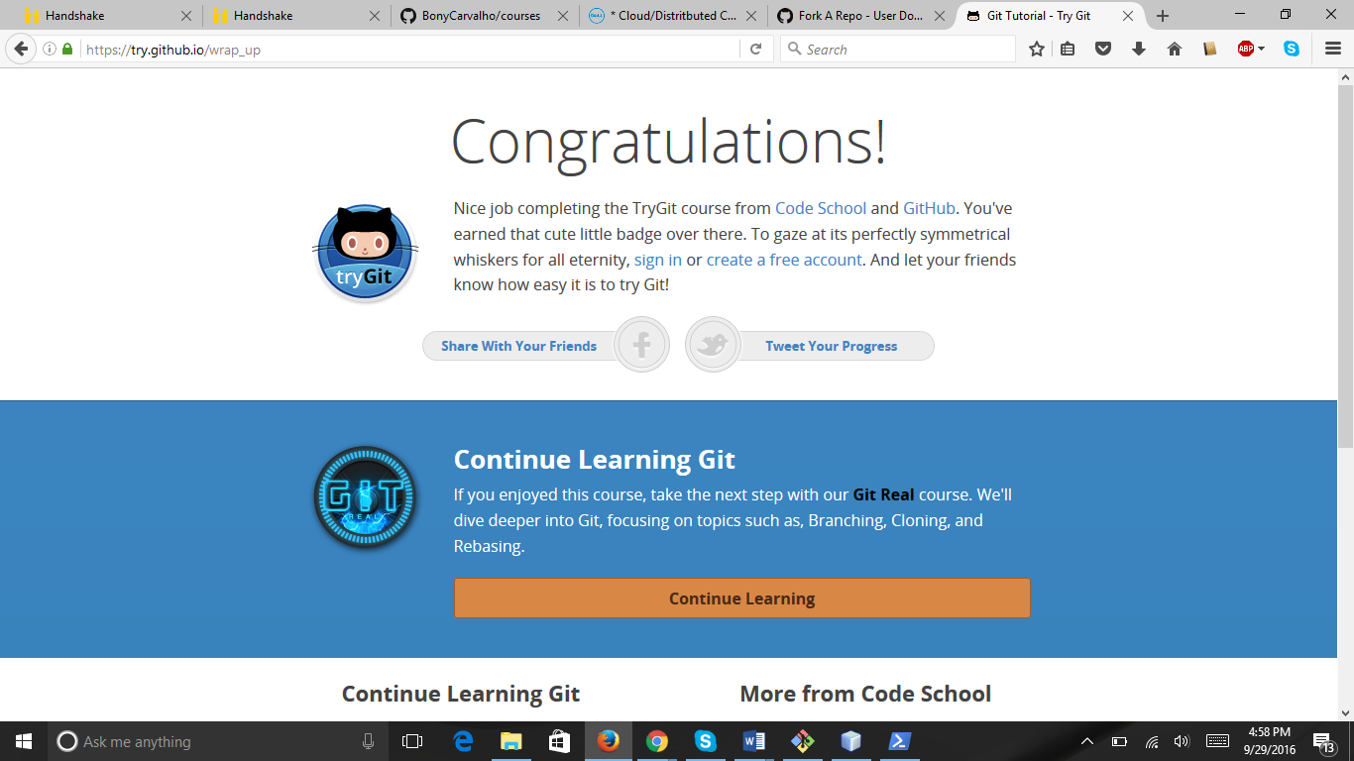

**Part 5:**

Define the following terms in the context of Git (2 lines maximum):

* Repository

The purpose of a repository is to manage a project, or a set of files, as they change over time. A repository is simply a place where the history of your project is stored.

* Commit

A Git Commit records changes to the repository.

* Push

A Git Push updates remote refs along with associated objects.

* Branch

In Git, a branch is simply a lightweight movable pointer to one of the commits. The default branch name in Git is master.

* Fork

A fork is a copy of a repository which allows you to freely experiment with changes without affecting the original project. Forks can be used for changes to someone else's project or to use someone else's project as a starting point for your own project.

* Merge

A Git Merge is to join two or more development histories together.

* Clone

A Git Clone is to clone a repository into a new directory.

* Pull

A Git Pull is to fetch from and integrate with another repository or a local branch.

* Pull request

A Git Pull requests tells you and others about changes you've pushed to a repository. Once a pull request is sent, interested parties can review the set of changes, discuss potential modifications, and even push follow-up commits if necessary.

**Part 7:**

Updating README.MD from courses.

* Go to <https://github.com/paceuniversity/courses>
* Fork it.
* Clone the courses folder using : git clone https://github.com/username/courses.git
* To check remote repository for your fork: git remote –v
* Start an upstream repository using command: git remote add upstream <https://github.com/username/courses.git>
* Then go to github and edit the readme.md
* Submit a pull request.