**Weed Seed: *Avena fatua* (Wild oat)**

**Family**

*Poaceae*

**Common Name**

Wild oat

**Regulation**

Secondary Noxious, Class 3 in the Canadian [*Weed Seeds Order*, 2016](https://www.inspection.gc.ca/english/reg/jredirect2.shtml?wsoagm2016) under the [*Seeds Act*](https://www.inspection.gc.ca/english/reg/jredirect2.shtml?seesema).

**Distribution**

**Canadian:** Occurs across Canada except in NU; ephemeral in YT (Brouillet et al. 2016[Footnote 1](https://www.inspection.gc.ca/plant-health/seeds/seed-testing-and-grading/seeds-identification/avena-fatua/eng/1473681928384/1473681928951#fn1)).

**Worldwide:** Native to Europe, northern Africa and central Asia (USDA-ARS 2016[Footnote 2](https://www.inspection.gc.ca/plant-health/seeds/seed-testing-and-grading/seeds-identification/avena-fatua/eng/1473681928384/1473681928951#fn2)); associated with the cultivation of oats and other cereals since the Iron Age (CABI 2016[Footnote 3](https://www.inspection.gc.ca/plant-health/seeds/seed-testing-and-grading/seeds-identification/avena-fatua/eng/1473681928384/1473681928951#fn3)). Introduced throughout temperate regions and present on all continents except Antarctica (CABI 2016[Footnote 3](https://www.inspection.gc.ca/plant-health/seeds/seed-testing-and-grading/seeds-identification/avena-fatua/eng/1473681928384/1473681928951#fn3); USDA-ARS 2016[Footnote 2](https://www.inspection.gc.ca/plant-health/seeds/seed-testing-and-grading/seeds-identification/avena-fatua/eng/1473681928384/1473681928951#fn2)). Occurs throughout the United States, except in a few southeastern states (Kartesz 2011[Footnote 4](https://www.inspection.gc.ca/plant-health/seeds/seed-testing-and-grading/seeds-identification/avena-fatua/eng/1473681928384/1473681928951#fn4), USDA-NRCS 2016[Footnote 5](https://www.inspection.gc.ca/plant-health/seeds/seed-testing-and-grading/seeds-identification/avena-fatua/eng/1473681928384/1473681928951#fn5)).

**Duration of life cycle**

Annual

**Seed or fruit type**

Floret

**Identification features**

**Size**

* Floret length: 10.0 - 15.0 mm
* Floret width: 2.5 - 4.0 mm
* Caryopsis length: 6.0 - 8.0 mm
* Caryopsis width: 2.0 - 3.0 mm

**Shape**

* Floret elongate; tapered at the top and narrowed at the base with a flared callus

**Surface Texture**

* Floret has a rough surface
* Long, stiff hairs around the base of floret

**Colour**

* Floret tends to be a reddish colour with a straw yellow tip, but can be straw yellow to brown

**Other Features**

* Callus at the base of the floret is prominent and spoon- shaped
* Caryopsis is covered in hairs, the scutellum is absent and often has an indentation where the awn arose from the lemma
* A strongly bent and twisted awn is attached to the upper 1/2 of the lemma; up to 40.0 mm long

**Habitat and Crop Association**

Cultivated fields, fallow fields, pastures, gardens, roadsides and disturbed areas (Sharma and Vanden Born 1978[Footnote 6](https://www.inspection.gc.ca/plant-health/seeds/seed-testing-and-grading/seeds-identification/avena-fatua/eng/1473681928384/1473681928951#fn6), Darbyshire 2003[Footnote 7](https://www.inspection.gc.ca/plant-health/seeds/seed-testing-and-grading/seeds-identification/avena-fatua/eng/1473681928384/1473681928951#fn7)). A serious weed of cereals, oilseeds and legume crops, mainly associated with fertile soils and spring cereals but can be found on nearly all soil types in a wide range of cropping systems (Sharma and Vanden Born 1978[Footnote 6](https://www.inspection.gc.ca/plant-health/seeds/seed-testing-and-grading/seeds-identification/avena-fatua/eng/1473681928384/1473681928951#fn6), CABI 2016[Footnote 3](https://www.inspection.gc.ca/plant-health/seeds/seed-testing-and-grading/seeds-identification/avena-fatua/eng/1473681928384/1473681928951#fn3)).

**General Information**

Wild oat has relatively large seeds and its dispersal is associated with the cultivation of cereal crops around the world (CABI 2016[Footnote 3](https://www.inspection.gc.ca/plant-health/seeds/seed-testing-and-grading/seeds-identification/avena-fatua/eng/1473681928384/1473681928951#fn3)). In North America, it was introduced by early European settlers as a contaminant in seeds and animal feed, and the earliest record in Canada indicates it was present in oats cultivated in Newfoundland in 1622 (Sharma and Vanden Born 1978[Footnote 6](https://www.inspection.gc.ca/plant-health/seeds/seed-testing-and-grading/seeds-identification/avena-fatua/eng/1473681928384/1473681928951#fn6)). Since then it has spread across the continent in cereals and other crops.

A single wild oat plant typically produces 100-150 seeds, with reports of up to 500 seeds per plant depending on growing conditions (Sharma and Vanden Born 1978[Footnote 6](https://www.inspection.gc.ca/plant-health/seeds/seed-testing-and-grading/seeds-identification/avena-fatua/eng/1473681928384/1473681928951#fn6)); seeds may remain viable for up to 14 years (CABI 2016[Footnote 3](https://www.inspection.gc.ca/plant-health/seeds/seed-testing-and-grading/seeds-identification/avena-fatua/eng/1473681928384/1473681928951#fn3)).

**Similar species**

**Tame oat (*Avena sativa*)**

* Tame oat florets are a similar to those of wild oat in length, elongated shape, lighter colour and a pointed rachilla.
* Tame oat florets tend to be wider (width: 2.5 - 4.5 mm), a uniform straw yellow (although red-brown and grey varieties occur), with a smooth to slightly pebbled surface.
* The callus of tame oat tends to be peg-like and fractured. There may be a rudimentary awn that does not create an indentation on the caryopsis.

**Photos**

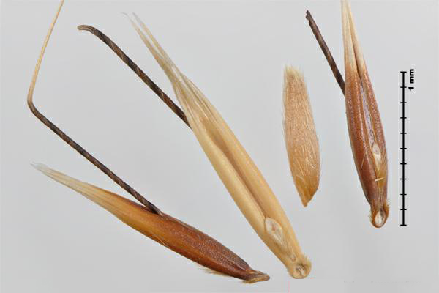Wild oat (*Avena fatua*); florets and caryopsis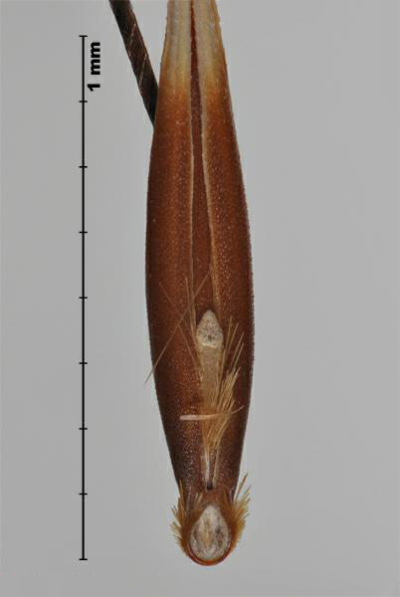Wild oat (*Avena fatua*) floret, palea view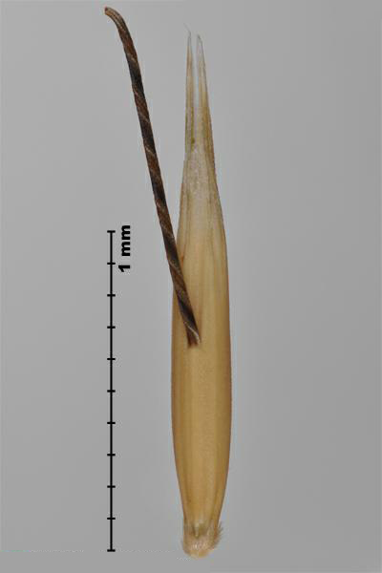Wild oat (*Avena fatua*) floret, lemma view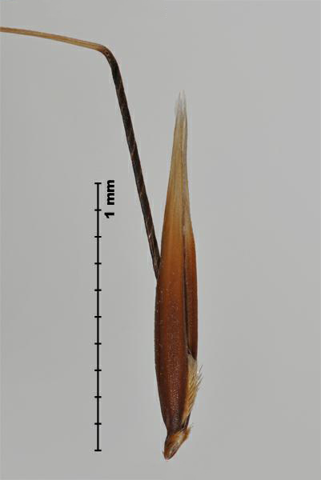Wild oat (*Avena fatua*) floret, side view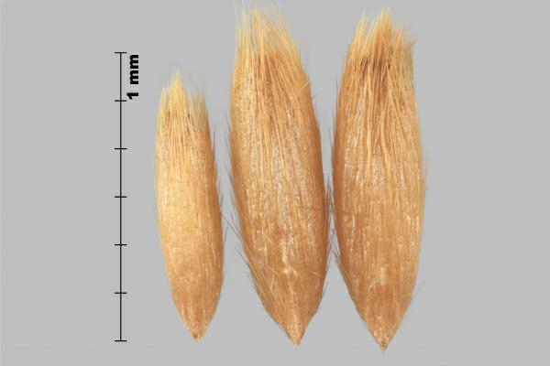Wild oat (*Avena fatua*) caryopses, embryo view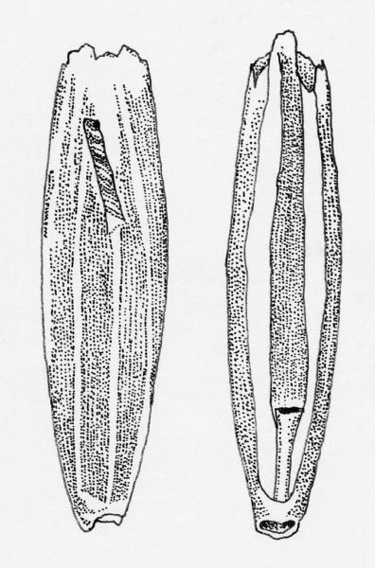Wild oat (*Avena fatua*) florets, lemma view (L) and palea view (R)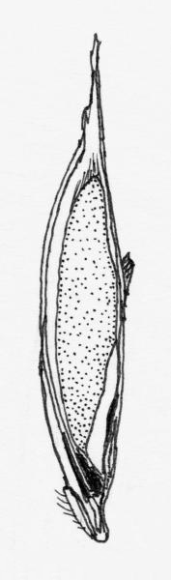Wild oat (*Avena fatua*) floret, cross-section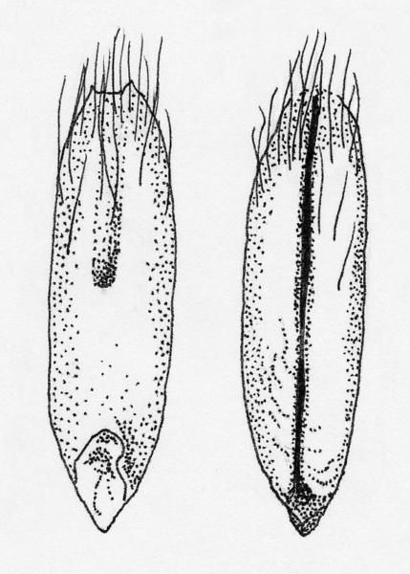Wild oat (*Avena fatua*) caryopses

**Similar species**

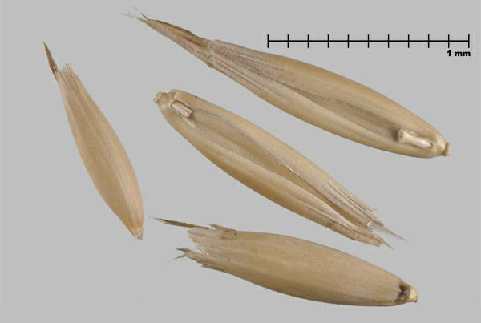Similar species: Tame oat (*Avena sativa*) florets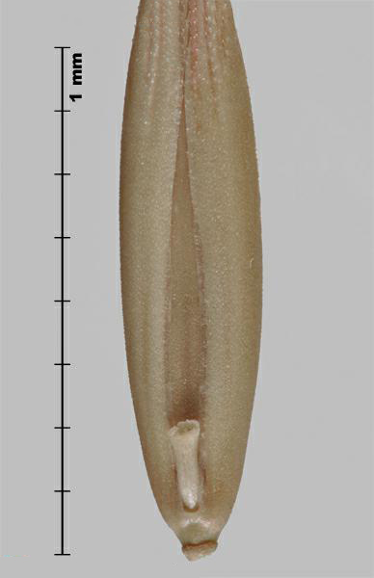Similar species: Tame oat (*Avena sativa*) floret, palea view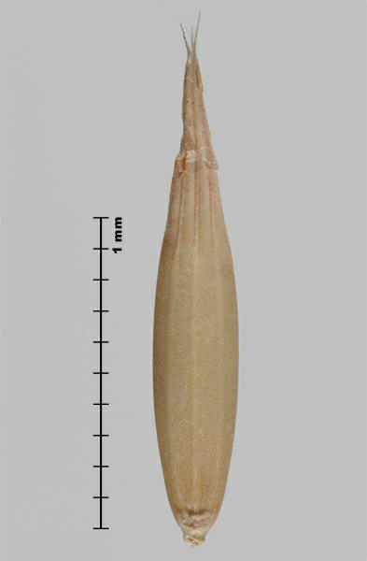Similar species: Tame oat (*Avena sativa*) floret, lemma view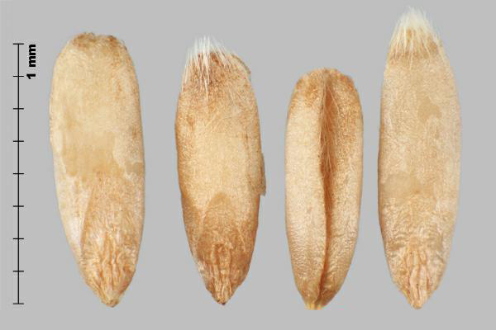Similar species: Tame oat (*Avena sativa*) caryopses, embryo view and centre - hilum view

**Footnotes**

**Footnote 1**

**Brouillet, L., Coursol, F., Favreau, M. and Anions, M. 2016**. VASCAN, the database vascular plants of Canada, http://data.canadensys.net/vascan/ [2016, May 30].

[Return to footnote 1 referrer](https://www.inspection.gc.ca/plant-health/seeds/seed-testing-and-grading/seeds-identification/avena-fatua/eng/1473681928384/1473681928951#fn1-rf)

**Footnote 2**

**USDA-ARS 2016**. Germplasm Resources Information Network - (GRIN), https://npgsweb.ars-grin.gov/gringlobal/taxon/taxonomysimple.aspx [2016, May 30].

[Return to footnote 2 referrer](https://www.inspection.gc.ca/plant-health/seeds/seed-testing-and-grading/seeds-identification/avena-fatua/eng/1473681928384/1473681928951#fn2a-rf)

**Footnote 3**

**CABI. 2016**. Invasive Species Compendium, www.cabi.org/isc [2016, May 30].

[Return to footnote 3 referrer](https://www.inspection.gc.ca/plant-health/seeds/seed-testing-and-grading/seeds-identification/avena-fatua/eng/1473681928384/1473681928951#fn3a-rf)

**Footnote 4**

**Kartesz, J. T. 2011**. The Biota of North America Program (BONAP). North American Plant Atlas. Chapel Hill, N.C., www.bonap.org/MapSwitchboard.html [2016, May 30].

[Return to footnote 4 referrer](https://www.inspection.gc.ca/plant-health/seeds/seed-testing-and-grading/seeds-identification/avena-fatua/eng/1473681928384/1473681928951#fn4-rf)

**Footnote 5**

**USDA-NRCS. 2016**. The PLANTS Database. National Plant Data Center, Baton Rouge, LA USA, http://plants.usda.gov [2016, May 30].

[Return to footnote 5 referrer](https://www.inspection.gc.ca/plant-health/seeds/seed-testing-and-grading/seeds-identification/avena-fatua/eng/1473681928384/1473681928951#fn5-rf)

**Footnote 6**

**Sharma, M. P. and Vanden Born W. H. 1978**. The biology of Canadian weeds. 27. *Avena fatua* L. Canadian Journal of Plant Science 58: 141-157.

[Return to footnote 6 referrer](https://www.inspection.gc.ca/plant-health/seeds/seed-testing-and-grading/seeds-identification/avena-fatua/eng/1473681928384/1473681928951#fn6a-rf)

**Footnote 7**

**Darbyshire, S. J. 2003**. Inventory of Canadian Agricultural Weeds. Agriculture and Agri-Food Canada, Research Branch. Ottawa, ON.

[Return to footnote 7 referrer](https://www.inspection.gc.ca/plant-health/seeds/seed-testing-and-grading/seeds-identification/avena-fatua/eng/1473681928384/1473681928951#fn7-rf)

[Report a problem on this page](https://www.canada.ca/en/report-problem.html)

[Share this page](https://www.inspection.gc.ca/plant-health/seeds/seed-testing-and-grading/seeds-identification/avena-fatua/eng/1473681928384/1473681928951#shr-pg0)